Supplementary Material S3. Main analyses on conservative dataset (N = 77)
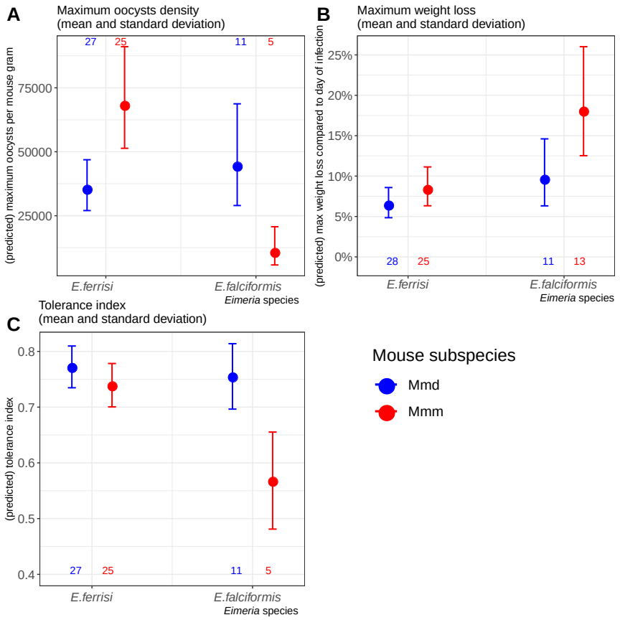
Resistance, impact on host health and tolerance marginal effects for the two mice subspecies and two Eimeria species. Values under bars represent the number of animals for each group. See Table 2 for summary statistics. (A) Resistance index measured as (- maximum number of oocysts per mouse gram + 300000) / 300000 ; (B) Impact on host health measured as the maximum weight loss during patent period relative to starting weight (%); (C) Tolerance Index measured as (log10(maximum relative weight loss / maximum number of oocysts per mouse gram + 1e-8) / -8

Post-hoc tests:

Linear regression of the tolerance index with the resistance index:

We found that tolerance index was negatively correlated with resistance index (LRT: G = 16.6, df = 2, p < 0.001), was different for both Eimeria species (LRT: G = 15.3, df = 2, p < 0.001), and that interaction between these two factors were significant (LRT: G = 12.5, df = 1, p < 0.001). Every increase of 1 unit of resistance index corresponds to a decrease of 0.08 unit of tolerance index for E. ferrisi (95%CI: [-0.25 , 0.09]) and to a decrease of 1 unit of tolerance index for E. falciformis (95%CI: [-1.58 , -0.54]).

