Supplementary Material S3. Main analyses on conservative dataset (Ntot = 77)
- Statistically significant differences in resistance: interaction between parasite species and mouse subspecies (glm/LRT; p-value=3e-05, n=68).
- Significant differences in impact on host health between mouse subspecies (glm/LRT, p-value=0.023, n=77) and between parasite species (glm/LRT, p-value=1e-04, n=77)
- Tolerance was found to differ significantly between mouse subspecies (lm/LRT, p-value=0.01, n=68), between parasite species (lm/LRT, p-value=0.04, n=68) and we found interactions between mouse subspecies and parasite species (lm/LRT, p-value=0.01, n=68).

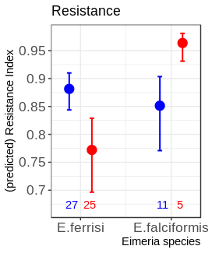
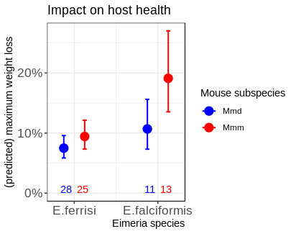

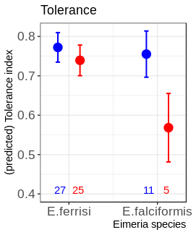

- We fit a linear model with Tolerance Index as response variable, explained by the interaction between Resistance Index and Eimeria species. The interaction term being statistically significant (t-statistic, p-value = 0.0006), we hereby conclude that the slopes of regression between both Eimeria species are significantly different.

