# Decoupling of resistance and tolerance against one of two related parasites (*Eimeria*) in mice

# Abstract

Resistance (the host’s capacity to reduce parasite burden) and tolerance (the host’s capacity to reduce impact on host health of a given parasite burden) manifest two different lines of immune defenses. In some host-parasite systems these two defenses are balanced against each other, while in others they are uncoupled. In hybrid hosts, resistance has sometimes been interpreted as having an effect on fitness without considering the modulatory effect of tolerance. Here, we used two closely related parasite species of genus *Eimeria* and measured proxies for resistance and tolerance in four wild-derived strains of inbred mice from two subspecies during controlled infection.

We found a negative correlation between resistance and tolerance against *E. falciformis*, while the two are uncoupled against *E. ferrisi*. This might be explained by trade-offs, as resistance limits infection load and thereby the scope of possible tolerance, and both resistance and tolerance can be costly in terms of resource allocation. Resistance can be assumed to be limited by immunopathogenicity, tolerance by carrying capacity of the host or energy drained by the parasite.

Findings of resistance in natural populations of hybrid mice have to be interpreted carefully in this context. Resistance and tolerance have to be studied in conjunction.

# Introduction

Using host concepts to compare between parasites

4 strains, 2 representant of 2 subspecies

Test local adaptation E fer

Efer-Efal different coupling

**COM 1 taxonomically too focused on your system, and you fail to cite work on other species that is relevant in this context**

COM 2 relevance of your work is in relation to the mouse hybrid zone,

Host defense mechanisms evolving in response to feedback between hosts and parasites can be categorised into two components: resistance and tolerance (Little, Shuker, Colegrave, Day, & Graham, 2010). Resistance (the ability of a host to reduce its parasite burden) results from defense against parasite infection or proliferation early after infection (Råberg, Graham, & Read, 2009). Resistance can be energetically costly and therefore limited by resource allocation as measured by a decrease of other fitness components (e.g. delayed maturity, lower fecundity) in the absence of infection (Langand, Jourdane, Coustau, Delay, & Morand, 1998; Sheldon & Verhulst, 1996; Vijendravarma, Kraaijeveld, & Godfray, 2009). Additionally, too strong immune response against pathogens can lead to a negative impact on health or immunopathology (Graham, Allen, & Read, 2005). Tolerance balances damage caused by parasites themselves and immunopathology (Medzhitov, Schneider, & Soares, 2012) through control mechanisms like stress response, damage repair and cellular regeneration (Soares, Teixeira, & Moita, 2017). This is why, just like resistance, tolerance can involve energetic costs (Simms & Triplett, 1994). In natural populations, costs of the two lines of defense against parasites predict that resistance and tolerance are negatively correlated (Råberg, 2014; Råberg, Sim, & Read, 2007). They can also be found uncoupled if they are at intermediate levels (Athanasiadou, Tolossa, Debela, Tolera, & Houdijk., 2015). As resistance alone is not an estimator of parasite impact on health, understanding how resistance and tolerance are coupled is necessary to conclude on health effects of parasitism.

The house mouse subspecies *Mus musculus musculus* and *M. m. domesticus* (hereafter Mmm and Mmd, respectively), whose genomes diverged some 0.5 million years ago, hybridize in a secondary contact zone running through Europe (Boursot, Auffray, Britton‐Davidian, & Bonhomme, 1993; Duvaux, Belkhir, Boulesteix, & Boursot,2011). Hybrids show elevated resistance to parasites compared to both parental subspecies (Baird et al., 2012; Balard et al., 2019). Newly generated diversity in the immune system can result in novel interplay in immunological response; interpretations of these results in terms of health or even fitness effects, however, have been attempted (Sage, Heyneman, Lim, & Wilson, 1986) and criticised (Baird & Goüy de Bellocq, 2019).

The protozoan parasite *Eimeria ferrisi* has been found to be the most prevalent (17%) *Eimeria* species in the house mouse hybrid zone in Brandenburg (Germany), followed by *E. falciformis (4%)* (Jarquín-Díaz, Balard, Jost, et al., 2019)*. Eimeria*spp. are monoxenous parasites that expand asexually and reproduce sexually in intestinal epithelial cells, leading to malabsorption of nutrients, tissue damage and weight loss (Chapman et al., 2013). They are generally considered to be host specific, and different species infect a wide range of animals including birds, mammals, reptiles, amphibians, and fish (Chapman et al., 2013; Jarquín-Díaz, Balard, Mácová, et al., 2019). *Eimeria ferrisi* and *E. falciformis* live in the cecum villar epithelial cells and cecum crypt cells, respectively (Schito, Barta, & Chobotar., 1996). Pre-patency (the time to shedding of infectious stages, so called oocysts) is longer for *E. falciformis* (7 days) than for *E. ferrisi* (5 days) (Al-khlifeh et al., 2019). While both species provoke inflammation, cellular infiltration, enteric lesions, diarrhea, and ultimately weight loss (Ankrom, Chobotar, & Ernst, 1975; Ehret, Spork, Dieterich, Lucius, & Heitlinger 2017; Schito et al., 1996), the symptoms are stronger for *E. falciformis* than for *E. ferrisi* infections (Al-khlifeh et al., 2019). The evolutionary history of these different *Eimeria* species in the two house mouse subspecies is unknown and is unclear whether subspecies-specific adaptation exists in one or the other.

Given differences in pathogenicity and prevalence between the two *Eimeria* species we suspected that coupling between resistance and tolerance might differ. We assessed this experimentally in controlled infections of Mmm and Mmd. We employed four wild-derived inbred strains representing the two mouse subspecies and assessed the symptoms both at the level of host subspecies and inbred strains.

# Material and methods

## Parasite strains

The three parasite isolates used in this study were isolated from feces of mice captured in a house mouse hybrid zone (HMHZ) running through Brandenburg, Germany (Macholán et al. 2019), in 2016 (capture permit No. 2347/35/2014). They belong to both the most prevalent *Eimeria* species in the wild (Jarquín-Díaz, Balard, Mácová, et al., 2019), namely *E. ferrisi* (isolates Brandenburg64 and Brandenburg139) and *E. falciformis* (isolate Brandenburg88). Hybrid index (HI) of each individual wild-caught mouse was calculated to account for the admixture of mouse genomes across the HMHZ as a proportion of Mmm alleles in a set of 14 diagnostic markers (Balard et al., 2019). Isolate Brandenburg64 was isolated in a 92% Mmd individual (HI = 0.08), isolate Brandenburg139 in a 85% Mmm (HI = 0.85) and isolate Brandenburg88 in a 80% Mmd (HI = 0.2). Pre-patency and the peak day of parasite shedding for these isolates were estimated during infection in NMRI laboratory mice (Al-khlifeh et al., 2019) which were also used for serial passaging of all the isolates. Parasite infective forms (oocysts) were recovered by flotation in saturated NaCl solution followed by washing and observation under light microscope (following the protocole described in Clerc, Fenton, Babayan, & Pedersen, 2019) and stored at room temperature in 1mL of 2% potassium dichromate for a maximum of 2 months before infection of the wild-derived mouse strains. Oocysts were allowed to sporulate 10 days before infection in a water bath at 30°C.

## Mouse strains

We used four wild-derived fully-inbred mouse strains: two representing Mmd: **SCHUNT** (Locality: Schweben, Hessen, Germany [N: 50° 26’, E: 9° 36’] (Martincová, Ďureje, Kreisinger, Macholán, & Piálek, 2019)) and **STRA** (Locality: Straas, Bavaria, Germany [N: 50° 11’, E: 11° 46’] (Piálek et al., 2008), and two derived from Mmm: **BUSNA** (Locality: Buškovice, Bohemia, Czech Republic [N: 50° 14’, E: 13° 22’] (Piálek et al., 2008)) and **PWD** (Locality: Kunratice, Bohemia, Czech Republic [N: 50° 01’, E: 14° 29’] (Gregorová & Forejt, 2000))(**Figure 1**). Age of the mice at the time of infection ranged between 7.6 and 21.4 weeks. All mouse strains were maintained before infection in the Institute of Vertebrate Biology in Studenec (licence number 61974/2017‐MZE‐17214; for further details on strains see <https://housemice.cz/en>).

Parasites of the *Eimeria* genus are known to induce host immune protection against reinfection (Rose, Hesketh, & Wakelin, 1992; Smith & Hayday, 2000). To ensure that our mice were *Eimeria*-naive, mice fecal samples were tested before infection for the presence of *Eimeria* spp. oocysts, by flotation in saturated NaCl solution followed by washing and observation under light microscope. All individuals were negative for *Eimeria* at the beginning of our experiment.

## Experimental infection

Mice were kept in individual cages during infection. Water and food (SNIFF, Rat/Mouse maintenance feed 10 mm) were provided *ad libitum* supplemented with 1 g of sunflower and barley seeds per day. Mice were orally infected with 150 sporulated oocysts of one *Eimeria* isolate suspended in 100 µl phosphate-buffer saline (PBS) and monitored daily until their sacrifice by cervical dislocation at 11 days after infection (dpi) (experiment license Reg. 0431/17). Individuals presenting severe health deficiency and/or a weight loss approaching 18% relative to their starting weight were sacrificed earlier. Weight was recorded and feces collected on a daily basis. Fecal pellets were collected every day from each individual cage and suspended in 2% potassium dichromate. Parasite oocysts were recovered using NaCl flotation (see above). In total, 108 mice were infected. Mice were randomly allocated to experimental groups ensuring homogeneous distribution of ages and sexes between groups. Our experiments were conducted in four consecutive batches for easy handling. The first two groups were infected by the two *E. ferrisi* isolates (Brandenburg64 and Brandenburg139), the two second by one *E. ferrisi* isolate (Brandenburg64) and one *E. falciformis* isolate (Brandenburg88). Summarised experiment design is shown in **Table 1**.

We observed *Eimeria* oocysts in the feces of 9 mice belonging to the last experimental batch at the day of infection, likely due to cross-contamination between batches. Moreover, before arrival to the infection facility, nematode eggs were observed in flotated feces of mice belonging to all genotypes. Nematode infection is common in breeding facilities (Baker, 1998). Despite treatment of the first infection batch of mice (22 mice) with anthelminthics (Profender®, Bayer AG, Levekusen, Germany) following the protocole of Mehlhorn et al. (2005), nematodes were still detected with PCR (following the protocole of Floyd, Rogers, Lambshead, & Smith, 2005) in randomly sampled fecal samples a week later. We therefore decided not to treat mice of the following infection batches. For following statistical tests, we considered the full data set and a conservative data set in which cross-contaminated animals and animals treated by anthelminthic are removed (see below).

## Statistical analyses

### Resistance

Resistance is the capacity of a host to reduce its parasite burden, therefore it is usually estimated by the inverse of infection intensity (Råberg et al., 2009). As a proxy we used the (inverse of) number of oocysts per gram of feces (OPG) at the day of maximal shedding. This measure is tightly correlated with the sum of oocysts shed throughout the experiment (Pearson correlation coefficient 0.91).

Appropriate distribution for maximum number of oocysts per gram of feces was found to be

(distribution: negative binomial)

selected based on log likelihood and AIC criteria and by comparing goodness-of-fits plots (density, CDF, Q-Q, P-P plots) between usual distributions (R packages MASS (Venables & Ripley, 2002) and fitdistrplus (Delignette-Muller & Dutang, 2015)). We modelled the maxiOPG using glm.nb as a response of mouse strain (N=4), parasite isolate (N=3) and their interaction. To test the significance of the marginal contribution to each parameter to the full model, each parameter was removed from the full model, and the difference between full model and sub-model was assessed using likelihood ratio tests (G).

Post-hoc multiple comparison tests (Tukey Multiple Comparisons of Means) were performed to test the significant difference of each host-parasite combination against all others.

### Weight loss upon infection / impact of Eimeria on fitness measure-dvp close proxy

The major measurable symptom in murine *Eimeria* infections is weight loss. Therefore, the impact of parasites on host health was measured as the maximum relative weight loss compared to day 0 (body weight taken at the start of the experimental infection).

Because ratio, the appropriate distribution for maximum weight loss relative to day 0 (distribution: Weibull) was selected based on log likelihood and AIC criteria and by comparing goodness-of-fits plots (density, CDF, Q-Q, P-P plots) between usual distributions (R packages MASS (Venables & Ripley, 2002) and fitdistrplus (Delignette-Muller & Dutang, 2015)). For modelling we added 0.01 to the raw value as the Weibull distribution regression requires positive values. We modelled the maxiOPG using survreg as a response of mouse strain (N=4), parasite isolate (N=3) and their interaction. To test the significance of the marginal contribution to each parameter to the full model, each parameter was removed from the full model, and the difference between full model and sub-model was assessed using likelihood ratio tests (G). Post-hoc multiple comparison tests (Tukey Multiple Comparisons of Means) were performed to test the significant difference of each host-parasite combination against all others.

### Tolerance

Tolerance is usually defined as the slope of the regression of host fitness, approximated by health condition, on infection intensity (Råberg, 2014). Comments reviewers

Tolerance was assessed as a reaction norm for each group (12 combinations of mouse strain - *Eimeria* isolate). We performed a linear regression with null intercept, modelling relative weight loss as a response of maximum oocysts per gram interacting with mouse strain (N=4), parasite isolate (N=3) and their interaction. To test the significance of the marginal contribution to each parameter, each parameter was removed from the full model, and the difference between full model and sub-model was assessed using likelihood ratio tests (G). The slope for each of the 12 groupswas then extracted from the full model as a proxy of tolerance for the group. Within each group, we tested the correlation between weight loss and maximum oocysts per gram using the non parametric Spearman correlation, after addition of one (0,0) point mimicking the null intercept.

Parler de local adaptation? Ou dans la discu?

### General sanity check etc.

We verified for each analysis the absence of impact of both previous contamination by *Eimeria* and anthelminthic treatment on our results on a conservative data set excluding the 22 mice treated by anthelminthics and the 9 mice showing contaminant infections.

All analyses were performed using the R software version 3.5.2 (R Development Core Team, 2018). Graphics were produced using the R package ggplot2 (Wickham, 2016) and compiled using the free software inkscape (https://inkscape.org).

All codes and data used for this article can be found at: https://github.com/alicebalard/Article_RelatedParasitesResTol

# Results

## 1. General parasitology

The life cycle of all isolates was successfully completed in all mouse strains (**Figure 2**). For *E. ferrisi* (both isolates), the pre-patent period was 5 dpi and the median day of maximal oocyst shedding was 6 dpi (standard deviation sd=0.73 and 0.61, respectively). The median day of maximum weight loss was 5 dpi for both isolates (sd=2.1 and 1.9 respectively). For *E. falciformis* (isolate Brandenburg88) pre-patency was 7 dpi, median day of maximal shedding was 8 dpi (sd=1.2) and median day of maximal weight loss 9 dpi (sd=1.5). All tested *Eimeria* isolates infected all individuals of the tested mouse strains.

A considerable number of Mmm mice (8/14; 5 of BUSNA and 3 of PWD) infected with *E. falciformis* (isolate Brandenburg88) died (or had to be sacrificed at humane end points specified in animal experimental procedures) before the peak of oocyst shedding. Moreover, one Mmd mouse (strain SCHUNT) infected by *E. ferrisi* isolate Brandenburg139 had liquid diarrhea in the peak shedding day, making its feces not collectable. These mice were assessed as missing data for both resistance and following tolerance measurements.

## **2. Resistance to *Eimeria spp.* in different mouse strains**

To establish differences of resistance between mouse strains infected by each parasite isolate, we modelled the maximum number of oocysts per gram of feces (OPG) as a measure of (inverse of) resistance (**Figure 3A**). Considering the 99 mice alive by the time of median peak shedding of each parasite isolate, we found statistically significant effects of parasite isolate (LRT: G = 35.5, df = 8, P < 0.001), mouse strain (LRT: G = 36.3, df = 9, P < 0.001) as well as an interaction between parasite isolate and mouse strain (LRT: G = 21.8, df = 6, P < 0.01). This means that mouse strains present different resistance depending on parasite isolates. Post-hoc multiple comparison tests performed between each group (one mouse genotype infected by one parasite isolate) can be found in **Supplementary** **Table S1.A**.

When the analysis was performed on the conservative data set (excluding anthelminthic treated and contaminated mice), no difference in the direction of difference of resistance between two tested groups were found compared to the full data set, thus we considered the influence of both confounding factors negligible (see post-hoc multiple comparison tests in **Supplementary Table S1.B** and **Supplementary Figure S1.A**).

### **2.1. Indication of local adaptation of one *E. ferrisi* isolate on resistance**

Upon infection with *E. ferrisi* isolate Brandenburg139, all mouse strains were found almost equally resistant (predicted average million OPG shed at peak and 95%CI: SCHUNT: 0.5 [0.3, 0.8]; STRA: 0.6 [0.4, 1.1]; BUSNA: 0.5 [0.3, 0.8]; PWD: 0.9 [0.5, 1.5]). Nevertheless, when infected with the second *E. ferrisi* isolate (Brandenburg64), both Western mouse (Mmd) strains were on average more resistant than both Eastern mouse (Mmm) strains (predicted average million OPG shed at peak and 95%CI: SCHUNT (Mmd): 0.5 [0.3, 0.6]; STRA (Mmd): 0.8 [0.6, 1.2]; BUSNA (Mmm): 1.1 [0.8, 1.6]; PWD (Mmm): 1.6 [1.1, 2.4]). As this parasite was isolated from a mouse with 92% Western mouse genotype, this is an indication that Western *E. ferrisi* could be locally adapted to Western mice in terms of resistance.

### **2.2. Western mice (Mmd) are more resistant to *E. ferrisi* than to *E. falciformis***

Upon infection with the other *Eimeria* species, *E. falciformis* (isolate Brandenburg88), one strain (PWD) of Eastern mouse (Mmm) was found more resistant than both Western mouse (Mmd) strains (predicted average million OPG shed at peak and 95%CI: SCHUNT (Mmd): 1.1 [0.7, 1.9]; STRA (Mmd): 2.1 [1.3, 3.4]; BUSNA (Mmm): 1.4 [0.5, 3.5]; PWD (Mmm): 0.4 [0.2, 0.8]). Of note, the second strain of Eastern mouse (BUSNA strain) was represented by only 2 animals, as 5 died before the peak of shedding, having shed few or no oocysts.

Eventually, when comparing the proxies of resistance of each mouse strain across infection isolates, both Western mouse (Mmd) strain (STRA and SCHUNT) were more resistant to *E. ferrisi* than to *E. falciformis*. While the low number of BUSNA mice alive by the time of peak does not allow a clear comparison between infection isolates, the second Eastern mouse (Mmm) strain (PWD) was less resistant to both isolates of *E. ferrisi* than to *E. falciformis.* In summary, Western mice (Mmd) seem more resistant to *E. ferrisi* than to *E. falciformis*, and the other way around for Eastern mice (Mmm).

## **3. Impact on weight of *Eimeria spp.* in different mouse strains**

We then modelled the weight loss upon infection relative to day 0 as a proxy for impact on host health of the full data set (N = 108) in response to mouse strain, parasite isolate, and their interaction (**Figure 3B**). We found statistically significant differences between parasite isolates (LRT: G = 30.7, df = 8, P < 0.001) and mouse strains (LRT: G = 23, df = 9, P < 0.01). Post-hoc multiple comparison tests performed between each group (one mouse genotype infected by one parasite isolate) can be found in **Supplementary Table S2.A**.

When the analysis was performed on the conservative data set (excluding anthelminthic treated and contaminated mice), no difference in the direction of difference of relative weight loss between 2 tested groups were found compared to the full data set, thus we considered the influence of both confounding factors negligible (see post-hoc multiple comparison tests in **Supplementary Table S2.B** and **Supplementary Figure S1.B**).

### **3.1. Indication of local adaptation of one *E. ferrisi* isolate on weight loss**

Upon infection with *E. ferrisi* isolate Brandenburg139, all mouse strains were affected equally, losing 6 to 10% of their initial weight at maximum (predicted average relative weight loss and 95%CI: SCHUNT (Mmd): 8% [5% – 13%]; STRA (Mmd): 10% [6% – 18%]; BUSNA (Mmm): 6% [4% – 10%]; PWD (Mmm): 9% [5% - 14%]). When infected with the second *E. ferrisi* isolate (Brandenburg64), the impact on weight loss was slightly higher for both Eastern mouse (Mmm) strains (predicted average relative weight loss and 95%CI: BUSNA: 8% [5% - 11%]; PWD: 10% [7% - 14%])) than for both Western mouse (Mmd) strains (predicted average relative weight loss and 95%CI: SCHUNT: 5% [4% - 8%]; STRA: 4% [3% - 6%]). As for resistance, this is an indication that Western *E. ferrisi* could be locally adapted to Western mice.

## **3.2. Eastern mice (Mmm) are more affected by *E. falciformis* than by *E. ferrisi***

The differences in relative weight loss were found more pronounced upon infection with *E. falciformis* isolate (Brandenburg88), with both Western mouse strains less affected by the infection (predicted average relative weight loss and 95%CI: SCHUNT 12% [7% - 20%]; STRA 7% [4% - 11%]) than both Eastern mouse strains (predicted average relative weight loss and 95%CI: BUSNA 18% [11% - 28%]; PWD 20% [12% - 31%]). Of note, the second strain of Eastern mouse (BUSNA strain) was represented by only 2 animals, as 5 died before the peak of shedding, an important number of Eastern mice (Mmm) died of infection by *E. falciformis* (3 out of 7 PWD and 5 out of 7 BUSNA). Such mortality was not found in *E. ferrisi* infected animals.

Eventually, when comparing the above values of relative weight loss of each mouse strain across infection isolates, both Western mouse (Mmd) strains (STRA and SCHUNT) lost on average between 4 and 12% of their starting weight for all infections, while both Eastern mouse (Mmm) strains (BUSNA and PWD) were on average more affected by *E. falciformis* (18 to 20% relative weight loss, and high mortality as described above) than by both *E. ferrisi* isolates (6 to 10% relative wight loss).

## **4. Tolerance to *Eimeria spp.* in different mouse strains**

Using jointly the two measurements analysed previously separately, we modelled the weight loss upon infection relative to day 0 as a linear regression of maximum oocysts per gram in interaction with *Eimeria* isolate, mouse strain and interactions between the two latter, on the full data set (N = 99). We found statistically significant differences between parasite isolates (LRT: G = 30.6, df = 9, P < 0.001), mouse strains (LRT: G = 30.2, df = 8, P < 0.001) and their interaction (LRT: G = 24, df = 6, P < 0.001)(**Figure 4**).

### **4.1. No evidence of local adaptation of *E. ferrisi* on tolerance**

Calculating slopes for each group (**Table 2**), we observe that all mouse strains infected with *E. ferrisi* isolate Brandenburg139 lose between 7 and 12% of their starting weight per million oocysts per gram. This homogeneity is found also in the other *E. ferrisi* isolate, Brandenburg64, but all mouse strains seem more tolerant to this parasite, and lose only between 3 and 6% of their starting weight per millions of OPG.

## **4.2. ancien titre à retrouver**

In the second parasite species infection, *E. falciformis* (isolate Brandenburg88), tolerance appears quite variable between mouse strains. While both Western mouse strain do not seem more or less tolerant to this parasite than to *E. ferrisi* isolate Brandenburg139, Eastern mouse strains appear lowly tolerant to this parasite isolate: PWD strain loses 35% of its starting weight per million oocysts per gram, and BUSNA strain 9%. This value is likely underestimated, as 5 out of 7 BUSNA died before their peak day of oocysts, and can therefore be considered qualitatively low tolerant. As a note of caution, especially in this last group, the low number of alive mice does not allow a precise estimation of the slope, as noted by the high p-values in **Table 2**.

# Discussion

Plotting for each isolate:

E139: resistance, impact, tolerance, homogeneous between all strains.

E64: resistance + (slightly) for western mice, tolerance identical. Comparison both things.

E88: indications than Mmm more resistant than Mmd BUT less tolerant.

High tolerance to a given parasite species means that the weight is lowly affected even in case of high parasite load, which corresponds to the lower right corner of the plot, and inversely the upper left corner represents low tolerance. We see that for *E. falciformis*, there is a trade-off between resistance and tolerance, with high tolerance-low resistance for Mmd, and high resistance-low tolerance for Mmm. In the case of *E. ferrisi*, resistance varies between both mouse subspecies, but tolerance does not vary consequently, showing a lack of coupling between resistance and tolerance for this parasite.

In this study, we used a controlled infection experiment to test whether two closely related parasites differ in their impact on their hosts – house mice. For this purpose, we assessed resistance and tolerance to *E. ferrisi* and *E. falciformis* and their effect on health in four different wild-derived strains from two mouse subspecies hybridising in Europe. . The Western mouse (*M. m. domesticus*, Mmd) is more resistant to *E. ferrisi* than to *E. falciformis*; The Eastern mouse (*M. m. musculus*, Mmm) is more tolerant to *E. ferrisi than to E. falciformis*. We found tolerance to be decoupled from resistance against *E. ferrisi.* The two types of responses against *E. falciformis* were negatively correlated, suggesting a trade-off between resistance and tolerance for this parasite. While resistance decreases parasite fitness and prevalence in natural populations, tolerance generally has no impact on parasite fitness and either increases or does not affect prevalence (Miller, White, & Boots, 2005; Roy & Kirchner, 2000). This allows speculation on host-parasite co-evolution for both *Eimeria* species.

*E. ferrisi* commits to sexual reproduction after a relatively short time with few cycles of asexual expansion (Al-khlifeh et al., 2019; Ankrom et al., 1975). As *E. ferrisi* infections do not reach extremely high intensities with this infection strategy, high tolerance might be the optimal strategy for both house mouse subspecies. Resistance could then evolve relatively freely without any major impact of the parasite on the hosts’ health. Enhanced virulence (reduction of host fitness upon infection e.g. due to prolonged asexual replication before commitment to sexual replication and transmission) might not evolve because the low resistance of the host already allows an optimal transmission rate, especially considering the fast production of transmission stages (Anderson & May, 1982). A global optimum of high tolerance might also be the reason why no subspecies-specific adaptation of Mmd or Mmm infecting strains, i.e. increased tolerance of matching host-parasite pairs, could be detected in this parasite species.

*E. falciformis* has a relatively long life cycle (Al-khlifeh et al., 2019; Haberkorn, 1970). This means that parasites multiply asexually for a relative long time leading to potentially higher tissue loads and – once it starts to reproduce sexually – extremely high reproductive output in strongly impacted hosts. Therefore, tolerance of this parasite might, on the one hand, lead to prohibitively high intensities if the parasite is allowed to expand asexually and damage the tissue (Ehret et al., 2017) without enough resistance. On the other hand, immunopathology has been observed in advanced *E. falciformis* infections. For example, proinflammatory T cell mediators have been shown to decrease parasite load but increase body weight loss upon infection (Stange et al., 2012). This might lead to multiple different optima for resistance and tolerance (Råberg et al., 2007).In this context, two alternative response strategies against *E. falciformis* might have evolved and stabilised in the house mouse subspecies: while Mmm rather resists *E. falciformis,* Mmd tends to tolerate it.

Instead of such more or less stable optima in the two mouse subspecies we could speculate two related alternative explanations. Firstly, *E. falciformis* could originally be a Mmd parasite dissipated into Mmm territory by a spillover through the hybrid zone. As an argument against this explanation, no significant difference in *E. falciformis* prevalence at each side of the hybrid zone have be observed (unpublished data). Secondly, the *E. falciformis* isolate Brandenburg88 employed here was taken close to the hybrid zone center but from a predominantly Mmd mouse (hybrid index 0.2). The isolate could hence be adapted to Mmd. Experiments with an additional *E. falciformis* isolate from Mmm are needed to answer the question whether host subspecies adaptation can lead to tolerance in matching pairs of *E. falciformis* and mouse subspecies.

Resistance and tolerance to parasites are highly relevant to the house mouse hybrid zone. As a so-called tension zone, this zone is maintained by a balance between dispersal and endogenous selection against hybrids (Barton & Hewitt, 1985; Macholán et al., 2007; Payseur, Krenz, & Nachman, 2004; Raufaste et al., 2005). It has been shown that hybrid mice are more resistant not only to *Eimeria* but also to other parasites including pinworms (Baird et al., 2012; Balard et al., 2019). Impact on tolerance could not be measured under natural conditions (Balard et al., 2019). The effect of parasites on hosts’ fitness in particular and the role they can play in the evolution of species barriers is thus still rather ambiguous. We here show that it is indispensable to measure both resistance and tolerance in *Eimeria* infections of house mice. Such measurements can be made in future laboratory experiments involving hybrid mice.

The contrast between two different *Eimeria* spp. invites future research on the relationship between infection intensity, parasite reproductive output, host health and immune response. This might allow us to better understand both the process and mechanisms of the evolution of tolerance and resistance in the context of hybrid hosts and beyond.

# Tables

|  |  |  |  |  |
| --- | --- | --- | --- | --- |
| **Mouse** | | **Eimeria species / isolate** | | |
| **strains** | **subspecies** | ***E. ferrisi***  **Brandenburg139** | ***E. ferrisi***  **Brandenburg64** | ***E. falciformis***  **Brandenburg88** |
| SCHUNT | *M.m.domesticus* | 7 (5M / 2F) | 14 (6M / 8F) | 6 (3M / 3F) |
| STRA | *M.m.domesticus* | 6 (2M / 4F) | 15 (8M / 7F) | 7 (4M /3F) |
| BUSNA | *M.m.musculus* | 6 (2M / 4F) | 14 (8M / 6F) | 7 (3M /4F) |
| PWD | *M.m.musculus* | 6 (3M / 3F) | 13 (10M / 3F) | 7 (1M / 6F) |

**Table 1. Infection experiment design.**

# Figures

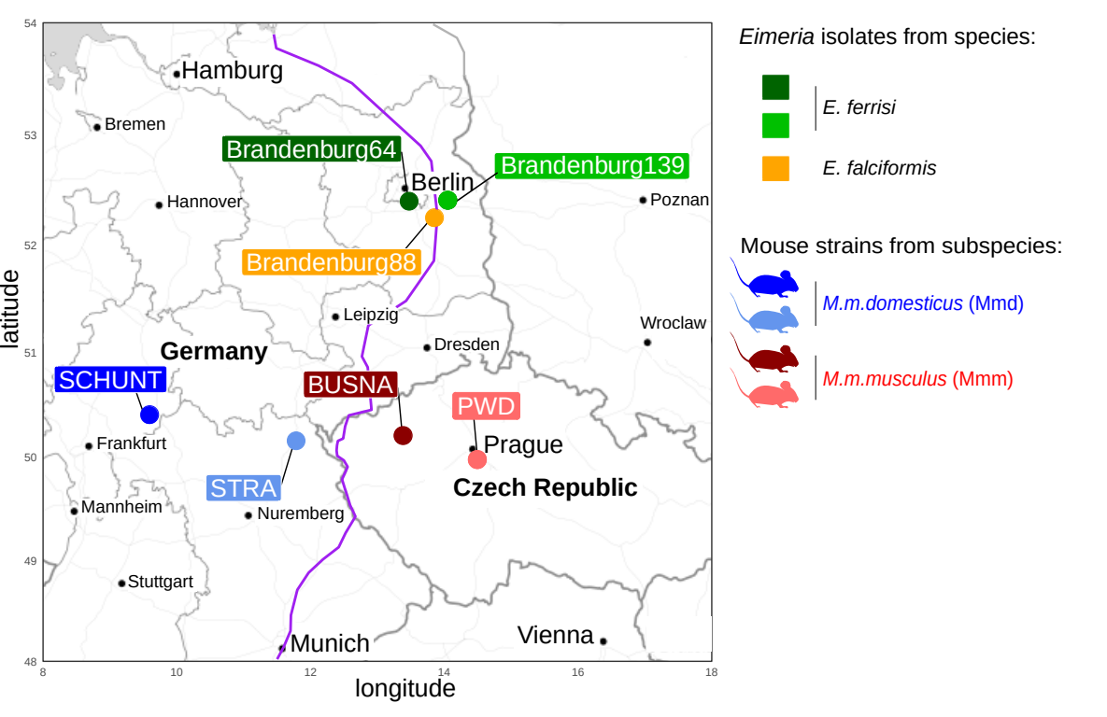**Figure 1. Parasite isolates and mouse strains.** The map shows locations at which mice were collected for breeding of mouse strains and isolation of parasites. The purple line is an estimation of the center of the house mouse hybrid zone between Mmd and Mmm based on sampling and genotyping of mice in this area (Balard et al., 2019; Ďureje, Macholán, Baird, & Piálek, 2012, Macholán et al. 2019).

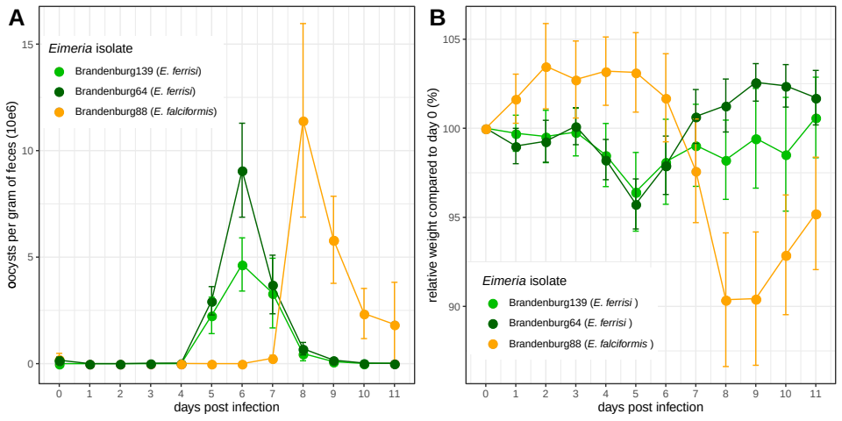

**Figure 2. Parasite density (A) and relative weight loss (B) during *Eimeria* infection.** Parasite density is calculated as number of oocysts detected (x10e6) per gram of feces, relative weight loss is calculated compared to day 0.Mean and 95% CI are plotted for each parasite isolate. All hosts strains are pooled together.

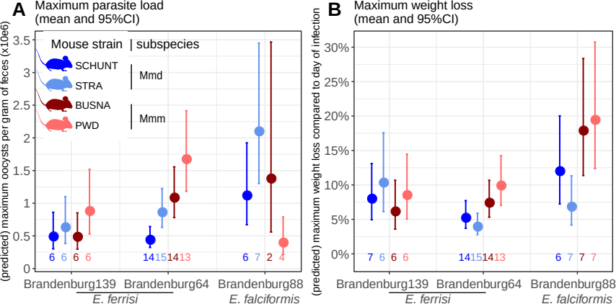**Figure 3. Predicted maximum parasite load and maximum weight loss by mouse strain and *Eimeria* isolates.** Values under bars represent the number of animals for each group. (A) Maximum oocysts per gram of feces used as a proxy for (inverse of) resistance; (B) Impact on host health measured as the maximum weight loss during patent period relative to starting weight (%)

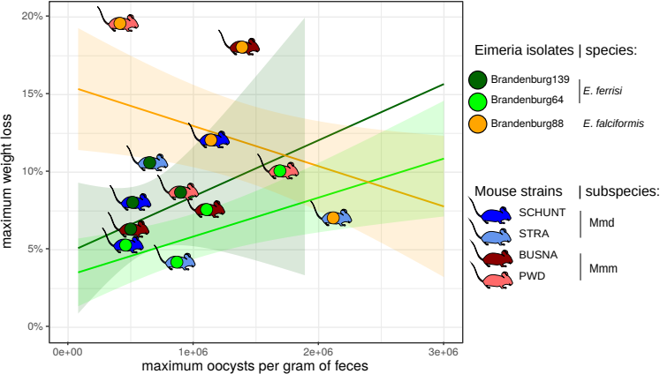**Figure 5. Predicted reaction norm (tolerance) for each infection group.** Regression lines and 95% confidence intervals are plotted for all infected mice, independent of their strain. Mouse-shaped points represent the observed mean for each mouse strain.Resistance is approximated as the inverse of maximum oocysts per gram of feces, impact on host health as maximum relative weight loss. The upper left corner represents the low tolerance area (strong impact on health despite low parasite load), the lower right the high tolerance area. There is a trade-off between resistance and tolerance between each mouse subspecies upon infection with *E. falciformis*, absent in the case of *E. ferrisi.*

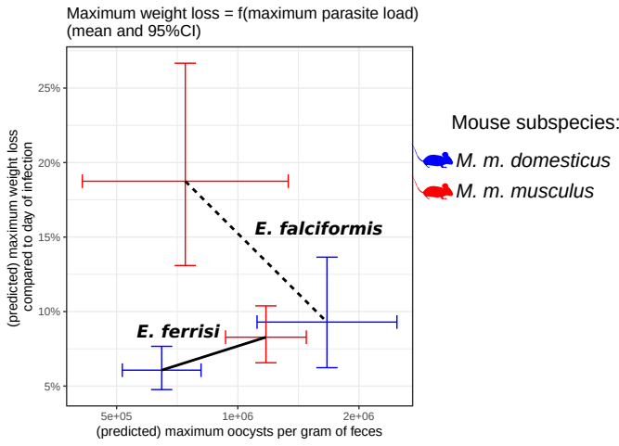

**Figure 6. Coupling between resistance and tolerance for two different *Eimeria* species.** Resistance is approximated as the inverse of maximum oocysts per gram of feces, impact on host health as maximum relative weight loss. The upper left corner represents the low tolerance area (strong impact on health despite low parasite load), the lower right the high tolerance area. There is a trade-off between resistance and tolerance between each mouse subspecies upon infection with *E. falciformis*, absent in the case of *E. ferrisi.*

# Funding

This work was funded by the German Research Foundation (DFG) Grant [HE 7320/1-1] to EH. VHJ is an associated student of GRK 2046 funded by the DFG. The maintenance of wild-derived strains was supported by the ROSE program from Czech Academy of Sciences and the Czech Science Foundation (project 16-23773S) to JP.

# References

Al-khlifeh, E., Balard, A., Jarquín-Díaz, V. H., Weyrich, A., Wibbelt, G., & Heitlinger, E. (2019). *Eimeria* *falciformis* BayerHaberkorn1970 and novel wild derived isolates from house mice: Differences in parasite lifecycle, pathogenicity and host immune reactions. *BioRxiv*. http://dx.doi.org/10.1101/611277

Anderson, R. M., & May, R. M. (1982). Coevolution of hosts and parasites. *Parasitology*, *85 (Pt 2)*, 411–426. https://doi.org/10.1017/s0031182000055360

Ankrom, S. L., Chobotar, B., & Ernst, J. V. (1975). Life cycle of *Eimeria ferrisi* Levine & Ivens, 1965 in the Mouse, *Mus musculus*. *The Journal of Protozoology*, *22*(3), 317–323. https://doi.org/10.1111/j.1550-7408.1975.tb05177.x

Athanasiadou, S., Tolossa, K., Debela, E., Tolera, A., & Houdijk, J. G. M. (2015). Tolerance and resistance to a nematode challenge are not always mutually exclusive. *International Journal for Parasitology*, *45*(4), 277–282. https://doi.org/10.1016/j.ijpara.2014.12.005

Baird, S. J. E., & Goüy de Bellocq, J. (2019). Shifting paradigms for studying parasitism in hybridising hosts: Response to Theodosopoulos, Hund, and Taylor. *Trends in Ecology & Evolution*, *34*, 387–389. https://doi.org/10.1016/j.tree.2019.01.011

Baird, S. J. E., Ribas, A., Macholán, M., Albrecht, T., Piálek, J., & Goüy de Bellocq, J. (2012). Where are the wormy mice? A reexamination of hybrid parasitism in the European house mouse hybrid zone. *Evolution*, *66*(9), 2757–2772. https://doi.org/10.1111/j.1558-5646.2012.01633.x

Balard, A., Jarquín-Díaz, V. H., Jost, J., Martincová, I., Ďureje, Ľ., Piálek, J., Macholán, M., Goüy de Bellocq, J., Baird, S. J. E., & Heitlinger, E. (2019). Intensity of infection with intracellular *Eimeria* spp. and pinworms is reduced in hybrid mice compared to parental subspecies. *BioRxiv*, *683698*. https://doi.org/10.1101/683698

Barton, N. H., & Hewitt, G. M. (1985). Analysis of hybrid zones. *Annual Review of Ecology and Systematics*, *16*(1), 113–148. https://doi.org/10.1146/annurev.es.16.110185.000553

Boursot, P., Auffray, J.‐C., Britton‐Davidian, J., & Bonhomme, F. (1993). The evolution of house mice. *Annual Review of Ecology and Systematics*, **24**, 119–152. [https://doi.org/10.1146/annurev.es.24.110193](https://doi.org/10.1146/annurev.es.24.110193.001003)

Chapman, H. D., Barta, J. R., Blake, D., Gruber, A., Jenkins, M., Smith, N. C., Suo, X., & Tomley, F. M. (2013). Chapter two—A selective review of advances in coccidiosis research. In D. Rollinson (Ed.), *Advances in Parasitology* (Vol. 83, pp. 93–171). Academic Press. https://doi.org/10.1016/B978-0-12-407705-8.00002-1

Clerc, M., Fenton, A., Babayan, S. A., & Pedersen, A. B. (2019). Parasitic nematodes simultaneously suppress and benefit from coccidian coinfection in their natural mouse host. *Parasitology*, *146*(8), 1096–1106. https://doi.org/10.1017/S0031182019000192

Delignette-Muller, M. L., & Dutang, C. (2015). fitdistrplus: An R Package for Fitting Distributions. *Journal of Statistical Software*, *64*(4), 1–34.

Ďureje, Ľ., Macholán, M., Baird, S. J., & Piálek, J. (2012). The mouse hybrid zone in Central Europe: From morphology to molecules. *Folia Zoologica*, *61*(3–4), 308–318.

Duvaux, L., Belkhir, K., Boulesteix, M., & Boursot, P. (2011). Isolation and gene flow: Inferring the speciation history of European house mice. *Molecular Ecology*, **20**, 5248–5264. <https://doi.org/10.1111/j.1365-294X.2011.05343.x>

Ehret, T., Spork, S., Dieterich, C., Lucius, R., & Heitlinger, E. (2017). Dual RNA-seq reveals no plastic transcriptional response of the coccidian parasite *Eimeria falciformis* to host immune defenses. *BMC Genomics*, *18*(1), 686. https://doi.org/10.1186/s12864-017-4095-6

Graham, A. L., Allen, J. E., & Read, A. F. (2005). Evolutionary causes and consequences of immunopathology. *Annual Review of Ecology, Evolution, and Systematics*, 373–397. https://doi.org/10.1146/annurev.ecolsys.36.102003.152622

Gregorová, S., & Forejt, J. (2000). PWD/Ph and PWK/Ph inbred mouse strains of *Mus m. Musculus* subspecies-a valuable resource of phenotypic variations and genomic polymorphisms. *Folia Biologica*, *46*(1), 31–41.

Haberkorn, A. (1970). Die Entwicklung von *Eimeria falciformis* (Eimer 1870) in der weißen Maus (*Mus musculus*). *Zeitschrift für Parasitenkunde*, *34*(1), 49–67. https://doi.org/10.1007/BF00629179

Jarquín-Díaz, V. H., Balard, A., Jost, J., Kraft, J., Dikmen, M. N., Kvičerová, J., & Heitlinger, E. (2019). Detection and quantification of house mouse *Eimeria* at the species level – Challenges and solutions for the assessment of coccidia in wildlife. *International Journal for Parasitology: Parasites and Wildlife*, *10*, 29–40. https://doi.org/10.1016/j.ijppaw.2019.07.004

Jarquín-Díaz, V. H., Balard, A., Mácová, A., Jost, J., Szepesbéla, T. R. von, Berktold, K., Tank, S., Kvičerová, J., & Heitlinger, E. (2019). Generalist Eimeria species in rodents: Multilocus analyses indicate inadequate resolution of established markers. *BioRxiv*, 690487. [https://doi.org/10.1101/](https://doi.org/10.1101/690487)690487

Kváč M., McEvoy J., Loudová M., Stenger B., Sak B., Květoňová D., Ditrich O., Rašková V., Moriarty E., Rost M., Macholán M., Piálek J. 2013. Coevolution of *Cryptosporidium tyzzeri* and the house mouse (*Mus musculus*). *International Journal for Parasitology* 43(10): 805–817. http://dx.doi.org/10.1016/j.ijpara.2013.04.007

Langand, J., Jourdane, J., Coustau, C., Delay, B., & Morand, S. (1998). Cost of resistance, expressed as a delayed maturity, detected in the host–parasite system *Biomphalaria glabrata*/*Echinostoma caproni*. *Heredity*, *80*(3), 320–325. https://doi.org/10.1046/j.1365-2540.1998.00291.x

Little, T. J., Shuker, D. M., Colegrave, N., Day, T., & Graham, A. L. (2010). The coevolution of virulence: Tolerance in perspective. *PLOS Pathogens*, *6*(9), e1001006. https://doi.org/10.1371/journal.ppat.1001006

Macholán, M., Munclinger, P., Sugerková, M., Dufková, P., Bímová, B., Bozíková, E., Zima, J., & Piálek, J. (2007). Genetic analysis of autosomal and X-linked markers across a mouse hybrid zone. *Evolution*, *61*(4), 746–771. https://doi.org/10.1111/j.1558-5646.2007.00065.x

Macholán M., Baird S.J.E., Fornuskova A., Martincová I., Rubík, P., Ďureje Ľ., Heitlinger E., Piálek J. 2019. Widespread introgression of the *Mus musculus musculus* Y chromosome in Central Europe. *BioRxiv*. http://dx.doi.org/10.1101/2019.12.23.887471

Martincová, I., Ďureje, Ľ., Kreisinger, J., Macholán, M., & Piálek, J. (2019). Phenotypic effects of the Y chromosome are variable and structured in hybrids among house mouse recombinant lines. *Ecology and Evolution*, *9*(10), 6124–6137. https://doi.org/10.1002/ece3.5196

Medzhitov, R., Schneider, D. S., & Soares, M. P. (2012). Disease tolerance as a defense strategy. *Science*, *335*(6071), 936–941. https://doi.org/10.1126/science.1214935

Miller, M. R., White, A., & Boots, M. (2005). The evolution of host resistance: Tolerance and control as distinct strategies. *Journal of Theoretical Biology*, *236*(2), 198–207. https://doi.org/10.1016/j.jtbi.2005.03.005

Payseur, B. A., Krenz, J. G., & Nachman, M. W. (2004). Differential patterns of introgression across the X chromosome in a hybrid zone between two species of house mice. *Evolution*, *58*(9), 2064–2078. https://doi.org/10.1111/j.0014-3820.2004.tb00490.x

Piálek, J., Vyskocilová, M., Bímová, B., Havelková, D., Piálková, J., Dufková, P., Bencová, V., Dureje, L., Albrecht, T., Hauffe, H. C., Macholán, M., Munclinger, P., Storchová, R., Zajícová, A., Holán, V., Gregorová, S., & Forejt, J. (2008). Development of unique house mouse resources suitable for evolutionary studies of speciation. *The Journal of Heredity*, *99*(1), 34–44. https://doi.org/10.1093/jhered/esm083

R Development Core Team. (2018). *R: A language and environment for statistical computing. R Foundation for Statistical Computing, Vienna, Austria*. http://www.R-project.org

Råberg, L. (2014). How to live with the enemy: Understanding tolerance to parasites. *PLoS Biology*, *12*(11), e1001989. https://doi.org/10.1371/journal.pbio.1001989

Råberg, L., Graham, A. L., & Read, A. F. (2009). Decomposing health: Tolerance and resistance to parasites in animals. *Philosophical Transactions of the Royal Society B: Biological Sciences*, *364*(1513), 37–49. https://doi.org/10.1098/rstb.2008.0184

Råberg, L., Sim, D., & Read, A. F. (2007). Disentangling genetic variation for resistance and tolerance to infectious diseases in animals. *Science*, *318*(5851), 812–814. https://doi.org/10.1126/science.1148526

Raufaste, N., Orth, A., Belkhir, K., Senet, D., Smadja, C., Baird, S. J. E., Bonhomme, F., Dod, B., & Boursot, P. (2005). Inferences of selection and migration in the Danish house mouse hybrid zone: Selection in the house mouse hybrid zone. *Biological Journal of the Linnean Society*, *84*(3), 593–616. https://doi.org/10.1111/j.1095-8312.2005.00457.x

Rose, M. E., Hesketh, P., & Wakelin, D. (1992). Immune control of murine coccidiosis: CD4+ and CD8+ T lymphocytes contribute differentially in resistance to primary and secondary infections. *Parasitology*, *105*, 349–354. https://doi.org/10.1017/s0031182000074515

Roy, B. A., & Kirchner, J. W. (2000). Evolutionary dynamics of pathogen resistance and tolerance. *Evolution*, *54*(1), 51–63. https://doi.org/10.1111/j.0014-3820.2000.tb00007.x

Sage, R. D., Heyneman, D., Lim, K. C., & Wilson, A. C. (1986). Wormy mice in a hybrid zone. *Nature*, *324*(6092), 60–63. https://doi.org/10.1038/324060a0

Schito, M. L., Barta, J. R., & Chobotar, B. (1996). Comparison of four murine *Eimeria* species in immunocompetent and immunodeficient mice. *The Journal of Parasitology*, *82*(2), 255–262. https://doi.org/10.2307/3284157

Sheldon, B. C., & Verhulst, S. (1996). Ecological immunology: Costly parasite defences and trade-offs in evolutionary ecology. *Trends in Ecology & Evolution*, *11*(8), 317–321. https://doi.org/10.1016/0169-5347(96)10039-2

Simms, E. L., & Triplett, J. (1994). Costs and benefits of plant response to disease: Resistance and tolerance. *Evolution*, *48*(6), 1973–1985. https://doi.org/10.1111/j.1558-5646.1994.tb02227.x

Smith, A. L., & Hayday, A. C. (2000). Genetic dissection of primary and secondary responses to a widespread natural pathogen of the gut, *Eimeria vermiformis*. *Infection and Immunity*, *68*(11), 6273–6280. https://doi.org/10.1128/iai.68.11.6273-6280.2000

Soares, M. P., Teixeira, L., & Moita, L. F. (2017). Disease tolerance and immunity in host protection against infection. *Nature Reviews Immunology*, *17*(2), 83–96. https://doi.org/10.1038/nri.2016.136

Stange, J., Hepworth, M. R., Rausch, S., Zajic, L., Kühl, A. A., Uyttenhove, C., Renauld, J.-C., Hartmann, S., & Lucius, R. (2012). IL-22 mediates host defense against an intestinal intracellular parasite in the absence of IFN-γ at the cost of Th17-driven immunopathology. *Journal of Immunology*, *188*(5), 2410–8. https://doi.org/10.4049/jimmunol.1102062

Venables, W. N., & Ripley, B. D. (2002). *Modern Applied Statistics with S* (Fourth). Springer. http://www.stats.ox.ac.uk/pub/MASS4

Vijendravarma, R. K., Kraaijeveld, A. R., & Godfray, H. C. J. (2009). Experimental evolution shows *Drosophila melanogaster* resistance to a microsporidian pathogen has fitness costs. *Evolution*, *63*(1), 104–114. https://doi.org/10.1111/j.1558-5646.2008.00516.x

Wickham, H. (2016). *ggplot2: Elegant Graphics for Data Analysis*. Springer-Verlag, New York.