# **Coupling between tolerance and resistance differs between related *Eimeria* parasite species: implications for coevolution with their mouse hosts**

# Abstract

Resistance (host capacity to reduce parasite burden) and tolerance (host capacity to reduce impact on its health for a given parasite burden) manifest two different lines of defenses. Tolerance can be independent from resistance, traded-off against it, or the two can be positively correlated because of redundancy in underlying (immune) processes. We here tested whether closely related parasite species could show differences in this coupling between tolerance and resistance.

We tested this in infections with two parasite species of genus *Eimeria.* We measured proxies for resistance (the (inverse of) number of parasite transmission stages (oocysts) per gram of feces at the day of maximal shedding) and tolerance (the slope of maximum relative weight loss compared to day of infection on number of oocysts per gram of feces at the day of maximal shedding for each host strain) in four inbred mouse strains belonging to two mouse subspecies, *Mus musculus domesticus* and *M. m. musculus*.

We found a negative correlation between resistance and tolerance against *E. falciformis*, while the two are uncoupled against *E. ferrisi.* We interpret this as indication that resistance and tolerance against the first parasite species might be traded off, but evolve independently in different mouse genotypes against the latter. We argue that host evolution can be studied largely irrespective of parasite strains if coupling is absent (*E. ferrisi*) but host-parasite coevolution is more likely observable and best studied in a system with coupled tolerance and resistance (*E. falciformis*).

**Keywords**: Resistance, Tolerance, Eimeria, Coevolution

# Introduction

Host defence mechanisms evolve to alleviate the detrimental effect of parasites. They can be categorised into two components: resistance and tolerance (Råberg, Graham, & Read, 2009). Resistance is the ability of a host to reduce parasite burden, resulting from defence against parasite infection or proliferation early after infection (Schmid-Hempel, 2013). The negative effect of resistance on parasite fitness can lead to antagonistic coevolution. According to theoretical models, fluctuating host and parasite genotypes arise, and balancing selection maintains resistance alleles polymorphic (Boots, Best, Miller, & White, 2008; Roy & Kirchner 2000). Resistance has been the classical “catch all” measure for host-parasite systems, but recently it has been shown to be incomplete, especially with respect to potential fitness effects on the host (Kutzer & Armitage, 2016; Råberg et al., 2009).

Disease tolerance (not to be confused from “immunological tolerance”, unresponsiveness to self antigens; Medzhitov, Schneider, & Soares, 2012) is the ability of the host to limit the impact of parasite on its fitness (Råberg et al., 2009; Vale & Little, 2012; Kutzer & Armitage, 2016). By potentially providing a longer-living niche, this defence mechanism improves, or at least does not deteriorate, the fitness of the parasite. Tolerance alleles are thus predicted by theoretical models to evolve to fixation due to positive feedback loops (Boots et al., 2008; Restif & Koella, 2004; Roy & Kirchner 2000). From a mechanistic perspective tolerance alleviates direct or indirect (e.g. excessive immune response underlying resistance against parasites, called immunopathology; Graham, Allen, & Read, 2005) damage caused by parasites (Råberg et al., 2009). Tolerance mechanisms include modulation of inflammatory response (Ayres & Schneider, 2012), tissue repair (stress response, damage repair and cellular regeneration mechanisms; Soares, Teixeira, & Moita, 2017), and compensation of parasite‐induced damage by increase of reproductive effort (Baucom & de Roode, 2011). The resulting metabolic costs of resistance and tolerance, with and without parasites infection, determine the optimal (steady state and infection ineducable) extent and of both immune defences (Sheldon & Verhulst, 1996).

Resistance and tolerance can be genetically and physiologically independent, involving different proximate mechanisms. Lack of correlation between both defences was shown for example in monarch butterflies (*Danaus plexippus*) infected by the protozoan parasite *Ophryocystis elektroscirrha*. This study found genetic variation in resistance between butterflies families, but a fixed tolerance (Lefèvre, Williams, & de Roode, 2010). Similarly, no correlation could be found between resistance and tolerance for the fish *Leuciscus burdigalensis* in response to infection with its parasite *Tracheliastes polycolpus*. The authors explain the decoupling of both defences by the fact that, in this system, tolerance likely involves wound repair rather than immune regulation, making resistance and tolerance mechanisms independent (Mazé-Guilmo, Loot, Páez, Lefèvre, & Blanchet, 2014).

In other systems, the two lines of defense can rely on similar genes and mechanisms and be positively correlated.

For example, Guivier et al (2010) showed that *Myodes glareolus* expresses the tumor necrosis factor-α (TNF-α), a mediator of resistance to *Puumala hantavirus* (PUUV) in several mammals, at a lower level inin PUUV endemic areas. These results suggest that the regulation of TNF-α is both a resistance and a tolerance mechanism. Similarly, genetic association studies of resistance and tolerance of *Drosophila melanogaster* against the bacterium *Providencia rettgeri* have shown positively correlated genetic effects, as the same loci were associated with both traits (Howick & Lazzaro, 2017).

Resistance and tolerance have been found negatively correlated in studies comparing distinct host populations or inbred host strains: Inbred laboratory mouse strains lose weight upon infection with *Plasmodium chabaudi.* The extent of this impact on host health is negatively correlated with the peak number of parasites found in the blood (Råberg, Sim, & Read, 2007), meaning that mouse strains with higher resistance present lower tolerance. Similarly, infections of sea trout (Salmo trutta trutta) and Atlantic salmon (Salmo salar) with the trematode Diplostomum pseudospathaceum showed that resistance and tolerance were negatively correlated when assessing mean levels of both traits in different host populations (Klemme & Karvonen, 2016). This is interpreted as a result of trade-off between resistance and tolerance (Sheldon & Verhulst, 1996; Restif & Koella, 2004; Råberg et al., 2009).

We have seen that resistance and tolerance can be (1) uncoupled (independent), (2) positively correlated (involving same genes and mechanisms), or (3) negatively correlated (traded-off). Theoretical models show that coupling between resistance and tolerance (or absence thereof) depends not only on host factors, but is also conditioned by parasite intrinsic factors (Carval & Ferriere, 2010).

Here add something on complexity of correlations

Dvp our hypothesis framework. Stronger if...

Here, we tested differences in the resistance-tolerance coupling upon infection with two closely related parasite species. We infected four inbred mouse strains representative of two house mouse subspecies, *M. m. domesticus* and *M. m. musculus*, with three parasite isolates representative of two naturally occuring parasite species, the protozoan parasite *Eimeria ferrisi* and *E. falciformis* (Jarquín-Díaz et al. 2019). *Eimeria*spp. are monoxenous parasites that expand asexually and reproduce sexually in intestinal epithelial cells, leading to malabsorption of nutrients, tissue damage and weight loss (Chapman et al., 2013). The evolutionary history of these different *Eimeria* species in the two house mouse subspecies is unknown and it is unclear whether subspecies-specific adaptation exists in one or the other. We tested (1) if coupling between resistance and tolerance of each host differs between both parasite species; and (2) local adaptation of *E. ferrisi* using a parasite isolated in a *M. m. domesticus* host and one in a *M. m. musculus* host.

# Material and methods

## Parasite isolates

The three parasite isolates used in this study were isolated from feces of three different *M. m. domesticus/M. m. musculus* hybrid mice captured in Brandenburg, Germany, in 2016 (capture permit No. 2347/35/2014). Hybrid index (HI) of each individual wild-caught mouse was calculated to account for the admixture of mouse genomes as a proportion of *M. m. musculus* alleles in a set of 14 diagnostic markers (Balard et al., 2020). The parasite isolates belong to both the most prevalent *Eimeria* species in this area, namely *E. ferrisi* (isolates Brandenburg64 and Brandenburg139) and *E. falciformis* (isolate Brandenburg88)(Jarquín-Díaz et al., 2019). Isolate Brandenburg64 was isolated in a 92% *M. m. domesticus* individual (HI=0.08), isolate Brandenburg139 in a 85% *M. m. musculus* (HI=0.85) and isolate Brandenburg88 in a 80% *M. m. domesticus* (HI=0.2). Pre-patency and the peak day of parasite shedding for these isolates were estimated during infection in NMRI laboratory mice (Al-khlifeh et al., 2019) which were also used for serial passaging of all the isolates. Parasite infective forms (oocysts) were recovered by flotation in saturated NaCl solution followed by washing and observation under light microscope (following the protocol described in Clerc, Fenton, Babayan, & Pedersen, 2019) and stored at room temperature in 1mL of 2% potassium dichromate for a maximum of 2 months before infection of the wild-derived mouse strains. Oocysts were allowed to sporulate 10 days before infection in a water bath at 30°C.

## Mouse strains

We used four wild-derived inbred mouse strains: two representing *M. m. domesticus*: **SCHUNT** (Locality: Schweben, Hessen, Germany [N: 50° 26’, E: 9° 36’] (Martincová, Ďureje, Kreisinger, Macholán, & Piálek, 2019)) and **STRA** (Locality: Straas, Bavaria, Germany [N: 50° 11’, E: 11° 46’] (Piálek et al., 2008), and two derived from *M. m. musculus*: **BUSNA** (Locality: Buškovice, Bohemia, Czech Republic [N: 50° 14’, E: 13° 22’] (Piálek et al., 2008)) and **PWD** (Locality: Kunratice, Bohemia, Czech Republic [N: 50° 01’, E: 14° 29’] (Gregorová & Forejt, 2000))(**Figure 1**). Add hybrids. Age of the mice at the time of infection ranged between 7.6 and 21.4 weeks. All mouse strains were maintained before infection in the Institute of Vertebrate Biology in Studenec (licence number 61974/2017‐MZE‐17214; for further details on strains see <https://housemice.cz/en>).

Parasites of the *Eimeria* genus are known to induce host immune protection against reinfection (Rose, Hesketh, & Wakelin, 1992; Smith & Hayday, 2000). To ensure that our mice were *Eimeria*-naive, mice fecal samples were tested before infection for the presence of *Eimeria* spp. oocysts, by flotation in saturated NaCl solution followed by washing and observation under light microscope.

## Experimental infection

Mice were kept in individual cages during infection. Water and food (SNIFF, Rat/Mouse maintenance feed 10 mm) were provided *ad libitum* supplemented with 1 g of sunflower and barley seeds per day. Mice were orally infected with 150 sporulated oocysts of one *Eimeria* isolate suspended in 100 µl phosphate-buffer saline (PBS) and monitored daily until their sacrifice by cervical dislocation at 11 days after infection (dpi) (experiment license Reg. 0431/17). Individuals presenting severe health deficiency and/or a weight loss approaching 18% relative to their starting weight were sacrificed earlier. Weight was recorded and feces collected on a daily basis. Fecal pellets were collected every day from each individual cage and suspended in 2% potassium dichromate. Parasite oocysts were recovered using NaCl flotation (see above).

All individuals were negative for *Eimeria* at the beginning of our experiment (before infection of first batch, as described in the next paragraph). In total, 108 mice were infected. Mice were randomly allocated to experimental groups ensuring homogeneous distribution of ages and sexes between groups. Our experiments were conducted in four (partially overlapping) consecutive batches for logistical reasons. The first two batches were infected with the two *E. ferrisi* isolates (Brandenburg64 and Brandenburg139), the third and fourth by one *E. ferrisi* isolate (Brandenburg64) and one *E. falciformis* isolate (Brandenburg88). Our experimental design is summarized in **Table 1** (chronology of experimental batches can be scrutinized in **Supplementary Table 1**).

Before arrival to the infection facility, nematode eggs were observed in flotated feces of mice belonging to all genotypes. Nematode infection is common in breeding facilities (Baker, 1998). Despite treatment of the first infection batch of mice (B1, 22 mice) with anthelminthics (Profender®, Bayer AG, Levekusen, Germany) following the protocole of Mehlhorn et al. (2005), nematodes were still detected with PCR (following the protocole of Floyd, Rogers, Lambshead, & Smith, 2005) in randomly sampled fecal samples a week later. We therefore decided not to treat mice of the following infection batches. Moreover, we observed *Eimeria* oocysts in the feces of 9 mice belonging to the last experimental batch (batch B4) at the day of infection, likely due to cross-contamination between batches. For following statistical analyses, we considered along with the full data set (N=108) a conservative data set in which cross-contaminated animals and animals treated by anthelminthic were removed (N=77). Results obtained on the conservative data set can be found in **Supplementary Material S2**. Despite differences in significance due to a lower statistical power, the main conclusions of our analyses were consistent with those obtained on the main data set.

## Statistical analyses

### Modelling of resistance, impact of parasite on host and tolerance

As resistance is the capacity of a host to reduce its parasite burden, it is usually estimated by the inverse of infection intensity (Råberg et al., 2009). Pre-patency (the time to shedding of infectious stages, so called oocysts) is longer for *E. falciformis* (7 days) than for *E. ferrisi* (5 days) (Al-khlifeh et al., 2019). Therefore, as a proxy of resistance we used the (inverse of) number of oocysts per gram of feces (OPG) at the day of maximal shedding. We found this measurement to be tightly correlated with the sum of oocysts shed throughout the experiment (Pearson correlation coefficient 0.91). Due to the aggregation characteristic of parasites (Shaw & Dobson, [1995](https://onlinelibrary.wiley.com/doi/full/10.1111/jeb.13578" \l "jeb13578-bib-0070)), the appropriate distribution for maximum number of OPG was found to be the negative binomial distribution. This was confirmed based on log likelihood, AIC criteria and goodness-of-fits plots (density, CDF, Q-Q, P-P plots; R packages MASS (Venables & Ripley, 2002) and fitdistrplus (Delignette-Muller & Dutang, 2015)).

Both parasite species provoke inflammation, cellular infiltration, enteric lesions, diarrhea, and ultimately weight loss (Ankrom, Chobotar, & Ernst, 1975; Ehret, Spork, Dieterich, Lucius, & Heitlinger 2017; Schito et al., 1996; Al-khlifeh et al., 2019). Therefore, the impact of parasites on host health was measured as the maximum relative weight loss compared to day 0 (body weight measured at the start of the experimental infection). Tolerance is usually defined as a reaction norm, i.e. the regression slope of host fitness (approximated by health condition) on infection intensity per genotype (Simms, 2000; Råberg et al., 2009). Thus tolerance was assessed as the slope of maximum relative weight loss compared to day 0 on number of OPG at the day of maximal shedding, within each mouse strain and for each parasite isolate. A steep slope indicates a low tolerance (high weight lost for a given parasite burden).

### Statistical design

Maximum OPG and relative weight loss were modelled separately as a response of mouse strain (N=4), parasite isolate (N=3) and their interaction, using a negative binomial generalised linear model for maximum OPG, and a linear model for relative weight loss. For tolerance, we performed a linear regression with null intercept (as each mouse was controlled against itself at start of the experiment, before losing weight or shedding parasite), modelling relative weight loss as a response of maximum OPG interacting with mouse strain (N=4), parasite isolate (N=3) and their interaction. To test the significance of the marginal contribution to each parameter to the full model, each parameter was removed from the full model, and the difference between full model and sub-model was assessed using likelihood ratio tests (G).

For each of our three models, we asked within each infection group if the response differed between mouse genotypes (i.e. variable “mouse strain” significant) using likelihood ratio tests (G) as described above. Of note, four mice infected by *E. falciformis* isolate Brandenburg88 did not shed any oocysts as death occurred at or one day before the peak of oocysts shedding in other mice. For this reason, we modelled maximum OPG in this infection group using a zero-inflated negative binomial (ZINB) generalised linear model, after verifying that it provided a better fit than the simple negative binomial based on log likelihood and AIC criteria.

Post-hoc multiple comparison tests (Tukey Multiple Comparisons of Means) were performed within each infection group to test the significant difference in response of each host against all others (R package emmeans; Lenth, 2019).

Eventually, we tested the correlation between resistance and tolerance for each of our three parasite isolates.

Hypothesis framework here: new figure 2

We estimated Spearman’s rank correlation estimate as measure of the strength of the monotonic relationship, and comped the mean and 95% confidence intervals of the two proxies between mouse strains. Indeed, the tolerance is calculated at the mouse strain level, meaning that the Spearman’s rank correlation test alone would not be sufficient to detect an effect, as N=4 for this test.

All analyses were performed using the R software version 3.5.2 (R Development Core Team, 2018; negative binomial: function glm.nb from R package MASS (Venables & Ripley, 2002); ZIBN: function zeroinfl from R package pscl (Jackman, 2017; Zeileis, Kleiber, & Jackman, 2008); linear model: function lm from R core package stats; mean and 95% confidence intervals: function ggpredict from R package ggeffect (Lüdecke, 2018)). Graphics were produced using the R package ggplot2 (Wickham, 2016) and compiled using the free software inkscape ([https://inkscape.org](https://inkscape.org/)). Codes and data used for this article can be found at: <https://github.com/alicebalard/Article_RelatedParasitesResTol>

# Results

## 1. General

Parasites of all isolates successfully infected all mouse strains, meaning that no “infection resistance” (*sensu* ref) was detected (**Figure 2**). For *E. ferrisi* (both isolates), the pre-patent period was 5 dpi and the median day of maximal oocyst shedding was 6 dpi (standard deviation sd=0.7 and 1, respectively). The median day of maximum weight loss was 5 dpi for both isolates (sd=2.1 and 1.9 respectively). For *E. falciformis* (isolate Brandenburg88) pre-patency was 7 dpi, median day of maximal shedding was 8 dpi (sd=1.8) and median day of maximal weight loss 9 dpi (sd=1.5). Of note a considerable number of *M. m. musculus* mice (8/14; 5 BUSNA and 3 PWD) infected with *E. falciformis* (isolate Brandenburg88) died (or had to be sacrificed at humane end points specified in animal experimental procedures) one day before or at the peak of oocyst shedding for the other mice in the group.

We tested the difference between mouse strains infected by each parasite of: 1) maximum number of OPG as a measure of (inverse of) resistance, 2) weight loss upon infection relative to day 0 as a proxy for impact on host health in response to infection, and 3) the slope between the two as a measure of (inverse of) tolerance. For ~~our three proxies~~, we found statistically significant effects of parasite isolate, mouse strain, as well as an interaction between parasite isolate and mouse strain (**Table 2**). Our results indicate that the four mouse strains are differently resistant, affected. No diff tolerant to the three parasite isolates could be detected.

## **2. Resistance and tolerance to both *E. ferrisi* isolates are uncoupled**

We tested within each infection group if our proxies for resistance, impact on weight and tolerance were different between the four mouse strains.

We found the maximum number of OPG to be statistically different between mouse strains for *E. ferrisi* isolate Brandenburg64 (LRT: G=19, df=3, P<0.001). More precisely, the SCHUNT mouse strain (*M. m. domesticus*) was more resistant than both *M. m. musculus* strains (Tukey test: SCHUNT-BUSNA: P<0.01; SCHUNT-PWD: P<0.001). No differences between mouse strains were found for resistance against the second *E. ferrisi* isolate Brandenburg139 (LRT: G=5.3, df=3, P=0.15; **Figure 3A**). The maximum relative weight loss was different between mouse strains infected with *E. ferrisi* Brandenburg64 (LRT: G=14.6, df=3, P=0.002), as one *M. m. musculus* strain (PWD) lost more weight than both *M. m. domesticus* strains (Tukey test: PWD-SCHUNT: P=0.03, PWD-STRA: P<0.01). Again, no differences between mouse strains could be detected upon infection with the second *E. ferrisi* isolate Brandenburg139 (**Figure 3B**). Finally, we did not find significant differences of tolerance slope between mouse strains for both *E. ferrisi* isolates. Brandenburg64 seems better tolerated than Brandenburg139, regardless of the mouse strains (**Figure 3C**).

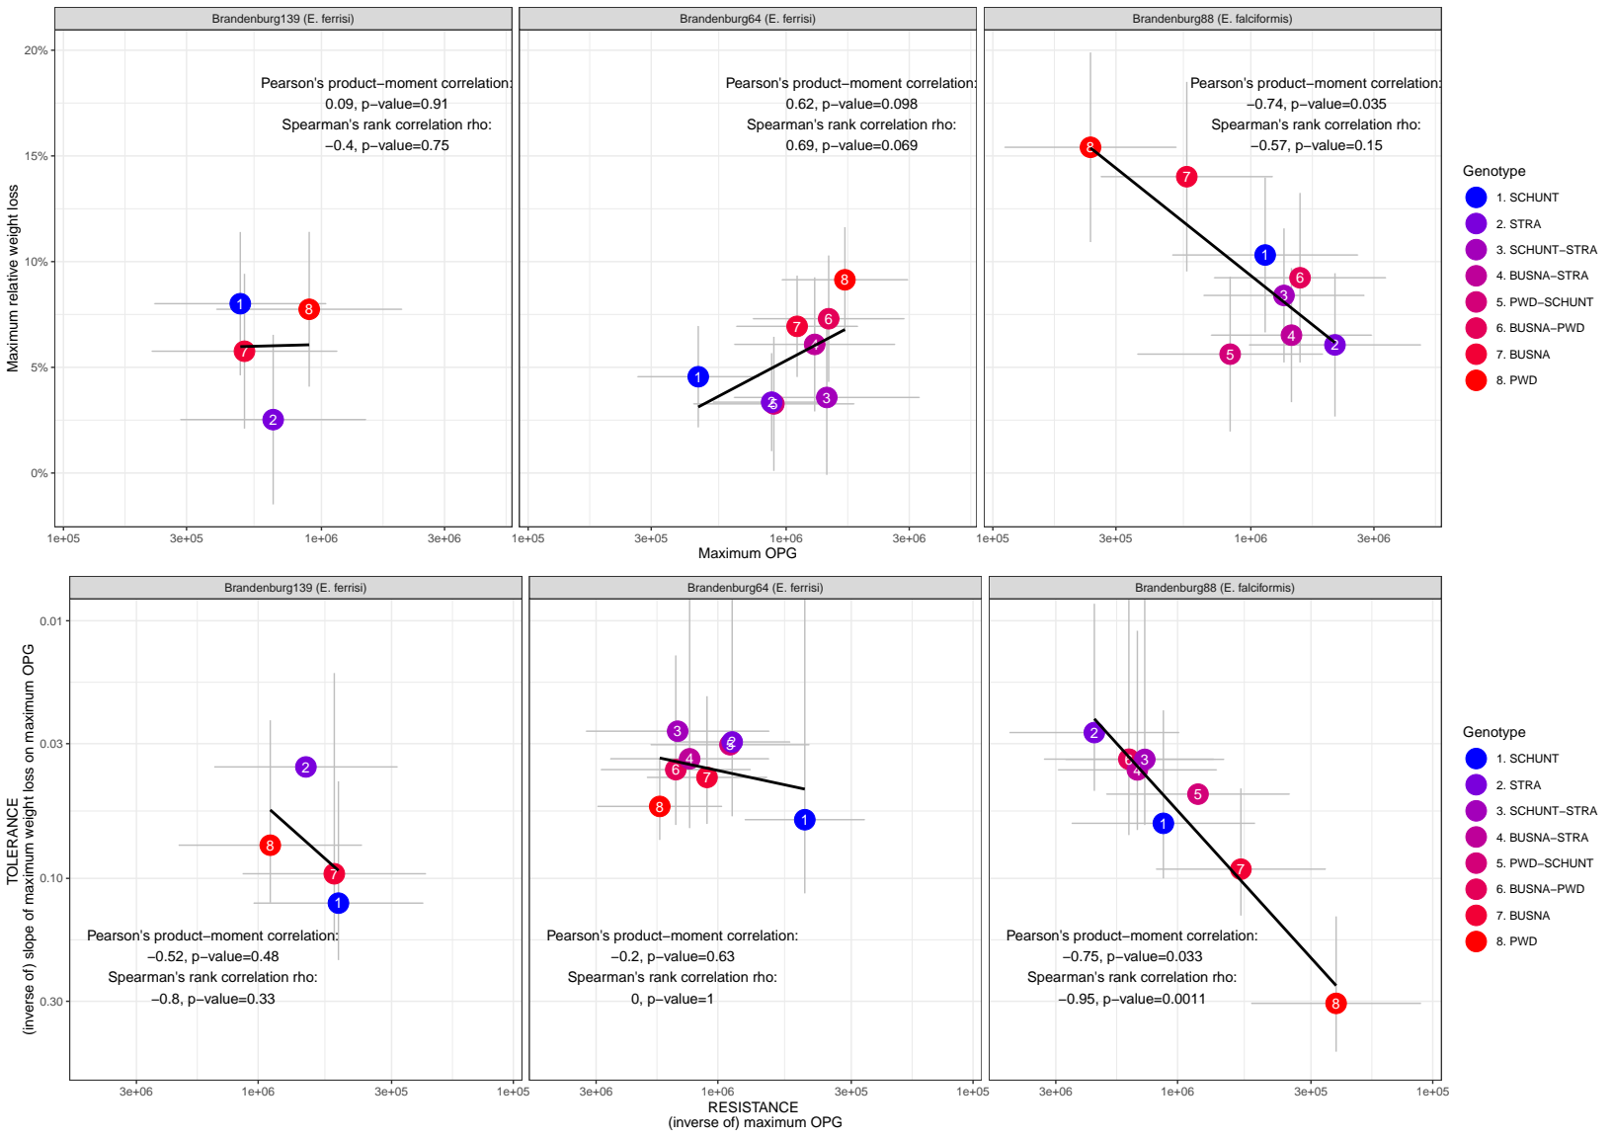Figure 4.

Hypothesis testing: 1. lm between wl and OPG and 2. lm between tol and res.

E139:

First: Figure 4.A

Second: Figure 4.B

E64:

First: Figure 4.C

Second: Figure 4.D

Then, we tested the correlation between resistance (inverse of maximum number of OPG) and tolerance (inverse of slope of maximum weight loss on maximum OPG; **Figure 4**). We found a week correlation for Brandenburg64 (rho = -0.2, p=XXX, Spearman's rank correlation). 95% confidence intervals indicate that the average resistance varies between mouse strains, but the tolerance remains constant, mice losing on average around 5% of their weight per million oocysts in a gram of faeces. For the second isolate, Brandenburg139, the monotonic correlation between resistance and tolerance was stronger (rho = -0.8, p=, Spearman's rank correlation), but the resistance-tolerance values for all four strains were found similar, all 95% confidence intervals overlapping. In conclusion, we did not find indication of resistance-tolerance trade-off in both of our *E. ferrisi* isolates.

## 3. No indication of local adaptation of *E. ferrisi*

We hypothesised a possible local adaptation of *E. ferrisi*, i.e. (1) a higher parasite fitness in sympatric than in allopatric host, or (2) a higher host fitness when infected with sympatric than allopatric parasite (Kaltz & Shykoff, 1998). The prediction drawn from (1) would be that the Eastern parasite (*E. ferrisi* isolate Brandenburg139) reproduces better in the matching Eastern mouse subspecies (*M. m. musculus*) than in the allopatric one (*M. m. musculus*), and similarly the Western parasite (*E. ferrisi* isolate Brandenburg64) should reproduce better in *M. m. domesticus* than in *M. m. musculus.* As seen in the previous section, for *E. ferrisi* isolate Brandenburg139, parasite reproductive output (the inverse of resistance) was similar in all four mouse strains. The second isolate, *E. ferrisi* isolate Brandenburg64, also showed similar values in all mouse strains, at the exception of the SCHUNT-PWD comparison. According to (2), a higher tolerance of the matching host despite similar parasite reproductive output could indicate increased host fitness, and host local adaptation, but this was also not detected. Our results do not indicate local adaptation between *E. ferrisi* and its host.

## 4. Negative correlation between resistance and tolerance to *E. falciformis*

We tested if our proxies for resistance, impact on weight and tolerance were different between the four mouse strains upon infection with the second *Eimeria* species, *E. falciformis*, represented by the isolate Brandenburg88.

We found the maximum number of OPG to be statistically different between mouse strains (LRT: G=16.3, df=6, P=0.01). More precisely, STRA mice (*M. m. domesticus* strain) were less resistant than PWD (*M. m. musculus* strains) (Tukey test: P=0.03; **Figure 3A**). The maximum relative weight loss was different between mouse strains infected with *E. falciformis* Brandenburg88 (LRT: G=18.3, df=3, P<0.001). Precisely, both *M. m. musculus* strain (PWD and BUSNA) lost more weight than one *M. m. domesticus* strain (STRA) (Tukey test: STRA-BUSNA: P<0.01, STRA-PWD: P<0.01; **Figure 3B**). Finally, and in contrary to our results on both *E. ferrisi* isolates, the tolerance slopes for *E. falciformis* isolate Brandenburg88 were different between mouse strains (LRT: G=8.1, df=3, P=0.04; **Figure 3C**).

Hypothesis testing: 1. lm between wl and OPG and 2. lm between tol and res.

E88:

First: Figure 4.E

Second: Figure 4.F

We found a negative correlation between resistance (inverse of maximum number of OPG) and tolerance (inverse of slope of maximum weight loss on maximum OPG), (rho = -1, p=X.XX, Spearman's rank correlation). Moreover, 95% confidence intervals indicate that the correlation between resistance and tolerance between SCHUNT (*Mus musculus domesticus* strain) and PWD (*Mus musculus musculus* strain) differed (TEST what was done? p-val), while the two other strains presented intermediate values. Our data indicate a negative correlation between resistance and tolerance for this parasite isolate (**Figure 5**).

# Discussion

Something on coevolution Raberg 2009 maybe in dicussion

dvp our framework and say how it solve issues here, and in general

In this study, we assessed resistance and tolerance to two closely related parasites, *E. ferrisi* (two isolates) and *E. falciformis* (one isolate), in four different inbred strains representative of two house mouse subspecies. Understanding this coupling has two major implications. From a practical “measurement” perspective we can ask whether tolerance can be predicted from resistance, as the later is easier to measure (e.g. in field sampling). A large number of studies draw conclusions about the impact of parasite on host fitness solely based on resistance, an approach potentially misleading (Baird & Goüy de Bellocq, 2019). Moreover, in a evolutionary perspective, this might determine whether coevolution between host and parasite can be expected. Coevolution in host-parasite systems is often assumed but rarely proven (Woolhouse, Webster, Domingo, Charlesworth, & Levin, 2002). Janzen (1980) notes that not all parasite-host systems are coevolving. For example, the presence of efficient host of defenses against a given parasite is not necessarily produced in response to this parasite, but could be evolved against a different parasite species. Decoupling of resistance and tolerance, means decoupling of host and parasite fitness and makes coevolution less likely.

We found tolerance to be decoupled from resistance against *E. ferrisi,* while the two types of response against *E. falciformis* were negatively correlated, suggesting a trade-off between resistance and tolerance for this parasite. Such trade-offs might arise because fitness costs of tolerance in the absence of infection or because XYZ. Pleiotropy (the same genetic loci affecting the two traits in opposite direction) and reinforcement by genetic linkage (loci for both traits evolving to be less recombining because of genetic proximity) could then stabilize such trade-offs (Råberg et al., 2009; Stowe, Marquis, Hochwender, & Simms, 2000; Mahmoud et al., 2018). We could speculate that such stabilizing mechanisms to couple resistance and tolerance are less likely in place if, as in our case, closely related parasites, fraught with similar mechanisms, show absence and presence of trade-offs, respectively.

Coupling between resistance and tolerance can then differ between closely related parasite species. This finding is relevant in our host system: it has been shown that hybrids between *M. m. domesticus* and *M. m. musculus* are more resistant not only to *Eimeria* but also to other parasites including pinworms (Baird et al., 2012; Balard et al., 2020) but impact on tolerance could not be measured under natural conditions (Balard et al., 2020). The effect of parasites on host fitness in the evolution of the house mouse hybrid zone is thus still rather ambiguous. Careful distinction between parasite species is necessary when analysing the influence of host genetics on such phenotypes (see also Jarquin et al 2019). We here show that it is indispensable to measure both resistance and tolerance in *Eimeria* infections of house mice, measurements that can best be made in future laboratory experiments with hybrid mice.

Resistance-tolerance trade-off could be explained by intrinsic characteristics *E. falciformis.* This parasite has a relatively long life cycle (Al-khlifeh et al., 2019; Haberkorn, 1970), meaning that it multiplies asexually for a relative long time. If the parasite is not resisted well enough, infection might lead to high tissue load and – once the parasite starts to reproduce sexually – extremely high reproductive output in strongly impacted hosts. Tissue damage is observed during sexual reproduction for this parasite (Ehret et al., 2017) and might mean that a certain level of resistance is required. But also immunopathology has been observed in advanced *E. falciformis* infections. For example, proinflammatory T cell mediators have been shown to decrease parasite load but increase body weight loss upon infection (Stange et al., 2012). This might lead to multiple different optima for resistance and tolerance.

In addition to more or less stable optima in the two mouse subspecies we could speculate on two related alternative explanations. Firstly, *E. falciformis* could originally be a *M. m. domesticus* parasite dissipated into *M. m. musculus* territory by a spillover through the hybrid zone. Secondly, the particular *E. falciformis* isolate employed here was collected from a predominantly *M. m. domesticus* mouse (hybrid index 0.2). The isolate could hence be locally adapted to *M. m. domesticus*. Experiments with additional *E. falciformis* isolates from *M. m. musculus* are needed to test whether host subspecies adaptation can lead to high tolerance and low resistance in matching pairs of *E. falciformis* isolates and mouse subspecies. This seems plausible, as the coupling between resistance and tolerance links host and parasite fitness, making coevolution and hence local adaptation more likely (Kaltz & Shykoff, 1998). Interestingly, this parasite-host coevolution wouldn’t be antagonistic but rather mutualistic with regards to tolerance and parasite reproduction (that is, the inverse of resistance) (Little, Shuker, Colegrave, Day, & Graham, 2010; Råberg et al., 2009).

Upon infection by the second parasite species, *E. ferrisi*, we found slight heterogeneity of resistance, but homogeneous impact on host weight and tolerance in each mouse strain. *E. ferrisi* commits to sexual reproduction after a relatively short time with few cycles of asexual expansion (Al-khlifeh et al., 2019; Ankrom et al., 1975). As *E. ferrisi* infections do not reach extremely high intensities with this infection strategy, high tolerance might be the optimal strategy for both house mouse subspecies. Resistance could then evolve relatively freely without any major impact of the parasite on the hosts’ health. Enhanced virulence (reduction of host fitness upon infection e.g. due to prolonged asexual replication before commitment to sexual replication and transmission) might not evolve because the low resistance of the host already allows an optimal transmission rate, especially considering the fast production of transmission stages (Anderson & May, 1982). As we did not find indications of lower resistance or increased tolerance (indicating increased parasite or host fitness) in matching host-parasite infections, local adaptation of *E. ferrisi* is not supported. This might be explained by the absence of host-parasite coevolution caused by uncoupling of parasite and host fitness.

In conclusion, we argue that the difference between resistance and tolerance coupling in two different parasites can guide research in our system: if the effects of host hybridisation should be studied independently of potential host-parasite coadaptation, the prevalent *E. ferrisi* might be the most suitable parasite. If coevolution between hosts and parasites should be studied, the pathogenic *E. falciformis* is a more plausible target*.* Generally, the coupling between resistance and tolerance can differ between closely related parasite species and we argue that this trait of a host-parasite system determines the questions to be best approached with a particular parasite.

# Tables

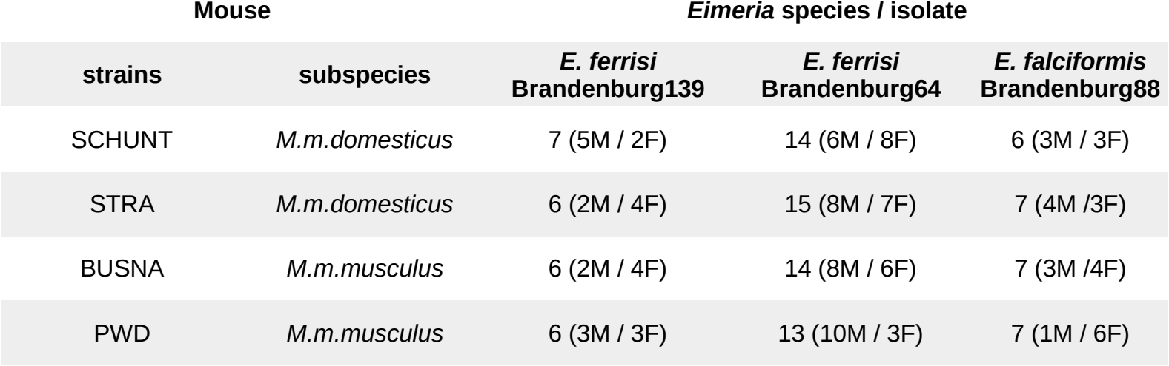**Table 1. Infection experiment design.**

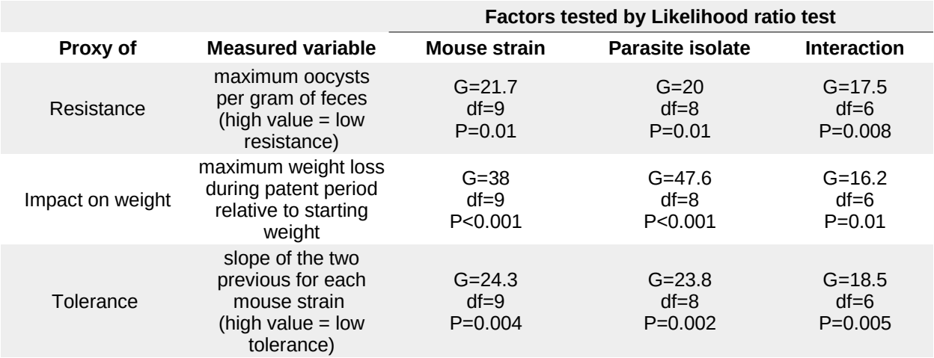

**Table 2. Likelihood ratio tests of factors significance.**

# Figures

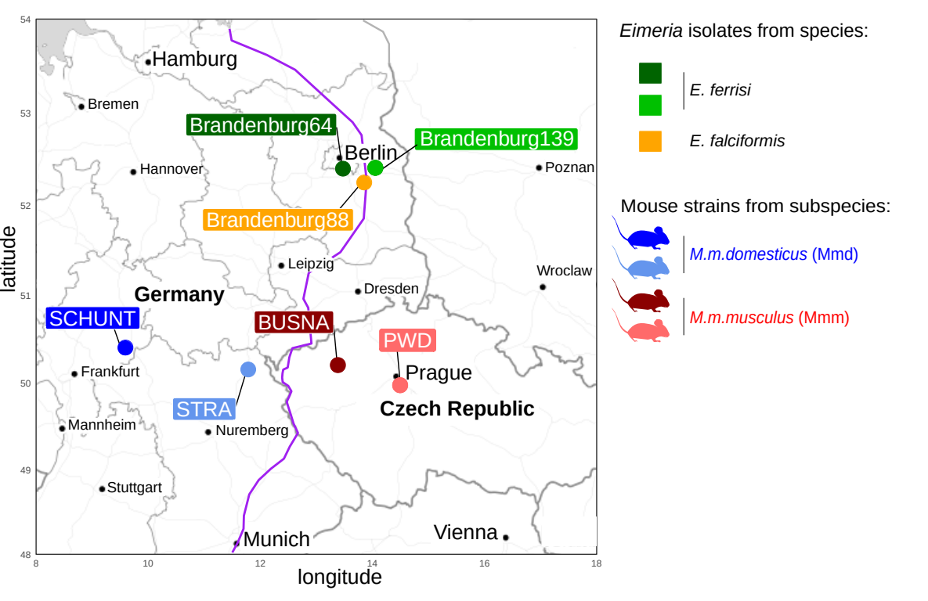**Figure 1. Parasite isolates and mouse strains.** The map shows locations at which mice were collected for breeding of mouse strains and isolation of parasites. The purple line is an estimation of the center of the house mouse hybrid zone between *M. m. domesticus* and *M. m. musculus* based on sampling and genotyping of mice in this area (Balard et al., 2020; Ďureje, Macholán, Baird, & Piálek, 2012, Macholán et al. 2019).

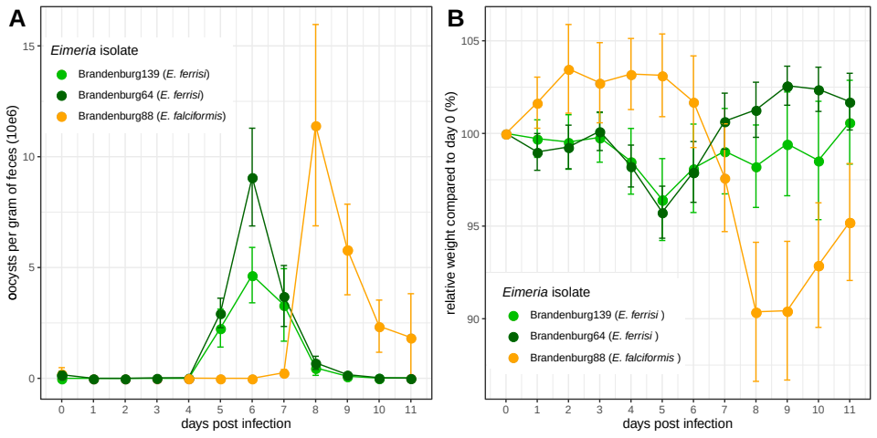

**Figure 2. Parasite density (A) and relative weight loss (B) during *Eimeria* infection.** Parasite density is calculated as number of oocysts detected (x10e6) per gram of feces, relative weight loss is calculated compared to day 0.Mean and 95% CI are plotted for each parasite isolate. All hosts strains are pooled together.

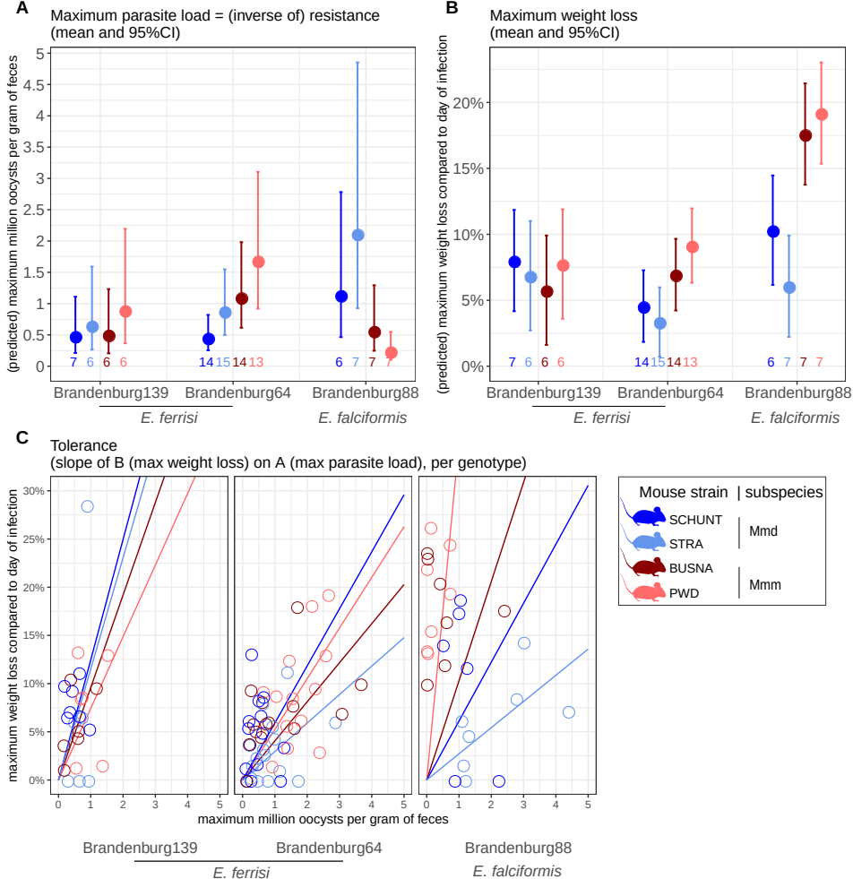

**Figure 3. Comparison of resistance, impact on weight and tolerance between mouse strain for each *Eimeria* isolates.** (A) Maximum oocysts per gram of feces used as a proxy for (inverse of) resistance; (B) Impact on host health measured as the maximum weight loss during patent period relative to starting weight (%); (C) Tolerance estimated by the slope of the linear regression with null intercept modelling maximum relative weight loss as a response of maximum oocysts per gram of feces. A steep slope corresponds to a low tolerance.

Differences of maximum parasite load and of maximum weight loss could be detected between mouse strains infected by *E. ferrisi* Brandenburg64 and *E. falciformis* Brandenburg88, but not *E. ferrisi* Brandenburg139. Tolerance differed between mouse strains only upon infection with *E. falciformis* Brandenburg88.

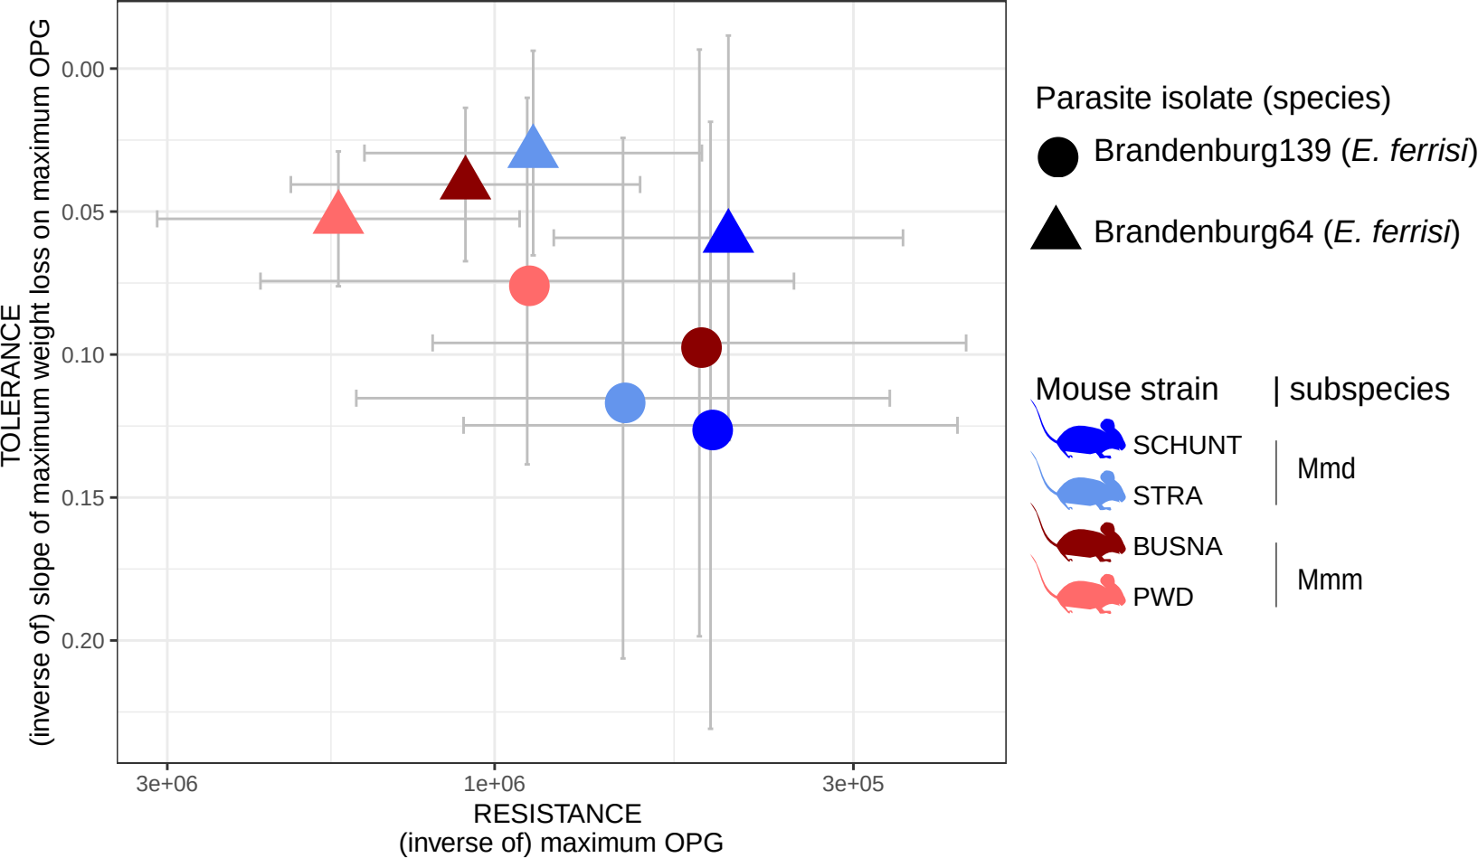

**Figure 4. No indication of resistance-tolerance coupling for both each *E. ferrisi* iso****lates.** X-axis represents resistance (maximum oocysts per gram of feces used as a proxy, a high value corresponding to a low resistance); Y-axis represent tolerance (slope of the linear regression with null intercept modelling relative weight loss as a response of maximum oocysts per gram of feces, a high value corresponding to a low tolerance). *E. ferrisi* isolate Brandenburg64: Spearman's rho = -0.2; *E. ferrisi* isolate Brandenburg139: Spearman's rho = -0.8. Grey error bars represent 95% confidence intervals.

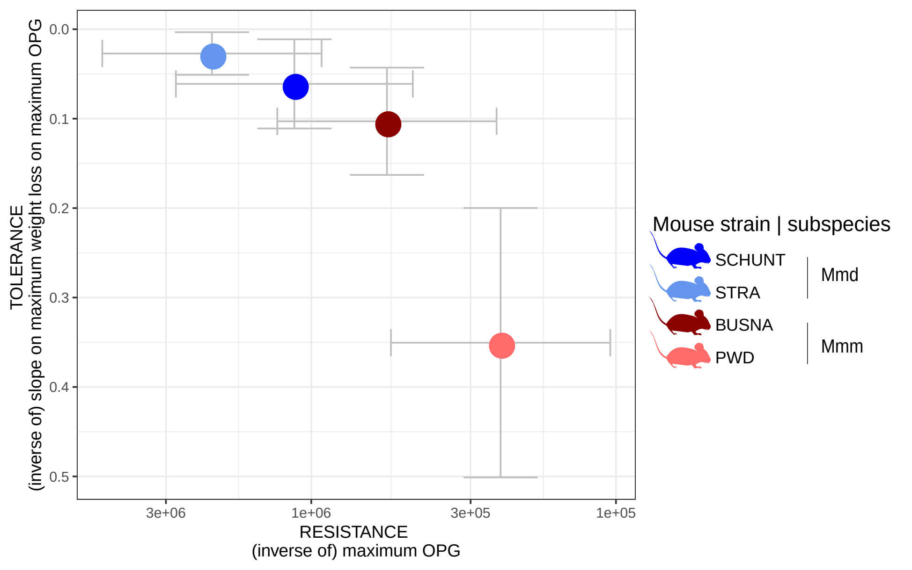**Figure 5. Negative correlation between resistance and tolerance for *E. falciformis* isolate Brandenburg88.** X-axis represents resistance (maximum oocysts per gram of feces used as a proxy, a high value corresponding to a low resistance); Y-axis represent tolerance (slope of the linear regression with null intercept modelling relative weight loss as a response of maximum oocysts per gram of feces, a high value corresponding to a low tolerance). (rho = -1, p=XXX, , Spearman's rank correlation). Grey error bars represent 95% confidence intervals.

# Supplementary material

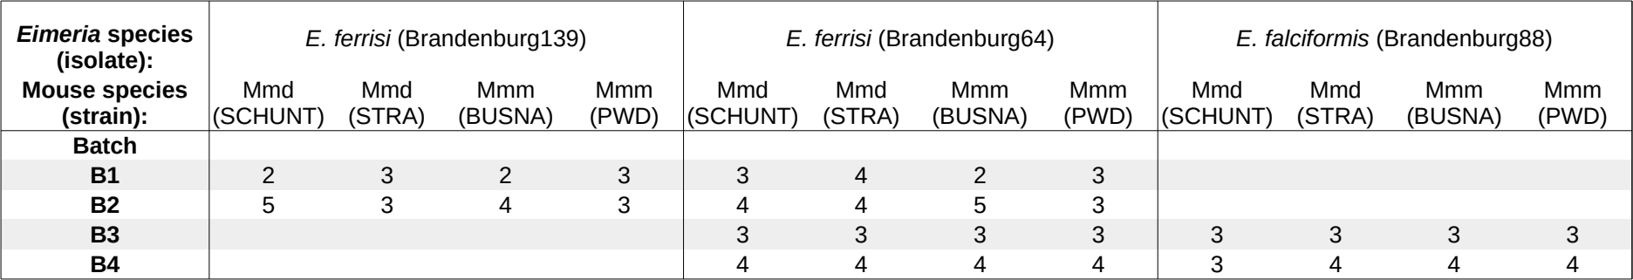**Supplementary Table S1. Chronology of experimental batches**

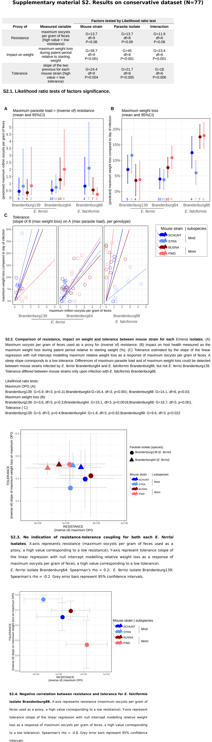



# Funding

This work was funded by the German Research Foundation (DFG) Grant [HE 7320/1-1] to EH. VHJ is an associated student of GRK 2046 funded by the DFG. The maintenance of wild-derived strains was supported by the ROSE program from Czech Academy of Sciences and the Czech Science Foundation (project 16-23773S) to JP.

# References

Al-khlifeh, E., Balard, A., Jarquín-Díaz, V. H., Weyrich, A., Wibbelt, G., & Heitlinger, E. (2019). *Eimeria falciformis* BayerHaberkorn1970 and novel wild derived isolates from house mice: Differences in parasite lifecycle, pathogenicity and host immune reactions. *BioRxiv*. doi: 10.1101/611277

Anderson, R. M., & May, R. M. (1982). Coevolution of hosts and parasites. *Parasitology*, *85 (Pt 2)*, 411–426. doi: 10.1017/s0031182000055360

Ankrom, S. L., Chobotar, B., & Ernst, J. V. (1975). Life cycle of *Eimeria ferrisi* Levine & Ivens, 1965 in the Mouse, *Mus musculus*. *The Journal of Protozoology*, *22*(3), 317–323. doi: 10.1111/j.1550-7408.1975.tb05177.x

Ayres, J. S., & Schneider, D. S. (2012). Tolerance of Infections. *Annual Review of Immunology*, 30(1), 271–294. doi: 10.1146/annurev-immunol-020711-075030

Baird, S. J. E., & Goüy de Bellocq, J. (2019). Shifting paradigms for studying parasitism in hybridising hosts: Response to Theodosopoulos, Hund, and Taylor. *Trends in Ecology & Evolution*, *34*, 387–389. doi: 10.1016/j.tree.2019.01.011

Baird, S. J. E., Ribas, A., Macholán, M., Albrecht, T., Piálek, J., & Goüy de Bellocq, J. (2012). Where are the wormy mice? A reexamination of hybrid parasitism in the European house mouse hybrid zone. *Evolution*, *66*(9), 2757–2772. doi: 10.1111/j.1558-5646.2012.01633.x

Balard, A., Jarquín‐Díaz, V. H., Jost, J., Martincová, I., Ďureje, Ľ., Piálek, J., Macholán, M., Goüy de Bellocq, J., Baird, S. J. E., & Heitlinger, E. (2020). Intensity of infection with intracellular Eimeria spp. and pinworms is reduced in hybrid mice compared to parental subspecies. *Journal of Evolutionary Biology*, 33(4), 435–448. doi: 10.1111/jeb.13578

Baucom, R. S., & de Roode, J. C. (2011). Ecological immunology and tolerance in plants and animals. *Functional Ecology*, 25(1), 18–28. doi: 10.1111/j.1365-2435.2010.01742.x

Boots, M., Best, A., Miller, M. R., & White, A. (2008). The role of ecological feedbacks in the evolution of host defence: what does theory tell us? Philosophical Transactions of the Royal Society B: Biological Sciences, 364(1513), 27–36. doi: 10.1098/rstb.2008.0160

Carval, D., & Ferriere, R. (2010). A unified model for the coevolution of resistance, tolerance, and virulence. Evolution, 64(10):2988-3009. doi: 10.1111/j.1558-5646.2010.01035.x

Chapman, H. D., Barta, J. R., Blake, D., Gruber, A., Jenkins, M., Smith, N. C., … Tomley, F. M. (2013). A selective review of advances in coccidiosis research. Advances in Parasitology, 83, 93–171. doi: 10.1016/B978-0-12-407705-8.00002-1

Clerc, M., Fenton, A., Babayan, S. A., & Pedersen, A. B. (2019). Parasitic nematodes simultaneously suppress and benefit from coccidian coinfection in their natural mouse host. *Parasitology*, *146*(8), 1096–1106. doi: 10.1017/S0031182019000192

Delignette-Muller, M. L., & Dutang, C. (2015). fitdistrplus: An R Package for Fitting Distributions. *Journal of Statistical Software*, *64*(4), 1–34.

Ďureje, Ľ., Macholán, M., Baird, S. J., & Piálek, J. (2012). The mouse hybrid zone in Central Europe: From morphology to molecules. *Folia Zoologica*, *61*(3–4), 308–318.

Ehret, T., Spork, S., Dieterich, C., Lucius, R., & Heitlinger, E. (2017). Dual RNA-seq reveals no plastic transcriptional response of the coccidian parasite *Eimeria falciformis* to host immune defenses. *BMC Genomics*, *18*(1), 686. doi: 10.1186/s12864-017-4095-6

Floyd, R. M., Rogers, A. D., Lambshead, P. J. D., & Smith, C. R. (2005). Nematode-specific PCR primers for the 18S small subunit rRNA gene. *Molecular Ecology Notes*, *5*(3), 611–612. doi: 10.1111/j.1471-8286.2005.01009.x

Graham, A. L., Allen, J. E., & Read, A. F. (2005). Evolutionary causes and consequences of immunopathology. *Annual Review of Ecology, Evolution, and Systematics*, 373–397. doi: 10.1146/annurev.ecolsys.36.102003.152622

Gregorová, S., & Forejt, J. (2000). PWD/Ph and PWK/Ph inbred mouse strains of *Mus m. Musculus* subspecies-a valuable resource of phenotypic variations and genomic polymorphisms. *Folia Biologica*, *46*(1), 31–41.

Guivier, E., Galan, M., Salvador, A. R., Xuéreb, A., Chaval, Y., Olsson, G. E., … Charbonnel, N. (2010). Tnf-α expression and promoter sequences reflect the balance of tolerance/resistance to Puumala hantavirus infection in European bank vole populations. Infection, Genetics and Evolution, 10(8), 1208–1217. doi: 10.1016/j.meegid.2010.07.022

Haberkorn, A. (1970). Die Entwicklung von *Eimeria falciformis* (Eimer 1870) in der weißen Maus (*Mus musculus*). *Zeitschrift für Parasitenkunde*, *34*(1), 49–67. doi: 10.1007/BF00629179

Howick, V. M., & Lazzaro, B. P. (2017). The genetic architecture of defence as resistance to and tolerance of bacterial infection in *Drosophila melanogaster*. *Molecular Ecology*, *26*(6), 1533–1546. doi: 10.1111/mec.14017

Jackman, S. (2017). pscl: classes and methods for R developed in the political science computational laboratory. United States Studies Centre, University of Sydney. R package version 1.5.2. <https://github.com/atahk/pscl/>

Janzen, D. H. (1980). When is it coevolution? *Evolution*, 34(3), 611–612. doi: 10.1111/j.1558-5646.1980.tb04849.x

Jarquín-Díaz, V. H., Balard, A., Jost, J., Kraft, J., Dikmen, M. N., Kvičerová, J., & Heitlinger, E. (2019). Detection and quantification of house mouse *Eimeria* at the species level – Challenges and solutions for the assessment of coccidia in wildlife. *International Journal for Parasitology: Parasites and Wildlife*, *10*, 29–40. doi: 10.1016/j.ijppaw.2019.07.004

Kaltz, O., & Shykoff, J. Local adaptation in host–parasite systems. *Heredity* **81,**361–370 (1998). doi: 10.1046/j.1365-2540.1998.00435.x

Klemme, I., & Karvonen, A. (2016). Vertebrate defense against parasites: Interactions between avoidance, resistance, and tolerance. *Ecology and Evolution*, *7*(2), 561–571. doi: 10.1002/ece3.2645

[Kutzer, M. A. M., & Armitage, S. A. O. (2016). Maximising fitness in the face of parasites: A review of host tolerance. *Zoology*, *119*](https://www.zotero.org/google-docs/?I2LRxy)(4), 281–289. doi: 10.1016/j.zool.2016.05.011

Lefèvre, T., Williams, A. J., & de Roode, J. C. (2010). Genetic variation in resistance, but not tolerance, to a protozoan parasite in the monarch butterfly. *Proceedings of the Royal Society B: Biological Sciences*, 278(1706), 751–759. doi: 10.1098/rspb.2010.1479

Lenth, R. (2019). emmeans: Estimated Marginal Means, aka Least-Squares Means, R package version 1.4.3.01, https://CRAN.R-project.org/package=emmeans

Little, T. J., Shuker, D. M., Colegrave, N., Day, T., & Graham, A. L. (2010). The coevolution of virulence: Tolerance in perspective. *PLOS Pathogens*, *6*(9), e1001006. doi: 10.1371/journal.ppat.1001006

Lüdecke D (2018). ggeffects: tidy data frames of marginal effects from regression models. Journal of Open Source Software, 3(26), 772. doi: 10.21105/joss.00772

Macholán M., Baird S.J.E., Fornuskova A., Martincová I., Rubík, P., Ďureje Ľ., Heitlinger E., Piálek J. 2019. Widespread introgression of the *Mus musculus musculus* Y chromosome in Central Europe. *BioRxiv*. doi: [10.1101/2019.12.23.887471](http://dx.doi.org/10.1101/2019.12.23.887471)

Mahmoud, M., Zeng, Y., Shirali, M., Yin, T., Brügemann, K., König, S., & Haley, C. (2018). Genome-wide pleiotropy and shared biological pathways for resistance to bovine pathogens. PLOS ONE, 13(4), e0194374. doi: 10.1371/journal.pone.0194374

Martincová, I., Ďureje, Ľ., Kreisinger, J., Macholán, M., & Piálek, J. (2019). Phenotypic effects of the Y chromosome are variable and structured in hybrids among house mouse recombinant lines. *Ecology and Evolution*, *9*(10), 6124–6137. doi: 10.1002/ece3.5196

Mazé-Guilmo, E., Loot, G., Páez, D. J., Lefèvre, T., & Blanchet, S. (2014). Heritable variation in host tolerance and resistance inferred from a wild host–parasite system. *Proceedings of the Royal Society B: Biological Sciences*, 281(1779), 20132567. doi: 10.1098/rspb.2013.2567

Medzhitov, R., Schneider, D. S., & Soares, M. P. (2012). Disease tolerance as a defense strategy. *Science*, *335*(6071), 936–941. doi: 10.1126/science.1214935

Piálek, J., Vyskocilová, M., Bímová, B., Havelková, D., Piálková, J., Dufková, P., Bencová, V., Dureje, L., Albrecht, T., Hauffe, H. C., Macholán, M., Munclinger, P., Storchová, R., Zajícová, A., Holán, V., Gregorová, S., & Forejt, J. (2008). Development of unique house mouse resources suitable for evolutionary studies of speciation. *The Journal of Heredity*, *99*(1), 34–44. doi: 10.1093/jhered/esm083

R Development Core Team. (2018). *R: A language and environment for statistical computing. R Foundation for Statistical Computing, Vienna, Austria*. http://www.R-project.org

Råberg, L., Sim, D., & Read, A. F. (2007). Disentangling genetic variation for resistance and tolerance to infectious diseases in animals. *Science*, *318*(5851), 812–814. doi: 10.1126/science.1148526

Råberg, L., Graham, A. L., & Read, A. F. (2009). Decomposing health: Tolerance and resistance to parasites in animals. *Philosophical Transactions of the Royal Society B: Biological Sciences*, *364*(1513), 37–49. doi: 10.1098/rstb.2008.0184

Restif, O., & Koella, J. C. (2004). Concurrent evolution of resistance and tolerance to pathogens. *The American Naturalist*, *164*(4). doi: 10.1086/423713

Rose, M. E., Hesketh, P., & Wakelin, D. (1992). Immune control of murine coccidiosis: CD4+ and CD8+ T lymphocytes contribute differentially in resistance to primary and secondary infections. *Parasitology*, *105*, 349–354. doi: 10.1017/s0031182000074515

Roy, B. A., & Kirchner, J. W. (2000). Evolutionary dynamics of pathogen resistance and tolerance. *Evolution*, *54*(1), 51–63. doi: 10.1111/j.0014-3820.2000.tb00007.x

Schito, M. L., Barta, J. R., & Chobotar, B. (1996). Comparison of four murine *Eimeria* species in immunocompetent and immunodeficient mice. *The Journal of Parasitology*, *82*(2), 255–262. doi: 10.2307/3284157

Shaw, D. J., & Dobson, A. P. (1995). Patterns of macroparasite abundance and aggregation in wildlife populations: A quantitative review.*Parasitology*, **11**(S1), S111–S127. [doi: 10.1017S0031182000075855](https://doi.org/10.1017/S0031182000075855)

Sheldon, B. C., & Verhulst, S. (1996). Ecological immunology: Costly parasite defences and trade-offs in evolutionary ecology. *Trends in Ecology & Evolution*, *11*(8), 317–321. doi: 10.1016/0169-5347(96)10039-2

Schmid-Hempel, P. (2013). Evolutionary parasitology: the integrated study of infections, immunology, ecology, and genetics. Oxford University Press. doi:10.1093/acprof:oso/9780199229482.001.0001

Simms, E.L. (2000) Defining tolerance as a norm of reaction. *Evolutionary Ecology*, 14, 563–570. doi: 10.1023/A:1010956716539

Smith, A. L., & Hayday, A. C. (2000). Genetic dissection of primary and secondary responses to a widespread natural pathogen of the gut, *Eimeria vermiformis*. *Infection and Immunity*, *68*(11), 6273–6280. doi: 10.1128/iai.68.11.6273-6280.2000

Soares, M. P., Teixeira, L., & Moita, L. F. (2017). Disease tolerance and immunity in host protection against infection. *Nature Reviews Immunology*, *17*(2), 83–96. doi: 10.1038/nri.2016.136

Stange, J., Hepworth, M. R., Rausch, S., Zajic, L., Kühl, A. A., Uyttenhove, C., Renauld, J.-C., Hartmann, S., & Lucius, R. (2012). IL-22 mediates host defense against an intestinal intracellular parasite in the absence of IFN-γ at the cost of Th17-driven immunopathology. *Journal of Immunology*, *188*(5), 2410–2418. doi: 10.4049/jimmunol.1102062

Stowe, K. A., Marquis, R. J., Hochwender, C. G., & Simms, E. L. (2000). The evolutionary ecology of tolerance to consumer damage. *Annual Review of Ecology and Systematics*, 31(1), 565–595. doi: 10.1146/annurev.ecolsys.31.1.565

Vale, P. F., & Little, T. J. (2012). Fecundity compensation and tolerance to a sterilizing pathogen in Daphnia. *Journal of Evolutionary Biology,* 25(9), 1888–1896. doi: 10.1111/j.1420-9101.2012.02579.x

Venables, W. N., & Ripley, B. D. (2002). Modern Applied Statistics with S (Fourth edition). New York, NY: Springer.

Wickham, H. (2016). Ggplot2: Elegant graphics for data analysis (Second edition). New York, NY: Springer.

Woolhouse, M., Webster, J., Domingo, E., Charlesworth, B., & Levin, B.R. (2002) Biological and biomedical implications of the co-evolution of pathogens and their hosts. *Nature Genetics*, 32, 569–577 (2002). doi: [10.1038/ng1202-569](https://doi.org/10.1038/ng1202-569)

Zeileis, A., Kleiber, C., & Jackman, S. (2008). Regression models for count data in R. Journal of Statistical Software 27(8). doi: 10.18637/JSS.V027.I08