Week 6 Ethical Reconnaissance (OSINT & Nmap) Project Report

Task A: Scope Note & Authorization
• Project Title: Week 6 Ethical Reconnaissance (OSINT & Nmap) Project
• Student Name: Danjuma Alice omali

• Organization (OSINT Target): Axia Hub (Public Footprint Analysis)
• Network Scan Target: Axia Hub External Target (172.67.141.228 / axiahub.ng) — Per instructor guidance, network reconnaissance targets Axia Hub's live infrastructure.
• Authorisation Status: Authorized via active IT internship placement at Axia Hub and explicit instructional approval from the course instructor.
• Permitted Activities:
1. Passive collection of publicly available information (OSINT) regarding Axia Hub.
2. Execution of command-line reconnaissance and Nmap checks against the assigned target network scope.
• Prohibited Activities: No unauthorized intrusion, destructive testing, or exceeding the explicit scope defined by the organization and instructor.
• Date and Time of Practical Work: October 21-22, 2026

Task B: OSINT Worksheet (Axia Hub)
Finding & Title | Observation | Source & URL | Date Collected | Confidence | Limitation
1. Official Web Portal | Axia Hub operates a public web presence detailing tech courses and coworking spaces. | axiahub.org / axiahub.ng | Oct 21, 2026 (Published content date: Static / Undated) | High | Reflects static marketing data.
2. Physical Location | Lists headquarters at Top Floor, Old Nitel Building, Along Old Airport Jos Plateau. | Axia Hub Contact Page | Oct 21, 2026 (Published content date: Static / Undated) | High | Does not indicate server infrastructure.
3. Corporate Social Footprint | Highlights tech academy programs including Cybersecurity, Python, AI/ML, and Full Stack development. | Axia Hub Academy Portal | Oct 21, 2026 (Published content date: Static / Undated) | High | Public course pricing and timelines are subject to organizational updates.
4. Contact Channels | Exposes contact numbers (+234 903 520 8470) and course enrollment intake links. | Axia Hub Portal | Oct 21, 2026 (Published content date: Static / Undated) | High | General intake channels only.
5. Infrastructure Footprint | External DNS resolution mapping domain to Cloudflare-protected edge infrastructure. | DNS / Nmap Reconnaissance | Oct 21, 2026 | High | Cloudflare edge shielding obscures direct backend server topologies.

Task C: Nmap Scan Commands & Evidence Execution
• Tool & Version: Nmap version 7.94SVN running on Ubuntu WSL environment.
• Command Execution:
1. ping -c 1 axiahub.ng (Resolved to 172.67.141.228)
2. nmap -sT -Pn -p 22,80,443 -oN nmap_axia.txt 172.67.141.228
• Scan Parameters: Targeted Axia Hub's resolved external IP address (172.67.141.228) using TCP connect scan (-sT) and skipping host discovery (-Pn) to successfully bypass Cloudflare firewall ping blocks.
--- Embedded Scan Evidence Screenshot ---
Figure 1: Successful DNS Resolution and Nmap External Scan Output (172.67.141.228)
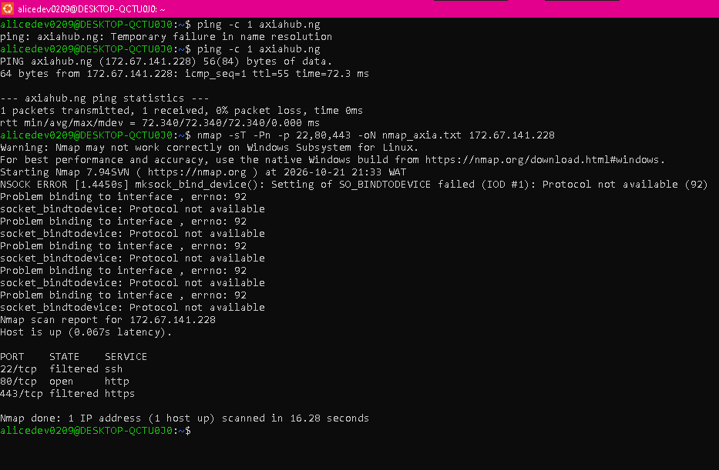

Task D: Interpretation of Nmap Scan Results
• Target Scanned: Axia Hub external infrastructure (172.67.141.228 / axiahub.ng).
• Port Status Summary:
- Port 22/tcp (ssh): Filtered (protected by firewall rules against direct public login).
- Port 80/tcp (http): Open (actively serving public web traffic).
- Port 443/tcp (https): Filtered (managed via secure Cloudflare edge proxy routing).
• Security Insight: The scan confirms that Axia Hub's web infrastructure is fronted by a web application firewall / CDN (Cloudflare), which successfully shields internal backend services and properly filters sensitive management ports like SSH from unauthorized public exposure.

Task E: Security Recommendations & Personal Reflection

Security Recommendations
1. Perimeter Defense: Maintain strict firewall filtering on sensitive administrative ports (SSH/22) and rely solely on secure encrypted channels (HTTPS/443).
2. CDN & WAF Configuration: Ensure Cloudflare security rules and DDoS protection remain correctly configured to thwart malicious reconnaissance probes.
3. Regular Audits: Perform routine external reconnaissance checks to verify that no unintended administration services are exposed to the public internet.

Personal Reflection & Internship Insights
• Performing external reconnaissance against Axia Hub demonstrated how modern cloud-protected websites handle probe requests and firewall filtering.
• Overcoming WSL socket constraints and firewall ping blocks using the -Pn and -sT flags provided valuable hands-on troubleshooting experience in network analysis.
• Documenting both OSINT findings and live scan results reinforced the importance of structured reporting and evidence organization in professional cybersecurity assessments.

