**Alisa Dubrovskaya**

**Task:** to develop an application that displays the last name of developer and asks how many days it takes to complete the task. It is necessary to calculate the date and time of the assignment. To get the date and time, use Calendar class from the java.util package.

**Execution stages:**

1. Create required class with .java extension

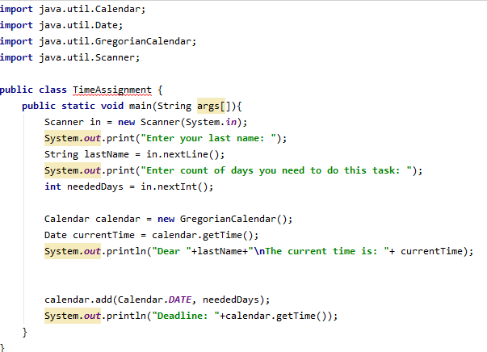

1. Move on to the required directory where created class is located



1. Compile the file using javac compiler



1. View the content of the file with **dir** command. TimeAssignment.class appeared in this directory.

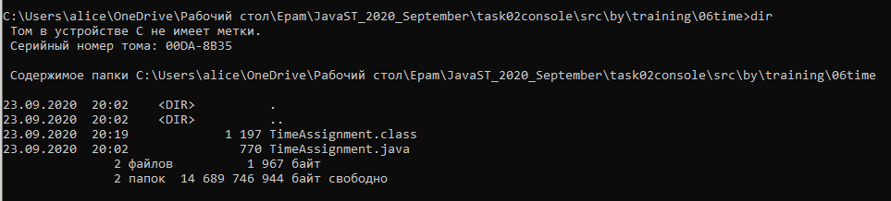

1. Start program



1. Program execution

