Health Check EndPoint

Get Customer1 August 2023 points

Get Customer1 September 2023 points

Get Customer1 October 2023 points

savePoints endpoint to save a new transaction points

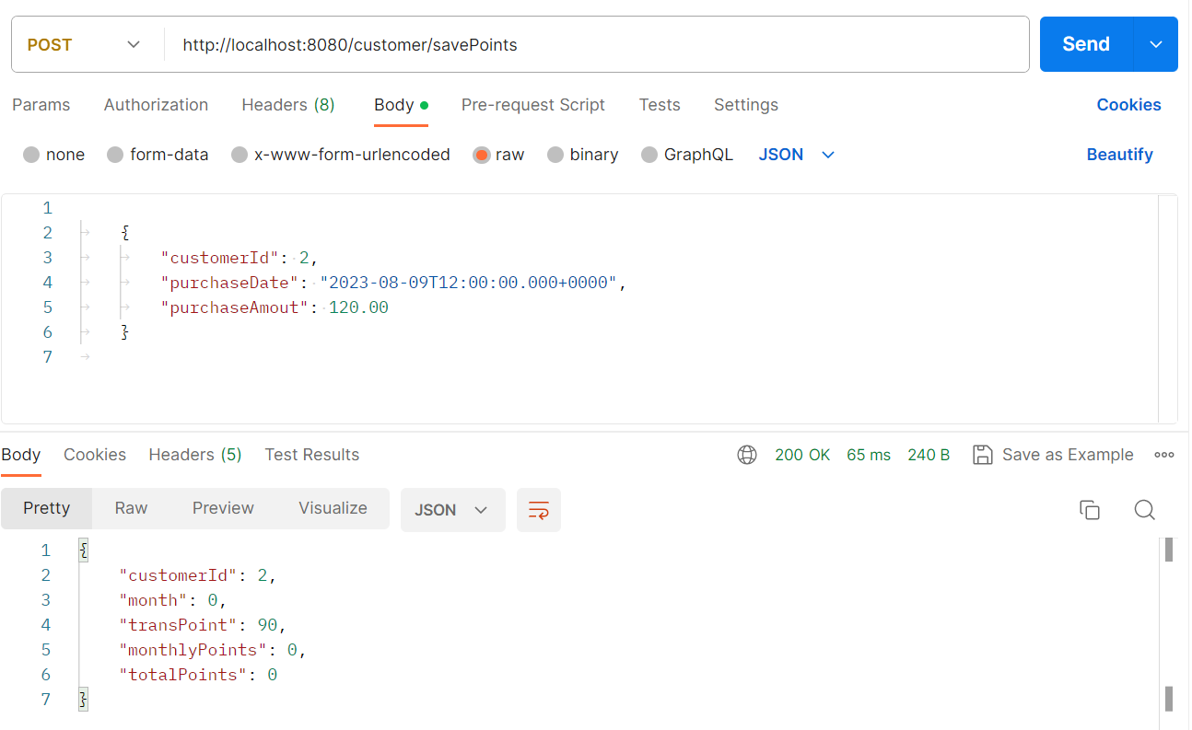

Get all Customers

Get all transactions for customer 1

