UX –Sit MAP

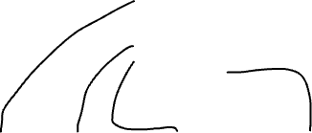

Policies

Contact number

Product 3

Picture

Name of product + features

Product 2

Picture

Name of product + features

Product 1

Picture

Name of product +

features

Who are we?

presentation of the brand

Picture

**HOME**

Picture

Who are we? (link)

Menu

-Product 1 (link)

-Product 2 (link)

-Product 3 (link)

-Policies & Contact number (link)