Statistical analysis plan for calibration of the Trident trial to a population-based cohort in Scotland.
Dr Alice Hosking, Prof Rustam Al-Shahi Salman, Prof William Whiteley, Prof David McAllister
2026-06-09
Table of Contents

1 Introduction

1.1 Purpose and scope of this document
This statistical analysis plan details the analyses planned for calibration of the TRIDENT trial to a population-based inception cohort, including a worked-through example with mock values of hazard ratios.

1.2 Study overview
Intracerebral haemorrhage causes around a third of strokes worldwide but half the death and disability after stroke.¹ Those with ICH have an estimated 2% annual risk of recurrent ICH and 2% annual risk of ischaemic stroke.² A single-pill combination of three blood pressure lowering medicines at half standard dose (telmisartan 20 mg, amlodipine 2.5 mg, and indapamide 1.25 mg) in addition to standard care could reduce the risk of recurrent stroke after ICH. TRIDENT was an international, double-blind, placebo-controlled, randomised trial in adults with ICH and mild-moderate hypertension (systolic BP: 130–160 mmHg). The primary outcome was any stroke; secondary outcomes include recurrent ICH, cardiovascular events, and safety.³
However, TRIDENT, as with any other trial, might be subject to selection bias, leading to low representativeness of the general population (i.e., lack of external validity).^{4–6} In particular, women, older people, and those with frailty and multimorbidity, are likely underrepresented in this trial.^{7–9} Furthermore, the trial was conducted in countries with different demography to the UK.The mean age of people with incident ICH in two pooled cohorts from Oxfordshire, England and Lothian, Scotland was 74.7 years, with 53% of the cohort being female.@Li2021 TRIDENT only includes those who survived long enough to be enrolled in the trial; nevertheless, the mean age was 58 years in both treatment and placebo arm, and women comprised 33% and 34% of each arm.
In recent years statistical trial calibration (or transportation), has been developed to deal with this issue.^{10,11} Calibration refers to the methods used to extend the results of a clinical trial to a different population than the one originally studied. Rather than using observational studies to assess the same clinical question, calibration keeps the randomisation intact and therefore does not introduce confounding bias. This process provides a quantitative estimate of the external validity of trial findings.

1.3 Objectives
The aim of this study is to calibrate the effect of a low-dose triple pill antihypertensive medication in people with ICH from the TRIDENT trial to a population-based cohort in Lothian, Scotland.
The outcome will be:
- A measure of relative effect, the risk ratio, calibrated to the Lothian population.
- A measure of absolute effect, the number needed to treat, calibrated to the Lothian population.

2 Study design, population and outcomes

2.1 Study design
This study will use stratified data from the TRIDENT trial (the trial population) and data from the LATCH study (the target population), a prospective, population-based inception cohort study of people with ICH in NHS Lothian.
The TRIDENT trial result showed no difference in the primary outcome (recurrent stroke) until approximately 18 months, from which point the cumulative incidence function for the primary outcome appeared to diverge between control and treatment arms. We will therefore calibrate at two time points, 18 months ($t_{1}$) and end of follow up (approx 6 years, $t_{2}$).
There are various methods to calibrate trials. Regression-based approaches and inverse probability weighting require individual patient data.¹² Alternatively, one can stratify a trial and target population by key factors, and extract hazard ratios from the trial for each stratum, obviating the need for individual participant data access. We propose to use this method to calibrate TRIDENT to the LATCH population.
We will calibrate based on age and sex, two factors by which the TRIDENT population differs to the UK population with ICH. Age is strongly related to other characteristics such as multimorbidity and frailty which are commonly under-represented in clinical trials, but were not directly measured in TRIDENT.@Barnett2012
In summary, the method is:
- Inspect the distribution of ages in TRIDENT and LATCH to choose stratification ages with sufficient overlap between LATCH and TRIDENT.
- Split TRIDENT into strata of age and sex (eg <65 years female, <65 years male, over 65 years female, over 65 years male)
- Obtain hazard ratios and their 95% confidence intervals for TRIDENT for each stratum at 18 months and from 18 months to end of trial (assumed to be 6 years for this document).
- Split LATCH into the same age- and sex-based strata. For each strata, fit a survival model to obtain rates and confidence intervals of the primary outcome at $t_{1}$ and $t_{2}$.
- Use these rates, and the hazard ratios from TRIDENT, to model absolute rates in untreated and treated in each stratum.
- The relative risk for each stratum is then (risk untreated/risk treated). We combine relative risks as a weighted mean, with the weights the number of people in each stratum in LATCH.
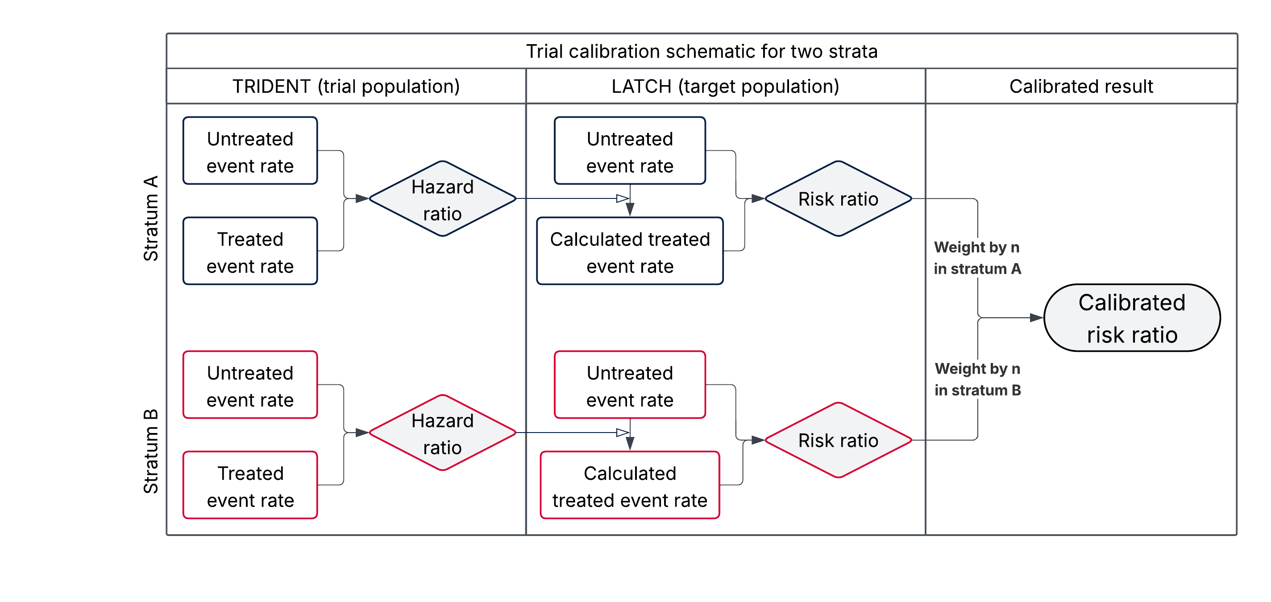
Figure 1: Flowchart schematic of trial calibration method using two strata.

2.2 Populations

2.2.1 Trial population
The trial population is the 1670 people included in the TRIDENT trial, an international multicentre double-blind placebo-controlled trial. The average time to randomisation after ICH onset was 54 days. The primary outcome was time to first recurrent stroke.
TRIDENT Inclusion Criteria
- Adults (≥18 years) with a history of primary ICH that was confirmed by imaging.
- Clinically stable, as judged by investigator.
- An average of two resting systolic blood pressure (SBP) levels measured 5 minutes apart in the range 130-160 mmHg recorded in a seated position. Patients with higher SBP could still be included if it was considered by the site investigator that their management would be consistent with local standards of clinical practice.
- Geographical proximity to the recruiting hospital and/or follow-up medical clinic site to allow ready access for in-person assessments during follow-up.
- No clear contraindication or indication to any of the individual components of the Investigational Medical Product (IMP).
- Provision of written informed consent
TRIDENT Exclusion Criteria
- Taking an angiotensin converting enzyme inhibitor (ACE-I) that could not be switched to any of the following alternatives: an angiotensin receptor blocker (ARB) (e.g. telmisartan 20 or 40 mg), a calcium channel blocker (CCB) (e.g. amlodipine 2.5 or 5 mg), or a thiazide (TZ)-like diuretic (e.g. indapamide 1.25 mg); an equivalent class (ARB, CCB or TZ); or a beta-blocker (BB).
- Contraindication to any component of the IMP in the context of currently prescribed BP lowering treatment.
- Unable to complete the study procedures and/or follow-up.

2.2.2 Target population
We aim to calibrate to a target population that reflects who might be prescribed the TRIDENT single pill, if it were recommended in clinical treatment guidelines.
The Lothian Audit of Intracerebral Haemorrhage (LATCH) was a population-based cohort study that ran between 1st June 2010 and 31st May 2013, and 1st November 2018 and 31st October 2021, with the aim of near-complete ascertainment of ICH in the Lothian Health board region of Scotland in residents aged ≥16 years. Approval for LATCH was granted by the Caldicott guardian of NHS Lothian. The LATCH audit has been described previously.¹³ Prospective sources included a trust-wide network of physicians, neurologists, neurosurgeons, radiologists, pathologists, specialist nurses and audit personnel; and daily neuroradiology meetings and review of all computed tomographic (CT) head scans. Retrospective sources were electronic patient notes, International Classification of Diseases 10th Revision (ICD-10) coded hospital discharge records, the Scottish Stroke Care Audit,¹⁴ and death records at the Office of the Procurator Fiscal.
The LATCH cohort includes 1077 people with ICH of any cause; 917 had ICH presumed due to microvascular cause. We aim to identify those in LATCH who might be prescribed the TRIDENT single pill, if it were recommended in clinical treatment guidelines, based on the TRIDENT inclusion criteria and prescribing practice:
- In clinical practice, antihypertensive treatment for secondary prevention is often started once a person is clinically stable. In the LATCH cohort, a third of people die within 7 days of ICH; beyond 7 days, the death rate reduces, and we pragmatically assume those alive at 7 days after ICH are clinically stable; there are 602 people alive at 7 days.
- We did not have measurement of post-ICH blood pressure for all of LATCH. Almost everyone with intracerebral haemorrhage is hypertensive; we expect very few to have blood pressure . If the triple pill used in TRIDENT were used in clinical practice, there would likely be no upper restriction on pre-treatment blood pressure; therefore we do not limit by blood pressure.
- The TRIDENT pill would only be used on those able to get out of bed; therefore, we will limit inclusion to those with pre-morbid modified Rankin Scale (mRS) of 4 or less. All 602 who survived 7 days had a pre-morbid mRS of 4 or less.

2.2.3 Assumptions and limitations
- We assume that the hazard ratios for each stratum reflect real variation in hazard by age and sex, rather than random variation around the mean.
- The trial and target populations are partially overlapping, as the Royal Infirmary of Edinburgh recruited 17 people with ICH for TRIDENT. Therefore approximately 9 people in the target population (1.5%) are on treatment. We cannot identify those treated, but assume this will make a negligible difference to the untreated rate.
- There were limitations to the maximum doses of additional blood pressure treatment for those in both treatment and placebo arms of TRIDENT. People in LATCH may have been prescribed doses in excess of this, but we do not have data on discharge medications for the whole LATCH population, so cannot exclude these people.

3 Analysis example
We now show the method for calibration through a worked example using real LATCH data, and mock hazard ratios (and their 95% confidence intervals) from TRIDENT. We create age/sex four strata for this example.

3.1 Time period definitions
We will calibrate at two time points, 18 months ($t_{1}$) and end of follow up (approx 6 years, $t_{2}$). The time period from start of follow-up to $t_{1}$ is $τ_{1}$. The time period from $t_{1}$ to $t_{2}$ is $τ_{2}$.

3.2 Data tidying
First we filter LATCH to only those who survived 7 days, format dates correctly, set censoring dates, and split into strata (under 65 and 65 and over, male and female). For this study, we censor LATCH follow up at the maximum TRIDENT follow-up time of six years.

3.3 Parametric survival model for LATCH
We model the event rate (stroke recurrence) in LATCH for each stratum. We use a parametric model.
First inspect the Kaplan Meier curve. This looks approximately exponential.
We model the event rate with a parametric survival model to select the most appropriate distribution, using the flexsurv package in R. There are various choices for the model distribution (exponential, gamma, Weibull etc). We compare the hazard and survival plots for each distribution to a non-parametric model (the kernel, in black), and the AIC for each distribution.
The exponential model allows much simpler calculations other models. The AICs are all similar (gamma is the lowest). Although other models have marginally better fits, the exponential model fit is acceptable, and for analytical simplicity, we choose an exponential model.

3.3.1 Kaplan Meier curve
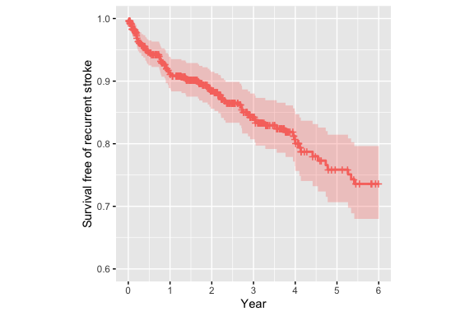

3.3.2 Plot of survivals of various distributions
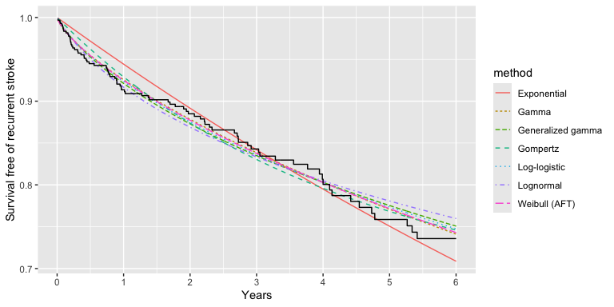

3.3.3 Plot of hazards of various distributions
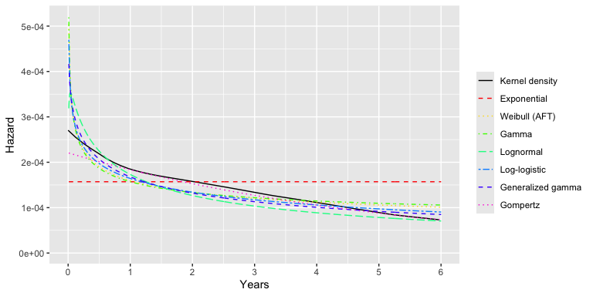

3.3.4 Comparison of AIC
Model | AIC
Exponential | 1602.43
Weibull (AFT) | 1593.8
Gamma | 1593.88
Lognormal | 1594.16
Log-logistic | 1593.95
Generalized gamma | 1595.53
Gompertz | 1598.55

3.4 Event rates in LATCH
Assuming exponential event rate across $τ_{1}$ and $τ_{2}$, we can calculate the event rate, the standard error, and simulate a normally distributed sample.@Greenland2004 Throughout, we simulate with 10,000 samples. We plot the sample and show the event rates for each stratum in a table.
The event rate is defined as:
$$λ_{u}=\text{rate in untreated}$$
We define $n_{s}$ as the number of people in each stratum, and $m_{s}$ as the number of events per stratum.
$$λ_{u}=\frac{m_{s}}{\text{Total follow up time for stratum}}$$
.
As we are assuming an exponential distribution, we can calculate the standard error directly:
$$ln\left(SE\right)=\frac{1}{\sqrt{m_{s}}}$$
.
We can then simulate a normally distributed sample for the event rates.

3.4.1 Table of event rates for each stratum
N in stratum | log(rate/day) | log(standard error) | Events per 100 person years (95% CI)
94 | -9.23 | 0.29 | 3.59 (2.04-6.33)
34 | -9.37 | 0.50 | 3.11 (1.17-8.29)
204 | -8.43 | 0.19 | 7.99 (5.55-11.49)
269 | -8.69 | 0.16 | 6.13 (4.44-8.47)

3.4.2 Plot of log event rates for each stratum
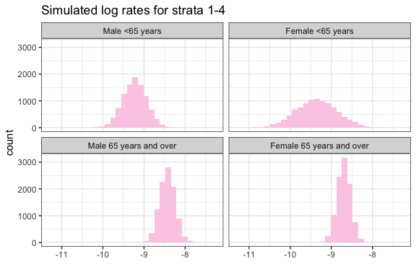

3.5 Hazard ratios for each stratum
For this mock-up we estimate hazard ratios for each time period (based roughly on published subgroup analysis). For the real analysis, the strata may be different; this is for demonstration only. We assume HR are independent; and make a guess at the HR for young men. We then split into two time periods: up to 18 months, where the HR are approximately 1; and beyond 18 months. We simulate 10,000 samples assuming a log normal distribution, for t1 and t2.

3.5.1 Hazard ratio for period $τ_{1}$
Hazard ratio | Lower CI | Upper CI
0.82 | 0.68 | 1.22
0.87 | 0.75 | 1.27
0.90 | 0.82 | 1.13
0.92 | 0.84 | 1.17

3.5.2 Hazard ratio for period $τ_{2}$
Hazard ratio | Lower CI | Upper CI
0.40 | 0.26 | 0.80
0.25 | 0.13 | 0.65
0.32 | 0.24 | 0.55
0.20 | 0.12 | 0.45

3.5.3 Histogram of simulated log hazard ratios for strata 1-4, $τ_{1}$
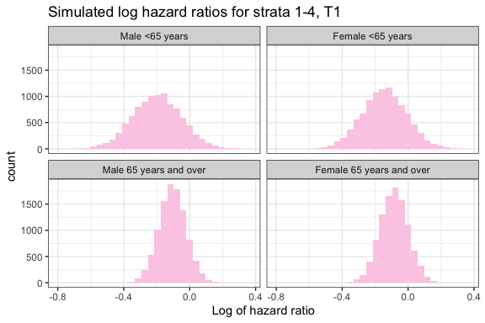

3.5.4 Histogram of simulated hazard ratios for strata 1-4, $τ_{2}$
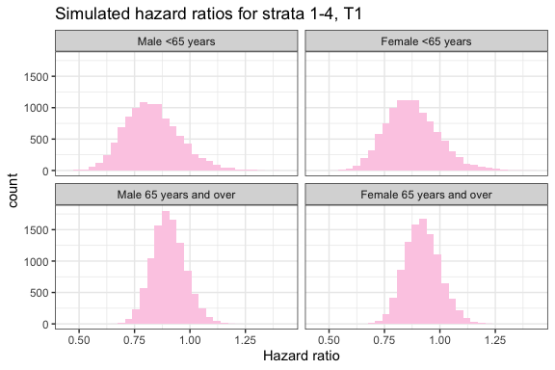

3.5.5 Histogram of simulated log hazard ratios for strata 1-4, $τ_{2}$
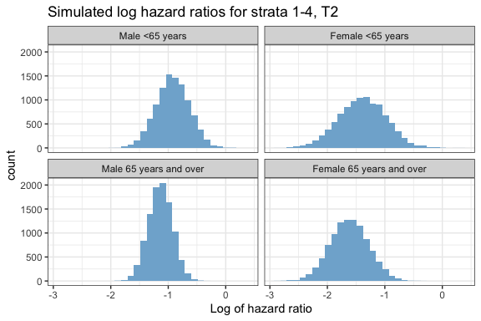

3.5.6 Histogram of simulated hazard ratios for strata 1-4, $τ_{2}$
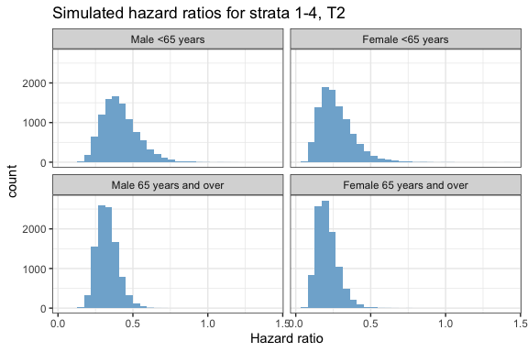

3.6 Calibrated rates and CIs for each stratum
For each age/sex stratum and for each time period, we combine the rate in the untreated and the hazard ratio to obtain a risk ratio.
Recall:
$$λ_{u}=\text{rate in untreated}$$
Multiply untreated rates by hazard ratios ($HR$) to get treated event rates in each time period:
$$λ_{treat1}=λ_{u}×HR_{1}$$
$$λ_{treat2}=λ_{u}×HR_{2}$$
We then transform these to risks for each stratum:
$$R_{untreated}=1−exp(−λ_{u}\left(τ_{1}+τ_{2}\right))$$
and
$$R_{treated}=1−exp(−\left(λ_{treat1}τ_{1}+λ_{treat2}τ_{2}\right))$$
The risk ratio at the end of the trial for each stratum is then:
$$RR_{S}=\frac{R_{treated}}{R_{untreated}}$$
We have already simulated 10,000 samples for each hazard ratio and event rate, to generate 10,000 risk ratios.

3.6.1 Simulated risk ratios for strata 1-4, $t_{1}$
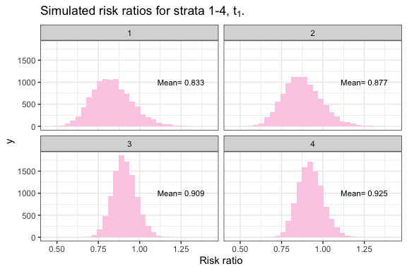

3.6.2 Simulated risk ratios for strata 1-4, $t_{2}$
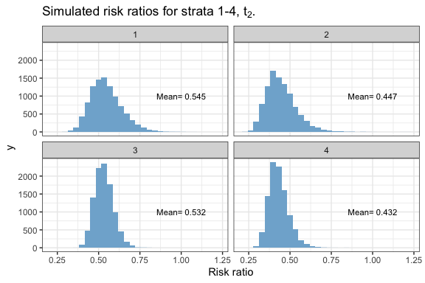

3.7 Pooled risk ratio
The final step is to pool the risk ratio for each stratum. We take a weighted mean, where the risk ratio for each stratum is weighted by the number of people in each stratum.
RRoverall=s​RRsns
We do this for all samples, then generate a mean and confidence intervals for the calibrated relative risk.

3.7.1 Calibrated risk ratio at the end of the trial, for the whole trial
The estimated calibrated risk ratio is 0.485 (95% confidence interval 0.42-0.564).
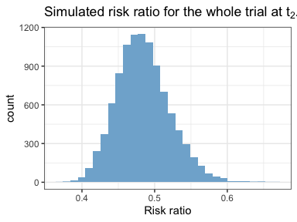

3.8 Absolute risk
We can use the new, calibrated risk ratio to estimate the number needed to treat (NNT) in the LATCH cohort from the absolute risk ratio (ARR). We use 10,000 samples of the risk ratio, and generate confidence intervals.
$$ARR=1/\left(λ_{u}−λ_{u}×RR_{overall}\right)$$
$$\text{NNT}=1/\text{ARR}$$
The number needed to treat is 33.99 (95% CI 30.06 - 39.96).

4 Extension to adverse events
Benefits of treatment must be balanced against potential risks, and so it might be informative to calibrate adverse events. In TRIDENT, adverse events of special interest were hypotension, syncope, headache, hyponatremia, hyperkalemia, injurious falls,and acute kidney injury. There was also a protocol requirement of discontinuation if serum creatinine increased level of 20% or more from the baseline value (creatinine was measured at baseline, 6 weeks and at the end of the trial).
Most of these adverse events were not measured in LATCH, but we have applied to link the LATCH cohort to routinely-collected data in Lothian, including renal function measurements. While a decline in renal function might not lead to discontinuation of a drug, it might have important implications for drug monitoring.
If sufficient people in LATCH have repeat measurements of renal function, we could apply a similar method to above, to calibrate the rate of decline in renal function to a specified threshold (eg >20% increase in creatinine, >30% decline in eGFR).

5 References
1. Feigin VL, Abate MD, Abate YH, et al. Global, regional, and national burden of stroke and its risk factors, 1990–2021: A systematic analysis for the global burden of disease study 2021. The Lancet Neurology. 2024;23:973-1003. doi:10.1016/S1474-4422(24)00369-7
2. Putri VP, Samarasekera N, Moullaali TJ, et al. Rates and risk factors for major adverse cardiovascular and cerebrovascular events after stroke due to intracerebral hemorrhage: Systematic review and study-level meta-analysis. International Journal of Stroke. October 2026. doi:10.1177/17474930261416692/SUPPL_FILE/SJ-DOCX-1-WSO-10.1177_17474930261416692.DOCX
3. The Trident Research Group. Three low-dose antihypertensive agents in a single pill after intracerebral hemorrhage. New England Journal of Medicine. 2026;394:1571-1582. doi:10.1056/NEJMOA2515043
4. Westreich D, Edwards JK, Lesko CR, Cole SR, Stuart EA. Target validity and the hierarchy of study designs. American journal of epidemiology. 2019;188:438-443. doi:10.1093/AJE/KWY228
5. Bareinboim E, Pearla J. Causal inference and the data-fusion problem. Proceedings of the National Academy of Sciences of the United States of America. 2016;113:7345-7352. doi:10.1073/PNAS.1510507113
6. Rothwell PM. External validity of randomised controlled trials: "To whom do the results of this trial apply?". Lancet (London, England). 2005;365:82-93. doi:10.1016/S0140-6736(04)17670-8
7. Sheppard JP, Lown M, Burt J, et al. Generalizability of blood pressure lowering trials to older patients: Cross-sectional analysis. Journal of the American Geriatrics Society. 2020;68:2508-2515. doi:10.1111/JGS.16749
8. Sardar MR, Badri M, Prince CT, Seltzer J, Kowey PR. Underrepresentation of women, elderly patients, and racial minorities in the randomized trials used for cardiovascular guidelines. JAMA Internal Medicine. 2014;174:1868-1870. doi:10.1001/JAMAINTERNMED.2014.4758
9. Carcel C, Reeves M. Under-enrollment of women in stroke clinical trials. Stroke. 2021;52:452-457. doi:10.1161/STROKEAHA.120.033227
10. Cole SR, Stuart EA. Generalizing evidence from randomized clinical trials to target populations: The ACTG 320 trial. American Journal of Epidemiology. 2010;172:107-115. doi:10.1093/AJE/KWQ084
11. Manke-Reimers F, Brugger V, Bärnighausen T, Kohler S. When, why and how are estimated effects transported between populations? A scoping review of studies applying transportability methods. European journal of epidemiology. 2025;40:255-273. doi:10.1007/S10654-025-01217-W
12. Wei L, Phillippo DM, Shah A, Cleland JGF, Lewsey J, McAllister DA. Transportability of two heart failure trials to a disease registry using individual patient data. Journal of clinical epidemiology. 2023;162:160-168. doi:10.1016/J.JCLINEPI.2023.08.019
13. Samarasekera N, Fonville A, Lerpiniere C, et al. Influence of intracerebral hemorrhage location on incidence, characteristics, and outcome: Population-based study. Stroke. 2015;46:361-368. doi:10.1161/STROKEAHA.114.007953/-/DC1
14. Turner M, Barber M, Dodds H, Dennis M, Langhorne P, Macleod MJ. Agreement between routine electronic hospital discharge and scottish stroke care audit (SSCA) data in identifying stroke in the scottish population. BMC health services research. 2015;15. doi:10.1186/S12913-015-1244-Y

6 Appendix
We can pool the risk ratio at $t_{1}$, to find the calibrated relative risk after 18 months.
The estimated calibrated risk ratio is 0.902 (95% confidence interval 0.816-0.994)
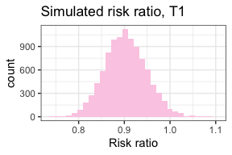

7 Extension: absolute risks in the prescence of competing risks.
To properly calculate absolute risk of recurrent stroke, we need to take into account competing risk of death. We earlier defined variables to allow us to calculate the rate of competing events.

7.1 Model selection

7.1.1 KM curve
First, look at the Kaplan-Meier curve.
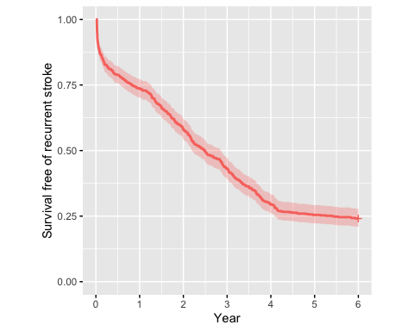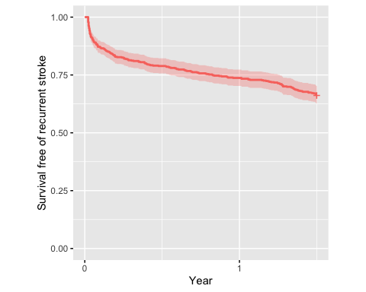 #### Parametric model
Look to see if the exponential model is acceptable at t2.
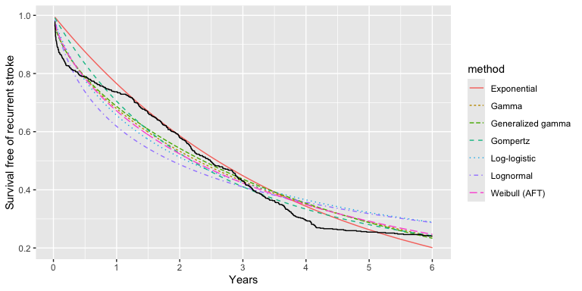

7.1.2 Model selction at t1
