Answers to questions in

Lab 3: Image segmentation

Name: ________Alice Karnsund___________ Program: _________TMAIM-17__________

**Instructions**: Complete the lab according to the instructions in the notes and respond to the questions stated below. Keep the answers short and focus on what is essential. Illustrate with figures only when explicitly requested.

Good luck!

___________________________________________________________________________

**Question 1**: How did you initialize the clustering process and why do you believe this was a good method of doing it?

Answers:

If one is given prior information about the image that is going to be segmented, it is easier to select initial centers more close to the optimal values. For example, if we know that we want to segment the image, 'orange.jpg', we can handpick initial centers to be close to the dominant colors in the image, such as white, orange, yellow and so on. In general, one might not have as much information about the image. Therefor randomly choosing K centers among the pixels in the image, possibly taking the diversity of the colors into account, is a good approach, which was the approach we used. This is a good way since it makes use of pixel values that for sure are in the picture. A bad idea would be to randomly sample a pixel value from the full color range, this could lead to initialization of centers that are extremely far from the actual values in the image and thus less amount of cluster will be used.

One of the greatest challenges in k-means clustering is positioning the initial cluster centers as close to optimal as possible in a recent amount of time. In 2007 the k-mean++ algorithm was introduced and is doing a good job in achieving this. This is also the way the built in MATLAB function kmeans(X,k) initializes the cluster centers.

___________________________________________________________________________

**Question 2**: How many iterations L do you typically need to reach convergence, that is the point where no additional iterations will affect the end results?

Answers:

Convergence depends on the parameter K, the quality of the image and the size.

A low K value means fewer clusters an often, but not necessarily, faster convergence. The scale_factor and the image_sigma affects the blur of the image. A high value on the scale_factor and a low value on the the image_sigma makes the image more detailed and the running time increases and the convergence is slower. Below are 4 plots for the convergences of the 'orange.jpg' and the 'tiger1.jpg'image. For both cases we made use of the convergence criteria that the average error should not change over the last 4 iterations with a precision of 2 decimals. The first two figures represents the mean error over 100 runs and a corresponding histogram over the runs for the orange, with the parameter settings,

In this case, with K=5, around 8-10 iterations are needed to reach convergence.

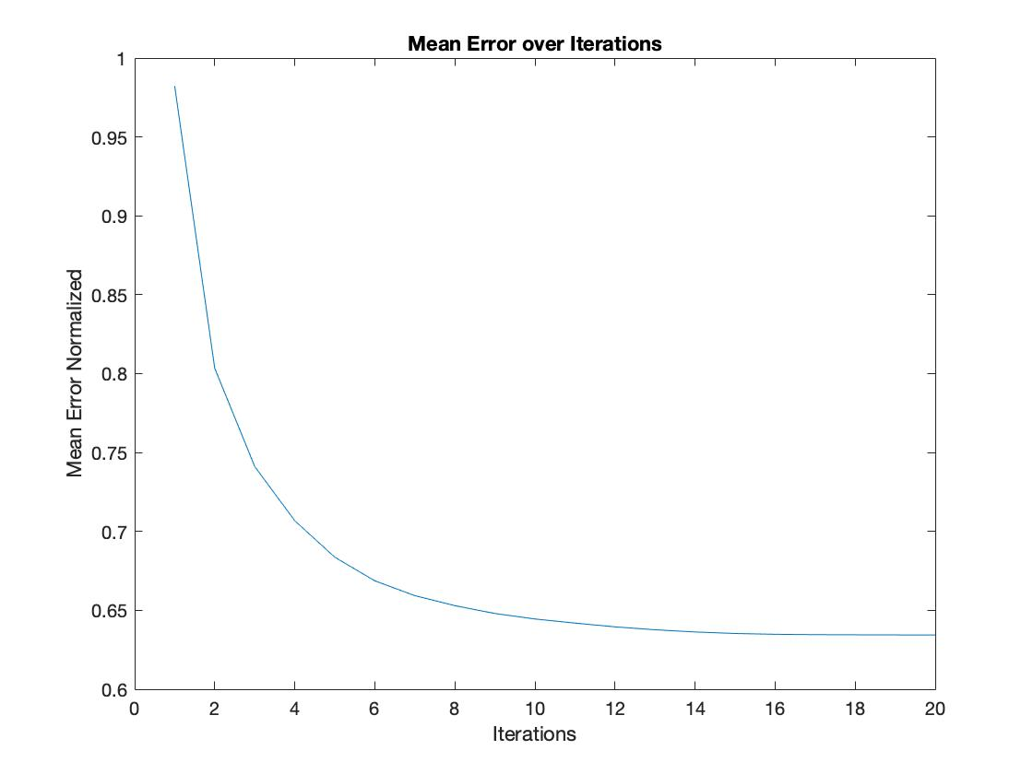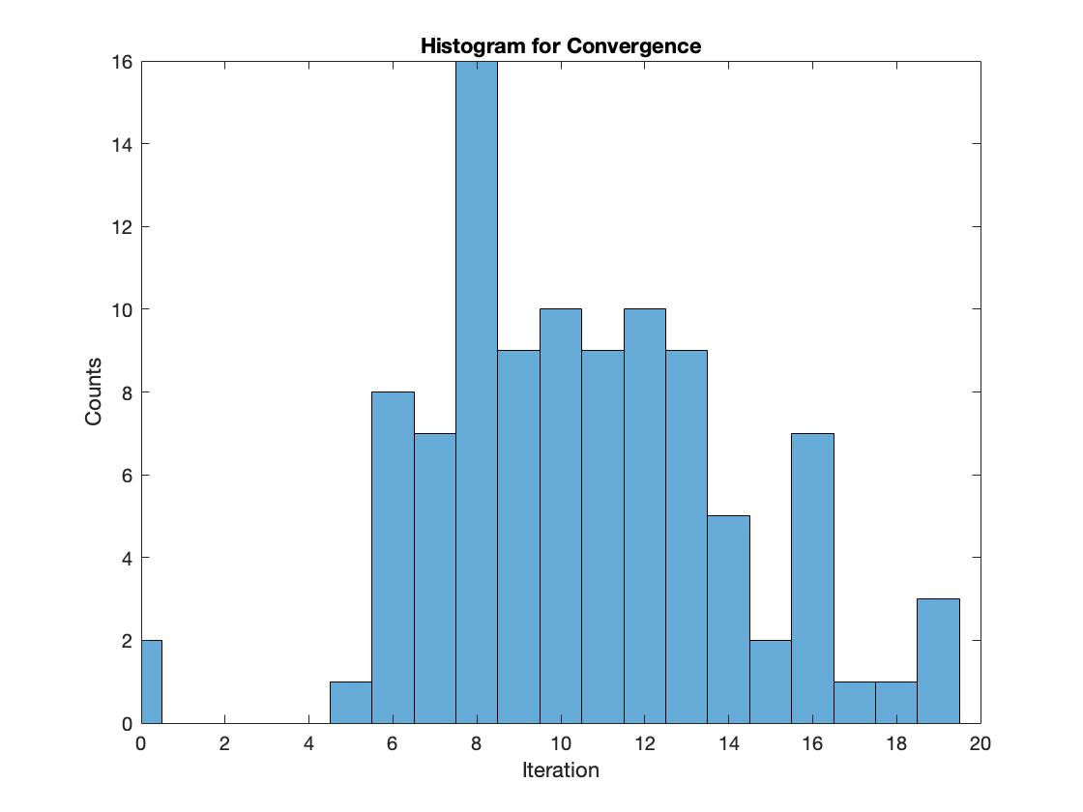

The next two images represents the mean error over 100 runs and a corresponding histogram for the tiger, with the parameter settings,

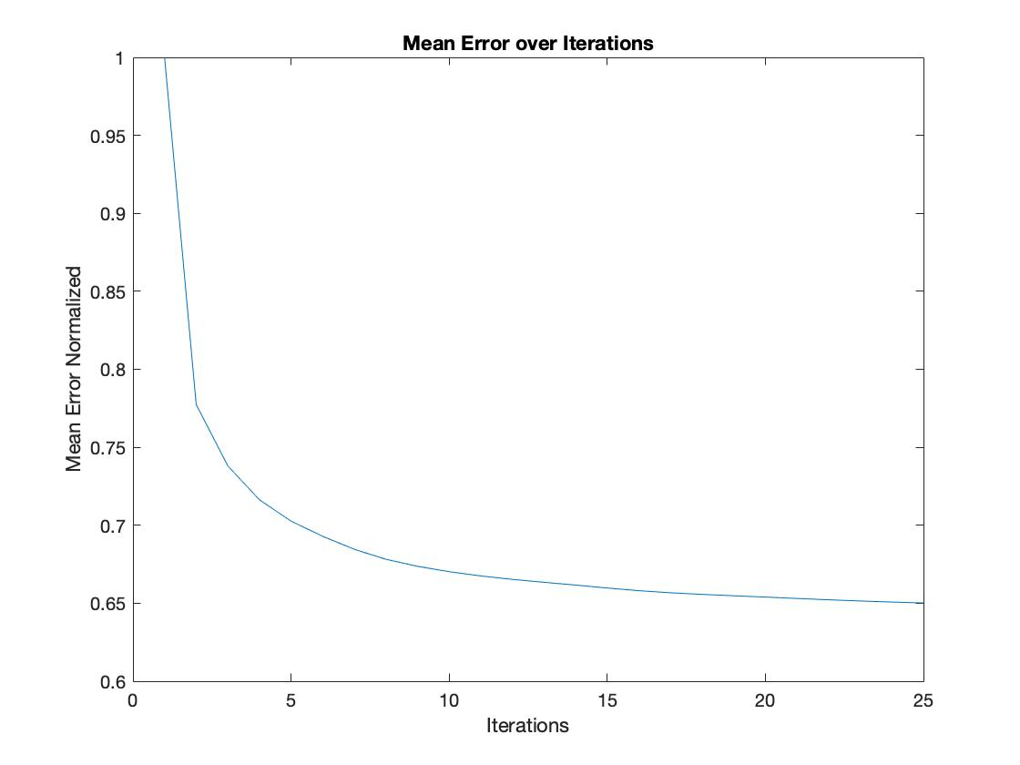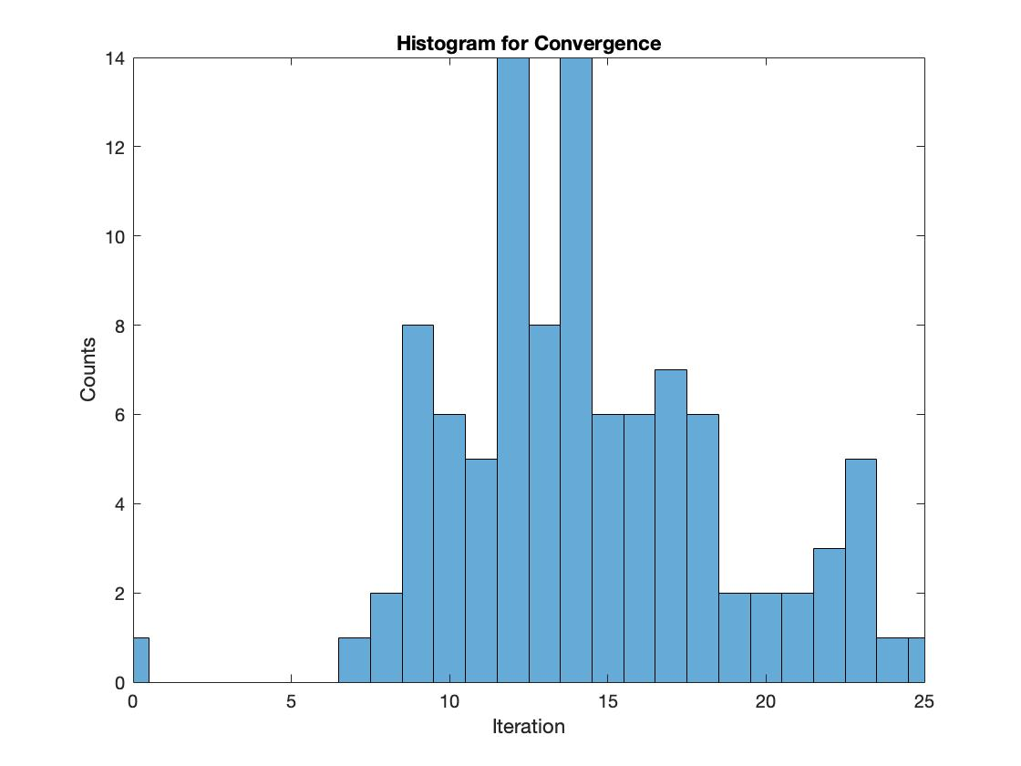

In this case when K=10, the tiger image needs around 14 iterations for convergence.

_

**Question 3**: What is the minimum value for K that you can use and still get no superpixel that covers parts from both halves of the orange? Illustrate with a figure.

Answers:

To make sure that no super pixels covers both parts of the orange halves we must, on average, increase K a bit. We found that on average this happens when K=6. Due to the random initialization, sometimes this happens at K=5 or K=7. Below is a figure showing the case when K=5 and K=6. This clearly illustrates that when going from K=6 to K=5 in this case, the criteria is no longer fulfilled.

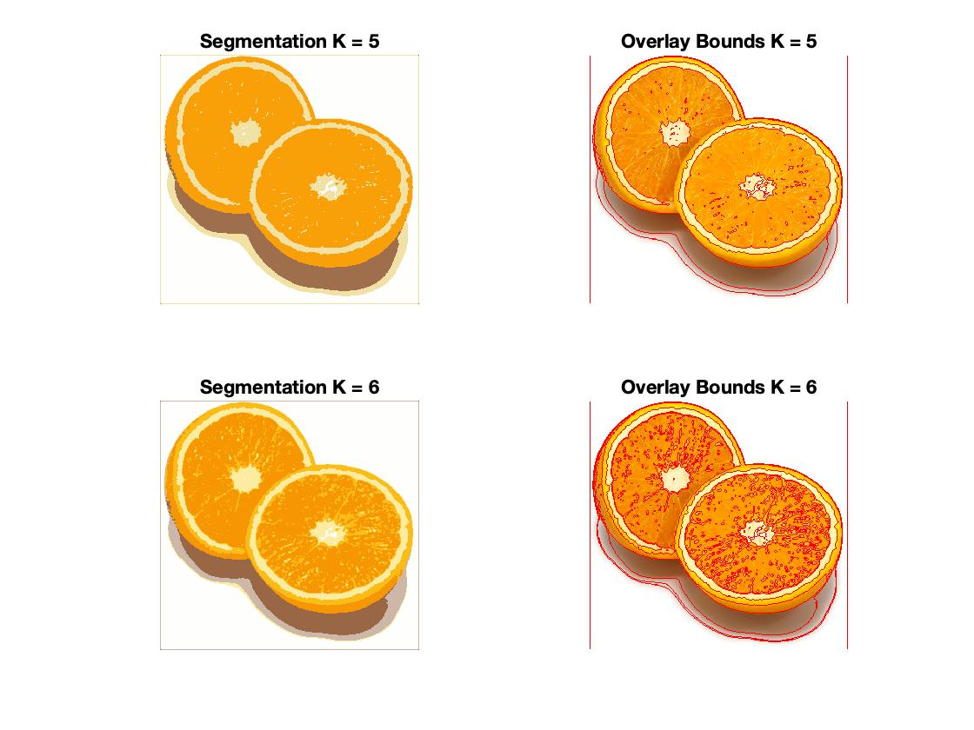

___________________________________________________________________________

**Question 4**: What needs to be changed in the parameters to get suitable superpixels for the tiger images as well?

Answers:

First of all the images of the tigers has a much greater diversity in the pixel values, they hold a greater variety of colors. This means that we must us a greater amount of clusters to be able to convey this diversity. Using K=7, which was appropriate in the case for the orange, will achieve this. A K-value around 10 is a much better choice for example. Also, as can be seen from Question 1, the algorithm needs more iterations to converge. Therefore, increasing L will also be necessary. Below is a figure showing this case for the 'tiger1.jpg'image. Since the algorithm only focuses on clustering pixels of the same color, we will have clusters that holds pixels both in the background and on the tiger. Also, the tiger images holds small areas of great variation in color and this will give rise to small super pixels. To decrease this effect, one can blur the image more before applying the segmentation procedure.

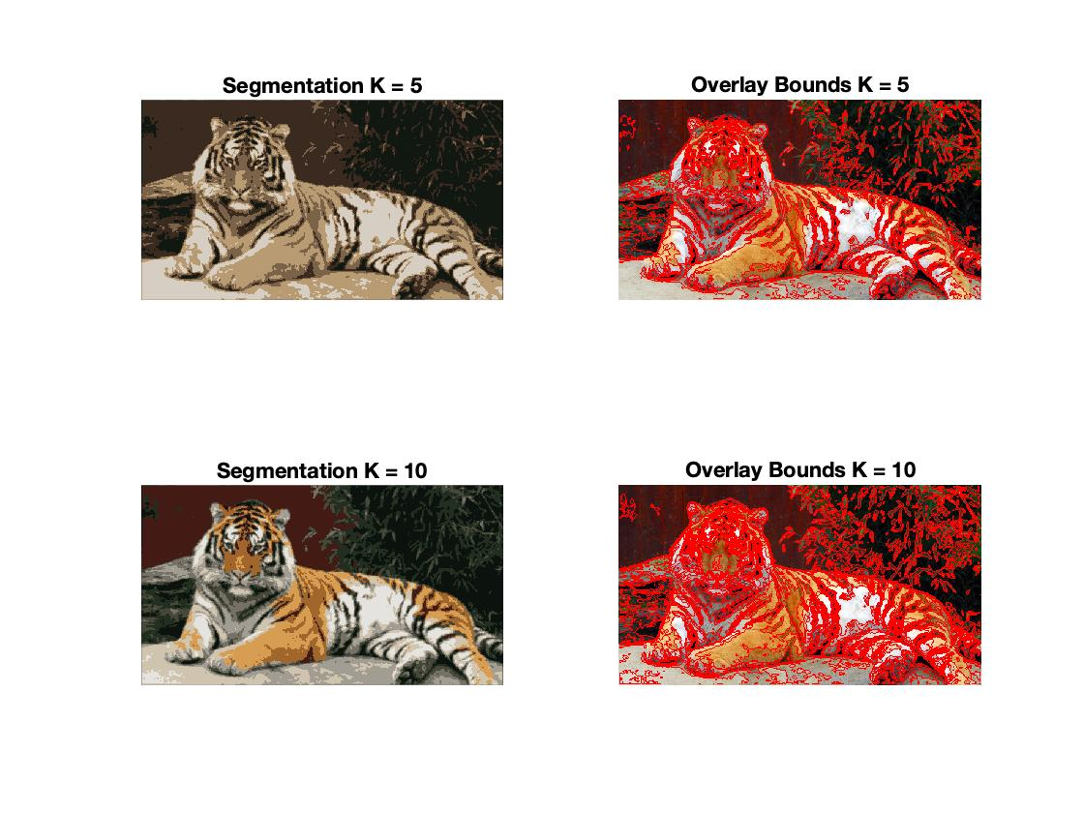

___________________________________________________________________________

**Question 5**: How do the results change depending on the bandwidths? What settings did you prefer for the different images? Illustrate with an example image with the parameter that you think are suitable for that image.

Answers:

The greater the value of the bandwidths, the wider the gaussian kernel. This means that more pixels are taken into account when the new cluster centers are being computed. This will result in fewer segments. But if the bandwidths are small, the gaussian kernel is more like a peak in 5G space, and not as much information is taken into account when computing the new cluster centers. This will thus give rise to more segments and the segmented picture can more easily be interpreted.

A high value on the color bandwidth will put almost all focus in segmenting the picture after colors. And a high value on the spatial bandwidth will make the algorithm focus on segmenting into spatial areas. To get as large segments as possible, but segments that each do not cover more than one object in the scene, we must find a balance between the two bandwidths. For almost all pictures, a slightly higher value on the spatial bandwidth compared to the color bandwidth seems to be profitable. In the figure below, an example is shown for the image Tiger3, with .

|  |  |  |
| --- | --- | --- |
| Image | σs2 | σc2 |
| Orange | 7 | 4 |
| Tiger1 | 10 | 4 |
| Tiger2 | 10 | 3 |
| Tiger3 | 6 | 4 |

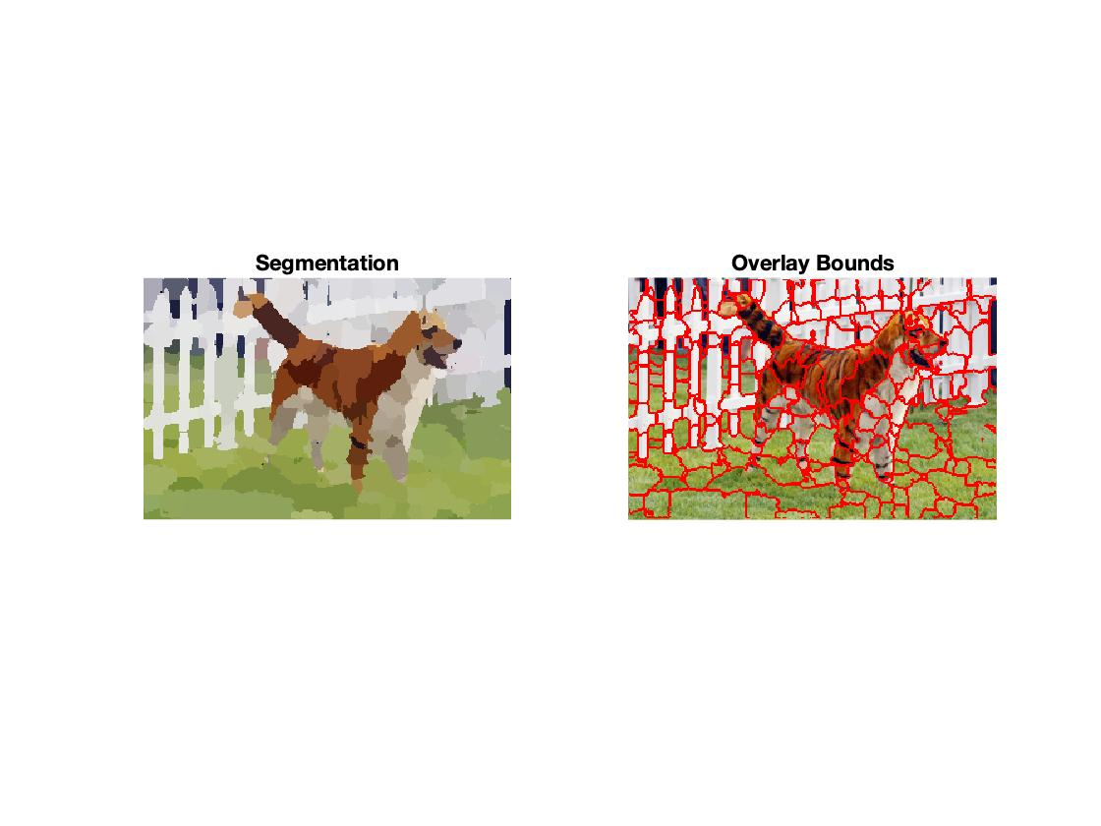

___________________________________________________________________________

**Question 6**: What kind of similarities and differences do you see between K-means and mean-shift segmentation?

Answers:

Both K-means and mean-shift are two unsupervised learning algorithms that both aim at finding optimal cluster centers. K-means are given the number of clusters K, thus it can be seen as a parameterized algorithm, and the outcome is strongly dependent on K. Mean-shift on the other hand finds an unknown number of modes and then determine which pixel corresponds to which mode. Thus mean-shift is not parametrized by the number of clusters K. K-means only looks at the color values of the pixels, not the spatial position, thus a segment in K-means can be spread out over different regions in the image. This is not the case with mean-shift, since mean-shift also takes the spatial position into account and represents each pixel as a 5 dimensional array. But this also means that mean-shift is strongly dependent on the parameters σs and σc which controls the size of the kernel and so the segments.

___________________________________________________________________________

**Question 7**: Does the ideal parameter setting vary depending on the images? If you look at the images, can you see a reason why the ideal settings might differ? Illustrate with an example image with the parameters you prefer for that image.

Answers:

___________________________________________________________________________

**Question 8**: Which parameter(s) was most effective for reducing the subdivision and still result in a satisfactory segmentation?

Answers:

___________________________________________________________________________

**Question 9**: Why does Normalized Cut prefer cuts of approximately equal size? Does this happen in practice?

Answers:

___________________________________________________________________________

**Question 10**: Did you manage to increase *radius* and how did it affect the results?

Answers:

___________________________________________________________________________

**Question 11**: Does the ideal choice of *alpha* and *sigma* vary a lot between different images? Illustrate with an example image with the parameters you prefer.

Answers:

___________________________________________________________________________

**Question 12**: How much can you lower K until the results get considerably worse?

Answers:

___________________________________________________________________________

**Question 13**: Unlike the earlier method Graph Cut segmentation relies on some input from a user for defining a rectangle. Is the benefit you get of this worth the effort? Motivate!

Answers:

___________________________________________________________________________

**Question 14**: What are the key differences and similarities between the segmentation methods (K-means, Mean-shift, Normalized Cut and energy-based segmentation with Graph Cuts) in this lab? Think carefully!!

Answers:

___________________________________________________________________________