Answers to questions in

Lab 1: Filtering operations

Name: _Alice Karnsund & Elin Samuelsson_____ Program: ___TMAIM-17____________

**Instructions**: Complete the lab according to the instructions in the notes and respond to the questions stated below. Keep the answers short and focus on what is essential. Illustrate with figures only when explicitly requested.

Good luck!

___________________________________________________________________________

**Question 1**: Repeat this exercise with the coordinates p and q set to (5, 9), (9, 5), (17, 9),

(17, 121), (5, 1) and (125, 1) respectively. What do you observe?

Answers:

(5, 1) and (125, 1) represents the points (4, 0) and (-4, 0) in the centered Fhat image respectively. We see that the vc-value of the frequency is 0, thus giving rise to a wave in the vertical direction. Translation affects the phase but not the magnitude, thus the magnitude is the same and the phase is shifted. With 4 and -4 as uc parts the difference in phase is π.

(17, 9) and (17, 21) represents (16, 8) and (16, -8) in the centered Fhat image respectively. They are each other’s reflections in the vc=0 plane. A rotation in one domain is a rotation in the other, thus the spatial image is rotated accordingly and the magnitude is kept the same since both points are the same distance from the center.

(5, 9) and (9, 5) represents (4, 8) and (8, 4) in the centered Fhat image respectively. In this case the uc and vc values are flipped. This is another case of rotation, thus the image is rotated the same amount and the magnitude is kept the same (and the phase is shifted?).

When the centered values (uc, vc) takes on values where uc=0 the real and imaginary parts of F will be waves travelling in the horizontal direction. But when vc=0 these will be waves travelling in the vertical direction. When uc=vc≠0 we get waves travelling in diagonal directions. This is simply due to the fact that the Fourier transform is a linear operation, a rotation in in one domain becomes a rotation in the other domain. The further we go from (uc,vc)=(0,0) the higher the frequencies. If (uc,vc)=(0,0) then the real and imaginary parts will simply show the means of F. Translations will only affect the phase as can be seen from comparing (uc,vc) with (-uc,-vc).

___________________________________________________________________________

**Question 2**: Explain how a position (p, q) in the Fourier domain will be projected as a sine wave in the spatial domain. Illustrate with a Matlab figure.

Answers:

In Matlab the coordinate system is rotated 90 degrees in relation to the Cartesian coordinate system. The x-axis (u) pointing downwards will correspond to waves in the vertical direction and the frequency will increase as the x-value are close to the middle value (x=64) and decrease when it is close to the max and min. The same argument goes for the y-axis (v) which pointing in the horizontal right direction, and corresponds to waves in the horizontal direction. The “centered Fhat” image is Fhat where the first and second quadrants and the second and fourths quadrants has been shifted. Thus points in the corners in the Fhat image corresponds to central points in the “centered Fhat” image and will have low frequency, and central points in Fhat will be placed in corners of “centered Fhat” and will have high frequencies. Selecting a point (p,q) in the Fourier domain will define the frequency components for a sine wave travelling out from the center of “centered Fhat”. Combining the x and y-values we will get rotated waves with frequencies increasing in the direction of towards (u,v)=(64,64). As can be seen in the pictures below.

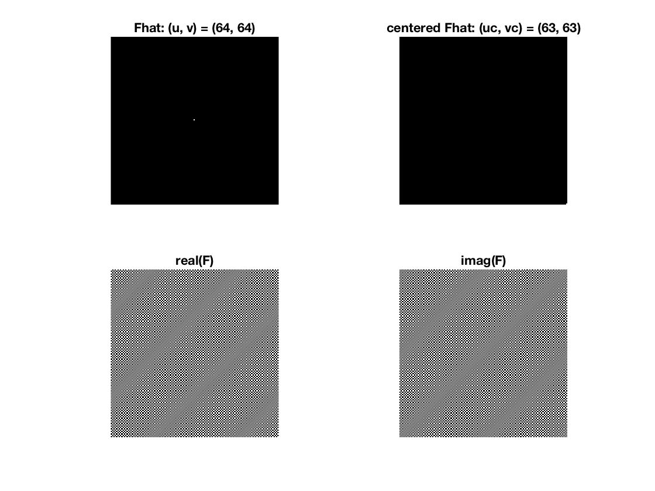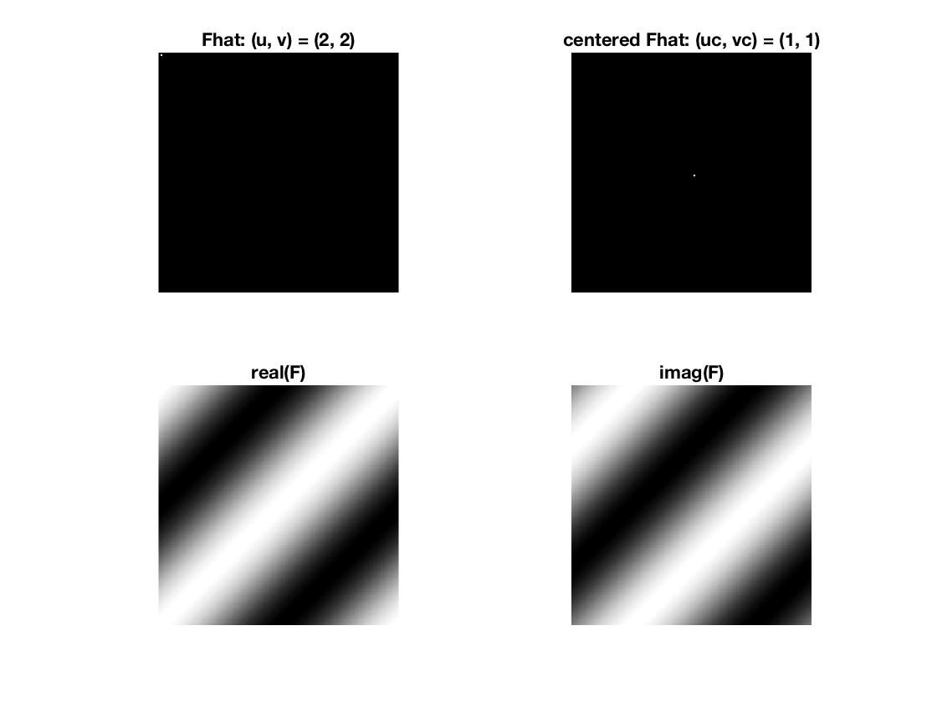

___________________________________________________________________________

**Question 3**: How large is the amplitude? Write down the expression derived from Equation (4) in the notes. Complement the code (variable amplitude) accordingly.

Answers:

We can express the Fourier transform as $F\left(u,v\right)=|F(u,v)|e^{iϕ(u,v)}$ where $|F(u,v)|$ is the Fourier spectrum and $ϕ(u,v)$ is the phase angle. The Fourier spectrum is the same as the amplitude and can be expressed $\left|F\left(u,v\right)\right|=\sqrt{Re^{2}\left(F(u,v)\right)+Im^{2}(F\left(u,v\right))}$. Thus for the inverse we simply get $\left|f\left(x,y\right)\right|=\sqrt{Re^{2}\left(x,y\right)+Im^{2}(x,y)}$, where $f$ is the inverse Fourier transform.

___________________________________________________________________________

**Question 4**: How does the direction and length of the sine wave depend on p and q? Write down the explicit expression that can be found in the lecture notes. Complement the code (variable wavelength) accordingly.

Answers:

If $ω=(ω_{x}, ω_{y})^{T}$ where $ω_{x}$ is the angular frequency in the x-direction and $ω_{y}$ is the angular frequency in the y-direction. Then the wavelength can be written $λ=\frac{2π}{\left|ω\right|}=\frac{2π}{\sqrt{ω_{x}^{2}+ω_{y}^{2}}}$, and with $ω_{D}=2π\frac{u}{N}$ we get, $λ=\frac{N}{\sqrt{{vc}^{2}+{uc}^{2}}}$.

___________________________________________________________________________

**Question 5**: What happens when we pass the point in the center and either p or q exceeds half the image size? Explain and illustrate graphically with Matlab!

Answers:

Since the “center Fhat” domain is the Fhat domain where the first and second quadrants and the second and fourths quadrants has been shifted. This means that when we pass the point in the center and either p or q exceeds half the image size, (CONTINUE)

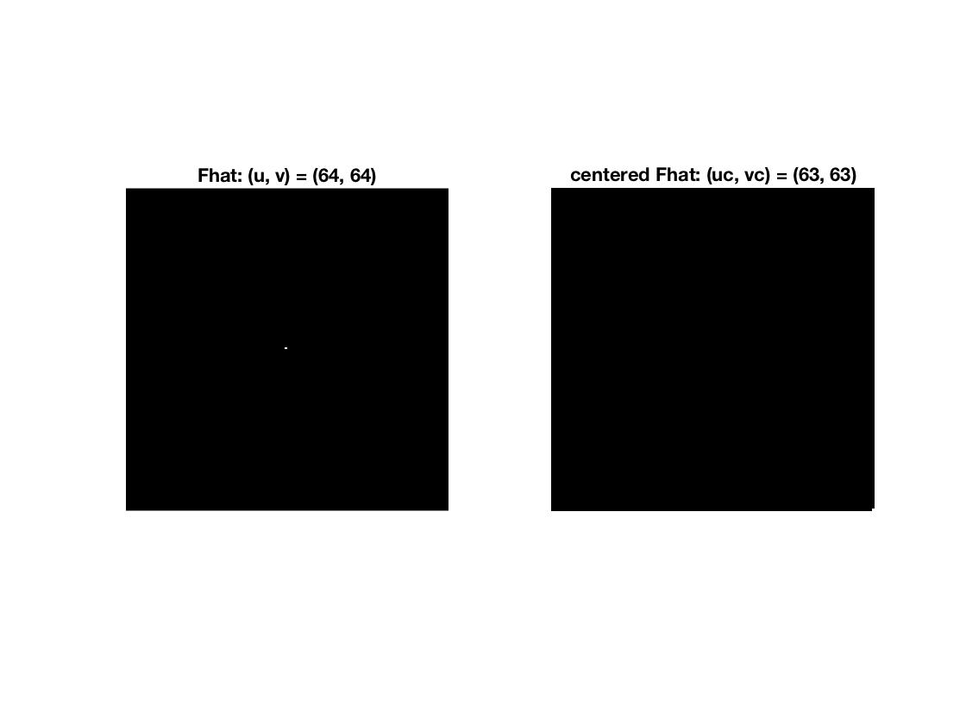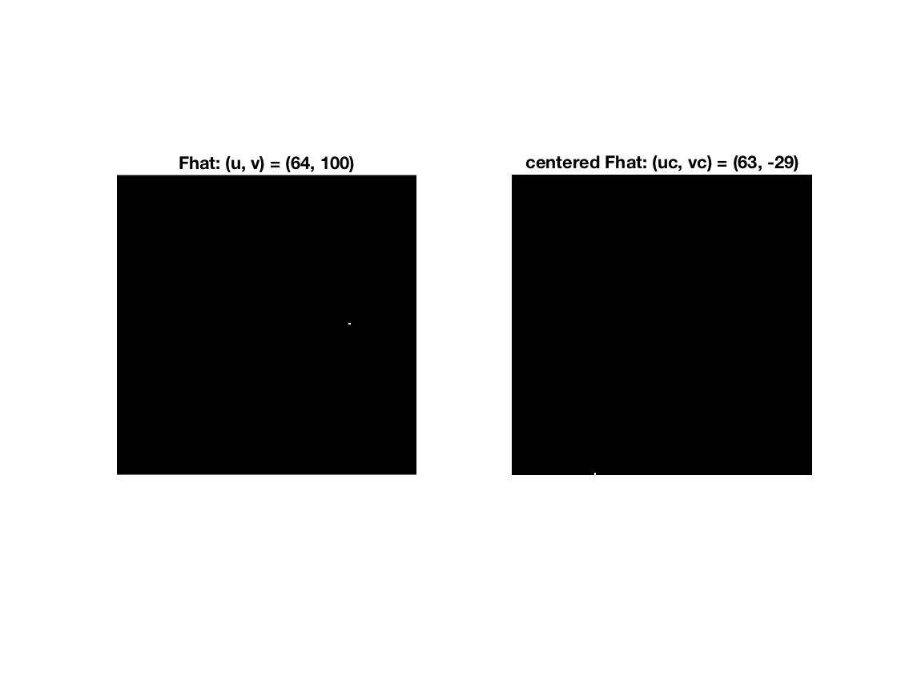

___________________________________________________________________________

**Question 6**: What is the purpose of the instructions following the question *What is done by these instructions?* in the code?

Answers:

The values (uc, vc) in the “center Fhat” domain are the mappings values from (u, v) in the Fhat domain. Thus since the “center Fhat” domain represents the Fourier space with zero frequency in the center and maximum frequency in the corners, the (uc, vc) values has to be calculated to fulfill this criteria. Since Fhat has the highest frequencies in the middle we have to shift the first and third quadrant and the second and fourth. This will give us the wanted space. In Matlab the coordinate system is rotated 90 degrees clockwise in relation to the Cartesian coordinate system, thus the second quadrant will have the lowest (u, v) values and the 4th will have the greatest. Thus the four statements in Matlab simply assigns the correct (uc, vc) values depending on in which quadrant (u, v) is.

___________________________________________________________________________

**Question 7**: Why are these Fourier spectra concentrated to the borders of the images? Can you give a mathematical interpretation? Hint: think of the frequencies in the source image and consider the resulting image as a Fourier transform applied to a 2D function. It might be easier to analyze each dimension separately!

Answers:

The images are constructed from box-functions in two-dimensions, i.e for the image F we can write:

$F\left(x,y\right)=\left\{\begin{aligned}1, { x}_{1}≤x≤x_{2} \\ 0, otherwise\end{aligned}\right.$ x is pointing downwards due to tilted coordinate system.

To understand the behavior in the Fourier domain we calculate the Fourier transform of this function (image):

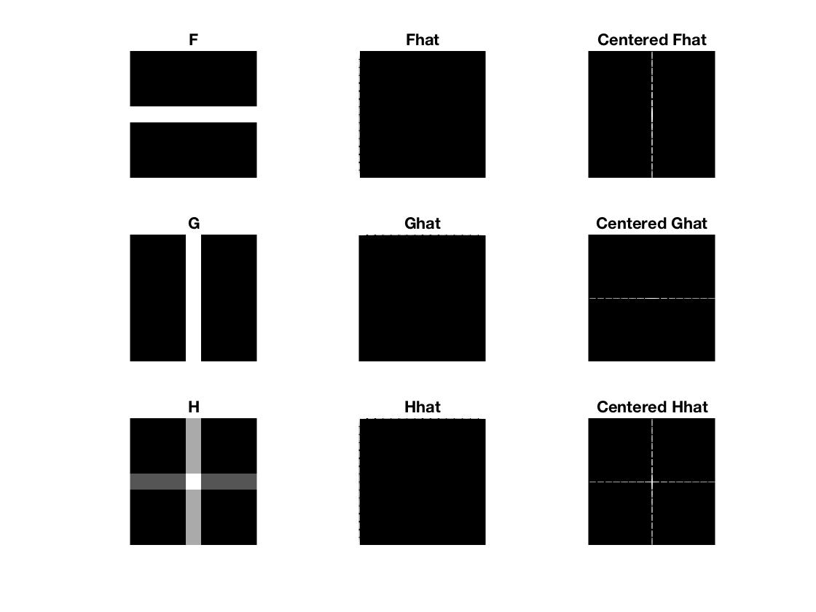

___________________________________________________________________________

**Question 8**: Why is the logarithm function applied?

Answers:

The dynamic range of the intensities can be compressed by replacing each pixel value with its logarithm. This has the effect that low intensity pixel values are enhanced, making those parts brighter (black = 0). Since the logarithm is not defined at 0, we add the constant 1 so that we can start at 0. This operation will finetune the frequency domain, by highlight the details.

___________________________________________________________________________

**Question 9**: What conclusions can be drawn regarding linearity? From your observations can you derive a mathematical expression in the general case?

Answers:

We have that $H=F+2G$, thus H is a linear combination of the images F and G, which can be seen from the figure in Question 7. If we look at the frequency spectra of H we see that this is a linear combination of the frequency spectra of F and G. Thus our observations correspond to the theory: (From lecture 4) If we add two functions (images) or rescale a function, either before or after computing the Fourier transform. It leads to the same result,

$$F\left[af_{1}\left(m,n\right)+bf_{2}\left(m,n\right)\right]=a\hat{f_{1}}\left(u,v\right)+b\hat{f_{2}}\left(u,v\right)$$

$${af}_{1}\left(m,n\right)+bf_{2}\left(m,n\right)=F^{-1}[a\hat{f_{1}}\left(u,v\right)+b\hat{f_{2}}\left(u,v\right)]$$

___________________________________________________________________________

**Question 10**: Are there any other ways to compute the last image? Remember what multiplication in Fourier domain equals to in the spatial domain! Perform these alternative computations in practice.

Answers:

___________________________________________________________________________

**Question 11**: What conclusions can be drawn from comparing the results with those in the previous exercise? See how the source images have changed and analyze the effects of scaling.

Answers:

___________________________________________________________________________

**Question 12**: What can be said about possible similarities and differences? Hint: think of the frequencies and how they are affected by the rotation.

Answers:

___________________________________________________________________________

**Question 13**: What information is contained in the phase and in the magnitude of the Fourier transform?

Answers:

___________________________________________________________________________

**Question 14**: Show the impulse response and variance for the above-mentioned t-values. What are the variances of your discretized Gaussian kernel for t = 0.1, 0.3, 1.0, 10.0 and

100.0?

Answers:

___________________________________________________________________________

**Question 15**: Are the results different from or similar to the estimated variance? How does the result correspond to the ideal continuous case? Lead: think of the relation between spatial and Fourier domains for different values of t.

Answers:

___________________________________________________________________________

**Question 16**: Convolve a couple of images with Gaussian functions of different variances (like t = 1.0, 4.0, 16.0, 64.0 and 256.0) and present your results. What effects can you observe?

Answers:

___________________________________________________________________________

**Question 17**: What are the positive and negative effects for each type of filter? Describe what you observe and name the effects that you recognize. How do the results depend on the filter parameters? Illustrate with Matlab figure(s).

Answers:

___________________________________________________________________________

**Question 18**: What conclusions can you draw from comparing the results of the respective methods?

Answers:

___________________________________________________________________________

**Question 19**: What effects do you observe when subsampling the original image and the smoothed variants? Illustrate both filters with the best results found for iteration i = 4.

Answers:

___________________________________________________________________________

**Question 20**: What conclusions can you draw regarding the effects of smoothing when combined with subsampling? Hint: think in terms of frequencies and side effects.

Answers:

___________________________________________________________________________