1. Introduction
   1. Range extremes and community ecology
      1. Community assembly as an ecological sorting process (Ackerly 2003)
         1. plants in saturated communities occupy optimal or near-optimal environments
         2. distribution is due to abiotic and biotic factors
         3. plasticity within a species alters functional traits
      2. Range limits as predetermined by environment/strength of biotic factors (Pigot and Tobias 2013; Sexton et. al 2009)
         1. Environment biogeographical history as more important than species interactions—all references cited in Pigot and Tobias 2013 (Shmida & Wilson 1985; Pearson & Dawson 2003; Cavender-Bares et al. 2009; Peterson et al. 2011; Wiens 2011), and that contiguous distributions mainly reflect autoecological differences rather than competition (Case et al. 2005; Sexton et al. 2009).
      3. Unclear how much of range limits are due to biotic or abiotic factors
         1. Likely that it varies among species due to different dispersal capabilities, competition (varies on local scale), and freezing tolerance (Louthan et. al 2015)
         2. Mixture of abiotic external factors that constrain traits appearing within limits and biotic internal forces that keep coexisting species from being too similar (Weihar et. al 1998)
      4. Climate change’s influence on range extremes
         1. Poleward range shifts observed in many well-studied species (Parmesan 2006)
            1. Linked to global climate change through historical data and observation
         2. Population’s responses to changing environments (Ackerly 2003)
            1. Shifts in the optimal environment: microhabitat and/or altitude
            2. Large-scale shifts in geographic distribution (range expansion and extirpation at “trailing edge”)
         3. Parmesan 2006: species expected to migrate towards poles
         4. Chen et. al 2011
   2. Plants at their edge at a disadvantage -> how does this become apparent in their functional traits and competitiveness?
      1. Trailing edge hypothesis – climate change’s rate affects how prevalent adaptive responses are (Ackerly 2003)
         1. Historically, species replacement (migration) outpace local adaptation
         2. Leading edge will become either site of extinction or site of migration
         3. Plants at range extremes outside optimal environment
            1. can’t track preferred environment simultaneously in multiple dimensions, thus effective dispersal will cause species to track preferred conditions
      2. Importance of trait-based and phylogenetic-based models in isolating species interaction signals (Pigot and Tobias 2013)
   3. Altered opportunities for trees at their range extremes
      1. Look at range extremes to predict future responses to climate change
      2. Competition slows advance of colonists into new environments when combatting the changes in environment due to global climate change (Urban et. al 2012)
   4. Hypotheses
      1. H1: Less competitive as you approach (climatic and/or latitudinal) range limit (plant at disadvantage) – niche grows smaller as plant approaches range limit (Sexton et. al 2009)
         1. A1: More competitive as you approach (climatic and/or latitudinal) range limit due to fewer competitors, greater realized niche
         2. A2: Competition not predicted by position in (climatic and/or latitudinal) range

They differ across and within the range – local factors matter more, community composition and local adaptation determine competitiveness (not position in range limit)

* + - * 1. Local community composition around each tree is most predictive
    1. H2: Trees at their range extremes exhibit altered suites of functional traits from trees in the range interior (Weiher et. al 1998)
       1. A1: Trait variation increases as plants approach their range extremes (indicates plants trying many different combinations of traits)

Edge populations more frequently experience strong, limiting factors (Sexton et. al 2009)

Varying environment that is outside of individual tolerance might contribute to increased phenotypic plasticity (Sexton et. al 2009)

* + - 1. A2: Trait variation decreases as plants approach range extremes

One combination of traits functions well in specific (limiting) environment

* + - 1. A3: Trait means vary across range
  1. Prediction given data!

1. Methods (draft)
   1. Species Selection
      1. At three different field sites across the latitudinal gradient, I examined 6 different species of woody plants with 6 different individuals from each species. The species in question are: *Acer pensylvanicum, Betula papyrifera, Cornus alternifolia, Fagus grandifolia, Hamamelis virginiana*, and *Sorbus americana*. All species are present in some capacity in at least one of the three sites. This was determined by the Wolkovich lab, which has tagged a number of individuals of these species, collected seeds from many, mapped them, and monitored them since about Fall 2015. The species in question have either a northern or southern range limit close to one of the three sites, determined through the websites bonap.org, plants.usda.gov, and gbif.org.
   2. Sites
      1. The three sites were located at Harvard Forest, near the Passaconaway Campground in the White Mountains of New Hampshire, and near Saint Hippolyte in Quebec.
   3. Measuring competition and community composition
      1. Using an individual of each species as the center of a circular plot, I measured a circle with a radius of 5m using a 100ft meter tape, with that individual of interest as the center of the circle. I measured the DBH of any trees or plants within that circle (where applicable), and took note of the presence/absence of any other species in the circular plot.
   4. Functional traits
      1. For functional traits, I used the data collected by Harry Stone during the Harvard Forest Summer Program 2015. The height of individuals not measured summer 2015 was measured through a clinometer. Additionally, I measured the DBH of any newly-tagged individuals (in cases where an individual is too close to another focal plant). In the field, I took notes on datasheets, noting the presence and absence of different species and the DBH of nearby individuals (when applicable). Functional traits for newly-tagged individuals were not measured, but instead the traits measured in 2015 will served as a representation of the traits of all the species within that site.
2. Results (expected figures)
   1. Differences in species composition across sites (possibly include in Methods?):
      1. MDS of species composition (understory and overstory)
   2. H1 figures: Less competitive as you approach (climatic and/or latitudinal) range limit
      1. 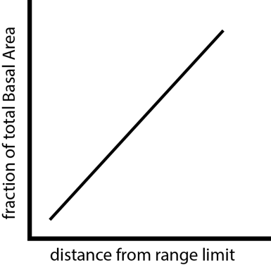Fraction Basal Area vs. Position in Range (Climatic and latitudinal)

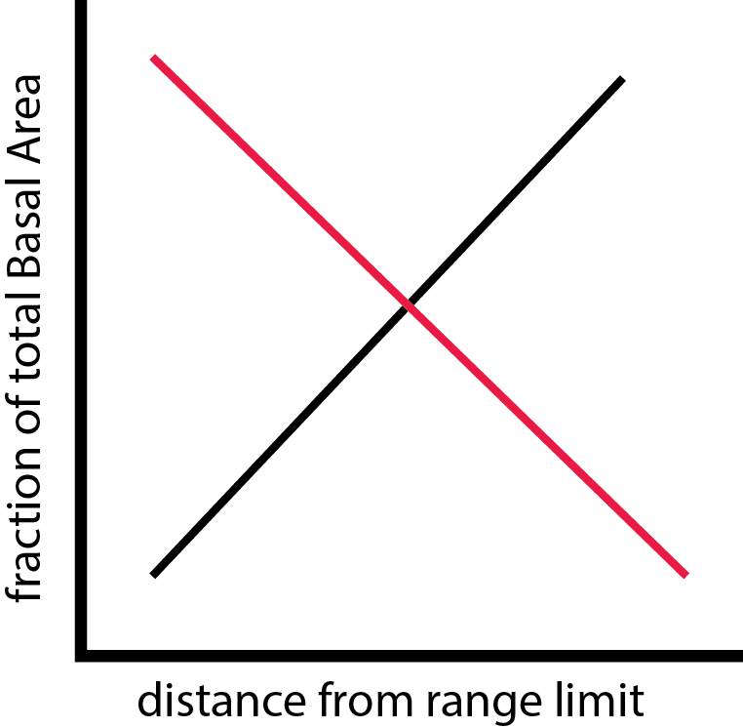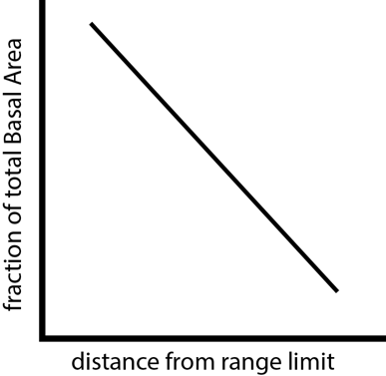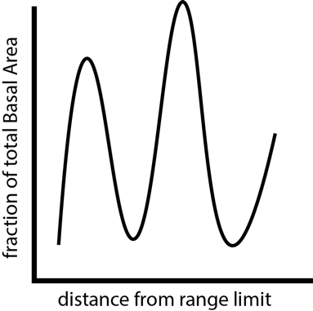

* + 1. Map of climatic ranges
    2. Map of latitudinal ranges
    3. All-Species dominance in plot vs. other species in plot (I remember discussing this over the summer—is there any reason to tie this in?)
  1. H2 figures: Trees at their range extremes exhibit altered suites of functional traits from trees in the range interior (Weiher et. al 1998)
     1. 3D Model of Suite of Traits across range: 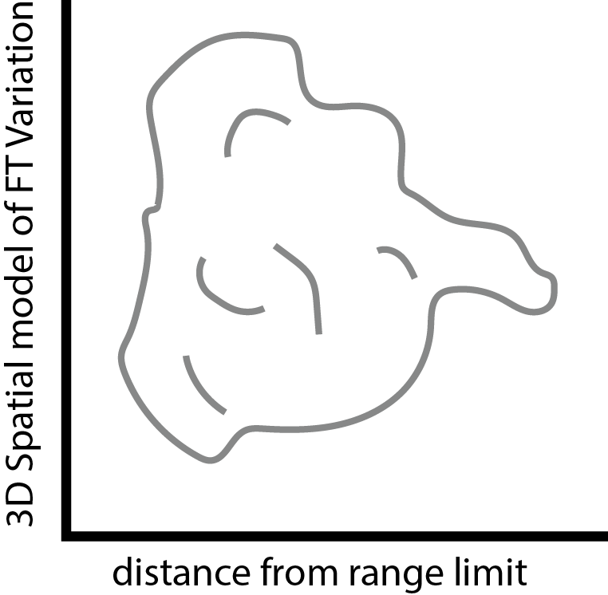
     2. Explanation of any variation, if not across the range then in small pockets w/in range (indicating local factors matter more in the form of competition or some other factor not examined in this experiment):
        1. Fraction Basal Area vs. Functional Trait Means or Variation

*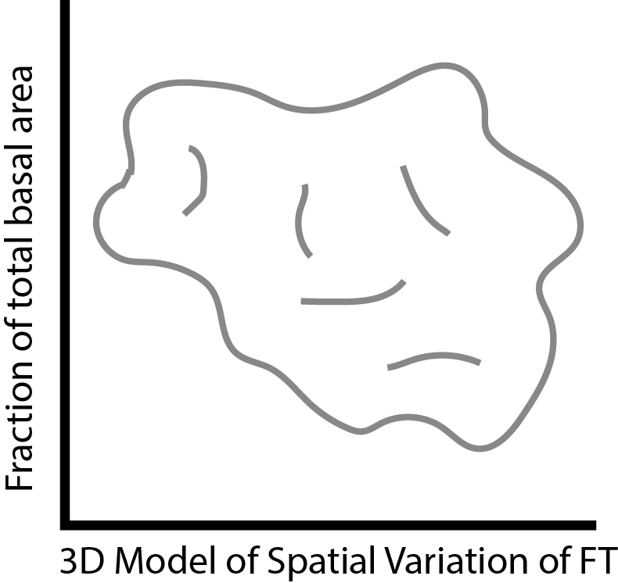Working Bibliography*:

Ackerly, David D. "Community Assembly, Niche Conservatism, and Adaptive Evolution in Changing Environments." International journal of plant sciences 164 (2003): S165-84. Print.

Chen, I-C, et al. "Rapid Range Shifts of Species Associated with High Levels of Climate Warming.(REPORTS)(Author Abstract)." Science 333.6045 (2011): 1024. Print.

Louthan, Am, Df Doak, and A. L. Angert. Where and when do Species Interactions Set Range Limits?. 30 Vol. , 2015. Print.

Parmesan, Camille. "Ecological and Evolutionary Responses to Recent Climate Change." Annual Review of Ecology, Evolution, and Systematics 37 (2006): 637. Print.

Pearson, Richard G., and Terence P. Dawson. "Predicting the Impacts of Climate Change on the Distribution of Species: Are Bioclimate Envelope Models Useful?" Global Ecology and Biogeography 12.5 (2003): 361-71. Print.

Pigot, Alex L., and Joseph A. Tobias. "Species Interactions Constrain Geographic Range Expansion Over Evolutionary Time." Ecology Letters 16.3 (2013): 330-8. Print.

Sexton, Jason, et al. "Evolution and Ecology of Species Range Limits." Annual Review of Ecology, Evolution, and Systematics 40 (2009): 415. Print.

Urban, Mark C., Josh J. Tewksbury, and Kimberly S. Sheldon. "On a Collision Course: Competition and Dispersal Differences Create no- Analogue Communities and Cause Extinctions during Climate Change." Proceedings of the Royal Society B 279.1735 (2012): 2072-80. Print.