**人工智能LAB1实验报告**

1. **实验目标**

实现BFS，A*算法，完成吃豆人寻找食物的静态搜索。实现minimax算法和alpha-beta剪枝，完成吃豆人与对手的动态博弈并减少搜索空间。

1. **实验环境和工具**

实验环境：Ubuntu 16.04 Python3.6.5

实验工具：PyCharm

1. **实验内容和过程**
2. BFS

考虑到BFS即广度优先搜索，区别于DFS深度优先搜索，BFS需要维护一个存储形式，使得状态先于子状态被遍历，容易想到是一个队列，故只需要把DFS的栈Stack改为队列Queue即可。代码如下：

def myBreadthFirstSearch(problem):  
 visited = {}  
 frontier = util.Queue()  
 frontier.push((problem.getStartState(), None))  
  
 while not frontier.isEmpty():  
 state, prev_state = frontier.pop()  
  
 if problem.isGoalState(state):  
 solution = [state]  
 while prev_state != None:  
 solution.append(prev_state)  
 prev_state = visited[prev_state]  
 return solution[::-1]  
  
 if state not in visited:  
 visited[state] = prev_state  
  
 for next_state, step_cost in problem.getChildren(state):  
 frontier.push((next_state, state))  
  
 return []

测试结果如下：

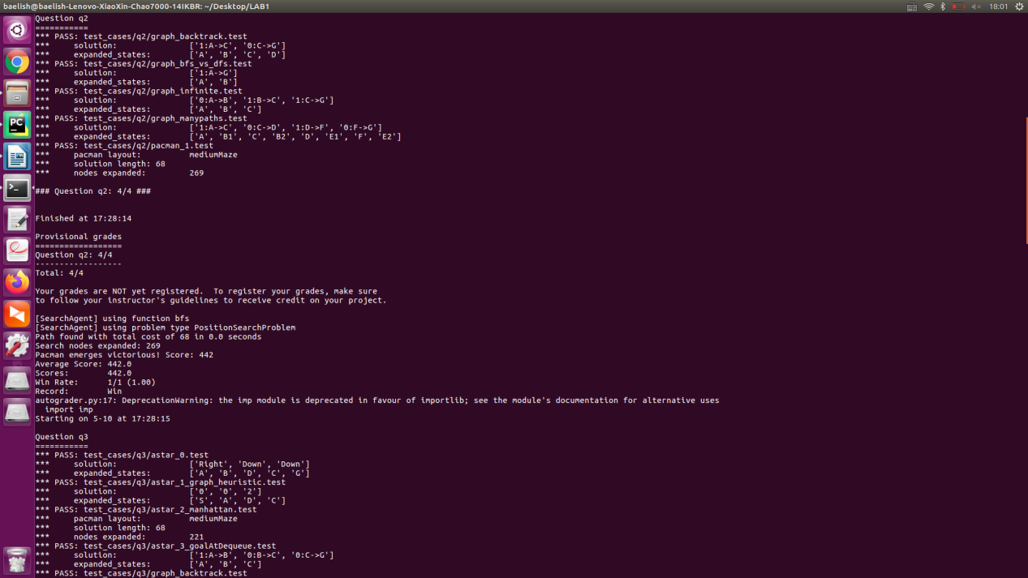

1. A*

A*算法需要依照最小的启发值选择搜索子状态，是一种高级的广度优先搜索，容易想到用优先队列存储状态空间，按照启发值选择搜索状态。代码如下：（其中f_state是开始状态到当前状态的实际值）

def myAStarSearch(problem, heuristic):  
 visited = {}  
 frontier = util.PriorityQueue()  
 frontier.push((problem.getStartState(), None, 0), heuristic(problem.getStartState()))  
  
 while not frontier.isEmpty():  
 state, prev_state, f_state = frontier.pop()  
  
 if problem.isGoalState(state):  
 solution = [state]  
 while prev_state != None:  
 solution.append(prev_state)  
 prev_state = visited[prev_state]  
 return solution[::-1]  
  
 if state not in visited:  
 visited[state] = prev_state  
  
 for next_state, step_cost in problem.getChildren(state):  
 frontier.push((next_state, state, f_state+step_cost), f_state+step_cost+heuristic(next_state))  
  
 return []

测试结果如下：

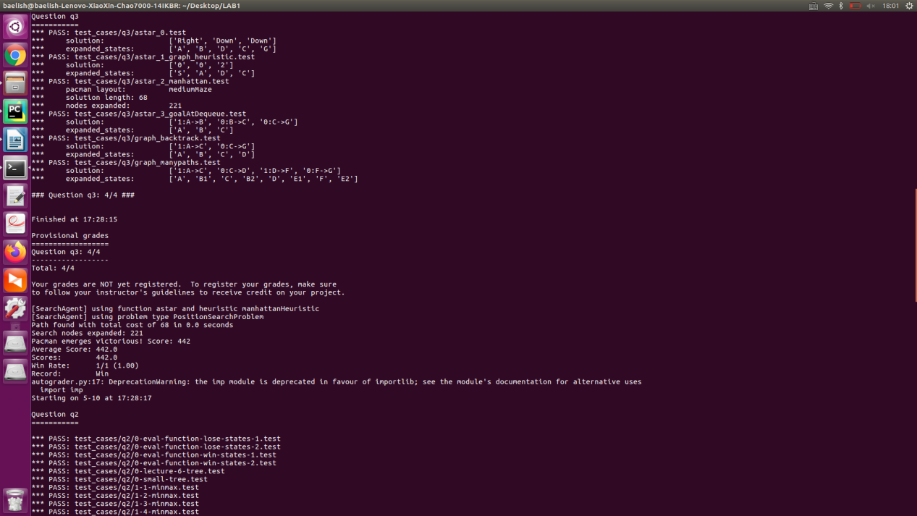

1. Minimax

考虑预估步数为depth，写一个递归函数minimax(state,depth)，每次从对手转移执行权到吃豆人时，把depth-1送入下次递归，如果是吃豆人执行操作，就求相对于吃豆人的状态最大值，反之求相对于吃豆人的状态最小值，把对应状态作为本次操作的子状态。代码如下：

def minimax(self, state, depth):  
 if state.isTerminated() or depth == 0:  
 return None, state.evaluateScore()   
  
 best_state, best_score = None, -float('inf') if state.isMe() else float('inf')  
  
 for child in state.getChildren():  
  
 if child.isMe():  
 _, score = self.minimax(child, depth - 1)  
 else:  
 _, score = self.minimax(child, depth)  
  
 if state.isMe() and score > best_score:  
 best_score = score  
 best_state = child  
 elif not state.isMe() and score < best_score:  
 best_score = score  
 best_state = child  
   
 return best_state, best_score

测试结果如下：

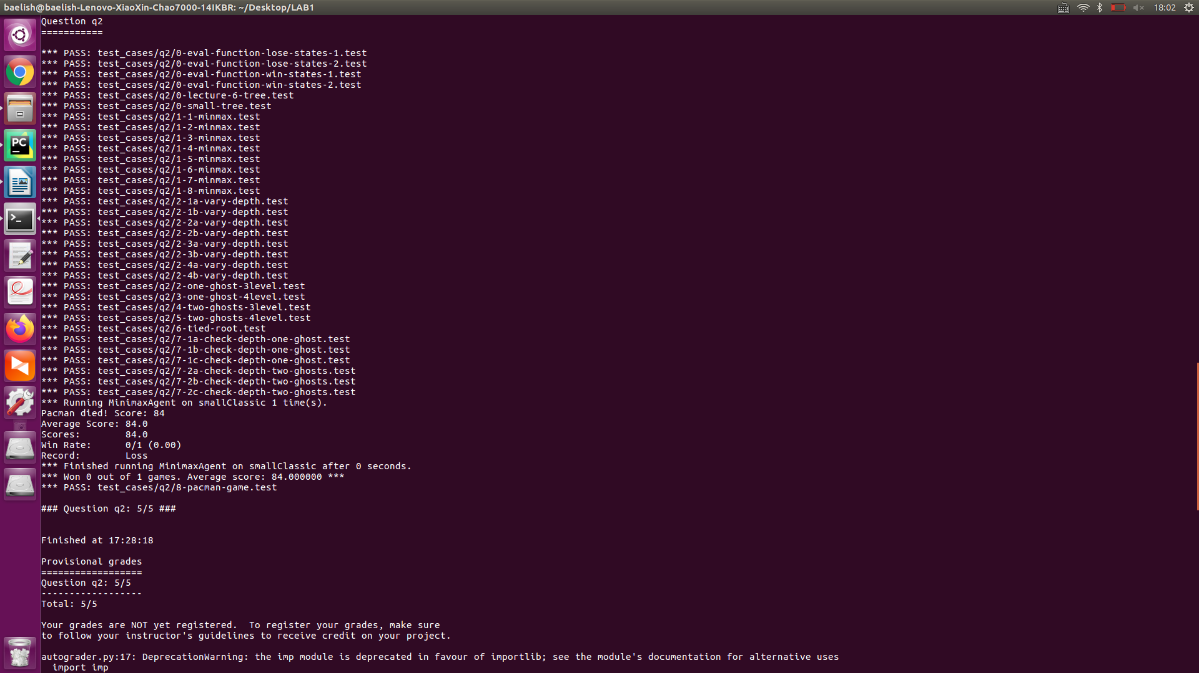

1. minimax的alpha-beta剪枝

在minimax算法上做剪枝，记录对手执行不同操作时的最大状态值alpha，如果在某次轮到吃豆人执行造作时，不管执行何种操作，获得状态值永远小于alpha，那么这个状态下的搜索子空间的状态值不可能比alpha大，对最终结果没有影响，故可以剪枝。beta同理，代码如下：

def alphabeta(self, state, depth, alpha, beta):  
 if state.isTerminated() or depth == 0:  
 return None, state.evaluateScore()  
  
 best_state, best_score = None, -float('inf') if state.isMe() else float('inf')  
  
 for child in state.getChildren():  
  
 if child.isMe():  
 _, score = self.alphabeta(child, depth - 1, alpha, beta)  
 else:  
 _, score = self.alphabeta(child, depth, alpha, beta)  
  
 if state.isMe():  
 if score > beta:  
 return child, score  
 if score > alpha:  
 alpha = score  
 if score > best_score:  
 best_score = score  
 best_state = child  
 else:  
 if score < alpha:  
 return child, score  
 if score < beta:  
 beta = score  
 if score < best_score:  
 best_score = score  
 best_state = child  
  
 return best_state, best_score  
  
def getNextState(self, state):  
 best_state, _ = self.alphabeta(state, self.depth, -float('inf'), float('inf'))  
 return best_state

测试结果如下：

