JavaScript Documentation and Validations

Case 1:

The DOB has invalid prompt formatting.

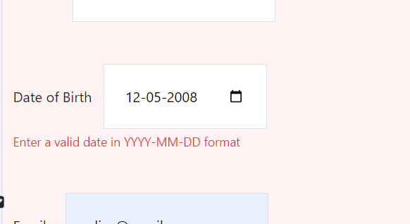

Changed the prompt message in JS file. Also the condition for DOB in YYYY-MM-DD is applied.

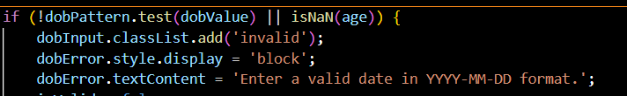

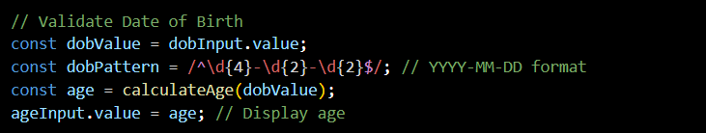

Case 2:

Password section was not accepting characters nor numeric values or atleast it wasn’t validating. The same followed in the “Confirm Password” section as a mismatch section. The prompt messages in JS file wasn’t validating right either.

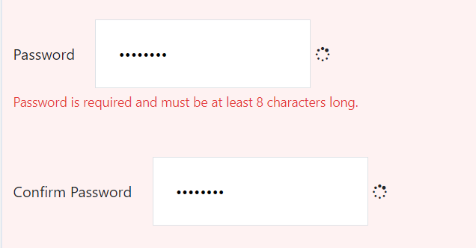

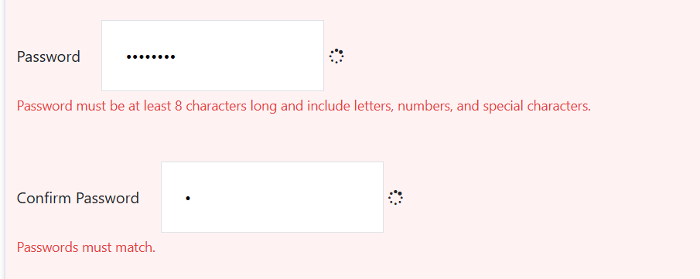

Made the password criteria more specific to include 8 characters, with 1 number and 1 special character.

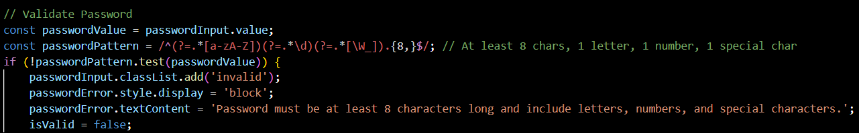

Case3:

Added an extra component to validate password “confirm password field”.

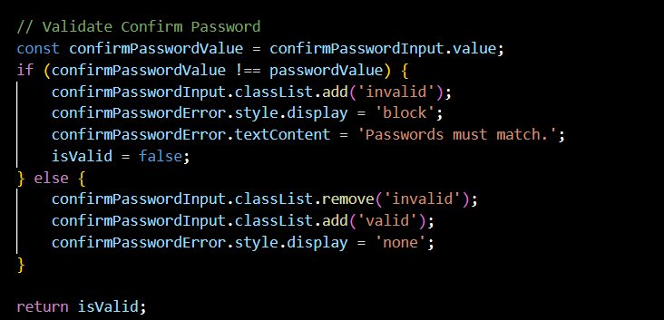

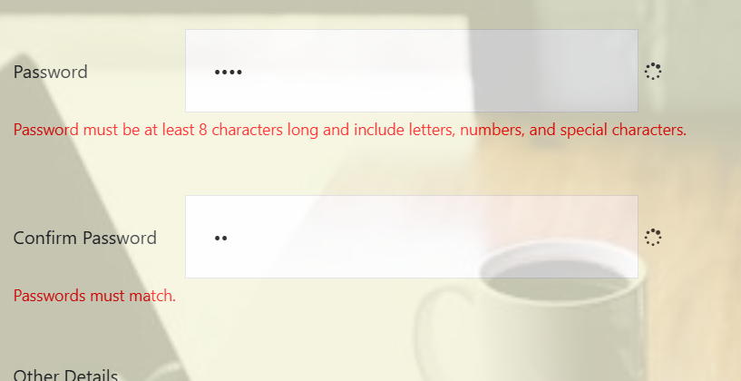

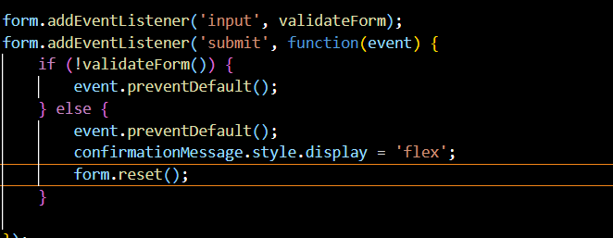

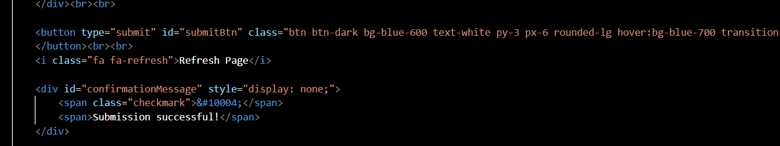

Case 4:

The Submit Button

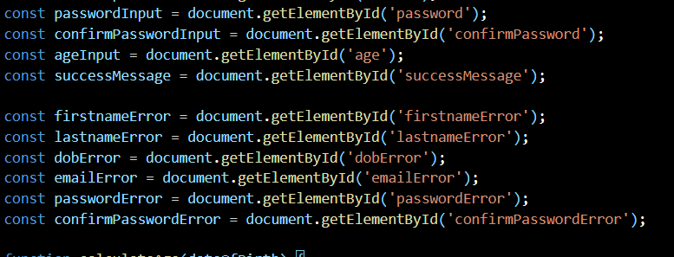

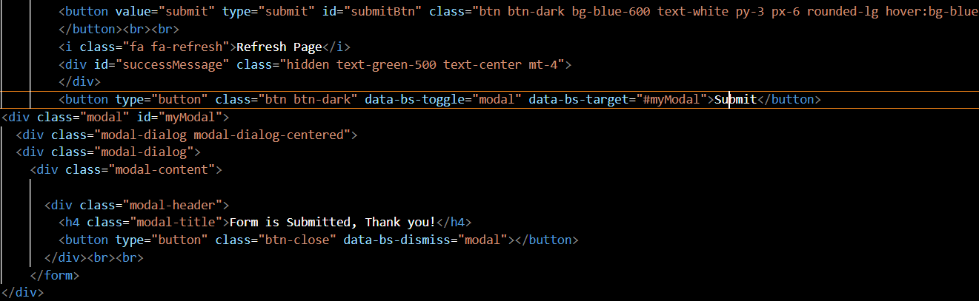

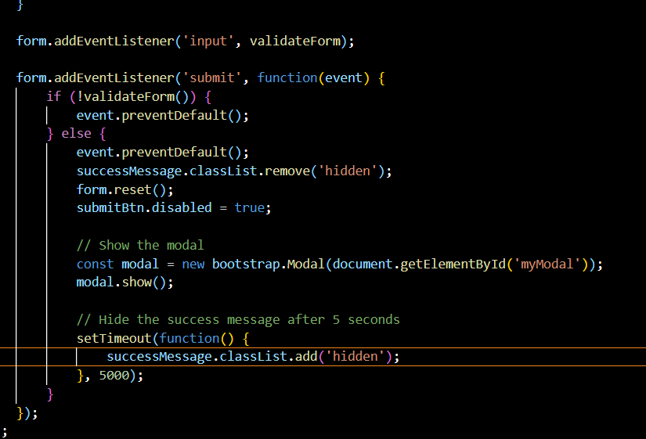

Added submit button so it display a prompt for confirming submission. Added a timer of 5s so the prompt will be closed after that in .JS file.

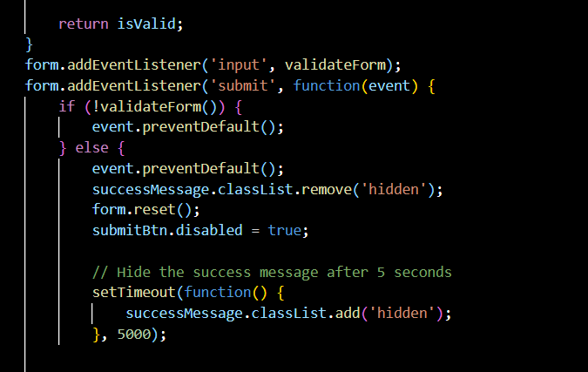

Case 5:

Age Calculator

For the age, as per the given condition, that the user must be evaluated before itself if he/she is above 18+ or not.

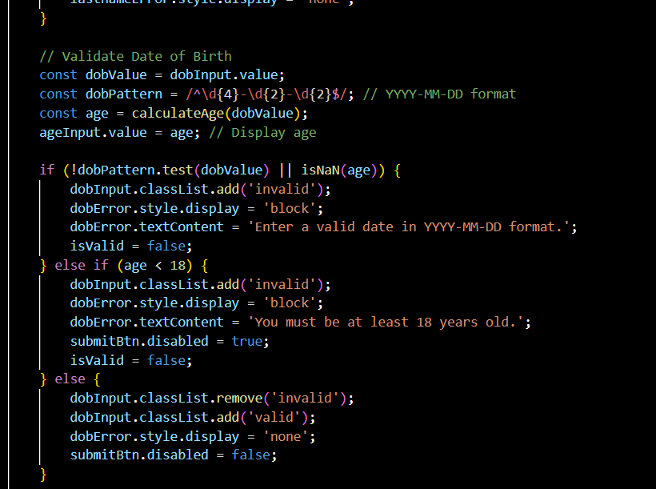

The above condition will check for

1. The DOB can be selected
2. According to the DOB the age is calculated and filled in the age bar.
3. It prompts the user, if the age selected is less than 18.

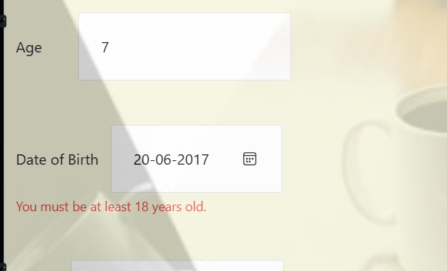

Other parameters and validations for the form registration page to look interactive:

1. Used fontAwesomes icon for understandings.
2. Used parallax scroll for the background.
3. Used self-learning component ‘Tailwind’ for styling form along with Bootstrap.

Case6:

Reset button

Add a reset button so it erases all the contents of the form if clicked.

