­­Computer Science A level Blog

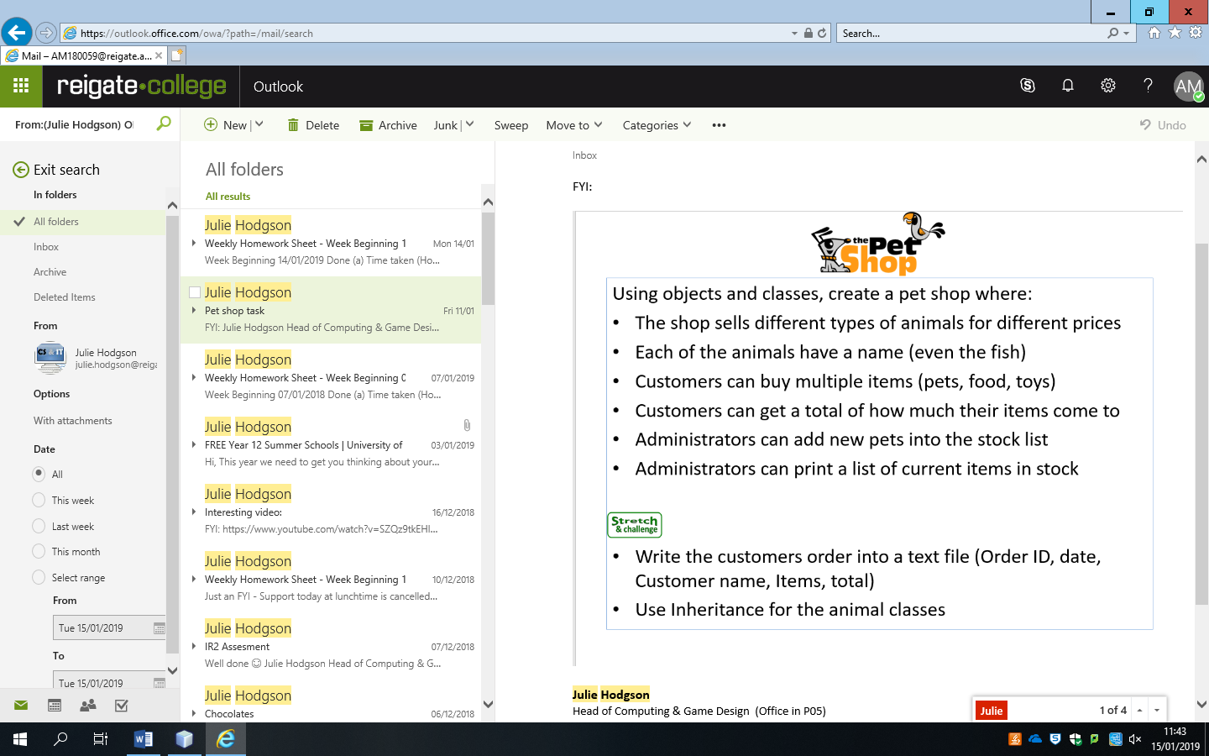Pet shop task

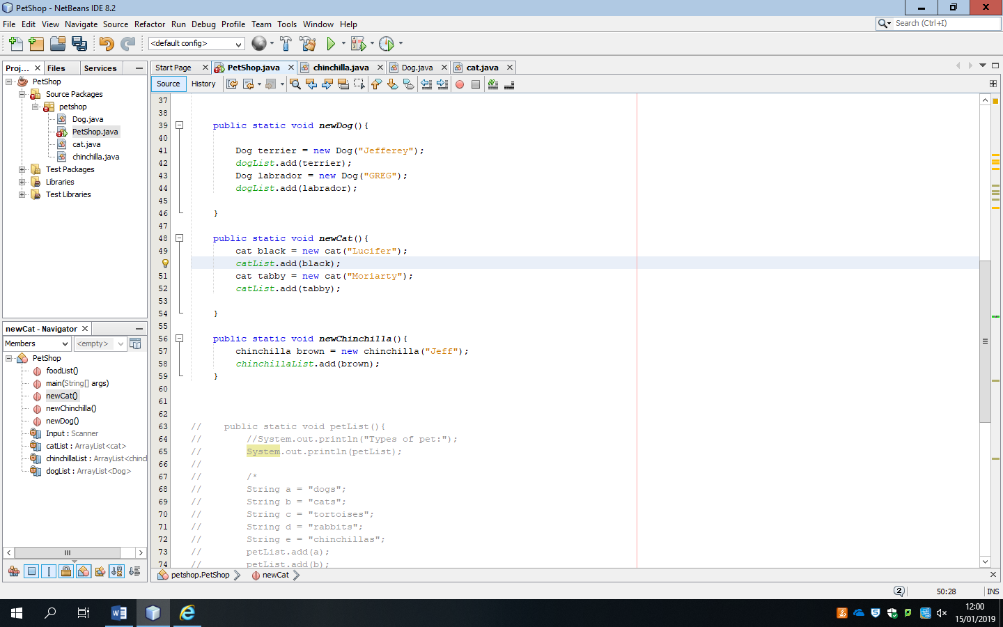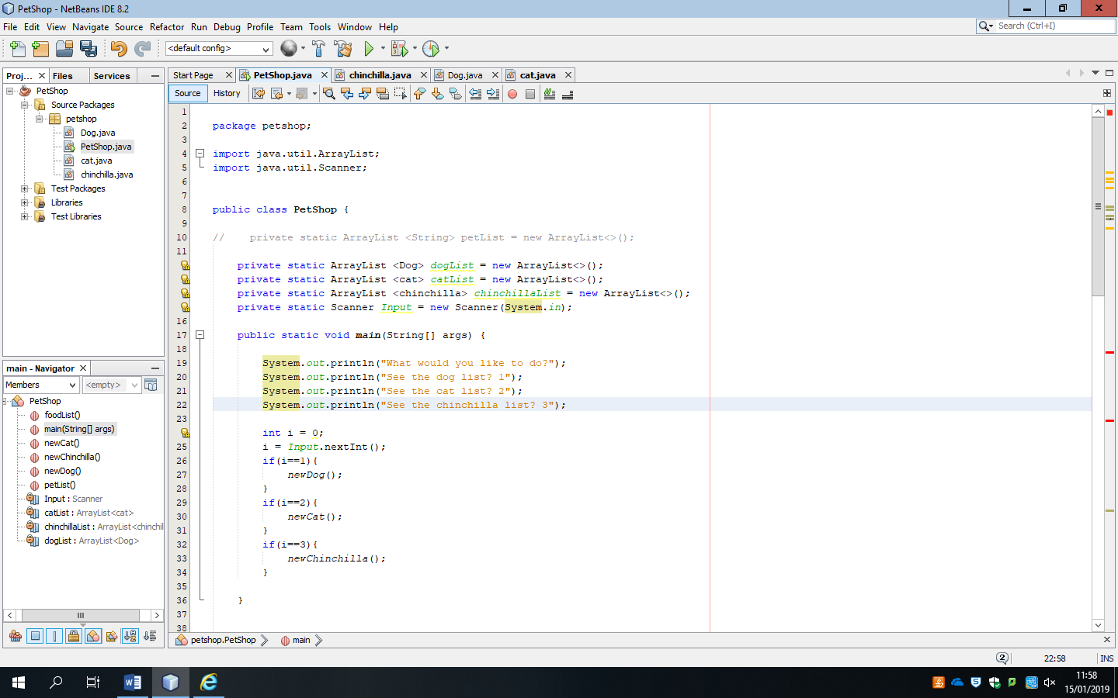First glance at this code I have tried to make a menu selection. Although the code isn’t fully functioning yet I thought I would use this as my start base on this particular piece of code. I think the menu selection is rather efficient as the user has an option of what pet they want to select instead of having to go through all of the pet options.

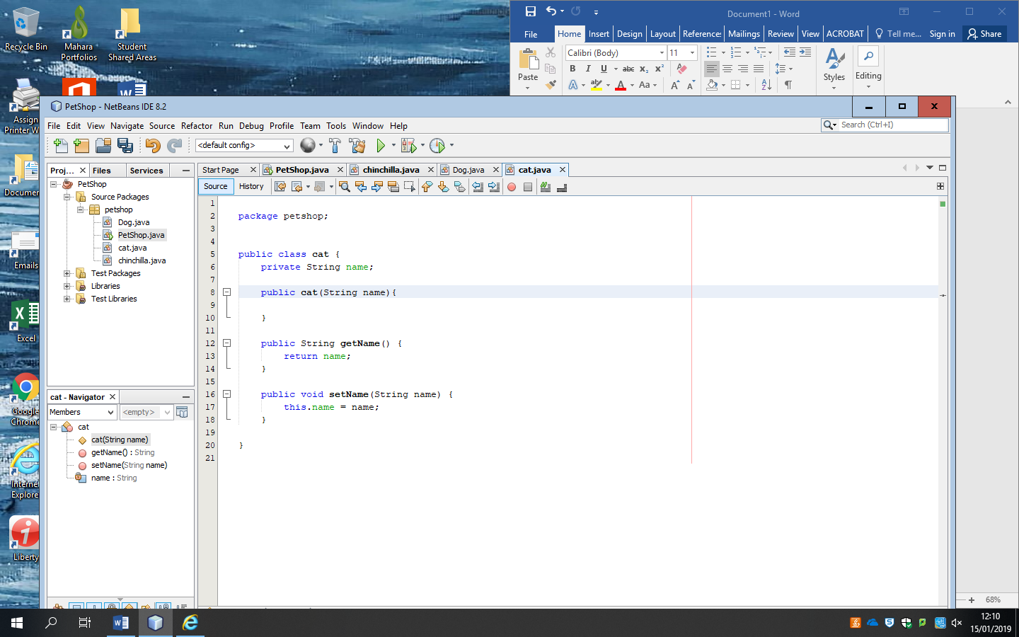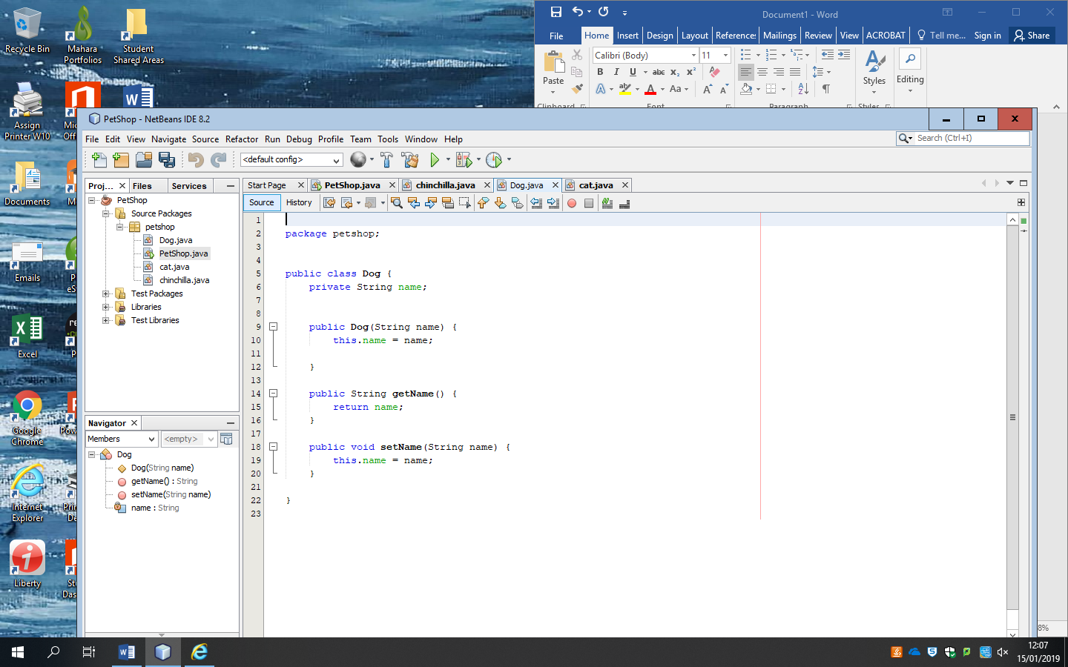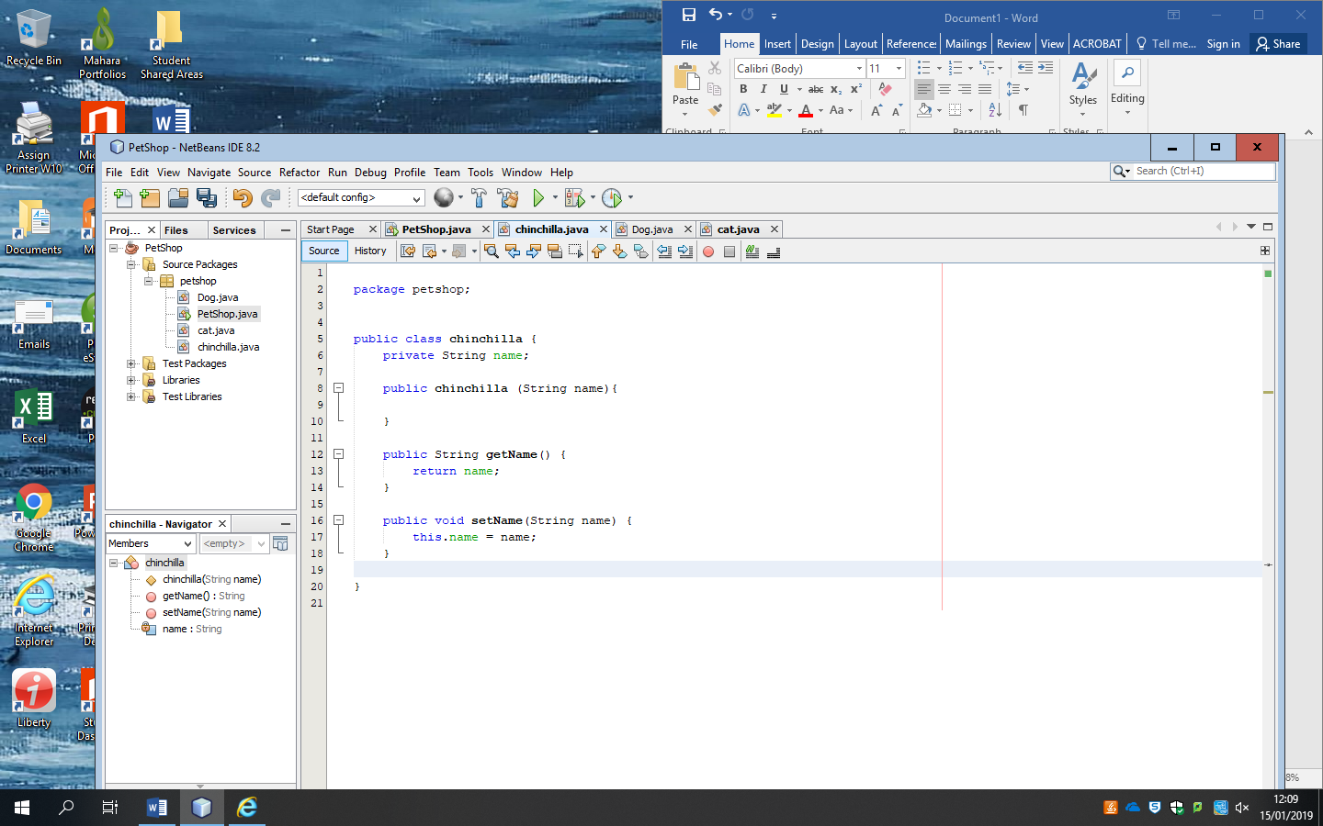I’ve also created different classes for each pet that I want to use for this program which I can edit individually without having to change the main method of the code. So far I have 3 pets to choose from: dogs, cats and chinchillas. A rather random selection so far; there should be a greater selection upon developing.

h