Dear friend:
I need a file exchange program, not only exchange the file i attached, but suit for all A4 shipment files to exchange

- original format is A4 size and 24-up labels ,70*36 mm
- need to change to bar code label paper: 70mm* 40mm
- in the blank, need add a letter "made in china"
4. the bar code must be the same as the original,because the label need to check with amazon FBA service more file need to sent to you when star the gig

- the A4 size original format :
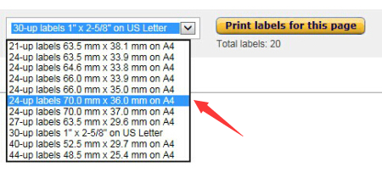
Down load from amazon:
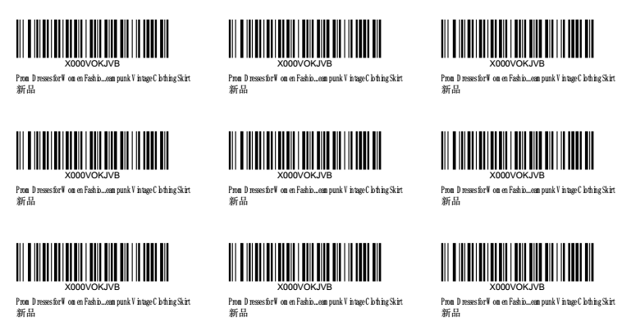

Change to 70mm* 40mm for each bar code:
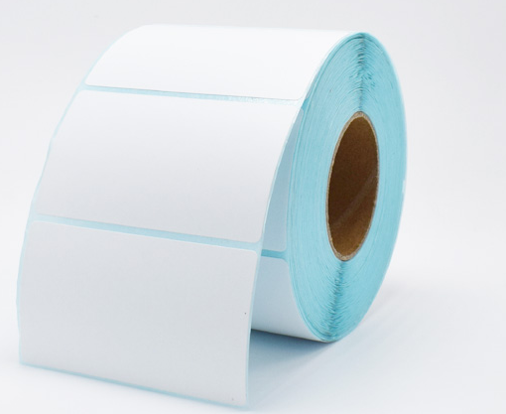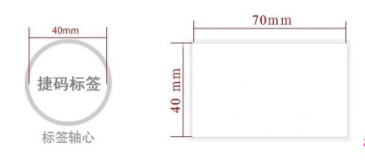
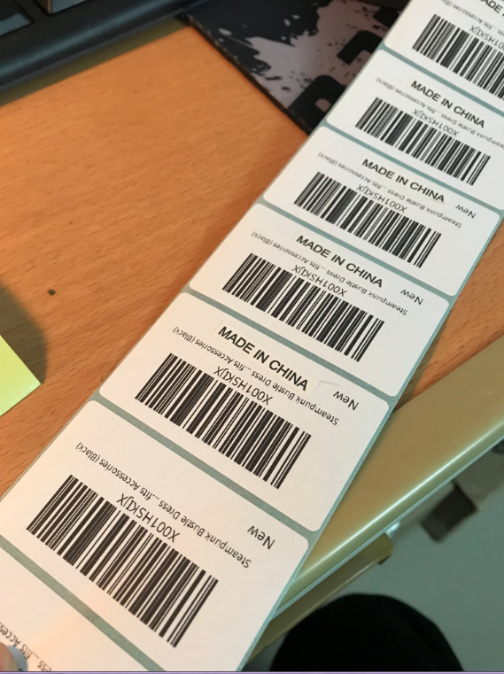

- in the blank, need add a letter "made in china"(the Tagged effect)

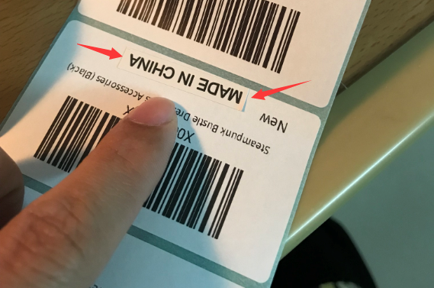

I think “make in china” latter should add first to A4 file then change the size format
