Homework2

SWOT Matrix

Strengths: The website of NY Department of Health has the newest official information for every health issue or health program, and has informative of the benefit from the health program.

Weaknesses: The website of NY Department of Health has many lists of health issue, but doesn’t categorize each health issue well thus people have to take more time to search the health issue. The organization of NY Department of Health website is confusing, although the website has lots of information, the organization of the website will mislead people to find what they are looking for.

Opportunities: The website of NY Department of Health provides lots of health issues, also provides the phone numbers and the address of each program and department, moreover, people can actually contact the health department by checking out this website.

Threats: The website of NY Department of Health doesn’t have other related information and doesn’t have the information for living healthy or improvement. Other websites provides the information that can improve your health problem and also introduces how to prevent the health issue from happening.

Client brief that explains the project

Improving the layout will attract more traffic to the website of NY Department of Health; also well-organized category can easily lead people to search what they need. Therefore, I will improve and reorganize the layout in this project, so the new layout can correctly and easily lead people to the direction of their desire. Before redesigning the layout of the website of NY Department of Health, I have analyzed the SWOT of this website and found out the weaknesses and threats. Confusing layout and unorganized categories are the weaknesses of the website of NY Department of Health. The website of NY Department of Health doesn’t have other related information of health issues, and doesn’t introduce other better methods to prevent the health issues from happening are the threats of the website of NY Department of Health.

Preliminary plan that addresses the issues raised in the SWOT

According to the SWOT matrix, the weakness indicates the problem of the unorganized layout and too many lists aren’t categorized, so reorganizing the layout and categorizing the lists will solve the confusion and faster the speed of researching. The layout will have a clear main navigation on the top, and second navigation on the left. The images will move to the bottom, and the news feed will place on center. Finally the advertisement will place on the center right. The clear layout can help leading people to identify the area that they can to explore more. After redesigning the layout, I will categorize the lists that are provided in the website, so it will be easier for people to search the right direction to solve their questions or problems. For the threats, I will add more related information of major health issues, and add other information that improve health issues or the other methods that can live healthy. Also, add more images will help explaining the article before reading the entire content.

2 sets of mockups for the site

Main page new layout

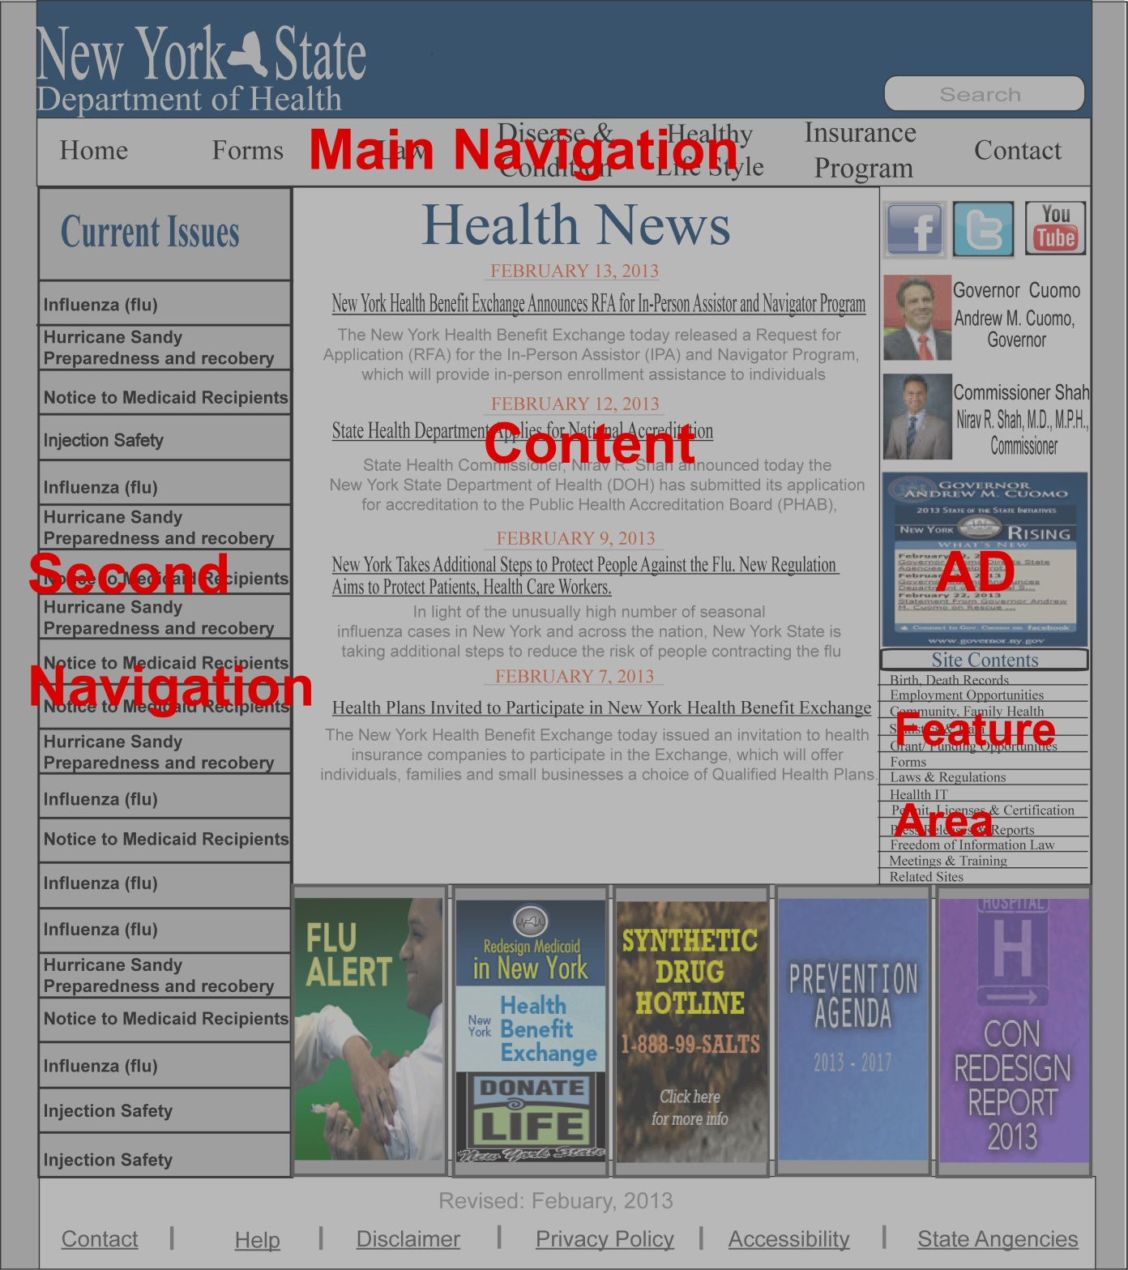

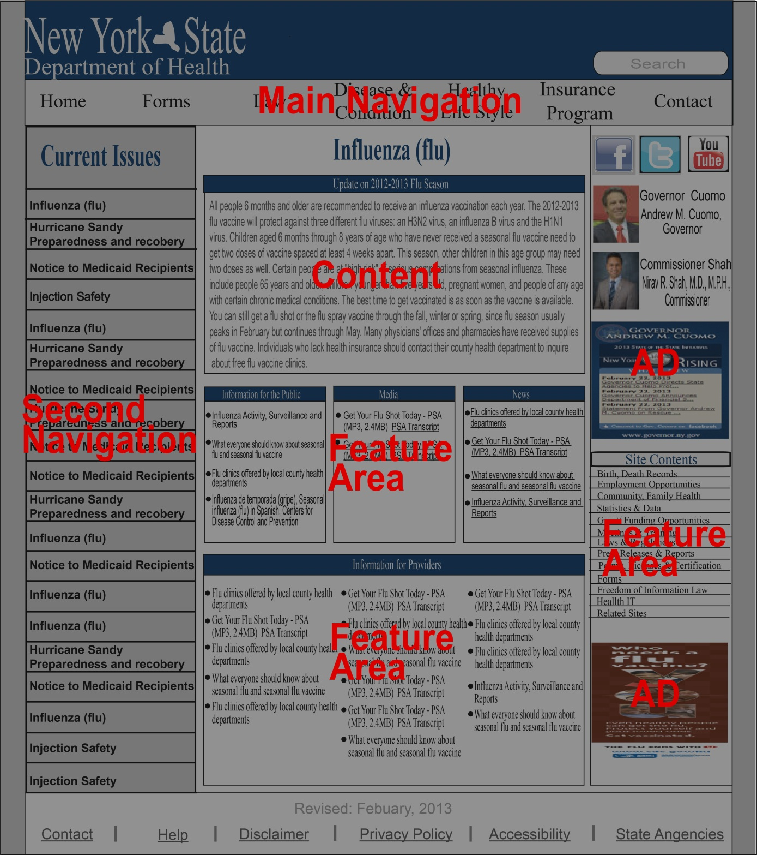Inside page new layout