Watermarking Turkish LLM Output: Calibration Failure, Scheme Fragility, and the Laundering Attack
Corresponding author: Ali Çetinkaya — Department of Computer Engineering, Faculty of Technology, Selçuk University, Alaeddin Keykubat Campus, 42075 Selçuklu, Konya, Türkiye. E-mail: ali.cetinkaya@selcuk.edu.tr · Tel: +90 332 241 11 02 · ORCID: 0000-0002-7747-6854
Keywords: LLM watermarking; Turkish; agglutinative morphology; detector calibration; false-positive rate; paraphrase attack; laundering

Abstract
Statistical watermarks for large language model (LLM) output are designed and evaluated predominantly on English. We measure how three schemes — the green-list watermark KGW, the Gumbel-sampling watermark EXP, and SynthID — behave on Turkish, an agglutinative language, using the MarkLLM toolkit with Qwen3-14B as generator (24 prompts × 4 seeds × 4 arms; 384 texts) and ten removal attacks. Two pre-registered studies complete the design: a false-positive study on 1,500 Turkish and 1,500 English Wikipedia excerpts, and a two-judge meaning-preservation study. We report three findings. First, calibration fails: on human Turkish the KGW detection statistic has null standard deviation 1.479 (theoretical value 1; English 1.321; Levene p = 0.00039), so the default z = 4 threshold yields an empirical false-positive rate of 0.002, approximately 63 times the nominal 3.17 × 10⁻⁵; the inflation replicates on a second, pre-registered Turkish register (1,000 Wikisource windows; standard deviation 1.420), and, in an exploratory analysis, thresholds calibrated on model-generated negatives do not transfer to human text (up to 7.4% FPR). Second, robustness trades off against calibration: SynthID has the cleanest null distribution (standard deviation 0.003) but is the most fragile scheme under attack (AUROC 0.816 under round-trip translation and 0.747 under laundering; significantly more fragile in 4 of 6 Holm-corrected paired tests). Third, laundering — rewriting watermarked text through an external LLM — is the only attack that meets the pre-declared success criterion (AUROC drop > 0.05 with meaning preserved by both judges) against all three schemes (post-attack AUROC 0.917, 0.863, 0.747). A planned morphology-based attack did not fire; we report this negative result with its coverage measurements. Deployed thresholds should be calibrated per language and per deployment distribution.

1 Introduction
Statistical watermarking embeds a detectable but, ideally, quality-neutral signal into the sampling process of a large language model, so that a detector holding the key can later test whether a given text was produced by the watermarked model. The main scheme families are logit-biasing green-list watermarks [KGW], distortion-free Gumbel-sampling watermarks [EXP-A, EXP-K], and tournament-sampling SynthID, which has been deployed at scale [SYNTHID]. In all three, detection is a hypothesis test: the detector computes a statistic whose distribution on unwatermarked text is assumed known, and a threshold — for KGW, a z-score threshold — is chosen for the false-positive rate that this null implies. The practical value of a watermark rests on that calibration. If the null distribution on real, unwatermarked text is wider than assumed, the advertised false-positive rate is wrong, and every downstream decision that consumes the detector's verdict — academic-misconduct cases, provenance labeling, content-policy enforcement — inherits the error.
These schemes were developed and are evaluated mostly on English [XLING, XLING-ROB]. Turkish differs from English in a way that plausibly reaches into watermark internals: it is agglutinative, expressing through chains of suffixes what English expresses through separate function words. Under a subword tokenizer these suffixes surface as a small set of high-frequency subtokens; on our corpus the generator's tokenizer produces 2.552 tokens per word. For a green-list scheme whose pseudo-random vocabulary partition is keyed on a context window of a single preceding token (prefix_length = 1, the MarkLLM default configuration we test), recurring suffix subtokens mean that successive green-list decisions revisit the same partitions rather than behaving independently. We put this forward as a proposed mechanism for the calibration results below; we explicitly do not claim to have established it causally.
This paper reports a pilot-scale but tightly instrumented measurement of the three schemes on Turkish. Using MarkLLM [MARKLLM] at a fixed commit (c45ddc40) with Qwen3-14B [QWEN3] as generator, we build a corpus of 24 Turkish prompts × 4 seeds × {no watermark, KGW, EXP, SynthID} = 384 texts and subject it to ten removal attacks: diacritic stripping at two intensities, two morphological-transform variants built on the zeyrek analyzer [ZEYREK] together with their diacritic combinations, round-trip translation through English with NLLB [NLLB], self-paraphrase and self-laundering by the generator itself, and laundering through an external, stronger, closed-weight LLM (Claude Opus 5). Two studies were pre-registered before their data were collected: S1 measures false-positive rates on 1,500 Turkish and 1,500 English human-written Wikipedia excerpts [WIKIDUMP] (commit 8f8df72), and S2 measures whether attacks preserve meaning, using two LLM judges from different model families, blind calibration pairs, and a decision rule declared before the run (commit cbcb988); corpus acceptance thresholds were fixed before Phase 1. The measurement protocol takes the corpus's dependence structure seriously: because EXP is deterministic given prompt and key, its four seeds are not independent replicates, so all confidence intervals are prompt-clustered bootstrap intervals (effective n = 24 prompts); degenerate AUROC = 1.000 cells carry a one-sided Clopper–Pearson lower bound (0.883); and we report the full realized false-positive table rather than assuming that a threshold calibrated on clean negatives keeps its nominal rate under attack.
The headline finding is a calibration failure. On human Turkish, the KGW null standard deviation is 1.479, against a theoretical value of 1 and 1.321 on matched English (Levene p = 0.00039); at the shipped z = 4 threshold, 3 of 1,500 Turkish excerpts cross the line — an empirical false-positive rate of 0.002, approximately 63× the nominal 3.17 × 10⁻⁵. All three pre-registered hypotheses of S1 are confirmed. An exploratory analysis further indicates that thresholds calibrated on model-generated negatives do not transfer to human text: EXP's model-calibrated 1% threshold yields a 7.4% false-positive rate on human Turkish. The second finding is a robustness–calibration trade-off: SynthID has the cleanest human-text null (standard deviation 0.003) yet is the most fragile scheme under attack, with AUROC 0.816 under round-trip translation and 0.747 under external laundering, and is significantly more fragile than KGW or EXP in 4 of 6 Holm-corrected paired comparisons. The third finding is the laundering attack: rewriting watermarked text through an external stronger model is the only attack that satisfies the pre-declared success rule (ΔAUROC > 0.05 with meaning preserved by both judges) for all three schemes, dropping AUROC to 0.917 (KGW), 0.863 (EXP), and 0.747 (SynthID), and the true-positive rate at the clean-calibrated threshold to 0.427, 0.490, and 0.250. Averaged over schemes, laundering removes 0.158 AUROC versus 0.091 for round-trip translation, at a measured API cost of USD 17.704 for the attack corpus.
We also report a negative result plainly, because the study was originally motivated by the conjecture that Turkish morphology itself would furnish a meaning-preserving removal attack. It does not, on this corpus. The v0 morphological transform averages 1.1 edits per text and leaves 60.4% of texts untouched, with a mean AUROC change of 0.000; the more aggressive v1 variant reaches 7.5 edits per text, but its apparent per-edit effect on the detection statistic is retracted after robustness testing (the bootstrap confidence interval includes zero, the Spearman correlation is non-significant, and the sign flips when the three highest-leverage points are removed). The v0 per-edit slope (+0.052 z per edit) survives the same tests but is practically negligible against a clean-text baseline z of 11.467. The proximate cause is coverage: the formal register that Qwen3-14B produces rarely contains the -Iyor progressive forms the transforms target. Whether informal-register Turkish is more vulnerable is an open question, not a finding of this paper.
The remainder of the paper is organized as follows. Section 2 reviews related work. Section 3 describes corpus construction — including the transparent prompt-length calibration — the attack suite, and the measurement protocol. Section 4 presents results: clean-text detection, the attack ordering, the S1 calibration study, and the S2 utility study. Section 5 discusses practical consequences and the threat model. Section 6 lists limitations in full, including the single generator model and single GPU environment, and Section 7 states the reproducibility provisions. In sum, this paper makes the following contributions:
1. Calibration failure on Turkish human text (pre-registered; commit 8f8df72). The KGW detector's null distribution on human Turkish has standard deviation 1.479 (theoretical 1; matched English 1.321; Levene p = 0.00039), and the default z = 4 threshold produces an empirical false-positive rate of 0.002 (3/1,500), approximately 63× nominal. An exploratory follow-up shows that thresholds calibrated on model-generated negatives reach up to 7.4% FPR on human text. Default thresholds are not portable across languages or negative distributions. 2. A robustness–calibration trade-off across schemes. SynthID shows the cleanest human-text null (standard deviation 0.003) but the largest attack losses (AUROC 0.816 under round-trip translation, 0.747 under laundering), and is significantly more fragile in 4 of 6 Holm-corrected paired comparisons (test family specified before the per-scheme results were inspected); no significant fragility difference between KGW and EXP is found. 3. The laundering attack (utility axis pre-registered; commit cbcb988). Rewriting through an external LLM is the only attack among ten that satisfies the pre-declared success rule for all three schemes while preserving meaning under both judges (meaning preserved in 1.00 of judged pairs in every condition): AUROC falls to 0.917/0.863/0.747 and TPR at the clean-calibrated threshold to 0.427/0.490/0.250 for KGW/EXP/SynthID, at a measured attack cost of USD 17.704. 4. A documented negative result and a disciplined measurement protocol. The planned Turkish morphological attack does not fire on formal-register model output (1.1 edits per text on average; 60.4% of texts unchanged; ΔAUROC 0.000), and the morph_v1 per-edit slope is retracted after robustness testing. Every reported number regenerates from data via code; confidence intervals are prompt-clustered; degenerate cells carry Clopper–Pearson bounds; and exploratory observations are labeled as exploratory throughout.

2 Related Work
Three families of decoding-time watermarks dominate current practice. The green-list scheme of Kirchenbauer et al. [KGW] pseudorandomly partitions the vocabulary at each step using a hash of the preceding context and adds a bias delta to the logits of "green" tokens; detection is a one-proportion z-test whose null model treats successive green/red outcomes as independent Bernoulli trials with parameter gamma. The exponential-minimum (Gumbel-trick) approach proposed by Aaronson [EXP-A] couples token selection to a pseudorandom sequence keyed on the context, leaving the sampling distribution unchanged in expectation; Kuditipudi et al. [EXP-K] develop distortion-free variants of this idea with robustness guarantees for the detector. SynthID [SYNTHID] modifies sampling through a tournament procedure and has been deployed at production scale. All three report detection behavior primarily on English text, and the calibration of their detection thresholds — the mapping from a score threshold to a false-positive rate on unwatermarked text — inherits distributional assumptions that were validated, where they were validated at all, on English.
We build on the MarkLLM toolkit [MARKLLM], which provides reference implementations of the three schemes and their detectors under a common interface; all experiments pin MarkLLM commit c45ddc40 so that scheme behavior is reproducible at the code level.
A separate line of work studies robustness of watermarks to post-hoc text transformations, in particular paraphrasing and translation [DIPPER, SADASIVAN, XLING]. Our laundering attack belongs to this family: it routes watermarked text through a rewriting model. We distinguish self-laundering (the generator rewrites its own output) from laundering through an external model, and we evaluate both under a pre-registered decision rule that requires meaning preservation, not only detection loss.
Work on watermarking in languages other than English is sparse [XLING, XLING-ROB]. Turkish is a stress case for the assumptions above: it is agglutinative, with long suffix chains governed by vowel harmony, so subword tokenizers emit repeated suffix tokens whose distribution differs from English [TOKENIZER]. Repeated suffix subtokens provide a candidate mechanism for interaction with context-hash schemes such as KGW when the hashing window is short. Morphological analysis for Turkish is available through the zeyrek analyzer [ZEYREK], which we use both to build a morphological attack and to verify that its edits are grammatical. We are aware of no published measurement of watermark detector calibration on Turkish text; Sections 4–5 report one.

3 Methods

3.1 Corpus construction
The generation corpus crosses 24 Turkish prompts with 4 sampling seeds and 4 arms — no watermark, KGW, EXP, and SynthID — for 384 texts, 96 per arm. The prompt file is content-addressed (SHA-256 prefix 8fcbe4074b46); prompts cover expository topics and request essays of at least 500 words. The generator is Qwen3-14B [QWEN3] in fp16 on a Quadro RTX 8000 (Turing), driven through MarkLLM commit c45ddc40 [MARKLLM]. Sampling uses temperature 0.8, top_p 0.95, top_k 20, repetition penalty 1.0, max_new_tokens 1800, and min_new_tokens 400. Two implementation details matter for cross-scheme comparability: SynthID applies temperature inside its own logits processor, so the Hugging Face temperature is disabled for that arm to avoid applying temperature twice and keep the effective temperature equal across schemes; and the SynthID processor state is reset before every generation, since the toolkit otherwise carries state across samples and makes output depend on generation order. Bit-identical regeneration under fixed seeds was verified on the target GPU; this is a single-environment reproducibility statement, not a portability claim.
Scheme configurations follow the toolkit defaults: KGW uses gamma 0.5, delta 2.0, prefix_length 1, and detection threshold z = 4 [KGW]; EXP [EXP-A, EXP-K] generates a fixed sequence_length of 950 tokens, does not consume the sampling kwargs above, and never stops at an end-of-sequence token; SynthID [SYNTHID] uses the mean detector without a trained scoring layer.
Prompt calibration is reported transparently because it is easy to misread as threshold tuning. In a preflight run whose prompts requested at least 300 words, the model delivered a median of 244 words — below the acceptance criterion; with prompts requesting at least 500 words, the median rose to 364. The prompts were therefore recalibrated to request 500 words, while the acceptance criterion itself stayed at 300 words: it was fixed, together with all corpus acceptance thresholds, before Phase 1 and before any corpus data was seen (pre-registered in the repository). What was calibrated is the instruction, not the bar. Measured tokenizer fertility on this corpus is 2.552 tokens per word, so the 1800-token budget covers the 300-word criterion with a wide margin.
The pre-registered acceptance thresholds are: at least 300 words per text with corpus-level compliance of at least 0.75; terminal punctuation at the end of at least 0.90 of texts; and non-Latin-script contamination in at most 0.05 of the corpus (above which the quality layer is retracted). The realized corpus passes all three: 375/384 texts (97.7%) meet the word criterion, and 283/288 (98.3%) end in terminal punctuation. EXP is structurally exempt from the termination criterion — it emits a fixed-length sequence by design and cannot stop at a sentence boundary — so its 96 texts are removed from that denominator (hence 288). The 0.90 and 0.05 values were fixed before the data but are not externally justified; no sensitivity analysis was run (see Limitations).
Table 1. Corpus statistics per arm.
arm | n | median words | median tokens | non-Latin contaminated | at 1800-token ceiling
no watermark | 96 | 365 | 935 | 2 | 0
KGW | 96 | 382 | 983.5 | 8 | 2
EXP | 96 | 376 | 947 | 0 | 0
SynthID | 96 | 371.5 | 950.5 | 9 | 2

The pooled contamination rate stays below the 0.05 ceiling, so the quality layer is retained; the per-arm contamination counts and the four ceiling-truncated texts are revisited in the Limitations. The token-length standard deviation of the EXP arm is 1.5 tokens (versus three-digit values in the other arms), the signature of its fixed-length design; token counts are logged per text so that length can be inspected as a confounder in every analysis.

3.2 Attacks
Ten transformations are applied to every positive text and, in parallel, to every negative text (the attacked negatives feed the false-positive analysis of Section 3.3). All attacks are seeded for reproducibility.
Diacritic stripping maps the Turkish-specific characters ç, ğ, ı, ö, ş, ü (and uppercase forms) to their ASCII counterparts: dia100 converts every occurrence; dia50 converts each occurrence independently with probability 0.5, imitating informal keyboard usage. The morphological attacks generate candidate edits by rule and accept an edit only if the zeyrek analyzer [ZEYREK] re-parses the result to the same lemma: morph (v0) applies a progressive-to-formal re-inflection (-Iyor to -mAktAdIr) and a subordinate-clause alternation; morph_v1 additionally drops copular suffixes, raising coverage. Measured coverage is low by construction of the register the model produces: morph makes a mean of 1.14 edits per text with 60.4% of texts receiving zero edits; morph_v1 makes 7.52 edits per text with 4.2% zero-edit texts. The combinations morph+dia and morph_v1+dia compose each morphological attack with full diacritic stripping. rtt is round-trip translation Turkish–English–Turkish with NLLB-200-distilled-600M [NLLB], translated sentence by sentence. para and launder are self-rewrites by the generator itself with the watermark processor disabled: para instructs a light paraphrase preserving sentence order, launder a complete rewrite "in your own sentences" — a zero-cost laundering model. launder_api is real laundering through an external, stronger LLM (Claude Opus 5) via its API; its measured generation cost for the full corpus was USD 17.704, a figure we report because attack economics are part of the threat model.
Because rewriting attacks can shorten text, and detector statistics scale with length (for KGW the z-score grows roughly with the square root of token count), any detection loss could in principle be a length artifact. We therefore report the attacked-to-source token-length ratio for the rewriting attacks: para has median ratio 0.992 (minimum 0.669), rtt 0.899 (minimum 0.781), and launder_api 0.976 (minimum 0.541). The most damaging attack, launder_api, barely shortens text at the median, and rtt shortens it by about 10%; under square-root scaling this bounds the length contribution well below the observed drops, so shortening cannot account for the bulk of the effects reported in Section 4. An earlier pilot version of the rewrite attacks had a fixed output cap that halved text length and would have manufactured exactly this artifact; the cap is now derived from the generation budget, and we flag the episode as a caution for replication.

3.3 Detection measurement
The primary metric is AUROC of the detector statistic, computed per scheme and condition from the 96 attacked positives against the 96 clean negatives. Confidence intervals come from a nonparametric bootstrap that resamples prompts, not rows. The rationale is an audit finding: EXP derives its pseudorandom key from the final prompt token(s) rather than from the torch generator, so under deterministic transformations its four seeds produce identical outputs — the four "replicates" are one measurement, and the effective number of independent units is the 24 prompts. Row-level resampling would understate uncertainty for EXP; prompt-clustered resampling is applied to all three schemes because the inferential target throughout is generalization to new prompts, not new samples of the same prompts.
Several cells reach AUROC 1.000 with a degenerate bootstrap interval of [1, 1]. A degenerate interval does not mean the absence of uncertainty; it means no counterexample was observed. For these cells we report a one-sided Clopper–Pearson 95% lower bound computed at the cluster level: zero failures in 24 clusters bounds AUROC at 0.883 or higher.
The operating-point metric is named honestly. A detection threshold is set on the clean negatives at their 1% false-positive point, and we report the true-positive rate at this clean-calibrated threshold — not "TPR at 1% FPR", because under attack the negatives are transformed too and the realized false-positive rate at that threshold is an empirical question. We answer it directly: the full 33-cell table (3 schemes by 11 conditions, the untransformed clean reference included) of realized FPR at that threshold on the corresponding negatives is reported, with one-sided binomial tests against the nominal rate under Bonferroni correction across the 33 cells. At n = 96 the FPR resolution is 1/96, which motivates Study S1 (Section 3.4). As a robustness check we also report the same-transformation AUROC, in which both classes are transformed; this is ecologically meaningful for diacritic stripping and round-trip translation (which occur in natural text) but not for laundering (no one launders human text to remove a watermark), so the headline remains the clean-negative AUROC.
Cross-scheme comparisons never compare raw statistics, whose scales are incommensurable; the unit is the per-prompt detection rate at each scheme's own clean-calibrated threshold. The test family was specified before the per-scheme results were inspected: {rtt, launder_api} crossed with the three scheme pairs — six paired Wilcoxon tests at prompt level (n = 24), Holm-corrected. Within each scheme, rtt and launder_api are compared by prompt-level paired Wilcoxon with Bonferroni correction across the three schemes (α = 0.05/3 ≈ 0.0167); row-level McNemar tests are retained only descriptively because they violate the independence structure identified above.

3.4 Study S1: false-positive rate on human text
S1 asks whether the detectors flag unwatermarked human Turkish, and whether the effect is specific to Turkish. It was pre-registered (commit 8f8df72) before any human-text data was collected, with three hypotheses: H1, the KGW null standard deviation on human Turkish exceeds 1 (the variance inflation seen on model negatives is not an artifact of model text); H2, the inflation on a matched English sample is smaller than on Turkish; H3, EXP and SynthID nulls show no comparable inflation (SynthID's null standard deviation predicted ≈ 0.003). The registered motivation came from the 96 model negatives: the KGW null there has mean 0.012 and standard deviation 1.313, placing the shipped threshold z = 4 — nominal one-sided false-positive rate 3.17 × 10⁻⁵ under the N(0,1) null [KGW] — only 3.04 standard deviations from the observed mean.
The sample is drawn from the Wikipedia dump of 2023-11-01 [WIKIDUMP]: random Turkish articles and a matched English set, one contiguous window per article, length-matched to the generation corpus, never cut mid-sentence, with page identifiers recorded for exact re-retrieval. The pre-registration targeted at least 1000 documents per language; the achieved n is 1500 per language. All three detectors run with model=None — we verified in the toolkit source that all three detection statistics are model-free, so scoring human text requires no generator. For each scheme and language we report the null mean and standard deviation, the observed FPR at the shipped configuration threshold, and the observed FPR at the threshold calibrated to 1% on the model negatives of Section 3.1 (testing whether model-derived calibration transfers to human text). The primary quantity is the empirical exceedance count; a Gaussian parametric estimate is reported only as an approximation, since H1 itself implies the parametric form is wrong. At n = 1500 the study resolves order of magnitude, not tenths of a percent; the single-register (encyclopedic) scope is a stated limitation.

3.5 Study S2: meaning and fluency under attack
An attack that destroys the text is destruction, not evasion. Embedding cosine similarity under multilingual E5 [E5] cannot make this distinction — it scores destructive and benign edits alike near the ceiling — so S2 measures utility with pairwise LLM judging. The protocol was pre-registered (commit cbcb988) before the run, including the decision rule: an attack counts as successful only if (i) its AUROC drop exceeds 0.05 and (ii) the judges rule meaning preserved.
Judging is pairwise only (original versus attacked), never pointwise, because a pointwise pilot pinned all scores to the scale floor. The conditions are rtt, para, launder, and launder_api, sourced from KGW positives; each condition contributes 40 pairs, every pair presented in both orders, giving 80 ordered comparisons per condition per judge. Blind calibration items are interleaved with the real pairs: identical pairs, where the expected verdict is a tie, and different-prompt pairs, where the expected verdict is meaning-not-preserved; both calibration sets were passed. EXP texts are excluded from calibration material because of the seed-duplication issue of Section 3.3.
Two judges are used, deliberately from different model families: Claude Opus 5 and gpt-oss-120b (served via Groq). The design breaks a conflict of interest — the launder_api texts were produced by Opus 5, so a meaning or fluency verdict on them from Opus 5 alone would be self-grading; the pre-registration requires agreement of both judges for any launder_api verdict, and fluency conclusions are drawn only from the independent judge. Position-flip rates (verdict changes when pair order is reversed) are reported per condition as a reliability measure, with a pre-registered acceptance bound of 30%; where flip rates exceed it, the corresponding dimension is reported as indistinguishable rather than as a difference in either direction. Measured judging cost for the Opus 5 judge was USD 7.021.

4 Results

4.1 Detection on clean text
On clean, unmodified Turkish output, all three schemes separate watermarked from unwatermarked text completely: AUROC is 1.000 for KGW, EXP, and SynthID (Table 2, first row), scored with each scheme's own MarkLLM detector [MARKLLM] under the prompt-clustered bootstrap of Section 3.3 (24 clusters). These cells are degenerate: the bootstrap interval collapses to [1.000, 1.000], which reflects the absence of counterexamples in the sample, not the absence of uncertainty; the one-sided 95% Clopper–Pearson lower bound places AUROC at 0.883 or higher. The separation behind these cells differs sharply in scale. KGW's [KGW] mean z-statistic is 10.550 on watermarked text against 0.012 on clean negatives; EXP's [EXP-A, EXP-K] mean statistic is 55.883 against 0.446; SynthID's [SYNTHID] mean detector score (untrained mean detector) is 0.535 against 0.501. Raw statistic scales are not comparable across schemes, but the narrow absolute margin of the SynthID mean detector foreshadows its behavior under attack (Section 4.2). The true-positive rate at each scheme's clean-calibrated threshold (set at nominal 1% FPR on clean model negatives) is 1.000 for all three schemes.
Table 2. AUROC (watermarked positives vs. clean negatives) for all 11 conditions, per scheme. Brackets give prompt-clustered bootstrap 95% CIs (n = 96 texts, 24 clusters per cell). † marks degenerate cells (bootstrap CI [1.000, 1.000]); for these the one-sided 95% Clopper–Pearson lower bound is 0.883. Attacks: dia50/dia100 = diacritic stripping (50%/100%); morph/morph_v1 = morphological transforms via zeyrek [ZEYREK]; rtt = NLLB round-trip translation TR→EN→TR [NLLB]; para/launder = self-paraphrase by the generator [QWEN3]; launder_api = laundering through an external LLM.
Condition | KGW | EXP | SynthID
clean | 1.000† | 1.000† | 1.000†
dia50 | 0.999 [0.996, 1.000] | 1.000† | 0.996 [0.989, 0.999]
dia100 | 0.994 [0.986, 0.999] | 0.983 [0.946, 1.000] | 0.929 [0.887, 0.963]
morph | 1.000† | 1.000† | 1.000†
morph+dia | 0.994 [0.986, 0.999] | 0.982 [0.944, 1.000] | 0.926 [0.884, 0.960]
morph_v1 | 1.000† | 1.000† | 1.000†
morph_v1+dia | 0.993 [0.984, 0.999] | 0.982 [0.945, 1.000] | 0.923 [0.882, 0.958]
para | 0.998 [0.995, 1.000] | 1.000† | 0.998 [0.994, 1.000]
launder | 0.999 [0.996, 1.000] | 0.997 [0.990, 1.000] | 0.981 [0.955, 0.997]
rtt | 0.954 [0.926, 0.979] | 0.956 [0.896, 0.998] | 0.816 [0.758, 0.870]
launder_api | 0.917 [0.865, 0.956] | 0.863 [0.790, 0.924] | 0.747 [0.650, 0.834]

4.2 Robustness under attack
Attack ranking. Table 3 ranks the ten attacks by mean AUROC drop relative to the clean condition, averaged over the three schemes. Two attacks dominate. Laundering through an external LLM (launder_api) is the most damaging, with a mean drop of 0.158; round-trip translation (rtt) follows at 0.091. The diacritic family produces small but non-zero drops (0.031–0.034 for the 100% variants), self-paraphrase attacks are near zero (launder 0.008, para 0.001), and the two purely morphological attacks produce a drop of exactly 0.000 — the planned morphological attack does not fire on this corpus, a negative result analyzed in Section 6. Notably, laundering through the generator itself (launder, mean drop 0.008) is nearly harmless, while the same operation through an external model (launder_api) is the strongest attack observed: per scheme, launder_api reduces AUROC from 1.000 to 0.917 (KGW), 0.863 (EXP), and 0.747 (SynthID).
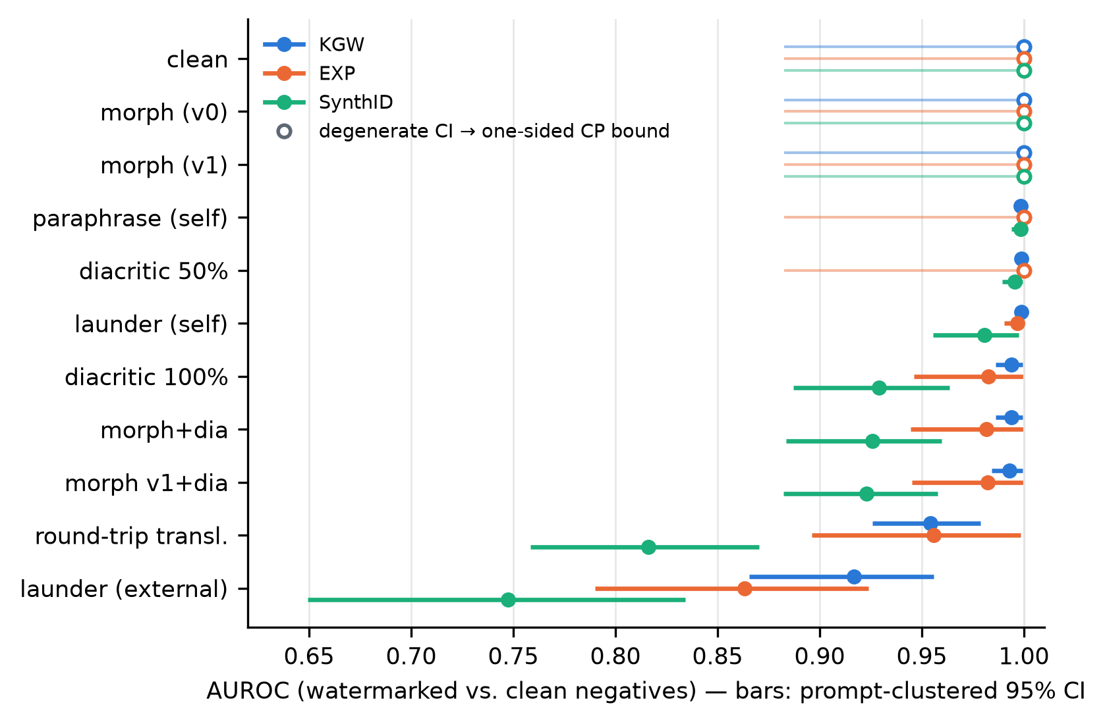
Figure 1. AUROC per attack condition and scheme (dots), with prompt-clustered bootstrap 95% CIs (bars). Conditions are ordered by mean AUROC drop; open markers denote degenerate bootstrap intervals ([1.000, 1.000]), for which the thin line shows the one-sided 95% Clopper–Pearson lower bound (0.883). Generated by paper/make_figures.py from results/detection_metrics.csv.
Table 3. Attacks ranked by mean AUROC drop vs. clean, averaged across the three schemes.
Rank | Attack | Mean AUROC drop
1 | launder_api | 0.158
2 | rtt | 0.091
3 | morph_v1+dia | 0.034
4 | morph+dia | 0.033
5 | dia100 | 0.031
6 | launder | 0.008
7 | dia50 | 0.002
8 | para | 0.001
9 | morph | 0.000
9 | morph_v1 | 0.000

AUROC understates the operational damage. At each scheme's clean-calibrated threshold, launder_api collapses the true positive rate to 0.427 (KGW), 0.490 (EXP), and 0.250 (SynthID); rtt yields 0.594, 0.792, and 0.312 respectively (Table 4). A detector deployed at its clean operating point misses half or more of laundered watermarked text under all three schemes.
Is laundering more destructive than translation? We compare launder_api against rtt — the two strongest attacks — with prompt-level paired Wilcoxon tests on per-prompt detection rates (n = 24 prompts; row-level tests would violate the clustering structure identified above). The direction is consistent in all three schemes: launder_api is more destructive. Nominal p-values are 0.0053 (KGW), 0.037 (EXP), and 0.019 (SynthID); after Bonferroni correction across the three schemes (α = 0.05/3 ≈ 0.0167), only KGW remains significant (Table 4). The ordering launder_api > rtt is therefore established for KGW and directionally consistent, but not individually significant, for EXP and SynthID.
Table 4. Prompt-level paired comparison of launder_api vs. rtt (Wilcoxon signed-rank on per-prompt detection rates at the clean-calibrated threshold; n = 24 prompts per scheme; Bonferroni over 3 schemes, α = 0.05/3 ≈ 0.0167).
Scheme | TPR (rtt) | TPR (launder_api) | Wilcoxon p | Bonferroni
KGW | 0.594 | 0.427 | 0.0053 | significant
EXP | 0.792 | 0.490 | 0.037 | —
SynthID | 0.312 | 0.250 | 0.019 | —

Scheme comparison. Because raw detection statistics are not comparable across schemes, scheme-pairwise comparisons use per-prompt detection rates at each scheme's own clean-calibrated threshold. The test family — {rtt, launder_api} × 3 scheme pairs = 6 paired Wilcoxon tests with Holm correction — was specified before the per-scheme results were inspected (Section 3.3; Table 5). SynthID is significantly more fragile than both alternatives under both attacks — all four tests involving SynthID survive Holm correction (4/6), with mean per-prompt detection-rate differences of 0.479 (EXP vs. SynthID, rtt), 0.281 (KGW vs. SynthID, rtt), 0.240 (EXP vs. SynthID, launder_api), and 0.177 (KGW vs. SynthID, launder_api). KGW and EXP are not distinguishable from each other under either attack (p = 0.104 and p = 0.513).
Table 5. Scheme-pairwise robustness comparison: paired Wilcoxon on per-prompt detection rates (positive mean difference = first scheme more robust), Holm correction over the family of 6 tests specified before the per-scheme results were inspected.
Condition | Pair | Mean diff. | n prompts | p | Holm threshold | Holm
rtt | EXP vs SynthID | 0.479 | 24 | 0.001 | 0.008 | significant
rtt | KGW vs SynthID | 0.281 | 24 | 0.001 | 0.010 | significant
launder_api | EXP vs SynthID | 0.240 | 24 | 0.003 | 0.013 | significant
launder_api | KGW vs SynthID | 0.177 | 24 | 0.013 | 0.017 | significant
rtt | KGW vs EXP | −0.198 | 24 | 0.104 | 0.025 | —
launder_api | KGW vs EXP | −0.062 | 24 | 0.513 | 0.050 | —

Under the pre-registered S2 decision rule (commit cbcb988; an attack is successful iff it reduces AUROC by more than 0.05 while preserving meaning, Section 4.4), launder_api qualifies against all three schemes, and rtt qualifies only against SynthID (Table 8 gives the per-scheme ΔAUROC values). Laundering through an external model is thus the only attack in this study that satisfies the rule for every scheme tested. SynthID's position is the mirror image of its calibration behavior reported in Section 4.3 (Figure 2): the scheme most fragile under attack has the cleanest null distribution on human text — an inverse pattern between attack robustness and null-distribution behavior that we return to in the Discussion.
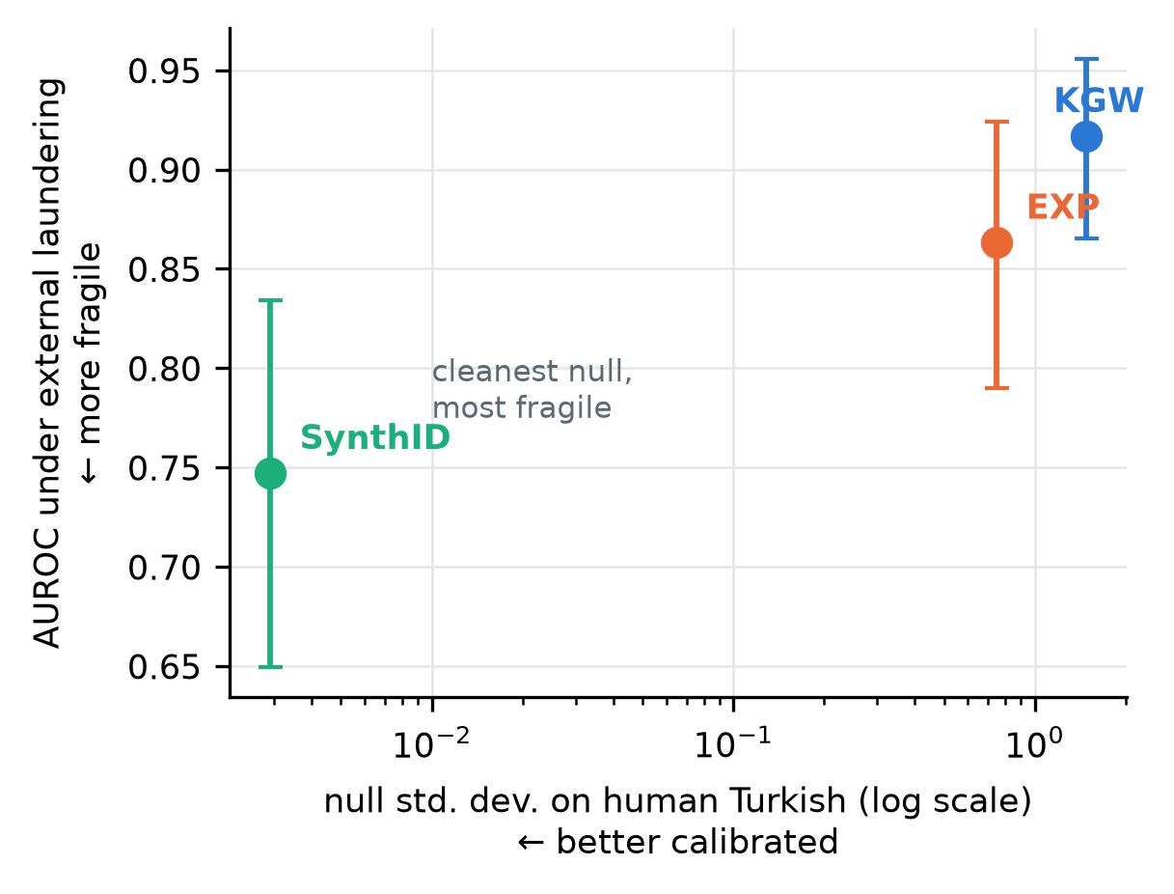
Figure 2. The robustness–calibration trade-off. Horizontal axis: null standard deviation on human Turkish (log scale; smaller = better calibrated). Vertical axis: AUROC under external laundering with clustered 95% CIs (lower = more fragile). SynthID occupies the clean-null/fragile corner; KGW the inflated-null/robust corner. Generated by paper/make_figures.py.
Exploratory: SynthID's weighted-mean detector. As a post-hoc check we re-scored every SynthID text with MarkLLM's alternative untrained detector (weighted_mean), after first verifying that our re-scoring pipeline reproduces the shipped mean scores bit-exactly (maximum absolute difference 5.55 × 10⁻¹⁷ over an 88-row sample). The alternative detector improves SynthID moderately — AUROC 0.816 → 0.857 under round-trip translation, 0.747 → 0.773 under laundering, 0.929 → 0.955 under full diacritic stripping — but does not change the ordering: SynthID remains the most fragile of the three schemes under both headline attacks. The pre-registered headline numbers use the default mean detector; this paragraph is exploratory.

4.3 Calibration on human text (S1)
The clean-text results of Section 4.1 are threshold-free: AUROC ranks watermarked against unwatermarked text without committing to an operating point. Deployment, however, requires a threshold, and a threshold is only as good as the null distribution it assumes. The KGW detector's [KGW] z-statistic is assumed approximately N(0,1) on unwatermarked text, so the configuration threshold z = 4 implies a one-sided nominal false-positive rate of 3.17 × 10⁻⁵ — an assumption already contradicted by the 96 unwatermarked model generations (null standard deviation 1.313; Section 3.4). Study S1 (pre-registered at commit 8f8df72, hypotheses H1–H3 as stated in Section 3.4) measures the null directly on the human-text sample of Section 3.4: 1,500 windows per language from random Wikipedia articles (dump 20231101 [WIKIDUMP]), scored by all three detectors with model=None. Table 6 reports, per scheme and language, the null mean and standard deviation, the false-positive rate at the configuration threshold, and the false-positive rate at the threshold calibrated to 1% FPR on the 96 clean model negatives.
Table 6. S1 null distributions on human Wikipedia text (pre-registration 8f8df72). Model-calibrated thresholds are fixed at 1% FPR on the 96 clean model negatives: 3.285 (KGW), 1.609 (EXP), 0.507 (SynthID).
Scheme | Language | n | Null mean | Null std | FPR @ config threshold | FPR @ model-calibrated threshold
KGW | TR | 1500 | −0.055 | 1.479 | 0.2% | 0.8%
EXP | TR | 1500 | 0.590 | 0.749 | 0.9% | 7.4%
SynthID | TR | 1500 | 0.499 | 0.003 | 0% | 1.1%
KGW | EN | 1500 | 0.278 | 1.321 | 0.2% | 0.9%
EXP | EN | 1500 | 0.452 | 0.470 | 0% | 3.2%
SynthID | EN | 1500 | 0.500 | 0.004 | 0% | 4.1%

H1 is confirmed. On human Turkish, the KGW null standard deviation is 1.479 against the theoretical value of 1; the largest observed statistic is z = 5.08, well above the detection threshold. Empirically, 3 of 1,500 Turkish windows exceed z = 4, a rate of 2.0 × 10⁻³, approximately 63 times the nominal rate. We treat this count-based estimate as primary. A Gaussian fit to the observed null implies 3.05 × 10⁻³ — i.e. 3.05 × 10⁻³ / 3.17 × 10⁻⁵ ≈ 96 times nominal — but H1 itself establishes that the Gaussian model is misspecified, so the parametric figure is reported only as approximate corroboration of the order of magnitude, never as the headline estimate. As pre-registered, n = 1,500 supports order-of-magnitude statements only; we make no claims at finer resolution.
H2 is confirmed on the distributional test, with a caveat we state plainly. The English null standard deviation is 1.321 versus 1.479 for Turkish (Levene test, p = 0.00039). The tail counts, however, are identical — 3 of 1,500 windows exceed z = 4 in each language (English parametric implied rate 2.42 × 10⁻³) — so at this sample size the exceedance counts cannot separate the languages, and the H2 verdict rests on the variance test alone. Equally important is what H2 does not say: with an English null standard deviation of 1.321, the z = 4 threshold is miscalibrated in English as well. Turkish makes the failure worse; it does not create it.
H3 is confirmed. SynthID's null is almost exactly as predicted (standard deviation 0.003 in Turkish, 0.004 in English, against the pre-registered ≈ 0.003) with no window exceeding its configuration threshold in either language. EXP likewise shows no analogue of the KGW failure, which is specific to pairing a parametric normality assumption with an inflated null; EXP ships no such nominal guarantee. We note, without attaching a hypothesis test, that the EXP Turkish null is wider and further right-shifted than its English counterpart (standard deviation 0.749 versus 0.470; mean 0.590 versus 0.452), and that this tail drives EXP's 0.9% Turkish false-positive rate at its configuration threshold; the consequence surfaces in the threshold-transfer finding below.
Proposed mechanism (hypothesis, not a causal claim). KGW's variance derivation assumes each green-list indicator is an independent draw. With prefix_length = 1, the green/red vocabulary partition for a token is determined by hashing the single preceding token [KGW]. Turkish is agglutinative: a small inventory of suffix subtokens recurs at high frequency, so the same seeding token — and therefore the same fixed partition — is consulted many times within one document. Successive indicators then share partitions rather than being independent draws; document-level green counts become over-dispersed, and the variance of the z-statistic exceeds its binomial value while the mean stays near zero. This account is consistent with the direction of H2, since English repeats seeding tokens less often, but we manipulated neither prefix_length nor the seed-repetition rate, so we advance it as a hypothesis only. A decisive test — recomputing the human-text null at larger prefix_length values and relating inflation to measured seed-repetition rates — is left to future work.
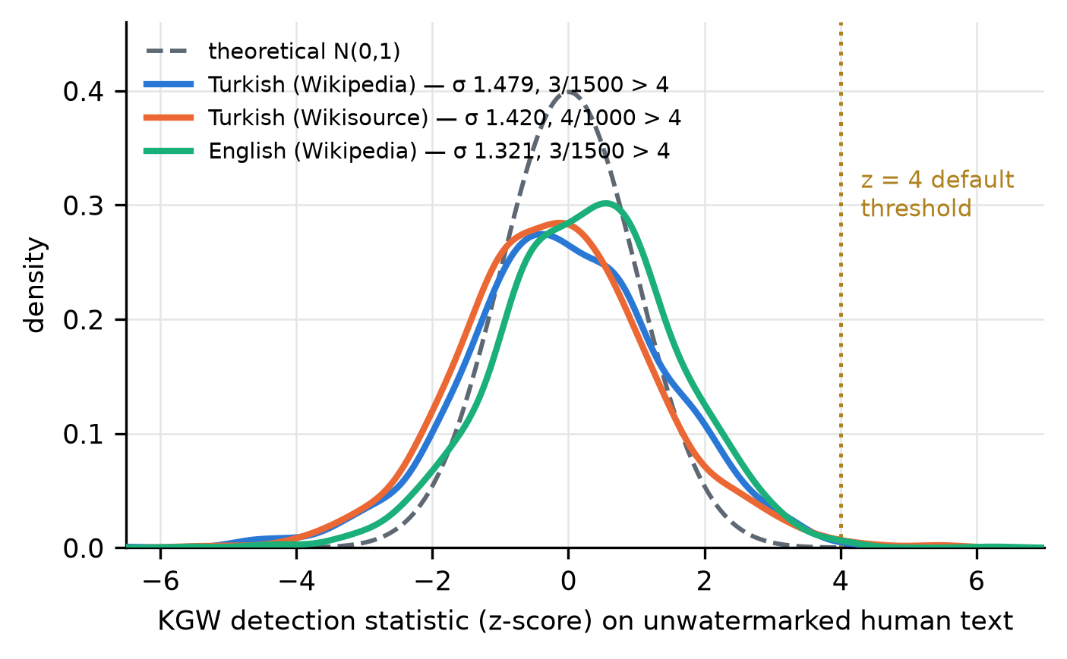
Figure 3. Kernel density estimates of the KGW detection statistic on unwatermarked human text: Turkish Wikipedia (n = 1,500), Turkish Wikisource (n = 1,000), and English Wikipedia (n = 1,500), against the theoretical N(0,1) null. All three empirical nulls are wider than the theory assumes; the annotated counts give the windows exceeding the default z = 4 threshold. Generated by paper/make_figures.py from the S1 score files.
Second register (pre-registered extension, commit 5c4f323). To test whether the inflation is a property of encyclopedic prose rather than of the language, we repeated the Turkish measurement on a second register: 1,000 windows of older official and literary prose from Turkish Wikisource (dump 20231201), collected under the same windowing and pre-registered before collection with the single hypothesis that H1 would hold. It does: the KGW null standard deviation is 1.420, and 4 of 1,000 windows cross z = 4 (empirical FPR 0.004, roughly 126 times nominal). The variance difference between the two Turkish registers is not significant (Levene p = 0.20), while each register separately differs from English; the inflation therefore tracks the language, not the register. The two registers are analyzed separately and never pooled.
Exploratory observations (labeled as such; not pre-registered). First, the English KGW null mean is shifted to +0.278, whereas the Turkish mean is −0.055; no hypothesis anticipated this shift, and we record it strictly as a replication target. Second, thresholds calibrated on model-generated negatives do not transfer to human text: the 1% model-calibrated thresholds yield 7.4% on Turkish human text for EXP and 4.1% on English human text for SynthID. The measurement column was pre-specified in the S1 protocol, but no hypothesis was attached, so we label the interpretation exploratory: model output appears to be an inadequate proxy for the human-text negative class, and operational thresholds should be calibrated on negatives drawn from the deployment distribution itself. Both observations are confined to a single register (encyclopedia text); Section 6 discusses this and the remaining limitations.

4.4 Utility axis (S2)
A detection drop alone does not make an attack successful (Section 3.5). The utility axis is therefore measured with pairwise LLM judgments under the protocol pre-registered at commit cbcb988: two judges from different model families (Claude Opus 5 and gpt-oss-120b), 40 pairs per condition presented in both orders — n = 80 ordered comparisons per condition–judge cell — blind calibration pairs passed by both judges before any real verdict was read, and the requirement that any launder_api verdict be supported by both judges, because Opus 5 produced the launder_api texts (Section 3.5). Judged conditions are rtt, para, launder, and launder_api, with source texts drawn from the KGW-positive arm.
Table 7 reports the outcome. Meaning is preserved in every cell: for all four attacks and both judges, the meaning-preservation rate is 1.00. No attack in this corpus destroys what the text says.
Table 7. S2 pairwise judging results per condition and judge (n = 80 ordered comparisons per cell).
Condition | Judge | n | Meaning preserved | Position-flip rate
rtt | gpt-oss-120b | 80 | 1.00 | 25.0%
rtt | Opus 5 | 80 | 1.00 | 10.0%
para | gpt-oss-120b | 80 | 1.00 | 42.5%
para | Opus 5 | 80 | 1.00 | 15.0%
launder | gpt-oss-120b | 80 | 1.00 | 57.5%
launder | Opus 5 | 80 | 1.00 | 5.0%
launder_api | gpt-oss-120b | 80 | 1.00 | 50.0%
launder_api | Opus 5 | 80 | 1.00 | 0.0%

The pre-registered decision rule declares an attack successful iff (i) ΔAUROC > 0.05 and (ii) meaning is preserved by judge majority, with (ii) required from both judges for launder_api. The pre-registration fixed the source arm for the judged texts but did not state against which scheme's AUROC clause (i) is evaluated; rather than selecting a scheme post hoc, we evaluate the rule for each scheme separately and report all three outcomes (Table 8; each ΔAUROC is computed as 1.000 — the clean AUROC of every scheme in Table 2 — minus that scheme's attacked AUROC in Table 2).
Table 8. Decision-rule evaluation per scheme (ΔAUROC = 1.000 minus the corresponding Table 2 value).
Scheme | Δ launder_api | Δ rtt | Δ para | Δ launder | Rule satisfied by
KGW | 0.083 | 0.046 | 0.002 | 0.001 | launder_api
EXP | 0.137 | 0.044 | 0.000 | 0.003 | launder_api
SynthID | 0.253 | 0.184 | 0.002 | 0.019 | launder_api, rtt

Under every resolution of the ambiguity the conclusion is the same: launder_api is the only attack that satisfies the rule for all three schemes. Round-trip translation satisfies it only for SynthID; para and launder clear the detection criterion for no scheme (largest ΔAUROC 0.019).
Fluency claims require discipline. The position-flip rate — how often a judge's fluency preference reverses when the same pair is shown in the opposite order — exceeds the pre-registered 30% reliability bound for the independent judge on para (42.5%), launder (57.5%), and launder_api (50.0%): a preference that flips with presentation order at near-chance rates is position noise, and no directional fluency claim is made from it. The conflicted cell illustrates why the second judge exists: Opus 5 judging launder_api pairs never prefers the original (0.0%, with a 0.0% flip rate), a verdict we discard rather than interpret. The defensible statement is that laundering does not measurably degrade fluency; the data cannot support "improves". Round-trip translation is the contrast case: both judges' flip rates fall within the bound (25.0% and 10.0%) and both prefer the original (85.0% and 95.0% of pairs), so rtt produces detectable fluency loss [NLLB] even where it fails as a detection attack.

5 Discussion

5.1 Thresholds must be calibrated per language and per negative distribution
The default KGW threshold z = 4 encodes an assumption — an approximately standard normal null — that fails on human Turkish. On 1500 Wikipedia windows [WIKIDUMP] the KGW null standard deviation is 1.479 against a theoretical 1, larger than the 1.321 measured on matched English (Levene p = 0.00039), and 3/1500 human Turkish windows (0.2%) cross z = 4 — approximately 63 times the nominal false-positive rate of 3.17 × 10⁻⁵ (empirical estimate primary; the Gaussian parametric figure of 3.05 × 10⁻³ / 3.17 × 10⁻⁵ ≈ 96× is approximate only, since the inflation itself shows the null is not the assumed Gaussian). A Turkish deployment that ships the default threshold therefore accuses human writers at roughly 63 times the rate the scheme's theory promises [KGW].
Calibration must also match the negative distribution, not just the language. An exploratory (not pre-registered) but operationally important observation: thresholds set to 1% FPR on the model's own unwatermarked outputs do not transfer to human text — the same thresholds yield 7.4% FPR on human Turkish for EXP and 4.1% on human English for SynthID. Model-generated negatives are an inadequate proxy for the human text a deployed detector will actually screen. The practical prescription is that deployments should calibrate on, and report, the negative distribution of their own language and register.

5.2 A robustness–calibration trade-off
No scheme dominates both axes. SynthID [SYNTHID] has by far the cleanest human-text null (standard deviation 0.003 on Turkish, 0.004 on English; zero config-threshold false positives on the 1500 Turkish windows) — yet it is the most fragile under attack: all four Holm-significant prompt-level pairwise differences are against SynthID (rtt: EXP +0.479, p = 0.001 and KGW +0.281, p = 0.001; launder_api: EXP +0.240, p = 0.003 and KGW +0.177, p = 0.013), and under launder_api its AUROC falls to 0.747 with TPR 0.250 at the clean-calibrated threshold. KGW is comparatively robust to attack but carries the inflated Turkish null of Section 4.3. EXP [EXP-A, EXP-K] sits between them (KGW–EXP differences are not significant: p = 0.104 for rtt, p = 0.513 for launder_api), with the caveat that its fixed-length generation is a structural confound noted in Section 6. Choosing a watermark for Turkish is thus a trade-off between attack robustness and null calibration, and the scheme with the most trustworthy false-positive behaviour is the easiest to wash out.

5.3 Laundering is cheap and effective; defense is open
Laundering through an external model is the only attack that satisfies the pre-registered success rule for all three schemes. Its mean AUROC drop across schemes is 0.158 — the next attack, rtt, achieves 0.091 — and it pushes TPR at the clean-calibrated thresholds down to 0.427 (KGW), 0.490 (EXP), and 0.250 (SynthID) while preserving meaning in every judged pair and leaving no fluency loss the independent judge can detect. Nor is it covert truncation: the median attacked-to-source length ratio is 0.976. At the prompt level, launder_api is more destructive than round-trip translation for KGW (paired Wilcoxon p = 0.0053, significant after Bonferroni correction across the three schemes); the direction is the same for EXP (p = 0.037) and SynthID (p = 0.019) without surviving correction. The contrast with self-paraphrase is instructive: asking the watermarking model itself to rewrite its output barely moves detection (mean AUROC drop 0.008 for launder, 0.001 for para), so the attack's power comes from routing text through a different, external model — one outside the defender's control — not from paraphrasing as such. The attack is also cheap and requires no knowledge of the scheme or key: the entire launder_api pass over the corpus cost USD 17.704 in measured API charges (the Opus 5 judge evaluation added USD 7.021; the second judge's cost was not separately metered), and it degrades all three schemes at once. We evaluate no defenses here; whether any watermarking scheme can survive a rewrite by a model outside the defender's control — in Turkish or in any language — remains an open question.

5.4 Exploratory observations
Two post-hoc observations are recorded as replication hypotheses, not findings. First, non-Latin script contamination concentrates in the logit-perturbing schemes: 8/96 KGW and 9/96 SynthID texts against 2/96 unwatermarked and 0/96 EXP texts. If this replicates, the logit-perturbing schemes would carry an additional Turkish-specific utility cost that the sampling-based scheme avoids. Second, the KGW null mean on human English is itself shifted positive (+0.278, against −0.055 on Turkish), suggesting that null miscalibration is not exclusively a Turkish phenomenon — Turkish is where the variance inflation is largest, not the only place the theoretical null bends.

6 Limitations
Scope of generalization. All generated text in this study comes from a single generator, Qwen3-14B [QWEN3]. This was not for lack of trying: five candidate generators were run through the same pre-registered acceptance gate (Latin-script purity 16/16 mandatory; overall gate ≥ 12/16), and only Qwen3-14B passed. Qwen2.5-3B and -7B failed on foreign-script contamination across five configurations; Mistral-Nemo-12B failed on contamination and under-delivery (Latin 14/16, gate 9/16, median 315 words); and the Turkish-tuned Turkish-Llama-8b produced clean, long text (Latin 16/16, word criterion 16/16, median 808.5 words) but degenerated into repetition and failed to terminate (repetition criterion 3/16, termination 2/16, gate 0/16). Cross-model replication was therefore attempted and not achieved — the gate records are in the repository — and producing acceptable long-form Turkish appears to be a barrier in its own right. Nothing in the design licenses generalization to other model families, scales, or tokenizers; the calibration failure in particular is a property of a scheme–tokenizer–language triple and must be re-measured for any other pairing. A side observation: the effective-γ deviation of Section 6 is Qwen-specific — both rejected candidates have tokenizers whose length equals their declared vocabulary size (deviation exactly 0). Similarly, the entire generation pipeline ran on a single machine and GPU (a Quadro RTX 8000). Reproducibility was measured within that one environment — the determinism test (T4) of the version-drift battery returned token-identical sequences across repeated generations under the pinned software stack — but this is a single-environment result, not a portability claim across hardware or library versions.
Human-text baseline (S1). The human corpus covers two registers — encyclopedic prose from Wikipedia [WIKIDUMP] and older official/literary prose from Turkish Wikisource — and the inflation replicates across both (Section 4.3); newspaper, essayistic, or conversational Turkish may still behave differently. Detector keys are device-class-bound: we measured that a SynthID detector instantiated on CPU draws a different pseudo-random key stream than one on CUDA, so watermarked text scored on the wrong device class collapses to chance (mean g-score 0.498 vs. 0.530), while re-scoring on the generation device reproduces the shipped scores bit-exactly (maximum difference 5.55 × 10⁻¹⁷). The S1 human-text measurements are unaffected — no watermark is present, and the null distribution is key-exchangeable (SynthID null standard deviation is 0.003 under either device class) — but any deployment must run detection on the same device class as generation, or serialize the key explicitly. Sample size bounds precision: with n = 1500 windows per language, the design supports order-of-magnitude statements — such as the empirical rate of 3/1500 = 0.002 at z = 4, roughly 63 times the nominal rate — but not claims at finer resolution, which is why we report the empirical estimate as primary and the Gaussian parametric extrapolation as approximate only.
The morphological attack did not fire. The attack planned as the central typological probe produced almost no edits in this corpus: the morph variant averages 1.1 edits per text, with 60.4% of texts receiving zero edits, and the broader morph_v1 variant averages 7.5 edits per text (zero edits in 4.2% of texts). The mechanism is a register mismatch: the transforms target the progressive suffix -(I)yor via the zeyrek analyzer [ZEYREK], and the formal expository register the model produces rarely uses that form. The measured detection effect is accordingly null (mean AUROC drop 0.000 for both variants). Where morph did fire (the n = 38 texts with nonzero edits), the per-edit slope survives our robustness battery — 0.052 z per edit, 95% CI [0.022, 0.071], Theil–Sen 0.051, Spearman ρ = 0.579 (p = 0.00014) — but is practically tiny: at the observed mean of 2.9 edits it implies a shift of about 0.15 z (0.052 z per edit × 2.9 edits ≈ 0.15) against a matched clean-signal mean of 11.467, invisible at AUROC level. The morph_v1 slope is retracted after the same battery: the OLS estimate of 0.026 has a 95% CI of [−0.005, 0.034] that includes zero, Theil–Sen falls to 0.005, Spearman ρ = 0.091 is not significant (p = 0.39), and the sign flips to −0.003 when the three highest-leverage points are removed (n = 92). Whether an informal-register corpus, where -(I)yor is common, changes this verdict is an open question, not a result of this paper.
Closed-model laundering. The launder_api attack routes text through a closed commercial model (Claude Opus 5) whose deployed version can change without notice. The raw laundered outputs are stored in the repository, so every detection score on those texts can be recomputed exactly; the attack generation itself, however, may not be re-creatable against a future version of the model. The result should be read as an existence demonstration — one available external model suffices — rather than as a stable measurement of a fixed system.
EXP is structurally different. The EXP implementation generates a fixed sequence length of 950 tokens, does not consume the shared sampling arguments, and never stops at an EOS token; its token-count standard deviation is 1.5, against 178.2 for KGW, 158.4 for SynthID, and 101.0 for the unwatermarked arm, and its 96 texts are exempt from the termination criterion (leaving 288 texts in that denominator). Any cross-scheme comparison of text quality is therefore confounded with this structural difference. Detection comparisons use each scheme's own clean-calibrated threshold, which mitigates but does not remove the concern.
Acceptance thresholds are only partly justified. Of the pre-fixed corpus acceptance thresholds (word count ≥ 300, compliance ≥ 0.75, termination ≥ 0.90, contamination ≤ 0.05), the compliance value is inherited from the pre-gate criterion, but the 0.90 and 0.05 values have no external justification. They were fixed before any corpus data existed, which protects against post-hoc tuning, but no sensitivity analysis was performed, and a different choice could have produced a different corpus-validity verdict.
Implementation-level caveats. Three smaller issues are recorded for completeness. First, KGW's effective green-list fraction deviates slightly from the configured γ = 0.5 because the implementation sizes the list from the tokenizer length rather than the declared vocabulary size; the measured effective fraction is 0.499118 (len(tokenizer) = 151,669 vs. vocabulary size 151,936; deviation -0.000882). Second, 2 of 96 KGW texts and 2 of 96 SynthID texts hit the 1800-token generation cap and are therefore truncated. Third, in the first run the attention implementation fell back to the transformers default (effectively sdpa); this was not a deliberate choice, and the provenance note is kept in hpc/config_cuda.py.
Post-hoc observation on contamination. Non-Latin-script contamination is more frequent in the two logit-perturbing arms — KGW 8/96 and SynthID 9/96, against 2/96 unwatermarked and 0/96 for EXP; in total 8 + 9 + 2 + 0 = 19 of 384 texts (4.9%), under the pre-registered 5% gate. This association was noticed after the data were collected. It is labeled exploratory and recorded as a replication hypothesis for future work, not as a finding of this study.

7 Reproducibility Statement
Every number reported in this paper is generated from the underlying data by code. The metrics module (pilot/metrics.py) produces the summary report and detection tables directly from the scored corpus, and a dedicated exporter (pilot/make_paper_numbers.py) emits the single JSON file (paper/numbers.json) from which all manuscript numbers are drawn; no number is typed by hand. A regime gate refuses to produce any report when the active configuration does not match the sealed run configuration, so numbers from mismatched settings cannot silently enter the output. Because the experiments span two environments (a local development machine and a university HPC container), the environment layer imports the scientific code rather than forking it, and a content hash over the scientific source files is recorded with each run so that the two environments can be verified to execute identical code. The upstream MarkLLM toolkit [MARKLLM] is pinned to a fixed commit (c45ddc40), the prompt file is sealed by hash (SHA-256 prefix 8fcbe4074b46), and the full generation settings are recorded alongside the results. Before the main run, a version-drift battery (tests T1–T6, pre-registered in hpc/README.md) re-measured every environment-dependent assumption on the target machine rather than inheriting local measurements; its determinism test (T4) yielded token-identical repeated generations. All three detectors run model-free (model=None), verified against the implementations, so detection scores do not depend on the GPU or numeric precision used for generation.
The human-text corpus of S1 is reproducible by construction: each window records its Wikipedia page identifier together with the dump version (wikimedia/wikipedia, 20231101 [WIKIDUMP]), so the exact text windows can be re-fetched deterministically. The corpus acceptance thresholds were fixed in code before Phase 1 began; the S1 protocol, hypotheses, and analysis plan were sealed at commit 8f8df72 before data collection; and the S2 judging protocol, blind calibration design, and decision rule were sealed at commit cbcb988 before the judging run. Code, corpus, scores, attacked texts (including the raw closed-model laundering outputs), and the pre-registration documents reside in a single repository, so the full path from raw text to every reported statistic can be re-executed.

References
(Bibliographic identity of every non-software entry verified against OpenAlex/Crossref on 2026-08-25; record: `paper/citation_verification.json`. Entries marked "no DOI" are non-archival or DOI-less venues cited by identifier.)
- [KGW] Kirchenbauer, J., Geiping, J., Wen, Y., Katz, J., Miers, I., Goldstein, T. "A Watermark for Large Language Models." Proceedings of ICML 2023, PMLR 202. DOI: 10.48550/arXiv.2301.10226 (arXiv; PMLR issues no DOIs).
- [EXP-A] Aaronson, S. "Watermarking of large language models." Talk and blog post, OpenAI, 2022–2023. Non-archival; no DOI.
- [EXP-K] Kuditipudi, R., Thickstun, J., Hashimoto, T., Liang, P. "Robust Distortion-free Watermarks for Language Models." TMLR 2024. DOI: 10.48550/arXiv.2307.15593 (TMLR issues no DOIs).
- [SYNTHID] Dathathri, S., et al. "Scalable watermarking for identifying large language model outputs." Nature 634, 818–823 (2024). DOI: 10.1038/s41586-024-08025-4.
- [MARKLLM] Pan, L., et al. "MarkLLM: An Open-Source Toolkit for LLM Watermarking." EMNLP 2024 System Demonstrations. DOI: 10.18653/v1/2024.emnlp-demo.7.
- [QWEN3] Qwen Team (Yang, A., et al.). "Qwen3 Technical Report." arXiv, 2025. DOI: 10.48550/arXiv.2505.09388.
- [NLLB] NLLB Team, et al. "No Language Left Behind: Scaling Human-Centered Machine Translation." arXiv, 2022. DOI: 10.48550/arXiv.2207.04672.
- [E5] Wang, L., et al. "Multilingual E5 Text Embeddings: A Technical Report." arXiv, 2024. DOI: 10.48550/arXiv.2402.05672.
- [ZEYREK] zeyrek: Python morphological analyzer for Turkish (port of Zemberek). Software; no DOI. Version pinned in the repository.
- [WIKIDUMP] Wikimedia Foundation. Wikipedia dumps via wikimedia/wikipedia (HuggingFace), version 20231101. Dataset; cited by version identifier.
- [XLING] He, Z., et al. "Can Watermarks Survive Translation? On the Cross-lingual Consistency of Text Watermark for Large Language Models." ACL 2024. DOI: 10.18653/v1/2024.acl-long.226.
- [DIPPER] Krishna, K., Song, Y., Karpinska, M., Wieting, J., Iyyer, M. "Paraphrasing evades detectors of AI-generated text, but retrieval is an effective defense." NeurIPS 2023. DOI: 10.48550/arXiv.2303.13408.
- [SADASIVAN] Sadasivan, V. S., Kumar, A., Balasubramanian, S., Wang, W., Feizi, S. "Can AI-Generated Text be Reliably Detected?" arXiv, 2023. DOI: 10.48550/arXiv.2303.11156.
- [TOKENIZER] Rust, P., Pfeiffer, J., Vulić, I., Ruder, S., Gurevych, I. "How Good is Your Tokenizer? On the Monolingual Performance of Multilingual Language Models." ACL 2021. DOI: 10.18653/v1/2021.acl-long.243.
- [XLING-ROB] Al Ghanim, M., et al. "Evaluating the Robustness and Accuracy of Text Watermarking Under Real-World Cross-Lingual Manipulations." arXiv preprint, 2025. DOI: 10.48550/arXiv.2502.16699. (preprint — cite with caution)

