|  |
| --- |
| **Bachelor's tesis** |
| **Study: Biomedical Engineering** |
| **Title:** Segmentation of brain lesions from medical images, for their subsequent digitization and 3D printing. |
| **Document**: Summary |
| **Student**: Xavier Beltran Urbano |
| **Tutor**: Xavier Lladó / Robert Martí  **Department**: Department of Computer Architecture and Technology (ATC)  **Field of expertise**: Computer vision and Medical Imaging (ViCOROB) |
| **Application period (month/year):** June 2022 |

**INDEX**

1. Introduction 1

2. Hypothesis and objectives 1

2.1. Research question 1

2.2. Hypothesis 1

2.3. Scope and project objectives 1

3. Materials and methods 1

3.1. Dataset 2

3.2. Project development 2

3.2.1. Preliminary preparation 2

3.2.2. Segmentation using unsupervised algorithms (K-Means) 2

3.2.3. Segmentation using supervised algorithms based on Deep Learning 2

3.2.4. Skull segmentation 2

3.2.5. 3D reconstruction 2

3.2.6. 3D printing 2

4. Results 3

4.1. Evaluation of segmentation 3

4.1.1. Evaluation of whole tumor segmentation 3

4.1.2. Evaluation of tumor segmentation into subregions 4

4.2. 3D printing 4

5. Conclusions 5

# Introduction

Neurological disorders impact over seven million persons within Spain. Moreover, they account for 19% of the total annual fatalities that transpire in the country. Due to the severity of the majority of these diseases, surgery is unfortunately required for a significant number of them. Hence, conducting a comprehensive and individualized assessment of every patient is critical for implementing the intervention with maximum success and efficacy.

Our research focuses on the development of support methods that facilitate a more comprehensive and individualized preoperative experience. More precisely, the techniques that we are going to develop will involve the implementation of artificial intelligence in tumor segmentation methods. After the tumor has been segmented, it will be digitized and 3D printed in conjunction with the patient's skull.

An enhancement in preoperative preparation will result from the utilization of the full-size printed 3D model, which will supply medical professionals with an exceptionally precise three-dimensional representation of the tumor situated within the patient's skull. Consequently, physicians and surgeons will be in a better position to strategize the intervention as a result of this enhanced data. For instance, they will be capable of evaluating diverse approaches to tumor extraction and selecting the one that is most suitable for the surgical procedure.Hypotheses and objectives

## Research question

Is it possible to combine computer and industrial engineering in order to develop strategies to perform a more complete and personalized medicine?

## Hypothesis

By integrating artificial intelligence algorithms and 3D printing, novel approaches can be devised to acquire preoperative information that is significantly more individualized and patient-specific, particularly in the context of brain tumor extraction surgical procedures.

## Purpose and objectives of the project

As stated previously, the primary objective of this endeavor is to devise techniques that assist medical professionals in conducting a more comprehensive and individualized preoperative phase. The primary aim will comprise two components:

**• The initial segment pertains to the development of the patient's model.** The initial phase will encompass the construction of various artificial intelligence techniques for the purpose of segmenting tumors. In order to construct the final model, distinct segmentations (skull, gray matter, white matter, etc.) will be derived from the patient's image subsequent to segmentation.

**•The second section concerns itself with 3D manufacturing.** We will begin this second section by performing a 3D reconstruction of the previously obtained segmentations. Next, the final file will be generated and saved to a USB drive utilizing the 'Ultimaker Cure' software.

# Materials and methods

The materials and methods used in this project will be described in detail below. First, we will describe the dataset used:

## Dataset

In this project, the dataset from the international challenge 'The **Brain Tumor Image Segmentation Challenge** 2018', also known as '***BraTS 2018****'*, has been used.This consists of 285 cases in NIfTI format (.nii.gz), where for each case, since these are multimodal, we can find the following modalities: T1, T2, T1 with contrast and FLAIR. In addition, there is also a fifth image which contains the Ground Truth (GT) of the tumor segmentation, which is composed by 3 different classes: the enhanced tumor (RT) in GD (label 4), the peritumoral edema (PD) (label 2), and the tumor nucleus (NT) necrtic without enhancement (label 1).

## Project development

### Preliminary preparation

To establish a solid foundation for the project, the first step consisted of an exhaustive investigation into the methods presently employed in the BraTS challenge.

### Segmentation using unsupervised algorithms (K-Means)

### As soon as we built a firm basis for the project, we began the segmentation-focused software development. The initial phase of this development involved the execution of unsupervised algorithms to segment brain tumors. In particular, we executed a program utilizing the MATLAB programming environment and the K-Means algorithm to achieve this objective.

### 2.2.3. Segmentation using supervised algorithms based on Deep Learning

Following that, we utilized DL algorithms to segment the entire tumor as well as its subregions, with the U-NET architecture serving as the framework.

After obtaining preliminary results with the whole tumor segmentation program that we initially developed, we implemented a number of enhancements to the initial iteration. The specific enhancements implemented were Background Crop (which involves cropping the background of images) and Data Augmentation (which involves rotating and reversing the original images). Following the implementation of the various enhancements, we employed the acquired models to predict the test group's (20 percent of the database images) images, thereby quantifying their outcomes. After quantifying the results, we proceeded to replicate this procedure for the tumor segmentation program into subregions, incorporating the necessary code modifications.

### Skull segmentation

After the preceding segmentations were completed, the 3D reconstructions could commence; however, prior to that, the masks (including segments of the skull, gray matter, and so forth) of the corresponding images had to be generated. We utilized software known as SPM12 to complete this endeavor.

### 3D reconstruction

After the completion of the previous mentioned masks, we conducted the 3D reconstruction using the MATLAB programming environment. Amir Safari's open source *'Make STL of 3D array (Optimal for 3D printing)*' was utilized in the development of this task.3D printing

Following the completion of the 3D reconstruction, we commenced the final phase of the project, which involved 3D printing. This section basically consisted of placing supports in order to reinforce the structure of the model and configuring the default parameters of the print. Once this was done, we exported the model in 'gcode' format and saved it on a USB medium. Finally, we put this USB magnet on the printer and started printing the model.

# Results

The outcomes of the various procedures conducted for the project will then be presented in this section. As the subject matter is evidently partitioned into two substantial groups, the findings have been categorized into two distinct sections: 1) segmentation evaluation and 2) 3D printing.

## Segmentation evaluation

This section has been partitioned into two distinct parts: an assessment of segmentation of the entire tumor and an examination of segmentation into subregions. The metrics of specificity, sensitivity, Dice Coefficient (DSC), and Hausdorff Distance (HD) were utilized to complete this endeavor. It is important to acknowledge that the outcomes we will present are derived from quantifying the predictions of the test group's images (specifically, for every 155 slices, we calculate the average result per slice). Having said that, the results obtained with the segmentation of the entire tumor are the following:

### Evaluation of whole tumor segmentation

Following the order of the previous sections, the first algorithm presented is the the K-means algorithm.

**-K-means:** the results obtained with this algorithm are DSC=0.4963, HD=63.915, Specificity=0.9762 and Sensitivity= 0.8015. In *illustration 1* we can see an slice segmentation example, using this algorithm.

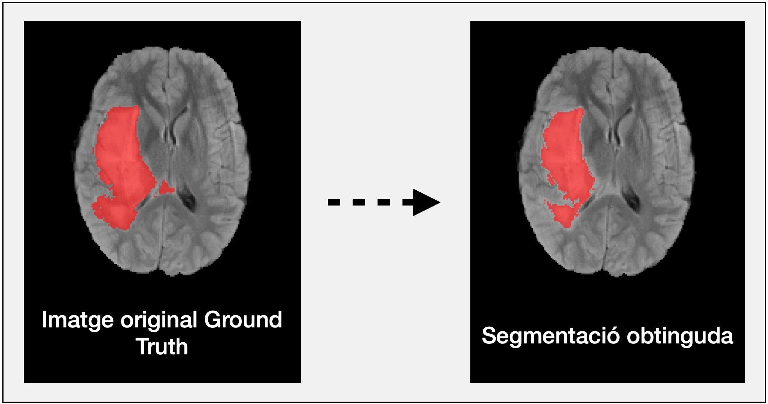

Segmentation

Ground Truth

*Illustration 1. Example of the 80th slice of image 1 of the test set.*

*The DSC obtained in the segmentation of this slice is 0.8466.*

**-Deep Learning:** the results obtained from the different stages of the algorithm, are the following:

* **Initial version:** the best results obtained, through the initial version, are DSC= 0.8346, HD=1.5223, Specificity=0.9992 and Sensitivity= 0.8091.
* **Enhanced Version 1 (Background Crop):** the best results obtained, using enhanced version 1, are DSC=0.8231, HD=1.7194, Specificity=0.9955 and Sensitivity=0.8267.
* **Enhanced Version 2 (Data Augmentation):** the best results obtained, using enhanced version 2, are DSC= 0.8249, HD=1.6741, Specificity=0.9892 and Sensitivity= 0.8505. In *illustration 2* we can see an example of the segmentation of a slice, using this version.

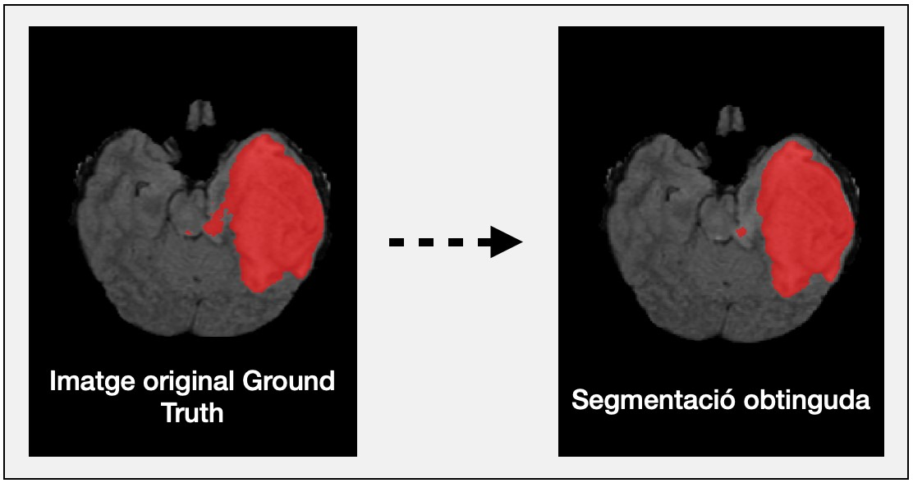

Segmentation

Ground Truth

*Illustration 2. Example of the results obtained, using model 5, of slice 48 in image 9 of the test set. The DSC obtained in the segmentation of this slice is 0.9595.*

### Evaluation of tumor segmentation into subregions

Then, once we finished with the segmentation part of the entire tumor, we started segmenting it into subregions. In this case, the results obtained come from calculating, in the same way as in the case of segmentation of the entire tumor, the DSC, HD, specificity and sensitivity, individually for each subregion. Having said that, the results obtained, when applying the different models to the testing data, were as follows:

* **Initial version:** the best results obtained, through the initial version, are DSC= 0.7429, 0.7019,

0.7798; HD=1.5207, 16736, 0.3059; Specificity=0.9998, 0.9935, 0.9997 and Sensitivity= 0.3233, 0.6760,

0.7112 from the NT, EP and TR subregions respectively.

* **Improved Version 1 (Background Crop):** the best results obtained, using enhanced version 1, are DSC= 0.6467, 0.7145, 0.8133; HD=2.1254, 1.7919, 0.3508; Specificity=0.9989, 0.9915, 0.9996 and Sensitivity= 0.3378, 0.6266, 0.6408 of the NT, EP and TR subregions respectively.
* **Improved Version 2 (Data Augmentation):** the best results obtained, using improved version 1, are DSC= 0.6557, 0.7196, 0.8212; HD=2.0893, 1.6987, 0.3418; Specificity=0.9973, 0.9949, 0.9995 and Sensitivity= 0.3951, 0.5977, 0.6554 of the NT, EP and TR subregions respectively. In *illustration 3* we can see an example of the segmentation of a slice, using this version.

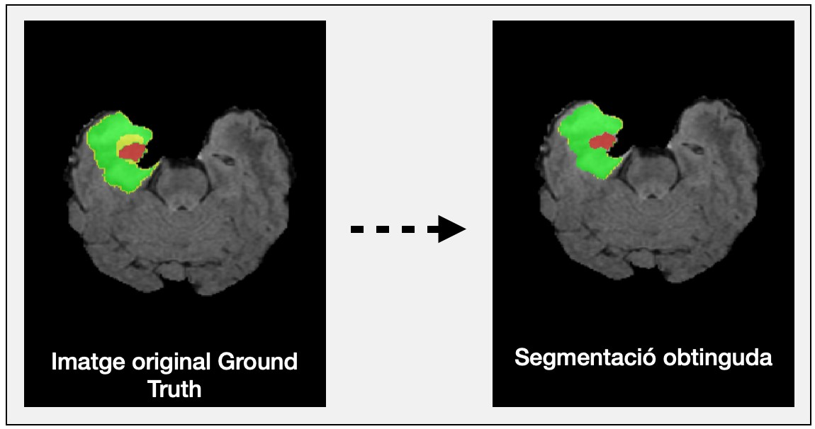

Segmentation

Ground Truth

*Illustration 3. Example of the results obtained, using the ensemble 2 method, from slice 46 in image 6 of the test set. The DSC obtained in the segmentation of this slice are 0.2584, 0.8829, 0.9166 of the NT (yellow), EP (green) and TR (red) respectively.*

## 3D printing

Subsequently, the prints of the models were produced, containing one model acquired via a sagittal cut and the other via a transversal cut. Illustrations 4, 5, 6, and 7 illustrate different examples of 3D-printed models.

*Illustration 7. Front view of the final model (transversal cut)*

*Illustration 6. Front view of the model of tumor + skull model (transverse cut).*

*Illustration 5. Front view of the model of tumor + the skull model (sagittal cut).*

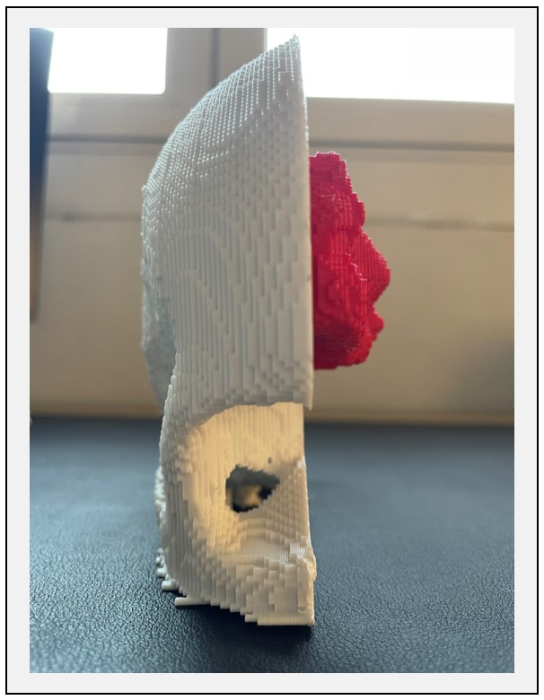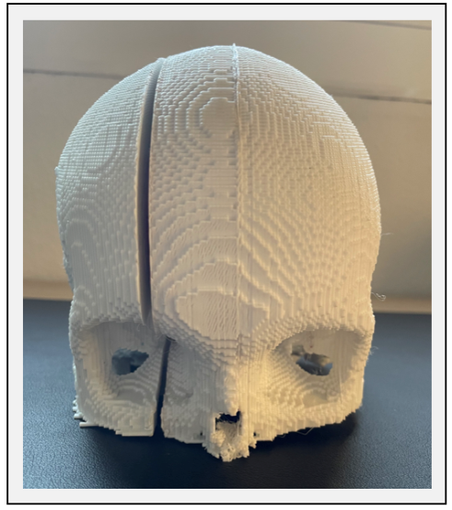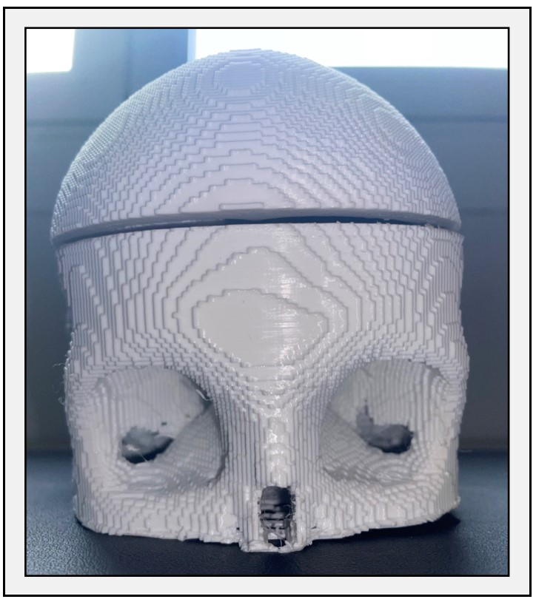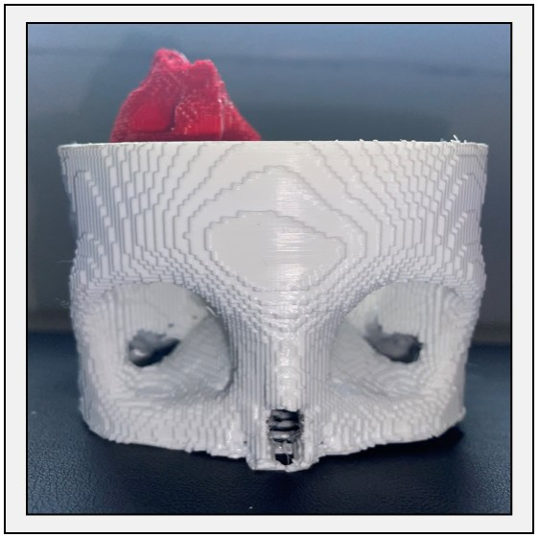

*Illustration 4. Front view of the*

*final model (sagittal cut).*

# Conclusions

As a result of this work, methods for segmenting brain tumors utilizing unsupervised algorithms, such as K-means, and supervised algorithms based on DL have been presented. The database utilized in the development of the aforementioned tumor segmentation methods was obtained from the international challenge BraTS'18. It comprises 285 instances of multimodal images (T1, T2, T1 with contrast and FLAIR), each consisting of 155 slices. After the tumor had been segmented, two 3D models of the patient's skull and tumor in their entirety were printed.

Initially, the first model that was developed was the K-means model. As predicted, considering the characteristics of this algorithm, the results were less than ideal. Specifically, the algorithm yielded an average DSC value of 0.49 when applied to the test images. The subsequent three models (the initial iteration and its two variants: Background Crop and Data Augmentation) were constructed using the DL to accomplish the identical objective as the K-means algorithm. Contrary to expectations, the outcomes did not exhibit an improvement when the various iterations of the program were implemented in comparison to those achieved in the initial iteration. Nevertheless, DSC values of nearly 0.84 have been acquired via the developed models; thus, we can assert that the outcomes derived from the segmentation of the entire tumor are exceptionally favorable.

Following this, the final three models (the initial version and its two variants: Background Crop and Data Augmentation) were created. These models utilized DL to segment tumors into subregions. In contrast to the outcome of whole tumor segmentation, the application of the program's various variants yielded marginally improved results in this instance, with DSC values of 0.6557 for NT, 0.7196 for ED, and 0.8212 for TR. Hence, drawing from the aforementioned findings, it can be concluded that the results achieved during the tumor's subregion segmentation process are quite favorable.

Subsequently, after acquiring the tumor segmentations, we proceeded to fabricate two three-dimensional models—one featuring a sagittal cut and the other a transversal— which enabled us to obtain an exceptionally precise representation of the patient's skull and tumor.

In light of the fact that both the segmentation and 3D printing of the tumor yielded exceptionally favorable outcomes, as well as the fact that the primary objective of the endeavor was to devise techniques for conducting a more comprehensive and individualized preoperative examination, it is possible to conclude that this project has been fruitful and exceedingly satisfactory.