**JUL 27 Recursion**

**Concepts**

Function

Recursion

Sorting

Design Algorithm

Something fun for last CLG

**Q8:**

Complete the fragment below to draw as many non-overlapping white disks of diameter W as possible within an L-by-W rectangle, 0 < W < L/2. The disks are evenly distributed within the rectangle with the leftmost and rightmost disks tangent to the left and right sides of the rectangle, respectively. The leftmost disk is centered at (0,0). Assume the availability of the function DrawDisk. For example, DrawDisk(3,5,2,’w’) draws a white disk of radius 2 centered at (3,5). Do NOT use built-in function linspace.



figure;

axis equal off;

hold on;

L = input(’What is the length L of the rectangle? ’);

 W = input(’What is the width W of the rectangle (W<L/2)? ’);

 r = W/2; % radius of each disk

DrawRect(-r,-r,L,W,’y’)

% yellow L-by-W rectangle with lowerleft corner at (-r,-r)

n = ______________________________________; % number of disks

g = ______________________________________; % gap between two disks

for ______________________________________

end

hold off

**Q9:**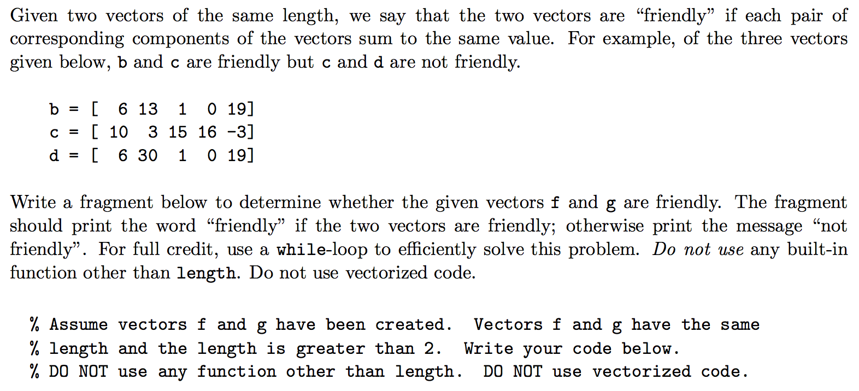

**Q10:**

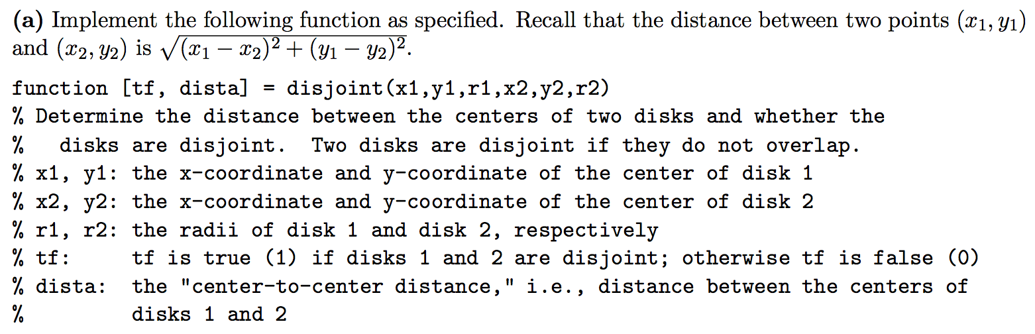

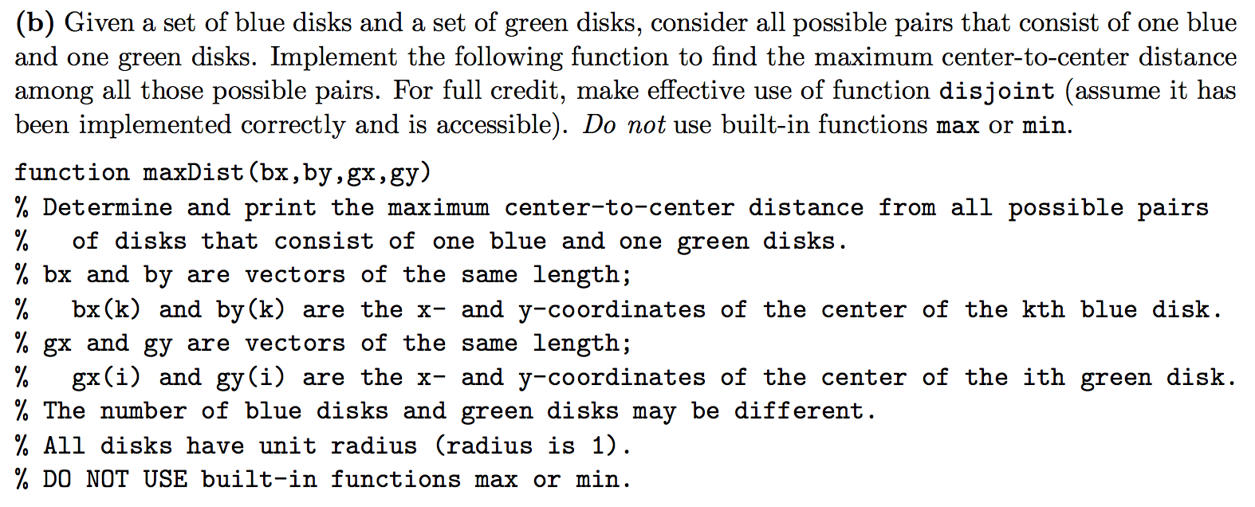

**Q11:**

A mode is the number in a sequence that appears the most number of times. A user is prompted to enter a sequence of non-negative numbers in non-decreasing order one-by-one. The user indicates the end of the sequence by entering a negative number. Write a script to obtain such user input and determine the mode of the sequence. If there are multiple modes, you may report any one of them as the mode. **Do NOT use arrays.** Below is an example run:

Determine mode of a set of nonnegative integers.

Use a negative number to quit.

Give me a number: 70

Another number not smaller than the previous: 71

Another number not smaller than the previous: 80

Another number not smaller than the previous: 80

Another number not smaller than the previous: 80

Another number not smaller than the previous: 91

Another number not smaller than the previous: 93

Another number not smaller than the previous: -1

Mode is 80 which occurred 3 times.

Answers:

**Q11:**

% Example program for computing the mode of a sequence of integers.

disp('Determine mode of a set of nonnegative integers.')

disp('Use a negative number to quit.')

previous = -1; % Previous number seen

count = 1; % Count of current number

mode = -1; % Mode seen so far

modeCount = 0; % Count for mode so far

number = input('Give me a number: ');

while number >= 0 % Quit when negative number is encountered

if number == previous % same run, so increment count

count = count + 1;

else % new run, so reset count

count = 1;

end

if count > modeCount

mode = number;

modeCount = count;

end

previous = number;

number = input('Another number not smaller than the previous: ');

end

if mode == -1

disp('Mode is undefined')

else

fprintf('Mode is %d which occurred %d times.\n', mode, modeCount)

end