2D Seismic Data Classification using Convolutional Neural Network and 2D Synthetic Data

Alice Y. Yang, Musa Manzi, Michael Westgate, and Ling Cheng

Johannesburg, South Africa

Abstract

The following paper looks at classifying 2-dimensional seismic data extracted from South African geo-location using a Convolutional Neural Network (CNN) that is trained with synthetic data. The purpose of this paper illustrates the difficulties in working with seismic data and the precision needed for au- tomating feature extraction within the CNN architecture in order to achieve a 90%. The CNN architecture is mainly constructed using 2D convolutional and max-pooling layers.

Keywords: 2D Seismic Data, Convolutional Neural Network, Synthetic Data

1 1. Introduction

2 In the recent years, Artificial Intelligence (AI) has grew exponentially

3 and is applied to various disciplines and it is no surprise that it has found its

4 way into amongst geologist in the geology field. Given that geologist work

5 with large quantities of geological data to map both the surface of the earth

6 and the mapping of faults below the surface, there is an enormous data and

7 potential for AI. The traditional method of interrupting subsurface data in-

8 cludes manual fault picking and horizons on section, which is then followed

9 by qualitative enhancements [1]. The qualitative enhancement techniques in-

10 volves structurally-oriented semblance, tensor, dip, and etc. for highlighting

11 the fault structure within the subsurface seismic dataset [1].

12 This paper addresses alternative approaches for classifying seismic data

13 using Artificial Intelligence and more specifically, using the Convolutional

14 Neural Network (CNN) for classifying 2D seismic image data. The objective

15 of the purposed technique is to detect whether there is intersecting fault or

Preprint submitted to Journal Name January 3, 2021

16 none-intersecting within 2D seismic data. The paper is structured in such a

17 manner where Section 2 gives a brief background of the techniques used in

18 the proposed technique. Section 4 describes the methodology and the process

19 of achieving the results addressed in Section 5 before finally concluding in

20 Section 7.

21  2. Background

22 2.1. Convolutional Neural Network

23 The Convolutional Neural Network (CNN) is a subsidiary of supervised

24 technique within in the deep learning field. It is commonly employed for

25 image classification purposes due to its exceptional ability to purpose image

26 analysis using the mathematical convolutional operation and obtaining high

27 classification accuracies [2, 3]. Due to the CNN’s high classification accu-

28 racy, it has been utilised within multiple fields including the geological realm

29 for earthquake detection and location [4], seismic inversions [5], and fault

30 detection [6, 7].

31 Given that the CNN is a supervised neural network, it learns images fea-

32 tures based in order to form an end-to-end model with the trained parameters

33 through the gradient descent method. Therefore, the CNN model makes use

34 of connected weights within the network as a form of sharing “knowledge”

35 and reducing the number of training parameters, and as a result also reducing

36 redundant complexity [3, 8]. In general, the first few layers of the CNN archi-

37 tecture consists of convolution and pooling layers, whilst the layers following

38 there after are fully-connected network [3, 9].

39 The training of the CNN is conducted mainly using both back- and for-

40 ward propagation algorithms to adjust the weights of the neurons based on

41 the given training data. The objective of the back-propagation algorithm is

42 to adjust the weights to minimise loss based on the network’s overall outcome

43 and the target. The network’s overall outcome is obtained using the forward

44 propagation. The back-propagation loss function, E(W, b) is expressed in (1)

45 as the Mean Squared Error (MSE).

|Y |

1 *−*

E(W, b) = (Y (i) Y¯ (i)2), (1)

|Y | i=1

46 where W is the weight value and b is the b is the bias value. Both the weight

47 value, W and bias value, b are updated during the back-propagation training

48 according to (2) and (3), respectively.

Wi = Wi − η

∂E(W, b)

∂Wi

(2)

bi = bi − η

49 where η is the learning rate.

∂E(W, b)

∂bi

, (3)

50 3. Literature Review

51 Wu, X. et al.performed image-to-image binary fault detection using a

52 fully-supervised CNN [6]. The authors made use of 3D seismic images which

53 where labelled with ones for fault and zeros elsewhere. The CNN model was

54 trained with 200 3D synthetic seismic images with a 128 128 128 dimension

*× ×*

55 for each fault and non-fault category. The training of the neural network was

56 performed on a TITAN Xp GPU which took the authors approximately 2

57 hours to train. The authors validated the network with 20 pairs of unseen

58 synthetic image data, in which the network achieved a 95% classification

59 accuracy. The generated synthetic data consists of faults at varying angles,

60 specially at 90◦, 180◦, and 270◦. Additionally, the authors applied the trained

61 CNN to detect faults on surveyed 3D data from four different locations,

62 namely the Netherlands off-shore data, Clyde Petroleum Plc., Costa Rica

63 margin North West of Osa Peninsula, and Campos Basin which is off-shore

64 of Brazil.

65 Zheng, Y. et al. presents two separate case studies involving supervised

66 deep learning as an alternative for the conventional techniques in seismic

67 data interpretation and inversion [10]. In the first case study, the authors

68 apply the CNN for seismic image classification as a way of interpretation.

69 The CNN is trained with 3D seismic volumes, such that images are classi-

70 fied into two categories, namely, fault and non-fault. The fault data consists

71 of certain dips as well as azimuth, which are distinguishing features in the

72 data considered as faults. In the second case study, the authors present an

73 elastic model building, in which a CNN is trained to perform predictions

74 of 1D velocity and density profiles within the given seismic data. In both

75 case studies, the authors have trained the CNN models using synthetic data

76 and tested the models on survey field data. The authors have found that

77 both CNN models obtained effective and efficient predictions when testing

78 on field data, therefore showing high-quality fault picks. However, challenges

79 are presented when the authors worked with pre-stacked seismic inversions,

80 where subsurface geological variations and preconditioning of the input seis-

81 mic data plays an important factor in the ability of the CNN models to

82 perform accurate predictions.

83 The author, Zhao, T. presents an encoder-decoder CNN model for seismic

84 facies classification [11]. The architecture of the encoder-decoder CNN model

85 consists of an encoding component, in which the input data given to the

86 model is reduced and a decoding component, whereby the reduced data is

87 then expanded once again. The purpose of the encoding component is to

88 reduce the input data such that only the significant portions of the input data

89 is kept, whilst the decoding component further highlights and expands on the

90 significant data such that contributing noise within the input data is removed.

91 This allows for enhanced fault predictions in seismic faces. Additionally, the

92 author has compared the presented CNN model to the architecture of the

93 more traditional patch-base CNN model, in which the author found that the

94 patch-base CNN model requires less training effort compared to the encoder-

95 decoder CNN model, however the patch-based CNN produced suboptimal

96 predictions compared to the encoder-decoder CNN.

97 Di, H et al. introduces a CNN model for the application of salt-body

98 delineation from 3D seismic data [12]. The authors have found the imple-

99 mentation of the CNN model is far more superior when compared to the tra-

100 ditional schemes of sample-based multi-attribute classification. The imple-

101 mented CNN model takes the local seismic patterns which are distinguishing

102 features within the target salt-body. Furthermore the CNN allows for op-

103 timal mapping relationship between the seismic signals and the salt-bodies,

104 and as a result it does not require laborious manual attribute selection as

105 performed in the traditional classification schemes. The CNN model was

106 trained using synthetic data from the SEG-SEAM dataset.

107 Xiong, W. et al. developed a method which employs the CNN to auto-

108 mate and map fault detection in 3D seismic images to mimic the traditional

109 approach by interpretors. The CNN is trained with image cubes obtained

110 from field data which are labelled as either fault or non-fault. The trained

111 CNN is then applied to unseen field data to predict the fault probabilities at

112 every location with given cube images. The authors have been able to obtain

113 a 99% classification accuracy using the trained CNN.

114  4. Methodology

115 The technique consists of two processes. The first process is training the

116 CNN and the second is applying the trained CNN to unseen 2D seismic data

117 extracted from South African geological sub-surfaces. The two processes are

118 illustrated in Figure 1, in which the training process is depicted on the left and the testing process on the right.

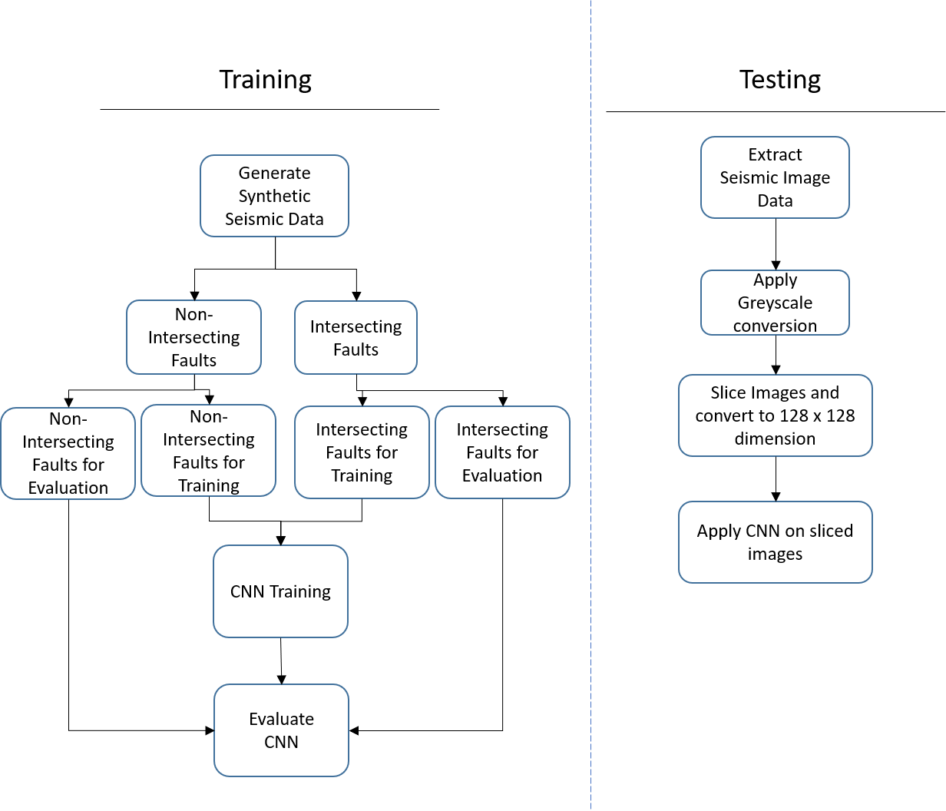

Figure 1: Diagrams illustrating the training and testing processes involving the Convolu- tional Neural Network.

119

120 4.1. Training Images

121 The data used for training the CNN is taken from [https://github.](https://github.com/xinwucwp/faultSeg)

122 [com/xinwucwp/faultSeg](https://github.com/xinwucwp/faultSeg), whereby the data is given as 3D 128 × 128 × 128

123 seismic data, which is generated by Wu, X. et al [6]. The data is transformed

124 from 3D to 2D, by taking slices of the 3D block to generate 2D 128 128

*×*

125 seismic data. From the synthetic data, only the seismic data which has

126 intersecting and none-intersecting faults are selected. Figures in 2 and 3

127 illustrates the training data. Both images 2(b) and 3(b) are not used as part

128 of the training data, however are used to assist in the labelling of intersecting

129 and non-intersecting fault data. A total of 350 seismuc images are used in

130 each category for the training of the CNN.

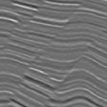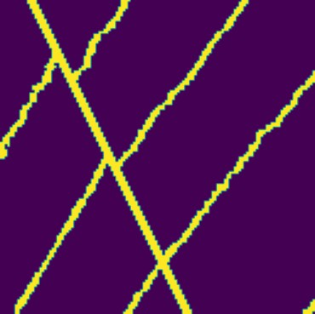

(a) Seismic Image with Intersect- (b) Hightlighted Intersecting Fault

ing Fault in Seismic Image

Figure 2: Images illustrating the Intersecting Seismic Data and Highlighted Faults in the Seismic image.

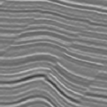 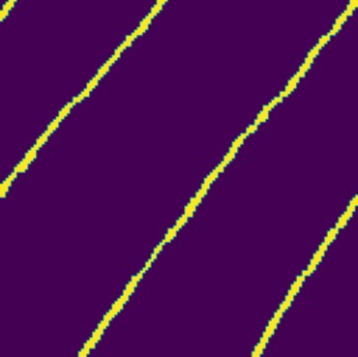

1. Seismic Image with Non- (b) Hightlighted Non-Intersecting

Intersecting Fault Fault in Seismic Image

Figure 3: Images illustrating the Non-Intersecting Seismic Data and Highlighted Faults in the Seismic image.

131 4.2. Convolutional Neural Network Architecture

132 The CNN is comprised of three distinct layers excluding the input and

133 output layer, namely 2D convolutional, max pooling and fully connected

134 layers. There are a total of four hidden layers in the neural network ar-

135 chitecture. The 2D convolutional layer makes use of the Rectified Linear

136 Unit (Relu) function. Figure 4 shows the detailed architecture of CNN. The

137 CNN is trained with 25 epochs. Figure 5 shows the accuracy and validation

138 accuracy of the CNN at each epoch.

Image

128x128

2

1x1x64

64

102x102x128 27x27x128

Convolution + ReLU Max Pooling Fully Connected Output

Figure 4: Figure illustrating the architecture of the Convolutional Neural Network

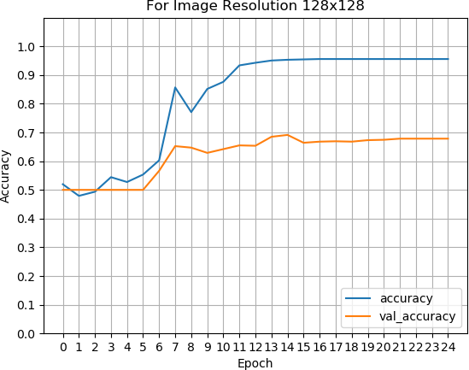

Figure 5: Figure illustrating accuracy of the CNN at each epoch

139 4.3. Seismic Data Testing

140 The seismic testing data consists of surface and edge detected images of

141 the orebody. The two image considered as shown in Figures 6 and 7, in which

142 both images are taken from a South African gold mine.

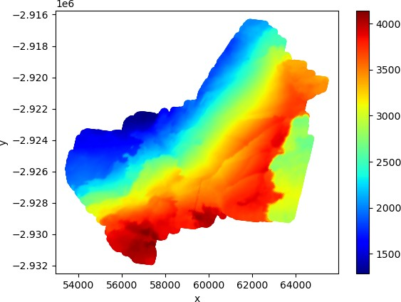

Figure 6: Figure illustrating the orebody surface extracted from a gold mine.

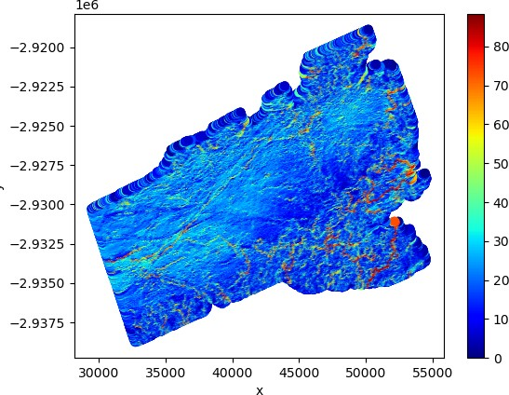

Figure 7: Figure illustrating the orebody surface with highlighted edges extracted from a gold mine.

143 Figure 7 has been further processed in order for the fault edges to be

144 highlighted. A closer and more detailed illustration of of both Figures 6 and

145 7 are shown in Figures 12(a) and 12(b). The detailed images are generated

146 through the process of slicing the original seismic image data. The process is

147 illustrated in Figure 10, whereby the process consists of converting the orig-

148 inal image into greyscale, followed by slicing the images into equal segments

149 before finally resizing the segmented images to images with the dimensions

150 of 128 128, using the k-nearest neighbour method.

*×*

153  5. Results

154 The segmented images from the different mines are fed into the CNN. The

155 results of the CNN are shown in the following section for the datasets from

156 gold, and oil and gas mines. Figures 15 and 16 illustrates the classification of

157 crossing faults (“x”) and none-crossing faults (“none-x”) are present in the

158 surface orebody image and highlighted edge image, respectively.

159 The result of the CNN for Figure 15 indicates that the CNN has classified

160 the surface image data as being an image with crossing faults based in the

161 training of the CNN, in which the classification is based on a 53% assurance.

162 This shows that CNN identifies 47% of none-crossing faults within the given

163 image. However since there are more crossing faults presented, the image is

164 classified in the category of having crossing faults.

165 Figure 16 shows the result of the CNN for highlighted edges for data

166 taken in a gold mine. With the highlighted edges the CNN can distinctively

167 identify with 99% confidence that the image is categorised as having crossing

168 faults, whilst there is still a 1% chance that there is non-crossing faults within

169 the section of data.

170 For the surface data taken from oil and gas mines, Figure 17 shows that

171 the CNN has a 71% confidence in classifying the given image as having none-

172 crossing faults, whilst having a 29% chance of having crossing faults within

173 the image. These crossing faults are difficult to identify with the naked eye.

174 However, it is presented in the bottom right corner within the image.

175 The classification of the highlighted edge image for the gas and oil mine

176 data is similar to that of the gold mine shown in Figure 18. The CNN is 97%

177 confident in classifying the given image as having crossing faults.

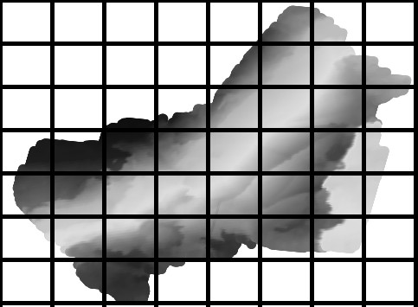

Figure 10: Slicing process of gold mine seismic image data for Figure 6.

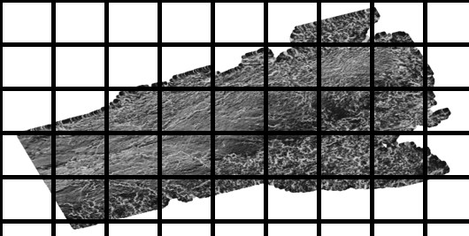

Figure 11: Slicing process of gold mine seismic image data for Figure 6.

 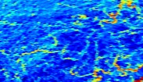

* 1. Surface Seismic Data (b) Hightlighted Edge Surface Data

Figure 12: Images illustrating both seismic orebody surface and highlighted edge surface data taken from two different gold mines.

178 6. Application

179 The results of the CNN in the classification of images with crossing and

180 non-crossing faults are promising as discussed in Section 5. Therefore, the

181 CNN can be applied to a set of data, in which it the areas of the image are

182 segmented into a number of images. This is illustrated in Figure 19. The

183 segmented images are then fed into the CNN to determine areas that consist

184 of a high density of intersecting faults, whilst all background images that

185 holds little to no information about the image data are disregarded.

186 The process depicted in Figure 19 is applied to the Figure 6 to deter-

187 mine the density of intersecting faults within the seismic data. The density

188 of intersecting faults is measured by the confidence level of the CNN in its

 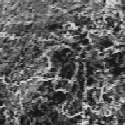

(a) Processed Surface Seismic Data (b) Processed Hightlighted Edge

of 14(a) Surface Data of 13(b)

Figure 14: Images illustrating both the processed seismic orebody surface and highlighted edge surface data.

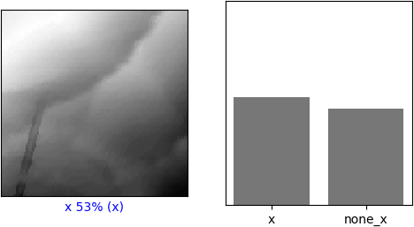

Figure 15: Figure illustrating the CNN classification result of Figure 14(a)

189 prediction of whether the segmented image is classified into the intersect-

190 ing and non-intersecting fault categories. The measurement is based on the

191 training of the CNN model, therefore a higher confidence in category predic-

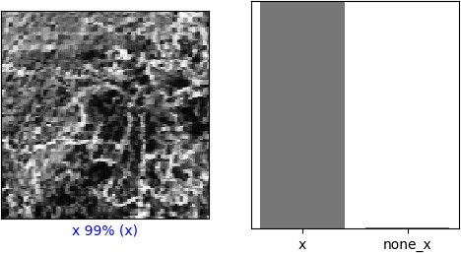

Figure 16: Figure illustrating the CNN classification result of Figure 14(b)

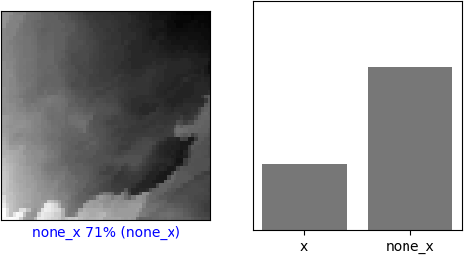

Figure 17: Figure illustrating the CNN classification result of Figure ??

192 tion shows that there is a higher likelihood of high density of the predicted

193 category. The prediction results shown in Figure 20 indicate that there is a

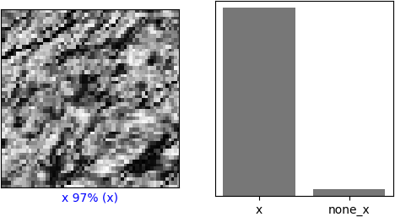

Figure 18: Figure illustrating the CNN classification result of Figure ??

194 low density of intersecting faults in majority of the surface image segments of

195 Figure 6, whilst there is a single segment with 81% confidence for classifying

196 the image segment in the intersecting fault category.

197 The results shown in Figure 21 is generated from Figure 7. The results

198 show more certainty in classification by the CNN in comparison to the results

199 shown in Figure 20. Therefore, with the highlighted edges provides additional

200 information to the CNN model for classification purposes. However, it must

201 be noted that the texture of within Figure 7 is similar to the training images

202 used in the training of the CNN, in which this is a contributing factor to the

203 increased decisiveness in categorising the image segments into intersecting

204 and non-intersecting categories. Whereas, the texture in Figure 6 has a

205 smooth texture in comparison to Figure 7, therefore the results presented

206 show a more indecisive prediction in the 50% to 60% range.

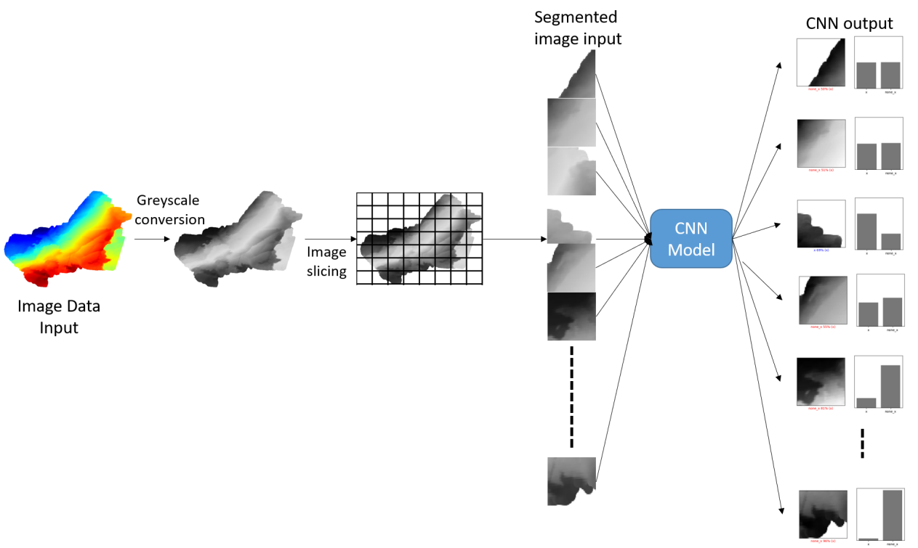

Figure 19: Diagram showing the process in the application of the CNN model. The diagram includes the processing of the seismic image data.

207  7. Conclusion

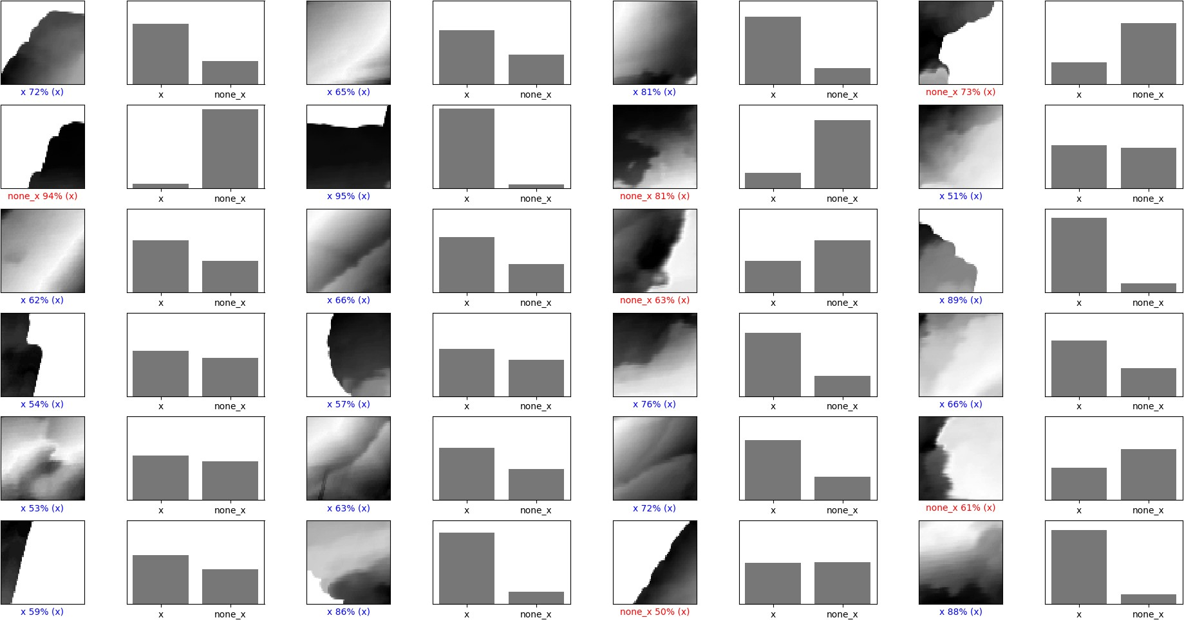

Figure 20: Figure illustrating region classification for the crossing fault detection for gold mine orebody surface

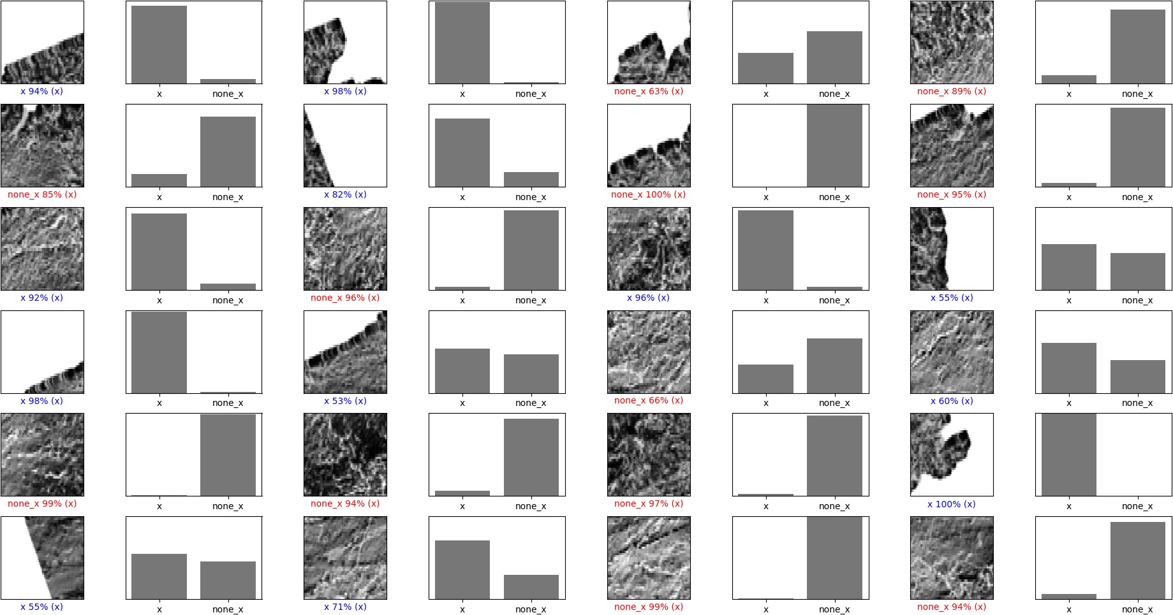

Figure 21: Figure illustrating region classification for crossing fault detection for the gold mine edge image data

208 References

209 [1] J. Lowell, P. Szafian, N. Tessen, Artificial Intelli-

210 gence and Seismic Interpretation, GEO ExPro (2019).

211 URL: [http://www.geoexpro.com/articles/2019/05/](http://www.geoexpro.com/articles/2019/05/artificial-intelligence-and-seismic-interpretation)

212 [artificial-intelligence-and-seismic-interpretation](http://www.geoexpro.com/articles/2019/05/artificial-intelligence-and-seismic-interpretation).

213 [2] A. Krizhevsky, I. Sutskever, G. E. Hinton, Imagenet classification with

214 deep convolutional neural networks, Communications of the ACM 60

215 (2017) 84–90.

216 [3] W. Zhiqiang, L. Jun, A review of object detection based on convolu-

217 tional neural network, in: 2017 36th Chinese Control Conference (CCC),

218 IEEE, 2017, pp. 11104–11109.

219 [4] T. Perol, M. Gharbi, M. Denolle, Convolutional neural network for

220 earthquake detection and location, Science Advances 4 (2018) e1700578.

221 [5] V. Das, A. Pollack, U. Wollner, T. Mukerji, Convolutional neural net-

222 work for seismic impedance inversion, in: SEG Technical Program Ex-

223 panded Abstracts 2018, Society of Exploration Geophysicists, 2018, pp.

224 2071–2075.

225 [6] X. Wu, L. Liang, Y. Shi, S. Fomel, Faultseg3d: Using synthetic data

226 sets to train an end-to-end convolutional neural network for 3d seismic

227 fault segmentation, Geophysics 84 (2019) IM35–IM45.

228 [7] W. Xiong, X. Ji, Y. Ma, Y. Wang, N. M. AlBinHassan, M. N. Ali,

229 Y. Luo, Seismic fault detection with convolutional neural network, Geo-

230 physics 83 (2018) O97–O103.

231 [8] N. Chumerin, Convolutional neural network, Neurocomputing 148

232 (2015) 136–142.

1. [9] Y. LeCun, L. Bottou, Y. Bengio, P. Haffner, Gradient-based learning

234 applied to document recognition, Proceedings of the IEEE 86 (1998)

235 2278–2324.

236 [10] Y. Zheng, Q. Zhang, A. Yusifov, Y. Shi, Applications of supervised deep

237 learning for seismic interpretation and inversion, The Leading Edge 38

238 (2019) 526–533.

239 [11] T. Zhao, Seismic facies classification using different deep convolutional

240 neural networks, in: SEG Technical Program Expanded Abstracts 2018,

241 Society of Exploration Geophysicists, 2018, pp. 2046–2050.

242 [12] H. Di, Z. Wang, G. AlRegib, Deep convolutional neural networks for

243 seismic salt-body delineation, in: AAPG Annual Convention and Exhi-

244 bition, 2018