Alice Zhang

Assignment 5 Deliverable

Low-Fidelity Prototype

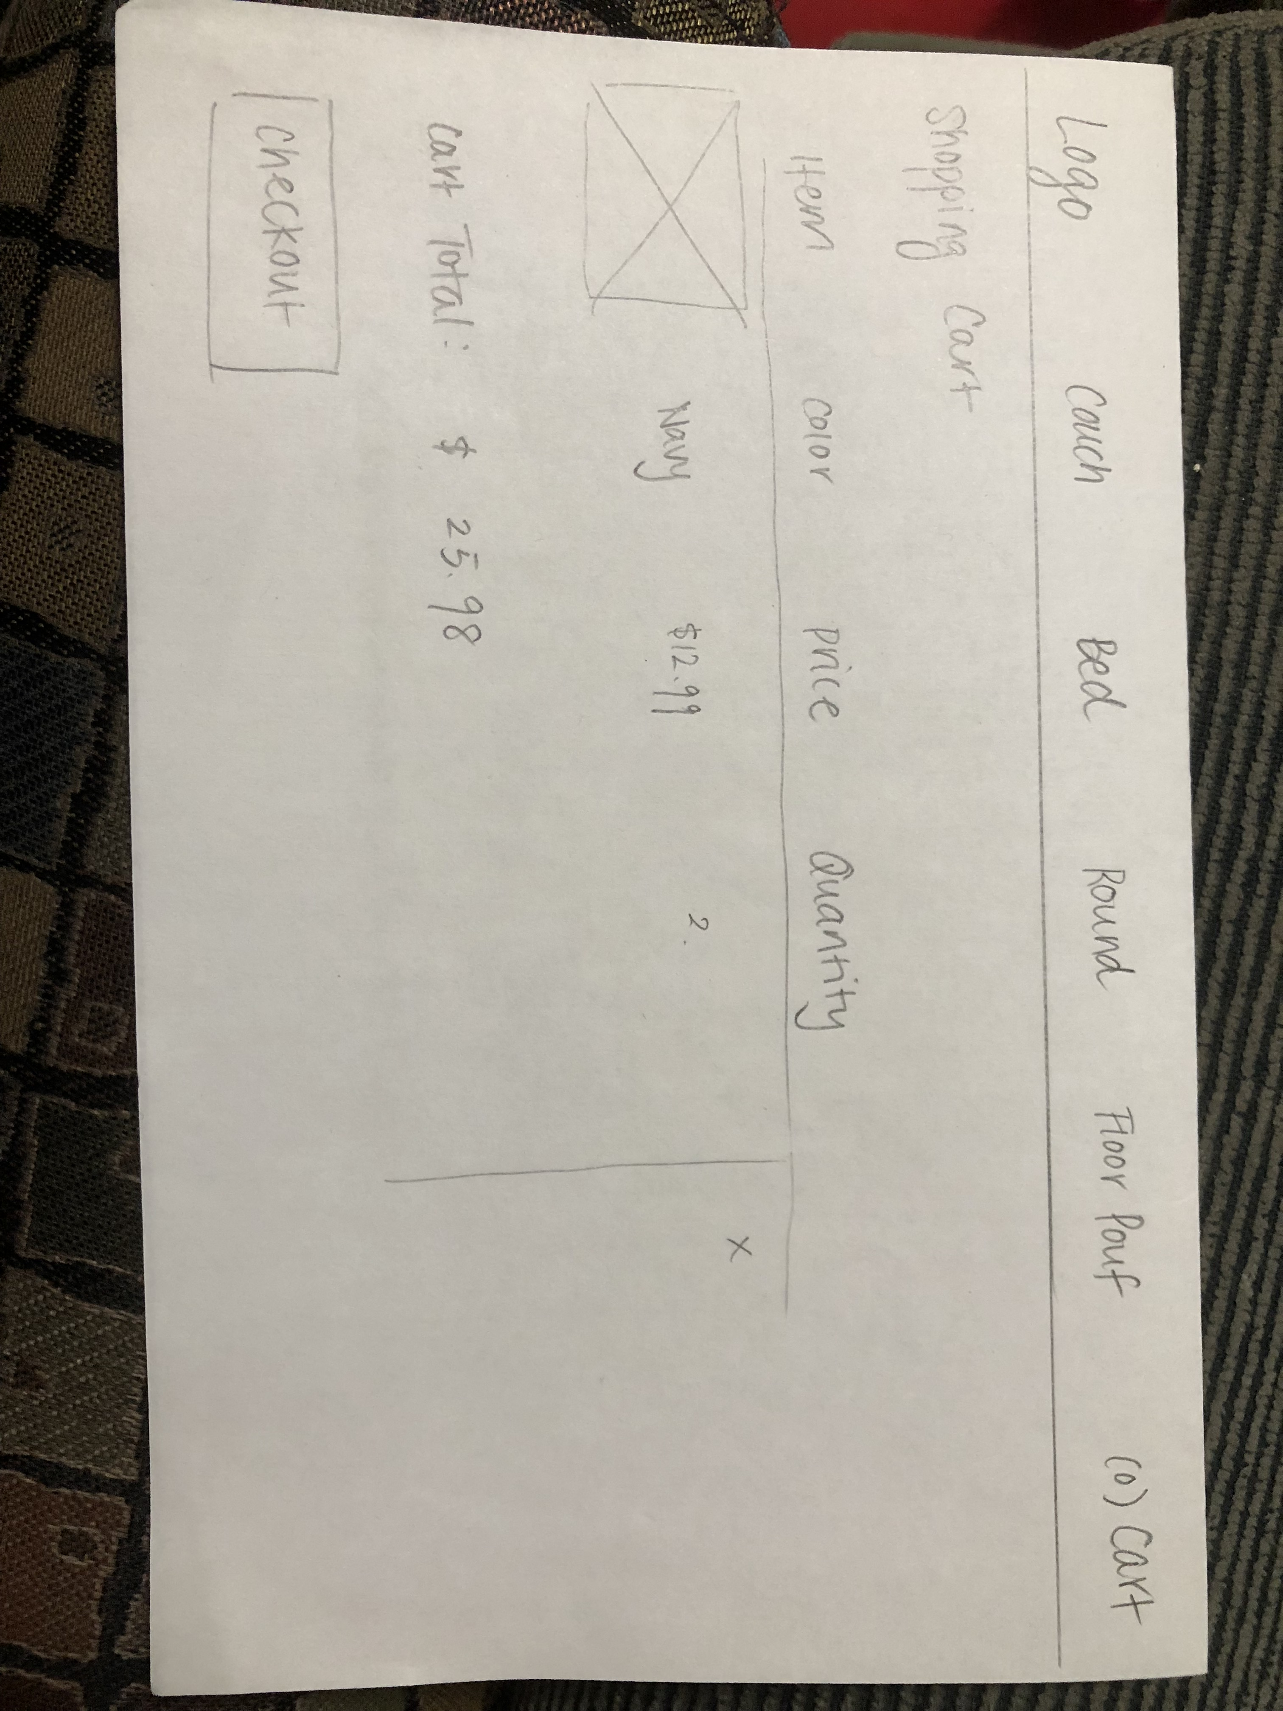

Hi-Fidelity Prototype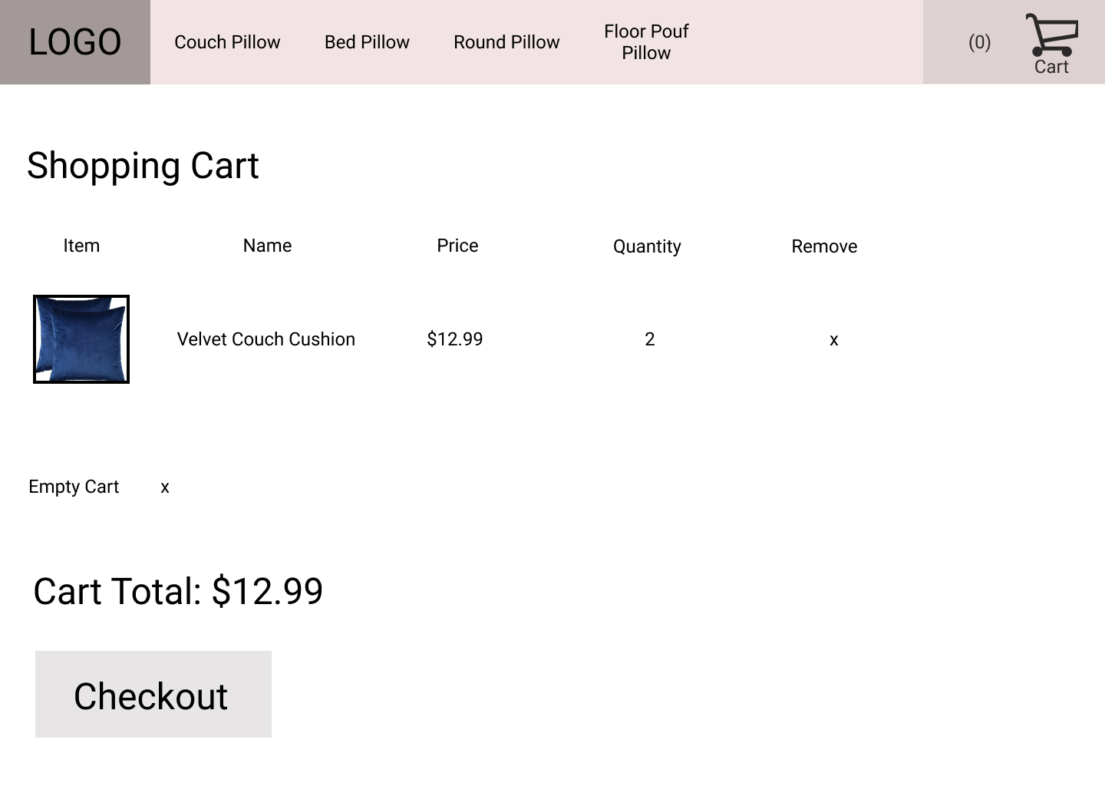

1. Design Choices

One thing I changed from the product detail page from Assignment 4 was the quantity option. I changed it to a drop down menu. The default is 1 and users can select any number up to 10. I chose to use a drop down and limit the max number so users have less of a chance of wrongly inputting a number. In the new shopping cart page, I chose to display relevant information for each of the product in the shopping cart. This includes the image in addition to the name of the product so users have a visual idea. It is often easier to remember and recall images than the name. Additionally, users are likely to care about the price of the objects and the quantity to check that they did not wrongly order the wrong number. If they do, it is important to be able to remove the item. I also included an empty cart option so that if users wish to start over, they can easily do so with and remove every item rather than each one individually.

3. Challenges and Solutions

I initially hard coded changes to the product options but found it very difficult when adding the product to cart so I switched to saving the product attributes in an object. Additionally, after I was able to add objects to the shopping cart, I ran into the problem of each object added would be a new row, even if the user selects the same object. Therefore, I had to create an array of objects so that every time I added a new object, my function would run through the array to check to see if the object already existed. If it did, the quantity would increase. Another problem I ran into was that in my shopping-cart.html, $(document).ready(function(), the table tag kept closing before I wanted it to so it was only displaying the first row. I overcame this by using “\” and adding the <\xxx> tag on to the end of my JSON string.