

CST1510
Programming for Data Communication and Networks

Coursework 2
Multi-Domain Intelligence Platform
Module Tutor:
Santhosh Menon

Name: Mohammad Ali Chaudhary
Student ID: M01026895
Program: Cyber Security and digital forensic
GitHub Repository (Labs): https://github.com/alichaudhary150508/Coursework-2-Labs
GitHub Repository (Coursework): https://github.com/alichaudhary150508/CST1510_CW2_MohammadAliChaudhary_M01026895
Context

Abstract

1 Introduction

2.1 Security & Database

2.2 System Structure

2.3 Code Organization (Optional: OOP Refactoring)

2.4 Key Features

3. Reflection & Conclusion (200-500 words)

3.1 What I Learned

3.2 Challenges I Faced

3.3 Conclusion

Abstract
This report covers the development of a Multi-Domain Intelligence Platform. It explains how a secure login system using hashed passwords was made, how user data is stored in text files and in SQL, and how the application is structured across five interactive pages with CRUD functions. Additionally, the report also describes the code organisation using a user class, the visual charts created for data analysis, and the AI chatbot connected to the dataset. Finally, it includes a reflection on what I learned, the challenges I faced, and the overall outcomes of the project.

1. Introduction
The Multi-Domain Intelligence Platform is an integrated system that gathers, analyses, and connects information across multiple domains, such as cyber, physical, operational, and informational environments to give users a unified understanding of complex situations. It strengthens data from diverse sources, applies advanced analytics or AI, and turns raw information into actionable insights. By linking patterns, and activities across domains, the platform helps organizations detect threats, predict emerging risks, and make faster better-informed decisions. Ultimately, it enables coordinated responses, improves situational awareness, and supports strategic planning in environments where information is vast, fragmented or rapidly changing.

I chose to do all three domains (Cybersecurity, Data Science and IT Operations) for this coursework and attempted to implement Tier 3.

2.1 Security & Database
For the log in system, I protect the user passwords by hashing them. Hashing means turning a password into a long, scrambled code using a one-way formula. This code cannot be turned back into the original password. When a user logs in, their password is hashed again and compared to the stored code. If the two match, access is granted. This way, the real password are never saved. So even if someone accesses the file or database, they only see unreadable hashes, not the actual password.

The user’s data is stored in two places. An SQLite database, and a simple text file. The database contains a user’s table created through SQL, which stores usernames, hashed passwords, emails, and names in structured columns, when a new account is created, the details are inserted into this table using “add_user_to_db().” At the same time, a text file stores usernames, and hashed password for quick lookup, ensuring both organization, and security.

Security is vital because it protects sensitive information, ensures privacy, and safeguards systems from malicious attacks. Without security, personal data, financial assets, and even national infrastructure can be compromised, leading to loss, fraud or damage. It builds trust, enables safe transactions, and ensures the stability of digital environments.

2.2 System Structure
The data in my applications is getting stored in an SQL table, and a “txt.” The SQL table stores the user’s username, hashed password, email, first name, last name, and the date the account was created. The “txt” file only stores the username, and the hashed password. Additionally, the data from the “cyber_incidents.csv”, “it_tickets.csv” and “datasets_metdata.csv” file is being stored in an SQL table.

The application has 5 pages. Home, Cyber Incidents, Data Science, IT Operations and Dashboard. When the user successfully logs in, the Home page layout changes, and 5 buttons a presented to the user, “Cyber Incidents”, ”Data Science”, “It Operations”, “Dashboard”, and “Logout”. When the user clicks on Cyber Incidents, for example, the users page will switch to the Cyber Incidents page using “st.switch_page()”, each page has “CRUD” implemented (Create, Read, Update, Delete). The same applies for when the user clicks any of the page buttons. However, when the user clicks the Logout button, the user is logged out and will be taken to the Login/Register page again.

2.3 Code Organization (Optional: OOP Refactoring)
The user information is organized into a class called “User”, which groups all the user data, and actions together. The “__init__” method sets up the users’s basic information like username, email, and password, and includes optional attributes like “first_name”, and “last_name.” This makes the code cleaner, and easier to maintain by keeping all related data in one place. Instead of having separate variables for each piece o fuser information, the class bundles everything together, which makes it simpler to update or change. For example, if I wanted to add a function to update a user’s email or password, I could do that within the class without affecting other parts of the code. This refactoring helps improve the readability of the code, makes it more flexible, and makes future changes easier. It also allows me to easily add more features, like adding new methods or improving security.

2.4 Key Features
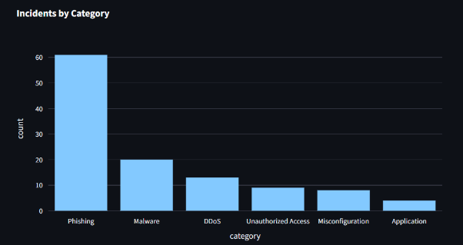
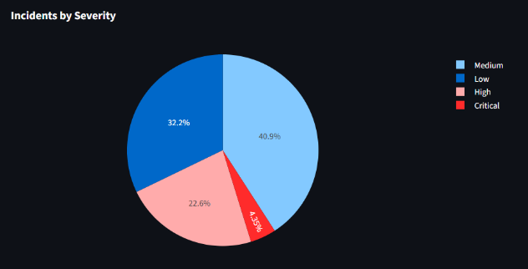
For my app, I have included many different charts such as pie charts, bar charts and more. This data in the charts include Incidents by severity, category, over time.

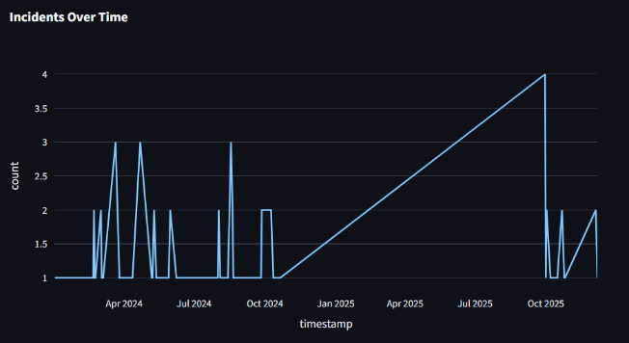

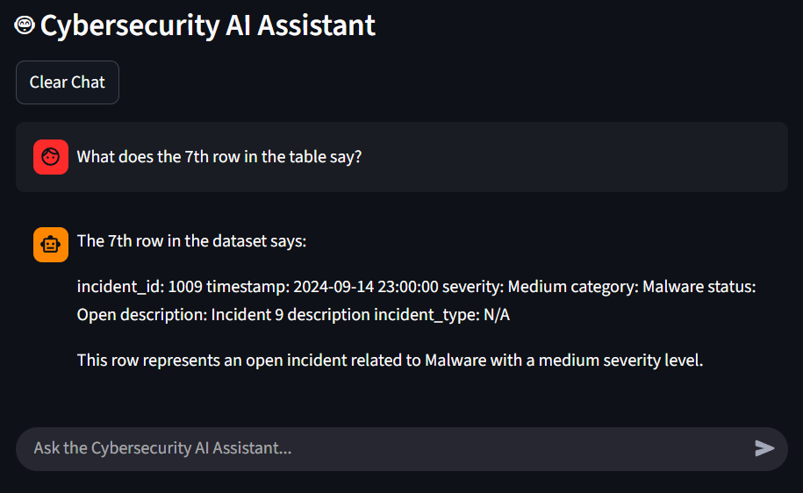
The AI features for this app is quite fascinating. The user can ask questions such as what do you do? What does the 7th row in the table say? And the AI will respond. The API Key used for the AI chatbot was from open router, without the API Key the chatbot will not work. The AI is linked to the CSV table by embedding the first 40 rows of the dataset as a CSV-formatted string into the system message sent to the OpenAI model. This dataset is then used by the AI to analyse and respond to the user queries about the cyber incidents.

3. Reflection & Conclusion (200-500 words)
3.1 What I Learned

There is doubt that I learned a lot from this coursework, I learnt about hashing, API Keys and much more. Learning about stream lite would most likely be my most valuable skill gained as I was taught how to make UI such as buttons, charts, text and text boxes. When it comes to which technical concepts were most useful, it would go to learning about AI and the API Keys. This is because of how popular AI has got over the years; therefore, it would be essential to know about it.

Over time, my understanding on this project has gotten better as the weeks went along. Learning new features every week was crucial and well planned as there was enough time to go over the topic before starting a new one.

3.2 Challenges I Faced
On this journey I faced many challenges, however, I tried my best to overcome them. I faced challenges such as errors, wrong table loading and SQL table not loading the data.

Solutions were some easy and hard, for example for the SQL table sometimes I would just have to close and reopen PyCharm. I did use AI to help me, for example, when making the AI, I had asked ChatGPT to fix the problem, however, even ChatGPT was still getting it wrong, so when I looked through the code I realised the code had the wrong URL for which API Key I was using, I was using Open Router but I think it had the URL for OpenAI. AI is very useful as it explains what the error is and gives a solution, helping to understand what is happening.

From this experience it has been made clear to me that I should not give up. There were times where I thought of just doing 1 domain and implementing tier 1, however, I am now working on all domains and trying to implement tier 3. When I get problems there is no point in worrying, what I should be doing is trying to fix them or to think of solutions.

3.3 Conclusion
The main achievement I would take away from this project would completing the app. After encountering many problems, I chose to continue doing all the domains aiming for a distinction.

Next time, it would be better to add excessive features that have not been asked. Reason for this is because it could gain me more marks and it could show the teacher how much more I am capable of.

