For Office Use Only (GSA)
Restricted access to viva approved? Yes / No
Time Specific viva required? Yes / No Date required by: ____ / ____ /____
Thesis title on eVision matches title on GSO.3 ❑
Thesis submitted / due to be submitted on: ____ /____ /____ GSA Acknowledged:________ (Initials)


APPLICATION FOR APPOINTMENT OF EXAMINERS

(D.Phil., M.Litt. M.Sc. By Research)

Candidates should read the notes entitled ‘Notes of Guidance for Research Examinations’ (GSO.20a) before completing this form and should return it to the relevant Graduate Studies Assistant (please refer to www.ox.ac.uk/students/academic/guidance/graduate/contacts for contact details) prior to thesis submission. The thesis should be submitted separately to the Examinations School. DPhil students: Confirmation of Status must be complete prior to the exam process commencing.
SECTION 1 – to be completed by the candidate. Please use BLOCK CAPITALS in all sections except ‘Title of thesis’.
Surname: | LLEDO LARA |  |  |  |  | Title (Mr/Mrs/Miss/Ms/etc): |  | MISS
First Name (in full): | ALICIA |  |  |  |  | Student Number: |  | 783229
College: | HERTFORD COLLEGE |  |  | Department: |  | NUFFIELD DEPARTMENT OF MEDICINE
Award for which you wish to submit your thesis:  (i.e.: DPhil/MSc By Research/MLitt) |  |  |  | DPHIL
Address for correspondence  (after submission of thesis): |  | TRINITY COURT 5, 4 BETWEEN TOWNS ROAD, OX4 3PP OXFORD, UK
Telephone Number: |  | 07427645988
Email Address - email communications from the Examination Schools relating to the examination of your thesis will be directed to your primary email, as indicated on Student Self Service. Please log in at www.evision.ox.ac.uk/ to check or amend your contact details.
Title of thesis: This is the title that will appear on your thesis and transcript. (Please print clearly including any desired capitalisation, punctuation, etc)
Cell and tissue specific functional genomics of psoriasis and psoriatic arthritis

Please indicate whether you are requesting a change of thesis title: |  |  |  |  |  |  | ❑X Yes ❑ No
If Yes, please state your most recently approved thesis title:
(Please note: if you are requesting a change of thesis title here, you do not need to also submit a separate GSO.6 (Change of title) form)
Functional genomics of psoriasis

Where submission of an integrated thesis is permitted by special regulations please indicate if you have received approval to submit an integrated thesis: https://www.admin.ox.ac.uk/examregs, |  |  |  |  |  |  | ❑ Yes ❑ No
Research Council-funded candidates: If you are requesting a change of topic, rather than an amendment to your existing title, please confirm that you have consulted with your funding body and received approval:
(If Yes, please attach any relevant documentation) (If you are an AHRC-funded student requesting a change of topic that has not yet been approved, you should contact the AHRC Studentships Officer now: ahrccomp@admin.ox.ac.uk)
❑ Yes ❑ No |  |  | Name of funding body:

SECTION 2 – statements to be completed by the candidate.
Please complete as appropriate in each case and supply details on a separate sheet if necessary (please note that copies of any separate sheets will be sent to your examiners, along with your thesis).
2.1 Statement of previous acceptance or concurrent submission of thesis for degree (please tick one box only)
X❑ | No part of my thesis has been accepted or is currently being submitted for any degree, diploma or certificate or other qualification in this University or elsewhere.
❑ | I attach on a separate sheet details of which part of my thesis has been accepted or is concurrently being submitted for a qualification in this University or elsewhere and I confirm that these are full and accurate. (Please attach THREE copies)
2.2 Statement of authorship (please tick one box only)
❑X | I confirm that the thesis I am submitting is wholly my own work.
❑ | I attach on a separate sheet details of which parts of my thesis are not my own work. (Please attach THREE copies)

2.3 Sensitive content
❑ | I have identified content in the thesis that is of a sensitive nature or where copyright is held by a third party and will take appropriate action before depositing the thesis in the Bodleian Library and ORA
2.4 Statement of thesis length
Candidates should check the regulations made by individual boards concerning word/page limits, and where applicable must state the approximate number of words in their thesis. Permission to exceed the word/page limit must be sought prior to the submission of the thesis and the GSO.3 and a copy of the approval letter attached to this form. A thesis which exceeds the stated limit, without approval, may be returned to the candidate.
Number of words/pages: |  | 57,000 words
2.5 Transfer of Status
Term transferred from PRS to D.Phil., M.Litt. or MSc by Research: |  |  | MICHAELMAS TERM 2016
2.6 Confirmation of Status (for D.Phil. Candidates only)
Please note that you must have completed your Confirmation of Status before submitting your thesis.
Term D.Phil. status confirmed: |  | TRINITY TERM 2017

SECTION 3 – submission details to be completed by the candidate.
3.1 Submission of thesis and abstract - please read carefully the notes accompanying this form (GSO.20a)
Please indicate when your thesis and abstract will be submitted. Please tick one box only:
❑X | (a) Two copies of my thesis and of the abstract were submitted to the Examinations School on: | 22/03/2019
❑ | (b) Two copies of my thesis and of the abstract will be delivered to the Examinations School before 5pm on: | / /
❑ | Note: this date may not be later than the last day of the vacation immediately following the term in which this form is being submitted. For clarification consult the relevant Graduate Studies Assistant (www.ox.ac.uk/students/academic/guidance/graduate/contacts/)
3.2 Resubmission fee – no fee is payable on initial submission
Are you resubmitting your thesis? |  |  | ❑ Yes ❑X No
A fee is payable on resubmission of a thesis and payment should be made online (http://tinyurl.com/8wj2cvt ) as soon as you receive notification that YOUR application for appointment of examiners HAS BEEN approved. Information on fees can be found at http://www.ox.ac.uk/students/academic/exams/research. Please note that YOUR THESIS WILL NOT BE SENT TO YOUR EXAMINERS until the resubmission fee has been paid.

SIGNATURE OF CANDIDATE:

Please check that you have completed all relevant sections of this form. After your viva, the Research Examinations Team will contact you where necessary to enquire whether you would like the examiners’ copies of your thesis returned. If you do not respond within 6 months, the copies will be destroyed.
I understand that information provided on this form will be held on the University’s administrative computer system for the purposes of student administration in accordance with the University’s Data Protection Policy, available at: http://www.admin.ox.ac.uk/councilsec/compliance/gdpr/universitypolicyondataprotection/
I agree that if successfully defended details of my thesis can be included in the publication of successful candidates for research degrees, which is circulated as appropriate to a number of libraries and other academic institutions in Europe, Canada and the USA.

I confirm that all the details given and declarations made are full and accurate.
Signature: |   ALICIA LLEDO LARA | Date: | 21/03/2019
Please also ensure that the following sections are completed by your supervisor and college before the form is returned to the relevant Graduate Studies Assistant - (please refer to www.ox.ac.uk/students/academic/guidance/graduate/contacts/ for contact details).
SECTION 4 – to be completed by the supervisor in consultation with the candidate. (BLOCK CAPITALS)
The supervisor is required to consult with the candidate concerning possible examiners, and to forward to the relevant board the names of suggested examiners together with details of any special considerations which the candidate or supervisor wishes to make known about any potential examiners. Where supervisors have other points about the thesis or examination which they wish to put to the board for possible communication to examiners, they are asked to do so on a separate sheet.
Statement by the supervisor
1. I have consulted with the candidate as required above. I support any application for change of thesis title which the
candidate has made in SECTION 1 of this form.
2. I certify that the candidate named above has pursued at Oxford the required course of research for the following number of terms in accordance with the provisions of the Examinations Regulations stated below |  |  |  |  |  | Terms
Minimum of 6 terms for D.Phil. (3 terms if candidate holds Oxford M.Litt., M.Sc., or M.Phil.). Minimum of 6 terms for M.Litt. Minimum of 3 terms for M.Sc.by Research.
3. I have checked and confirmed that the nominated external examiner (and the reserve) does not fall into any of the categories or circumstances that may be deemed conflicts of interest |  |  |  |  |  | X❑
Two examiners are required, normally one internal examiner and one external examiner (and one reserve for each).
FIRST CHOICE EXAMINERS
Internal examiner: |  |  |  |  | Informally invited? |  | X❑
Full name (including title and forename): |  | PROFESSOR PAUL BOWNESS
College (where applicable) |  | Professor of Experimental Rheumatology and Consultant Rheumatologist
Statement of Suitability/Additional Information (Oriental Studies requirement/Optional)
Professor Bowness is an experienced principal investigator with expertise in inflammatory arthritis, immunology and functional genomics applied to clinical samples.

Address:
Botnar Research Centre
Windmill Road
Oxford
OX3 7LD

Telephone number: | 01865 227 374 |  | Email address: | paul.bowness@imm.ox.ac.uk
External examiner: |  |  |  |  | Informally invited? |  | X❑
Full name (including title and forename): |  | Professor Anne Barton
Current position held: |  | Professor of Rheumatology and Honorary Consultant in Rheumatology
Statement of Suitability/Additional Information (Oriental Studies requirement/Optional)
Professor Barton is a leading international authority in human disease genomics, with a breadth of expertise that is highly relevant to the content of this thesis including psoriatic arthritis. She leads the Centre for Musculoskeletal Research and Arthritis Research UK Centre for Genetics and Genomics.

Address: | Division of Musculoskeletal & Dermatological Sciences  The University of Manchester  Oxford Rd  Manchester  M13 9PL
Telephone number: | +44 (0) 161 306 6000 |  | Email address: | Anne.Barton@manchester.ac.uk
SECOND CHOICE EXAMINERS
Internal examiner (reserve): |  |  |  |  | Informally invited? |  | ❑
Full name (including title and forename):
College (where applicable):
Statement of Suitability/Additional Information (Oriental Studies requirement/Optional)
Address:
Telephone number: |  |  | Email address:
External examiner (reserve): |  |  |  |  | Informally invited? |  | ❑
Full name (including title and forename):
Current position held:
Statement of Suitability/Additional Information (Oriental Studies requirement/Optional)
Address:
Telephone number: |  |  | Email address:

Supervisor:
Full name (including title and forename): |  | Julian Charles Knight
Address for correspondence:
Wellcome Centre for Human Genetics, Roosevelt Drive, Oxford OX3 7BN

Email address: | julian@well.ox.ac.uk
Signature: |  |  | Date: | 29th March 2019
Joint supervisor (if applicable): If you have further supervisors please attach details on a separate sheet.
Full name (including title and forename): |  |  | Dr. Antonio Berlanga-Taylor
Address for correspondence:
Email address: | a.berlanga@imperial.ac.uk
Signature: | 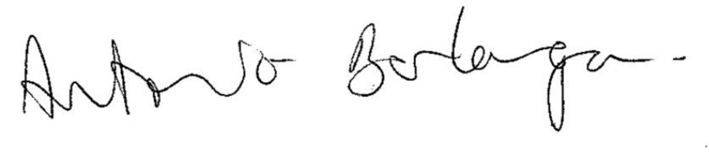 |  | Date: | March 19, 2019

SECTION 5 – to be completed by the college
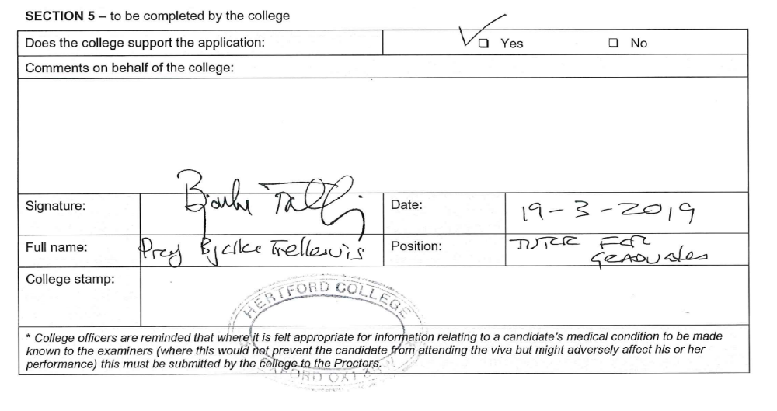

SECTION 6 – to be completed by the Director of Graduate Studies (or equivalent)
I certify that this application has the approval of the candidate’s department |  |  | ❑ Yes ❑ No
Signature: |  | Date:
Full name:
Note: Unless otherwise indicated, approval of this application will be taken to include approval of any change to thesis title which has been made by the candidate in SECTION 1.

SECTION 7 – Restriction of access at the viva (to be completed if appropriate)
Restriction of access at the viva
In the case of theses in Biological Sciences, Clinical Medicine, Mathematical Sciences, Physical Sciences, Physiological Sciences, and Psychological Studies, a candidate, supervisor or department may request that the attendance of any person or all persons at an viva (other than the candidate and the examiners) should be forbidden or subject to such conditions as the Proctors may impose.
Applications should indicate the reason for the request, e.g. that the presence of someone other than the examiners would put at risk confidential material or invalidate an application for a patent on a product or process covered by the thesis, and provide sufficient information for an informed judgement to be made. Applications made at the request of the candidate should be supported by the supervisor.
I request that access to the viva should be restricted for the following reason(s): Please supply supplementary material if necessary.
Signature: |  | Application made by: | ❑ Candidate ❑ Supervisor  ❑ Head of Department
In the case of applications made by the candidate:
I support the above application for the restriction of access to the viva for the following reason(s):
Signature of supervisor:

GSO.3. Revised July 2017

This page should only be completed where an examination result is required by a specific date, and for exceptional circumstances. The page should not be used to specify certain dates when an examination is preferred / not preferred – this should be negotiated directly in consultation with the examiners. Please ensure this page is included when the GSO.3 is submitted, regardless of whether a time specific exam request is made.

SECTION 8a – Application for Time Specific Examination
Applications can only be agreed for exceptional reasons, since the availability of examiners of national and international reputation is likely to be limited. Students and supervisors should not expect that applications for a time specific viva will be approved automatically.
Candidates may apply to the relevant board for the viva to be held not later than a certain date. Please note, the date cannot be earlier than one calendar month after the date on which the thesis has been received at the Examination Schools or after the date on which the examiners have agreed to act, whichever is the later. Also the date will depend on the availability of the examiners.
Date by when you wish to have your viva:
Reason for request: (please continue on separate sheet if necessary)

SECTION 8b – to be completed by the supervisor
Supervisor’s remarks: (please continue on separate sheet if necessary)
Signature: |  | Date:
Full Name:

SECTION 8c – to be completed by the Director of Graduate Studies (or equivalent)
Approved: |  | ❑ Yes ❑ No
Signature of DGS: |  | Date:
Full Name:

Regulations
Candidates may apply to the board of the faculty or department concerned for the oral examination to be held not later than a certain date, provided that this date shall not be earlier than one calendar month after the date on which the thesis has been received at the Examination Schools or after the date on which the examiners have agreed to act, whichever is the later. If the board is satisfied that there are special circumstances justifying this application, it will ask the examiners to make arrangements to enable the oral examination to be held within the period specified.
In such cases the examiners, when invited to act, will be informed that the candidate has asked that the oral examination should be held not later than a certain date, and acceptance of the invitation to examine will be on the understanding that they would seek to meet this request. If it is not practical to meet the student’s request, then the board/department shall decide how to proceed.
Note: Students must ensure that they can be readily contacted by the Research Examinations Team so that, if examiners are unable to meet a request for a viva by a certain date, alternative arrangements can be discussed.
Where students wish to apply for a time-specific examination, the form and the application for the appointment of examiners (GSO.3) should be submitted BEFORE the thesis so that the necessary approvals can be given in good time.

GSO.3. Revised September 2018

Conflicts of interest as set out in the Policy on Research Degrees Section 7: Examination (http://www.admin.ox.ac.uk/edc/policiesandguidance/policyonresearchdegrees/section7examination/#d.en.136869)

