# Sprint Summary Sprint #_1__

**Team Name: ValleyKidz**

**Member Names: Bruce Turner, Zachary Lindgren , Michael Britt, Alicia Buener, Jadivan**

**Scrum Master for this sprint: Alicia Buener**

**Site URL (if applicable): valleykidz.greenriverdev.com/valleykidz**

**Login credentials (if applicable): Login: jadivan pw: test Login: member pw: test**

**GitHub Repo (also submit URL in Canvas): https://github.com/aliciaNB/valleykidz**

**Trello Board: www.trello.com/valleykidz/home**

### Team/Stand-up Meetings ____ / 2 pts

The following team and stand-up meetings occurred during this sprint. Include meetings with and without the client, as well as pair-programming sessions. You should have at least *six* team meetings (three per week), outside of class, during each sprint.

Include both face-to-face and virtual meetings. (Face-to-face meetings are ideal, whenever possible.) Email and text does not count! For virtual meetings, identify the technology used under "Location", e.g. Google Hangouts, Skype, or Discord.

| **Attendees** | **Date/Time** | **Location** |
| --- | --- | --- |
| Jadivan, Bruce, Alicia, Zach, Mike | **10/11 8:30am – 9:45am** | **Valley Cities Auburn** |
| Jadivan, Bruce, Alicia, Zach, Mike | **10/16 8:30am – 9:45am** | **Green River Meeting room** |
| Zach, Bruce | **10/4 12:00pm- 1:30pm** | **Green River Meeting Room** |
| Jadivan, Bruce, Alicia, Zach, Mike | **10/15 12:00pm – 9:45am** | **Green River Meeting Room** |
| Alicia, Mike | **10/10 12:00pm -2:45** | **Green River Auburn Center** |
| Bruce, Alicia, Zach, Mike | **10/8 12:00pm- 2:00pm** | **Green River Auburn Center** |
| Bruce, Alicia, Zach, Mike | **10/3 12:00pm- 2:00pm** | **Green River Auburn Center** |
| Jadivan, Bruce, Alicia, Zach, Mike | **10/16 - 8:30am –**  **9:40 am** | **Green River Auburn**  **Center** |
| Michael, Zach, Alicia | **12:00pm – 3:00pm** | **Green River Auburn** |

### Definition of Done ____ / 3 pts

Every user story should meet the criteria in your Definition of Done. Add your own items to the checklist below, and check the items that have been completed for***every user story that was finished****.* Do not remove items from the list below, unless they are not relevant to your project. For example, if you are creating a desktop application, you may remove valid HTML and CSS.

* Code adheres to the documentation for styling that Valley Cities has provided.
* The code has been well commented and consistent.
* Code meets PEAR standards.
* Code passes applicable validation (HTML & CSS).
* Code adheres to HIPAA standards.
* All copy has been proofread for grammar and syntactic errors.
* The code has been checked in to the repository and has adequate commit comments.
* The product had been thoroughly tested meeting usability tests
* Works across browsers
* Has been mobile friendly tested.
* All code has been peer reviewed and signed off by at least one other team member.
* The product meets the client’s requirements and has been signed off by the client.

### Completion ____ / 6 pts

Enter the total story points *planned* and *completed* for this sprint.

**Total Points Planned: __51____ Total Points Completed: ____51__**

For a user story to be done, all of its *acceptance criteria* must be fulfilled. List each user story along with its points, status, and acceptance criteria. [What is the difference between acceptance criteria and the Definition of Done?](https://www.mountaingoatsoftware.com/blog/clarifying-the-relationship-between-definition-of-done-and-conditions-of-sa) You may copy/paste your user stories from Trello, if you wish, but be sure to include points, status, and acceptance criteria. Make sure that completed acceptance criteria are *checked.*

If a user story is complete, but was not demonstrated in your Sprint Review, attach evidence of completion (e.g. screen shots).

If a user story is not complete, describe why not and provide the status of the story. Is it almost done? Not started? Will it go into the next Sprint Backlog, or back to the Product Backlog?

For ***learning spikes***, briefly summarize what you learned/take-aways, and attach your documentation to this sprint summary.

| **Story** | | **Points** | | **Result** |
| --- | --- | --- | --- | --- |
| “As a user I want a dummy login to the web app so that I can visualize how the log-in process works” | | 2 | | Finished |
|  | | | | |
| “As a group leader I want to visualize creating new DBT diary forms for my clients so I can make sure my clients are focusing on the correct targets and emotion | | 4 | | Finished |
|  | | | | |
| “As a group leader I would like to visualize how my profile will look so that I can verify that I can reacted new DBT diary forms from my clients | | 4 | | Finished |
|  | | | | |
| “As a client, I want to be able to update my target progress in my dummy form so that I can complete my DBT diary entry.” | | 13 | | Finished |
|  | | | | |
| “As a client, I want to be able to update my emotion progress in my dummy form so that I can complete my DBT diary entry.” | | 13 | | Finished |
|  | | | | |
| “As a client, I want to be able to update my skills progress in my dummy form so that I can complete my DBT diary entry.” | 15 | | Finished | |
|  | | | | |

### Testing __ / 3 pts

### Usability Testing

You should perform *at least* one usability review of your product per sprint. (More is better!) Summarize the results of the team's usability reviews here, and the key decisions you made as a result. *Upload observations/notes from your usability reviews in Trello under the current sprint list.* Your upload in Trello should include who performed the usability test, when and where, what tasks they were asked to carry out, and detailed notes about the feedback you received.

Usability Tests:

Test 1: As a clinician remove an emotion or target from an existing list.

Test 2: As a clinician add an emotion and target.

Test 3: As a clinician add a new client to my profile.

First Tester: Kaephas Kain

Results Test 1: User was able to quickly hover over X remove button and delete the value and found the experience easy.

Results Test 2: User kept adding additional inputs beyond the amount that they desired. They felt this happened because a default box was present, and the button directed to add a new target they immediately gravitated towards the button.

Results Test 3: User was able to add a new client but originally pressed the button before providing the value of the client they wished to add.

Second Test: Jason Engelbrecht

Results Test 1: User was able to quickly hover over the X remove button and delete the value.

Results Test 2: User clicked the add target button first which let to extra field being produced was eventually able to remove field and accomplish task. Asked what target and emotions mean. Also, curious as to why field can be blank.

Results Test 3: User clicked the add button and was able to add client with no issues.

Summary:

In summary the users found that removing targets and emotions was easy, but the layout of the adding features/emotions button lead to confusion and creation of extra fields. This also occurred on the add/remove client as one of our users tried to immediately submit no data.

To correct this, we have removed the original default field and provided new cleared button labels to help guide the user. On us add/remove client section we have created a header and moved the input above the button selections as to prompt the user for input before a button press.

### Sprint Review __ / 4 pts

The sprint review was held on <date> and attended by <names>. All team members participate. Presentation is well organized, prepared, and delivered. Presentation is under 5 minutes. User stories are clearly articulated. Business value is clearly presented and communicated. Presenters ask for feedback.

Before approving or rejecting product backlog items, summarize the feedback you received from the sprint review, and the key decisions you made as a result. (If your client was not present at the Sprint Review, then be sure to include feedback you received from the client in your summary.)

Please note that if a team member is not present for the Sprint Review, they will not receive these points.

<Summary>

* <first decision>
* <second decision>

### Sprint Retrospective __ / 1 pt

The team held a sprint retrospective on <date>. It was attended by <everyone or list>. Key decisions were:

* <first decision>
* <second decision>

Update your Working Agreement as needed based on your key decisions.

*Be sure to upload a picture of your retrospective in Trello* under the current sprint list*.*

### Client Signoff __ / 1 pt

Unless your client is present at the Sprint Review (always encouraged!), please have them review the product *before* the sprint review and sign off below, *or* attach an email or text from the client to this document.

I, __________attached on following page, reviewed the product on ___________10/16/19___

[date]

and provided feedback to the team.

Comments/Feedback:

Please see attached email as signature in place of actual signature

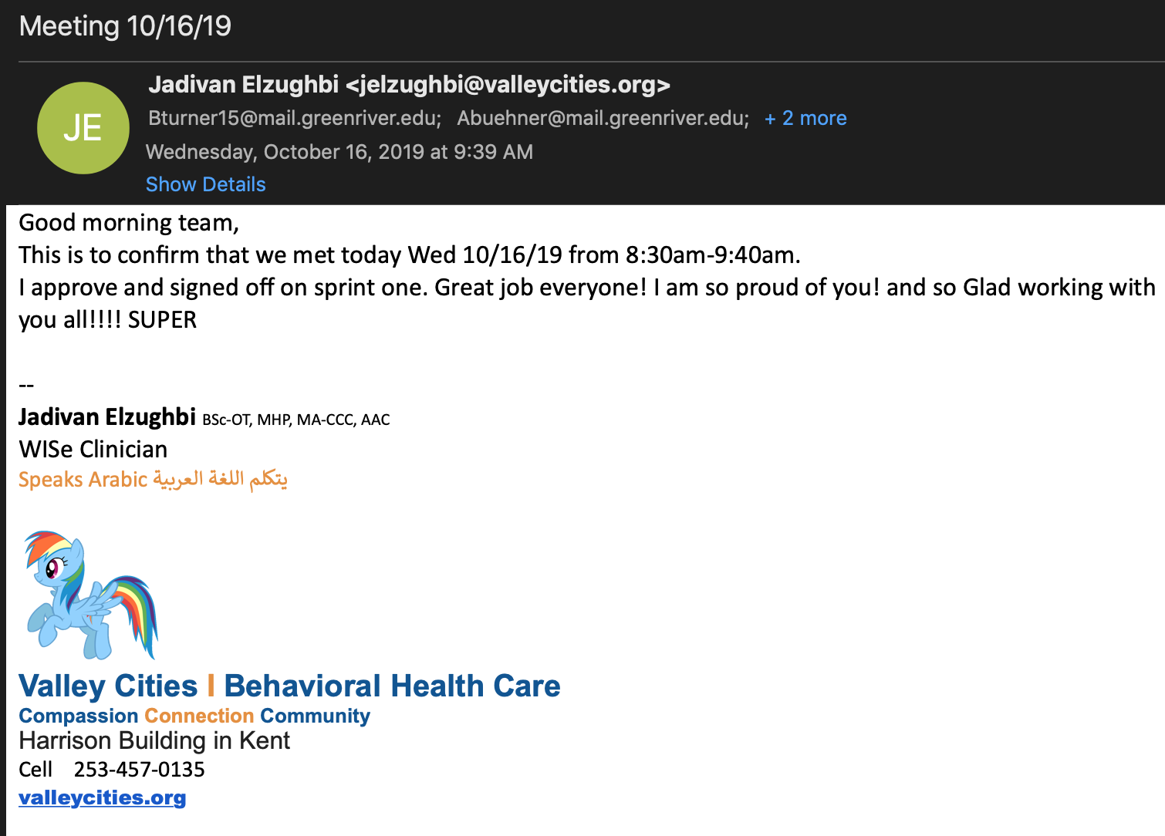

Adapted from   
<https://www.mountaingoatsoftware.com/blog/summarizing-the-results-of-a-sprint>