trend

General

**Community**

**Human Behaviour**

Nature

Strength

Weakness unconfidence

learn Avoid

observe

hear

inner world of others failure reason of others

**Imitation**

**Creativity**

Try

imagine

by age limitation

reality

give up ridiculars thoughts unconstrained

think taste smell

unreal

Know the World

last feeling

**Learning Ability**

**Know yourself**

educate

focus on

waste time

practical courses art

music handmade

experience

reading

understand truth

lessons from others Judge & Classify

**Complicated life**

frustration happiness fluctuate

Different people

Archiving Management

improve

self-improvement

get along

learn

switch another ways

our behaviour

No same people

**Uniqueness**

**Learn from mistakes**

seek wiser methods

other channels

unknown

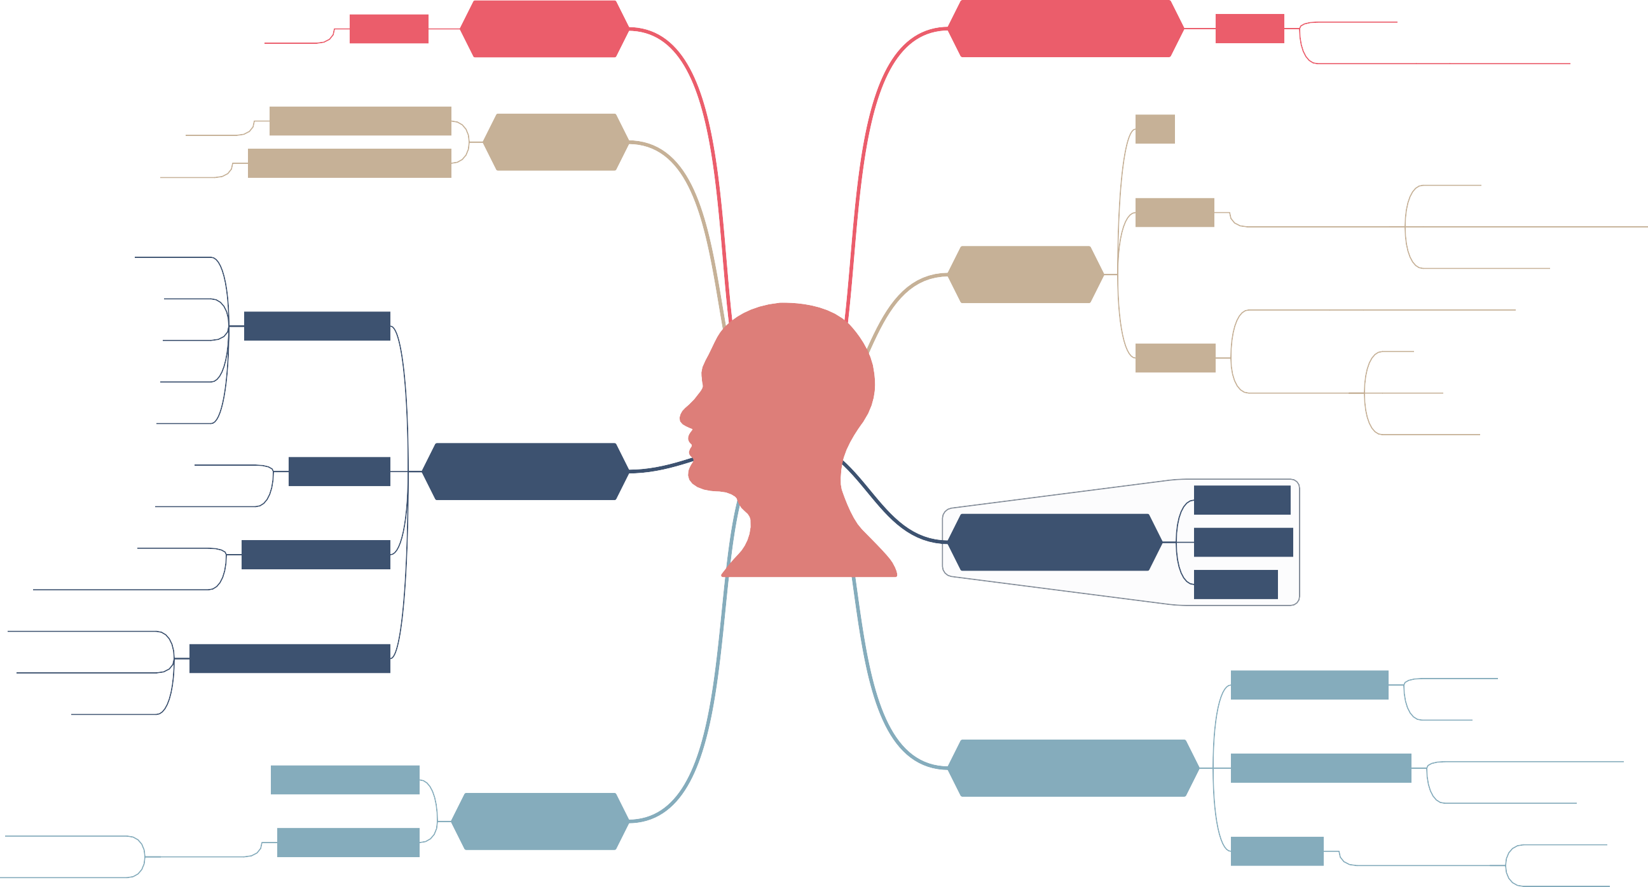

others attitude

influence

mental process

obstinacy

poorly effective

inertness