Meadowbrook breakout guide
  - Student instructions and worked examples
Work with your group to explore how communication between residents, families and care professionals could improve at Meadowbrook. Use your assigned persona as your starting point. Prepare two ideas, sketch one and get ready to pitch it when we return together.

Your fictional setting
Meadowbrook is an invented Dutch nursing home. Its digital platform supports family messages, resident updates and selected care information. The clinical record is separate. Platform use is inconsistent and responsibility for replies is unclear. AI routing, plain-language summaries and draft replies are proposals only. None has been implemented.

Your group
There are 10 groups of approximately 5 students. Read only your assigned persona in detail. The other cards can help you understand the wider setting.
Groups | Assigned persona
1–2 | Sophie, unit nurse
3–4 | Jan, resident
5–6 | Linda, Jan’s daughter
7–8 | Thomas, physician
9–10 | Emma, nursing home manager

Use your 30 minutes
Discover 8 minutes · Define 8 minutes · Develop 10 minutes · Deliver preparation 4 minutes. Follow the facilitator’s instruction for the return time. Pitches and peer feedback take place after the breakout.

You may use AI in every phase
Use any AI tool you have access to: for interview questions, organising notes, exploring ideas, making a sketch or preparing your pitch. AI is optional. Your group decides what to keep and checks the output. Use only invented, non-identifying material. Do not enter real patient information.
Pip the guinea pig provides a separate worked example. Develop your own interpretation of the Meadowbrook persona. Role-play answers and AI output are not research evidence from real residents.

Your personas

Jan de Vries Resident, 78

Jan is a retired bus driver who has lived at Meadowbrook for eighteen months following a stroke. He uses a wheelchair and finds small buttons difficult with his right hand. When tired, he sometimes needs more time to find words. He enjoys football and radio. His support needs do not mean he cannot make decisions.
Last Thursday, Linda and a staff member discussed a platform note about his quiet afternoon while he was present. They suggested extra activities before asking him. Jan had chosen to listen to a radio programme. There was no emergency or new medical condition.
“Of course Linda can know how I am. But please ask me too.”

Linda Bakker Jan’s daughter, 50

Linda balances work with visits to her father. Between visits, she checks the platform. Some updates feel personal. Others are brief and leave her wondering what happened. She and Jan also enjoy talking about football and family news.
After reading about Jan’s quiet afternoon, she asked about more activities. Only later did she hear about his radio programme. When a message goes unanswered, she wonders whether to call.
“When I visit, I also want to be his daughter.”
All personas and quotations are fictional. Portraits are AI-generated. Use appearance for introduction, not as evidence of feelings or ability.

Your personas continued

Sophie Unit nurse, 32

Sophie supports residents and stays in touch with families. Questions arrive through conversations, phone calls and the platform. She reads messages when her shift allows it, but sometimes cannot tell whether a colleague is already replying.
A family asks how a resident spent the afternoon. Sophie was only there for part of it, so she checks with a colleague before answering.
“Typing a short message is manageable. Working out what I can say takes longer.”

Thomas Physician, 45

Thomas is a physician involved in the care of Meadowbrook residents. He speaks with residents, nurses and relatives. He uses the clinical record for medical information, while families also ask questions through the separate platform.
Linda asks what a brief update means for Jan. Thomas checks the context with Sophie and asks Jan how he experienced the afternoon. He wonders how a proposed AI summary would preserve that context and who would check it.
“Before I explain what a note means, I want to hear what Jan has to say.”

Emma Nursing home manager, 46

Emma hears different experiences of the platform. Some families appreciate updates. Others still phone. Staff use it in different ways. In a team meeting, she discovers different expectations about who follows up questions.
She is exploring AI proposals for routing messages and creating summaries. Nothing has been implemented. She wonders how the team would know whether these ideas help in everyday work.
“If everyone thinks someone else is replying, the question goes unanswered.”
All personas and quotations are fictional. Portraits are AI-generated. Use appearance for introduction, not as evidence of feelings or ability.

1 Discover
  - 8 minutes
Understand the person’s experience before proposing a solution.

Your task
1. Choose one group member to play your assigned persona. The others interview them and take notes.
2. Ask open questions about everyday experiences, then follow up on specific details. Ask one question at a time.
3. Keep the role-play consistent with the card. If information is missing, say so or mark a small invented detail as an assumption. Do not add new diagnoses or serious incidents.
4. Record useful quotes and behaviour. Distinguish details from the persona card, invented role-play details and your interpretations.

Example with Pip
Pip is a fictional guinea pig. His owner notices him making sounds and approaching the enclosure door when a food bag rustles. For this playful example, a student imagines Pip’s replies.
Interviewer “Tell me what happens when you hear the bag rustle.”
Pip in the role play “I run to the door because I think food might be coming.”
Follow up “What happens next?”
The sounds and movement are observable in the example. Pip’s English reply is imagined. The same distinction matters when classmates role-play a human persona.

Optional AI support
Optional AI prompt “Based on this fictional persona card, suggest five open interview questions about everyday communication. Avoid leading questions and proposed solutions. Do not invent experiences.”
Bring to the next step Interview notes with useful quotes, observations and open questions.

2 Define
  - 8 minutes
Identify a possible need and frame a challenge that allows different solutions.

Your task
1. Create an empathy map with SAYS, DOES, THINKS and FEELS. Use your interview notes.
2. Label thoughts and feelings as interpretations. Note what you would need to ask a real person to check them.
3. Agree on one possible need. Write one How Might We question.
Useful structure How might we help [persona] to [desired outcome]?
Keep the question focused, but do not build a solution into it. “How might we build an automatic feeder?” already commits to a product.

Example with Pip
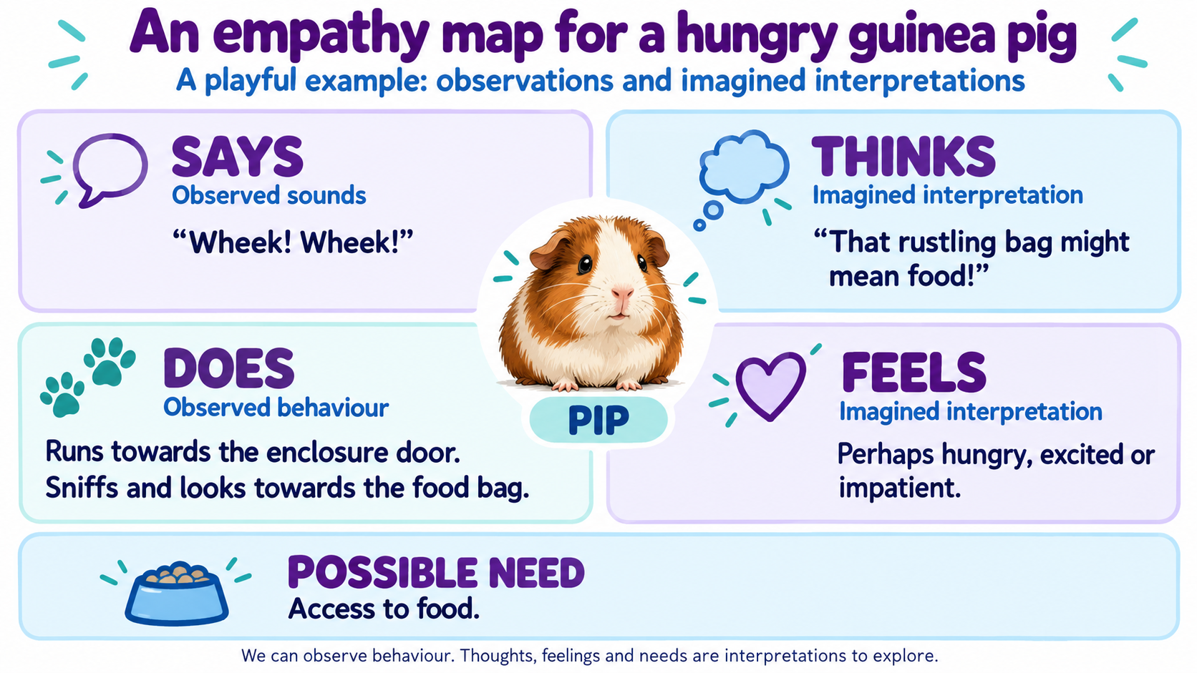
Possible need Access to food when needed.
HMW question How might we help Pip get food when he needs it?
Optional AI prompt “Organise these fictional interview notes into an empathy map. Separate quotes from interpretations. Flag gaps without filling them in. Suggest two open How Might We questions.”
Bring to the next step One empathy map and one How Might We question.

3 Develop
  - 10 minutes
Explore different ways to address the need, then make one idea concrete.

Your task
1. Generate two different ideas for your How Might We question. An idea may use AI, but does not have to.
2. Compare the ideas from your persona’s perspective. Choose one to explore and explain your choice.
3. Sketch a screen, storyboard or service interaction. Show who does what and what happens next.

Example with Pip
Idea A A feeding reminder prompts the owner to check whether food is available.
Idea B A food-level sensor sends an alert when the supply is running low.
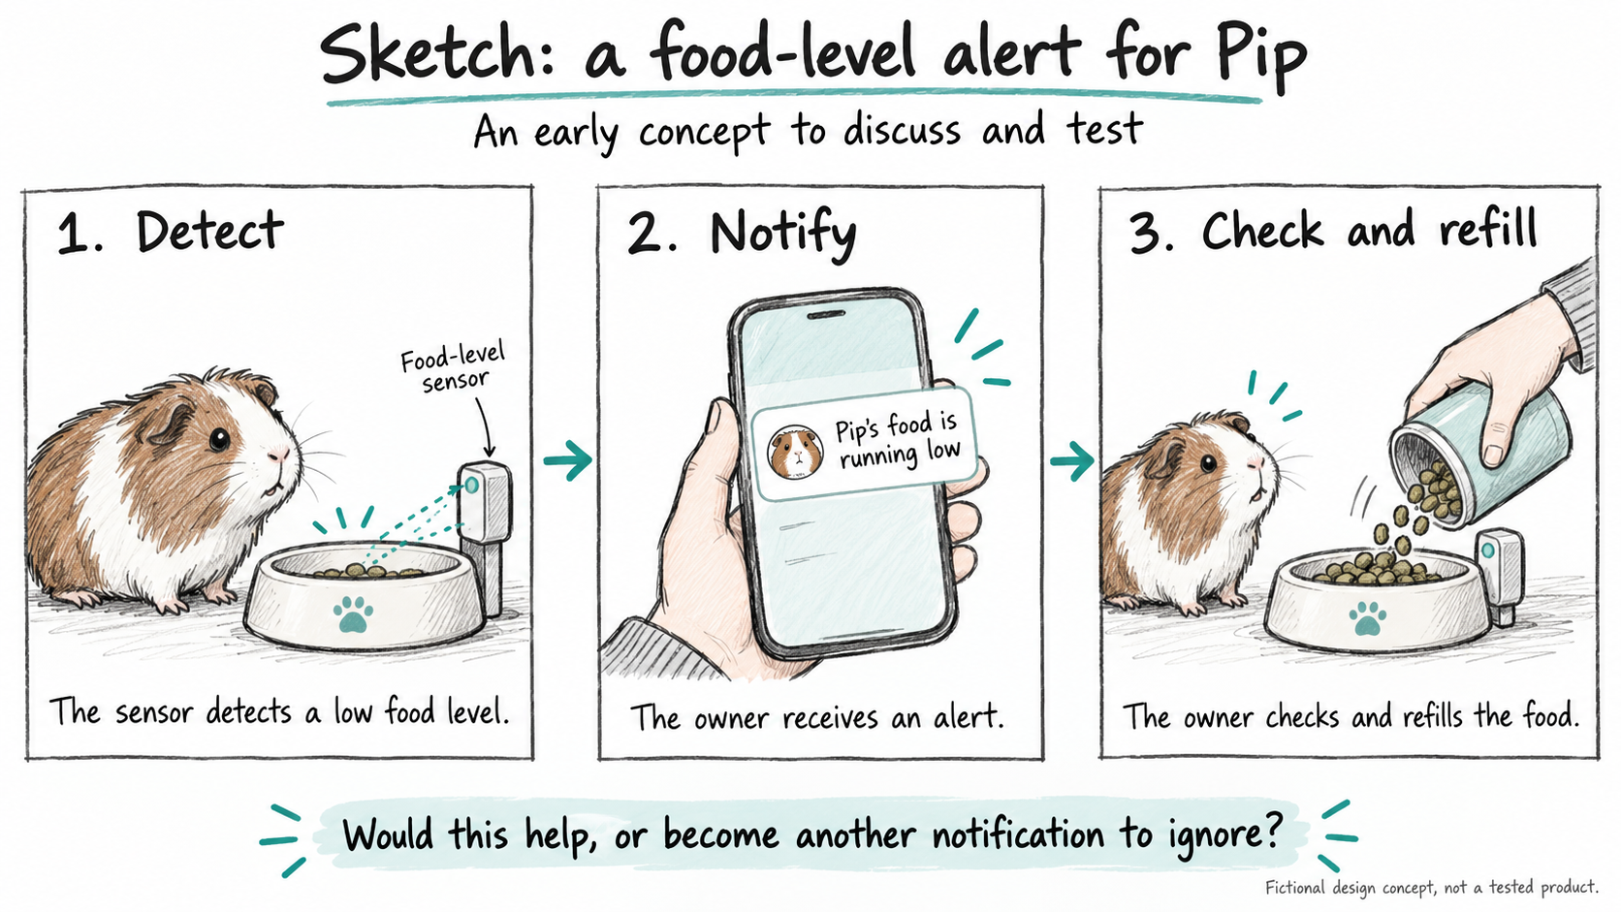
This sketch explores Idea B. It is a proposed concept, not a tested product. A low food level also does not prove that Pip is hungry. That is an assumption to explore.
Optional AI prompt “Suggest two distinct concepts for this HMW question and fictional persona. Include a non-AI option. Describe a simple sketch for each and flag assumptions.”
Bring to the next step Two ideas and one sketch of your chosen concept.

4 Deliver
  - 4 minutes to prepare during the breakout
Prepare your pitch now. A few groups will pitch when everyone returns. Other groups will give feedback from their assigned persona’s perspective.

Your task
1. Prepare a short pitch using your sketch. Explain the persona’s need, your idea and how it would work.
2. When invited to pitch, ask what fits and what remains unclear. Other groups respond from their own persona’s perspective.
3. Record the feedback. Identify one revision and one assumption to test with real people later.

Example pitch for Pip
“Our example suggests Pip needs access to food when he is hungry. We propose a sensor that detects when food is running low and alerts his owner. The owner checks the bowl and refills it if needed. Our sketch shows detection, notification and the owner’s response. We still need to explore whether the alert would be useful.”

After the pitch
Owner feedback “What if I receive the alert while I’m away from home?”
Revision Let the owner share the alert with another caregiver who can check Pip’s food.
Still to explore How would they know who has responded?
The shared alert is a revision after feedback. It is not part of the first concept. In your own group, let feedback influence what you change.

Optional AI support
Optional AI prompt Before pitching: “Turn our fictional persona’s need and concept into a short pitch. Explain how it would work. Do not claim that it is tested.”
Optional AI prompt After feedback: “Group this peer feedback into themes. Suggest one revision and one question for a future real-user test. Do not invent feedback.”
Your final output Your sketch, a short pitch and, after feedback, one proposed revision.
Peer role-play helps you explore perspectives. Real-world validation comes later.

