5 suggested reviewers:

Elsa Cleland ecleland@ucsd.edu
Inés Ibáñez iibanez@umich.edu
Jill Anderson jta24@uga.edu
David Inouye Inouye@umd.edu
Arthur Weis arthur.weis@utoronto.ca

Answers to the following questions (max 50 words per answer):

What is the scientific question you are addressing?
We investigate phenotypic and genotypic responses of flowering phenology to increased temperatures. Using a unique natural experiment, we examine if flowering phenology is related to small-scale variation in geothermal soil warming, if temperature influences selection on phenology, and if temperature-driven differences in selection have resulted in small-scale genetic differentiation.

What is/are the key finding(s) that answers this question?
Plants might respond to higher temperatures not only plastically, but also genetically, with a combination of short-term plastic responses and long-term evolutionary responses in opposite directions. Plants at warmer microsites flowered relatively earlier than plants at colder microsites in field conditions, but relatively later when grown in a common environment.

Why is this work important and timely?
Our results are important because they illustrate why long-term responses to climate change are likely to be a combination of phenotypic and genotypic responses acting in opposed directions. This is timely as much effort is currently devoted to understand and predict how organisms will respond to climate change.

Does your paper fall within the scope of GCB; what biological AND global change aspects does it address?
Our paper clearly falls within the scope of GCB, as it addresses biological adaptations to global climate change and related evolutionary processes. It specifically addresses plant phenological responses to higher temperatures, showing that for observed phenotypic responses to climate change, adaptive evolution might be as important as plastic responses.

What are the three most recently published papers that are relevant to this question? This information will assist the Editors in selecting reviewers.
Anderson, J. T., Inouye, D. W., McKinney, A. M., Colautti, R. I., & Mitchell-Olds, T. (2012). Phenotypic plasticity and adaptive evolution contribute to advancing flowering phenology in response to climate change. Proceedings of the Royal Society of London B: Biological Sciences, 279(1743), 3843–3852. https://doi.org/10.1098/rspb.2012.1051
Leblans, N. I. W., Sigurdsson, B. D., Vicca, S., Fu, Y., Penuelas, J., & Janssens, I. A. (2017). Phenological responses of Icelandic subarctic grasslands to short-term and long-term natural soil warming. Global Change Biology, 23(11), 4932–4945. https://doi.org/10.1111/gcb.13749
O’Gorman, E. J., Benstead, J. P., Cross, W. F., Friberg, N., Hood, J. M., Johnson, P. W., … Woodward, G. (2014). Climate change and geothermal ecosystems: natural laboratories, sentinel systems, and future refugia. Global Change Biology, 20(11), 3291–3299. https://doi.org/10.1111/gcb.12602

Graphical Abstract File
One figure (diagram or illustration selected from the manuscript or an additional "eye-catching" figure)
Accompanying text
PNG, JPEG, or WEBP file format
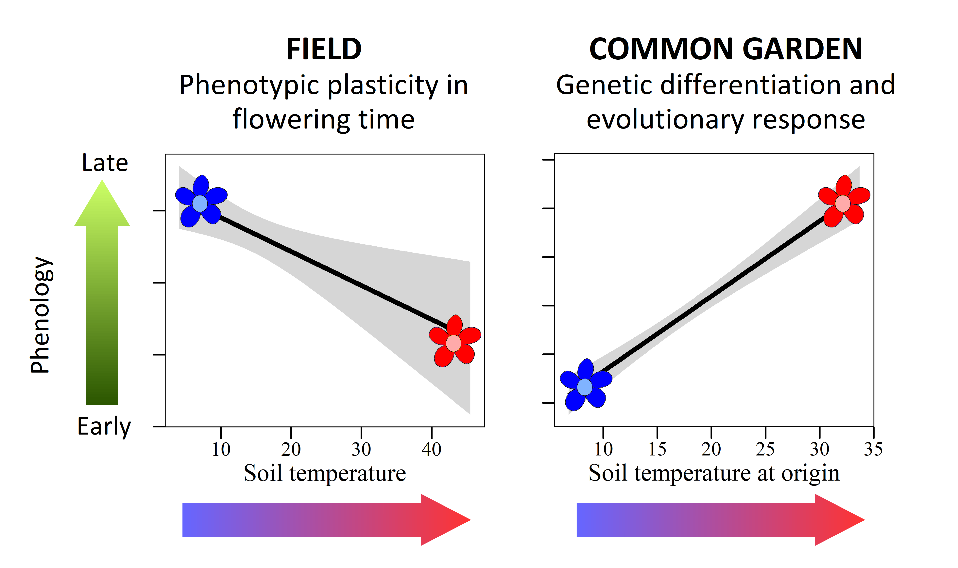
Phenotypic and genotypic responses to warming in Cerastium fontanum over a geothermally induced soil temperature gradient. Left: Effect of soil temperature on flowering phenology of C. fontanum in field conditions. Right: Effect of soil temperature at the origin of the mother plant on flowering phenology of C. fontanum in a common garden. Plants originating from colder microsites are represented in blue, and plants originating from warmer microsites are represented in red.

In the field, we observed a plastic response of flowering phenology to soil temperature, with earlier flowering in locally warmer microsites. When plants were grown in a common garden, their phenology was related to soil temperature at the origin of the mother plant, suggesting the existence of genetic differentiation and an evolutionary response to warming in a counter-gradient fashion. Plants from warm microsites experience an earlier start of the growing season, and show an earlier phenology in field conditions. Plants from cold microsites experience a later start of the growing season, and are selected to start development at lower temperatures.

