Results *Cerastium* data 27/12/2017

To take into account: Differences among streams

There are significant differences in mean temperature, phenological stage and probability of flowering (i.e. flowered/not flowered) among streams

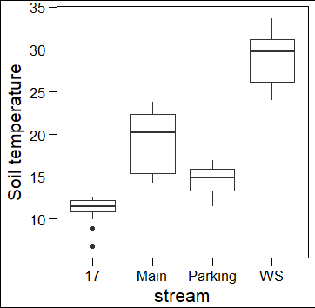 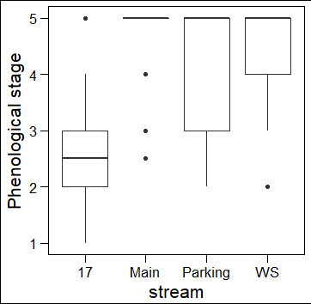 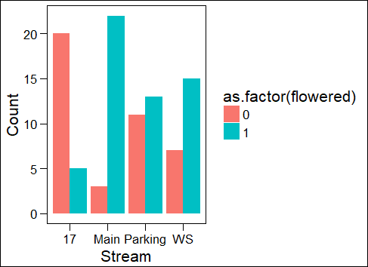

1. Is there a relationship between soil temperature and flowering phenology in the field?

Using only probability of flowering because phenological stage is difficult to fit to any distribution (see histogram below)

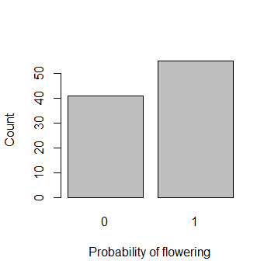 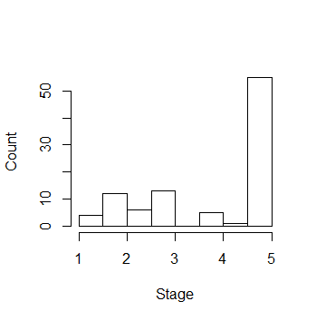

Relationship among probability of flowering and soil temperature:

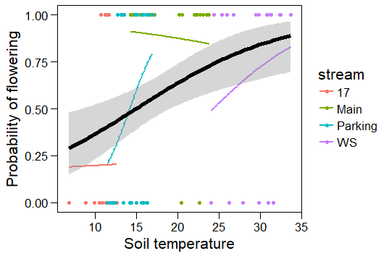

black = logistic regression fitted for the pooled data (i.e. including all plants, significant)

colors = stream-specific logistic regressions (not significant)

> model <- glm(flowered~temp*stream,family="binomial",data_field)

> summary(model) #Different slopes and intercepts for each stream

Coefficients:

Estimate Std. Error z value Pr(>|z|)

(Intercept) -1.55830 4.45734 -0.350 0.727

temp 0.01527 0.39283 0.039 0.969

streamMain 4.82119 5.70746 0.845 0.398

streamParking -5.50216 6.09764 -0.902 0.367

streamWS -2.49671 6.51990 -0.383 0.702

temp:streamMain -0.08097 0.43159 -0.188 0.851

temp:streamParking 0.48232 0.48530 0.994 0.320

temp:streamWS 0.15215 0.42640 0.357 0.721

> model2 <- glm(flowered~temp+stream,family="binomial",data_field)

> summary(model2) #Common slope, different intercepts for each stream

Coefficients:

Estimate Std. Error z value Pr(>|z|)

(Intercept) -2.8303 1.3169 -2.149 0.0316 *

temp 0.1275 0.1070 1.192 0.2333

streamMain 2.4704 1.0580 2.335 0.0195 *

streamParking 1.1427 0.7308 1.564 0.1179

streamWS -0.0842 1.9702 -0.043 0.9659

> #Likelihood ratio test comparing both models

> anova(model,model2, test="Chisq")

Analysis of Deviance Table

Model 1: flowered ~ temp * stream

Model 2: flowered ~ temp + stream

Resid. Df Resid. Dev Df Deviance Pr(>Chi)

1 88 99.323

2 91 102.522 -3 -3.1996 0.3619

#No support for significant differences between slopes (despite the graph!)-->keep model2 with a common slope and different intercepts for each stream

> model3 <- glm(flowered~temp,family="binomial",data_field)

> summary(model3) #Only effect of temperature

Coefficients:

Estimate Std. Error z value Pr(>|z|)

(Intercept) -1.66669 0.64331 -2.591 0.00958 **

temp 0.11144 0.03581 3.112 0.00186 **

> #Likelihood ratio test comparing model2 and model3

> anova(model2,model3, test="Chisq")

#Highly significant differences in intercepts between streams-->keep model2

Analysis of Deviance Table

Model 1: flowered ~ temp + stream

Model 2: flowered ~ temp

Resid. Df Resid. Dev Df Deviance Pr(>Chi)

1 91 102.52

2 94 119.42 -3 -16.9 0.0007409 ***

In the field, the probability of flowering increases with soil temperature. This relationship is highly significant when the data are pooled for all the streams, but the effects are inconsistent among streams. This might mean that differences in temperature at larger scales (among sites) are more important than differences at small scales (within sites). This is probably also due to much larger variations in temperature among sites than within sites (see boxplots at the beginning).

1. Is there an effect of mother plant (and site) on the flowering phenology in the common garden?

Treating mother plant as a random effect and site (=stream) as a fixed effect. We could also treat both as random effects and the conclusion would be similar. But I did it like this because there are many mothers, and we are not interested in the effect of “a particular mother”. On the contrary, there are few streams, and we might be interested in the effect of a particular stream due to the very large differences in temperature among them.

> mod6<-lmer(first_fl_j ~ stream+(1|mother_pl_id_new), REML=F,data = subset_data)

> #This takes into account that mother is nested within stream

> summary(mod6)

Linear mixed model fit by REML

t-tests use Satterthwaite approximations to degrees of freedom ['lmerMod']

Random effects:

Groups Name Variance Std.Dev.

mother_pl_id_new (Intercept) 4.907 2.215

Residual 31.703 5.631

Number of obs: 540, groups: mother_pl_id_new, 98

Fixed effects:

Estimate Std. Error df t value Pr(>|t|)

(Intercept) 148.0606 0.6586 73.4600 224.796 < 2e-16 ***

streamMain 3.5747 0.9291 70.9900 3.848 0.000258 ***

streamPark -1.5323 0.9179 66.0000 -1.669 0.099782 .

streamWS 6.4666 1.0458 83.8900 6.183 2.19e-08 ***

> #Likelihood ratio test comparing a model with a given random effect to that same model without the random effect – for testing the significance of random effects.

I found this way of testing the significance of random factors in a mixed model (significance is not provided by the output from the models in R)

> rand(mod6) #mother is significant

Analysis of Random effects Table:

Chi.sq Chi.DF p.value

mother_pl_id_new 15 1 1e-04 ***

There is an effect of both mother plant and site (stream) of origin on flowering phenology (first flowering day) in the common garden: there are differences among streams, and differences among mothers within streams.

1. Is there an effect of mother plant (and site) on the flower size in the common garden?

Treating mother plant as a random effect and site as a fixed effect again.

> mod11<-lmer(diam_fl_mean ~ stream+(1|mother_pl_id_new), REML=T,data = subset_data2)

> #This takes into account that mother is nested within stream

> summary(mod11)

Linear mixed model fit by REML

t-tests use Satterthwaite approximations to degrees of freedom ['lmerMod']

Random effects:

Groups Name Variance Std.Dev.

mother_pl_id_new (Intercept) 0.2326 0.4823

Residual 0.7597 0.8716

Number of obs: 311, groups: mother_pl_id_new, 89

Fixed effects:

Estimate Std. Error df t value Pr(>|t|)

(Intercept) 6.9922 0.1509 75.1800 46.331 <2e-16 ***

streamMain -0.1093 0.2031 73.5700 -0.538 0.592

streamPark -0.1789 0.2088 75.1400 -0.857 0.394

streamWS -0.1005 0.2270 81.3600 -0.443 0.659

> #Likelihood ratio test comparing a model with a given random effect to that same model without the random effect

> rand(mod11) #mother is significant

Analysis of Random effects Table:

Chi.sq Chi.DF p.value

mother_pl_id_new 21.8 1 3e-06 ***

There are differences among mother plants within streams on flower size in the common garden, but no differences among streams.

1. Are differences among mother plants related to soil temperature at the site of origin? Hypotheses:
   1. We expect plants to respond to warming in spring in a counter-gradient fashion, i.e. plants growing on warmer soils will flower early in the field but later in the common garden (requiring more warm days to start development) than plants from cold soils.
   2. Plants from warmer sites will have smaller flowers, as they are flowering when there are few pollinators available and thus have to depend more on selfing, and smaller flower size is expected as part of a selfing syndrome.

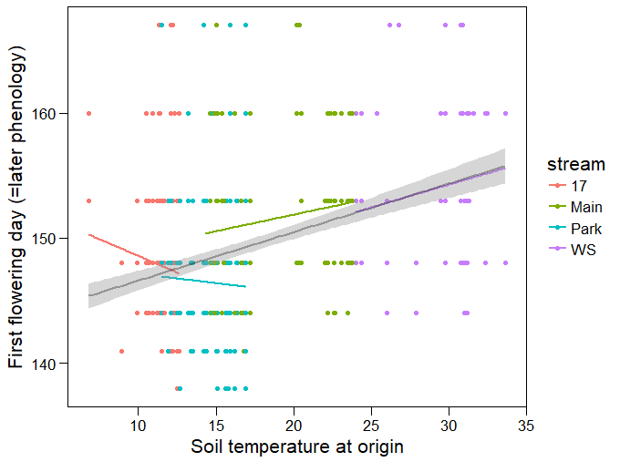

black = linear model fitted for the pooled data (significant)

colors = stream-specific linear models (not significant)

> mod13<-lmer(first_fl_j ~ temp_ori+(1|stream)+(1|mother_pl_id_new),data = data_cgarden_short)

> #This takes into account that mother is nested within stream

> summary(mod13) #Temperature is significant

Linear mixed model fit by REML

t-tests use Satterthwaite approximations to degrees of freedom ['lmerMod']

Random effects:

Groups Name Variance Std.Dev.

mother_pl_id_new (Intercept) 4.611 2.147

stream (Intercept) 2.996 1.731

Residual 31.806 5.640

Number of obs: 540, groups: mother_pl_id_new, 98; stream, 4

Fixed effects:

Estimate Std. Error df t value Pr(>|t|)

(Intercept) 144.46193 2.02092 5.81500 71.483 8.73e-10 ***

temp_ori 0.30697 0.09757 9.03200 3.146 0.0118 *

> rand(mod13) #Stream and mother are significant

Analysis of Random effects Table:

Chi.sq Chi.DF p.value

stream 8.5 1 0.004 **

mother_pl_id_new 13.8 1 2e-04 ***

Hypothesis 4a is true: Differences among mother plants in phenology are related to soil temperature at origin. Plants respond to warming a counter-gradient fashion – plants from warmer soils flower later in the common garden than plants from cold soils.

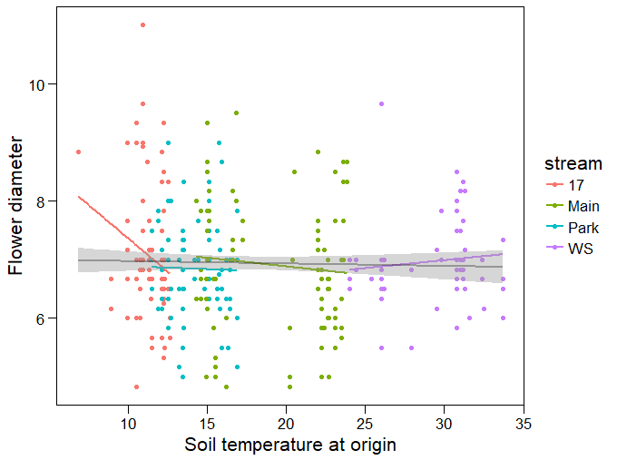

black = linear model fitted for the pooled data (NS)

colors = stream-specific linear models (NS)

> mod16<-lmer(diam_fl_mean ~ temp_ori+(1|stream)+(1|mother_pl_id_new),data = data_cgarden_short)

> #This takes into account that mother is nested within stream

> summary(mod16) #Temperature is not significant

Linear mixed model fit by REML

t-tests use Satterthwaite approximations to degrees of freedom ['lmerMod']

Random effects:

Groups Name Variance Std.Dev.

mother_pl_id_new (Intercept) 2.267e-01 4.762e-01

stream (Intercept) 3.901e-16 1.975e-08

Residual 7.583e-01 8.708e-01

Number of obs: 311, groups: mother_pl_id_new, 89; stream, 4

Fixed effects:

Estimate Std. Error df t value Pr(>|t|)

(Intercept) 6.992955 0.208658 78.700000 33.514 <2e-16 ***

temp_ori -0.005597 0.010941 80.770000 -0.512 0.61

> rand(mod16) #Stream is not significant, mother is significant

Analysis of Random effects Table:

Chi.sq Chi.DF p.value

stream 0.0 1 1

mother_pl_id_new 22.1 1 3e-06 ***

Hypothesis 4b is not true: Differences among mother plants in flower size are not related to soil temperature at origin – there is no effect of soil temperature at origin on flower size