Analyses Cerastium transplants paper 1

Analyses with FFD

Alicia Valdés

10 April, 2024

Table of Contents

# Load previously created objects

load(file="output/models/model1_22_FFD_boot.rda")  
load(file="output/models/model1_22_LFD_boot.rda")  
load(file="output/models/model1_22_MeanFD_boot.rda")  
load(file="output/models/model1_23_FFD_boot.rda")  
load(file="output/models/model1_23_LFD_boot.rda")  
load(file="output/models/model1_23_MeanFD_boot.rda")  
load(file="output/models/model2_22_FFD_qf_boot.rda")  
load(file="output/models/model2_22_LFD_qf_boot.rda")  
load(file="output/models/model2_22_MeanFD_qf_boot.rda")  
load(file="output/models/model2_22_FFD_qf_boot_fixef.rda")  
load(file="output/models/model2_22_LFD_qf_boot_fixef.rda")  
load(file="output/models/model2_22_MeanFD_qf_boot_fixef.rda")  
load(file="output/models/model2_22_FFD_qf_boot_pvals.rda")  
#load(file="output/models/model2_22_LFD_qf_boot_pvals.rda")  
load(file="output/models/model2_22_MeanFD_qf_boot_pvals.rda")  
load(file="output/models/model2_23_FFD_boot.rda")  
load(file="output/models/model2_23_LFD_boot.rda")  
load(file="output/models/model2_23_MeanFD_boot.rda")  
load(file="output/models/model2_23_FFD_boot_fixef.rda")  
load(file="output/models/model2_23_LFD_boot_fixef.rda")  
load(file="output/models/model2_23_MeanFD_boot_fixef.rda")  
load(file="output/models/model2_23_FFD_boot_pvals.rda")  
load(file="output/models/model2_23_LFD_boot_pvals.rda")  
#load(file="output/models/model2_23_MeanFD_boot_pvals.rda")  
load(file="output/models/model3_22_FFD_boot_fixef.rda")  
load(file="output/models/model3_22_LFD_boot_fixef.rda")  
load(file="output/models/model3_22_MeanFD_boot_fixef.rda")  
load(file="output/models/model3_22_FFD_boot_pvals.rda")  
load(file="output/models/model3_22_LFD_boot_pvals.rda")  
load(file="output/models/model3_22_MeanFD_boot_pvals.rda")  
load(file="output/models/model3_23_FFD_boot_fixef.rda")  
load(file="output/models/model3_23_LFD_boot_fixef.rda")  
load(file="output/models/model3_23_MeanFD_boot_fixef.rda")  
load(file="output/models/model3_23_FFD_boot_pvals.rda")  
load(file="output/models/model3_23_LFD_boot_pvals.rda")  
load(file="output/models/model3_23_MeanFD_boot_pvals.rda")  
load(file="output/models/model4_22_FFD_boot_fixef.rda")  
load(file="output/models/model4_22_LFD_boot_fixef.rda")  
load(file="output/models/model4_22_MeanFD_boot_fixef.rda")  
#load(file="output/models/model4_22_FFD_boot_pvals.rda")  
load(file="output/models/model4_22_LFD_boot_pvals.rda")  
load(file="output/models/model4_22_MeanFD_boot_pvals.rda")  
load(file="output/models/model4_23_FFD_boot_fixef.rda")  
load(file="output/models/model4_23_LFD_boot_fixef.rda")  
load(file="output/models/model4_23_MeanFD_boot_fixef.rda")  
load(file="output/models/model4_23_FFD_boot_pvals.rda")  
load(file="output/models/model4_23_LFD_boot_pvals.rda")  
#load(file="output/models/model4_23_MeanFD_boot_pvals.rda")  
load(file="output/b_model_phensel_FFD_f.RData")  
load(file="output/b_model_phensel_LFD_f.RData")  
load(file="output/b_model_phensel_MeanFD_f.RData")

# Read clean data from .csv files

data_transplants <- read_csv("data/clean/data_transplants.csv")%>%  
 mutate_at(c("unique_id","heat_zone","group","mother","father","id","repl",  
 "plot","peak","fruit_coll","poll_type","crossing","F_NF_A",  
 "year"),as.factor)%>%  
 mutate_at(c("n_fl_stems","n_opened_fl","n_closed_buds","tot_fl_bodies",  
 "median_h","per_invert_herb","n_stems_grazed","n_closed_coll_fr",  
 "n_open_coll_fr","n_count_fr","n_tot_fr","n_seed_fr1",  
 "n_seed_fr2","n_seed_fr3","n_seed_fr4","rest_combined",  
 "n_tot_seed","tot_fl_bodies_corr"),as.integer)

# Distributions phenology variables

ggplot(data_transplants,aes(x=FFD_corr))+  
 geom_histogram(color="black",fill="white")+  
 my_theme()+facet_wrap(~year)

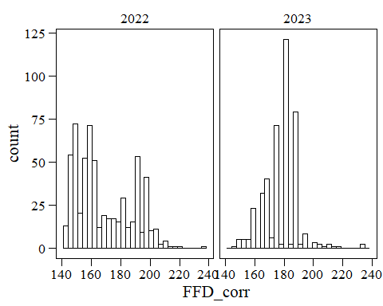

ggplot(data_transplants,aes(x=LFD_corr))+  
 geom_histogram(color="black",fill="white")+  
 my_theme()+facet_wrap(~year)

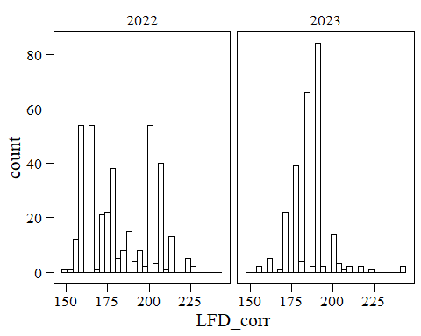

ggplot(data_transplants,aes(x=MeanFD))+  
 geom_histogram(color="black",fill="white")+  
 my_theme()+facet_wrap(~year)

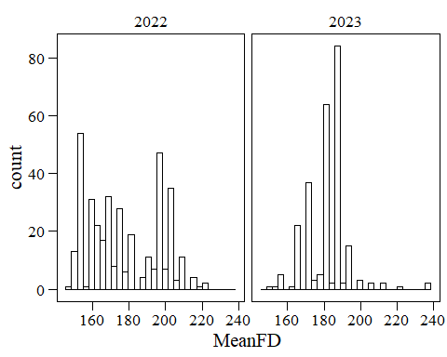

ggplot(data_transplants,aes(x=log(FFD_corr)))+  
 geom_histogram(color="black",fill="white")+  
 my_theme()+facet_wrap(~year)

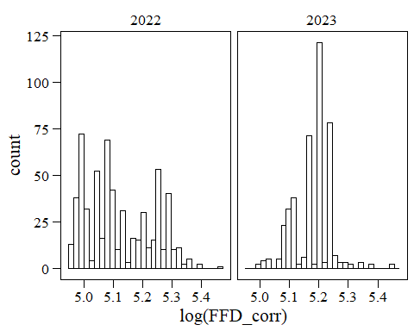

ggplot(data_transplants,aes(x=log(LFD_corr)))+  
 geom_histogram(color="black",fill="white")+  
 my_theme()+facet_wrap(~year)

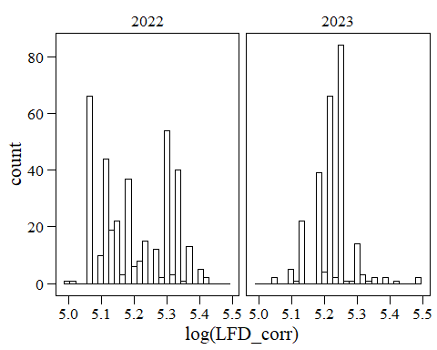

ggplot(data_transplants,aes(x=log(MeanFD)))+  
 geom_histogram(color="black",fill="white")+  
 my_theme()+facet_wrap(~year)

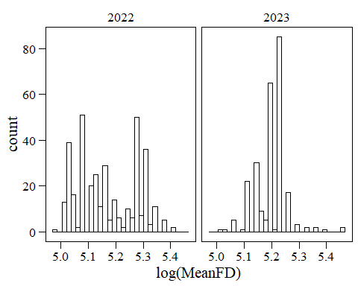

ggplot(data_transplants,aes(x=sqrt(FFD_corr)))+  
 geom_histogram(color="black",fill="white")+  
 my_theme()+facet_wrap(~year)

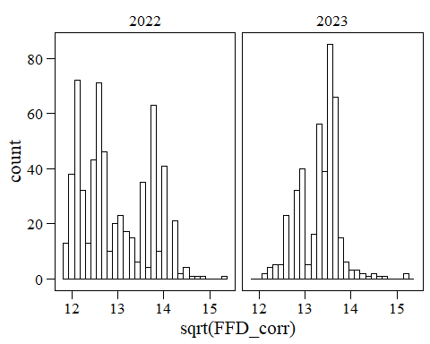

ggplot(data_transplants,aes(x=sqrt(LFD_corr)))+  
 geom_histogram(color="black",fill="white")+  
 my_theme()+facet_wrap(~year)

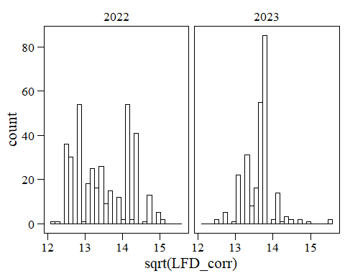

ggplot(data_transplants,aes(x=sqrt(MeanFD)))+  
 geom_histogram(color="black",fill="white")+  
 my_theme()+facet_wrap(~year)

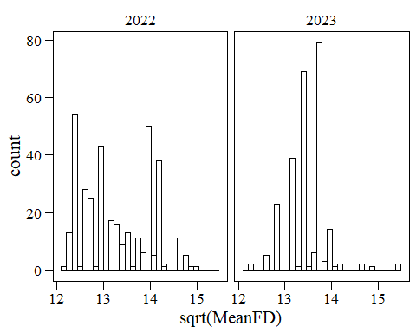

None of the distribution is looking super normal.

# TO DO: Include vegetative phenology

# PREDICTION 1

“Trait expression is a function of both the current temperature environment, in terms of plasticity, and the past temperature environment, in terms of genetic effects, and follows a counter-gradient pattern, i.e. environmental and genetic effects of soil temperature on flowering time are in opposite directions.”

The models below are a series of models similar to the ones use in the greenhouse paper. For this paper, we might want to keep only models including origin temperatures and soil temperature, but I have kept everything so far.

## A) Heritability of mean responses (Prediction 1 in greenhouse paper)

### Models

Including random effects of father, mother and plot. Random effects with variance = 0 were removed to avoid singular fit.

#### 2022

model1_22_FFD<-lmer(FFD_corr~1+(1|father)+(1|mother)+  
 #(1|father:mother)+ # Not included because variance=0  
 # to avoid singular fit  
 (1|plot),  
 data_transplants%>%filter(year==2022&!is.na(FFD_corr)))  
model1_22_LFD<-lmer(LFD_corr~1+(1|father)+(1|mother)+  
 #(1|father:mother)+ # Not included because variance=2.459e-07  
 # to avoid singular fit  
 (1|plot),  
 data_transplants%>%filter(year==2022&!is.na(LFD_corr)))  
model1_22_MeanFD<-lmer(MeanFD~1+(1|father)+(1|mother)+  
 #(1|father:mother)+ # Not included because variance=0  
 # to avoid singular fit  
 (1|plot),  
 data_transplants%>%filter(year==2022&!is.na(MeanFD)))  
summary(model1_22_FFD)

## Linear mixed model fit by REML. t-tests use Satterthwaite's method [  
## lmerModLmerTest]  
## Formula: FFD_corr ~ 1 + (1 | father) + (1 | mother) + (1 | plot)  
## Data: data_transplants %>% filter(year == 2022 & !is.na(FFD_corr))  
##   
## REML criterion at convergence: 4349.2  
##   
## Scaled residuals:   
## Min 1Q Median 3Q Max   
## -2.2029 -0.6613 -0.0692 0.5486 5.0403   
##   
## Random effects:  
## Groups Name Variance Std.Dev.  
## father (Intercept) 0.06275 0.2505   
## mother (Intercept) 8.83026 2.9716   
## plot (Intercept) 333.09810 18.2510   
## Residual 69.36945 8.3288   
## Number of obs: 603, groups: father, 64; mother, 63; plot, 8  
##   
## Fixed effects:  
## Estimate Std. Error df t value Pr(>|t|)   
## (Intercept) 172.338 6.486 7.077 26.57 2.37e-08 ***  
## ---  
## Signif. codes: 0 '***' 0.001 '**' 0.01 '*' 0.05 '.' 0.1 ' ' 1

summary(model1_22_LFD)

## Linear mixed model fit by REML. t-tests use Satterthwaite's method [  
## lmerModLmerTest]  
## Formula: LFD_corr ~ 1 + (1 | father) + (1 | mother) + (1 | plot)  
## Data: data_transplants %>% filter(year == 2022 & !is.na(LFD_corr))  
##   
## REML criterion at convergence: 2653.9  
##   
## Scaled residuals:   
## Min 1Q Median 3Q Max   
## -2.3988 -0.7025 -0.0959 0.4784 4.5886   
##   
## Random effects:  
## Groups Name Variance Std.Dev.  
## father (Intercept) 5.21 2.282   
## mother (Intercept) 6.38 2.526   
## plot (Intercept) 307.73 17.542   
## Residual 70.34 8.387   
## Number of obs: 364, groups: father, 59; mother, 59; plot, 8  
##   
## Fixed effects:  
## Estimate Std. Error df t value Pr(>|t|)   
## (Intercept) 183.185 6.258 7.125 29.27 1.09e-08 ***  
## ---  
## Signif. codes: 0 '***' 0.001 '**' 0.01 '*' 0.05 '.' 0.1 ' ' 1

summary(model1_22_MeanFD)

## Linear mixed model fit by REML. t-tests use Satterthwaite's method [  
## lmerModLmerTest]  
## Formula: MeanFD ~ 1 + (1 | father) + (1 | mother) + (1 | plot)  
## Data: data_transplants %>% filter(year == 2022 & !is.na(MeanFD))  
##   
## REML criterion at convergence: 2644.5  
##   
## Scaled residuals:   
## Min 1Q Median 3Q Max   
## -2.2400 -0.7146 -0.0838 0.5046 4.6854   
##   
## Random effects:  
## Groups Name Variance Std.Dev.  
## father (Intercept) 3.443 1.855   
## mother (Intercept) 6.517 2.553   
## plot (Intercept) 310.776 17.629   
## Residual 69.280 8.323   
## Number of obs: 364, groups: father, 59; mother, 59; plot, 8  
##   
## Fixed effects:  
## Estimate Std. Error df t value Pr(>|t|)   
## (Intercept) 178.253 6.285 7.110 28.36 1.41e-08 ***  
## ---  
## Signif. codes: 0 '***' 0.001 '**' 0.01 '*' 0.05 '.' 0.1 ' ' 1

#### 2023

model1_23_FFD<-lmer(FFD_corr~1+(1|father)+(1|mother)+  
 #(1|father:mother)+ # Not included because variance=0  
 # to avoid singular fit  
 (1|plot),  
 data_transplants%>%filter(year==2023&!is.na(FFD_corr)))  
model1_23_LFD<-lmer(LFD_corr~1+(1|father)+(1|mother)+(1|father:mother)+  
 #(1|father:mother)+ # Not included because variance=2.459e-07  
 # to avoid singular fit  
 (1|plot),  
 data_transplants%>%filter(year==2023&!is.na(LFD_corr)))  
model1_23_MeanFD<-lmer(MeanFD~1+(1|mother)+  
 #(1|father)+(1|father:mother)+ # Not included because variance=0  
 # to avoid singular fit  
 (1|plot),  
 data_transplants%>%filter(year==2023&!is.na(MeanFD)))  
summary(model1_23_FFD)

## Linear mixed model fit by REML. t-tests use Satterthwaite's method [  
## lmerModLmerTest]  
## Formula: FFD_corr ~ 1 + (1 | father) + (1 | mother) + (1 | plot)  
## Data: data_transplants %>% filter(year == 2023 & !is.na(FFD_corr))  
##   
## REML criterion at convergence: 2906.6  
##   
## Scaled residuals:   
## Min 1Q Median 3Q Max   
## -2.4654 -0.6272 -0.0455 0.3437 5.9028   
##   
## Random effects:  
## Groups Name Variance Std.Dev.  
## father (Intercept) 0.4286 0.6547   
## mother (Intercept) 1.2457 1.1161   
## plot (Intercept) 110.7227 10.5225   
## Residual 60.2636 7.7630   
## Number of obs: 414, groups: father, 62; mother, 62; plot, 7  
##   
## Fixed effects:  
## Estimate Std. Error df t value Pr(>|t|)   
## (Intercept) 178.491 4.019 5.978 44.41 9.21e-09 ***  
## ---  
## Signif. codes: 0 '***' 0.001 '**' 0.01 '*' 0.05 '.' 0.1 ' ' 1

summary(model1_23_LFD)

## Linear mixed model fit by REML. t-tests use Satterthwaite's method [  
## lmerModLmerTest]  
## Formula: LFD_corr ~ 1 + (1 | father) + (1 | mother) + (1 | father:mother) +   
## (1 | plot)  
## Data: data_transplants %>% filter(year == 2023 & !is.na(LFD_corr))  
##   
## REML criterion at convergence: 1805.1  
##   
## Scaled residuals:   
## Min 1Q Median 3Q Max   
## -2.6030 -0.5921 0.0496 0.1566 5.5871   
##   
## Random effects:  
## Groups Name Variance Std.Dev.  
## father:mother (Intercept) 1.225e+00 1.106896  
## mother (Intercept) 1.118e+00 1.057548  
## father (Intercept) 9.403e-05 0.009697  
## plot (Intercept) 8.408e+01 9.169415  
## Residual 6.783e+01 8.235846  
## Number of obs: 252, groups:   
## father:mother, 115; mother, 57; father, 57; plot, 7  
##   
## Fixed effects:  
## Estimate Std. Error df t value Pr(>|t|)   
## (Intercept) 187.654 3.543 5.862 52.97 4.38e-09 ***  
## ---  
## Signif. codes: 0 '***' 0.001 '**' 0.01 '*' 0.05 '.' 0.1 ' ' 1

summary(model1_23_MeanFD)

## Linear mixed model fit by REML. t-tests use Satterthwaite's method [  
## lmerModLmerTest]  
## Formula: MeanFD ~ 1 + (1 | mother) + (1 | plot)  
## Data: data_transplants %>% filter(year == 2023 & !is.na(MeanFD))  
##   
## REML criterion at convergence: 1810  
##   
## Scaled residuals:   
## Min 1Q Median 3Q Max   
## -2.4581 -0.6100 0.0342 0.1887 5.4872   
##   
## Random effects:  
## Groups Name Variance Std.Dev.  
## mother (Intercept) 1.79 1.338   
## plot (Intercept) 90.93 9.536   
## Residual 69.70 8.348   
## Number of obs: 252, groups: mother, 57; plot, 7  
##   
## Fixed effects:  
## Estimate Std. Error df t value Pr(>|t|)   
## (Intercept) 182.972 3.680 5.869 49.72 6.23e-09 ***  
## ---  
## Signif. codes: 0 '***' 0.001 '**' 0.01 '*' 0.05 '.' 0.1 ' ' 1

#### Model diagnostics

plot(simulateResiduals(model1_22_FFD))

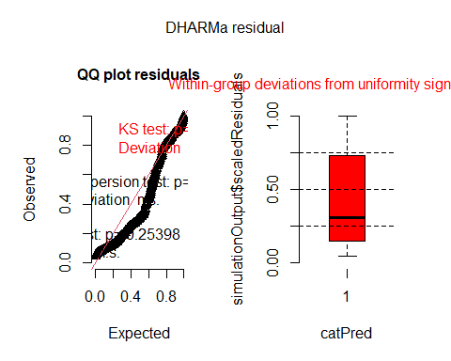

plot(simulateResiduals(model1_22_LFD))

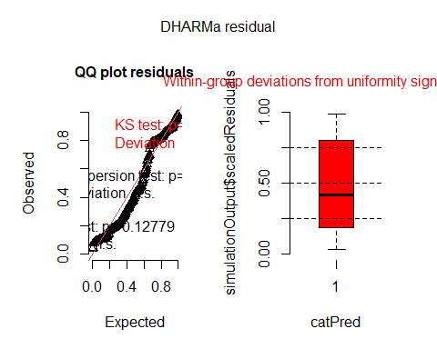

plot(simulateResiduals(model1_22_MeanFD))

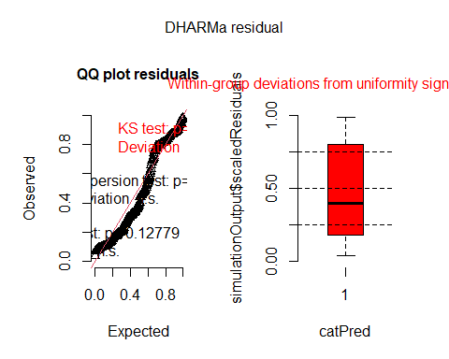

plot(simulateResiduals(model1_23_FFD))

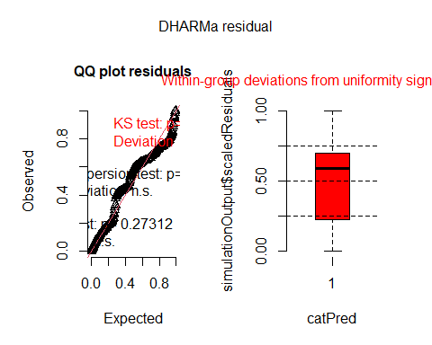

plot(simulateResiduals(model1_23_LFD))

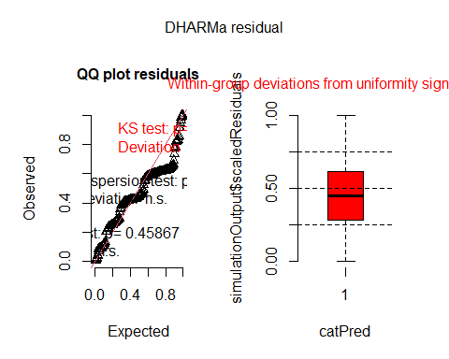

plot(simulateResiduals(model1_23_MeanFD))

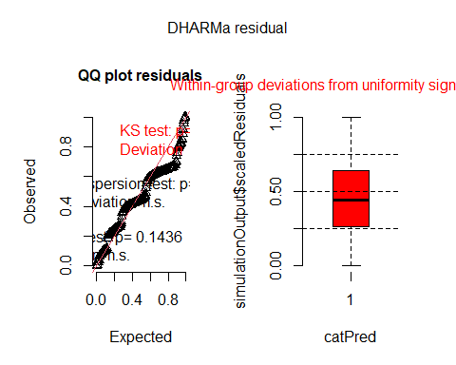

Overall deviations from the expected distribution detected.

#### Bootstrapped models

I tried to bootstrap the model using the function bootstrap in the package lmeresampler. Bootstrapping is supposed to allow for bias correction, adjusted standard errors and confidence intervals when distributional assumptions are not met (i.e. our case). I used 1000 bootstrap resamples and a residual bootstrap. Reference: <https://journal.r-project.org/articles/RJ-2023-015/>

Function to calculate variances from model objects:

variances <- function(object) {  
 vc <- setNames(as.numeric(as.data.frame(VarCorr(object))[, c(1, 4)]$vcov), as.character(as.data.frame(VarCorr(object))$grp))  
 vc  
}

Bootstrap using the variances function (takes long to run).

Using residual bootstrap - need to do research on different types of bootstrap!

##### 2022

##### 2023

### Proportions of variance

Calculated with the bootstrapped variance components (but very, very similar to proportions of variance calculated with original variance components - not shown).

Maybe bootstrapping is more important for significance of effects?

#### 2022

Variance_22_FFD_boot<-as.data.frame(model1_22_FFD_boot$observed)%>%  
 rownames_to_column(var="grp")%>%  
 mutate(vcov=model1_22_FFD_boot$observed)%>%  
 select(grp,vcov)  
Variance_22_LFD_boot<-as.data.frame(model1_22_LFD_boot$observed)%>%  
 rownames_to_column(var="grp")%>%  
 mutate(vcov=model1_22_LFD_boot$observed)%>%  
 select(grp,vcov)  
Variance_22_MeanFD_boot<-as.data.frame(model1_22_MeanFD_boot$observed)%>%  
 rownames_to_column(var="grp")%>%  
 mutate(vcov=model1_22_MeanFD_boot$observed)%>%  
 select(grp,vcov)  
# Intra-class correlations  
PropVar_22_FFD_boot <- Variance_22_FFD_boot%>%  
 mutate(propvar=vcov/sum(vcov))%>%  
 mutate(variable="FFD")  
PropVar_22_LFD_boot <- Variance_22_LFD_boot%>%  
 mutate(propvar=vcov/sum(vcov))%>%  
 mutate(variable="LFD")  
PropVar_22_MeanFD_boot <- Variance_22_MeanFD_boot%>%  
 mutate(propvar=vcov/sum(vcov))%>%  
 mutate(variable="MeanFD")  
Props_var_22_boot<-rbind(PropVar_22_FFD_boot,PropVar_22_LFD_boot,  
 PropVar_22_MeanFD_boot)

#### 2023

Variance_23_FFD_boot<-as.data.frame(model1_23_FFD_boot$observed)%>%  
 rownames_to_column(var="grp")%>%  
 mutate(vcov=model1_23_FFD_boot$observed)%>%  
 select(grp,vcov)  
Variance_23_LFD_boot<-as.data.frame(model1_23_LFD_boot$observed)%>%  
 rownames_to_column(var="grp")%>%  
 mutate(vcov=model1_23_LFD_boot$observed)%>%  
 select(grp,vcov)  
Variance_23_MeanFD_boot<-as.data.frame(model1_23_MeanFD_boot$observed)%>%  
 rownames_to_column(var="grp")%>%  
 mutate(vcov=model1_23_MeanFD_boot$observed)%>%  
 select(grp,vcov)  
# Intra-class correlations  
PropVar_23_FFD_boot <- Variance_23_FFD_boot%>%  
 mutate(propvar=vcov/sum(vcov))%>%  
 mutate(variable="FFD")  
PropVar_23_LFD_boot <- Variance_23_LFD_boot%>%  
 mutate(propvar=vcov/sum(vcov))%>%  
 mutate(variable="LFD")  
PropVar_23_MeanFD_boot <- Variance_23_MeanFD_boot%>%  
 mutate(propvar=vcov/sum(vcov))%>%  
 mutate(variable="MeanFD")  
Props_var_23_boot<-rbind(PropVar_23_FFD_boot,PropVar_23_LFD_boot,  
 PropVar_23_MeanFD_boot)

#### Comparison both years

grid.arrange(  
 ggplot(Props_var_22_boot,aes(x=variable,y=propvar,fill=grp))+geom_col()+  
 ggtitle("2022"),  
 ggplot(Props_var_23_boot,aes(x=variable,y=propvar,fill=grp))+geom_col()+  
 ggtitle("2023"),  
 ncol=2)

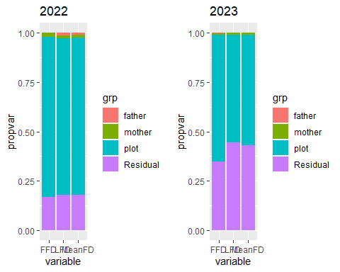

Very low proportions of variance explained by father and mother. Most variance explained by plot (especially in 2022).

### Heritability and maternal effects

#### 2022

# h^2 (paternal effects)  
her_22_FFD<-as.numeric(4*subset(PropVar_22_FFD_boot,grp=="father")[3])  
her_22_LFD<-as.numeric(4*subset(PropVar_22_LFD_boot,grp=="father")[3])  
her_22_MeanFD<-as.numeric(4*subset(PropVar_22_MeanFD_boot,grp=="father")[3])  
# Because the additive genetic variance, VA,  
# is expected to be four times the among pollen‐donor variance   
# (Falconer & Mackay, 1996; Lynch & Walsh, 1998)  
her_22<-data.frame(value=rbind(her_22_FFD,her_22_LFD,her_22_MeanFD))%>%  
 rownames_to_column()%>%  
 mutate(variable=c("FFD","LFD","MeanFD"),  
 effect="Heritability")

# maternal effects  
  
# Maternal - paternal  
# ----------------------  
# summed effects  
  
# Because the pollen‐recipient variance component contains a combination of  
# genetic and environmental effects, we subtracted the additive genetic   
# (pollen donor) component from the pollen-recipient variance component  
# before dividing the resulting estimate by VP to estimate   
# m2 (m2 = (Vpollen recipient − Vpollen donor)/VP).  
  
# But what about the interaction?  
  
mat_22_FFD<-as.numeric(((Variance_22_FFD_boot%>%filter(grp=="mother"))$vcov-  
 (Variance_22_FFD_boot%>%filter(grp=="father"))$vcov))/  
 as.numeric(Variance_22_FFD_boot%>%summarise(sum(vcov)))  
mat_22_LFD<-as.numeric(((Variance_22_LFD_boot%>%filter(grp=="mother"))$vcov-  
 (Variance_22_LFD_boot%>%filter(grp=="father"))$vcov))/  
 as.numeric(Variance_22_LFD_boot%>%summarise(sum(vcov)))  
mat_22_MeanFD<-as.numeric(((Variance_22_MeanFD_boot%>%filter(grp=="mother"))$vcov-  
 (Variance_22_MeanFD_boot%>%filter(grp=="father"))$vcov))/  
 as.numeric(Variance_22_MeanFD_boot%>%summarise(sum(vcov)))  
  
mat_22<-data.frame(value=rbind(mat_22_FFD))%>%  
 rownames_to_column()%>%  
 mutate(variable=c("FFD"),  
 effect="Maternal effects")  
mat_22<-data.frame(value=rbind(mat_22_FFD,mat_22_LFD,mat_22_MeanFD))%>%  
 rownames_to_column()%>%  
 mutate(variable=c("FFD","LFD","MeanFD"),  
 effect="Maternal effects")

her_mat_22<-rbind(her_22,mat_22)  
her_mat_22

## rowname value variable effect  
## 1 her_22_FFD 0.0006101254 FFD Heritability  
## 2 her_22_LFD 0.0534781140 LFD Heritability  
## 3 her_22_MeanFD 0.0353074920 MeanFD Heritability  
## 4 mat_22_FFD 0.0213134506 FFD Maternal effects  
## 5 mat_22_LFD 0.0030045819 LFD Maternal effects  
## 6 mat_22_MeanFD 0.0078828739 MeanFD Maternal effects

#### 2023

# h^2 (paternal effects)  
her_23_FFD<-as.numeric(4*subset(PropVar_23_FFD_boot,grp=="father")[3])  
her_23_LFD<-as.numeric(4*subset(PropVar_23_LFD_boot,grp=="father")[3])  
her_23_MeanFD<-as.numeric(4*0)  
# Because the additive genetic variance, VA,  
# is expected to be four times the among pollen‐donor variance   
# (Falconer & Mackay, 1996; Lynch & Walsh, 1998)  
her_23<-data.frame(value=rbind(her_23_FFD,her_23_LFD,her_23_MeanFD))%>%  
 rownames_to_column()%>%  
 mutate(variable=c("FFD","LFD","MeanFD"),  
 effect="Heritability")

# maternal effects  
  
# Maternal - paternal  
# ----------------------  
# summed effects  
  
# Because the pollen‐recipient variance component contains a combination of  
# genetic and environmental effects, we subtracted the additive genetic   
# (pollen donor) component from the pollen-recipient variance component  
# before dividing the resulting estimate by VP to estimate   
# m2 (m2 = (Vpollen recipient − Vpollen donor)/VP).  
  
# But what about the interaction?  
  
mat_23_FFD<-as.numeric(((Variance_23_FFD_boot%>%filter(grp=="mother"))$vcov-  
 (Variance_23_FFD_boot%>%filter(grp=="father"))$vcov))/  
 as.numeric(Variance_23_FFD_boot%>%summarise(sum(vcov)))  
mat_23_LFD<-as.numeric(((Variance_23_LFD_boot%>%filter(grp=="mother"))$vcov-  
 (Variance_23_LFD_boot%>%filter(grp=="father"))$vcov))/  
 as.numeric(Variance_23_LFD_boot%>%summarise(sum(vcov)))  
mat_23_MeanFD<-as.numeric(((Variance_23_MeanFD_boot%>%filter(grp=="mother"))$vcov-  
 0))/  
 as.numeric(Variance_23_MeanFD_boot%>%summarise(sum(vcov)))  
  
mat_23<-data.frame(value=rbind(mat_23_FFD))%>%  
 rownames_to_column()%>%  
 mutate(variable=c("FFD"),  
 effect="Maternal effects")  
mat_23<-data.frame(value=rbind(mat_23_FFD,mat_23_LFD,mat_23_MeanFD))%>%  
 rownames_to_column()%>%  
 mutate(variable=c("FFD","LFD","MeanFD"),  
 effect="Maternal effects")

her_mat_23<-rbind(her_23,mat_23)  
her_mat_23

## rowname value variable effect  
## 1 her_23_FFD 0.009929714 FFD Heritability  
## 2 her_23_LFD 0.003101001 LFD Heritability  
## 3 her_23_MeanFD 0.000000000 MeanFD Heritability  
## 4 mat_23_FFD 0.004732225 FFD Maternal effects  
## 5 mat_23_LFD 0.009307642 LFD Maternal effects  
## 6 mat_23_MeanFD 0.011021396 MeanFD Maternal effects

#### Comparison both years

grid.arrange(  
 ggplot(her_mat_22,aes(x=variable,y=value,fill=effect))+  
 geom_bar(stat="identity",position="dodge")+ggtitle("2022"),  
 ggplot(her_mat_23,aes(x=variable,y=value,fill=effect))+  
 geom_bar(stat="identity",position="dodge")+ggtitle("2023"),  
 ncol=2)

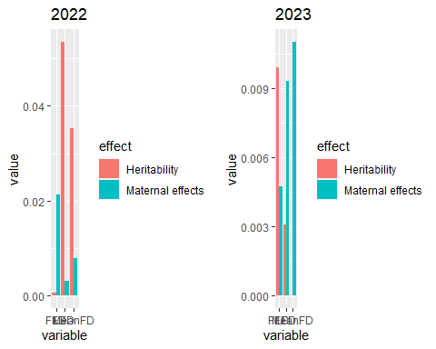

Heritabilities are very low (all <0.05 in 2022, and even lower (all <0.01) in 2023.

### Likelihood ratio tests for variance components

Based on original models, not on bootstrap.

(These results could be used to add asterisks to the previous plot).

ranova(model1_22_FFD)

## ANOVA-like table for random-effects: Single term deletions  
##   
## Model:  
## FFD_corr ~ (1 | father) + (1 | mother) + (1 | plot)  
## npar logLik AIC LRT Df Pr(>Chisq)   
## <none> 5 -2174.6 4359.2   
## (1 | father) 4 -2174.6 4357.2 0.00 1 0.9716408   
## (1 | mother) 4 -2180.7 4369.3 12.14 1 0.0004945 ***  
## (1 | plot) 4 -2636.2 5280.3 923.18 1 < 2.2e-16 ***  
## ---  
## Signif. codes: 0 '***' 0.001 '**' 0.01 '*' 0.05 '.' 0.1 ' ' 1

ranova(model1_22_LFD)

## ANOVA-like table for random-effects: Single term deletions  
##   
## Model:  
## LFD_corr ~ (1 | father) + (1 | mother) + (1 | plot)  
## npar logLik AIC LRT Df Pr(>Chisq)   
## <none> 5 -1326.9 2663.9   
## (1 | father) 4 -1327.9 2663.8 1.95 1 0.16266   
## (1 | mother) 4 -1328.8 2665.7 3.82 1 0.05067 .   
## (1 | plot) 4 -1590.8 3189.7 527.80 1 < 2e-16 ***  
## ---  
## Signif. codes: 0 '***' 0.001 '**' 0.01 '*' 0.05 '.' 0.1 ' ' 1

ranova(model1_22_MeanFD)

## ANOVA-like table for random-effects: Single term deletions  
##   
## Model:  
## MeanFD ~ (1 | father) + (1 | mother) + (1 | plot)  
## npar logLik AIC LRT Df Pr(>Chisq)   
## <none> 5 -1322.2 2654.5   
## (1 | father) 4 -1322.7 2653.5 0.99 1 0.3186   
## (1 | mother) 4 -1324.2 2656.5 4.01 1 0.0451 *   
## (1 | plot) 4 -1591.3 3190.7 538.20 1 <2e-16 ***  
## ---  
## Signif. codes: 0 '***' 0.001 '**' 0.01 '*' 0.05 '.' 0.1 ' ' 1

ranova(model1_23_FFD)

## ANOVA-like table for random-effects: Single term deletions  
##   
## Model:  
## FFD_corr ~ (1 | father) + (1 | mother) + (1 | plot)  
## npar logLik AIC LRT Df Pr(>Chisq)   
## <none> 5 -1453.3 2916.6   
## (1 | father) 4 -1453.3 2914.7 0.066 1 0.7974   
## (1 | mother) 4 -1453.6 2915.1 0.481 1 0.4878   
## (1 | plot) 4 -1601.1 3210.2 295.529 1 <2e-16 ***  
## ---  
## Signif. codes: 0 '***' 0.001 '**' 0.01 '*' 0.05 '.' 0.1 ' ' 1

ranova(model1_23_LFD)

## ANOVA-like table for random-effects: Single term deletions  
##   
## Model:  
## LFD_corr ~ (1 | father) + (1 | mother) + (1 | father:mother) + (1 | plot)  
## npar logLik AIC LRT Df Pr(>Chisq)   
## <none> 6 -902.54 1817.1   
## (1 | father) 5 -902.54 1815.1 0.000 1 1.0000   
## (1 | mother) 5 -902.58 1815.2 0.085 1 0.7702   
## (1 | father:mother) 5 -902.55 1815.1 0.033 1 0.8550   
## (1 | plot) 5 -960.28 1930.6 115.482 1 <2e-16 ***  
## ---  
## Signif. codes: 0 '***' 0.001 '**' 0.01 '*' 0.05 '.' 0.1 ' ' 1

ranova(model1_23_MeanFD)

## ANOVA-like table for random-effects: Single term deletions  
##   
## Model:  
## MeanFD ~ (1 | mother) + (1 | plot)  
## npar logLik AIC LRT Df Pr(>Chisq)   
## <none> 4 -904.99 1818.0   
## (1 | mother) 3 -905.20 1816.4 0.418 1 0.5177   
## (1 | plot) 3 -965.49 1937.0 120.991 1 <2e-16 ***  
## ---  
## Signif. codes: 0 '***' 0.001 '**' 0.01 '*' 0.05 '.' 0.1 ' ' 1

Father always NS, mother only significant for FFD and meanFD in 2022.

## B) Heritability of plasticities (Prediction 2 in greenhouse paper)

### Models (linear)

Including random effects of father, mother and plot, and fixed effect of temperature at the planting site as well and interactions of temperature at the planting site with father and mother. Random effects with variance = 0 were removed to avoid singular fit. Only including linear effects of temperature.

#### 2022

model2_22_FFD<-lmer(FFD_corr~temp+(1|father)+(1|mother)+  
 #(1|father:mother)+ # Not included because variance=0  
 # to avoid singular fit  
 (1|plot)+(1|temp:father)+(1|temp:mother),  
 data_transplants%>%filter(year==2022&!is.na(FFD_corr)))  
model2_22_LFD<-lmer(LFD_corr~temp+  
 #(1|father)+ # Not included because variance=0  
 # to avoid singular fit  
 (1|mother)+  
 #(1|father:mother)+ # Not included because variance=0  
 # to avoid singular fit  
 (1|plot)+  
 #(1|temp:father)+ # Not included because variance=0  
 # to avoid singular fit  
 (1|temp:mother),  
 data_transplants%>%filter(year==2022&!is.na(LFD_corr)))  
model2_22_MeanFD<-lmer(MeanFD~temp+  
 #(1|father)+ # Not included because variance=6.776e-05  
 # to avoid singular fit  
 (1|mother)+  
 #(1|father:mother)+ # Not included because variance=0  
 # to avoid singular fit  
 (1|plot)+(1|temp:father)+(1|temp:mother),  
 data_transplants%>%filter(year==2022&!is.na(MeanFD)))  
summary(model2_22_FFD)

## Linear mixed model fit by REML. t-tests use Satterthwaite's method [  
## lmerModLmerTest]  
## Formula: FFD_corr ~ temp + (1 | father) + (1 | mother) + (1 | plot) +   
## (1 | temp:father) + (1 | temp:mother)  
## Data: data_transplants %>% filter(year == 2022 & !is.na(FFD_corr))  
##   
## REML criterion at convergence: 4192.4  
##   
## Scaled residuals:   
## Min 1Q Median 3Q Max   
## -2.2868 -0.5248 -0.0903 0.4013 5.0764   
##   
## Random effects:  
## Groups Name Variance Std.Dev.  
## temp:father (Intercept) 9.216e-07 0.00096  
## temp:mother (Intercept) 1.364e+01 3.69377  
## father (Intercept) 9.206e-01 0.95950  
## mother (Intercept) 8.925e+00 2.98745  
## plot (Intercept) 1.705e+02 13.05581  
## Residual 3.891e+01 6.23803  
## Number of obs: 603, groups:   
## temp:father, 561; temp:mother, 554; father, 64; mother, 63; plot, 8  
##   
## Fixed effects:  
## Estimate Std. Error df t value Pr(>|t|)   
## (Intercept) 185.16686 4.75194 7.66402 38.97 4.33e-10 ***  
## temp -0.71624 0.05285 525.59858 -13.55 < 2e-16 ***  
## ---  
## Signif. codes: 0 '***' 0.001 '**' 0.01 '*' 0.05 '.' 0.1 ' ' 1  
##   
## Correlation of Fixed Effects:  
## (Intr)  
## temp -0.198

summary(model2_22_LFD)

## Linear mixed model fit by REML. t-tests use Satterthwaite's method [  
## lmerModLmerTest]  
## Formula: LFD_corr ~ temp + (1 | mother) + (1 | plot) + (1 | temp:mother)  
## Data: data_transplants %>% filter(year == 2022 & !is.na(LFD_corr))  
##   
## REML criterion at convergence: 2562.4  
##   
## Scaled residuals:   
## Min 1Q Median 3Q Max   
## -1.97511 -0.37245 -0.09377 0.27358 2.79439   
##   
## Random effects:  
## Groups Name Variance Std.Dev.  
## temp:mother (Intercept) 41.714 6.459   
## mother (Intercept) 9.388 3.064   
## plot (Intercept) 148.294 12.178   
## Residual 17.286 4.158   
## Number of obs: 364, groups: temp:mother, 336; mother, 59; plot, 8  
##   
## Fixed effects:  
## Estimate Std. Error df t value Pr(>|t|)   
## (Intercept) 197.33630 4.60811 8.64699 42.824 2.26e-11 ***  
## temp -0.80640 0.08378 320.71759 -9.626 < 2e-16 ***  
## ---  
## Signif. codes: 0 '***' 0.001 '**' 0.01 '*' 0.05 '.' 0.1 ' ' 1  
##   
## Correlation of Fixed Effects:  
## (Intr)  
## temp -0.319

summary(model2_22_MeanFD)

## Linear mixed model fit by REML. t-tests use Satterthwaite's method [  
## lmerModLmerTest]  
## Formula: MeanFD ~ temp + (1 | mother) + (1 | plot) + (1 | temp:father) +   
## (1 | temp:mother)  
## Data: data_transplants %>% filter(year == 2022 & !is.na(MeanFD))  
##   
## REML criterion at convergence: 2550.5  
##   
## Scaled residuals:   
## Min 1Q Median 3Q Max   
## -1.89760 -0.33495 -0.07523 0.23819 2.78731   
##   
## Random effects:  
## Groups Name Variance Std.Dev.  
## temp:father (Intercept) 0.2255 0.4749   
## temp:mother (Intercept) 41.5802 6.4483   
## mother (Intercept) 8.2965 2.8804   
## plot (Intercept) 150.6400 12.2735   
## Residual 15.8117 3.9764   
## Number of obs: 364, groups:   
## temp:father, 342; temp:mother, 336; mother, 59; plot, 8  
##   
## Fixed effects:  
## Estimate Std. Error df t value Pr(>|t|)   
## (Intercept) 192.32469 4.63041 8.56502 41.535 3.53e-11 ***  
## temp -0.80056 0.08272 320.78608 -9.678 < 2e-16 ***  
## ---  
## Signif. codes: 0 '***' 0.001 '**' 0.01 '*' 0.05 '.' 0.1 ' ' 1  
##   
## Correlation of Fixed Effects:  
## (Intr)  
## temp -0.313

#### 2023

model2_23_FFD<-lmer(FFD_corr~temp+(1|father)+(1|mother)+(1|father:mother)+  
 (1|plot)+(1|temp:father)+(1|temp:mother),  
 data_transplants%>%filter(year==2023&!is.na(FFD_corr)))  
model2_23_LFD<-lmer(LFD_corr~temp+  
 #(1|father)+ # Not included because variance=0  
 # to avoid singular fit  
 (1|mother)+(1|father:mother)+  
 #(1|father:mother)+ # Not included because variance=0  
 # to avoid singular fit  
 (1|plot)+(1|temp:father),  
 #(1|temp:mother) not included because singular fit  
 data_transplants%>%filter(year==2023&!is.na(LFD_corr)))  
model2_23_MeanFD<-lmer(MeanFD~temp+  
 #(1|father)+ # Not included because variance=6.776e-05  
 # to avoid singular fit  
 (1|mother)+(1|father:mother)+  
 (1|plot)+(1|temp:father)+(1|temp:mother),  
 data_transplants%>%filter(year==2023&!is.na(MeanFD)))  
summary(model2_23_FFD)

## Linear mixed model fit by REML. t-tests use Satterthwaite's method [  
## lmerModLmerTest]  
## Formula: FFD_corr ~ temp + (1 | father) + (1 | mother) + (1 | father:mother) +   
## (1 | plot) + (1 | temp:father) + (1 | temp:mother)  
## Data: data_transplants %>% filter(year == 2023 & !is.na(FFD_corr))  
##   
## REML criterion at convergence: 2862.2  
##   
## Scaled residuals:   
## Min 1Q Median 3Q Max   
## -1.8471 -0.5068 -0.0551 0.3057 5.1468   
##   
## Random effects:  
## Groups Name Variance Std.Dev.  
## temp:mother (Intercept) 10.7467 3.2782   
## temp:father (Intercept) 3.2473 1.8020   
## father:mother (Intercept) 1.5302 1.2370   
## mother (Intercept) 0.3990 0.6317   
## father (Intercept) 0.7242 0.8510   
## plot (Intercept) 95.2773 9.7610   
## Residual 43.8294 6.6204   
## Number of obs: 409, groups:   
## temp:mother, 389; temp:father, 389; father:mother, 128; mother, 62; father, 62; plot, 7  
##   
## Fixed effects:  
## Estimate Std. Error df t value Pr(>|t|)   
## (Intercept) 180.25557 3.93256 7.06601 45.837 5.24e-10 ***  
## temp -0.12026 0.08563 378.18918 -1.404 0.161   
## ---  
## Signif. codes: 0 '***' 0.001 '**' 0.01 '*' 0.05 '.' 0.1 ' ' 1  
##   
## Correlation of Fixed Effects:  
## (Intr)  
## temp -0.314

summary(model2_23_LFD)

## Linear mixed model fit by REML. t-tests use Satterthwaite's method [  
## lmerModLmerTest]  
## Formula: LFD_corr ~ temp + (1 | mother) + (1 | father:mother) + (1 | plot) +   
## (1 | temp:father)  
## Data: data_transplants %>% filter(year == 2023 & !is.na(LFD_corr))  
##   
## REML criterion at convergence: 1781.5  
##   
## Scaled residuals:   
## Min 1Q Median 3Q Max   
## -1.54165 -0.29744 -0.02117 0.09251 2.79158   
##   
## Random effects:  
## Groups Name Variance Std.Dev.  
## temp:father (Intercept) 50.4364 7.1019   
## father:mother (Intercept) 0.9368 0.9679   
## mother (Intercept) 1.6960 1.3023   
## plot (Intercept) 58.8925 7.6741   
## Residual 16.6131 4.0759   
## Number of obs: 250, groups:   
## temp:father, 241; father:mother, 115; mother, 57; plot, 7  
##   
## Fixed effects:  
## Estimate Std. Error df t value Pr(>|t|)   
## (Intercept) 191.2709 3.4536 8.8544 55.384 1.47e-12 ***  
## temp -0.2487 0.1200 207.7894 -2.073 0.0394 *   
## ---  
## Signif. codes: 0 '***' 0.001 '**' 0.01 '*' 0.05 '.' 0.1 ' ' 1  
##   
## Correlation of Fixed Effects:  
## (Intr)  
## temp -0.499

summary(model2_23_MeanFD)

## Linear mixed model fit by REML. t-tests use Satterthwaite's method [  
## lmerModLmerTest]  
## Formula: MeanFD ~ temp + (1 | mother) + (1 | father:mother) + (1 | plot) +   
## (1 | temp:father) + (1 | temp:mother)  
## Data: data_transplants %>% filter(year == 2023 & !is.na(MeanFD))  
##   
## REML criterion at convergence: 1788.4  
##   
## Scaled residuals:   
## Min 1Q Median 3Q Max   
## -1.57516 -0.33803 -0.02433 0.11789 3.07666   
##   
## Random effects:  
## Groups Name Variance Std.Dev.  
## temp:father (Intercept) 4.692e+01 6.849971  
## temp:mother (Intercept) 2.819e-06 0.001679  
## father:mother (Intercept) 8.380e-01 0.915421  
## mother (Intercept) 1.573e+00 1.254159  
## plot (Intercept) 6.560e+01 8.099455  
## Residual 2.170e+01 4.658005  
## Number of obs: 250, groups:   
## temp:father, 241; temp:mother, 240; father:mother, 115; mother, 57; plot, 7  
##   
## Fixed effects:  
## Estimate Std. Error df t value Pr(>|t|)   
## (Intercept) 186.4272 3.6018 8.6712 51.759 4.17e-12 ***  
## temp -0.2397 0.1216 212.7649 -1.972 0.0499 *   
## ---  
## Signif. codes: 0 '***' 0.001 '**' 0.01 '*' 0.05 '.' 0.1 ' ' 1  
##   
## Correlation of Fixed Effects:  
## (Intr)  
## temp -0.485

#### Model diagnostics

plot(simulateResiduals(model2_22_FFD))

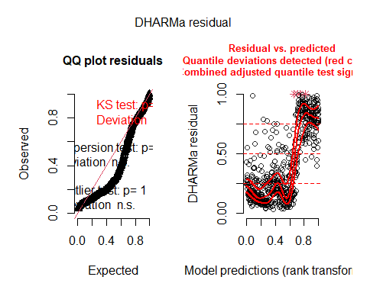

plot(simulateResiduals(model2_22_LFD))

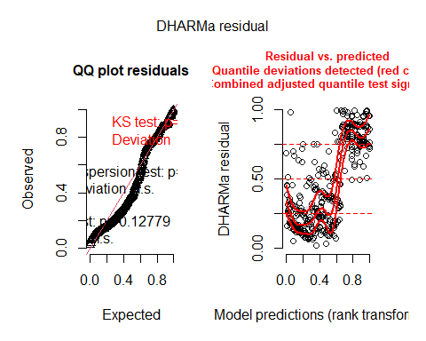

plot(simulateResiduals(model2_22_MeanFD))

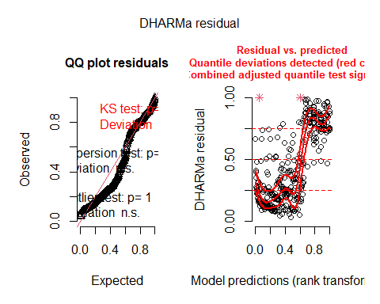

plot(simulateResiduals(model2_23_FFD))

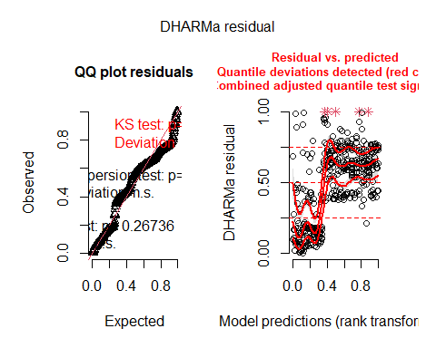

plot(simulateResiduals(model2_23_LFD))

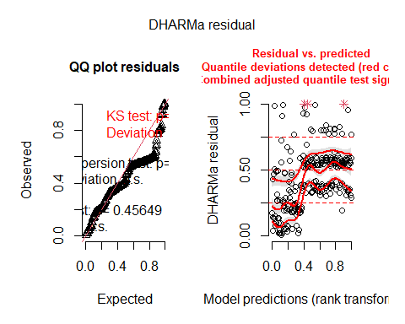

plot(simulateResiduals(model2_23_MeanFD))

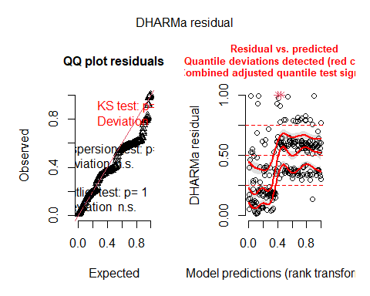

Overall deviations from the expected distribution detected. Heteroscedasticity.

### Models (quadratic)

Including random effects of father, mother and plot, and fixed effect of temperature at the planting site as well and interactions of temperature at the planting site with father and mother. Random effects with variance = 0 were removed to avoid singular fit. Including linear + quadratic effects of temperature.

#### 2022

data_transplants$temp_square<-(data_transplants$temp)^2  
model2_22_FFD_q<-lmer(FFD_corr~temp+temp_square+(1|father)+(1|mother)+  
 #(1|father:mother)+ # Not included because variance=0  
 # to avoid singular fit  
 (1|plot)+  
 (1|temp:father)+(1|temp:mother)+  
 (1|temp_square:father)+(1|temp_square:mother),  
 data_transplants%>%filter(year==2022&!is.na(FFD_corr)))  
# Some warnings, not sure what to do  
model2_22_LFD_q<-lmer(LFD_corr~temp+temp_square+  
 #(1|father)+ # Not included because variance=0  
 # to avoid singular fit  
 (1|mother)+  
 #(1|father:mother)+ # Not included because variance=0  
 # to avoid singular fit  
 (1|plot)+  
 (1|temp:father)+(1|temp:mother)+  
 (1|temp_square:father)+(1|temp_square:mother),  
 data_transplants%>%filter(year==2022&!is.na(LFD_corr)))  
# Some warnings, not sure what to do  
model2_22_MeanFD_q<-lmer(MeanFD~temp+temp_square+  
 #(1|father)+ # Not included because variance=0  
 # to avoid singular fit  
 (1|mother)+  
 #(1|father:mother)+ # Not included because variance=0  
 # to avoid singular fit  
 (1|plot)+  
 (1|temp:father)+(1|temp:mother)+  
 (1|temp_square:father)+(1|temp_square:mother),  
 data_transplants%>%filter(year==2022&!is.na(MeanFD)))  
summary(model2_22_FFD_q)

## Linear mixed model fit by REML. t-tests use Satterthwaite's method [  
## lmerModLmerTest]  
## Formula: FFD_corr ~ temp + temp_square + (1 | father) + (1 | mother) +   
## (1 | plot) + (1 | temp:father) + (1 | temp:mother) + (1 |   
## temp_square:father) + (1 | temp_square:mother)  
## Data: data_transplants %>% filter(year == 2022 & !is.na(FFD_corr))  
##   
## REML criterion at convergence: 4175.4  
##   
## Scaled residuals:   
## Min 1Q Median 3Q Max   
## -2.3603 -0.5387 -0.1078 0.3949 5.3308   
##   
## Random effects:  
## Groups Name Variance Std.Dev.  
## temp_square:father (Intercept) 0.1952 0.4419   
## temp:father (Intercept) 0.4317 0.6571   
## temp_square:mother (Intercept) 6.2422 2.4984   
## temp:mother (Intercept) 4.2591 2.0638   
## father (Intercept) 0.5882 0.7670   
## mother (Intercept) 8.7109 2.9514   
## plot (Intercept) 91.2946 9.5548   
## Residual 39.7031 6.3010   
## Number of obs: 603, groups:   
## temp_square:father, 561; temp:father, 561; temp_square:mother, 554; temp:mother, 554; father, 64; mother, 63; plot, 8  
##   
## Fixed effects:  
## Estimate Std. Error df t value Pr(>|t|)   
## (Intercept) 203.23959 4.93246 25.77939 41.205 < 2e-16 ***  
## temp -2.37646 0.31877 510.23620 -7.455 3.88e-13 ***  
## temp_square 0.02978 0.00567 526.31663 5.252 2.18e-07 ***  
## ---  
## Signif. codes: 0 '***' 0.001 '**' 0.01 '*' 0.05 '.' 0.1 ' ' 1  
##   
## Correlation of Fixed Effects:  
## (Intr) temp   
## temp -0.714   
## temp_square 0.693 -0.987  
## optimizer (nloptwrap) convergence code: 0 (OK)  
## unable to evaluate scaled gradient  
## Model failed to converge: degenerate Hessian with 2 negative eigenvalues

summary(model2_22_LFD_q)

## Linear mixed model fit by REML. t-tests use Satterthwaite's method [  
## lmerModLmerTest]  
## Formula: LFD_corr ~ temp + temp_square + (1 | mother) + (1 | plot) + (1 |   
## temp:father) + (1 | temp:mother) + (1 | temp_square:father) +   
## (1 | temp_square:mother)  
## Data: data_transplants %>% filter(year == 2022 & !is.na(LFD_corr))  
##   
## REML criterion at convergence: 2544.4  
##   
## Scaled residuals:   
## Min 1Q Median 3Q Max   
## -1.92180 -0.36130 -0.08658 0.24964 2.90809   
##   
## Random effects:  
## Groups Name Variance Std.Dev.  
## temp_square:father (Intercept) 0.18434 0.4293   
## temp:father (Intercept) 0.03157 0.1777   
## temp_square:mother (Intercept) 27.04471 5.2005   
## temp:mother (Intercept) 11.72724 3.4245   
## mother (Intercept) 7.90840 2.8122   
## plot (Intercept) 54.27834 7.3674   
## Residual 17.34910 4.1652   
## Number of obs: 364, groups:   
## temp_square:father, 342; temp:father, 342; temp_square:mother, 336; temp:mother, 336; mother, 59; plot, 8  
##   
## Fixed effects:  
## Estimate Std. Error df t value Pr(>|t|)   
## (Intercept) 223.870367 5.563836 50.173936 40.237 < 2e-16 ***  
## temp -3.268937 0.443453 202.297945 -7.372 4.23e-12 ***  
## temp_square 0.045027 0.008105 236.588724 5.555 7.43e-08 ***  
## ---  
## Signif. codes: 0 '***' 0.001 '**' 0.01 '*' 0.05 '.' 0.1 ' ' 1  
##   
## Correlation of Fixed Effects:  
## (Intr) temp   
## temp -0.869   
## temp_square 0.837 -0.983  
## optimizer (nloptwrap) convergence code: 0 (OK)  
## unable to evaluate scaled gradient  
## Model failed to converge: degenerate Hessian with 1 negative eigenvalues

summary(model2_22_MeanFD_q)

## Linear mixed model fit by REML. t-tests use Satterthwaite's method [  
## lmerModLmerTest]  
## Formula: MeanFD ~ temp + temp_square + (1 | mother) + (1 | plot) + (1 |   
## temp:father) + (1 | temp:mother) + (1 | temp_square:father) +   
## (1 | temp_square:mother)  
## Data: data_transplants %>% filter(year == 2022 & !is.na(MeanFD))  
##   
## REML criterion at convergence: 2532.8  
##   
## Scaled residuals:   
## Min 1Q Median 3Q Max   
## -1.84250 -0.33680 -0.07347 0.22621 2.88132   
##   
## Random effects:  
## Groups Name Variance Std.Dev.  
## temp_square:father (Intercept) 0.001353 0.03679   
## temp:father (Intercept) 0.684666 0.82745   
## temp_square:mother (Intercept) 10.738570 3.27698   
## temp:mother (Intercept) 27.920896 5.28402   
## mother (Intercept) 7.023529 2.65019   
## plot (Intercept) 56.893152 7.54275   
## Residual 15.637399 3.95442   
## Number of obs: 364, groups:   
## temp_square:father, 342; temp:father, 342; temp_square:mother, 336; temp:mother, 336; mother, 59; plot, 8  
##   
## Fixed effects:  
## Estimate Std. Error df t value Pr(>|t|)   
## (Intercept) 218.350887 5.548665 49.373298 39.352 < 2e-16 ***  
## temp -3.216161 0.438899 214.454368 -7.328 4.69e-12 ***  
## temp_square 0.044172 0.008015 247.230084 5.511 8.96e-08 ***  
## ---  
## Signif. codes: 0 '***' 0.001 '**' 0.01 '*' 0.05 '.' 0.1 ' ' 1  
##   
## Correlation of Fixed Effects:  
## (Intr) temp   
## temp -0.863   
## temp_square 0.831 -0.983

#### 2023

model2_23_FFD_q<-lmer(FFD_corr~temp+temp_square+(1|father)+(1|mother)+  
 (1|father:mother)+(1|plot)+  
 (1|temp:father)+(1|temp:mother)+  
 (1|temp_square:father)+(1|temp_square:mother),  
 data_transplants%>%filter(year==2023&!is.na(FFD_corr)))  
# Some warnings, not sure what to do  
model2_23_LFD_q<-lmer(LFD_corr~temp+temp_square+  
 #(1|father)+ # Not included because variance=0  
 # to avoid singular fit  
 (1|mother)+  
 #(1|father:mother)+ # Not included because variance=0  
 # to avoid singular fit  
 (1|plot)+  
 (1|temp:mother)+  
 (1|temp_square:mother),  
 #(1|temp:father)+(1|temp_square:father)+   
 # removed due to singular fit  
 data_transplants%>%filter(year==2023&!is.na(LFD_corr)))  
# Some warnings, not sure what to do  
model2_23_MeanFD_q<-lmer(MeanFD~temp+temp_square+  
 #(1|father)+ # Not included because variance=0  
 # to avoid singular fit  
 (1|mother)+  
 #(1|father:mother)+ # Not included because variance=0  
 # to avoid singular fit  
 (1|plot)+  
 (1|temp:mother)+  
 (1|temp_square:mother),  
 #(1|temp:father)+(1|temp_square:father)+   
 # removed due to singular fit  
 data_transplants%>%filter(year==2023&!is.na(MeanFD)))  
# Some warnings, not sure what to do  
summary(model2_23_FFD_q)

## Linear mixed model fit by REML. t-tests use Satterthwaite's method [  
## lmerModLmerTest]  
## Formula: FFD_corr ~ temp + temp_square + (1 | father) + (1 | mother) +   
## (1 | father:mother) + (1 | plot) + (1 | temp:father) + (1 |   
## temp:mother) + (1 | temp_square:father) + (1 | temp_square:mother)  
## Data: data_transplants %>% filter(year == 2023 & !is.na(FFD_corr))  
##   
## REML criterion at convergence: 2869.3  
##   
## Scaled residuals:   
## Min 1Q Median 3Q Max   
## -1.8414 -0.5072 -0.0652 0.3033 5.1287   
##   
## Random effects:  
## Groups Name Variance Std.Dev.  
## temp_square:mother (Intercept) 2.5193 1.5872   
## temp_square:father (Intercept) 3.6337 1.9062   
## temp:mother (Intercept) 7.9287 2.8158   
## temp:father (Intercept) 0.1522 0.3902   
## father:mother (Intercept) 1.6694 1.2921   
## mother (Intercept) 0.4998 0.7070   
## father (Intercept) 0.6856 0.8280   
## plot (Intercept) 84.8000 9.2087   
## Residual 43.5991 6.6030   
## Number of obs: 409, groups:   
## temp_square:mother, 389; temp_square:father, 389; temp:mother, 389; temp:father, 389; father:mother, 128; mother, 62; father, 62; plot, 7  
##   
## Fixed effects:  
## Estimate Std. Error df t value Pr(>|t|)   
## (Intercept) 183.674522 6.114626 24.350093 30.039 <2e-16 ***  
## temp -0.476102 0.512766 131.549908 -0.928 0.355   
## temp_square 0.006368 0.009130 152.026178 0.697 0.487   
## ---  
## Signif. codes: 0 '***' 0.001 '**' 0.01 '*' 0.05 '.' 0.1 ' ' 1  
##   
## Correlation of Fixed Effects:  
## (Intr) temp   
## temp -0.814   
## temp_square 0.791 -0.986  
## optimizer (nloptwrap) convergence code: 0 (OK)  
## unable to evaluate scaled gradient  
## Model failed to converge: degenerate Hessian with 1 negative eigenvalues

summary(model2_23_LFD_q)

## Linear mixed model fit by REML. t-tests use Satterthwaite's method [  
## lmerModLmerTest]  
## Formula: LFD_corr ~ temp + temp_square + (1 | mother) + (1 | plot) + (1 |   
## temp:mother) + (1 | temp_square:mother)  
## Data: data_transplants %>% filter(year == 2023 & !is.na(LFD_corr))  
##   
## REML criterion at convergence: 1787.4  
##   
## Scaled residuals:   
## Min 1Q Median 3Q Max   
## -1.48761 -0.27253 -0.02585 0.10365 2.73821   
##   
## Random effects:  
## Groups Name Variance Std.Dev.  
## temp_square:mother (Intercept) 27.25 5.220   
## temp:mother (Intercept) 25.47 5.047   
## mother (Intercept) 1.07 1.034   
## plot (Intercept) 57.10 7.556   
## Residual 16.31 4.039   
## Number of obs: 250, groups:   
## temp_square:mother, 240; temp:mother, 240; mother, 57; plot, 7  
##   
## Fixed effects:  
## Estimate Std. Error df t value Pr(>|t|)   
## (Intercept) 192.992145 6.563945 18.526929 29.402 <2e-16 ***  
## temp -0.432089 0.607388 37.949300 -0.711 0.481   
## temp_square 0.003433 0.011133 50.172193 0.308 0.759   
## ---  
## Signif. codes: 0 '***' 0.001 '**' 0.01 '*' 0.05 '.' 0.1 ' ' 1  
##   
## Correlation of Fixed Effects:  
## (Intr) temp   
## temp -0.889   
## temp_square 0.854 -0.980  
## optimizer (nloptwrap) convergence code: 0 (OK)  
## unable to evaluate scaled gradient  
## Model failed to converge: degenerate Hessian with 1 negative eigenvalues

summary(model2_23_MeanFD_q)

## Linear mixed model fit by REML. t-tests use Satterthwaite's method [  
## lmerModLmerTest]  
## Formula: MeanFD ~ temp + temp_square + (1 | mother) + (1 | plot) + (1 |   
## temp:mother) + (1 | temp_square:mother)  
## Data: data_transplants %>% filter(year == 2023 & !is.na(MeanFD))  
##   
## REML criterion at convergence: 1794.2  
##   
## Scaled residuals:   
## Min 1Q Median 3Q Max   
## -1.5799 -0.3101 -0.0354 0.1270 2.9042   
##   
## Random effects:  
## Groups Name Variance Std.Dev.  
## temp_square:mother (Intercept) 7.7038 2.7756   
## temp:mother (Intercept) 43.0446 6.5608   
## mother (Intercept) 0.9738 0.9868   
## plot (Intercept) 65.3518 8.0840   
## Residual 19.7383 4.4428   
## Number of obs: 250, groups:   
## temp_square:mother, 240; temp:mother, 240; mother, 57; plot, 7  
##   
## Fixed effects:  
## Estimate Std. Error df t value Pr(>|t|)   
## (Intercept) 187.45458 6.80351 19.49014 27.553 <2e-16 ***  
## temp -0.34841 0.62409 43.16479 -0.558 0.580   
## temp_square 0.00205 0.01141 56.23627 0.180 0.858   
## ---  
## Signif. codes: 0 '***' 0.001 '**' 0.01 '*' 0.05 '.' 0.1 ' ' 1  
##   
## Correlation of Fixed Effects:  
## (Intr) temp   
## temp -0.883   
## temp_square 0.849 -0.981  
## optimizer (nloptwrap) convergence code: 0 (OK)  
## unable to evaluate scaled gradient  
## Model failed to converge: degenerate Hessian with 1 negative eigenvalues

#### Model diagnostics

plot(simulateResiduals(model2_22_FFD_q))

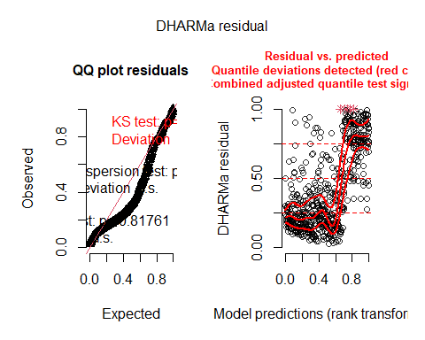

plot(simulateResiduals(model2_22_LFD_q))

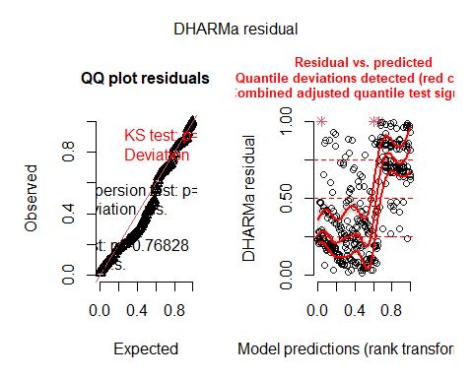

plot(simulateResiduals(model2_22_MeanFD_q))

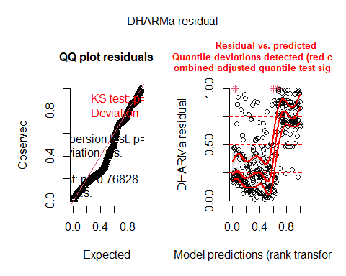

plot(simulateResiduals(model2_23_FFD_q))

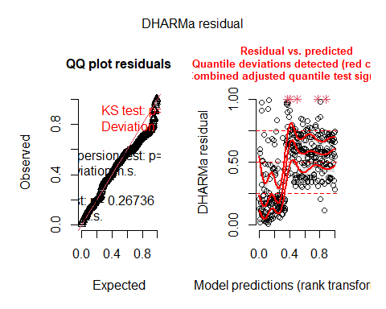

plot(simulateResiduals(model2_23_LFD_q))

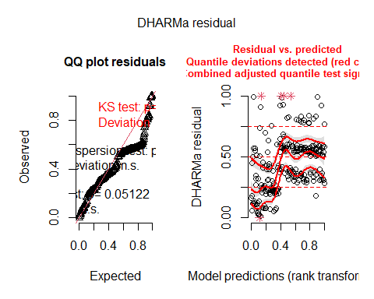

plot(simulateResiduals(model2_23_MeanFD_q))

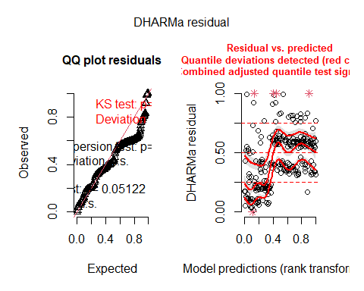

Overall deviations from the expected distribution detected. Heteroscedasticity.

### Models (quadratic only in fixed effects)

Including random effects of father, mother and plot, and fixed effect of temperature at the planting site as well and interactions of temperature at the planting site with father and mother. Random effects with variance = 0 were removed to avoid singular fit. Including linear + quadratic effects of temperature (quadratic only in fixed effects).

#### 2022

model2_22_FFD_qf<-lmer(FFD_corr~temp+I(temp^2)+  
 # same as temp+temp_square but better for ggpredict  
 (1|father)+(1|mother)+  
 #(1|father:mother)+ # Not included because variance=0  
 # to avoid singular fit  
 (1|plot)+(1|temp:father)+(1|temp:mother),  
 data_transplants%>%filter(year==2022&!is.na(FFD_corr)))  
model2_22_LFD_qf<-lmer(LFD_corr~temp+I(temp^2)+  
 # same as temp+temp_square but better for ggpredict  
 # (1|father)+ # Not included because variance=0  
 # to avoid singular fit  
 (1|mother)+  
 #(1|father:mother)+ # Not included because variance=0  
 # to avoid singular fit  
 (1|plot)+(1|temp:father)+(1|temp:mother),  
 data_transplants%>%filter(year==2022&!is.na(LFD_corr)))  
model2_22_MeanFD_qf<-lmer(MeanFD~temp+I(temp^2)+  
 # same as temp+temp_square but better for ggpredict  
 # (1|father)+ # Not included because variance=0  
 # to avoid singular fit  
 (1|mother)+  
 #(1|father:mother)+ # Not included because variance=0  
 # to avoid singular fit  
 (1|plot)+(1|temp:father)+(1|temp:mother),  
 data_transplants%>%filter(year==2022&!is.na(MeanFD)))  
summary(model2_22_FFD_qf)

## Linear mixed model fit by REML. t-tests use Satterthwaite's method [  
## lmerModLmerTest]  
## Formula: FFD_corr ~ temp + I(temp^2) + (1 | father) + (1 | mother) + (1 |   
## plot) + (1 | temp:father) + (1 | temp:mother)  
## Data: data_transplants %>% filter(year == 2022 & !is.na(FFD_corr))  
##   
## REML criterion at convergence: 4175.4  
##   
## Scaled residuals:   
## Min 1Q Median 3Q Max   
## -2.3604 -0.5387 -0.1078 0.3949 5.3308   
##   
## Random effects:  
## Groups Name Variance Std.Dev.  
## temp:father (Intercept) 0.6247 0.7904   
## temp:mother (Intercept) 10.5040 3.2410   
## father (Intercept) 0.5883 0.7670   
## mother (Intercept) 8.7116 2.9515   
## plot (Intercept) 91.2646 9.5533   
## Residual 39.7026 6.3010   
## Number of obs: 603, groups:   
## temp:father, 561; temp:mother, 554; father, 64; mother, 63; plot, 8  
##   
## Fixed effects:  
## Estimate Std. Error df t value Pr(>|t|)   
## (Intercept) 203.24011 4.93206 25.79750 41.208 < 2e-16 ***  
## temp -2.37651 0.31877 510.23258 -7.455 3.87e-13 ***  
## I(temp^2) 0.02978 0.00567 526.31432 5.253 2.18e-07 ***  
## ---  
## Signif. codes: 0 '***' 0.001 '**' 0.01 '*' 0.05 '.' 0.1 ' ' 1  
##   
## Correlation of Fixed Effects:  
## (Intr) temp   
## temp -0.715   
## I(temp^2) 0.693 -0.987

summary(model2_22_LFD_qf)

## Linear mixed model fit by REML. t-tests use Satterthwaite's method [  
## lmerModLmerTest]  
## Formula: LFD_corr ~ temp + I(temp^2) + (1 | mother) + (1 | plot) + (1 |   
## temp:father) + (1 | temp:mother)  
## Data: data_transplants %>% filter(year == 2022 & !is.na(LFD_corr))  
##   
## REML criterion at convergence: 2544.4  
##   
## Scaled residuals:   
## Min 1Q Median 3Q Max   
## -1.92183 -0.36127 -0.08658 0.24963 2.90797   
##   
## Random effects:  
## Groups Name Variance Std.Dev.  
## temp:father (Intercept) 0.216 0.4647   
## temp:mother (Intercept) 38.774 6.2269   
## mother (Intercept) 7.907 2.8119   
## plot (Intercept) 54.272 7.3670   
## Residual 17.348 4.1651   
## Number of obs: 364, groups:   
## temp:father, 342; temp:mother, 336; mother, 59; plot, 8  
##   
## Fixed effects:  
## Estimate Std. Error df t value Pr(>|t|)   
## (Intercept) 223.870963 5.563749 50.180132 40.237 < 2e-16 ***  
## temp -3.268987 0.443452 202.290519 -7.372 4.23e-12 ***  
## I(temp^2) 0.045028 0.008105 236.582781 5.555 7.43e-08 ***  
## ---  
## Signif. codes: 0 '***' 0.001 '**' 0.01 '*' 0.05 '.' 0.1 ' ' 1  
##   
## Correlation of Fixed Effects:  
## (Intr) temp   
## temp -0.869   
## I(temp^2) 0.837 -0.983

summary(model2_22_MeanFD_qf)

## Linear mixed model fit by REML. t-tests use Satterthwaite's method [  
## lmerModLmerTest]  
## Formula: MeanFD ~ temp + I(temp^2) + (1 | mother) + (1 | plot) + (1 |   
## temp:father) + (1 | temp:mother)  
## Data: data_transplants %>% filter(year == 2022 & !is.na(MeanFD))  
##   
## REML criterion at convergence: 2532.8  
##   
## Scaled residuals:   
## Min 1Q Median 3Q Max   
## -1.84252 -0.33680 -0.07347 0.22621 2.88134   
##   
## Random effects:  
## Groups Name Variance Std.Dev.  
## temp:father (Intercept) 0.6856 0.828   
## temp:mother (Intercept) 38.6597 6.218   
## mother (Intercept) 7.0234 2.650   
## plot (Intercept) 56.8964 7.543   
## Residual 15.6376 3.954   
## Number of obs: 364, groups:   
## temp:father, 342; temp:mother, 336; mother, 59; plot, 8  
##   
## Fixed effects:  
## Estimate Std. Error df t value Pr(>|t|)   
## (Intercept) 218.350683 5.548716 49.369871 39.352 < 2e-16 ***  
## temp -3.216143 0.438901 214.460740 -7.328 4.70e-12 ***  
## I(temp^2) 0.044171 0.008015 247.236307 5.511 8.96e-08 ***  
## ---  
## Signif. codes: 0 '***' 0.001 '**' 0.01 '*' 0.05 '.' 0.1 ' ' 1  
##   
## Correlation of Fixed Effects:  
## (Intr) temp   
## temp -0.863   
## I(temp^2) 0.831 -0.983

#### 2023

model2_23_FFD_qf<-lmer(FFD_corr~temp+I(temp^2)+  
 # same as temp+temp_square but better for ggpredict  
 (1|father)+(1|mother)+(1|father:mother)+  
 (1|plot)+(1|temp:father)+(1|temp:mother),  
 data_transplants%>%filter(year==2023&!is.na(FFD_corr)))  
model2_23_LFD_qf<-lmer(LFD_corr~temp+I(temp^2)+  
 # same as temp+temp_square but better for ggpredict  
 # (1|father)+ # Not included because variance=0  
 # to avoid singular fit  
 (1|mother)+(1|father:mother)+  
 #(1|father:mother)+ # Not included because variance=0  
 # to avoid singular fit  
 (1|plot)+(1|temp:father),  
 #+(1|temp:mother) removed due to singular fit  
 data_transplants%>%filter(year==2023&!is.na(LFD_corr)))  
model2_23_MeanFD_qf<-lmer(MeanFD~temp+I(temp^2)+  
 # same as temp+temp_square but better for ggpredict  
 # (1|father)+ # Not included because variance=0  
 # to avoid singular fit  
 (1|mother)+  
 #(1|father:mother)+ # Not included because variance=0  
 # to avoid singular fit  
 (1|plot)+(1|temp:mother),  
 #(1|temp:father)+ removed due to singular fit  
 data_transplants%>%filter(year==2023&!is.na(MeanFD)))  
summary(model2_23_FFD_qf)

## Linear mixed model fit by REML. t-tests use Satterthwaite's method [  
## lmerModLmerTest]  
## Formula: FFD_corr ~ temp + I(temp^2) + (1 | father) + (1 | mother) + (1 |   
## father:mother) + (1 | plot) + (1 | temp:father) + (1 | temp:mother)  
## Data: data_transplants %>% filter(year == 2023 & !is.na(FFD_corr))  
##   
## REML criterion at convergence: 2869.3  
##   
## Scaled residuals:   
## Min 1Q Median 3Q Max   
## -1.8417 -0.5073 -0.0652 0.3034 5.1294   
##   
## Random effects:  
## Groups Name Variance Std.Dev.  
## temp:mother (Intercept) 10.4451 3.2319   
## temp:father (Intercept) 3.7762 1.9433   
## father:mother (Intercept) 1.6670 1.2911   
## mother (Intercept) 0.5002 0.7073   
## father (Intercept) 0.6865 0.8285   
## plot (Intercept) 84.7872 9.2080   
## Residual 43.6129 6.6040   
## Number of obs: 409, groups:   
## temp:mother, 389; temp:father, 389; father:mother, 128; mother, 62; father, 62; plot, 7  
##   
## Fixed effects:  
## Estimate Std. Error df t value Pr(>|t|)   
## (Intercept) 183.674755 6.114419 24.355575 30.040 <2e-16 ***  
## temp -0.476118 0.512759 131.547614 -0.929 0.355   
## I(temp^2) 0.006368 0.009130 152.024476 0.697 0.487   
## ---  
## Signif. codes: 0 '***' 0.001 '**' 0.01 '*' 0.05 '.' 0.1 ' ' 1  
##   
## Correlation of Fixed Effects:  
## (Intr) temp   
## temp -0.814   
## I(temp^2) 0.791 -0.986

summary(model2_23_LFD_qf)

## Linear mixed model fit by REML. t-tests use Satterthwaite's method [  
## lmerModLmerTest]  
## Formula: LFD_corr ~ temp + I(temp^2) + (1 | mother) + (1 | father:mother) +   
## (1 | plot) + (1 | temp:father)  
## Data: data_transplants %>% filter(year == 2023 & !is.na(LFD_corr))  
##   
## REML criterion at convergence: 1788.5  
##   
## Scaled residuals:   
## Min 1Q Median 3Q Max   
## -1.54513 -0.29488 -0.02447 0.09908 2.77017   
##   
## Random effects:  
## Groups Name Variance Std.Dev.  
## temp:father (Intercept) 50.7804 7.1260   
## father:mother (Intercept) 0.9962 0.9981   
## mother (Intercept) 1.7395 1.3189   
## plot (Intercept) 55.6774 7.4617   
## Residual 16.5158 4.0640   
## Number of obs: 250, groups:   
## temp:father, 241; father:mother, 115; mother, 57; plot, 7  
##   
## Fixed effects:  
## Estimate Std. Error df t value Pr(>|t|)   
## (Intercept) 193.72615 6.54540 18.43603 29.597 <2e-16 ***  
## temp -0.50897 0.60794 36.85269 -0.837 0.408   
## I(temp^2) 0.00480 0.01114 48.61553 0.431 0.669   
## ---  
## Signif. codes: 0 '***' 0.001 '**' 0.01 '*' 0.05 '.' 0.1 ' ' 1  
##   
## Correlation of Fixed Effects:  
## (Intr) temp   
## temp -0.891   
## I(temp^2) 0.856 -0.980

summary(model2_23_MeanFD_qf)

## Linear mixed model fit by REML. t-tests use Satterthwaite's method [  
## lmerModLmerTest]  
## Formula: MeanFD ~ temp + I(temp^2) + (1 | mother) + (1 | plot) + (1 |   
## temp:mother)  
## Data: data_transplants %>% filter(year == 2023 & !is.na(MeanFD))  
##   
## REML criterion at convergence: 1794.2  
##   
## Scaled residuals:   
## Min 1Q Median 3Q Max   
## -1.5799 -0.3101 -0.0354 0.1270 2.9042   
##   
## Random effects:  
## Groups Name Variance Std.Dev.  
## temp:mother (Intercept) 50.7483 7.1238   
## mother (Intercept) 0.9739 0.9869   
## plot (Intercept) 65.3503 8.0840   
## Residual 19.7384 4.4428   
## Number of obs: 250, groups: temp:mother, 240; mother, 57; plot, 7  
##   
## Fixed effects:  
## Estimate Std. Error df t value Pr(>|t|)   
## (Intercept) 187.45470 6.80348 19.49040 27.553 <2e-16 ***  
## temp -0.34842 0.62408 43.16459 -0.558 0.580   
## I(temp^2) 0.00205 0.01141 56.23614 0.180 0.858   
## ---  
## Signif. codes: 0 '***' 0.001 '**' 0.01 '*' 0.05 '.' 0.1 ' ' 1  
##   
## Correlation of Fixed Effects:  
## (Intr) temp   
## temp -0.883   
## I(temp^2) 0.849 -0.981

#### Model diagnostics

plot(simulateResiduals(model2_22_FFD_qf))

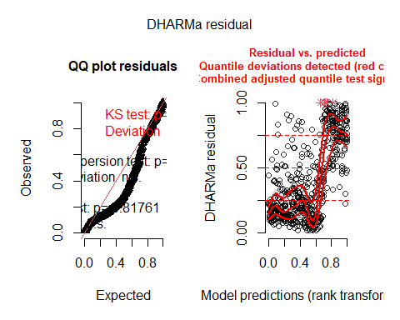

plot(simulateResiduals(model2_22_LFD_qf))

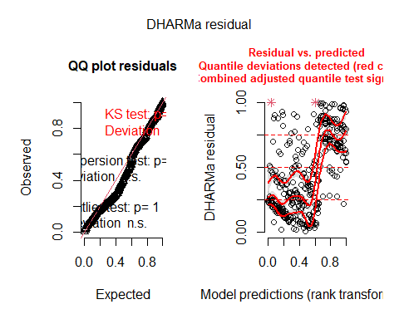

plot(simulateResiduals(model2_22_MeanFD_qf))

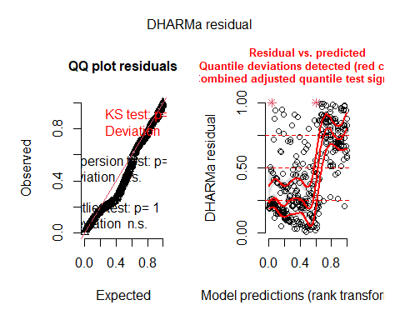

plot(simulateResiduals(model2_23_FFD_qf))

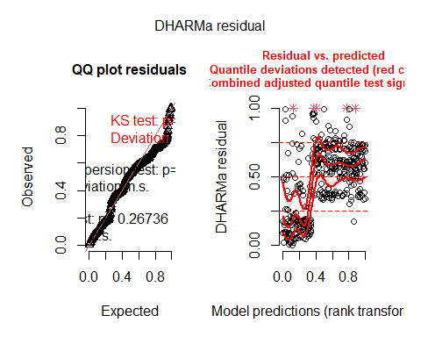

plot(simulateResiduals(model2_23_LFD_qf))

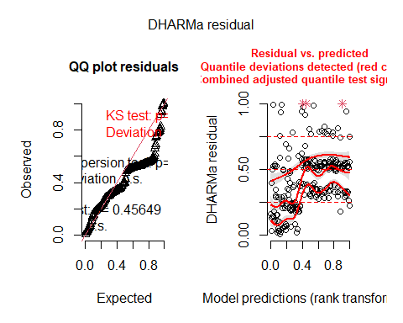

plot(simulateResiduals(model2_23_MeanFD_qf))

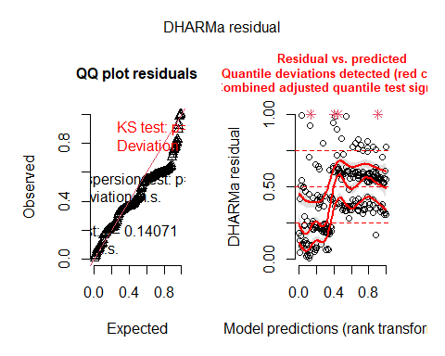

Overall deviations from the expected distribution detected. Heteroscedasticity.

### Compare linear and quadratic

#### 2022

r2_nakagawa(model2_22_FFD)

## # R2 for Mixed Models  
##   
## Conditional R2: 0.857  
## Marginal R2: 0.147

r2_nakagawa(model2_22_FFD_q)

## # R2 for Mixed Models  
##   
## Conditional R2: 0.830  
## Marginal R2: 0.352

r2_nakagawa(model2_22_FFD_qf)

## # R2 for Mixed Models  
##   
## Conditional R2: 0.830  
## Marginal R2: 0.352

r2_nakagawa(model2_22_LFD)

## # R2 for Mixed Models  
##   
## Conditional R2: 0.934  
## Marginal R2: 0.168

r2_nakagawa(model2_22_LFD_q)

## # R2 for Mixed Models  
##   
## Conditional R2: 0.927  
## Marginal R2: 0.499

r2_nakagawa(model2_22_LFD_qf)

## # R2 for Mixed Models  
##   
## Conditional R2: 0.927  
## Marginal R2: 0.499

r2_nakagawa(model2_22_MeanFD)

## # R2 for Mixed Models  
##   
## Conditional R2: 0.939  
## Marginal R2: 0.166

r2_nakagawa(model2_22_MeanFD_q)

## # R2 for Mixed Models  
##   
## Conditional R2: 0.933  
## Marginal R2: 0.492

r2_nakagawa(model2_22_MeanFD_qf)

## # R2 for Mixed Models  
##   
## Conditional R2: 0.933  
## Marginal R2: 0.492

Conditional R2 (fixed + random effects) only slightly lower in q and qf models. Marginal R2 (fixed effects) much higher in q and qf models.

AIC(model2_22_FFD,model2_22_FFD_q,model2_22_FFD_qf)

## df AIC  
## model2_22_FFD 8 4208.395  
## model2_22_FFD_q 11 4197.414  
## model2_22_FFD_qf 9 4193.414

AIC(model2_22_LFD,model2_22_LFD_q,model2_22_LFD_qf)

## df AIC  
## model2_22_LFD 6 2574.356  
## model2_22_LFD_q 10 2564.431  
## model2_22_LFD_qf 8 2560.431

AIC(model2_22_MeanFD,model2_22_MeanFD_q,model2_22_MeanFD_qf)

## df AIC  
## model2_22_MeanFD 7 2564.496  
## model2_22_MeanFD_q 10 2552.766  
## model2_22_MeanFD_qf 8 2548.766

Models with quadratic effect of temperature only in fixed effects are always best. I will use these models so far for 2022.

#### 2023

r2_nakagawa(model2_23_FFD)

## # R2 for Mixed Models  
##   
## Conditional R2: 0.720  
## Marginal R2: 0.006

r2_nakagawa(model2_23_FFD_q)

## # R2 for Mixed Models  
##   
## Conditional R2: 0.707  
## Marginal R2: 0.023

r2_nakagawa(model2_23_FFD_qf)

## # R2 for Mixed Models  
##   
## Conditional R2: 0.707  
## Marginal R2: 0.023

r2_nakagawa(model2_23_LFD)

## # R2 for Mixed Models  
##   
## Conditional R2: 0.875  
## Marginal R2: 0.029

r2_nakagawa(model2_23_LFD_q)

## # R2 for Mixed Models  
##   
## Conditional R2: 0.877  
## Marginal R2: 0.042

r2_nakagawa(model2_23_LFD_qf)

## # R2 for Mixed Models  
##   
## Conditional R2: 0.875  
## Marginal R2: 0.050

r2_nakagawa(model2_23_MeanFD)

## # R2 for Mixed Models  
##   
## Conditional R2: 0.845  
## Marginal R2: 0.026

r2_nakagawa(model2_23_MeanFD_q)

## # R2 for Mixed Models  
##   
## Conditional R2: 0.860  
## Marginal R2: 0.032

r2_nakagawa(model2_23_MeanFD_qf)

## # R2 for Mixed Models  
##   
## Conditional R2: 0.860  
## Marginal R2: 0.032

Conditional R2 (fixed + random effects) only slightly lower in q and qf models. Marginal R2 (fixed effects) much higher in q and qf models.

AIC(model2_23_FFD,model2_23_FFD_q,model2_23_FFD_qf)

## df AIC  
## model2_23_FFD 9 2880.175  
## model2_23_FFD_q 12 2893.290  
## model2_23_FFD_qf 10 2889.290

AIC(model2_23_LFD,model2_23_LFD_q,model2_23_LFD_qf)

## df AIC  
## model2_23_LFD 7 1795.470  
## model2_23_LFD_q 8 1803.381  
## model2_23_LFD_qf 8 1804.452

AIC(model2_23_MeanFD,model2_23_MeanFD_q,model2_23_MeanFD_qf)

## df AIC  
## model2_23_MeanFD 8 1804.378  
## model2_23_MeanFD_q 8 1810.217  
## model2_23_MeanFD_qf 7 1808.217

Models with only linear effect of temperature are always best. I will use these models so far for 2023.

### Bootstrapped models

Bootstrap models with quadratic effect of temperature only in fixed effects for 2022, and with linear effect of temperature for 2023.

Bootstrapped variances will serve to calculate proportions of variance. Bootstrapping of fixed effects and p-values will serve to confirm significance of the effect of temperature.

#### 2022

##### Bootstrap variances

This works with type=“residual” but not with type=“parametric” - I need to do a bit of research on the different types of bootstrap!

##### Bootstrap fixed effects

This works with type=“residual” but not with type=“parametric” - I need to do a bit of research on the different types of bootstrap!

confint(model2_22_FFD_qf_boot_fixef)

## # A tibble: 9 × 6  
## term estimate lower upper type level  
## <chr> <dbl> <dbl> <dbl> <chr> <dbl>  
## 1 (Intercept) 203. 197. 209. norm 0.95  
## 2 temp -2.38 -2.93 -1.82 norm 0.95  
## 3 I(temp^2) 0.0298 0.0200 0.0396 norm 0.95  
## 4 (Intercept) 203. 197. 209. basic 0.95  
## 5 temp -2.38 -2.91 -1.80 basic 0.95  
## 6 I(temp^2) 0.0298 0.0197 0.0395 basic 0.95  
## 7 (Intercept) 203. 197. 210. perc 0.95  
## 8 temp -2.38 -2.96 -1.84 perc 0.95  
## 9 I(temp^2) 0.0298 0.0201 0.0399 perc 0.95

confint(model2_22_LFD_qf_boot_fixef)

## # A tibble: 9 × 6  
## term estimate lower upper type level  
## <chr> <dbl> <dbl> <dbl> <chr> <dbl>  
## 1 (Intercept) 224. 214. 233. norm 0.95  
## 2 temp -3.27 -4.09 -2.40 norm 0.95  
## 3 I(temp^2) 0.0450 0.0291 0.0600 norm 0.95  
## 4 (Intercept) 224. 214. 233. basic 0.95  
## 5 temp -3.27 -4.10 -2.38 basic 0.95  
## 6 I(temp^2) 0.0450 0.0291 0.0600 basic 0.95  
## 7 (Intercept) 224. 215. 233. perc 0.95  
## 8 temp -3.27 -4.16 -2.44 perc 0.95  
## 9 I(temp^2) 0.0450 0.0300 0.0609 perc 0.95

confint(model2_22_MeanFD_qf_boot_fixef)

## # A tibble: 9 × 6  
## term estimate lower upper type level  
## <chr> <dbl> <dbl> <dbl> <chr> <dbl>  
## 1 (Intercept) 218. 210. 227. norm 0.95  
## 2 temp -3.22 -4.02 -2.42 norm 0.95  
## 3 I(temp^2) 0.0442 0.0295 0.0589 norm 0.95  
## 4 (Intercept) 218. 210. 227. basic 0.95  
## 5 temp -3.22 -3.97 -2.45 basic 0.95  
## 6 I(temp^2) 0.0442 0.0302 0.0575 basic 0.95  
## 7 (Intercept) 218. 210. 227. perc 0.95  
## 8 temp -3.22 -3.98 -2.46 perc 0.95  
## 9 I(temp^2) 0.0442 0.0309 0.0582 perc 0.95

See which type of confidence intervals we use!

##### Bootstrap p-values

model2_22_FFD_qf_boot_pvals

## Bootstrap type: residual   
##   
## Number of resamples: 1000   
##   
## # A tibble: 3 × 7  
## term Estimate `Std. Error` df `t value` `Pr(>|t|)` p.value  
## <chr> <dbl> <dbl> <dbl> <dbl> <dbl> <dbl>  
## 1 (Intercept) 203. 4.93 25.8 41.2 4.53e-25 0.000999  
## 2 temp -2.38 0.319 510. -7.46 3.87e-13 0.000999  
## 3 I(temp^2) 0.0298 0.00567 526. 5.25 2.18e- 7 0.000999

#model2_22_LFD_qf_boot_pvals  
model2_22_MeanFD_qf_boot_pvals

## Bootstrap type: residual   
##   
## Number of resamples: 1000   
##   
## # A tibble: 3 × 7  
## term Estimate `Std. Error` df `t value` `Pr(>|t|)` p.value  
## <chr> <dbl> <dbl> <dbl> <dbl> <dbl> <dbl>  
## 1 (Intercept) 218. 5.55 49.4 39.4 6.07e-39 0.000999  
## 2 temp -3.22 0.439 214. -7.33 4.70e-12 0.000999  
## 3 I(temp^2) 0.0442 0.00802 247. 5.51 8.96e- 8 0.000999

#### 2023

##### Bootstrap variances

This works with type=“residual” but not with type=“parametric” - I need to do a bit of research on the different types of bootstrap!

##### Bootstrap fixed effects

This works with type=“residual” but not with type=“parametric” - I need to do a bit of research on the different types of bootstrap!

confint(model2_23_FFD_boot_fixef)

## # A tibble: 6 × 6  
## term estimate lower upper type level  
## <chr> <dbl> <dbl> <dbl> <chr> <dbl>  
## 1 (Intercept) 180. 178. 183. norm 0.95  
## 2 temp -0.120 -0.275 0.0274 norm 0.95  
## 3 (Intercept) 180. 178. 183. basic 0.95  
## 4 temp -0.120 -0.277 0.0158 basic 0.95  
## 5 (Intercept) 180. 178. 182. perc 0.95  
## 6 temp -0.120 -0.256 0.0368 perc 0.95

confint(model2_23_LFD_boot_fixef)

## # A tibble: 6 × 6  
## term estimate lower upper type level  
## <chr> <dbl> <dbl> <dbl> <chr> <dbl>  
## 1 (Intercept) 191. 188. 195. norm 0.95  
## 2 temp -0.249 -0.472 -0.0274 norm 0.95  
## 3 (Intercept) 191. 188. 195. basic 0.95  
## 4 temp -0.249 -0.506 -0.0619 basic 0.95  
## 5 (Intercept) 191. 187. 194. perc 0.95  
## 6 temp -0.249 -0.436 0.00898 perc 0.95

confint(model2_23_MeanFD_boot_fixef)

## # A tibble: 6 × 6  
## term estimate lower upper type level  
## <chr> <dbl> <dbl> <dbl> <chr> <dbl>  
## 1 (Intercept) 186. 183. 190. norm 0.95  
## 2 temp -0.240 -0.454 -0.0361 norm 0.95  
## 3 (Intercept) 186. 184. 190. basic 0.95  
## 4 temp -0.240 -0.475 -0.0558 basic 0.95  
## 5 (Intercept) 186. 183. 189. perc 0.95  
## 6 temp -0.240 -0.424 -0.00408 perc 0.95

See which type of confidence intervals we use!

##### Bootstrap p-values

model2_23_FFD_boot_pvals

## Bootstrap type: residual   
##   
## Number of resamples: 1000   
##   
## # A tibble: 2 × 7  
## term Estimate `Std. Error` df `t value` `Pr(>|t|)` p.value  
## <chr> <dbl> <dbl> <dbl> <dbl> <dbl> <dbl>  
## 1 (Intercept) 180. 3.93 7.07 45.8 5.24e-10 0.000999  
## 2 temp -0.120 0.0856 378. -1.40 1.61e- 1 0.169

model2_23_LFD_boot_pvals

## Bootstrap type: residual   
##   
## Number of resamples: 1000   
##   
## # A tibble: 2 × 7  
## term Estimate `Std. Error` df `t value` `Pr(>|t|)` p.value  
## <chr> <dbl> <dbl> <dbl> <dbl> <dbl> <dbl>  
## 1 (Intercept) 191. 3.45 8.85 55.4 1.47e-12 0.000999  
## 2 temp -0.249 0.120 208. -2.07 3.94e- 2 0.0569

#model2_23_MeanFD_boot_pvals

### Proportions of variance

#### 2022

# extract variance components  
Variance_22_FFD_temp_boot <- as.data.frame(model2_22_FFD_qf_boot$observed)%>%  
 rownames_to_column(var="grp")%>%  
 mutate(vcov=model2_22_FFD_qf_boot$observed)%>%  
 select(grp,vcov)  
Variance_22_LFD_temp_boot <- as.data.frame(model2_22_LFD_qf_boot$observed)%>%  
 rownames_to_column(var="grp")%>%  
 mutate(vcov=model2_22_LFD_qf_boot$observed)%>%  
 select(grp,vcov)  
Variance_22_MeanFD_temp_boot <- as.data.frame(model2_22_MeanFD_qf_boot$observed)%>%  
 rownames_to_column(var="grp")%>%  
 mutate(vcov=model2_22_MeanFD_qf_boot$observed)%>%  
 select(grp,vcov)   
# Intra-class correlation  
PropVar_22_FFD_temp_boot <- Variance_22_FFD_temp_boot%>%  
 mutate(propvar=vcov/sum(vcov))%>%mutate(variable="FFD")  
PropVar_22_LFD_temp_boot <- Variance_22_LFD_temp_boot%>%  
 mutate(propvar=vcov/sum(vcov))%>%mutate(variable="LFD")  
PropVar_22_MeanFD_temp_boot <- Variance_22_MeanFD_temp_boot%>%  
 mutate(propvar=vcov/sum(vcov))%>%mutate(variable="MeanFD")  
# Proportional variance  
Props_var_22_temp_boot<-rbind(PropVar_22_FFD_temp_boot,PropVar_22_LFD_temp_boot,  
 PropVar_22_MeanFD_temp_boot)

#### 2023

# extract variance components  
Variance_23_FFD_temp_boot <- as.data.frame(model2_23_FFD_boot$observed)%>%  
 rownames_to_column(var="grp")%>%  
 mutate(vcov=model2_23_FFD_boot$observed)%>%  
 select(grp,vcov)  
Variance_23_LFD_temp_boot <- as.data.frame(model2_23_LFD_boot$observed)%>%  
 rownames_to_column(var="grp")%>%  
 mutate(vcov=model2_23_LFD_boot$observed)%>%  
 select(grp,vcov)  
Variance_23_MeanFD_temp_boot <- as.data.frame(model2_23_MeanFD_boot$observed)%>%  
 rownames_to_column(var="grp")%>%  
 mutate(vcov=model2_23_MeanFD_boot$observed)%>%  
 select(grp,vcov)   
# Intra-class correlation  
PropVar_23_FFD_temp_boot <- Variance_23_FFD_temp_boot%>%  
 mutate(propvar=vcov/sum(vcov))%>%mutate(variable="FFD")  
PropVar_23_LFD_temp_boot <- Variance_23_LFD_temp_boot%>%  
 mutate(propvar=vcov/sum(vcov))%>%mutate(variable="LFD")  
PropVar_23_MeanFD_temp_boot <- Variance_23_MeanFD_temp_boot%>%  
 mutate(propvar=vcov/sum(vcov))%>%mutate(variable="MeanFD")  
# Proportional variance  
Props_var_23_temp_boot<-rbind(PropVar_23_FFD_temp_boot,PropVar_23_LFD_temp_boot,  
 PropVar_23_MeanFD_temp_boot)

#### Comparison both years

grid.arrange(  
 ggplot(Props_var_22_temp_boot,aes(x=variable,y=propvar,fill=grp))+geom_col()+  
 ggtitle("2022"),  
 ggplot(Props_var_23_temp_boot,aes(x=variable,y=propvar,fill=grp))+geom_col()+  
 ggtitle("2023"),  
 ncol=2)

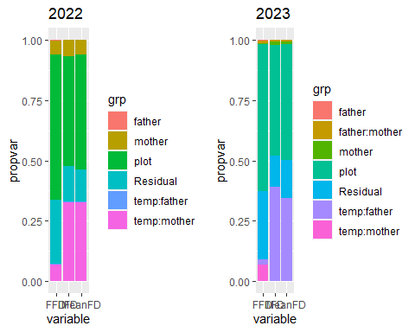

2022: Very low proportions of variance explained by temp:father, higher proportion of variance explained by temp:mother (larger in LFD and MeanFD). Most variance explained by plot.

2023: Higher proportions of variance explained by temp:father for LFD and MeanFD. temp:mother only explains some for FFD. Most variance explained by plot.

### Heritability and maternal effects

#### 2022

# h^2 (paternal effects)  
her_22_FFD_temp<-4*subset(PropVar_22_FFD_temp_boot,grp=="temp:father")[3]  
her_22_LFD_temp<-4*subset(PropVar_22_LFD_temp_boot,grp=="temp:father")[3]  
her_22_MeanFD_temp<-4*subset(PropVar_22_MeanFD_temp_boot,grp=="temp:father")[3]  
# Because the additive genetic variance, VA,  
# is expected to be four times the among pollen‐donor variance   
# (Falconer & Mackay, 1996; Lynch & Walsh, 1998)  
her_22_temp<-data.frame(value=rbind(her_22_FFD_temp,her_22_LFD_temp,  
 her_22_MeanFD_temp))%>%  
 mutate(variable=c("FFD","LFD","MeanFD"),  
 effect="Heritability")%>%  
 rename(value=propvar)

# maternal effects  
  
# Maternal - paternal  
# ----------------------  
# summed effects  
  
# Because the pollen‐recipient variance component contains a combination of  
# genetic and environmental effects, we subtracted the additive genetic   
# (pollen donor) component from the pollen-recipient variance component  
# before dividing the resulting estimate by VP to estimate   
# m2 (m2 = (Vpollen recipient − Vpollen donor)/VP).  
  
mat_22_FFD_temp<-(subset(Variance_22_FFD_temp_boot,grp=="temp:mother")[2]-  
 subset(Variance_22_FFD_temp_boot,grp=="temp:father")[2])/  
 Variance_22_FFD_temp_boot%>%summarise(sum(vcov))  
mat_22_LFD_temp<-(subset(Variance_22_LFD_temp_boot,grp=="temp:mother")[2]-  
 subset(Variance_22_LFD_temp_boot,grp=="temp:father")[2])/  
 Variance_22_LFD_temp_boot%>%summarise(sum(vcov))  
mat_22_MeanFD_temp<-(subset(Variance_22_MeanFD_temp_boot,grp=="temp:mother")[2]-  
 subset(Variance_22_MeanFD_temp_boot,grp=="temp:father")[2])/  
 Variance_22_MeanFD_temp_boot%>%summarise(sum(vcov))  
mat_22_temp<-data.frame(value=rbind(mat_22_FFD_temp,mat_22_LFD_temp,  
 mat_22_MeanFD_temp))%>%  
 mutate(variable=c("FFD","LFD","MeanFD"),  
 effect="Maternal effects")%>%  
 rename(value=vcov)

her_mat_22_temp<-rbind(her_22_temp,mat_22_temp)  
her_mat_22_temp

## value variable effect  
## 1 0.016505725 FFD Heritability  
## 2 0.007288806 LFD Heritability  
## 3 0.023065678 MeanFD Heritability  
## 23 0.065254732 FFD Maternal effects  
## 21 0.325338124 LFD Maternal effects  
## 22 0.319370770 MeanFD Maternal effects

#### 2023

# h^2 (paternal effects)  
her_23_FFD_temp<-4*subset(PropVar_23_FFD_temp_boot,grp=="temp:father")[3]  
her_23_LFD_temp<-4*subset(PropVar_23_LFD_temp_boot,grp=="temp:father")[3]  
her_23_MeanFD_temp<-4*subset(PropVar_23_MeanFD_temp_boot,grp=="temp:father")[3]  
# Because the additive genetic variance, VA,  
# is expected to be four times the among pollen‐donor variance   
# (Falconer & Mackay, 1996; Lynch & Walsh, 1998)  
her_23_temp<-data.frame(value=rbind(her_23_FFD_temp,her_23_LFD_temp,  
 her_23_MeanFD_temp))%>%  
 mutate(variable=c("FFD","LFD","MeanFD"),  
 effect="Heritability")%>%  
 rename(value=propvar)

# maternal effects  
  
# Maternal - paternal  
# ----------------------  
# summed effects  
  
# Because the pollen‐recipient variance component contains a combination of  
# genetic and environmental effects, we subtracted the additive genetic   
# (pollen donor) component from the pollen-recipient variance component  
# before dividing the resulting estimate by VP to estimate   
# m2 (m2 = (Vpollen recipient − Vpollen donor)/VP).  
  
mat_23_FFD_temp<-(subset(Variance_23_FFD_temp_boot,grp=="temp:mother")[2]-  
 subset(Variance_23_FFD_temp_boot,grp=="temp:father")[2])/  
 Variance_23_FFD_temp_boot%>%summarise(sum(vcov))  
mat_23_LFD_temp<-(0-  
 subset(Variance_23_LFD_temp_boot,grp=="temp:father")[2])/  
 Variance_23_LFD_temp_boot%>%summarise(sum(vcov))  
mat_23_MeanFD_temp<-(subset(Variance_23_MeanFD_temp_boot,grp=="temp:mother")[2]-  
 subset(Variance_23_MeanFD_temp_boot,grp=="temp:father")[2])/  
 Variance_23_MeanFD_temp_boot%>%summarise(sum(vcov))  
mat_23_temp<-data.frame(value=rbind(mat_23_FFD_temp,mat_23_LFD_temp,  
 mat_23_MeanFD_temp))%>%  
 mutate(variable=c("FFD","LFD","MeanFD"),  
 effect="Maternal effects")%>%  
 rename(value=vcov)

her_mat_23_temp<-rbind(her_23_temp,mat_23_temp)  
her_mat_23_temp

## value variable effect  
## 2 0.08339579 FFD Heritability  
## 1 1.56909243 LFD Heritability  
## 11 1.37368630 MeanFD Heritability  
## 12 0.04814903 FFD Maternal effects  
## 22 -0.39227311 LFD Maternal effects  
## 21 -0.34342155 MeanFD Maternal effects

#### Comparison both years

grid.arrange(  
 ggplot(her_mat_22_temp,aes(x=variable,y=value,fill=effect))+  
 geom_bar(stat="identity",position="dodge")+ggtitle("2022"),  
 ggplot(her_mat_23_temp,aes(x=variable,y=value,fill=effect))+  
 geom_bar(stat="identity",position="dodge")+ggtitle("2023"),  
 ncol=2)

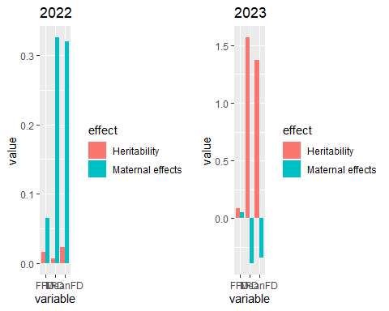

Heritabilities much higher in 2023, and maternal effects much higher in 2022…

### Likelihood ratio tests for variance components

Based on original models, not on bootstrap.

(These results could be used to add asterisks to the previous plot).

ranova(model2_22_FFD_qf)

## ANOVA-like table for random-effects: Single term deletions  
##   
## Model:  
## FFD_corr ~ temp + I(temp^2) + (1 | father) + (1 | mother) + (1 | plot) + (1 | temp:father) + (1 | temp:mother)  
## npar logLik AIC LRT Df Pr(>Chisq)   
## <none> 9 -2087.7 4193.4   
## (1 | father) 8 -2087.8 4191.6 0.193 1 0.6608   
## (1 | mother) 8 -2098.2 4212.5 21.044 1 4.489e-06 ***  
## (1 | plot) 8 -2196.0 4407.9 216.522 1 < 2.2e-16 ***  
## (1 | temp:father) 8 -2087.7 4191.4 0.008 1 0.9276   
## (1 | temp:mother) 8 -2088.1 4192.2 0.818 1 0.3658   
## ---  
## Signif. codes: 0 '***' 0.001 '**' 0.01 '*' 0.05 '.' 0.1 ' ' 1

ranova(model2_22_LFD_qf)

## ANOVA-like table for random-effects: Single term deletions  
##   
## Model:  
## LFD_corr ~ temp + I(temp^2) + (1 | mother) + (1 | plot) + (1 | temp:father) + (1 | temp:mother)  
## npar logLik AIC LRT Df Pr(>Chisq)   
## <none> 8 -1272.2 2560.4   
## (1 | mother) 7 -1278.2 2570.5 12.039 1 0.0005209 ***  
## (1 | plot) 7 -1319.2 2652.4 94.019 1 < 2.2e-16 ***  
## (1 | temp:father) 7 -1272.2 2558.4 0.002 1 0.9645393   
## (1 | temp:mother) 7 -1277.2 2568.5 10.061 1 0.0015147 **   
## ---  
## Signif. codes: 0 '***' 0.001 '**' 0.01 '*' 0.05 '.' 0.1 ' ' 1

ranova(model2_22_MeanFD_qf)

## ANOVA-like table for random-effects: Single term deletions  
##   
## Model:  
## MeanFD ~ temp + I(temp^2) + (1 | mother) + (1 | plot) + (1 | temp:father) + (1 | temp:mother)  
## npar logLik AIC LRT Df Pr(>Chisq)   
## <none> 8 -1266.4 2548.8   
## (1 | mother) 7 -1271.5 2557.1 10.307 1 0.001325 **   
## (1 | plot) 7 -1317.2 2648.4 101.686 1 < 2.2e-16 ***  
## (1 | temp:father) 7 -1266.4 2546.8 0.022 1 0.881613   
## (1 | temp:mother) 7 -1271.7 2557.4 10.649 1 0.001101 **   
## ---  
## Signif. codes: 0 '***' 0.001 '**' 0.01 '*' 0.05 '.' 0.1 ' ' 1

ranova(model2_23_FFD)

## ANOVA-like table for random-effects: Single term deletions  
##   
## Model:  
## FFD_corr ~ temp + (1 | father) + (1 | mother) + (1 | father:mother) + (1 | plot) + (1 | temp:father) + (1 | temp:mother)  
## npar logLik AIC LRT Df Pr(>Chisq)   
## <none> 9 -1431.1 2880.2   
## (1 | father) 8 -1431.2 2878.3 0.127 1 0.7215   
## (1 | mother) 8 -1431.1 2878.2 0.038 1 0.8459   
## (1 | father:mother) 8 -1431.2 2878.3 0.159 1 0.6902   
## (1 | plot) 8 -1493.9 3003.8 125.674 1 <2e-16 ***  
## (1 | temp:father) 8 -1431.1 2878.2 0.076 1 0.7832   
## (1 | temp:mother) 8 -1431.2 2878.5 0.308 1 0.5788   
## ---  
## Signif. codes: 0 '***' 0.001 '**' 0.01 '*' 0.05 '.' 0.1 ' ' 1

ranova(model2_23_LFD)

## ANOVA-like table for random-effects: Single term deletions  
##   
## Model:  
## LFD_corr ~ temp + (1 | mother) + (1 | father:mother) + (1 | plot) + (1 | temp:father)  
## npar logLik AIC LRT Df Pr(>Chisq)   
## <none> 7 -890.74 1795.5   
## (1 | mother) 6 -890.85 1793.7 0.222 1 0.6378   
## (1 | father:mother) 6 -890.75 1793.5 0.032 1 0.8578   
## (1 | plot) 6 -909.10 1830.2 36.735 1 1.353e-09 ***  
## (1 | temp:father) 6 -891.81 1795.6 2.145 1 0.1431   
## ---  
## Signif. codes: 0 '***' 0.001 '**' 0.01 '*' 0.05 '.' 0.1 ' ' 1

ranova(model2_23_MeanFD)

## ANOVA-like table for random-effects: Single term deletions  
##   
## Model:  
## MeanFD ~ temp + (1 | mother) + (1 | father:mother) + (1 | plot) + (1 | temp:father) + (1 | temp:mother)  
## npar logLik AIC LRT Df Pr(>Chisq)   
## <none> 8 -894.19 1804.4   
## (1 | mother) 7 -893.61 1801.2 -1.150 1 1   
## (1 | father:mother) 7 -893.57 1801.1 -1.240 1 1   
## (1 | plot) 7 -913.62 1841.2 38.867 1 4.538e-10 ***  
## (1 | temp:father) 7 -893.57 1801.1 -1.240 1 1   
## (1 | temp:mother) 7 -894.19 1802.4 0.000 1 1   
## ---  
## Signif. codes: 0 '***' 0.001 '**' 0.01 '*' 0.05 '.' 0.1 ' ' 1

Temp:father always NS, temp:mother significant only for LFD and MeanFD in 2022.

### Figures effect of temp

Main effect of temperature (quadratic) significant for FFD, LFD and MeanFD in 2022. In 2023, NS for FFD, significant for LFD and MeanFD (but close to 0.05). Bootstrapped p-value NS for LFD, gives error for MeanFD (see above)

plot(ggpredict(model2_22_FFD_qf,terms="temp[all]"),add.data=T)

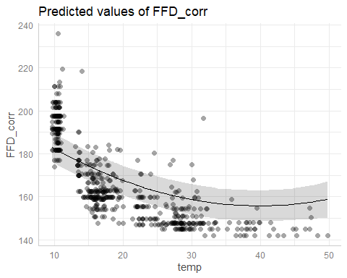

plot(ggpredict(model2_22_LFD_qf,terms="temp[all]"),add.data=T)

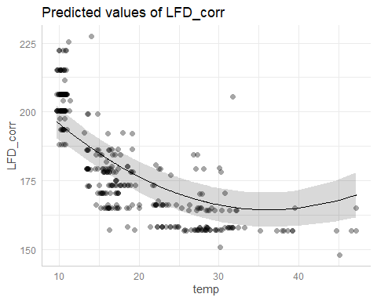

plot(ggpredict(model2_22_MeanFD_qf,terms="temp[all]"),add.data=T)

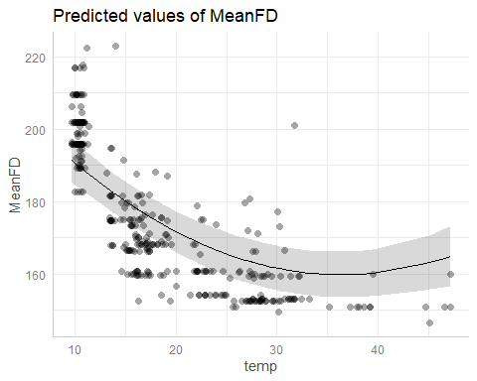

plot(ggpredict(model2_23_FFD,terms="temp[all]"),add.data=T)

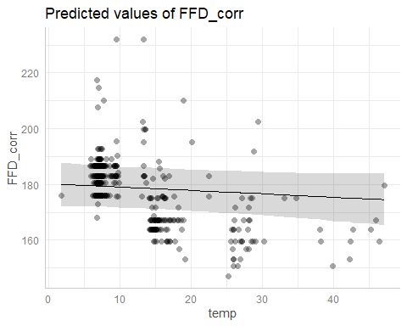

plot(ggpredict(model2_23_LFD,terms="temp[all]"),add.data=T)

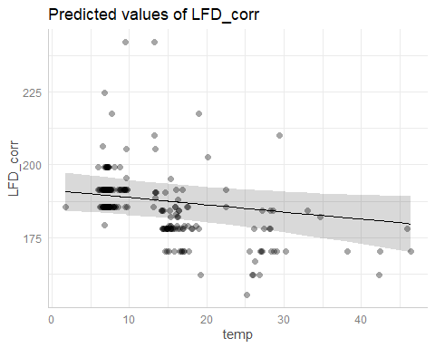

plot(ggpredict(model2_23_MeanFD,terms="temp[all]"),add.data=T)

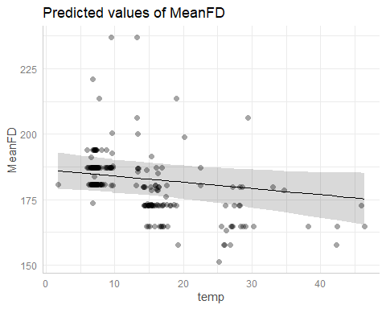

### Copmarison all heritabilities

her_mat_all<-rbind(  
 rbind(her_mat_22%>%select(-rowname)%>%mutate(year=2022),  
 her_mat_23%>%select(-rowname)%>%mutate(year=2023))%>%  
 mutate(type="Mean response"),  
 rbind(her_mat_22_temp%>%mutate(year=2022),  
 her_mat_23_temp%>%mutate(year=2023))%>%  
 mutate(type="Plasticity")  
 )

ggplot(her_mat_all,  
 aes(x=variable,y=value,fill=type))+  
 geom_bar(stat="identity",position="dodge")+  
 facet_grid(rows=vars(effect),cols=vars(year))

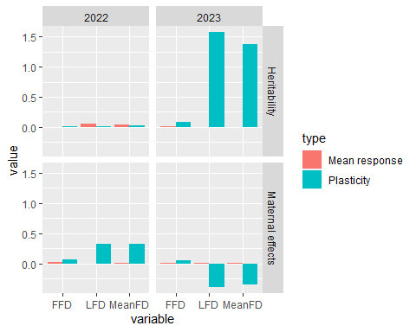

Very high heritabilities for plasticity in 2023. Why?

## C) Genetic differentiation in mean responses (Prediction 3 in greenhouse paper)

### Models

#### 2022

model3_22_FFD<-lmer(FFD_corr~temp_father+temp_mother+  
 #(1|father)+ # Not included because variance=0  
 # to avoid singular fit  
 (1|mother)+  
 #(1|father:mother)+ # Not included because variance=0  
 # to avoid singular fit  
 (1|plot),  
 data_transplants%>%filter(year==2022&!is.na(FFD_corr)))  
model3_22_LFD<-lmer(LFD_corr~temp_father+temp_mother+  
 (1|father)+(1|mother)+  
 #(1|father:mother)+ # Not included because variance=0  
 # to avoid singular fit  
 (1|plot),  
 data_transplants%>%filter(year==2022&!is.na(LFD_corr)))  
model3_22_MeanFD<-lmer(MeanFD~temp_father+temp_mother+  
 (1|father)+(1|mother)+  
 #(1|father:mother)+ # Not included because variance=0  
 # to avoid singular fit  
 (1|plot),  
 data_transplants%>%filter(year==2022&!is.na(MeanFD)))  
summary(model3_22_FFD)

## Linear mixed model fit by REML. t-tests use Satterthwaite's method [  
## lmerModLmerTest]  
## Formula: FFD_corr ~ temp_father + temp_mother + (1 | mother) + (1 | plot)  
## Data: data_transplants %>% filter(year == 2022 & !is.na(FFD_corr))  
##   
## REML criterion at convergence: 4354.6  
##   
## Scaled residuals:   
## Min 1Q Median 3Q Max   
## -2.2256 -0.6720 -0.0671 0.5574 5.0480   
##   
## Random effects:  
## Groups Name Variance Std.Dev.  
## mother (Intercept) 9.799 3.13   
## plot (Intercept) 334.171 18.28   
## Residual 68.897 8.30   
## Number of obs: 603, groups: mother, 63; plot, 8  
##   
## Fixed effects:  
## Estimate Std. Error df t value Pr(>|t|)   
## (Intercept) 172.75479 6.60100 7.54177 26.171 1.12e-08 ***  
## temp_father -0.06680 0.03745 537.69651 -1.784 0.075 .   
## temp_mother 0.04900 0.05918 45.26370 0.828 0.412   
## ---  
## Signif. codes: 0 '***' 0.001 '**' 0.01 '*' 0.05 '.' 0.1 ' ' 1  
##   
## Correlation of Fixed Effects:  
## (Intr) tmp_ft  
## temp_father -0.061   
## temp_mother -0.138 -0.306

summary(model3_22_LFD)

## Linear mixed model fit by REML. t-tests use Satterthwaite's method [  
## lmerModLmerTest]  
## Formula: LFD_corr ~ temp_father + temp_mother + (1 | father) + (1 | mother) +   
## (1 | plot)  
## Data: data_transplants %>% filter(year == 2022 & !is.na(LFD_corr))  
##   
## REML criterion at convergence: 2660.5  
##   
## Scaled residuals:   
## Min 1Q Median 3Q Max   
## -2.4220 -0.6954 -0.0682 0.4691 4.5709   
##   
## Random effects:  
## Groups Name Variance Std.Dev.  
## father (Intercept) 4.951 2.225   
## mother (Intercept) 7.147 2.673   
## plot (Intercept) 308.652 17.568   
## Residual 70.332 8.386   
## Number of obs: 364, groups: father, 59; mother, 59; plot, 8  
##   
## Fixed effects:  
## Estimate Std. Error df t value Pr(>|t|)   
## (Intercept) 184.30929 6.42266 7.85174 28.697 3.11e-09 ***  
## temp_father -0.04725 0.05937 21.97364 -0.796 0.435   
## temp_mother -0.01094 0.06935 37.49578 -0.158 0.876   
## ---  
## Signif. codes: 0 '***' 0.001 '**' 0.01 '*' 0.05 '.' 0.1 ' ' 1  
##   
## Correlation of Fixed Effects:  
## (Intr) tmp_ft  
## temp_father -0.108   
## temp_mother -0.136 -0.366

summary(model3_22_MeanFD)

## Linear mixed model fit by REML. t-tests use Satterthwaite's method [  
## lmerModLmerTest]  
## Formula: MeanFD ~ temp_father + temp_mother + (1 | father) + (1 | mother) +   
## (1 | plot)  
## Data: data_transplants %>% filter(year == 2022 & !is.na(MeanFD))  
##   
## REML criterion at convergence: 2651.3  
##   
## Scaled residuals:   
## Min 1Q Median 3Q Max   
## -2.2674 -0.7054 -0.0638 0.5218 4.6725   
##   
## Random effects:  
## Groups Name Variance Std.Dev.  
## father (Intercept) 3.301 1.817   
## mother (Intercept) 7.255 2.694   
## plot (Intercept) 311.690 17.655   
## Residual 69.224 8.320   
## Number of obs: 364, groups: father, 59; mother, 59; plot, 8  
##   
## Fixed effects:  
## Estimate Std. Error df t value Pr(>|t|)   
## (Intercept) 179.257302 6.439371 7.782891 27.838 4.48e-09 ***  
## temp_father -0.046803 0.055560 20.375143 -0.842 0.409   
## temp_mother -0.004863 0.068191 40.368857 -0.071 0.944   
## ---  
## Signif. codes: 0 '***' 0.001 '**' 0.01 '*' 0.05 '.' 0.1 ' ' 1  
##   
## Correlation of Fixed Effects:  
## (Intr) tmp_ft  
## temp_father -0.098   
## temp_mother -0.138 -0.360

All effects of orgin temperatures are NS.

#### 2023

model3_23_FFD<-lmer(FFD_corr~temp_father+temp_mother+  
 (1|father)+(1|mother)+  
 #(1|father:mother)+ # Not included because variance=0  
 # to avoid singular fit  
 (1|plot),  
 data_transplants%>%filter(year==2023&!is.na(FFD_corr)))  
model3_23_LFD<-lmer(LFD_corr~temp_father+temp_mother+  
 #(1|father)+# Not included because variance=0  
 # to avoid singular fit  
 (1|mother)+  
 #(1|father:mother)+ # Not included because variance=0  
 # to avoid singular fit  
 (1|plot),  
 data_transplants%>%filter(year==2023&!is.na(FFD_corr)))  
model3_23_MeanFD<-lmer(MeanFD~temp_father+temp_mother+  
 #(1|father)+# Not included because variance=0  
 # to avoid singular fit  
 (1|mother)+  
 #(1|father:mother)+ # Not included because variance=0  
 # to avoid singular fit  
 (1|plot),  
 data_transplants%>%filter(year==2023&!is.na(FFD_corr)))  
summary(model3_23_FFD)

## Linear mixed model fit by REML. t-tests use Satterthwaite's method [  
## lmerModLmerTest]  
## Formula: FFD_corr ~ temp_father + temp_mother + (1 | father) + (1 | mother) +   
## (1 | plot)  
## Data: data_transplants %>% filter(year == 2023 & !is.na(FFD_corr))  
##   
## REML criterion at convergence: 2895.3  
##   
## Scaled residuals:   
## Min 1Q Median 3Q Max   
## -2.4435 -0.6006 -0.0334 0.3438 5.8772   
##   
## Random effects:  
## Groups Name Variance Std.Dev.  
## father (Intercept) 0.4589 0.6774   
## mother (Intercept) 1.5591 1.2487   
## plot (Intercept) 112.4896 10.6061   
## Residual 60.3785 7.7704   
## Number of obs: 411, groups: father, 61; mother, 61; plot, 7  
##   
## Fixed effects:  
## Estimate Std. Error df t value Pr(>|t|)   
## (Intercept) 178.867547 4.172118 6.721082 42.872 1.9e-09 ***  
## temp_father -0.013479 0.041391 34.444108 -0.326 0.747   
## temp_mother -0.008837 0.046040 29.199486 -0.192 0.849   
## ---  
## Signif. codes: 0 '***' 0.001 '**' 0.01 '*' 0.05 '.' 0.1 ' ' 1  
##   
## Correlation of Fixed Effects:  
## (Intr) tmp_ft  
## temp_father -0.130   
## temp_mother -0.156 -0.277

summary(model3_23_LFD)

## Linear mixed model fit by REML. t-tests use Satterthwaite's method [  
## lmerModLmerTest]  
## Formula: LFD_corr ~ temp_father + temp_mother + (1 | mother) + (1 | plot)  
## Data: data_transplants %>% filter(year == 2023 & !is.na(FFD_corr))  
##   
## REML criterion at convergence: 1803.6  
##   
## Scaled residuals:   
## Min 1Q Median 3Q Max   
## -2.3920 -0.6114 0.0053 0.1913 5.5361   
##   
## Random effects:  
## Groups Name Variance Std.Dev.  
## mother (Intercept) 1.723 1.313   
## plot (Intercept) 86.466 9.299   
## Residual 68.426 8.272   
## Number of obs: 251, groups: mother, 56; plot, 7  
##   
## Fixed effects:  
## Estimate Std. Error df t value Pr(>|t|)   
## (Intercept) 187.91051 3.81967 7.48144 49.195 1.14e-10 ***  
## temp_father -0.06545 0.05594 213.74205 -1.170 0.243   
## temp_mother 0.04759 0.06250 28.21302 0.762 0.453   
## ---  
## Signif. codes: 0 '***' 0.001 '**' 0.01 '*' 0.05 '.' 0.1 ' ' 1  
##   
## Correlation of Fixed Effects:  
## (Intr) tmp_ft  
## temp_father -0.186   
## temp_mother -0.224 -0.271

summary(model3_23_MeanFD)

## Linear mixed model fit by REML. t-tests use Satterthwaite's method [  
## lmerModLmerTest]  
## Formula: MeanFD ~ temp_father + temp_mother + (1 | mother) + (1 | plot)  
## Data: data_transplants %>% filter(year == 2023 & !is.na(FFD_corr))  
##   
## REML criterion at convergence: 1808.6  
##   
## Scaled residuals:   
## Min 1Q Median 3Q Max   
## -2.2451 -0.6226 0.0098 0.2288 5.4010   
##   
## Random effects:  
## Groups Name Variance Std.Dev.  
## mother (Intercept) 1.933 1.390   
## plot (Intercept) 93.441 9.666   
## Residual 69.559 8.340   
## Number of obs: 251, groups: mother, 56; plot, 7  
##   
## Fixed effects:  
## Estimate Std. Error df t value Pr(>|t|)   
## (Intercept) 183.30116 3.95557 7.40950 46.340 2.12e-10 ***  
## temp_father -0.06379 0.05651 215.76220 -1.129 0.260   
## temp_mother 0.04120 0.06351 29.13282 0.649 0.522   
## ---  
## Signif. codes: 0 '***' 0.001 '**' 0.01 '*' 0.05 '.' 0.1 ' ' 1  
##   
## Correlation of Fixed Effects:  
## (Intr) tmp_ft  
## temp_father -0.181   
## temp_mother -0.220 -0.273

All effects of orgin temperatures are NS.

#### Model diagnostics

plot(simulateResiduals(model3_22_FFD))

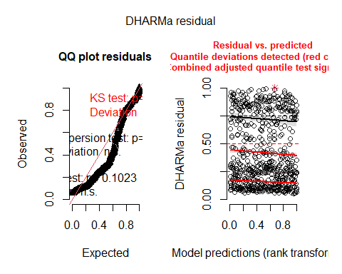

plot(simulateResiduals(model3_22_LFD))

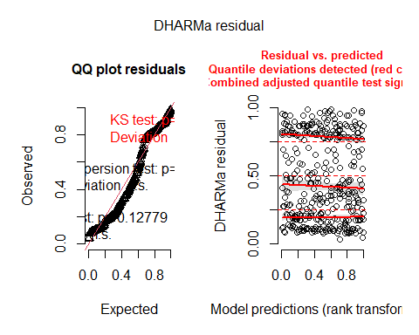

plot(simulateResiduals(model3_22_MeanFD))

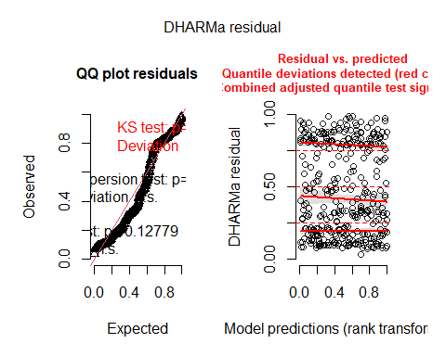

plot(simulateResiduals(model3_23_FFD))

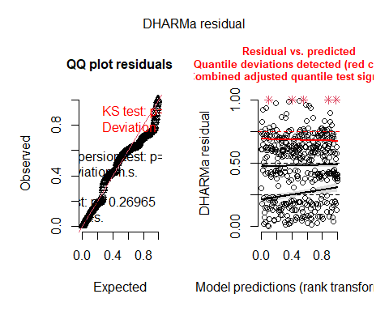

plot(simulateResiduals(model3_23_LFD))

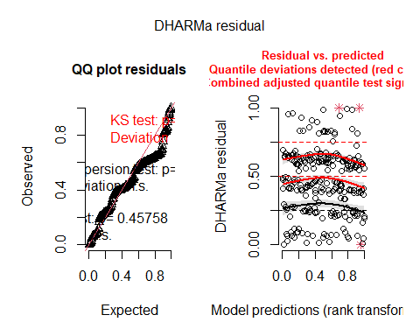

plot(simulateResiduals(model3_23_MeanFD))

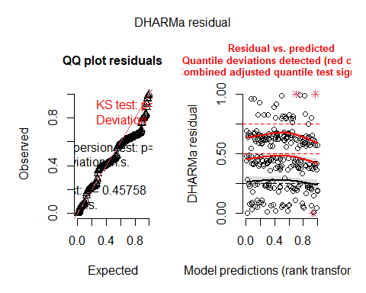

Overall deviations from the expected distribution detected. Heteroscedasticity.

#### Bootstrapped models

Bootstrapping of fixed effects and p-values will serve to check significance of the effects of origin temperatures.

##### 2022

###### Bootstrap fixed effects

confint(model3_22_FFD_boot_fixef)

## # A tibble: 18 × 6  
## term estimate lower upper type level  
## <chr> <dbl> <dbl> <dbl> <chr> <dbl>  
## 1 beta1 173. 170. 175. norm 0.95  
## 2 beta2 -0.0668 -0.135 0.00348 norm 0.95  
## 3 beta3 0.0490 -0.0603 0.165 norm 0.95  
## 4 vc1 9.80 3.51 15.5 norm 0.95  
## 5 vc2 334. 247. 325. norm 0.95  
## 6 vc3 68.9 61.6 84.9 norm 0.95  
## 7 beta1 173. 170. 175. basic 0.95  
## 8 beta2 -0.0668 -0.136 0.000139 basic 0.95  
## 9 beta3 0.0490 -0.0591 0.169 basic 0.95  
## 10 vc1 9.80 3.09 15.0 basic 0.95  
## 11 vc2 334. 244. 325. basic 0.95  
## 12 vc3 68.9 61.0 83.6 basic 0.95  
## 13 beta1 173. 170. 175. perc 0.95  
## 14 beta2 -0.0668 -0.134 0.00245 perc 0.95  
## 15 beta3 0.0490 -0.0706 0.157 perc 0.95  
## 16 vc1 9.80 4.61 16.5 perc 0.95  
## 17 vc2 334. 343. 424. perc 0.95  
## 18 vc3 68.9 54.1 76.8 perc 0.95

confint(model3_22_LFD_boot_fixef)

## # A tibble: 21 × 6  
## term estimate lower upper type level  
## <chr> <dbl> <dbl> <dbl> <chr> <dbl>  
## 1 beta1 184. 181. 187. norm 0.95  
## 2 beta2 -0.0472 -0.162 0.0699 norm 0.95  
## 3 beta3 -0.0109 -0.141 0.122 norm 0.95  
## 4 vc1 4.95 -3.04 12.2 norm 0.95  
## 5 vc2 7.15 -1.10 15.5 norm 0.95  
## 6 vc3 309. 217. 314. norm 0.95  
## 7 vc4 70.3 64.2 91.6 norm 0.95  
## 8 beta1 184. 181. 187. basic 0.95  
## 9 beta2 -0.0472 -0.165 0.0652 basic 0.95  
## 10 beta3 -0.0109 -0.149 0.115 basic 0.95  
## # ℹ 11 more rows

confint(model3_22_MeanFD_boot_fixef)

## # A tibble: 21 × 6  
## term estimate lower upper type level  
## <chr> <dbl> <dbl> <dbl> <chr> <dbl>  
## 1 beta1 179. 176. 182. norm 0.95  
## 2 beta2 -0.0468 -0.153 0.0581 norm 0.95  
## 3 beta3 -0.00486 -0.137 0.124 norm 0.95  
## 4 vc1 3.30 -2.91 8.98 norm 0.95  
## 5 vc2 7.26 -0.472 15.1 norm 0.95  
## 6 vc3 312. 219. 313. norm 0.95  
## 7 vc4 69.2 62.2 90.2 norm 0.95  
## 8 beta1 179. 177. 182. basic 0.95  
## 9 beta2 -0.0468 -0.156 0.0567 basic 0.95  
## 10 beta3 -0.00486 -0.139 0.121 basic 0.95  
## # ℹ 11 more rows

###### Bootstrap p-values

model3_22_FFD_boot_pvals

## Bootstrap type: residual   
##   
## Number of resamples: 1000   
##   
## # A tibble: 3 × 7  
## term Estimate `Std. Error` df `t value` `Pr(>|t|)` p.value  
## <chr> <dbl> <dbl> <dbl> <dbl> <dbl> <dbl>  
## 1 (Intercept) 173. 6.60 7.54 26.2 0.0000000112 0.000999  
## 2 temp_father -0.0668 0.0374 538. -1.78 0.0750 0.0779   
## 3 temp_mother 0.0490 0.0592 45.3 0.828 0.412 0.414

model3_22_LFD_boot_pvals

## Bootstrap type: residual   
##   
## Number of resamples: 1000   
##   
## # A tibble: 3 × 7  
## term Estimate `Std. Error` df `t value` `Pr(>|t|)` p.value  
## <chr> <dbl> <dbl> <dbl> <dbl> <dbl> <dbl>  
## 1 (Intercept) 184. 6.42 7.85 28.7 0.00000000311 0.000999  
## 2 temp_father -0.0472 0.0594 22.0 -0.796 0.435 0.465   
## 3 temp_mother -0.0109 0.0693 37.5 -0.158 0.876 0.882

model3_22_MeanFD_boot_pvals

## Bootstrap type: residual   
##   
## Number of resamples: 1000   
##   
## # A tibble: 3 × 7  
## term Estimate `Std. Error` df `t value` `Pr(>|t|)` p.value  
## <chr> <dbl> <dbl> <dbl> <dbl> <dbl> <dbl>  
## 1 (Intercept) 179. 6.44 7.78 27.8 0.00000000448 0.000999  
## 2 temp_father -0.0468 0.0556 20.4 -0.842 0.409 0.425   
## 3 temp_mother -0.00486 0.0682 40.4 -0.0713 0.944 0.944

All effects of orgin temperatures are still NS.

##### 2023

###### Bootstrap fixed effects

confint(model3_23_FFD_boot_fixef)

## # A tibble: 21 × 6  
## term estimate lower upper type level  
## <chr> <dbl> <dbl> <dbl> <chr> <dbl>  
## 1 beta1 179. 177. 181. norm 0.95  
## 2 beta2 -0.0135 -0.0915 0.0666 norm 0.95  
## 3 beta3 -0.00884 -0.0972 0.0813 norm 0.95  
## 4 vc1 0.459 -2.40 2.50 norm 0.95  
## 5 vc2 1.56 -2.13 4.84 norm 0.95  
## 6 vc3 112. 66.2 121. norm 0.95  
## 7 vc4 60.4 45.2 81.9 norm 0.95  
## 8 beta1 179. 177. 181. basic 0.95  
## 9 beta2 -0.0135 -0.0934 0.0653 basic 0.95  
## 10 beta3 -0.00884 -0.0994 0.0791 basic 0.95  
## # ℹ 11 more rows

confint(model3_23_LFD_boot_fixef)

## # A tibble: 18 × 6  
## term estimate lower upper type level  
## <chr> <dbl> <dbl> <dbl> <chr> <dbl>  
## 1 beta1 188. 185. 191. norm 0.95  
## 2 beta2 -0.0654 -0.174 0.0415 norm 0.95  
## 3 beta3 0.0476 -0.0745 0.172 norm 0.95  
## 4 vc1 1.72 -4.09 6.51 norm 0.95  
## 5 vc2 86.5 41.7 102. norm 0.95  
## 6 vc3 68.4 45.1 100. norm 0.95  
## 7 beta1 188. 185. 191. basic 0.95  
## 8 beta2 -0.0654 -0.179 0.0349 basic 0.95  
## 9 beta3 0.0476 -0.0719 0.170 basic 0.95  
## 10 vc1 1.72 -5.77 3.45 basic 0.95  
## 11 vc2 86.5 40.8 101. basic 0.95  
## 12 vc3 68.4 43.8 97.5 basic 0.95  
## 13 beta1 188. 185. 191. perc 0.95  
## 14 beta2 -0.0654 -0.166 0.0485 perc 0.95  
## 15 beta3 0.0476 -0.0753 0.167 perc 0.95  
## 16 vc1 1.72 0 9.21 perc 0.95  
## 17 vc2 86.5 71.8 132. perc 0.95  
## 18 vc3 68.4 39.4 93.1 perc 0.95

confint(model3_23_MeanFD_boot_fixef)

## # A tibble: 18 × 6  
## term estimate lower upper type level  
## <chr> <dbl> <dbl> <dbl> <chr> <dbl>  
## 1 beta1 183. 180. 186. norm 0.95  
## 2 beta2 -0.0638 -0.171 0.0495 norm 0.95  
## 3 beta3 0.0412 -0.0842 0.169 norm 0.95  
## 4 vc1 1.93 -5.45 7.75 norm 0.95  
## 5 vc2 93.4 46.5 109. norm 0.95  
## 6 vc3 69.6 48.6 100. norm 0.95  
## 7 beta1 183. 180. 186. basic 0.95  
## 8 beta2 -0.0638 -0.171 0.0505 basic 0.95  
## 9 beta3 0.0412 -0.0779 0.169 basic 0.95  
## 10 vc1 1.93 -7.61 3.87 basic 0.95  
## 11 vc2 93.4 43.4 108. basic 0.95  
## 12 vc3 69.6 46.2 97.8 basic 0.95  
## 13 beta1 183. 180. 186. perc 0.95  
## 14 beta2 -0.0638 -0.178 0.0439 perc 0.95  
## 15 beta3 0.0412 -0.0867 0.160 perc 0.95  
## 16 vc1 1.93 0 11.5 perc 0.95  
## 17 vc2 93.4 79.1 143. perc 0.95  
## 18 vc3 69.6 41.3 92.9 perc 0.95

###### Bootstrap p-values

model3_23_FFD_boot_pvals

## Bootstrap type: residual   
##   
## Number of resamples: 1000   
##   
## # A tibble: 3 × 7  
## term Estimate `Std. Error` df `t value` `Pr(>|t|)` p.value  
## <chr> <dbl> <dbl> <dbl> <dbl> <dbl> <dbl>  
## 1 (Intercept) 179. 4.17 6.72 42.9 0.00000000190 0.000999  
## 2 temp_father -0.0135 0.0414 34.4 -0.326 0.747 0.726   
## 3 temp_mother -0.00884 0.0460 29.2 -0.192 0.849 0.856

model3_23_LFD_boot_pvals

## Bootstrap type: residual   
##   
## Number of resamples: 1000   
##   
## # A tibble: 3 × 7  
## term Estimate `Std. Error` df `t value` `Pr(>|t|)` p.value  
## <chr> <dbl> <dbl> <dbl> <dbl> <dbl> <dbl>  
## 1 (Intercept) 188. 3.82 7.48 49.2 1.14e-10 0.000999  
## 2 temp_father -0.0654 0.0559 214. -1.17 2.43e- 1 0.247   
## 3 temp_mother 0.0476 0.0625 28.2 0.762 4.53e- 1 0.477

model3_23_MeanFD_boot_pvals

## Bootstrap type: residual   
##   
## Number of resamples: 1000   
##   
## # A tibble: 3 × 7  
## term Estimate `Std. Error` df `t value` `Pr(>|t|)` p.value  
## <chr> <dbl> <dbl> <dbl> <dbl> <dbl> <dbl>  
## 1 (Intercept) 183. 3.96 7.41 46.3 2.12e-10 0.000999  
## 2 temp_father -0.0638 0.0565 216. -1.13 2.60e- 1 0.276   
## 3 temp_mother 0.0412 0.0635 29.1 0.649 5.22e- 1 0.507

All effects of orgin temperatures are still NS.

### Proportions of variance

Proportion of variance explained by temperature of origin of fathers and mothers = proportion of variance explained by fixed effects: marginal R2.

#### 2022

PropVar_22_FFD_temp_origin<-as.numeric(r2_nakagawa(model3_22_FFD)$R2_marginal)  
PropVar_22_LFD_temp_origin<-as.numeric(r2_nakagawa(model3_22_LFD)$R2_marginal)  
PropVar_22_MeanFD_temp_origin<-as.numeric(r2_nakagawa(model3_22_MeanFD)$R2_marginal)  
Props_var_22_temp_origin<-data.frame(  
 values=c(PropVar_22_FFD_temp_origin,PropVar_22_LFD_temp_origin,  
 PropVar_22_MeanFD_temp_origin),variable=c("FFD","LFD","MeanFD"))

ggplot(Props_var_22_temp_origin,aes(x=variable,y=values))+  
 geom_bar(stat="identity",position="dodge")

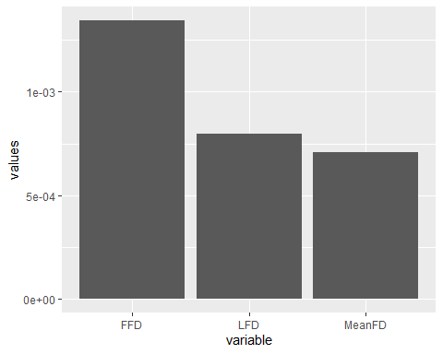

Temperature mother and father: partR2 - DO?

#### 2022

PropVar_23_FFD_temp_origin<-as.numeric(r2_nakagawa(model3_23_FFD)$R2_marginal)  
PropVar_23_LFD_temp_origin<-as.numeric(r2_nakagawa(model3_23_LFD)$R2_marginal)  
PropVar_23_MeanFD_temp_origin<-as.numeric(r2_nakagawa(model3_23_MeanFD)$R2_marginal)  
Props_var_23_temp_origin<-data.frame(  
 values=c(PropVar_23_FFD_temp_origin,PropVar_23_LFD_temp_origin,  
 PropVar_23_MeanFD_temp_origin),variable=c("FFD","LFD","MeanFD"))

ggplot(Props_var_23_temp_origin,aes(x=variable,y=values))+  
 geom_bar(stat="identity",position="dodge")

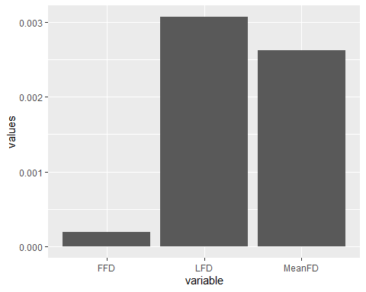

Temperature mother and father: partR2 - DO?

### Models mid-parental values

data_transplants<-data_transplants%>%  
 mutate(mean_temp_parents=(temp_mother+temp_father)/2)

#### 2022

model3_22_FFD_midP<-lmer(FFD_corr~mean_temp_parents+  
 #(1|father)+ # Not included because variance=0  
 # to avoid singular fit  
 (1|mother)+  
 #(1|father:mother)+ # Not included because variance=0  
 # to avoid singular fit  
 (1|plot),  
 data_transplants%>%filter(year==2022&!is.na(FFD_corr)))  
model3_22_LFD_midP<-lmer(LFD_corr~mean_temp_parents+  
 (1|father)+(1|mother)+  
 #(1|father:mother)+ # Not included because variance=0  
 # to avoid singular fit  
 (1|plot),  
 data_transplants%>%filter(year==2022&!is.na(LFD_corr)))  
model3_22_MeanFD_midP<-lmer(MeanFD~mean_temp_parents+  
 (1|father)+(1|mother)+  
 #(1|father:mother)+ # Not included because variance=0  
 # to avoid singular fit  
 (1|plot),  
 data_transplants%>%filter(year==2022&!is.na(MeanFD)))  
summary(model3_22_FFD_midP)

## Linear mixed model fit by REML. t-tests use Satterthwaite's method [  
## lmerModLmerTest]  
## Formula: FFD_corr ~ mean_temp_parents + (1 | mother) + (1 | plot)  
## Data: data_transplants %>% filter(year == 2022 & !is.na(FFD_corr))  
##   
## REML criterion at convergence: 4352.1  
##   
## Scaled residuals:   
## Min 1Q Median 3Q Max   
## -2.2370 -0.6714 -0.0730 0.5611 5.0286   
##   
## Random effects:  
## Groups Name Variance Std.Dev.  
## mother (Intercept) 9.446 3.073   
## plot (Intercept) 333.641 18.266   
## Residual 69.168 8.317   
## Number of obs: 603, groups: mother, 63; plot, 8  
##   
## Fixed effects:  
## Estimate Std. Error df t value Pr(>|t|)   
## (Intercept) 173.44932 6.57659 7.45507 26.37 1.24e-08 ***  
## mean_temp_parents -0.05577 0.05313 161.67501 -1.05 0.295   
## ---  
## Signif. codes: 0 '***' 0.001 '**' 0.01 '*' 0.05 '.' 0.1 ' ' 1  
##   
## Correlation of Fixed Effects:  
## (Intr)  
## mn_tmp_prnt -0.160

summary(model3_22_LFD_midP)

## Linear mixed model fit by REML. t-tests use Satterthwaite's method [  
## lmerModLmerTest]  
## Formula: LFD_corr ~ mean_temp_parents + (1 | father) + (1 | mother) +   
## (1 | plot)  
## Data: data_transplants %>% filter(year == 2022 & !is.na(LFD_corr))  
##   
## REML criterion at convergence: 2656.6  
##   
## Scaled residuals:   
## Min 1Q Median 3Q Max   
## -2.4077 -0.6877 -0.0739 0.4574 4.5687   
##   
## Random effects:  
## Groups Name Variance Std.Dev.  
## father (Intercept) 4.874 2.208   
## mother (Intercept) 6.700 2.588   
## plot (Intercept) 308.525 17.565   
## Residual 70.406 8.391   
## Number of obs: 364, groups: father, 59; mother, 59; plot, 8  
##   
## Fixed effects:  
## Estimate Std. Error df t value Pr(>|t|)   
## (Intercept) 184.37510 6.41529 7.82294 28.740 3.25e-09 ***  
## mean_temp_parents -0.06218 0.07135 63.61807 -0.872 0.387   
## ---  
## Signif. codes: 0 '***' 0.001 '**' 0.01 '*' 0.05 '.' 0.1 ' ' 1  
##   
## Correlation of Fixed Effects:  
## (Intr)  
## mn_tmp_prnt -0.214

summary(model3_22_MeanFD_midP)

## Linear mixed model fit by REML. t-tests use Satterthwaite's method [  
## lmerModLmerTest]  
## Formula: MeanFD ~ mean_temp_parents + (1 | father) + (1 | mother) + (1 |   
## plot)  
## Data: data_transplants %>% filter(year == 2022 & !is.na(MeanFD))  
##   
## REML criterion at convergence: 2647.3  
##   
## Scaled residuals:   
## Min 1Q Median 3Q Max   
## -2.2515 -0.7071 -0.0588 0.5261 4.6670   
##   
## Random effects:  
## Groups Name Variance Std.Dev.  
## father (Intercept) 3.167 1.779   
## mother (Intercept) 6.859 2.619   
## plot (Intercept) 311.588 17.652   
## Residual 69.329 8.326   
## Number of obs: 364, groups: father, 59; mother, 59; plot, 8  
##   
## Fixed effects:  
## Estimate Std. Error df t value Pr(>|t|)   
## (Intercept) 179.36014 6.43004 7.74447 27.894 4.74e-09 ***  
## mean_temp_parents -0.05787 0.06846 59.65671 -0.845 0.401   
## ---  
## Signif. codes: 0 '***' 0.001 '**' 0.01 '*' 0.05 '.' 0.1 ' ' 1  
##   
## Correlation of Fixed Effects:  
## (Intr)  
## mn_tmp_prnt -0.205

Mid-parental temperature always NS.

#### 2023

model3_23_FFD_midP<-lmer(FFD_corr~mean_temp_parents+  
 #(1|father)+ # Not included because variance=0  
 # to avoid singular fit  
 (1|mother)+  
 #(1|father:mother)+ # Not included because variance=0  
 # to avoid singular fit  
 (1|plot),  
 data_transplants%>%filter(year==2023&!is.na(FFD_corr)))  
model3_23_LFD_midP<-lmer(LFD_corr~mean_temp_parents+  
 (1|father)+(1|mother)+  
 #(1|father:mother)+ # Not included because variance=0  
 # to avoid singular fit  
 (1|plot),  
 data_transplants%>%filter(year==2023&!is.na(LFD_corr)))  
model3_23_MeanFD_midP<-lmer(MeanFD~mean_temp_parents+  
 #(1|father)+  
 (1|mother)+  
 #(1|father:mother)+ # Not included because variance=0  
 # to avoid singular fit  
 (1|plot),  
 data_transplants%>%filter(year==2023&!is.na(MeanFD)))  
summary(model3_23_FFD_midP)

## Linear mixed model fit by REML. t-tests use Satterthwaite's method [  
## lmerModLmerTest]  
## Formula: FFD_corr ~ mean_temp_parents + (1 | mother) + (1 | plot)  
## Data: data_transplants %>% filter(year == 2023 & !is.na(FFD_corr))  
##   
## REML criterion at convergence: 2890.5  
##   
## Scaled residuals:   
## Min 1Q Median 3Q Max   
## -2.4314 -0.6213 -0.0510 0.3421 5.8922   
##   
## Random effects:  
## Groups Name Variance Std.Dev.  
## mother (Intercept) 1.651 1.285   
## plot (Intercept) 112.199 10.592   
## Residual 60.568 7.783   
## Number of obs: 411, groups: mother, 61; plot, 7  
##   
## Fixed effects:  
## Estimate Std. Error df t value Pr(>|t|)   
## (Intercept) 178.86504 4.16014 6.68397 42.995 2.03e-09 ***  
## mean_temp_parents -0.02338 0.05156 134.03025 -0.453 0.651   
## ---  
## Signif. codes: 0 '***' 0.001 '**' 0.01 '*' 0.05 '.' 0.1 ' ' 1  
##   
## Correlation of Fixed Effects:  
## (Intr)  
## mn_tmp_prnt -0.233

summary(model3_23_LFD_midP)

## Linear mixed model fit by REML. t-tests use Satterthwaite's method [  
## lmerModLmerTest]  
## Formula: LFD_corr ~ mean_temp_parents + (1 | father) + (1 | mother) +   
## (1 | plot)  
## Data: data_transplants %>% filter(year == 2023 & !is.na(LFD_corr))  
##   
## REML criterion at convergence: 1800.8  
##   
## Scaled residuals:   
## Min 1Q Median 3Q Max   
## -2.5820 -0.6100 0.0415 0.1670 5.6044   
##   
## Random effects:  
## Groups Name Variance Std.Dev.  
## father (Intercept) 6.092e-06 0.002468  
## mother (Intercept) 1.980e+00 1.407266  
## plot (Intercept) 8.703e+01 9.328806  
## Residual 6.832e+01 8.265565  
## Number of obs: 251, groups: father, 56; mother, 56; plot, 7  
##   
## Fixed effects:  
## Estimate Std. Error df t value Pr(>|t|)   
## (Intercept) 188.11603 3.83066 7.48120 49.108 1.16e-10 ***  
## mean_temp_parents -0.02874 0.07154 119.19083 -0.402 0.689   
## ---  
## Signif. codes: 0 '***' 0.001 '**' 0.01 '*' 0.05 '.' 0.1 ' ' 1  
##   
## Correlation of Fixed Effects:  
## (Intr)  
## mn_tmp_prnt -0.339  
## optimizer (nloptwrap) convergence code: 0 (OK)  
## unable to evaluate scaled gradient  
## Model failed to converge: degenerate Hessian with 1 negative eigenvalues

summary(model3_23_MeanFD_midP)

## Linear mixed model fit by REML. t-tests use Satterthwaite's method [  
## lmerModLmerTest]  
## Formula: MeanFD ~ mean_temp_parents + (1 | mother) + (1 | plot)  
## Data: data_transplants %>% filter(year == 2023 & !is.na(MeanFD))  
##   
## REML criterion at convergence: 1805.5  
##   
## Scaled residuals:   
## Min 1Q Median 3Q Max   
## -2.4200 -0.6058 0.0295 0.2028 5.4652   
##   
## Random effects:  
## Groups Name Variance Std.Dev.  
## mother (Intercept) 2.179 1.476   
## plot (Intercept) 93.979 9.694   
## Residual 69.401 8.331   
## Number of obs: 251, groups: mother, 56; plot, 7  
##   
## Fixed effects:  
## Estimate Std. Error df t value Pr(>|t|)   
## (Intercept) 183.49980 3.96497 7.40395 46.280 2.17e-10 ***  
## mean_temp_parents -0.03308 0.07235 120.41798 -0.457 0.648   
## ---  
## Signif. codes: 0 '***' 0.001 '**' 0.01 '*' 0.05 '.' 0.1 ' ' 1  
##   
## Correlation of Fixed Effects:  
## (Intr)  
## mn_tmp_prnt -0.331

Mid-parental temperature always NS.

#### Model diagnostics

plot(simulateResiduals(model3_22_FFD_midP))

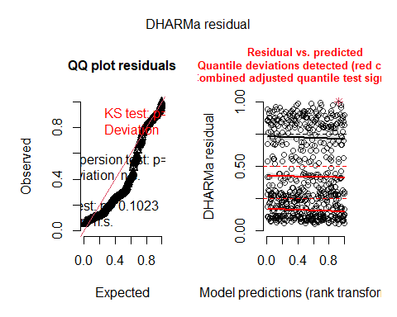

plot(simulateResiduals(model3_22_LFD_midP))

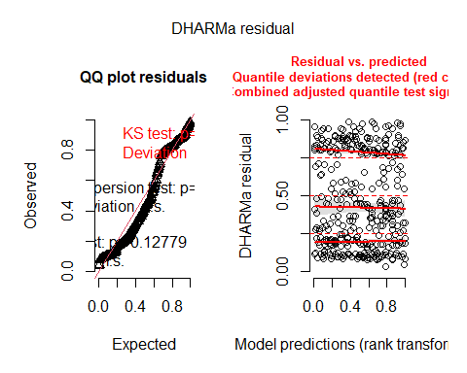

plot(simulateResiduals(model3_22_MeanFD_midP))

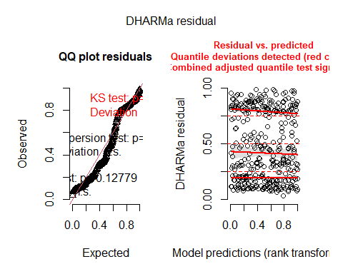

plot(simulateResiduals(model3_23_FFD_midP))

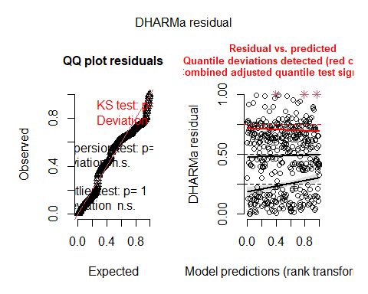

plot(simulateResiduals(model3_23_LFD_midP))

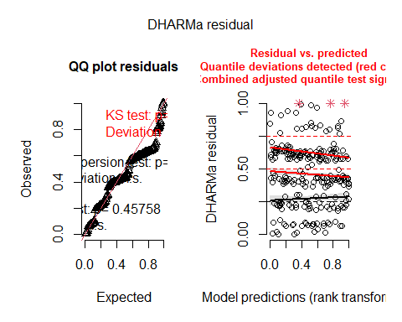

plot(simulateResiduals(model3_23_MeanFD_midP))

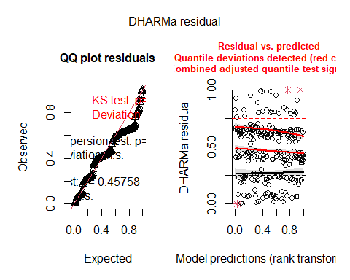

Overall deviations from the expected distribution detected. Heteroscedasticity.

#### Bootstrapped models: TO DO?

## D) Genetic differentiation in plasticities (Prediction 4 in greenhouse paper)

### Models

#### 2022

model4_22_FFD<-lmer(FFD_corr~temp*(temp_father+temp_mother)+  
 (1|father)+(1|mother)+  
 #(1|father:mother)+ # Not included because variance=0  
 # to avoid singular fit  
 (1|plot),  
 data_transplants%>%filter(year==2022&!is.na(FFD_corr)))  
model4_22_LFD<-lmer(LFD_corr~temp*(temp_father+temp_mother)+  
 (1|father)+(1|mother)+  
 #(1|father:mother)+ # Not included because variance=0  
 # to avoid singular fit  
 (1|plot),  
 data_transplants%>%filter(year==2022&!is.na(LFD_corr)))  
model4_22_MeanFD<-lmer(MeanFD~temp*(temp_father+temp_mother)+  
 (1|father)+(1|mother)+  
 #(1|father:mother)+ # Not included because variance=0  
 # to avoid singular fit  
 +(1|plot),  
 data_transplants%>%filter(year==2022&!is.na(MeanFD)))  
summary(model4_22_FFD)

## Linear mixed model fit by REML. t-tests use Satterthwaite's method [  
## lmerModLmerTest]  
## Formula: FFD_corr ~ temp * (temp_father + temp_mother) + (1 | father) +   
## (1 | mother) + (1 | plot)  
## Data: data_transplants %>% filter(year == 2022 & !is.na(FFD_corr))  
##   
## REML criterion at convergence: 4212.8  
##   
## Scaled residuals:   
## Min 1Q Median 3Q Max   
## -2.4131 -0.6276 -0.0775 0.4469 5.9576   
##   
## Random effects:  
## Groups Name Variance Std.Dev.  
## father (Intercept) 0.1719 0.4146   
## mother (Intercept) 10.2061 3.1947   
## plot (Intercept) 171.5902 13.0992   
## Residual 51.8038 7.1975   
## Number of obs: 603, groups: father, 64; mother, 63; plot, 8  
##   
## Fixed effects:  
## Estimate Std. Error df t value Pr(>|t|)   
## (Intercept) 188.950127 5.120500 10.196761 36.901 3.43e-12 ***  
## temp -0.899010 0.095217 544.197277 -9.442 < 2e-16 ***  
## temp_father -0.180435 0.068461 198.614349 -2.636 0.00906 **   
## temp_mother -0.011005 0.085981 226.303282 -0.128 0.89827   
## temp:temp_father 0.006411 0.003153 536.184488 2.033 0.04251 *   
## temp:temp_mother 0.002946 0.003281 532.583132 0.898 0.36965   
## ---  
## Signif. codes: 0 '***' 0.001 '**' 0.01 '*' 0.05 '.' 0.1 ' ' 1  
##   
## Correlation of Fixed Effects:  
## (Intr) temp tmp_ft tmp_mt tmp:tmp_f  
## temp -0.347   
## temp_father -0.179 0.413   
## temp_mother -0.258 0.403 -0.272   
## tmp:tmp_fth 0.176 -0.499 -0.869 0.180   
## tmp:tmp_mth 0.190 -0.532 0.230 -0.752 -0.238

summary(model4_22_LFD)

## Linear mixed model fit by REML. t-tests use Satterthwaite's method [  
## lmerModLmerTest]  
## Formula: LFD_corr ~ temp * (temp_father + temp_mother) + (1 | father) +   
## (1 | mother) + (1 | plot)  
## Data: data_transplants %>% filter(year == 2022 & !is.na(LFD_corr))  
##   
## REML criterion at convergence: 2596.1  
##   
## Scaled residuals:   
## Min 1Q Median 3Q Max   
## -2.1918 -0.6293 -0.1117 0.4479 5.3030   
##   
## Random effects:  
## Groups Name Variance Std.Dev.  
## father (Intercept) 1.256 1.121   
## mother (Intercept) 8.071 2.841   
## plot (Intercept) 145.207 12.050   
## Residual 57.143 7.559   
## Number of obs: 364, groups: father, 59; mother, 59; plot, 8  
##   
## Fixed effects:  
## Estimate Std. Error df t value Pr(>|t|)   
## (Intercept) 202.146266 5.171861 14.241320 39.086 6.80e-16 ***  
## temp -1.041819 0.145984 329.792969 -7.137 6.12e-12 ***  
## temp_father -0.124554 0.095528 218.774724 -1.304 0.194   
## temp_mother -0.125598 0.117452 250.359986 -1.069 0.286   
## temp:temp_father 0.005890 0.004679 314.065721 1.259 0.209   
## temp:temp_mother 0.005986 0.005778 327.935822 1.036 0.301   
## ---  
## Signif. codes: 0 '***' 0.001 '**' 0.01 '*' 0.05 '.' 0.1 ' ' 1  
##   
## Correlation of Fixed Effects:  
## (Intr) temp tmp_ft tmp_mt tmp:tmp_f  
## temp -0.492   
## temp_father -0.221 0.332   
## temp_mother -0.311 0.447 -0.353   
## tmp:tmp_fth 0.205 -0.396 -0.869 0.309   
## tmp:tmp_mth 0.253 -0.524 0.311 -0.835 -0.371

summary(model4_22_MeanFD)

## Linear mixed model fit by REML. t-tests use Satterthwaite's method [  
## lmerModLmerTest]  
## Formula: MeanFD ~ temp * (temp_father + temp_mother) + (1 | father) +   
## (1 | mother) + +(1 | plot)  
## Data: data_transplants %>% filter(year == 2022 & !is.na(MeanFD))  
##   
## REML criterion at convergence: 2586.1  
##   
## Scaled residuals:   
## Min 1Q Median 3Q Max   
## -2.0332 -0.6273 -0.1003 0.4274 5.4430   
##   
## Random effects:  
## Groups Name Variance Std.Dev.  
## father (Intercept) 0.5984 0.7736   
## mother (Intercept) 7.6063 2.7580   
## plot (Intercept) 147.5914 12.1487   
## Residual 56.0535 7.4869   
## Number of obs: 364, groups: father, 59; mother, 59; plot, 8  
##   
## Fixed effects:  
## Estimate Std. Error df t value Pr(>|t|)   
## (Intercept) 196.504557 5.172780 13.829783 37.988 2.18e-15 ***  
## temp -1.007407 0.144287 330.379474 -6.982 1.60e-11 ***  
## temp_father -0.114285 0.093538 231.265935 -1.222 0.223   
## temp_mother -0.100849 0.115615 257.798635 -0.872 0.384   
## temp:temp_father 0.005526 0.004628 314.743007 1.194 0.233   
## temp:temp_mother 0.004730 0.005710 329.163432 0.828 0.408   
## ---  
## Signif. codes: 0 '***' 0.001 '**' 0.01 '*' 0.05 '.' 0.1 ' ' 1  
##   
## Correlation of Fixed Effects:  
## (Intr) temp tmp_ft tmp_mt tmp:tmp_f  
## temp -0.485   
## temp_father -0.215 0.335   
## temp_mother -0.307 0.449 -0.353   
## tmp:tmp_fth 0.202 -0.396 -0.878 0.311   
## tmp:tmp_mth 0.249 -0.524 0.316 -0.840 -0.372

Interaction temp:temp_father is significant (P = 0.04251) for FFD. There are temperature-related differences among fathers in the response to temperature of the planting site = Genetic differentiation related to origin temperature of the father in the slope of RNs?

plot(ggpredict(model4_22_FFD,terms=c("temp_father")))

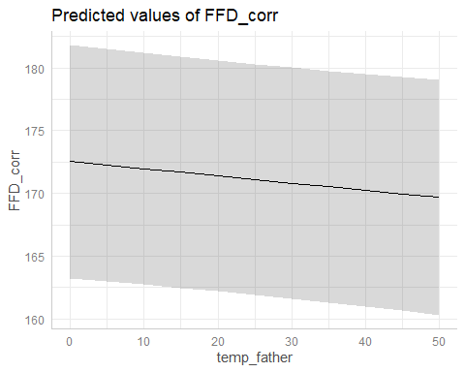

The sign of temp_father goes in the opposite direction as expected! (earlier FFD at a given temperature in individuals with fathers from warmer soils). But maybe we should not interpret this main effect, as the interaction with temp is significant??

plot(ggpredict(model4_22_FFD,terms=c("temp_father","temp[quart]")))

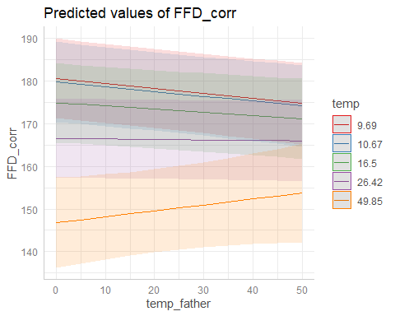

As predicted: differences in phenology between high and low soil temperatures are predicted to be smaller for plants with fathers from warm soils than for plants with fathers from colder soils.

#### 2023

model4_23_FFD<-lmer(FFD_corr~temp*(temp_father+temp_mother)+  
 (1|father)+(1|mother)+  
 (1|father:mother)+ # Not included because variance=0  
 # to avoid singular fit  
 (1|plot),  
 data_transplants%>%filter(year==2023&!is.na(FFD_corr)))  
model4_23_LFD<-lmer(LFD_corr~temp*(temp_father+temp_mother)+  
 #(1|father)+# Not included because variance=0  
 # to avoid singular fit  
 (1|mother)+  
 (1|father:mother)+   
 (1|plot),  
 data_transplants%>%filter(year==2023&!is.na(LFD_corr)))  
model4_23_MeanFD<-lmer(MeanFD~temp*(temp_father+temp_mother)+  
 (1|father)+(1|mother)+  
 (1|father:mother)+   
 +(1|plot),  
 data_transplants%>%filter(year==2023&!is.na(MeanFD)))  
summary(model4_23_FFD)

## Linear mixed model fit by REML. t-tests use Satterthwaite's method [  
## lmerModLmerTest]  
## Formula: FFD_corr ~ temp * (temp_father + temp_mother) + (1 | father) +   
## (1 | mother) + (1 | father:mother) + (1 | plot)  
## Data: data_transplants %>% filter(year == 2023 & !is.na(FFD_corr))  
##   
## REML criterion at convergence: 2860.7  
##   
## Scaled residuals:   
## Min 1Q Median 3Q Max   
## -2.0001 -0.5657 -0.0816 0.3524 5.9226   
##   
## Random effects:  
## Groups Name Variance Std.Dev.  
## father:mother (Intercept) 1.8908 1.3751   
## mother (Intercept) 0.6290 0.7931   
## father (Intercept) 0.6431 0.8019   
## plot (Intercept) 98.6147 9.9305   
## Residual 56.7175 7.5311   
## Number of obs: 406, groups:   
## father:mother, 127; mother, 61; father, 61; plot, 7  
##   
## Fixed effects:  
## Estimate Std. Error df t value Pr(>|t|)   
## (Intercept) 176.674487 4.328515 9.690449 40.816 3.6e-12 ***  
## temp 0.188196 0.139535 373.820949 1.349 0.1782   
## temp_father 0.060414 0.070623 200.041024 0.855 0.3933   
## temp_mother 0.115849 0.075907 191.338317 1.526 0.1286   
## temp:temp_father -0.005512 0.004877 367.721467 -1.130 0.2592   
## temp:temp_mother -0.010059 0.004698 365.710743 -2.141 0.0329 *   
## ---  
## Signif. codes: 0 '***' 0.001 '**' 0.01 '*' 0.05 '.' 0.1 ' ' 1  
##   
## Correlation of Fixed Effects:  
## (Intr) temp tmp_ft tmp_mt tmp:tmp_f  
## temp -0.419   
## temp_father -0.203 0.347   
## temp_mother -0.243 0.375 -0.333   
## tmp:tmp_fth 0.162 -0.455 -0.798 0.264   
## tmp:tmp_mth 0.198 -0.469 0.287 -0.809 -0.320

summary(model4_23_LFD)

## Linear mixed model fit by REML. t-tests use Satterthwaite's method [  
## lmerModLmerTest]  
## Formula: LFD_corr ~ temp * (temp_father + temp_mother) + (1 | mother) +   
## (1 | father:mother) + (1 | plot)  
## Data: data_transplants %>% filter(year == 2023 & !is.na(LFD_corr))  
##   
## REML criterion at convergence: 1791.3  
##   
## Scaled residuals:   
## Min 1Q Median 3Q Max   
## -1.9893 -0.5653 -0.0739 0.1803 5.6577   
##   
## Random effects:  
## Groups Name Variance Std.Dev.  
## father:mother (Intercept) 1.810 1.345   
## mother (Intercept) 1.442 1.201   
## plot (Intercept) 65.711 8.106   
## Residual 63.541 7.971   
## Number of obs: 249, groups: father:mother, 114; mother, 56; plot, 7  
##   
## Fixed effects:  
## Estimate Std. Error df t value Pr(>|t|)   
## (Intercept) 1.865e+02 4.300e+00 1.736e+01 43.373 < 2e-16 ***  
## temp 1.501e-01 2.065e-01 2.354e+02 0.727 0.46798   
## temp_father -3.842e-02 1.016e-01 1.916e+02 -0.378 0.70568   
## temp_mother 2.678e-01 1.106e-01 1.612e+02 2.421 0.01658 *   
## temp:temp_father -8.346e-04 7.251e-03 2.277e+02 -0.115 0.90847   
## temp:temp_mother -1.932e-02 7.268e-03 2.183e+02 -2.659 0.00842 **   
## ---  
## Signif. codes: 0 '***' 0.001 '**' 0.01 '*' 0.05 '.' 0.1 ' ' 1  
##   
## Correlation of Fixed Effects:  
## (Intr) temp tmp_ft tmp_mt tmp:tmp_f  
## temp -0.608   
## temp_father -0.301 0.390   
## temp_mother -0.328 0.358 -0.356   
## tmp:tmp_fth 0.278 -0.513 -0.829 0.285   
## tmp:tmp_mth 0.270 -0.445 0.302 -0.827 -0.318

summary(model4_23_MeanFD)

## Linear mixed model fit by REML. t-tests use Satterthwaite's method [  
## lmerModLmerTest]  
## Formula: MeanFD ~ temp * (temp_father + temp_mother) + (1 | father) +   
## (1 | mother) + (1 | father:mother) + +(1 | plot)  
## Data: data_transplants %>% filter(year == 2023 & !is.na(MeanFD))  
##   
## REML criterion at convergence: 1797.2  
##   
## Scaled residuals:   
## Min 1Q Median 3Q Max   
## -1.9178 -0.5773 -0.0930 0.2280 5.4938   
##   
## Random effects:  
## Groups Name Variance Std.Dev.  
## father:mother (Intercept) 1.915e+00 1.384004  
## mother (Intercept) 1.048e+00 1.023727  
## father (Intercept) 1.279e-05 0.003576  
## plot (Intercept) 7.286e+01 8.536053  
## Residual 6.528e+01 8.079893  
## Number of obs: 249, groups:   
## father:mother, 114; mother, 56; father, 56; plot, 7  
##   
## Fixed effects:  
## Estimate Std. Error df t value Pr(>|t|)   
## (Intercept) 1.816e+02 4.441e+00 1.647e+01 40.901 < 2e-16 ***  
## temp 1.669e-01 2.093e-01 2.367e+02 0.798 0.42594   
## temp_father -3.692e-02 1.028e-01 1.946e+02 -0.359 0.71978   
## temp_mother 2.655e-01 1.114e-01 1.635e+02 2.382 0.01835 *   
## temp:temp_father -9.646e-04 7.342e-03 2.293e+02 -0.131 0.89558   
## temp:temp_mother -1.954e-02 7.360e-03 2.194e+02 -2.655 0.00852 **   
## ---  
## Signif. codes: 0 '***' 0.001 '**' 0.01 '*' 0.05 '.' 0.1 ' ' 1  
##   
## Correlation of Fixed Effects:  
## (Intr) temp tmp_ft tmp_mt tmp:tmp_f  
## temp -0.597   
## temp_father -0.295 0.389   
## temp_mother -0.320 0.361 -0.356   
## tmp:tmp_fth 0.272 -0.512 -0.830 0.287   
## tmp:tmp_mth 0.265 -0.446 0.303 -0.831 -0.319

plot(ggpredict(model4_23_FFD,terms=c("temp_mother","temp[quart]")))

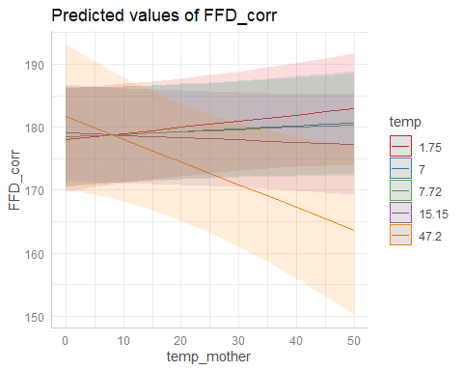

plot(ggpredict(model4_23_LFD,terms=c("temp_mother","temp[quart]")))

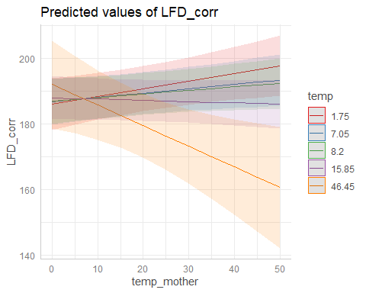

plot(ggpredict(model4_23_MeanFD,terms=c("temp_mother","temp[quart]")))

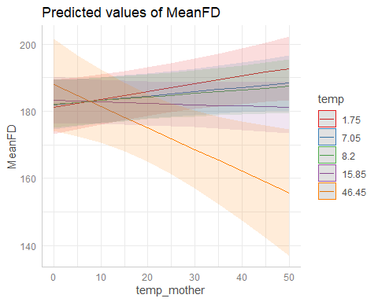

Predicted: differences in phenology between high and low soil temperatures are predicted to be smaller for plants with mothers from warm soils than for plants with mothers from colder soils.

But the effect goes in the opposite direction as expected! Why?

#### Model diagnostics

plot(simulateResiduals(model4_22_FFD))

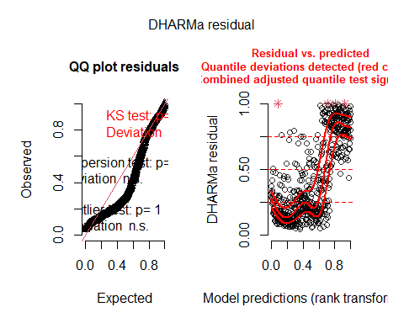

plot(simulateResiduals(model4_22_LFD))

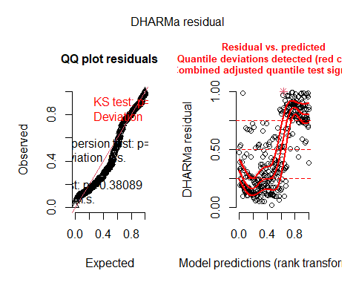

plot(simulateResiduals(model4_22_MeanFD))

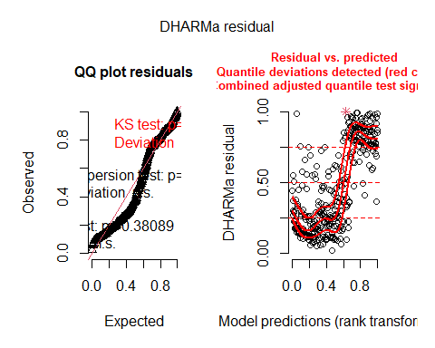

plot(simulateResiduals(model4_23_FFD))

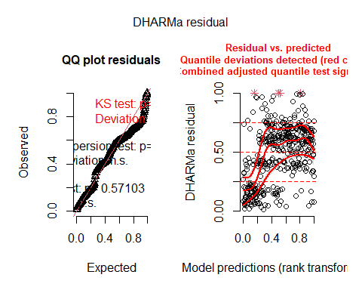

plot(simulateResiduals(model4_23_LFD))

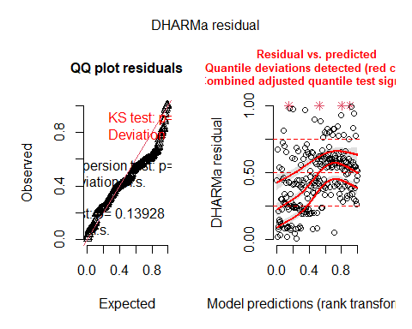

plot(simulateResiduals(model4_23_MeanFD))

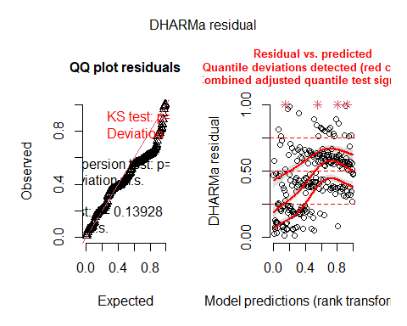

Overall deviations from the expected distribution detected. Heteroscedasticity.

#### Bootstrapped models

Bootstrapping of fixed effects and p-values will serve to check significance of the effects of origin temperatures.

##### 2022

###### Bootstrap fixed effects

confint(model4_22_FFD_boot_fixef)

## # A tibble: 30 × 6  
## term estimate lower upper type level  
## <chr> <dbl> <dbl> <dbl> <chr> <dbl>  
## 1 beta1 189. 185. 193. norm 0.95  
## 2 beta2 -0.899 -1.07 -0.727 norm 0.95  
## 3 beta3 -0.180 -0.308 -0.0510 norm 0.95  
## 4 beta4 -0.0110 -0.179 0.154 norm 0.95  
## 5 beta5 0.00641 0.000589 0.0122 norm 0.95  
## 6 beta6 0.00295 -0.00309 0.00909 norm 0.95  
## 7 vc1 0.172 -1.63 1.33 norm 0.95  
## 8 vc2 10.2 4.72 15.9 norm 0.95  
## 9 vc3 172. 121. 173. norm 0.95  
## 10 vc4 51.8 46.1 66.6 norm 0.95  
## # ℹ 20 more rows

confint(model4_22_LFD_boot_fixef)

## # A tibble: 30 × 6  
## term estimate lower upper type level  
## <chr> <dbl> <dbl> <dbl> <chr> <dbl>  
## 1 beta1 202. 197. 207. norm 0.95  
## 2 beta2 -1.04 -1.29 -0.766 norm 0.95  
## 3 beta3 -0.125 -0.306 0.0622 norm 0.95  
## 4 beta4 -0.126 -0.339 0.107 norm 0.95  
## 5 beta5 0.00589 -0.00308 0.0146 norm 0.95  
## 6 beta6 0.00599 -0.00538 0.0163 norm 0.95  
## 7 vc1 1.26 -2.97 4.66 norm 0.95  
## 8 vc2 8.07 0.576 15.6 norm 0.95  
## 9 vc3 145. 92.1 157. norm 0.95  
## 10 vc4 57.1 49.7 77.0 norm 0.95  
## # ℹ 20 more rows

confint(model4_22_MeanFD_boot_fixef)

## # A tibble: 30 × 6  
## term estimate lower upper type level  
## <chr> <dbl> <dbl> <dbl> <chr> <dbl>  
## 1 beta1 197. 191. 202. norm 0.95  
## 2 beta2 -1.01 -1.28 -0.727 norm 0.95  
## 3 beta3 -0.114 -0.294 0.0581 norm 0.95  
## 4 beta4 -0.101 -0.309 0.117 norm 0.95  
## 5 beta5 0.00553 -0.00291 0.0142 norm 0.95  
## 6 beta6 0.00473 -0.00602 0.0151 norm 0.95  
## 7 vc1 0.598 -2.64 2.92 norm 0.95  
## 8 vc2 7.61 0.439 14.7 norm 0.95  
## 9 vc3 148. 95.8 158. norm 0.95  
## 10 vc4 56.1 47.7 75.9 norm 0.95  
## # ℹ 20 more rows

###### RUN from here w 100 iter: Bootstrap p-values

#model4_22_FFD_boot_pvals  
model4_22_LFD_boot_pvals

## Bootstrap type: residual   
##   
## Number of resamples: 100   
##   
## # A tibble: 6 × 7  
## term Estimate `Std. Error` df `t value` `Pr(>|t|)` p.value  
## <chr> <dbl> <dbl> <dbl> <dbl> <dbl> <dbl>  
## 1 (Intercept) 202. 5.17 14.2 39.1 6.80e-16 0.00990  
## 2 temp -1.04 0.146 330. -7.14 6.12e-12 0.00990  
## 3 temp_father -0.125 0.0955 219. -1.30 1.94e- 1 0.218   
## 4 temp_mother -0.126 0.117 250. -1.07 2.86e- 1 0.287   
## 5 temp:temp_father 0.00589 0.00468 314. 1.26 2.09e- 1 0.168   
## 6 temp:temp_mother 0.00599 0.00578 328. 1.04 3.01e- 1 0.356

model4_22_MeanFD_boot_pvals

## Bootstrap type: residual   
##   
## Number of resamples: 100   
##   
## # A tibble: 6 × 7  
## term Estimate `Std. Error` df `t value` `Pr(>|t|)` p.value  
## <chr> <dbl> <dbl> <dbl> <dbl> <dbl> <dbl>  
## 1 (Intercept) 197. 5.17 13.8 38.0 2.18e-15 0.00990  
## 2 temp -1.01 0.144 330. -6.98 1.60e-11 0.00990  
## 3 temp_father -0.114 0.0935 231. -1.22 2.23e- 1 0.208   
## 4 temp_mother -0.101 0.116 258. -0.872 3.84e- 1 0.347   
## 5 temp:temp_father 0.00553 0.00463 315. 1.19 2.33e- 1 0.208   
## 6 temp:temp_mother 0.00473 0.00571 329. 0.828 4.08e- 1 0.455

Interaction temp:temp_father still significant for FFD with p = 0.0480.

##### 2023

###### Bootstrap fixed effects

confint(model4_23_FFD_boot_fixef)

## # A tibble: 33 × 6  
## term estimate lower upper type level  
## <chr> <dbl> <dbl> <dbl> <chr> <dbl>  
## 1 beta1 177. 173. 181. norm 0.95  
## 2 beta2 0.188 -0.0723 0.447 norm 0.95  
## 3 beta3 0.0604 -0.0681 0.190 norm 0.95  
## 4 beta4 0.116 -0.0221 0.257 norm 0.95  
## 5 beta5 -0.00551 -0.0146 0.00366 norm 0.95  
## 6 beta6 -0.0101 -0.0189 -0.00140 norm 0.95  
## 7 vc1 1.89 -2.42 6.34 norm 0.95  
## 8 vc2 0.629 -3.26 3.63 norm 0.95  
## 9 vc3 0.643 -2.58 3.16 norm 0.95  
## 10 vc4 98.6 56.0 109. norm 0.95  
## # ℹ 23 more rows

confint(model4_23_LFD_boot_fixef)

## # A tibble: 30 × 6  
## term estimate lower upper type level  
## <chr> <dbl> <dbl> <dbl> <chr> <dbl>  
## 1 beta1 186. 181. 192. norm 0.95  
## 2 beta2 0.150 -0.235 0.548 norm 0.95  
## 3 beta3 -0.0384 -0.221 0.151 norm 0.95  
## 4 beta4 0.268 0.0690 0.471 norm 0.95  
## 5 beta5 -0.000835 -0.0148 0.0125 norm 0.95  
## 6 beta6 -0.0193 -0.0324 -0.00649 norm 0.95  
## 7 vc1 1.81 -7.29 8.82 norm 0.95  
## 8 vc2 1.44 -5.29 7.01 norm 0.95  
## 9 vc3 65.7 27.4 82.9 norm 0.95  
## 10 vc4 63.5 44.2 96.5 norm 0.95  
## # ℹ 20 more rows

confint(model4_23_MeanFD_boot_fixef)

## # A tibble: 33 × 6  
## term estimate lower upper type level  
## <chr> <dbl> <dbl> <dbl> <chr> <dbl>  
## 1 beta1 182. 176. 187. norm 0.95  
## 2 beta2 0.167 -0.225 0.578 norm 0.95  
## 3 beta3 -0.0369 -0.237 0.170 norm 0.95  
## 4 beta4 0.265 0.0604 0.473 norm 0.95  
## 5 beta5 -0.000965 -0.0156 0.0133 norm 0.95  
## 6 beta6 -0.0195 -0.0337 -0.00571 norm 0.95  
## 7 vc1 1.92 -6.98 8.83 norm 0.95  
## 8 vc2 1.05 -5.21 5.93 norm 0.95  
## 9 vc3 0.0000128 -0.0000133 0.0000376 norm 0.95  
## 10 vc4 72.9 31.4 90.0 norm 0.95  
## # ℹ 23 more rows

###### RUN w 1000 iter: Bootstrap p-values

model4_23_FFD_boot_pvals

## Bootstrap type: residual   
##   
## Number of resamples: 100   
##   
## # A tibble: 6 × 7  
## term Estimate `Std. Error` df `t value` `Pr(>|t|)` p.value  
## <chr> <dbl> <dbl> <dbl> <dbl> <dbl> <dbl>  
## 1 (Intercept) 177. 4.33 9.69 40.8 3.60e-12 0.00990  
## 2 temp 0.188 0.140 374. 1.35 1.78e- 1 0.149   
## 3 temp_father 0.0604 0.0706 200. 0.855 3.93e- 1 0.376   
## 4 temp_mother 0.116 0.0759 191. 1.53 1.29e- 1 0.0891   
## 5 temp:temp_father -0.00551 0.00488 368. -1.13 2.59e- 1 0.337   
## 6 temp:temp_mother -0.0101 0.00470 366. -2.14 3.29e- 2 0.0297

model4_23_LFD_boot_pvals

## Bootstrap type: residual   
##   
## Number of resamples: 100   
##   
## # A tibble: 6 × 7  
## term Estimate `Std. Error` df `t value` `Pr(>|t|)` p.value  
## <chr> <dbl> <dbl> <dbl> <dbl> <dbl> <dbl>  
## 1 (Intercept) 186. 4.30 17.4 43.4 3.79e-19 0.00990  
## 2 temp 0.150 0.207 235. 0.727 4.68e- 1 0.535   
## 3 temp_father -0.0384 0.102 192. -0.378 7.06e- 1 0.683   
## 4 temp_mother 0.268 0.111 161. 2.42 1.66e- 2 0.0594   
## 5 temp:temp_father -0.000835 0.00725 228. -0.115 9.08e- 1 0.950   
## 6 temp:temp_mother -0.0193 0.00727 218. -2.66 8.42e- 3 0.0495

#model4_23_MeanFD_boot_pvals

### Models mid-parental values

#### 2022

model4_22_FFD_midP<-lmer(FFD_corr~temp*mean_temp_parents+  
 (1|father)+(1|mother)+  
 #(1|father:mother)+ # Not included because variance=0  
 # to avoid singular fit  
 (1|plot),  
 data_transplants%>%filter(year==2022&!is.na(FFD_corr)))  
model4_22_LFD_midP<-lmer(LFD_corr~temp*mean_temp_parents+  
 (1|father)+(1|mother)+  
 #(1|father:mother)+ # Not included because variance=0  
 # to avoid singular fit  
 (1|plot),  
 data_transplants%>%filter(year==2022&!is.na(LFD_corr)))  
model4_22_MeanFD_midP<-lmer(MeanFD~temp*mean_temp_parents+  
 (1|father)+(1|mother)+  
 #(1|father:mother)+ # Not included because variance=0  
 # to avoid singular fit  
 (1|plot),  
 data_transplants%>%filter(year==2022&!is.na(MeanFD)))  
summary(model4_22_FFD_midP)

## Linear mixed model fit by REML. t-tests use Satterthwaite's method [  
## lmerModLmerTest]  
## Formula: FFD_corr ~ temp * mean_temp_parents + (1 | father) + (1 | mother) +   
## (1 | plot)  
## Data: data_transplants %>% filter(year == 2022 & !is.na(FFD_corr))  
##   
## REML criterion at convergence: 4200.2  
##   
## Scaled residuals:   
## Min 1Q Median 3Q Max   
## -2.4568 -0.6145 -0.0779 0.4629 5.9683   
##   
## Random effects:  
## Groups Name Variance Std.Dev.  
## father (Intercept) 0.2487 0.4987   
## mother (Intercept) 9.8828 3.1437   
## plot (Intercept) 170.9405 13.0744   
## Residual 51.8854 7.2032   
## Number of obs: 603, groups: father, 64; mother, 63; plot, 8  
##   
## Fixed effects:  
## Estimate Std. Error df t value Pr(>|t|)   
## (Intercept) 189.785695 5.078566 9.942514 37.370 5.04e-12 ***  
## temp -0.906470 0.095152 545.613918 -9.527 < 2e-16 ***  
## mean_temp_parents -0.235271 0.089124 278.783251 -2.640 0.00876 **   
## temp:mean_temp_parents 0.009669 0.003969 539.510250 2.436 0.01518 *   
## ---  
## Signif. codes: 0 '***' 0.001 '**' 0.01 '*' 0.05 '.' 0.1 ' ' 1  
##   
## Correlation of Fixed Effects:  
## (Intr) temp mn_tm_  
## temp -0.346   
## mn_tmp_prnt -0.350 0.693   
## tmp:mn_tmp_ 0.295 -0.835 -0.833

summary(model4_22_LFD_midP)

## Linear mixed model fit by REML. t-tests use Satterthwaite's method [  
## lmerModLmerTest]  
## Formula: LFD_corr ~ temp * mean_temp_parents + (1 | father) + (1 | mother) +   
## (1 | plot)  
## Data: data_transplants %>% filter(year == 2022 & !is.na(LFD_corr))  
##   
## REML criterion at convergence: 2582.8  
##   
## Scaled residuals:   
## Min 1Q Median 3Q Max   
## -2.1858 -0.6284 -0.1182 0.4479 5.3142   
##   
## Random effects:  
## Groups Name Variance Std.Dev.  
## father (Intercept) 1.102 1.050   
## mother (Intercept) 7.922 2.815   
## plot (Intercept) 145.029 12.043   
## Residual 56.968 7.548   
## Number of obs: 364, groups: father, 59; mother, 59; plot, 8  
##   
## Fixed effects:  
## Estimate Std. Error df t value Pr(>|t|)   
## (Intercept) 202.152845 5.140620 13.943414 39.325 1.1e-15 ***  
## temp -1.042048 0.144339 330.853920 -7.219 3.6e-12 ***  
## mean_temp_parents -0.249707 0.118948 298.674112 -2.099 0.0366 *   
## temp:mean_temp_parents 0.011842 0.005769 330.638610 2.052 0.0409 *   
## ---  
## Signif. codes: 0 '***' 0.001 '**' 0.01 '*' 0.05 '.' 0.1 ' ' 1  
##   
## Correlation of Fixed Effects:  
## (Intr) temp mn_tm_  
## temp -0.490   
## mn_tmp_prnt -0.463 0.689   
## tmp:mn_tmp_ 0.409 -0.821 -0.856

summary(model4_22_MeanFD_midP)

## Linear mixed model fit by REML. t-tests use Satterthwaite's method [  
## lmerModLmerTest]  
## Formula: MeanFD ~ temp * mean_temp_parents + (1 | father) + (1 | mother) +   
## (1 | plot)  
## Data: data_transplants %>% filter(year == 2022 & !is.na(MeanFD))  
##   
## REML criterion at convergence: 2572.6  
##   
## Scaled residuals:   
## Min 1Q Median 3Q Max   
## -2.0272 -0.6318 -0.1043 0.4343 5.4612   
##   
## Random effects:  
## Groups Name Variance Std.Dev.  
## father (Intercept) 0.4808 0.6934   
## mother (Intercept) 7.4405 2.7277   
## plot (Intercept) 147.5085 12.1453   
## Residual 55.8796 7.4753   
## Number of obs: 364, groups: father, 59; mother, 59; plot, 8  
##   
## Fixed effects:  
## Estimate Std. Error df t value Pr(>|t|)   
## (Intercept) 196.532968 5.141656 13.526284 38.224 3.55e-15 ***  
## temp -1.009433 0.142670 331.527383 -7.075 8.92e-12 ***  
## mean_temp_parents -0.216483 0.116681 300.005022 -1.855 0.0645 .   
## temp:mean_temp_parents 0.010356 0.005701 331.697135 1.816 0.0702 .   
## ---  
## Signif. codes: 0 '***' 0.001 '**' 0.01 '*' 0.05 '.' 0.1 ' ' 1  
##   
## Correlation of Fixed Effects:  
## (Intr) temp mn_tm_  
## temp -0.483   
## mn_tmp_prnt -0.453 0.694   
## tmp:mn_tmp_ 0.404 -0.821 -0.863

plot(ggpredict(model4_22_FFD_midP,terms=c("mean_temp_parents","temp[quart]")))

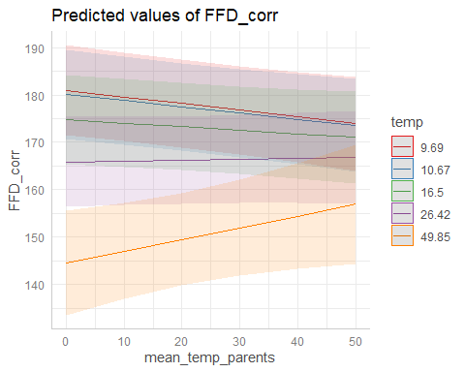

plot(ggpredict(model4_22_LFD_midP,terms=c("mean_temp_parents","temp[quart]")))

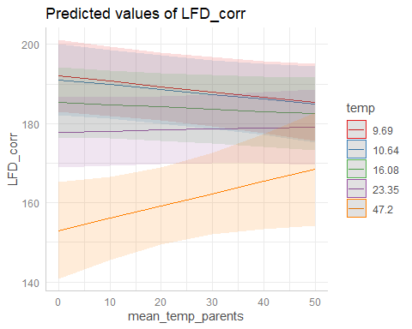

plot(ggpredict(model4_22_MeanFD_midP,terms=c("mean_temp_parents","temp[quart]"))) # Marginally *

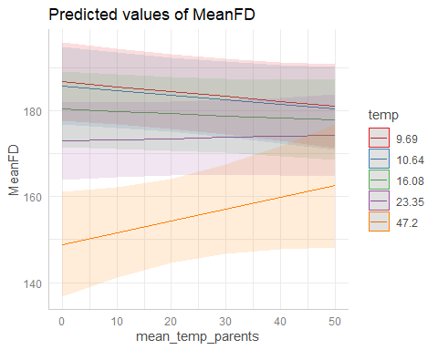

As predicted: differences in phenology between high and low soil temperatures are predicted to be smaller for plants with parents from warm soils than for plants with parents from colder soils.

#### 2023

model4_23_FFD_midP<-lmer(FFD_corr~temp*mean_temp_parents+  
 (1|father)+(1|mother)+  
 (1|father:mother)+ # Not included because variance=0  
 # to avoid singular fit  
 (1|plot),  
 data_transplants%>%filter(year==2023&!is.na(FFD_corr)))  
model4_23_LFD_midP<-lmer(LFD_corr~temp*mean_temp_parents+  
 #(1|father)+# Not included because variance=0  
 # to avoid singular fit  
 (1|mother)+  
 (1|father:mother)+   
 (1|plot),  
 data_transplants%>%filter(year==2023&!is.na(LFD_corr)))  
model4_23_MeanFD_midP<-lmer(MeanFD~temp*mean_temp_parents+  
 #(1|father)+# Not included because variance=0  
 # to avoid singular fit  
 (1|mother)+  
 (1|father:mother)+   
 (1|plot),  
 data_transplants%>%filter(year==2023&!is.na(MeanFD)))  
summary(model4_23_FFD_midP)

## Linear mixed model fit by REML. t-tests use Satterthwaite's method [  
## lmerModLmerTest]  
## Formula: FFD_corr ~ temp * mean_temp_parents + (1 | father) + (1 | mother) +   
## (1 | father:mother) + (1 | plot)  
## Data: data_transplants %>% filter(year == 2023 & !is.na(FFD_corr))  
##   
## REML criterion at convergence: 2846.9  
##   
## Scaled residuals:   
## Min 1Q Median 3Q Max   
## -2.0129 -0.5698 -0.0723 0.3597 5.9455   
##   
## Random effects:  
## Groups Name Variance Std.Dev.  
## father:mother (Intercept) 1.8940 1.3762   
## mother (Intercept) 0.6681 0.8173   
## father (Intercept) 0.4412 0.6642   
## plot (Intercept) 98.3644 9.9179   
## Residual 56.5974 7.5231   
## Number of obs: 406, groups:   
## father:mother, 127; mother, 61; father, 61; plot, 7  
##   
## Fixed effects:  
## Estimate Std. Error df t value Pr(>|t|)   
## (Intercept) 176.703648 4.317462 9.642926 40.928 3.88e-12 ***  
## temp 0.189139 0.139051 376.786521 1.360 0.17458   
## mean_temp_parents 0.175462 0.083986 318.832392 2.089 0.03748 *   
## temp:mean_temp_parents -0.015739 0.005554 359.584284 -2.834 0.00486 **   
## ---  
## Signif. codes: 0 '***' 0.001 '**' 0.01 '*' 0.05 '.' 0.1 ' ' 1  
##   
## Correlation of Fixed Effects:  
## (Intr) temp mn_tm_  
## temp -0.418   
## mn_tmp_prnt -0.384 0.625   
## tmp:mn_tmp_ 0.307 -0.791 -0.785

summary(model4_23_LFD_midP)

## Linear mixed model fit by REML. t-tests use Satterthwaite's method [  
## lmerModLmerTest]  
## Formula:   
## LFD_corr ~ temp * mean_temp_parents + (1 | mother) + (1 | father:mother) +   
## (1 | plot)  
## Data: data_transplants %>% filter(year == 2023 & !is.na(LFD_corr))  
##   
## REML criterion at convergence: 1781.7  
##   
## Scaled residuals:   
## Min 1Q Median 3Q Max   
## -1.9828 -0.5699 -0.0492 0.1690 5.7598   
##   
## Random effects:  
## Groups Name Variance Std.Dev.  
## father:mother (Intercept) 0.7421 0.8615   
## mother (Intercept) 1.7330 1.3164   
## plot (Intercept) 65.4926 8.0927   
## Residual 64.5908 8.0368   
## Number of obs: 249, groups: father:mother, 114; mother, 56; plot, 7  
##   
## Fixed effects:  
## Estimate Std. Error df t value Pr(>|t|)   
## (Intercept) 186.669477 4.290444 17.287394 43.508 <2e-16 ***  
## temp 0.154700 0.206648 238.503589 0.749 0.4548   
## mean_temp_parents 0.212315 0.120013 230.229314 1.769 0.0782 .   
## temp:mean_temp_parents -0.019835 0.008497 230.716323 -2.334 0.0204 *   
## ---  
## Signif. codes: 0 '***' 0.001 '**' 0.01 '*' 0.05 '.' 0.1 ' ' 1  
##   
## Correlation of Fixed Effects:  
## (Intr) temp mn_tm_  
## temp -0.609   
## mn_tmp_prnt -0.552 0.660   
## tmp:mn_tmp_ 0.469 -0.821 -0.809

summary(model4_23_MeanFD_midP)

## Linear mixed model fit by REML. t-tests use Satterthwaite's method [  
## lmerModLmerTest]  
## Formula:   
## MeanFD ~ temp * mean_temp_parents + (1 | mother) + (1 | father:mother) +   
## (1 | plot)  
## Data: data_transplants %>% filter(year == 2023 & !is.na(MeanFD))  
##   
## REML criterion at convergence: 1787.5  
##   
## Scaled residuals:   
## Min 1Q Median 3Q Max   
## -1.9113 -0.5809 -0.0496 0.1985 5.6003   
##   
## Random effects:  
## Groups Name Variance Std.Dev.  
## father:mother (Intercept) 0.7379 0.859   
## mother (Intercept) 1.5012 1.225   
## plot (Intercept) 72.6312 8.522   
## Residual 66.2708 8.141   
## Number of obs: 249, groups: father:mother, 114; mother, 56; plot, 7  
##   
## Fixed effects:  
## Estimate Std. Error df t value Pr(>|t|)   
## (Intercept) 181.809241 4.432262 16.415129 41.020 <2e-16 ***  
## temp 0.170774 0.209279 239.568133 0.816 0.4153   
## mean_temp_parents 0.212006 0.121264 230.801201 1.748 0.0817 .   
## temp:mean_temp_parents -0.020145 0.008594 231.265561 -2.344 0.0199 *   
## ---  
## Signif. codes: 0 '***' 0.001 '**' 0.01 '*' 0.05 '.' 0.1 ' ' 1  
##   
## Correlation of Fixed Effects:  
## (Intr) temp mn_tm_  
## temp -0.598   
## mn_tmp_prnt -0.541 0.662   
## tmp:mn_tmp_ 0.460 -0.820 -0.811

plot(ggpredict(model4_23_FFD_midP,terms=c("mean_temp_parents","temp[quart]")))

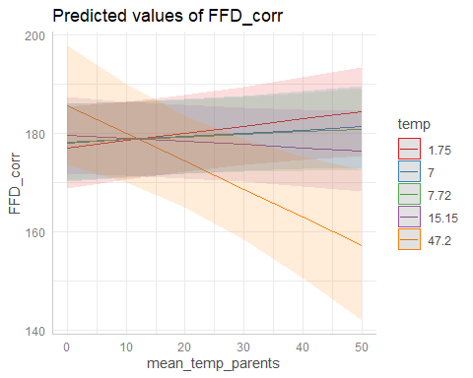

plot(ggpredict(model4_23_LFD_midP,terms=c("mean_temp_parents","temp[quart]")))

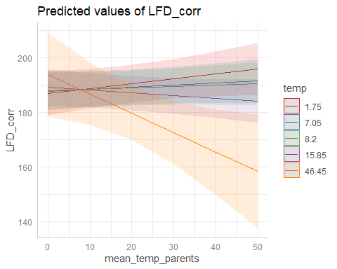

plot(ggpredict(model4_23_MeanFD_midP,terms=c("mean_temp_parents","temp[quart]")))

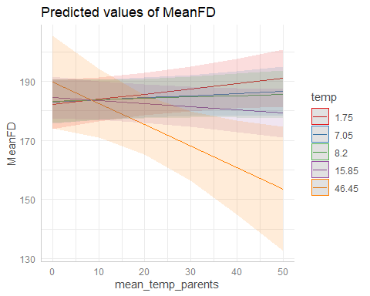

Predicted: differences in phenology between high and low soil temperatures are predicted to be smaller for plants with parents from warm soils than for plants with parents from colder soils.

But the effect goes in the opposite direction as expected! Why?

#### Model diagnostics

plot(simulateResiduals(model4_22_FFD_midP))

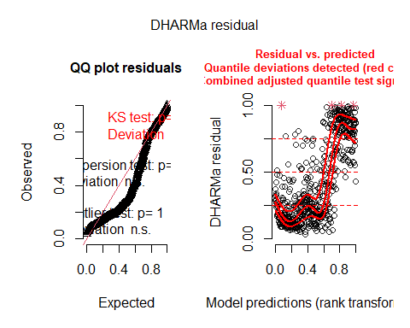

plot(simulateResiduals(model4_22_LFD_midP))

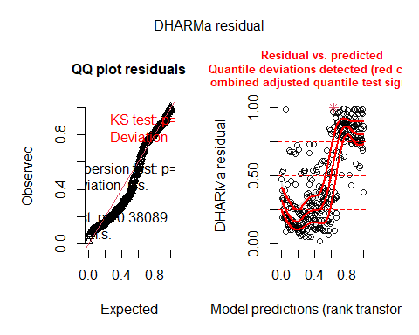

plot(simulateResiduals(model4_22_MeanFD_midP))

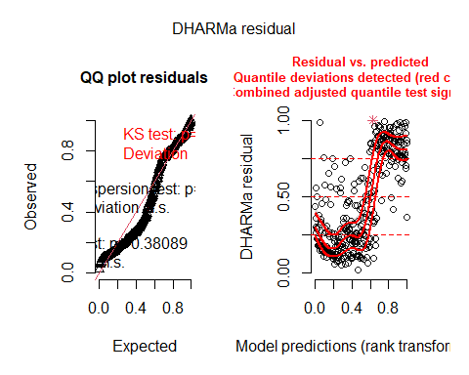

plot(simulateResiduals(model4_23_FFD_midP))

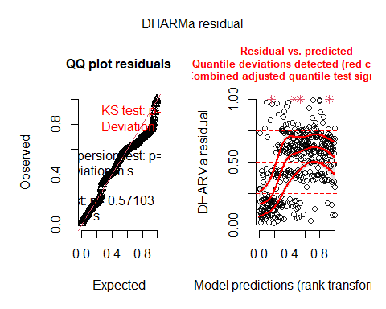

plot(simulateResiduals(model4_23_LFD_midP))

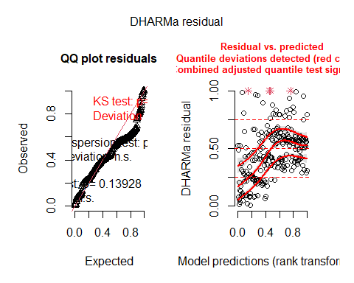

plot(simulateResiduals(model4_23_MeanFD_midP))

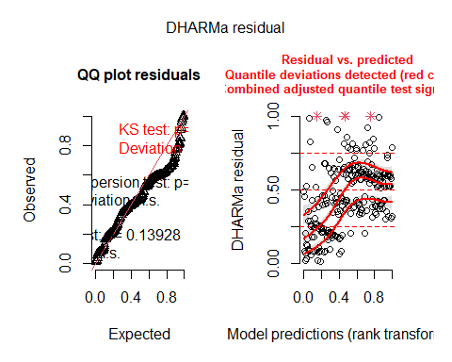

Overall deviations from the expected distribution detected. Heteroscedasticity.

#### Bootstrapped models: TO DO?

## Models genetic differentiation with breeding values?

# PREDICTION 2

“There is temperature-dependent phenotypic selection on flowering time, and selection favors an earlier phenology at low soil temperatures but a later phenology at high temperatures.”

Fitness = total number of seeds (n_tot_seeds).

ggplot(data_transplants,aes(x=n_tot_seed))+  
 geom_histogram(color="black",fill="white")+  
 my_theme()

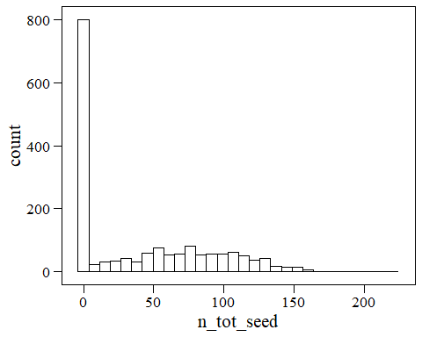

ggplot(data_transplants,aes(x=tot_fl_bodies))+  
 geom_histogram(color="black",fill="white")+  
 my_theme()

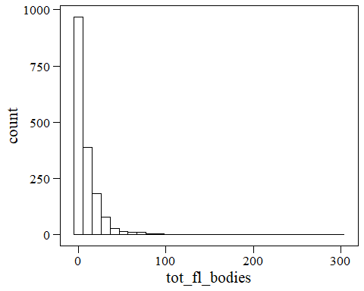

ggplot(data_transplants,aes(x=log(tot_fl_bodies)))+  
 geom_histogram(color="black",fill="white")+  
 my_theme()

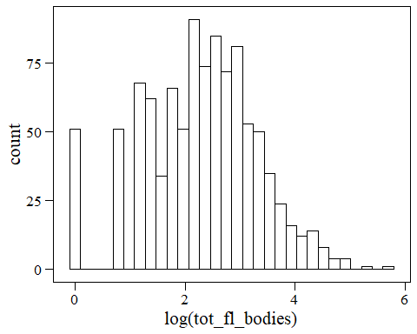

## Models both years

### With n flowers as condition trait

model_phensel_FFD_f<-lmer(fitness_rel~FFD_std*temp+FFD_std:year+temp:year+  
 FFD_std:temp:year+n_fl_std+(1|unique_id)+(1|plot),  
 data_transplants)  
model_phensel_LFD_f<-lmer(fitness_rel~LFD_std*temp+LFD_std:year+temp:year+  
 LFD_std:temp:year+n_fl_std+(1|unique_id)+(1|plot),  
 data_transplants)  
model_phensel_MeanFD_f<-lmer(fitness_rel~MeanFD_std*temp+MeanFD_std:year+  
 temp:year+MeanFD_std:temp:year+n_fl_std+  
 (1|unique_id)+(1|plot),data_transplants)  
# Is this what we want to test?  
summary(model_phensel_FFD_f)

## Linear mixed model fit by REML. t-tests use Satterthwaite's method [  
## lmerModLmerTest]  
## Formula:   
## fitness_rel ~ FFD_std * temp + FFD_std:year + temp:year + FFD_std:temp:year +   
## n_fl_std + (1 | unique_id) + (1 | plot)  
## Data: data_transplants  
##   
## REML criterion at convergence: 2935  
##   
## Scaled residuals:   
## Min 1Q Median 3Q Max   
## -3.4921 -0.5613 -0.0046 0.5053 3.3439   
##   
## Random effects:  
## Groups Name Variance Std.Dev.  
## unique_id (Intercept) 0.21287 0.4614   
## plot (Intercept) 0.04866 0.2206   
## Residual 0.81234 0.9013   
## Number of obs: 1011, groups: unique_id, 712; plot, 8  
##   
## Fixed effects:  
## Estimate Std. Error df t value Pr(>|t|)   
## (Intercept) 1.392e+00 1.632e-01 3.753e+01 8.526 2.61e-10 ***  
## FFD_std -1.188e-01 1.425e-01 1.052e+02 -0.834 0.406   
## temp -9.592e-03 9.382e-03 9.550e+01 -1.022 0.309   
## n_fl_std 4.880e-01 5.065e-02 9.061e+02 9.634 < 2e-16 ***  
## FFD_std:temp -4.781e-04 8.652e-03 2.266e+02 -0.055 0.956   
## FFD_std:year2023 2.130e-02 1.609e-01 6.627e+02 0.132 0.895   
## temp:year2023 2.711e-02 5.828e-03 7.425e+02 4.652 3.89e-06 ***  
## FFD_std:temp:year2023 -5.262e-03 9.825e-03 7.105e+02 -0.536 0.592   
## ---  
## Signif. codes: 0 '***' 0.001 '**' 0.01 '*' 0.05 '.' 0.1 ' ' 1  
##   
## Correlation of Fixed Effects:  
## (Intr) FFD_st temp n_fl_s FFD_s: FFD_:2 t:2023  
## FFD_std 0.301   
## temp -0.785 -0.610   
## n_fl_std -0.345 0.119 0.215   
## FFD_std:tmp -0.489 -0.887 0.785 0.151   
## FFD_st:2023 -0.221 -0.665 0.410 0.013 0.644   
## temp:yr2023 -0.006 0.405 -0.219 -0.037 -0.419 -0.544   
## FFD_s::2023 0.241 0.625 -0.461 -0.077 -0.695 -0.911 0.685

summary(model_phensel_LFD_f)

## Linear mixed model fit by REML. t-tests use Satterthwaite's method [  
## lmerModLmerTest]  
## Formula:   
## fitness_rel ~ LFD_std * temp + LFD_std:year + temp:year + LFD_std:temp:year +   
## n_fl_std + (1 | unique_id) + (1 | plot)  
## Data: data_transplants  
##   
## REML criterion at convergence: 1781.2  
##   
## Scaled residuals:   
## Min 1Q Median 3Q Max   
## -3.4192 -0.5251 -0.0039 0.4990 2.7483   
##   
## Random effects:  
## Groups Name Variance Std.Dev.  
## unique_id (Intercept) 0.27423 0.5237   
## plot (Intercept) 0.03146 0.1774   
## Residual 0.73378 0.8566   
## Number of obs: 613, groups: unique_id, 492; plot, 8  
##   
## Fixed effects:  
## Estimate Std. Error df t value Pr(>|t|)   
## (Intercept) 1.374969 0.183378 48.918892 7.498 1.14e-09 ***  
## LFD_std -0.070918 0.173520 90.768369 -0.409 0.684   
## temp -0.012262 0.011273 77.724046 -1.088 0.280   
## n_fl_std 0.496235 0.063585 545.503355 7.804 3.07e-14 ***  
## LFD_std:temp -0.002082 0.010489 190.850696 -0.198 0.843   
## LFD_std:year2023 -0.040618 0.208219 444.552834 -0.195 0.845   
## temp:year2023 0.031928 0.006995 465.867009 4.564 6.42e-06 ***  
## LFD_std:temp:year2023 -0.001970 0.012418 521.372106 -0.159 0.874   
## ---  
## Signif. codes: 0 '***' 0.001 '**' 0.01 '*' 0.05 '.' 0.1 ' ' 1  
##   
## Correlation of Fixed Effects:  
## (Intr) LFD_st temp n_fl_s LFD_s: LFD_:2 t:2023  
## LFD_std 0.205   
## temp -0.837 -0.496   
## n_fl_std -0.417 0.145 0.284   
## LFD_std:tmp -0.438 -0.882 0.724 0.127   
## LFD_st:2023 -0.153 -0.699 0.347 -0.040 0.653   
## temp:yr2023 0.015 0.380 -0.247 -0.106 -0.446 -0.526   
## LFD_s::2023 0.194 0.635 -0.412 -0.057 -0.705 -0.908 0.668

summary(model_phensel_MeanFD_f)

## Linear mixed model fit by REML. t-tests use Satterthwaite's method [  
## lmerModLmerTest]  
## Formula: fitness_rel ~ MeanFD_std * temp + MeanFD_std:year + temp:year +   
## MeanFD_std:temp:year + n_fl_std + (1 | unique_id) + (1 | plot)  
## Data: data_transplants  
##   
## REML criterion at convergence: 1781.7  
##   
## Scaled residuals:   
## Min 1Q Median 3Q Max   
## -3.4251 -0.5262 0.0092 0.4991 2.7562   
##   
## Random effects:  
## Groups Name Variance Std.Dev.  
## unique_id (Intercept) 0.27390 0.5234   
## plot (Intercept) 0.03125 0.1768   
## Residual 0.73496 0.8573   
## Number of obs: 613, groups: unique_id, 492; plot, 8  
##   
## Fixed effects:  
## Estimate Std. Error df t value Pr(>|t|)   
## (Intercept) 1.373695 0.184630 50.477720 7.440 1.17e-09 ***  
## MeanFD_std -0.056884 0.173347 87.855331 -0.328 0.744   
## temp -0.012411 0.011352 79.100589 -1.093 0.278   
## n_fl_std 0.499153 0.064189 542.297853 7.776 3.78e-14 ***  
## MeanFD_std:temp -0.002480 0.010523 190.250190 -0.236 0.814   
## MeanFD_std:year2023 -0.013191 0.208502 448.479395 -0.063 0.950   
## temp:year2023 0.031380 0.007031 467.868655 4.463 1.01e-05 ***  
## MeanFD_std:temp:year2023 -0.003548 0.012470 522.376831 -0.285 0.776   
## ---  
## Signif. codes: 0 '***' 0.001 '**' 0.01 '*' 0.05 '.' 0.1 ' ' 1  
##   
## Correlation of Fixed Effects:  
## (Intr) MnFD_s temp n_fl_s MnFD_: MFD_:2 t:2023  
## MeanFD_std 0.205   
## temp -0.840 -0.495   
## n_fl_std -0.429 0.138 0.299   
## MnFD_std:tm -0.445 -0.879 0.727 0.143   
## MnFD_s:2023 -0.157 -0.692 0.347 -0.030 0.648   
## temp:yr2023 0.020 0.379 -0.250 -0.111 -0.447 -0.529   
## MnFD_::2023 0.201 0.629 -0.414 -0.068 -0.703 -0.909 0.671

plot(ggpredict(model_phensel_FFD_f,terms=c("temp","year")))

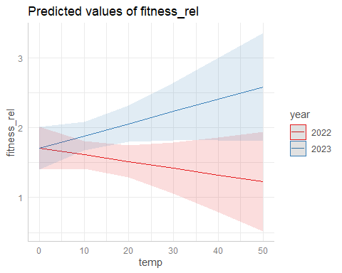

plot(ggpredict(model_phensel_LFD_f,terms=c("temp","year")))

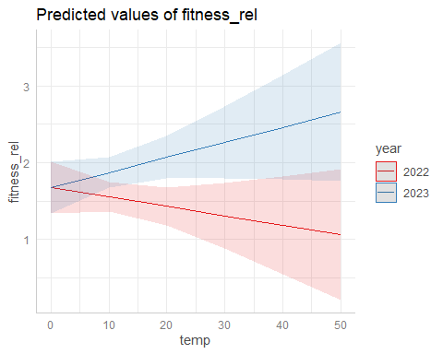

plot(ggpredict(model_phensel_MeanFD_f,terms=c("temp","year")))

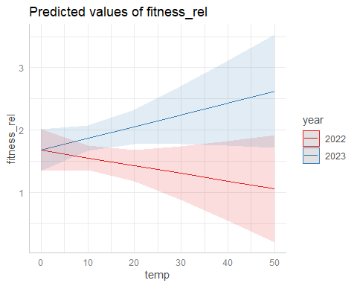

Fitness decreases with temperature in 2022 and increases in 2023.

(Significantly higher temperatures in 2022: summary(lm(temp~year,data_transplants)))

#### Boostrappred confidence intervals

confint(b_model_phensel_FFD_f,level=0.95, method="boot") # Percentile method

## 2.5 % 97.5 %  
## (Intercept) 1.04162792 1.71539929  
## FFD_std -0.42129805 0.15253622  
## temp -0.02883763 0.01080469  
## n_fl_std 0.39027344 0.58716599  
## FFD_std:temp -0.01715061 0.01715037  
## FFD_std:year2023 -0.29727523 0.34370363  
## temp:year2023 0.01597074 0.03822273  
## FFD_std:temp:year2023 -0.02508068 0.01436022

confint(b_model_phensel_LFD_f,level=0.95, method="boot") # Percentile method

## 2.5 % 97.5 %  
## (Intercept) 1.01233187 1.74923945  
## LFD_std -0.42775484 0.26472924  
## temp -0.03578483 0.01047655  
## n_fl_std 0.36704888 0.61871281  
## LFD_std:temp -0.02194305 0.01738589  
## LFD_std:year2023 -0.41326058 0.39198998  
## temp:year2023 0.01812009 0.04464708  
## LFD_std:temp:year2023 -0.02679212 0.02086489

confint(b_model_phensel_MeanFD_f,level=0.95, method="boot") # Percentile method

## 2.5 % 97.5 %  
## (Intercept) 1.00257201 1.74834277  
## MeanFD_std -0.40923547 0.29634312  
## temp -0.03607836 0.01142662  
## n_fl_std 0.36983790 0.63604836  
## MeanFD_std:temp -0.02429846 0.01979345  
## MeanFD_std:year2023 -0.45924245 0.40324063  
## temp:year2023 0.01734883 0.04507547  
## MeanFD_std:temp:year2023 -0.02757636 0.02194392

#### Bootstrapped mdoels as before - DO?

### With median h as condition trait

model_phensel_FFD_h<-lmer(fitness_rel~FFD_std*temp+FFD_std:year+temp:year+  
 FFD_std:temp:year+median_h_std+(1|unique_id)+  
 (1|plot),data_transplants)  
model_phensel_LFD_h<-lmer(fitness_rel~LFD_std*temp+LFD_std:year+temp:year+  
 LFD_std:temp:year+median_h_std+(1|unique_id)+  
 (1|plot),data_transplants)  
model_phensel_MeanFD_h<-lmer(fitness_rel~MeanFD_std*temp+MeanFD_std:year+  
 temp:year+MeanFD_std:temp:year+median_h_std+  
 (1|unique_id)+(1|plot),data_transplants)  
summary(model_phensel_FFD_h)

## Linear mixed model fit by REML. t-tests use Satterthwaite's method [  
## lmerModLmerTest]  
## Formula:   
## fitness_rel ~ FFD_std * temp + FFD_std:year + temp:year + FFD_std:temp:year +   
## median_h_std + (1 | unique_id) + (1 | plot)  
## Data: data_transplants  
##   
## REML criterion at convergence: 2954.9  
##   
## Scaled residuals:   
## Min 1Q Median 3Q Max   
## -2.7587 -0.5735 0.0084 0.5453 3.2986   
##   
## Random effects:  
## Groups Name Variance Std.Dev.  
## unique_id (Intercept) 0.23440 0.4841   
## plot (Intercept) 0.09917 0.3149   
## Residual 0.83295 0.9127   
## Number of obs: 1003, groups: unique_id, 708; plot, 8  
##   
## Fixed effects:  
## Estimate Std. Error df t value Pr(>|t|)   
## (Intercept) 1.782766 0.182930 16.495117 9.746 2.98e-08 ***  
## FFD_std -0.375466 0.153118 144.590697 -2.452 0.0154 *   
## temp -0.018354 0.010130 90.807914 -1.812 0.0733 .   
## median_h_std 0.208240 0.036695 981.219464 5.675 1.83e-08 ***  
## FFD_std:temp -0.006144 0.009150 218.742625 -0.671 0.5026   
## FFD_std:year2023 0.146884 0.167023 684.359613 0.879 0.3795   
## temp:year2023 0.025426 0.005990 745.465664 4.245 2.46e-05 ***  
## FFD_std:temp:year2023 -0.005724 0.010194 701.273360 -0.562 0.5746   
## ---  
## Signif. codes: 0 '***' 0.001 '**' 0.01 '*' 0.05 '.' 0.1 ' ' 1  
##   
## Correlation of Fixed Effects:  
## (Intr) FFD_st temp mdn_h_ FFD_s: FFD_:2 t:2023  
## FFD_std 0.387   
## temp -0.722 -0.696   
## medin_h_std -0.051 0.009 0.043   
## FFD_std:tmp -0.468 -0.928 0.799 0.027   
## FFD_st:2023 -0.244 -0.674 0.443 0.053 0.660   
## temp:yr2023 0.016 0.423 -0.241 -0.073 -0.432 -0.549   
## FFD_s::2023 0.244 0.647 -0.480 -0.024 -0.701 -0.915 0.684

summary(model_phensel_LFD_h)

## Linear mixed model fit by REML. t-tests use Satterthwaite's method [  
## lmerModLmerTest]  
## Formula:   
## fitness_rel ~ LFD_std * temp + LFD_std:year + temp:year + LFD_std:temp:year +   
## median_h_std + (1 | unique_id) + (1 | plot)  
## Data: data_transplants  
##   
## REML criterion at convergence: 1810.4  
##   
## Scaled residuals:   
## Min 1Q Median 3Q Max   
## -2.53401 -0.52810 0.01646 0.51881 2.77306   
##   
## Random effects:  
## Groups Name Variance Std.Dev.  
## unique_id (Intercept) 0.36579 0.6048   
## plot (Intercept) 0.06594 0.2568   
## Residual 0.70604 0.8403   
## Number of obs: 611, groups: unique_id, 491; plot, 8  
##   
## Fixed effects:  
## Estimate Std. Error df t value Pr(>|t|)   
## (Intercept) 1.794097 0.197968 18.794197 9.063 2.75e-08 ***  
## LFD_std -0.403438 0.186489 98.283188 -2.163 0.032940 *   
## temp -0.025396 0.012234 46.894518 -2.076 0.043408 *   
## median_h_std 0.175417 0.046847 591.561446 3.744 0.000198 ***  
## LFD_std:temp -0.004077 0.011201 150.384620 -0.364 0.716396   
## LFD_std:year2023 0.180187 0.216606 447.026776 0.832 0.405929   
## temp:year2023 0.035312 0.007084 446.496468 4.985 8.90e-07 ***  
## LFD_std:temp:year2023 -0.004746 0.012969 502.011501 -0.366 0.714540   
## ---  
## Signif. codes: 0 '***' 0.001 '**' 0.01 '*' 0.05 '.' 0.1 ' ' 1  
##   
## Correlation of Fixed Effects:  
## (Intr) LFD_st temp mdn_h_ LFD_s: LFD_:2 t:2023  
## LFD_std 0.359   
## temp -0.804 -0.623   
## medin_h_std -0.084 -0.011 0.067   
## LFD_std:tmp -0.459 -0.925 0.747 0.034   
## LFD_st:2023 -0.232 -0.702 0.411 0.023 0.676   
## temp:yr2023 -0.002 0.403 -0.231 -0.070 -0.439 -0.531   
## LFD_s::2023 0.225 0.653 -0.438 0.006 -0.709 -0.916 0.655

summary(model_phensel_MeanFD_h)

## Linear mixed model fit by REML. t-tests use Satterthwaite's method [  
## lmerModLmerTest]  
## Formula: fitness_rel ~ MeanFD_std * temp + MeanFD_std:year + temp:year +   
## MeanFD_std:temp:year + median_h_std + (1 | unique_id) + (1 | plot)  
## Data: data_transplants  
##   
## REML criterion at convergence: 1810.7  
##   
## Scaled residuals:   
## Min 1Q Median 3Q Max   
## -2.52743 -0.51401 0.01055 0.52500 2.78019   
##   
## Random effects:  
## Groups Name Variance Std.Dev.  
## unique_id (Intercept) 0.36918 0.6076   
## plot (Intercept) 0.06439 0.2537   
## Residual 0.70376 0.8389   
## Number of obs: 611, groups: unique_id, 491; plot, 8  
##   
## Fixed effects:  
## Estimate Std. Error df t value Pr(>|t|)   
## (Intercept) 1.813615 0.197528 19.009214 9.182 2.04e-08 ***  
## MeanFD_std -0.380198 0.186501 93.660821 -2.039 0.04431 *   
## temp -0.026985 0.012250 45.784782 -2.203 0.03268 *   
## median_h_std 0.173820 0.046897 591.391514 3.706 0.00023 ***  
## MeanFD_std:temp -0.005628 0.011214 145.063205 -0.502 0.61650   
## MeanFD_std:year2023 0.195236 0.216825 448.972745 0.900 0.36837   
## temp:year2023 0.035001 0.007111 448.544854 4.922 1.21e-06 ***  
## MeanFD_std:temp:year2023 -0.005461 0.013014 503.207508 -0.420 0.67493   
## ---  
## Signif. codes: 0 '***' 0.001 '**' 0.01 '*' 0.05 '.' 0.1 ' ' 1  
##   
## Correlation of Fixed Effects:  
## (Intr) MnFD_s temp mdn_h_ MnFD_: MFD_:2 t:2023  
## MeanFD_std 0.360   
## temp -0.806 -0.624   
## medin_h_std -0.088 -0.014 0.072   
## MnFD_std:tm -0.462 -0.925 0.749 0.039   
## MnFD_s:2023 -0.233 -0.695 0.410 0.026 0.671   
## temp:yr2023 -0.001 0.402 -0.232 -0.070 -0.440 -0.534   
## MnFD_::2023 0.227 0.648 -0.439 0.003 -0.706 -0.917 0.658

plot(ggpredict(model_phensel_FFD_h,terms=c("temp","year")))

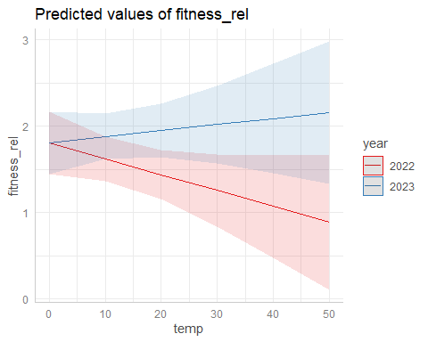

plot(ggpredict(model_phensel_LFD_h,terms=c("temp","year")))

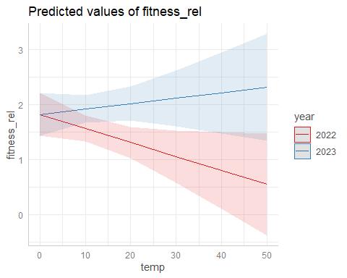

plot(ggpredict(model_phensel_MeanFD_h,terms=c("temp","year")))

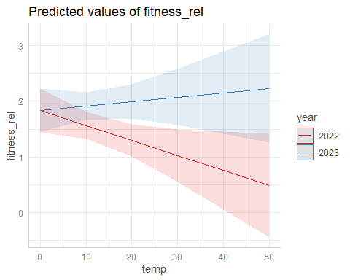

Fitness decreases with temperature in 2022 and increases in 2023.

(Significantly higher temperatures in 2022: summary(lm(temp~year,data_transplants)))

#### DO: Boostrappred confidence intervals

#### Bootstrapped mdoels as before - DO?

### With no condition trait

model_phensel_FFD<-lmer(fitness_rel~FFD_std*temp+FFD_std:year+temp:year+  
 FFD_std:temp:year+(1|unique_id)+(1|plot),  
 data_transplants)  
model_phensel_LFD<-lmer(fitness_rel~LFD_std*temp+LFD_std:year+temp:year+  
 LFD_std:temp:year+(1|unique_id)+(1|plot),  
 data_transplants)  
model_phensel_MeanFD<-lmer(fitness_rel~MeanFD_std*temp+MeanFD_std:year+  
 temp:year+MeanFD_std:temp:year+  
 (1|unique_id)+(1|plot),data_transplants)  
summary(model_phensel_FFD)

## Linear mixed model fit by REML. t-tests use Satterthwaite's method [  
## lmerModLmerTest]  
## Formula:   
## fitness_rel ~ FFD_std * temp + FFD_std:year + temp:year + FFD_std:temp:year +   
## (1 | unique_id) + (1 | plot)  
## Data: data_transplants  
##   
## REML criterion at convergence: 3016  
##   
## Scaled residuals:   
## Min 1Q Median 3Q Max   
## -2.5263 -0.5854 0.0135 0.5289 3.6667   
##   
## Random effects:  
## Groups Name Variance Std.Dev.  
## unique_id (Intercept) 0.2723 0.5218   
## plot (Intercept) 0.1710 0.4136   
## Residual 0.8410 0.9171   
## Number of obs: 1011, groups: unique_id, 712; plot, 8  
##   
## Fixed effects:  
## Estimate Std. Error df t value Pr(>|t|)   
## (Intercept) 1.779277 0.212162 14.471711 8.386 6.21e-07 ***  
## FFD_std -0.446110 0.160776 240.207202 -2.775 0.00596 **   
## temp -0.017485 0.010782 155.520408 -1.622 0.10688   
## FFD_std:temp -0.004556 0.009548 338.415238 -0.477 0.63356   
## FFD_std:year2023 0.082706 0.169021 713.591482 0.489 0.62476   
## temp:year2023 0.027097 0.006078 751.358915 4.458 9.52e-06 ***  
## FFD_std:temp:year2023 -0.003133 0.010325 751.674681 -0.303 0.76165   
## ---  
## Signif. codes: 0 '***' 0.001 '**' 0.01 '*' 0.05 '.' 0.1 ' ' 1  
##   
## Correlation of Fixed Effects:  
## (Intr) FFD_st temp FFD_s: FFD_:2 t:2023  
## FFD_std 0.380   
## temp -0.664 -0.720   
## FFD_std:tmp -0.443 -0.933 0.809   
## FFD_st:2023 -0.233 -0.677 0.452 0.663   
## temp:yr2023 0.028 0.433 -0.252 -0.438 -0.556   
## FFD_s::2023 0.233 0.654 -0.488 -0.705 -0.916 0.693

summary(model_phensel_LFD)

## Linear mixed model fit by REML. t-tests use Satterthwaite's method [  
## lmerModLmerTest]  
## Formula:   
## fitness_rel ~ LFD_std * temp + LFD_std:year + temp:year + LFD_std:temp:year +   
## (1 | unique_id) + (1 | plot)  
## Data: data_transplants  
##   
## REML criterion at convergence: 1832.1  
##   
## Scaled residuals:   
## Min 1Q Median 3Q Max   
## -2.29179 -0.53289 -0.00088 0.49890 2.78091   
##   
## Random effects:  
## Groups Name Variance Std.Dev.  
## unique_id (Intercept) 0.41263 0.6424   
## plot (Intercept) 0.08915 0.2986   
## Residual 0.69673 0.8347   
## Number of obs: 613, groups: unique_id, 492; plot, 8  
##   
## Fixed effects:  
## Estimate Std. Error df t value Pr(>|t|)   
## (Intercept) 1.866e+00 2.115e-01 1.840e+01 8.821 4.96e-08 ***  
## LFD_std -3.997e-01 1.928e-01 1.120e+02 -2.073 0.0405 *   
## temp -2.969e-02 1.276e-02 5.343e+01 -2.326 0.0238 *   
## LFD_std:temp -6.315e-03 1.152e-02 1.673e+02 -0.548 0.5842   
## LFD_std:year2023 1.043e-01 2.179e-01 4.488e+02 0.479 0.6322   
## temp:year2023 3.714e-02 7.130e-03 4.362e+02 5.208 2.95e-07 ***  
## LFD_std:temp:year2023 -7.079e-07 1.297e-02 5.003e+02 0.000 1.0000   
## ---  
## Signif. codes: 0 '***' 0.001 '**' 0.01 '*' 0.05 '.' 0.1 ' ' 1  
##   
## Correlation of Fixed Effects:  
## (Intr) LFD_st temp LFD_s: LFD_:2 t:2023  
## LFD_std 0.376   
## temp -0.788 -0.642   
## LFD_std:tmp -0.461 -0.929 0.753   
## LFD_st:2023 -0.232 -0.703 0.414 0.676   
## temp:yr2023 0.002 0.405 -0.230 -0.441 -0.538   
## LFD_s::2023 0.223 0.656 -0.438 -0.711 -0.916 0.668

summary(model_phensel_MeanFD)

## Linear mixed model fit by REML. t-tests use Satterthwaite's method [  
## lmerModLmerTest]  
## Formula: fitness_rel ~ MeanFD_std * temp + MeanFD_std:year + temp:year +   
## MeanFD_std:temp:year + (1 | unique_id) + (1 | plot)  
## Data: data_transplants  
##   
## REML criterion at convergence: 1832.1  
##   
## Scaled residuals:   
## Min 1Q Median 3Q Max   
## -2.28632 -0.52300 0.00917 0.50460 2.78993   
##   
## Random effects:  
## Groups Name Variance Std.Dev.  
## unique_id (Intercept) 0.41609 0.6450   
## plot (Intercept) 0.08685 0.2947   
## Residual 0.69416 0.8332   
## Number of obs: 613, groups: unique_id, 492; plot, 8  
##   
## Fixed effects:  
## Estimate Std. Error df t value Pr(>|t|)   
## (Intercept) 1.890e+00 2.108e-01 1.854e+01 8.966 3.64e-08 ***  
## MeanFD_std -3.728e-01 1.929e-01 1.058e+02 -1.932 0.0560 .   
## temp -3.164e-02 1.277e-02 5.146e+01 -2.477 0.0166 *   
## MeanFD_std:temp -8.201e-03 1.153e-02 1.598e+02 -0.711 0.4778   
## MeanFD_std:year2023 1.123e-01 2.178e-01 4.476e+02 0.516 0.6064   
## temp:year2023 3.694e-02 7.156e-03 4.381e+02 5.162 3.72e-07 ***  
## MeanFD_std:temp:year2023 -2.404e-04 1.299e-02 4.986e+02 -0.019 0.9852   
## ---  
## Signif. codes: 0 '***' 0.001 '**' 0.01 '*' 0.05 '.' 0.1 ' ' 1  
##   
## Correlation of Fixed Effects:  
## (Intr) MnFD_s temp MnFD_: MFD_:2 t:2023  
## MeanFD_std 0.377   
## temp -0.790 -0.643   
## MnFD_std:tm -0.463 -0.928 0.755   
## MnFD_s:2023 -0.233 -0.695 0.412 0.672   
## temp:yr2023 0.003 0.404 -0.230 -0.441 -0.540   
## MnFD_::2023 0.225 0.651 -0.438 -0.708 -0.917 0.670

plot(ggpredict(model_phensel_FFD,terms=c("temp","year")))

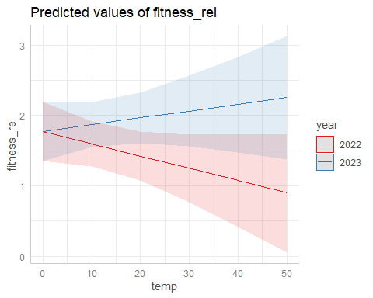

plot(ggpredict(model_phensel_LFD,terms=c("temp","year")))

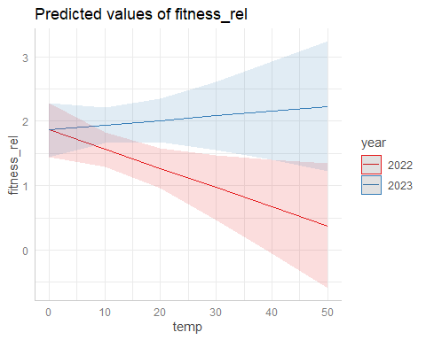

plot(ggpredict(model_phensel_MeanFD,terms=c("temp","year")))

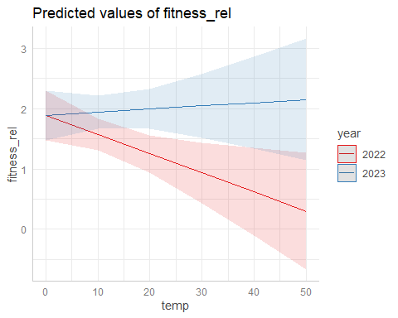

Fitness decreases with temperature in 2022 and increases in 2023.

(Significantly higher temperatures in 2022: summary(lm(temp~year,data_transplants)))

#### DO: Boostrappred confidence intervals

#### Bootstrapped mdoels as before - DO?

## Yearly models

### 2022

#### With n flowers as condition trait

model_phensel_22_FFD_f<-lmer(fitness_rel~FFD_std*temp+n_fl_std+  
 (1|plot),subset(data_transplants,year==2022))  
model_phensel_22_LFD_f<-lmer(fitness_rel~LFD_std*temp++n_fl_std+  
 (1|plot),subset(data_transplants,year==2022))  
model_phensel_22_MeanFD_f<-lmer(fitness_rel~MeanFD_std*temp+n_fl_std+  
 (1|plot),  
 subset(data_transplants,year==2022))  
# Is this what we want to test?  
summary(model_phensel_22_FFD_f)

## Linear mixed model fit by REML. t-tests use Satterthwaite's method [  
## lmerModLmerTest]  
## Formula: fitness_rel ~ FFD_std * temp + n_fl_std + (1 | plot)  
## Data: subset(data_transplants, year == 2022)  
##   
## REML criterion at convergence: 1186.1  
##   
## Scaled residuals:   
## Min 1Q Median 3Q Max   
## -2.59732 -0.73781 0.03009 0.77176 2.55106   
##   
## Random effects:  
## Groups Name Variance Std.Dev.  
## plot (Intercept) 0.004546 0.06742   
## Residual 0.398762 0.63148   
## Number of obs: 602, groups: plot, 8  
##   
## Fixed effects:  
## Estimate Std. Error df t value Pr(>|t|)   
## (Intercept) 1.205e+00 1.334e-01 2.073e+02 9.038 <2e-16 ***  
## FFD_std 1.981e-02 8.061e-02 2.464e+01 0.246 0.808   
## temp -5.628e-04 7.766e-03 2.789e+02 -0.072 0.942   
## n_fl_std 4.247e-01 4.162e-02 5.890e+02 10.202 <2e-16 ***  
## FFD_std:temp -2.225e-03 5.708e-03 1.415e+02 -0.390 0.697   
## ---  
## Signif. codes: 0 '***' 0.001 '**' 0.01 '*' 0.05 '.' 0.1 ' ' 1  
##   
## Correlation of Fixed Effects:  
## (Intr) FFD_st temp n_fl_s  
## FFD_std 0.138   
## temp -0.933 -0.338   
## n_fl_std -0.375 -0.034 0.274   
## FFD_std:tmp -0.618 -0.782 0.778 0.301

summary(model_phensel_22_LFD_f)

## Linear mixed model fit by REML. t-tests use Satterthwaite's method [  
## lmerModLmerTest]  
## Formula: fitness_rel ~ LFD_std * temp + +n_fl_std + (1 | plot)  
## Data: subset(data_transplants, year == 2022)  
##   
## REML criterion at convergence: 708.4  
##   
## Scaled residuals:   
## Min 1Q Median 3Q Max   
## -2.53631 -0.73798 0.05488 0.76637 2.63458   
##   
## Random effects:  
## Groups Name Variance Std.Dev.  
## plot (Intercept) 0.002392 0.04891   
## Residual 0.382769 0.61868   
## Number of obs: 363, groups: plot, 8  
##   
## Fixed effects:  
## Estimate Std. Error df t value Pr(>|t|)   
## (Intercept) 1.250769 0.159222 127.029573 7.855 1.46e-12 ***  
## LFD_std 0.020001 0.096954 22.260573 0.206 0.838   
## temp -0.005574 0.009727 185.036718 -0.573 0.567   
## n_fl_std 0.468756 0.052240 354.105257 8.973 < 2e-16 ***  
## LFD_std:temp -0.002910 0.006758 114.589219 -0.431 0.668   
## ---  
## Signif. codes: 0 '***' 0.001 '**' 0.01 '*' 0.05 '.' 0.1 ' ' 1  
##   
## Correlation of Fixed Effects:  
## (Intr) LFD_st temp n_fl_s  
## LFD_std 0.050   
## temp -0.944 -0.247   
## n_fl_std -0.364 0.041 0.256   
## LFD_std:tmp -0.560 -0.783 0.726 0.224

summary(model_phensel_22_MeanFD_f)

## Linear mixed model fit by REML. t-tests use Satterthwaite's method [  
## lmerModLmerTest]  
## Formula: fitness_rel ~ MeanFD_std * temp + n_fl_std + (1 | plot)  
## Data: subset(data_transplants, year == 2022)  
##   
## REML criterion at convergence: 708.5  
##   
## Scaled residuals:   
## Min 1Q Median 3Q Max   
## -2.54255 -0.74056 0.06481 0.77370 2.63282   
##   
## Random effects:  
## Groups Name Variance Std.Dev.  
## plot (Intercept) 0.002221 0.04713   
## Residual 0.382972 0.61885   
## Number of obs: 363, groups: plot, 8  
##   
## Fixed effects:  
## Estimate Std. Error df t value Pr(>|t|)   
## (Intercept) 1.219975 0.161669 121.990613 7.546 8.95e-12 ***  
## MeanFD_std 0.027902 0.096337 22.153609 0.290 0.775   
## temp -0.003806 0.009883 179.499848 -0.385 0.701   
## n_fl_std 0.473440 0.052686 353.582873 8.986 < 2e-16 ***  
## MeanFD_std:temp -0.002357 0.006823 114.807141 -0.345 0.730   
## ---  
## Signif. codes: 0 '***' 0.001 '**' 0.01 '*' 0.05 '.' 0.1 ' ' 1  
##   
## Correlation of Fixed Effects:  
## (Intr) MnFD_s temp n_fl_s  
## MeanFD_std 0.056   
## temp -0.946 -0.248   
## n_fl_std -0.382 0.028 0.278   
## MnFD_std:tm -0.574 -0.778 0.734 0.248

No interaction (no temperature-dependent selection). No selection on phenology.

#### With median h as condition trait

model_phensel_22_FFD_h<-lmer(fitness_rel~FFD_std*temp+median_h_std+  
 (1|plot),subset(data_transplants,year==2022))  
model_phensel_22_LFD_h<-lmer(fitness_rel~LFD_std*temp++median_h_std+  
 (1|plot),subset(data_transplants,year==2022))  
model_phensel_22_MeanFD_h<-lmer(fitness_rel~MeanFD_std*temp+median_h_std+  
 (1|plot),  
 subset(data_transplants,year==2022))  
# Is this what we want to test?  
summary(model_phensel_22_FFD_h)

## Linear mixed model fit by REML. t-tests use Satterthwaite's method [  
## lmerModLmerTest]  
## Formula: fitness_rel ~ FFD_std * temp + median_h_std + (1 | plot)  
## Data: subset(data_transplants, year == 2022)  
##   
## REML criterion at convergence: 1236.5  
##   
## Scaled residuals:   
## Min 1Q Median 3Q Max   
## -2.49299 -0.69761 0.05529 0.74193 3.06804   
##   
## Random effects:  
## Groups Name Variance Std.Dev.  
## plot (Intercept) 0.003798 0.06163   
## Residual 0.441109 0.66416   
## Number of obs: 597, groups: plot, 8  
##   
## Fixed effects:  
## Estimate Std. Error df t value Pr(>|t|)   
## (Intercept) 1.741367 0.128733 114.792800 13.527 < 2e-16 ***  
## FFD_std 0.019555 0.082807 18.663192 0.236 0.81589   
## temp -0.022753 0.007797 193.880668 -2.918 0.00394 **   
## median_h_std 0.121703 0.027943 509.841851 4.355 1.61e-05 ***  
## FFD_std:temp -0.019048 0.005666 90.026749 -3.362 0.00114 **   
## ---  
## Signif. codes: 0 '***' 0.001 '**' 0.01 '*' 0.05 '.' 0.1 ' ' 1  
##   
## Correlation of Fixed Effects:  
## (Intr) FFD_st temp mdn_h_  
## FFD_std 0.124   
## temp -0.935 -0.328   
## medin_h_std 0.008 -0.084 -0.001   
## FFD_std:tmp -0.573 -0.806 0.755 0.040

summary(model_phensel_22_LFD_h)

## Linear mixed model fit by REML. t-tests use Satterthwaite's method [  
## lmerModLmerTest]  
## Formula: fitness_rel ~ LFD_std * temp + +median_h_std + (1 | plot)  
## Data: subset(data_transplants, year == 2022)  
##   
## REML criterion at convergence: 767.6  
##   
## Scaled residuals:   
## Min 1Q Median 3Q Max   
## -2.51251 -0.70988 0.09645 0.82003 2.14249   
##   
## Random effects:  
## Groups Name Variance Std.Dev.  
## plot (Intercept) 0.0000 0.0000   
## Residual 0.4546 0.6742   
## Number of obs: 362, groups: plot, 8  
##   
## Fixed effects:  
## Estimate Std. Error df t value Pr(>|t|)   
## (Intercept) 1.772846 0.156832 357.000000 11.304 < 2e-16 ***  
## LFD_std -0.036788 0.099428 357.000000 -0.370 0.71160   
## temp -0.027964 0.010049 357.000000 -2.783 0.00568 **   
## median_h_std 0.100338 0.035122 357.000000 2.857 0.00453 **   
## LFD_std:temp -0.016057 0.006988 357.000000 -2.298 0.02214 *   
## ---  
## Signif. codes: 0 '***' 0.001 '**' 0.01 '*' 0.05 '.' 0.1 ' ' 1  
##   
## Correlation of Fixed Effects:  
## (Intr) LFD_st temp mdn_h_  
## LFD_std 0.051   
## temp -0.953 -0.245   
## medin_h_std -0.004 -0.100 0.001   
## LFD_std:tmp -0.532 -0.808 0.709 0.032  
## optimizer (nloptwrap) convergence code: 0 (OK)  
## boundary (singular) fit: see help('isSingular')

summary(model_phensel_22_MeanFD_h)

## Linear mixed model fit by REML. t-tests use Satterthwaite's method [  
## lmerModLmerTest]  
## Formula: fitness_rel ~ MeanFD_std * temp + median_h_std + (1 | plot)  
## Data: subset(data_transplants, year == 2022)  
##   
## REML criterion at convergence: 768.1  
##   
## Scaled residuals:   
## Min 1Q Median 3Q Max   
## -2.37559 -0.72397 0.09251 0.82920 2.14424   
##   
## Random effects:  
## Groups Name Variance Std.Dev.   
## plot (Intercept) 1.782e-21 4.221e-11  
## Residual 4.552e-01 6.747e-01  
## Number of obs: 362, groups: plot, 8  
##   
## Fixed effects:  
## Estimate Std. Error df t value Pr(>|t|)   
## (Intercept) 1.774508 0.158214 357.000000 11.216 < 2e-16 ***  
## MeanFD_std -0.020681 0.099291 357.000000 -0.208 0.83512   
## temp -0.028383 0.010153 357.000000 -2.796 0.00546 **   
## median_h_std 0.099443 0.035150 357.000000 2.829 0.00493 **   
## MeanFD_std:temp -0.016953 0.007025 357.000000 -2.413 0.01632 *   
## ---  
## Signif. codes: 0 '***' 0.001 '**' 0.01 '*' 0.05 '.' 0.1 ' ' 1  
##   
## Correlation of Fixed Effects:  
## (Intr) MnFD_s temp mdn_h_  
## MeanFD_std 0.055   
## temp -0.953 -0.247   
## medin_h_std -0.005 -0.102 0.002   
## MnFD_std:tm -0.539 -0.806 0.714 0.034  
## optimizer (nloptwrap) convergence code: 0 (OK)  
## boundary (singular) fit: see help('isSingular')

plot(ggpredict(model_phensel_22_FFD_h,terms=c("FFD_std","temp[quart]")))

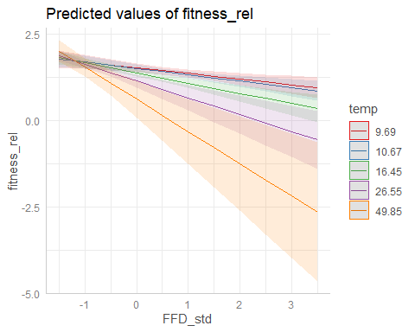

plot(ggpredict(model_phensel_22_LFD_h,terms=c("LFD_std","temp[quart]")))

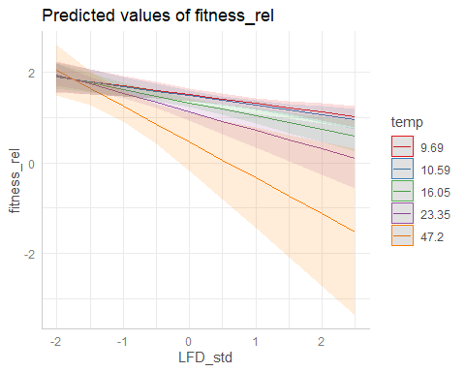

plot(ggpredict(model_phensel_22_MeanFD_h,terms=c("MeanFD_std","temp[quart]")))

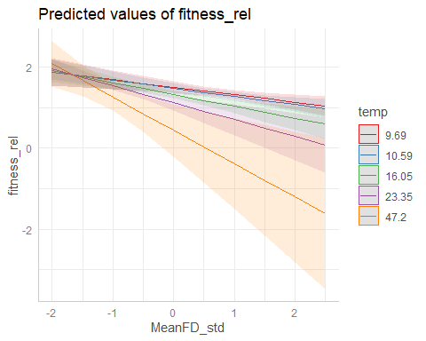

Significant interaction (temperature-dependent selection).

Predicted: Selection favors an earlier phenology at low soil temperatures but a later phenology at high temperatures.

But we found that selection always favors an earlier phenology, and that selection for earlier phenology is stronger at warmer temperatures (opposite to our prediction!).

#### With no condition trait

model_phensel_22_FFD<-lmer(fitness_rel~FFD_std*temp+  
 (1|plot),subset(data_transplants,year==2022))  
model_phensel_22_LFD<-lmer(fitness_rel~LFD_std*temp+  
 (1|plot),subset(data_transplants,year==2022))  
model_phensel_22_MeanFD<-lmer(fitness_rel~MeanFD_std*temp+  
 (1|plot),  
 subset(data_transplants,year==2022))  
# Is this what we want to test?  
summary(model_phensel_22_FFD)

## Linear mixed model fit by REML. t-tests use Satterthwaite's method [  
## lmerModLmerTest]  
## Formula: fitness_rel ~ FFD_std * temp + (1 | plot)  
## Data: subset(data_transplants, year == 2022)  
##   
## REML criterion at convergence: 1277.7  
##   
## Scaled residuals:   
## Min 1Q Median 3Q Max   
## -2.64635 -0.68679 0.07061 0.76308 2.97105   
##   
## Random effects:  
## Groups Name Variance Std.Dev.  
## plot (Intercept) 0.004286 0.06547   
## Residual 0.467863 0.68401   
## Number of obs: 602, groups: plot, 8  
##   
## Fixed effects:  
## Estimate Std. Error df t value Pr(>|t|)   
## (Intercept) 1.718035 0.132776 91.212557 12.939 < 2e-16 ***  
## FFD_std 0.053159 0.085239 13.828577 0.624 0.54301   
## temp -0.022490 0.008039 158.124633 -2.798 0.00579 **   
## FFD_std:temp -0.019940 0.005836 70.013089 -3.417 0.00106 **   
## ---  
## Signif. codes: 0 '***' 0.001 '**' 0.01 '*' 0.05 '.' 0.1 ' ' 1  
##   
## Correlation of Fixed Effects:  
## (Intr) FFD_st temp   
## FFD_std 0.127   
## temp -0.935 -0.332   
## FFD_std:tmp -0.574 -0.807 0.756

summary(model_phensel_22_LFD)

## Linear mixed model fit by REML. t-tests use Satterthwaite's method [  
## lmerModLmerTest]  
## Formula: fitness_rel ~ LFD_std * temp + (1 | plot)  
## Data: subset(data_transplants, year == 2022)  
##   
## REML criterion at convergence: 776.5  
##   
## Scaled residuals:   
## Min 1Q Median 3Q Max   
## -2.6990 -0.7279 0.1107 0.7695 2.1256   
##   
## Random effects:  
## Groups Name Variance Std.Dev.  
## plot (Intercept) 0.0000 0.0000   
## Residual 0.4683 0.6843   
## Number of obs: 363, groups: plot, 8  
##   
## Fixed effects:  
## Estimate Std. Error df t value Pr(>|t|)   
## (Intercept) 1.771e+00 1.592e-01 3.590e+02 11.124 < 2e-16 ***  
## LFD_std -2.244e-04 1.003e-01 3.590e+02 -0.002 0.99822   
## temp -2.810e-02 1.020e-02 3.590e+02 -2.755 0.00617 **   
## LFD_std:temp -1.701e-02 7.087e-03 3.590e+02 -2.400 0.01693 *   
## ---  
## Signif. codes: 0 '***' 0.001 '**' 0.01 '*' 0.05 '.' 0.1 ' ' 1  
##   
## Correlation of Fixed Effects:  
## (Intr) LFD_st temp   
## LFD_std 0.051   
## temp -0.953 -0.246   
## LFD_std:tmp -0.532 -0.809 0.709  
## optimizer (nloptwrap) convergence code: 0 (OK)  
## boundary (singular) fit: see help('isSingular')

summary(model_phensel_22_MeanFD)

## Linear mixed model fit by REML. t-tests use Satterthwaite's method [  
## lmerModLmerTest]  
## Formula: fitness_rel ~ MeanFD_std * temp + (1 | plot)  
## Data: subset(data_transplants, year == 2022)  
##   
## REML criterion at convergence: 776.8  
##   
## Scaled residuals:   
## Min 1Q Median 3Q Max   
## -2.5293 -0.7267 0.1151 0.7874 2.1034   
##   
## Random effects:  
## Groups Name Variance Std.Dev.  
## plot (Intercept) 0.0000 0.0000   
## Residual 0.4687 0.6846   
## Number of obs: 363, groups: plot, 8  
##   
## Fixed effects:  
## Estimate Std. Error df t value Pr(>|t|)   
## (Intercept) 1.772038 0.160535 359.000000 11.038 < 2e-16 ***  
## MeanFD_std 0.015986 0.100162 359.000000 0.160 0.87328   
## temp -0.028509 0.010303 359.000000 -2.767 0.00595 **   
## MeanFD_std:temp -0.017910 0.007124 359.000000 -2.514 0.01237 *   
## ---  
## Signif. codes: 0 '***' 0.001 '**' 0.01 '*' 0.05 '.' 0.1 ' ' 1  
##   
## Correlation of Fixed Effects:  
## (Intr) MnFD_s temp   
## MeanFD_std 0.055   
## temp -0.954 -0.249   
## MnFD_std:tm -0.540 -0.807 0.714  
## optimizer (nloptwrap) convergence code: 0 (OK)  
## boundary (singular) fit: see help('isSingular')

plot(ggpredict(model_phensel_22_FFD,terms=c("FFD_std","temp[quart]")))

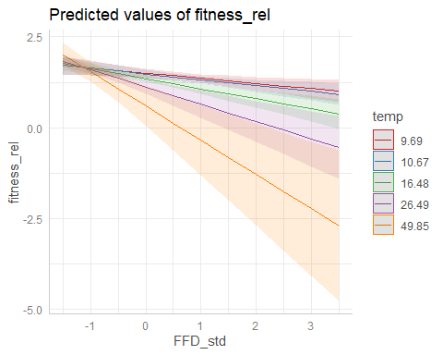

plot(ggpredict(model_phensel_22_LFD,terms=c("LFD_std","temp[quart]")))

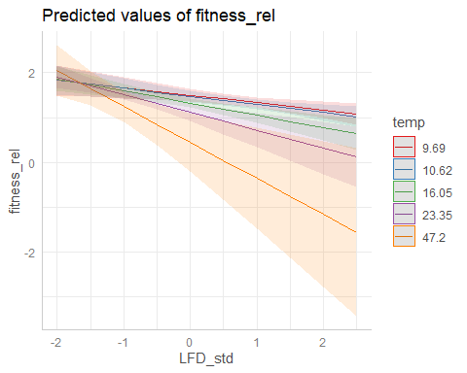

plot(ggpredict(model_phensel_22_MeanFD,terms=c("MeanFD_std","temp[quart]")))

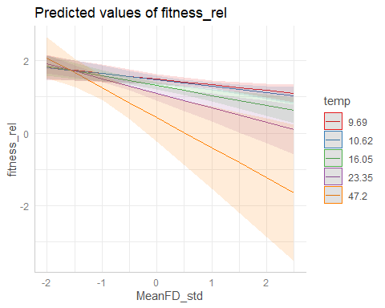

Significant interaction (temperature-dependent selection).

Predicted: Selection favors an earlier phenology at low soil temperatures but a later phenology at high temperatures.

But we found that selection always favors an earlier phenology, and that selection for earlier phenology is stronger at warmer temperatures (opposite to our prediction!).

### 2023

#### With n flowers as condition trait

model_phensel_23_FFD_f<-lmer(fitness_rel~FFD_std*temp+n_fl_std+  
 (1|plot),subset(data_transplants,year==2023))  
model_phensel_23_LFD_f<-lmer(fitness_rel~LFD_std*temp++n_fl_std+  
 (1|plot),subset(data_transplants,year==2023))  
model_phensel_23_MeanFD_f<-lmer(fitness_rel~MeanFD_std*temp+n_fl_std+  
 (1|plot),  
 subset(data_transplants,year==2023))  
# Is this what we want to test?  
summary(model_phensel_23_FFD_f)

## Linear mixed model fit by REML. t-tests use Satterthwaite's method [  
## lmerModLmerTest]  
## Formula: fitness_rel ~ FFD_std * temp + n_fl_std + (1 | plot)  
## Data: subset(data_transplants, year == 2023)  
##   
## REML criterion at convergence: 1433.7  
##   
## Scaled residuals:   
## Min 1Q Median 3Q Max   
## -3.0177 -0.7933 -0.1090 0.7692 2.7109   
##   
## Random effects:  
## Groups Name Variance Std.Dev.  
## plot (Intercept) 0.1785 0.4224   
## Residual 1.8204 1.3492   
## Number of obs: 409, groups: plot, 7  
##   
## Fixed effects:  
## Estimate Std. Error df t value Pr(>|t|)   
## (Intercept) 1.480475 0.300727 30.548741 4.923 2.77e-05 ***  
## FFD_std 0.101303 0.187451 189.392115 0.540 0.590   
## temp 0.005204 0.016975 118.934254 0.307 0.760   
## n_fl_std 0.588739 0.106018 369.419853 5.553 5.37e-08 ***  
## FFD_std:temp -0.012601 0.010527 337.313442 -1.197 0.232   
## ---  
## Signif. codes: 0 '***' 0.001 '**' 0.01 '*' 0.05 '.' 0.1 ' ' 1  
##   
## Correlation of Fixed Effects:  
## (Intr) FFD_st temp n_fl_s  
## FFD_std 0.078   
## temp -0.744 -0.351   
## n_fl_std -0.385 0.257 0.192   
## FFD_std:tmp -0.325 -0.809 0.597 0.066

summary(model_phensel_23_LFD_f)

## Linear mixed model fit by REML. t-tests use Satterthwaite's method [  
## lmerModLmerTest]  
## Formula: fitness_rel ~ LFD_std * temp + +n_fl_std + (1 | plot)  
## Data: subset(data_transplants, year == 2023)  
##   
## REML criterion at convergence: 880.9  
##   
## Scaled residuals:   
## Min 1Q Median 3Q Max   
## -3.13154 -0.82135 -0.05706 0.78380 2.33630   
##   
## Random effects:  
## Groups Name Variance Std.Dev.  
## plot (Intercept) 0.1752 0.4186   
## Residual 1.8045 1.3433   
## Number of obs: 250, groups: plot, 7  
##   
## Fixed effects:  
## Estimate Std. Error df t value Pr(>|t|)   
## (Intercept) 1.388611 0.353888 32.368120 3.924 0.000427 ***  
## LFD_std -0.027870 0.221919 154.222881 -0.126 0.900225   
## temp 0.014182 0.020798 64.232415 0.682 0.497746   
## n_fl_std 0.595888 0.132965 220.727209 4.482 1.19e-05 ***  
## LFD_std:temp -0.006984 0.013045 207.191857 -0.535 0.592948   
## ---  
## Signif. codes: 0 '***' 0.001 '**' 0.01 '*' 0.05 '.' 0.1 ' ' 1  
##   
## Correlation of Fixed Effects:  
## (Intr) LFD_st temp n_fl_s  
## LFD_std 0.085   
## temp -0.788 -0.339   
## n_fl_std -0.410 0.202 0.184   
## LFD_std:tmp -0.334 -0.835 0.575 0.065

summary(model_phensel_23_MeanFD_f)

## Linear mixed model fit by REML. t-tests use Satterthwaite's method [  
## lmerModLmerTest]  
## Formula: fitness_rel ~ MeanFD_std * temp + n_fl_std + (1 | plot)  
## Data: subset(data_transplants, year == 2023)  
##   
## REML criterion at convergence: 880.9  
##   
## Scaled residuals:   
## Min 1Q Median 3Q Max   
## -3.13679 -0.82042 -0.06814 0.78612 2.34650   
##   
## Random effects:  
## Groups Name Variance Std.Dev.  
## plot (Intercept) 0.177 0.4207   
## Residual 1.804 1.3433   
## Number of obs: 250, groups: plot, 7  
##   
## Fixed effects:  
## Estimate Std. Error df t value Pr(>|t|)   
## (Intercept) 1.395569 0.355399 32.641494 3.927 0.00042 ***  
## MeanFD_std 0.015331 0.226097 142.593619 0.068 0.94603   
## temp 0.012805 0.020880 63.891874 0.613 0.54186   
## n_fl_std 0.599364 0.134238 217.022590 4.465 1.29e-05 ***  
## MeanFD_std:temp -0.009066 0.013159 203.067318 -0.689 0.49162   
## ---  
## Signif. codes: 0 '***' 0.001 '**' 0.01 '*' 0.05 '.' 0.1 ' ' 1  
##   
## Correlation of Fixed Effects:  
## (Intr) MnFD_s temp n_fl_s  
## MeanFD_std 0.080   
## temp -0.787 -0.341   
## n_fl_std -0.414 0.213 0.186   
## MnFD_std:tm -0.332 -0.836 0.577 0.061

No interaction (no temperature-dependent selection). No selection on phenology.

#### With median h as condition trait

model_phensel_23_FFD_h<-lmer(fitness_rel~FFD_std*temp+median_h_std+  
 (1|plot),subset(data_transplants,year==2023))  
model_phensel_23_LFD_h<-lmer(fitness_rel~LFD_std*temp++median_h_std+  
 (1|plot),subset(data_transplants,year==2023))  
model_phensel_23_MeanFD_h<-lmer(fitness_rel~MeanFD_std*temp+median_h_std+  
 (1|plot),  
 subset(data_transplants,year==2023))  
# Is this what we want to test?  
summary(model_phensel_23_FFD_h)

## Linear mixed model fit by REML. t-tests use Satterthwaite's method [  
## lmerModLmerTest]  
## Formula: fitness_rel ~ FFD_std * temp + median_h_std + (1 | plot)  
## Data: subset(data_transplants, year == 2023)  
##   
## REML criterion at convergence: 1426.6  
##   
## Scaled residuals:   
## Min 1Q Median 3Q Max   
## -2.51144 -0.85150 -0.08642 0.72809 2.60401   
##   
## Random effects:  
## Groups Name Variance Std.Dev.  
## plot (Intercept) 0.1897 0.4355   
## Residual 1.8323 1.3536   
## Number of obs: 406, groups: plot, 7  
##   
## Fixed effects:  
## Estimate Std. Error df t value Pr(>|t|)   
## (Intercept) 1.879576 0.285868 18.820067 6.575 2.84e-06 ***  
## FFD_std -0.070538 0.183355 229.872199 -0.385 0.701   
## temp -0.002102 0.016939 93.209266 -0.124 0.902   
## median_h_std 0.420532 0.084913 400.851130 4.952 1.08e-06 ***  
## FFD_std:temp -0.015917 0.010631 330.993372 -1.497 0.135   
## ---  
## Signif. codes: 0 '***' 0.001 '**' 0.01 '*' 0.05 '.' 0.1 ' ' 1  
##   
## Correlation of Fixed Effects:  
## (Intr) FFD_st temp mdn_h_  
## FFD_std 0.182   
## temp -0.740 -0.407   
## medin_h_std -0.139 0.065 0.090   
## FFD_std:tmp -0.318 -0.851 0.585 0.056

summary(model_phensel_23_LFD_h)

## Linear mixed model fit by REML. t-tests use Satterthwaite's method [  
## lmerModLmerTest]  
## Formula: fitness_rel ~ LFD_std * temp + +median_h_std + (1 | plot)  
## Data: subset(data_transplants, year == 2023)  
##   
## REML criterion at convergence: 880.1  
##   
## Scaled residuals:   
## Min 1Q Median 3Q Max   
## -2.51247 -0.83632 -0.07664 0.72342 2.47447   
##   
## Random effects:  
## Groups Name Variance Std.Dev.  
## plot (Intercept) 0.2019 0.4494   
## Residual 1.8182 1.3484   
## Number of obs: 249, groups: plot, 7  
##   
## Fixed effects:  
## Estimate Std. Error df t value Pr(>|t|)   
## (Intercept) 1.796179 0.338957 17.481896 5.299 5.37e-05 ***  
## LFD_std -0.203299 0.220679 183.747885 -0.921 0.358132   
## temp 0.008716 0.021097 50.204588 0.413 0.681253   
## median_h_std 0.420907 0.112141 243.539560 3.753 0.000218 ***  
## LFD_std:temp -0.007259 0.013334 210.935822 -0.544 0.586758   
## ---  
## Signif. codes: 0 '***' 0.001 '**' 0.01 '*' 0.05 '.' 0.1 ' ' 1  
##   
## Correlation of Fixed Effects:  
## (Intr) LFD_st temp mdn_h_  
## LFD_std 0.182   
## temp -0.791 -0.383   
## medin_h_std -0.117 -0.020 0.068   
## LFD_std:tmp -0.332 -0.865 0.558 0.129

summary(model_phensel_23_MeanFD_h)

## Linear mixed model fit by REML. t-tests use Satterthwaite's method [  
## lmerModLmerTest]  
## Formula: fitness_rel ~ MeanFD_std * temp + median_h_std + (1 | plot)  
## Data: subset(data_transplants, year == 2023)  
##   
## REML criterion at convergence: 880.2  
##   
## Scaled residuals:   
## Min 1Q Median 3Q Max   
## -2.51117 -0.83227 -0.07157 0.71589 2.45686   
##   
## Random effects:  
## Groups Name Variance Std.Dev.  
## plot (Intercept) 0.2035 0.4511   
## Residual 1.8187 1.3486   
## Number of obs: 249, groups: plot, 7  
##   
## Fixed effects:  
## Estimate Std. Error df t value Pr(>|t|)   
## (Intercept) 1.810278 0.339599 17.447614 5.331 5.06e-05 ***  
## MeanFD_std -0.168862 0.224477 175.022818 -0.752 0.452913   
## temp 0.007109 0.021164 49.598395 0.336 0.738366   
## median_h_std 0.417077 0.112342 243.561643 3.713 0.000254 ***  
## MeanFD_std:temp -0.009347 0.013466 207.684840 -0.694 0.488377   
## ---  
## Signif. codes: 0 '***' 0.001 '**' 0.01 '*' 0.05 '.' 0.1 ' ' 1  
##   
## Correlation of Fixed Effects:  
## (Intr) MnFD_s temp mdn_h_  
## MeanFD_std 0.183   
## temp -0.790 -0.388   
## medin_h_std -0.119 -0.016 0.070   
## MnFD_std:tm -0.331 -0.867 0.560 0.129

No interaction (no temperature-dependent selection). No selection on phenology.

#### With no condition trait

model_phensel_23_FFD<-lmer(fitness_rel~FFD_std*temp+  
 (1|plot),subset(data_transplants,year==2023))  
model_phensel_23_LFD<-lmer(fitness_rel~LFD_std*temp+  
 (1|plot),subset(data_transplants,year==2023))  
model_phensel_23_MeanFD<-lmer(fitness_rel~MeanFD_std*temp+  
 (1|plot),  
 subset(data_transplants,year==2023))  
# Is this what we want to test?  
summary(model_phensel_23_FFD)

## Linear mixed model fit by REML. t-tests use Satterthwaite's method [  
## lmerModLmerTest]  
## Formula: fitness_rel ~ FFD_std * temp + (1 | plot)  
## Data: subset(data_transplants, year == 2023)  
##   
## REML criterion at convergence: 1460.5  
##   
## Scaled residuals:   
## Min 1Q Median 3Q Max   
## -2.25174 -0.91505 -0.05211 0.80671 3.11900   
##   
## Random effects:  
## Groups Name Variance Std.Dev.  
## plot (Intercept) 0.2722 0.5217   
## Residual 1.9454 1.3948   
## Number of obs: 409, groups: plot, 7  
##   
## Fixed effects:  
## Estimate Std. Error df t value Pr(>|t|)   
## (Intercept) 2.10305 0.31362 17.68965 6.706 3e-06 ***  
## FFD_std -0.17558 0.19058 256.56864 -0.921 0.358   
## temp -0.01144 0.01783 117.06579 -0.642 0.522   
## FFD_std:temp -0.01590 0.01098 344.41880 -1.449 0.148   
## ---  
## Signif. codes: 0 '***' 0.001 '**' 0.01 '*' 0.05 '.' 0.1 ' ' 1  
##   
## Correlation of Fixed Effects:  
## (Intr) FFD_st temp   
## FFD_std 0.211   
## temp -0.707 -0.445   
## FFD_std:tmp -0.322 -0.857 0.605

summary(model_phensel_23_LFD)

## Linear mixed model fit by REML. t-tests use Satterthwaite's method [  
## lmerModLmerTest]  
## Formula: fitness_rel ~ LFD_std * temp + (1 | plot)  
## Data: subset(data_transplants, year == 2023)  
##   
## REML criterion at convergence: 897.8  
##   
## Scaled residuals:   
## Min 1Q Median 3Q Max   
## -2.26118 -0.98604 -0.04318 0.80051 2.47362   
##   
## Random effects:  
## Groups Name Variance Std.Dev.  
## plot (Intercept) 0.2648 0.5146   
## Residual 1.9318 1.3899   
## Number of obs: 250, groups: plot, 7  
##   
## Fixed effects:  
## Estimate Std. Error df t value Pr(>|t|)   
## (Intercept) 2.014503 0.361855 18.077739 5.567 2.72e-05 ***  
## LFD_std -0.240309 0.228387 188.355561 -1.052 0.294   
## temp -0.001069 0.022088 60.728097 -0.048 0.962   
## LFD_std:temp -0.010105 0.013638 209.531050 -0.741 0.460   
## ---  
## Signif. codes: 0 '***' 0.001 '**' 0.01 '*' 0.05 '.' 0.1 ' ' 1  
##   
## Correlation of Fixed Effects:  
## (Intr) LFD_st temp   
## LFD_std 0.206   
## temp -0.773 -0.415   
## LFD_std:tmp -0.343 -0.869 0.585

summary(model_phensel_23_MeanFD)

## Linear mixed model fit by REML. t-tests use Satterthwaite's method [  
## lmerModLmerTest]  
## Formula: fitness_rel ~ MeanFD_std * temp + (1 | plot)  
## Data: subset(data_transplants, year == 2023)  
##   
## REML criterion at convergence: 897.7  
##   
## Scaled residuals:   
## Min 1Q Median 3Q Max   
## -2.25954 -0.99259 -0.04514 0.80680 2.45466   
##   
## Random effects:  
## Groups Name Variance Std.Dev.  
## plot (Intercept) 0.2664 0.5162   
## Residual 1.9308 1.3895   
## Number of obs: 250, groups: plot, 7  
##   
## Fixed effects:  
## Estimate Std. Error df t value Pr(>|t|)   
## (Intercept) 2.029600 0.362401 17.963668 5.600 2.6e-05 ***  
## MeanFD_std -0.212163 0.232300 179.590101 -0.913 0.362   
## temp -0.002728 0.022162 59.529243 -0.123 0.902   
## MeanFD_std:temp -0.011949 0.013764 205.445196 -0.868 0.386   
## ---  
## Signif. codes: 0 '***' 0.001 '**' 0.01 '*' 0.05 '.' 0.1 ' ' 1  
##   
## Correlation of Fixed Effects:  
## (Intr) MnFD_s temp   
## MeanFD_std 0.208   
## temp -0.772 -0.421   
## MnFD_std:tm -0.343 -0.872 0.588

No interaction (no temperature-dependent selection). No selection on phenology.

### DO: Boostrappred confidence intervals

And bootstrapped mdoels as before - DO?

# PREDICTION 3

“This temperature-dependent phenotypic selection corresponds, partly, to genotypic selection.”

But we found no temperature-dependent phenotypic selection (or opposite to expectation sometimes).

# PREDICTION 4

“Divergent temperature-dependent selection has resulted in small-scale genetic differentiation and local adaptation along gradients of soil temperature, and this local adaptation involves flowering time.”

To test if plants are adapted to their local thermal environment, we regressed fitness on the absolute difference in temperature between the transplantation site and the mean temperature of the parents’ sites of origin.

Calculate temperature difference:

data_transplants<-data_transplants%>%  
 mutate(temp_diff=abs(temp-((temp_mother+temp_father)/2)))  
hist(data_transplants$temp_diff)

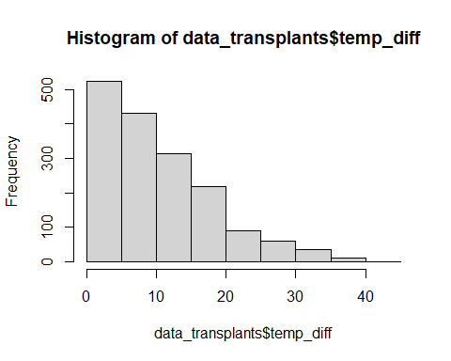

## Fitness

### Models without phenology

#### Both years

model_local_adapt<-glmmTMB(n_tot_seed~temp_diff*year+(1|unique_id)+(1|plot),  
 data_transplants,family="nbinom2")  
model_local_adapt_zi<-glmmTMB(n_tot_seed~temp_diff*year+(1|unique_id),  
 #+(1|plot), # Removed because it explained very  
 # low variance, and gave a warming  
 ziformula=~temp_diff*year+(1|unique_id)+(1|plot),  
 data_transplants,family="nbinom2")  
summary(model_local_adapt)

## Family: nbinom2 ( log )  
## Formula: n_tot_seed ~ temp_diff * year + (1 | unique_id) + (1 | plot)  
## Data: data_transplants  
##   
## AIC BIC logLik deviance df.resid   
## 13019.8 13057.8 -6502.9 13005.8 1675   
##   
## Random effects:  
##   
## Conditional model:  
## Groups Name Variance Std.Dev.   
## unique_id (Intercept) 5.231e-09 7.233e-05  
## plot (Intercept) 3.412e-01 5.842e-01  
## Number of obs: 1682, groups: unique_id, 854; plot, 8  
##   
## Dispersion parameter for nbinom2 family (): 0.194   
##   
## Conditional model:  
## Estimate Std. Error z value Pr(>|z|)   
## (Intercept) 4.14213 0.25056 16.531 < 2e-16 ***  
## temp_diff -0.01188 0.01065 -1.115 0.265   
## year2023 -1.29474 0.19379 -6.681 2.37e-11 ***  
## temp_diff:year2023 0.01098 0.01425 0.771 0.441   
## ---  
## Signif. codes: 0 '***' 0.001 '**' 0.01 '*' 0.05 '.' 0.1 ' ' 1

summary(model_local_adapt_zi)

## Family: nbinom2 ( log )  
## Formula: n_tot_seed ~ temp_diff * year + (1 | unique_id)  
## Zero inflation: ~temp_diff * year + (1 | unique_id) + (1 | plot)  
## Data: data_transplants  
##   
## AIC BIC logLik deviance df.resid   
## 11227.8 11292.9 -5601.9 11203.8 1670   
##   
## Random effects:  
##   
## Conditional model:  
## Groups Name Variance Std.Dev.   
## unique_id (Intercept) 4.94e-09 7.029e-05  
## Number of obs: 1682, groups: unique_id, 854  
##   
## Zero-inflation model:  
## Groups Name Variance Std.Dev.   
## unique_id (Intercept) 8.004e-10 2.829e-05  
## plot (Intercept) 6.904e-01 8.309e-01  
## Number of obs: 1682, groups: unique_id, 854; plot, 8  
##   
## Dispersion parameter for nbinom2 family (): 3.52   
##   
## Conditional model:  
## Estimate Std. Error z value Pr(>|z|)   
## (Intercept) 4.401462 0.037108 118.61 < 2e-16 ***  
## temp_diff 0.005194 0.003075 1.69 0.0912 .   
## year2023 -0.382189 0.062228 -6.14 8.16e-10 ***  
## temp_diff:year2023 0.005966 0.004871 1.22 0.2206   
## ---  
## Signif. codes: 0 '***' 0.001 '**' 0.01 '*' 0.05 '.' 0.1 ' ' 1  
##   
## Zero-inflation model:  
## Estimate Std. Error z value Pr(>|z|)   
## (Intercept) -1.010475 0.322575 -3.133 0.00173 **   
## temp_diff 0.035339 0.009842 3.591 0.00033 ***  
## year2023 1.433330 0.179842 7.970 1.59e-15 ***  
## temp_diff:year2023 -0.012572 0.013382 -0.939 0.34748   
## ---  
## Signif. codes: 0 '***' 0.001 '**' 0.01 '*' 0.05 '.' 0.1 ' ' 1

AIC(model_local_adapt,model_local_adapt_zi)

## df AIC  
## model_local_adapt 7 13019.79  
## model_local_adapt_zi 12 11227.82

Model with zero inflation is best.

plot(ggpredict(model_local_adapt_zi,terms=c("temp_diff"),type="count"))

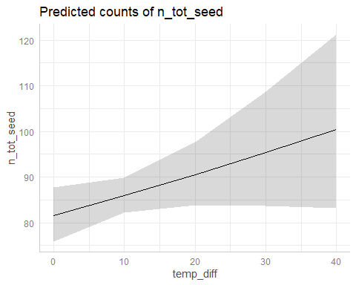

# NS (P = 0.09)  
plot(ggpredict(model_local_adapt_zi,terms=c("temp_diff"),type="zi_prob"))

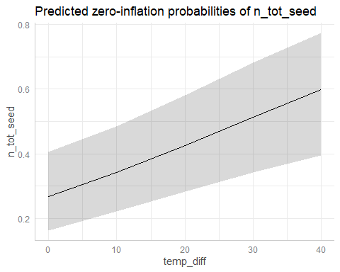

# *  
plot(ggpredict(model_local_adapt_zi,terms=c("temp_diff","year"),type="count"))

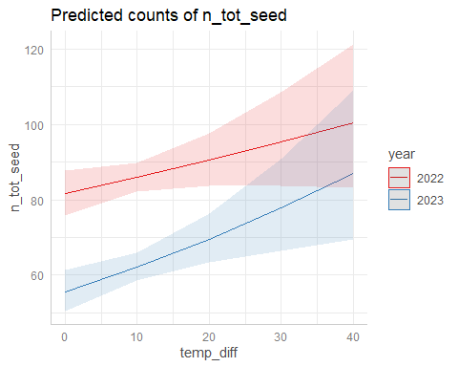

# NS  
plot(ggpredict(model_local_adapt_zi,terms=c("temp_diff","year"),type="zi_prob"))

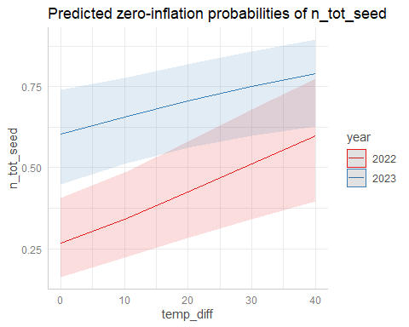

# NS

#### 2022

model_local_adapt_22<-glmmTMB(n_tot_seed~temp_diff+(1|plot),  
 subset(data_transplants,year==2022),family="nbinom2")  
model_local_adapt_22_zi<-glmmTMB(n_tot_seed~temp_diff+(1|plot),  
 ziformula=~.,  
 subset(data_transplants,year==2022),  
 family="nbinom2")  
summary(model_local_adapt_22)

## Family: nbinom2 ( log )  
## Formula: n_tot_seed ~ temp_diff + (1 | plot)  
## Data: subset(data_transplants, year == 2022)  
##   
## AIC BIC logLik deviance df.resid   
## 7952.2 7971.2 -3972.1 7944.2 845   
##   
## Random effects:  
##   
## Conditional model:  
## Groups Name Variance Std.Dev.  
## plot (Intercept) 0.05803 0.2409   
## Number of obs: 849, groups: plot, 8  
##   
## Dispersion parameter for nbinom2 family (): 0.312   
##   
## Conditional model:  
## Estimate Std. Error z value Pr(>|z|)   
## (Intercept) 3.996746 0.144385 27.681 <2e-16 ***  
## temp_diff -0.002474 0.008311 -0.298 0.766   
## ---  
## Signif. codes: 0 '***' 0.001 '**' 0.01 '*' 0.05 '.' 0.1 ' ' 1

summary(model_local_adapt_22_zi)

## Family: nbinom2 ( log )  
## Formula: n_tot_seed ~ temp_diff + (1 | plot)  
## Zero inflation: ~.  
## Data: subset(data_transplants, year == 2022)  
##   
## AIC BIC logLik deviance df.resid   
## 6930.7 6963.9 -3458.3 6916.7 842   
##   
## Random effects:  
##   
## Conditional model:  
## Groups Name Variance Std.Dev.   
## plot (Intercept) 1.393e-09 3.733e-05  
## Number of obs: 849, groups: plot, 8  
##   
## Zero-inflation model:  
## Groups Name Variance Std.Dev.  
## plot (Intercept) 0.5934 0.7703   
## Number of obs: 849, groups: plot, 8  
##   
## Dispersion parameter for nbinom2 family (): 3.92   
##   
## Conditional model:  
## Estimate Std. Error z value Pr(>|z|)   
## (Intercept) 4.401484 0.035243 124.89 <2e-16 ***  
## temp_diff 0.005193 0.002920 1.78 0.0753 .   
## ---  
## Signif. codes: 0 '***' 0.001 '**' 0.01 '*' 0.05 '.' 0.1 ' ' 1  
##   
## Zero-inflation model:  
## Estimate Std. Error z value Pr(>|z|)   
## (Intercept) -0.83870 0.30363 -2.762 0.00574 **  
## temp_diff 0.03163 0.01009 3.135 0.00172 **  
## ---  
## Signif. codes: 0 '***' 0.001 '**' 0.01 '*' 0.05 '.' 0.1 ' ' 1

AIC(model_local_adapt_22,model_local_adapt_22_zi)

## df AIC  
## model_local_adapt_22 4 7952.235  
## model_local_adapt_22_zi 7 6930.689

Model with zero inflation is best.

plot(ggpredict(model_local_adapt_22_zi,type="count")) #NS (P = 0.08)

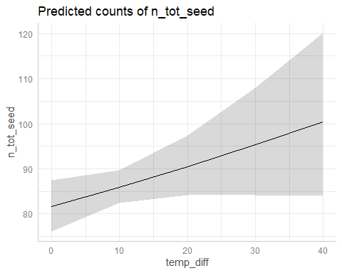

plot(ggpredict(model_local_adapt_22_zi,type="zi_prob")) #*

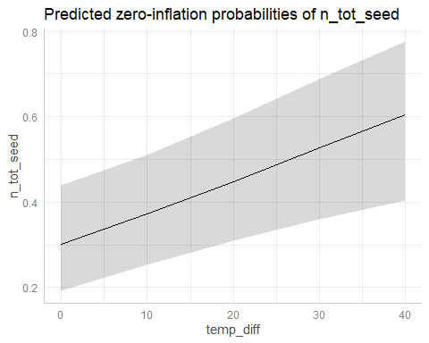

#### 2023

model_local_adapt_23<-glmmTMB(n_tot_seed~temp_diff+(1|plot),  
 subset(data_transplants,year==2023),family="nbinom2")  
model_local_adapt_23_zi<-glmmTMB(n_tot_seed~temp_diff+(1|plot),  
 ziformula=~.,  
 subset(data_transplants,year==2023),  
 family="nbinom2")  
summary(model_local_adapt_23)

## Family: nbinom2 ( log )  
## Formula: n_tot_seed ~ temp_diff + (1 | plot)  
## Data: subset(data_transplants, year == 2023)  
##   
## AIC BIC logLik deviance df.resid   
## 4842.4 4861.3 -2417.2 4834.4 829   
##   
## Random effects:  
##   
## Conditional model:  
## Groups Name Variance Std.Dev.  
## plot (Intercept) 7.015 2.649   
## Number of obs: 833, groups: plot, 8  
##   
## Dispersion parameter for nbinom2 family (): 0.134   
##   
## Conditional model:  
## Estimate Std. Error z value Pr(>|z|)   
## (Intercept) 2.29691 0.96672 2.376 0.0175 *  
## temp_diff -0.01943 0.01216 -1.598 0.1100   
## ---  
## Signif. codes: 0 '***' 0.001 '**' 0.01 '*' 0.05 '.' 0.1 ' ' 1

summary(model_local_adapt_23_zi)

## Family: nbinom2 ( log )  
## Formula: n_tot_seed ~ temp_diff + (1 | plot)  
## Zero inflation: ~.  
## Data: subset(data_transplants, year == 2023)  
##   
## AIC BIC logLik deviance df.resid   
## 4114.7 4147.7 -2050.3 4100.7 826   
##   
## Random effects:  
##   
## Conditional model:  
## Groups Name Variance Std.Dev.  
## plot (Intercept) 0.02178 0.1476   
## Number of obs: 833, groups: plot, 8  
##   
## Zero-inflation model:  
## Groups Name Variance Std.Dev.  
## plot (Intercept) 3.953 1.988   
## Number of obs: 833, groups: plot, 8  
##   
## Dispersion parameter for nbinom2 family (): 3.1   
##   
## Conditional model:  
## Estimate Std. Error z value Pr(>|z|)   
## (Intercept) 3.970244 0.080585 49.27 <2e-16 ***  
## temp_diff 0.009319 0.004132 2.26 0.0241 *   
## ---  
## Signif. codes: 0 '***' 0.001 '**' 0.01 '*' 0.05 '.' 0.1 ' ' 1  
##   
## Zero-inflation model:  
## Estimate Std. Error z value Pr(>|z|)   
## (Intercept) 0.32374 0.73306 0.442 0.659   
## temp_diff 0.04518 0.01094 4.129 3.64e-05 ***  
## ---  
## Signif. codes: 0 '***' 0.001 '**' 0.01 '*' 0.05 '.' 0.1 ' ' 1

AIC(model_local_adapt_23,model_local_adapt_23_zi)

## df AIC  
## model_local_adapt_23 4 4842.403  
## model_local_adapt_23_zi 7 4114.661

Model with zero inflation is best.

plot(ggpredict(model_local_adapt_23_zi,type="count")) #*

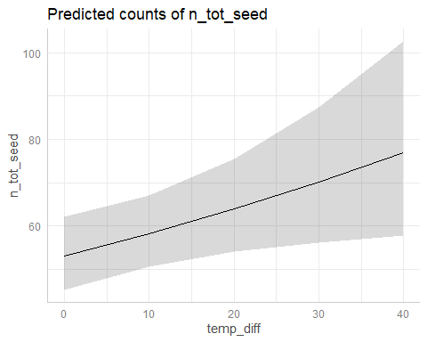

plot(ggpredict(model_local_adapt_22_zi,type="zi_prob")) #*



#### Diagnostics

plot(simulateResiduals(model_local_adapt_zi))

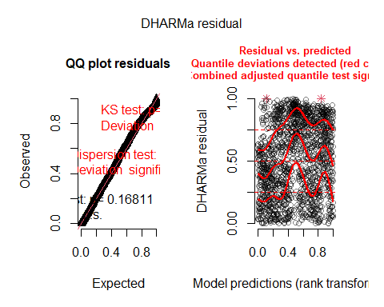

plot(simulateResiduals(model_local_adapt_22_zi))

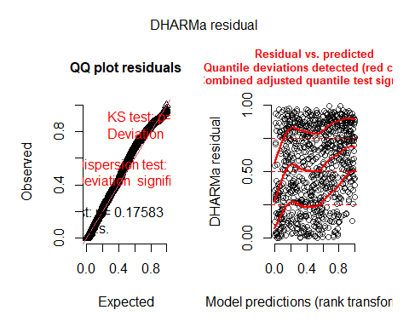

plot(simulateResiduals(model_local_adapt_23_zi))

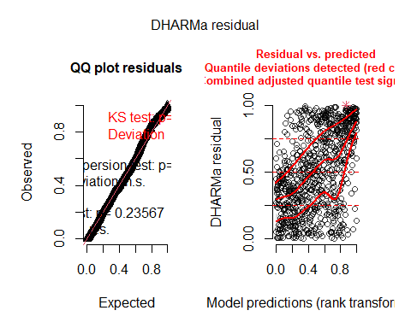

Take as OK??

### Models with phenology

To test to what extent any such evidence of local adaptation to the thermal environment was mediated by differences in flowering time, we ran a model including also expressed flowering time of focal individuals.

If the decrease in fitness with temperature difference is not significant when including flowering time, we can conclude that local adaptation is mediated by differences in flowering time?

#### Both years

model_local_adapt_FFD<-glmmTMB(n_tot_seed~temp_diff*year+FFD_corr+  
 (1|unique_id)+(1|plot),  
 data_transplants,family="nbinom2")  
model_local_adapt_zi_FFD<-glmmTMB(n_tot_seed~temp_diff+year+FFD_corr,  
 #+(1|unique_id)+(1|plot), # Removed because it explained very  
 # low variance, and gave a warming  
 ziformula=~temp_diff+year+FFD_corr+  
 (1|unique_id)+(1|plot),  
 data_transplants,family="nbinom2")  
# Still gives warnings (not sure why, but results seem OK)  
# Warning messages:  
# 1: In (function (start, objective, gradient = NULL, hessian = NULL, :  
# NA/NaN function evaluation  
# 2: In (function (start, objective, gradient = NULL, hessian = NULL, :  
# NA/NaN function evaluation  
summary(model_local_adapt_FFD)

## Family: nbinom2 ( log )  
## Formula: n_tot_seed ~ temp_diff * year + FFD_corr + (1 | unique_id) +   
## (1 | plot)  
## Data: data_transplants  
##   
## AIC BIC logLik deviance df.resid   
## 10517.7 10557.0 -5250.8 10501.7 1000   
##   
## Random effects:  
##   
## Conditional model:  
## Groups Name Variance Std.Dev.   
## unique_id (Intercept) 2.279e-09 4.774e-05  
## plot (Intercept) 2.171e-02 1.473e-01  
## Number of obs: 1008, groups: unique_id, 711; plot, 8  
##   
## Dispersion parameter for nbinom2 family (): 1.18   
##   
## Conditional model:  
## Estimate Std. Error z value Pr(>|z|)   
## (Intercept) 6.302923 0.549548 11.469 < 2e-16 ***  
## temp_diff 0.004603 0.005230 0.880 0.378810   
## year2023 -0.483383 0.101137 -4.779 1.76e-06 ***  
## FFD_corr -0.011447 0.003157 -3.626 0.000288 ***  
## temp_diff:year2023 0.001022 0.007659 0.133 0.893800   
## ---  
## Signif. codes: 0 '***' 0.001 '**' 0.01 '*' 0.05 '.' 0.1 ' ' 1

summary(model_local_adapt_zi_FFD)

## Family: nbinom2 ( log )  
## Formula: n_tot_seed ~ temp_diff + year + FFD_corr  
## Zero inflation:   
## ~temp_diff + year + FFD_corr + (1 | unique_id) + (1 | plot)  
## Data: data_transplants  
##   
## AIC BIC logLik deviance df.resid   
## 9726.2 9780.3 -4852.1 9704.2 997   
##   
## Random effects:  
##   
## Zero-inflation model:  
## Groups Name Variance Std.Dev.  
## unique_id (Intercept) 3070.511 55.412   
## plot (Intercept) 7.351 2.711   
## Number of obs: 1008, groups: unique_id, 711; plot, 8  
##   
## Dispersion parameter for nbinom2 family (): 2.82   
##   
## Conditional model:  
## Estimate Std. Error z value Pr(>|z|)   
## (Intercept) 5.280096 0.205164 25.736 < 2e-16 ***  
## temp_diff 0.008672 0.002643 3.281 0.00104 **   
## year2023 -0.249429 0.042951 -5.807 6.35e-09 ***  
## FFD_corr -0.005582 0.001204 -4.636 3.55e-06 ***  
## ---  
## Signif. codes: 0 '***' 0.001 '**' 0.01 '*' 0.05 '.' 0.1 ' ' 1  
##   
## Zero-inflation model:  
## Estimate Std. Error z value Pr(>|z|)   
## (Intercept) -29.960810 12.939364 -2.315 0.0206 *   
## temp_diff 0.020858 0.075198 0.277 0.7815   
## year2023 15.662113 2.478203 6.320 2.62e-10 ***  
## FFD_corr 0.004855 0.069831 0.070 0.9446   
## ---  
## Signif. codes: 0 '***' 0.001 '**' 0.01 '*' 0.05 '.' 0.1 ' ' 1

AIC(model_local_adapt_FFD,model_local_adapt_zi_FFD)

## df AIC  
## model_local_adapt_FFD 8 10517.66  
## model_local_adapt_zi_FFD 11 9726.19

Not sure how to interpret this, easier with yearly models?

#### 2022

model_local_adapt_22_FFD<-glmmTMB(n_tot_seed~temp_diff+FFD_corr+(1|plot),  
 subset(data_transplants,year==2022),family="nbinom2")  
model_local_adapt_22_zi_FFD<-glmmTMB(n_tot_seed~temp_diff+FFD_corr+(1|plot),  
 ziformula=~.,  
 subset(data_transplants,year==2022),  
 family="nbinom2")  
summary(model_local_adapt_22_FFD)

## Family: nbinom2 ( log )  
## Formula: n_tot_seed ~ temp_diff + FFD_corr + (1 | plot)  
## Data: subset(data_transplants, year == 2022)  
##   
## AIC BIC logLik deviance df.resid   
## 6389.5 6411.5 -3189.7 6379.5 597   
##   
## Random effects:  
##   
## Conditional model:  
## Groups Name Variance Std.Dev.   
## plot (Intercept) 1.098e-09 3.314e-05  
## Number of obs: 602, groups: plot, 8  
##   
## Dispersion parameter for nbinom2 family (): 2.15   
##   
## Conditional model:  
## Estimate Std. Error z value Pr(>|z|)   
## (Intercept) 5.187176 0.250764 20.685 < 2e-16 ***  
## temp_diff 0.005758 0.003832 1.502 0.132985   
## FFD_corr -0.004966 0.001461 -3.399 0.000677 ***  
## ---  
## Signif. codes: 0 '***' 0.001 '**' 0.01 '*' 0.05 '.' 0.1 ' ' 1

summary(model_local_adapt_22_zi_FFD)

## Family: nbinom2 ( log )  
## Formula: n_tot_seed ~ temp_diff + FFD_corr + (1 | plot)  
## Zero inflation: ~.  
## Data: subset(data_transplants, year == 2022)  
##   
## AIC BIC logLik deviance df.resid   
## 6126.5 6166.1 -3054.2 6108.5 593   
##   
## Random effects:  
##   
## Conditional model:  
## Groups Name Variance Std.Dev.   
## plot (Intercept) 3.784e-09 6.151e-05  
## Number of obs: 602, groups: plot, 8  
##   
## Zero-inflation model:  
## Groups Name Variance Std.Dev.  
## plot (Intercept) 2.432e-16 1.56e-08  
## Number of obs: 602, groups: plot, 8  
##   
## Dispersion parameter for nbinom2 family (): 4.04   
##   
## Conditional model:  
## Estimate Std. Error z value Pr(>|z|)  
## (Intercept) 5.169908 NaN NaN NaN  
## temp_diff 0.005098 NaN NaN NaN  
## FFD_corr -0.004584 NaN NaN NaN  
##   
## Zero-inflation model:  
## Estimate Std. Error z value Pr(>|z|)  
## (Intercept) -4.563017 NaN NaN NaN  
## temp_diff -0.015272 NaN NaN NaN  
## FFD_corr 0.008943 NaN NaN NaN

# NaNs in the summary, not sure why. Estimates quite low  
# Considering effects of temp_diff only significant in the zero-inflated part,  
# try binomial model with any seeds / no seeds  
AIC(model_local_adapt_22_FFD,model_local_adapt_22_zi_FFD)

## df AIC  
## model_local_adapt_22_FFD 5 6389.460  
## model_local_adapt_22_zi_FFD 9 6126.451

#### 2023

model_local_adapt_23_FFD<-glmmTMB(n_tot_seed~temp_diff+FFD_corr+(1|plot),  
 subset(data_transplants,year==2023),family="nbinom2")  
model_local_adapt_23_zi_FFD<-glmmTMB(n_tot_seed~temp_diff+FFD_corr+(1|plot),  
 ziformula=~.,  
 subset(data_transplants,year==2023),  
 family="nbinom2")  
summary(model_local_adapt_23_FFD)

## Family: nbinom2 ( log )  
## Formula: n_tot_seed ~ temp_diff + FFD_corr + (1 | plot)  
## Data: subset(data_transplants, year == 2023)  
##   
## AIC BIC logLik deviance df.resid   
## 3947.8 3967.8 -1968.9 3937.8 401   
##   
## Random effects:  
##   
## Conditional model:  
## Groups Name Variance Std.Dev.  
## plot (Intercept) 0.06318 0.2514   
## Number of obs: 406, groups: plot, 7  
##   
## Dispersion parameter for nbinom2 family (): 0.652   
##   
## Conditional model:  
## Estimate Std. Error z value Pr(>|z|)   
## (Intercept) 8.962375 1.652486 5.424 5.84e-08 ***  
## temp_diff 0.009340 0.007877 1.186 0.23571   
## FFD_corr -0.029266 0.009331 -3.136 0.00171 **   
## ---  
## Signif. codes: 0 '***' 0.001 '**' 0.01 '*' 0.05 '.' 0.1 ' ' 1

summary(model_local_adapt_23_zi_FFD)

## Family: nbinom2 ( log )  
## Formula: n_tot_seed ~ temp_diff + FFD_corr + (1 | plot)  
## Zero inflation: ~.  
## Data: subset(data_transplants, year == 2023)  
##   
## AIC BIC logLik deviance df.resid   
## 3544.7 3580.8 -1763.3 3526.7 397   
##   
## Random effects:  
##   
## Conditional model:  
## Groups Name Variance Std.Dev.  
## plot (Intercept) 0.03419 0.1849   
## Number of obs: 406, groups: plot, 7  
##   
## Zero-inflation model:  
## Groups Name Variance Std.Dev.  
## plot (Intercept) 1.781 1.335   
## Number of obs: 406, groups: plot, 7  
##   
## Dispersion parameter for nbinom2 family (): 3.34   
##   
## Conditional model:  
## Estimate Std. Error z value Pr(>|z|)   
## (Intercept) 8.038914 0.935990 8.589 < 2e-16 ***  
## temp_diff 0.010942 0.004080 2.682 0.00732 **   
## FFD_corr -0.023196 0.005303 -4.374 1.22e-05 ***  
## ---  
## Signif. codes: 0 '***' 0.001 '**' 0.01 '*' 0.05 '.' 0.1 ' ' 1  
##   
## Zero-inflation model:  
## Estimate Std. Error z value Pr(>|z|)   
## (Intercept) -9.74000 3.24716 -2.999 0.0027 **  
## temp_diff 0.01536 0.01833 0.838 0.4021   
## FFD_corr 0.04068 0.01759 2.313 0.0207 *   
## ---  
## Signif. codes: 0 '***' 0.001 '**' 0.01 '*' 0.05 '.' 0.1 ' ' 1

# NaNs in the summary, not sure why. Estimates quite low  
# Considering effects of temp_diff only significant in the zero-inflated part,  
# try binomial model with any seeds / no seeds  
AIC(model_local_adapt_23_FFD,model_local_adapt_23_zi_FFD)

## df AIC  
## model_local_adapt_23_FFD 5 3947.796  
## model_local_adapt_23_zi_FFD 9 3544.693

Do models also with MeanFD / LFD

## Fitnes 0/1

### Models without phenology

Calculate fitness 0/1:

data_transplants<-data_transplants%>%  
 mutate(fitness_01=ifelse(n_tot_seed>0,1,0))  
hist(data_transplants$fitness_01)

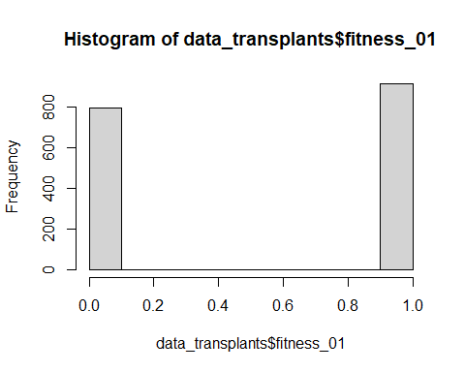

#### Both years

model_local_adapt_01<-glmmTMB(fitness_01~temp_diff*year+(1|unique_id)+(1|plot),  
 data_transplants,family="binomial")  
summary(model_local_adapt_01)

## Family: binomial ( logit )  
## Formula: fitness_01 ~ temp_diff * year + (1 | unique_id) + (1 | plot)  
## Data: data_transplants  
##   
## AIC BIC logLik deviance df.resid   
## 2028.7 2061.3 -1008.3 2016.7 1676   
##   
## Random effects:  
##   
## Conditional model:  
## Groups Name Variance Std.Dev.   
## unique_id (Intercept) 1.074e-08 0.0001036  
## plot (Intercept) 6.904e-01 0.8309024  
## Number of obs: 1682, groups: unique_id, 854; plot, 8  
##   
## Conditional model:  
## Estimate Std. Error z value Pr(>|z|)   
## (Intercept) 1.010391 0.322562 3.132 0.00173 **   
## temp_diff -0.035336 0.009841 -3.591 0.00033 ***  
## year2023 -1.433322 0.179834 -7.970 1.58e-15 ***  
## temp_diff:year2023 0.012572 0.013381 0.940 0.34746   
## ---  
## Signif. codes: 0 '***' 0.001 '**' 0.01 '*' 0.05 '.' 0.1 ' ' 1

plot(ggpredict(model_local_adapt_01,terms=c("temp_diff"))) # *

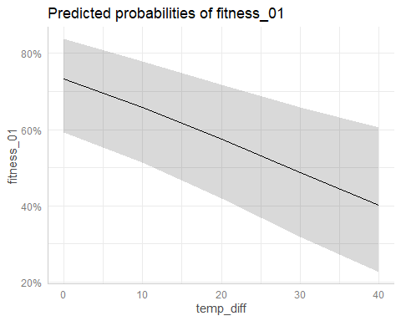

plot(ggpredict(model_local_adapt_01,terms=c("year"))) # *

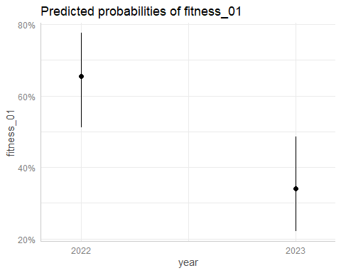

plot(ggpredict(model_local_adapt_01,terms=c("temp_diff","year"))) # NS

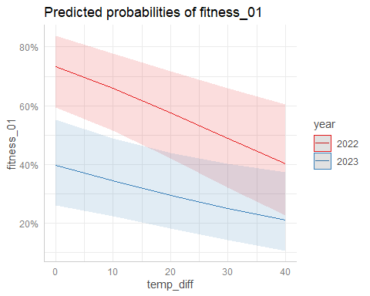

#### 2022

model_local_adapt_01_22<-glmmTMB(fitness_01~temp_diff+(1|plot),  
 subset(data_transplants,year==2022),family="binomial")  
summary(model_local_adapt_01_22)

## Family: binomial ( logit )  
## Formula: fitness_01 ~ temp_diff + (1 | plot)  
## Data: subset(data_transplants, year == 2022)  
##   
## AIC BIC logLik deviance df.resid   
## 998.2 1012.4 -496.1 992.2 846   
##   
## Random effects:  
##   
## Conditional model:  
## Groups Name Variance Std.Dev.  
## plot (Intercept) 0.5934 0.7703   
## Number of obs: 849, groups: plot, 8  
##   
## Conditional model:  
## Estimate Std. Error z value Pr(>|z|)   
## (Intercept) 0.83868 0.30362 2.762 0.00574 **  
## temp_diff -0.03163 0.01009 -3.135 0.00172 **  
## ---  
## Signif. codes: 0 '***' 0.001 '**' 0.01 '*' 0.05 '.' 0.1 ' ' 1

plot(ggpredict(model_local_adapt_01_22))

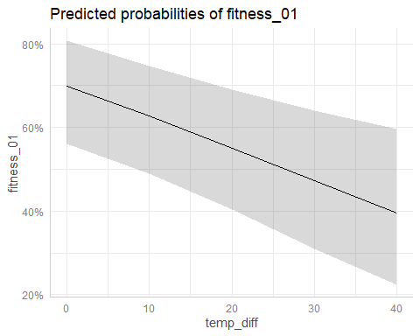

#### 2023

model_local_adapt_01_23<-glmmTMB(fitness_01~temp_diff+(1|plot),  
 subset(data_transplants,year==2023),family="binomial")  
summary(model_local_adapt_01_23)

## Family: binomial ( logit )  
## Formula: fitness_01 ~ temp_diff + (1 | plot)  
## Data: subset(data_transplants, year == 2023)  
##   
## AIC BIC logLik deviance df.resid   
## 857.9 872.0 -425.9 851.9 830   
##   
## Random effects:  
##   
## Conditional model:  
## Groups Name Variance Std.Dev.  
## plot (Intercept) 3.952 1.988   
## Number of obs: 833, groups: plot, 8  
##   
## Conditional model:  
## Estimate Std. Error z value Pr(>|z|)   
## (Intercept) -0.32408 0.73297 -0.442 0.658   
## temp_diff -0.04517 0.01094 -4.129 3.65e-05 ***  
## ---  
## Signif. codes: 0 '***' 0.001 '**' 0.01 '*' 0.05 '.' 0.1 ' ' 1

plot(ggpredict(model_local_adapt_01_23))

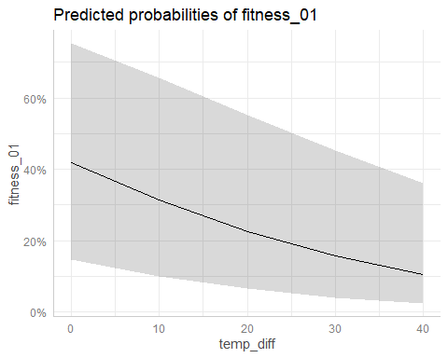

### Models with phenology

model_local_adapt_01_FFD<-glmmTMB(fitness_01~temp_diff*year+FFD_corr+  
 (1|unique_id)+(1|plot),  
 data_transplants,family="binomial")  
summary(model_local_adapt_01_FFD)

## Family: binomial ( logit )  
## Formula: fitness_01 ~ temp_diff * year + FFD_corr + (1 | unique_id) +   
## (1 | plot)  
## Data: data_transplants  
##   
## AIC BIC logLik deviance df.resid   
## 544.5 578.9 -265.3 530.5 1001   
##   
## Random effects:  
##   
## Conditional model:  
## Groups Name Variance Std.Dev.  
## unique_id (Intercept) 0.1164 0.3412   
## plot (Intercept) 1.1435 1.0694   
## Number of obs: 1008, groups: unique_id, 711; plot, 8  
##   
## Conditional model:  
## Estimate Std. Error z value Pr(>|z|)   
## (Intercept) 7.09156 2.18833 3.241 0.00119 **  
## temp_diff 0.01560 0.03085 0.506 0.61300   
## year2023 -1.39917 0.43869 -3.189 0.00143 **  
## FFD_corr -0.02098 0.01181 -1.776 0.07580 .   
## temp_diff:year2023 -0.03667 0.03504 -1.046 0.29537   
## ---  
## Signif. codes: 0 '***' 0.001 '**' 0.01 '*' 0.05 '.' 0.1 ' ' 1

plot(ggpredict(model_local_adapt_01_FFD,terms=c("temp_diff"))) # NS

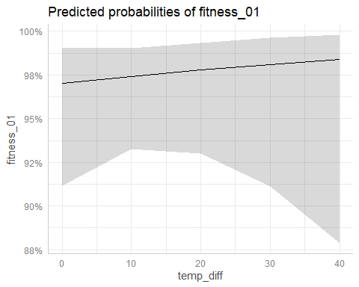

plot(ggpredict(model_local_adapt_01_FFD,terms=c("year"))) # *

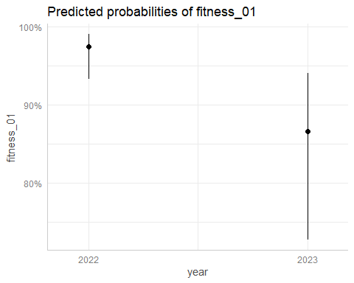

plot(ggpredict(model_local_adapt_01_FFD,terms=c("FFD_corr"))) # NS

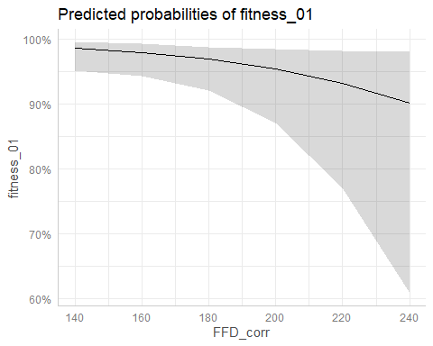

plot(ggpredict(model_local_adapt_01_FFD,terms=c("temp_diff","year"))) # NS

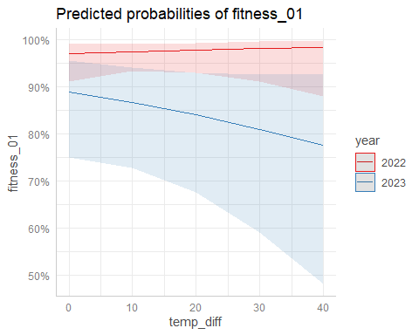

#### 2022

model_local_adapt_01_22_FFD<-glmmTMB(fitness_01~temp_diff+FFD_corr+(1|plot),  
 subset(data_transplants,year==2022),family="binomial")  
summary(model_local_adapt_01_22_FFD)

## Family: binomial ( logit )  
## Formula: fitness_01 ~ temp_diff + FFD_corr + (1 | plot)  
## Data: subset(data_transplants, year == 2022)  
##   
## AIC BIC logLik deviance df.resid   
## 208.7 226.3 -100.3 200.7 598   
##   
## Random effects:  
##   
## Conditional model:  
## Groups Name Variance Std.Dev.   
## plot (Intercept) 2.875e-09 5.362e-05  
## Number of obs: 602, groups: plot, 8  
##   
## Conditional model:  
## Estimate Std. Error z value Pr(>|z|)   
## (Intercept) 4.563289 1.850587 2.466 0.0137 *  
## temp_diff 0.015274 0.029449 0.519 0.6040   
## FFD_corr -0.008945 0.010517 -0.851 0.3950   
## ---  
## Signif. codes: 0 '***' 0.001 '**' 0.01 '*' 0.05 '.' 0.1 ' ' 1

#### 2023

model_local_adapt_01_23_FFD<-glmmTMB(fitness_01~temp_diff+FFD_corr+(1|plot),  
 subset(data_transplants,year==2023),family="binomial")  
summary(model_local_adapt_01_23_FFD)

## Family: binomial ( logit )  
## Formula: fitness_01 ~ temp_diff + FFD_corr + (1 | plot)  
## Data: subset(data_transplants, year == 2023)  
##   
## AIC BIC logLik deviance df.resid   
## 316.8 332.8 -154.4 308.8 402   
##   
## Random effects:  
##   
## Conditional model:  
## Groups Name Variance Std.Dev.  
## plot (Intercept) 1.775 1.332   
## Number of obs: 406, groups: plot, 7  
##   
## Conditional model:  
## Estimate Std. Error z value Pr(>|z|)   
## (Intercept) 9.80540 3.22144 3.044 0.00234 **  
## temp_diff -0.01529 0.01832 -0.834 0.40408   
## FFD_corr -0.04107 0.01742 -2.357 0.01840 *   
## ---  
## Signif. codes: 0 '***' 0.001 '**' 0.01 '*' 0.05 '.' 0.1 ' ' 1

## Path analysis?

[Possibly do a small path-model with direct and indirect, via phenology, effects of origin on fitness?]

# Session info

sessionInfo()

## R version 4.3.2 (2023-10-31 ucrt)  
## Platform: x86_64-w64-mingw32/x64 (64-bit)  
## Running under: Windows 11 x64 (build 22631)  
##   
## Matrix products: default  
##   
##   
## locale:  
## [1] LC_COLLATE=English_United States.utf8   
## [2] LC_CTYPE=English_United States.utf8   
## [3] LC_MONETARY=English_United States.utf8  
## [4] LC_NUMERIC=C   
## [5] LC_TIME=English_United States.utf8   
##   
## time zone: Europe/Madrid  
## tzcode source: internal  
##   
## attached base packages:  
## [1] stats graphics grDevices utils datasets methods base   
##   
## other attached packages:  
## [1] gridExtra_2.3 lmeresampler_0.2.4 DHARMa_0.4.6 partR2_0.9.1.9000   
## [5] performance_0.10.8 ggeffects_1.3.4 sjPlot_2.8.15 car_3.1-2   
## [9] carData_3.0-5 lmerTest_3.1-3 lme4_1.1-35.1 Matrix_1.6-4   
## [13] glmmTMB_1.1.8 ggthemes_5.0.0 knitr_1.45 RColorBrewer_1.1-3  
## [17] readxl_1.4.3 lubridate_1.9.3 forcats_1.0.0 stringr_1.5.1   
## [21] dplyr_1.1.4 purrr_1.0.2 readr_2.1.4 tidyr_1.3.0   
## [25] tibble_3.2.1 ggplot2_3.4.4 tidyverse_2.0.0   
##   
## loaded via a namespace (and not attached):  
## [1] Rdpack_2.6 sandwich_3.1-0 rlang_1.1.2   
## [4] magrittr_2.0.3 multcomp_1.4-25 snakecase_0.11.1   
## [7] compiler_4.3.2 mgcv_1.9-0 vctrs_0.6.5   
## [10] reshape2_1.4.4 crayon_1.5.2 pkgconfig_2.0.3   
## [13] fastmap_1.1.1 ellipsis_0.3.2 backports_1.4.1   
## [16] labeling_0.4.3 HLMdiag_0.5.0 utf8_1.2.4   
## [19] promises_1.2.1 rmarkdown_2.25 tzdb_0.4.0   
## [22] haven_2.5.4 nloptr_2.0.3 bit_4.0.5   
## [25] xfun_0.41 later_1.3.2 highr_0.10   
## [28] sjmisc_2.8.9 parallel_4.3.2 broom_1.0.5   
## [31] gap.datasets_0.0.6 R6_2.5.1 qgam_1.3.4   
## [34] stringi_1.8.3 boot_1.3-28.1 cellranger_1.1.0   
## [37] numDeriv_2016.8-1.1 estimability_1.4.1 iterators_1.0.14   
## [40] Rcpp_1.0.11 modelr_0.1.11 zoo_1.8-12   
## [43] httpuv_1.6.13 splines_4.3.2 timechange_0.2.0   
## [46] tidyselect_1.2.0 rstudioapi_0.15.0 abind_1.4-5   
## [49] yaml_2.3.8 doParallel_1.0.17 TMB_1.9.10   
## [52] codetools_0.2-19 sjlabelled_1.2.0 lattice_0.22-5   
## [55] plyr_1.8.9 shiny_1.8.0 withr_2.5.2   
## [58] bayestestR_0.13.1 coda_0.19-4 evaluate_0.23   
## [61] survival_3.5-7 ggdist_3.3.1 pillar_1.9.0   
## [64] gap_1.5-3 foreach_1.5.2 insight_0.19.10   
## [67] distributional_0.3.2 generics_0.1.3 vroom_1.6.5   
## [70] nlmeU_0.70-9 hms_1.1.3 munsell_0.5.0   
## [73] scales_1.3.0 minqa_1.2.6 xtable_1.8-4   
## [76] glue_1.6.2 janitor_2.2.0 emmeans_1.9.0   
## [79] tools_4.3.2 mvtnorm_1.2-4 grid_4.3.2   
## [82] rbibutils_2.2.16 datawizard_0.9.1 diagonals_6.4.0   
## [85] colorspace_2.1-0 nlme_3.1-164 cli_3.6.2   
## [88] fansi_1.0.6 sjstats_0.18.2 gtable_0.3.4   
## [91] digest_0.6.33 TH.data_1.1-2 farver_2.1.1   
## [94] htmltools_0.5.7 lifecycle_1.0.4 mime_0.12   
## [97] statmod_1.5.0 bit64_4.0.5 MASS_7.3-60