Analyses Cerastium transplants paper 1

Alicia Valdés

10 April, 2024

Distributions phenology variables

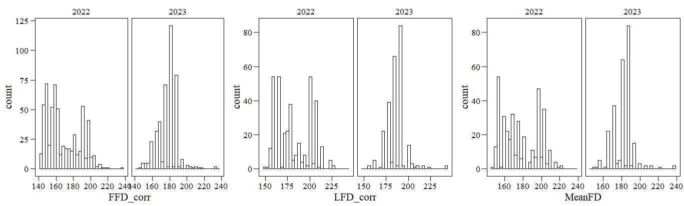None of the distribution is looking very close to normal, even with transformations (log, square root… not shown).

Below are analyses including only reproductive phenology (FFD, LFD and Mean FD): I still need to incorporate vegetative phenology. Shoot measurements are available in the Excel file for 2022 but I could not find them for 2023. Was this recorded in 2023?

# PREDICTION 1

“Trait expression is a function of both the current temperature environment, in terms of plasticity, and the past temperature environment, in terms of genetic effects, and follows a counter-gradient pattern, i.e. environmental and genetic effects of soil temperature on flowering time are in opposite directions.”

I performed a series of models similar to the ones used in the greenhouse paper. For this paper, we might want to keep only models including origin temperatures and soil temperature, but I have kept everything so far.

As the residuals of the models were not normally distributed, I used bootstrapped models to calculate proportions of variance and significance of effects. Bootstrapping is supposed to allow for bias correction, adjusted standard errors and confidence intervals when distributional assumptions are not met (i.e. our case). I used 1000 bootstrap resamples and a residual bootstrap. Reference: <https://journal.r-project.org/articles/RJ-2023-015/>

Below I show only the main results (plots and text describing effects) and not the whole details of the models, so it is easier to go through

## A) Heritability of mean responses (Prediction 1 in greenhouse paper)

Models included random effects of father, mother and plot.

### Proportions of variance in mean responses

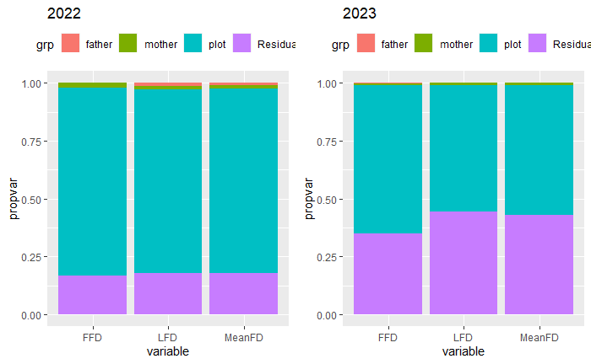Very low proportions of variance explained by father and mother. Most variance explained by plot (especially in 2022). According to Likelihood Ratio Tests, effect of father always NS, mother only significant for FFD and meanFD in 2022.

### Heritability and maternal effects of mean responses

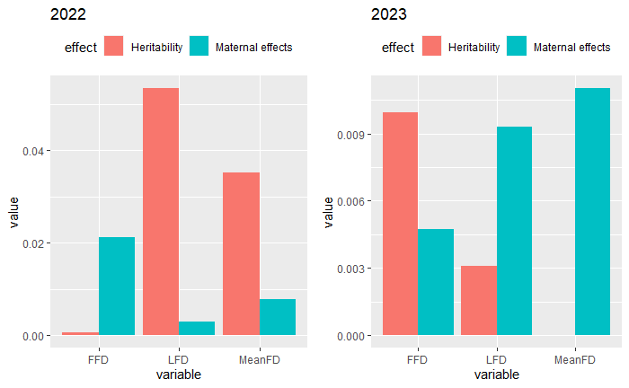Heritabilities are very low (all <0.05 in 2022, and even lower (all <0.01) in 2023.

## B) Heritability of plasticities (Prediction 2 in greenhouse paper)

Models included random effects of father, mother and plot, and fixed effect of temperature at the planting site as well and interactions of temperature at the planting site with father and mother. I also tried including a quadratic effect of temperature in the fixed part. Model comparisons using AIC indicated that models with quadratic effect of temperature provided the best fit in 2022, while models with only linear effect of temperature provided the best fit in 2023.

### Proportions of variance in plasticity (note! Different legend colors for 2022-23)

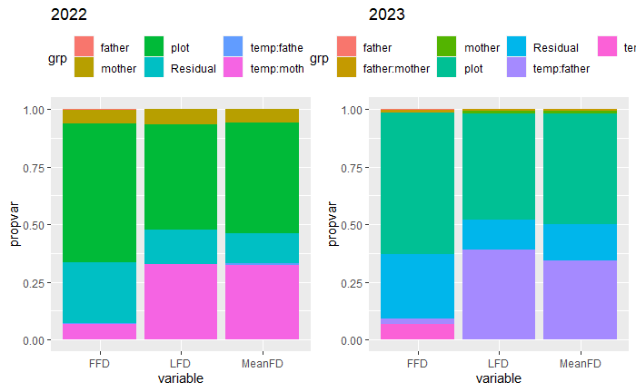2022: Very low proportions of variance explained by temp:father, higher proportion of variance explained by temp:mother (larger in LFD and MeanFD). Most variance explained by plot.

2023: Higher proportions of variance explained by temp:father for LFD and MeanFD. temp:mother only explains some for FFD. Most variance explained by plot.

According to Likelihood Ratio Tests, effect of temp:father always NS. Effect of temp:mother significant only for LFD and MeanFD in 2022.

### Heritability and maternal effects of plasticities

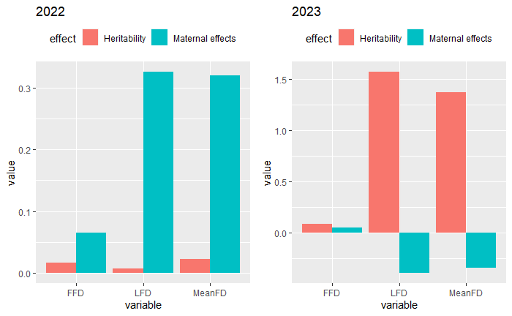Heritabilities much higher in 2023, and maternal effects much higher in 2022…

### Figures effect of temperature on flowering time

Main effect of temperature (quadratic) significant for FFD, LFD and MeanFD in 2022. In 2023, linear effect NS for FFD, NS for LFD (P = 0.06) and significant for MeanFD (but close to 0.05).

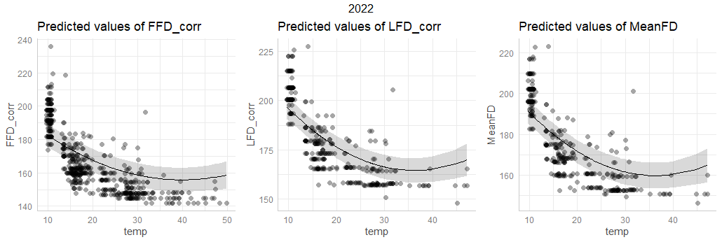

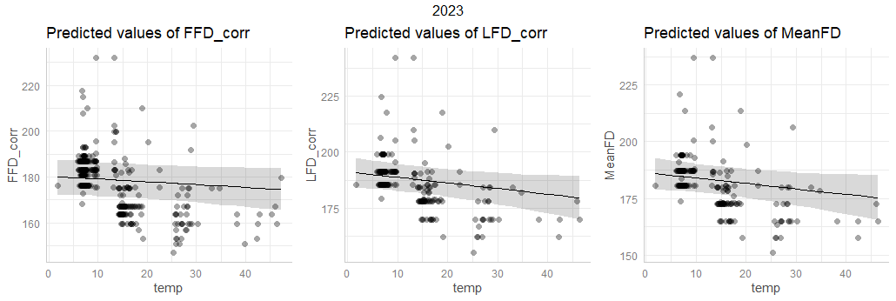

### Copmarison all heritabilities (mean responses & plasticities)

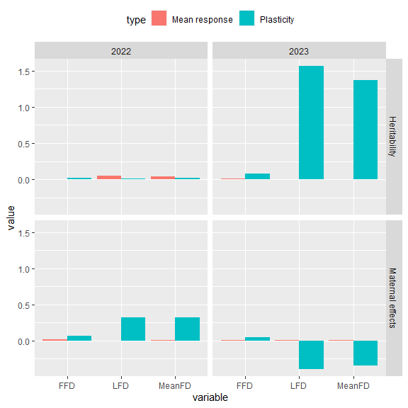Very high heritabilities for plasticity in 2023. Why?

## C) Genetic differentiation in mean responses (Prediction 3 in greenhouse paper)

Models included random effects of father, mother and plot, and fixed effects of temperatures of origin of father and mother. All effects of origin temperatures are NS. Marginal R2 values indicate that the proportion of variance explained by origin temperatures is extremely low (<0.2%). I also performed models with mid-parental values of origin temperature, and results were similar.

## D) Genetic differentiation in plasticities (Prediction 4 in greenhouse paper)

Models included random effects of father, mother and plot, and fixed effects of temperatures of origin of father and mother, as well as the interactions of temperatures of origin with temperature at the planting site.

### 2022

Interaction temp at planting site (temp):temp_father is significant (P = 0.04251) for FFD. (I still did not bootstrap the model here – maybe this will become NS after bootstrapping). Anyway, this seems to indicate that there are temperature-related differences among fathers in the response to temperature of the planting site = Genetic differentiation related to origin temperature of the father in the slope of RNs?

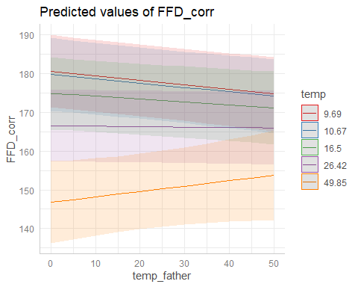

As predicted: differences in phenology between high and low soil temperatures are predicted to be smaller for plants with fathers from warm soils than for plants with fathers from colder soils.

### 2023

Interaction temp at planting site (temp):temp_mother is significant for FFD, LFD and MeanFD. This seems to indicate that there are temperature-related differences among mothers in the response to temperature of the planting site = Genetic differentiation related to origin temperature of the mother in the slope of RNs?

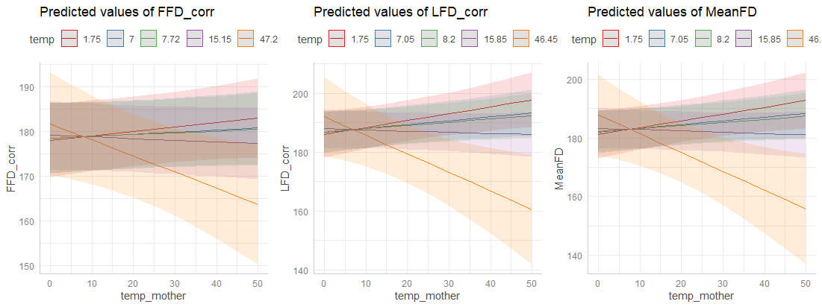

But here, the effect goes in the opposite direction as predicted: differences in phenology between high and low soil temperatures are larger for plants with mothers from warm soils than for plants with mothers from colder soils. Why?

Models with mid-parental values show significant effects of the interaction temp at planting site (temp):temp_father for FFD and LFD in 2022, and similar effects as above in 2023.

# PREDICTION 2

“There is temperature-dependent phenotypic selection on flowering time, and selection favors an earlier phenology at low soil temperatures but a later phenology at high temperatures.”

Fitness = total number of seeds (n_tot_seeds). See distribution:

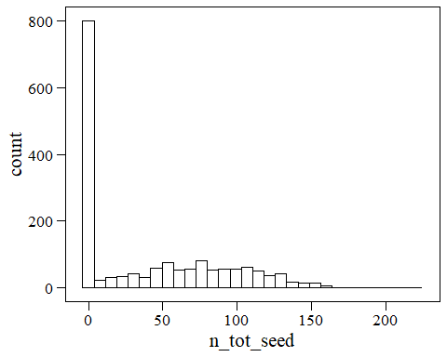

## Models both years

Models included fitness relativized within years as the response. Predictors (fixed effects) were flowering time (FFD/LFD/MeanFD, standardized within years), temperature at planting site, and the interactions flowering time x temperature at planting site, flowering time x year, temperature at planting site x year. I also included random effects of individual and plot. I tried models with either number of flowers or median height as condition variables (standardized within years) or with no condition variable.

The only significant effect (apart from condition traits) was the interaction temperature at planting site x year.

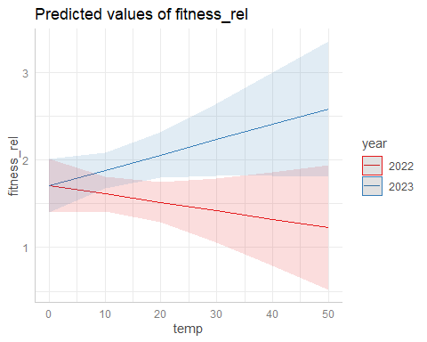

Fitness decreases with temperature in 2022 and increases in 2023. This interaction looked similar for models with either FFD, LFD and MeanFD, and with or without condition trait.

## Yearly models

### 2022

#### With n flowers as condition trait

No interaction (no temperature-dependent selection). No selection on phenology.

#### With median h as condition trait

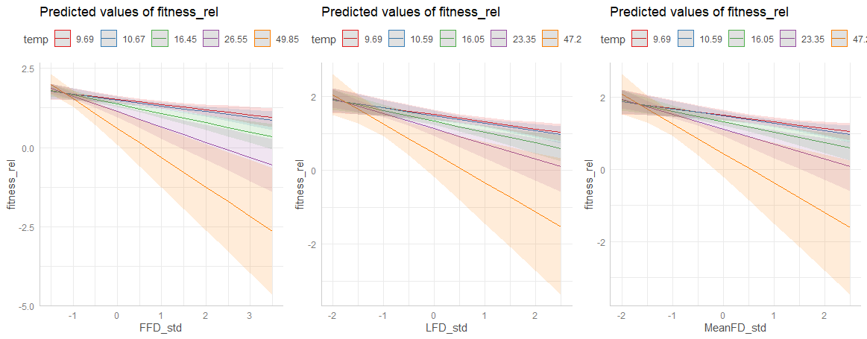

Significant interaction (temperature-dependent selection).

We predicted that selection would favor an earlier phenology at low soil temperatures but a later phenology at high temperatures (as found for 2018 in the Ecology paper). However, here selection always favors an earlier phenology, and selection for earlier phenology is stronger at warmer temperatures (opposite to our prediction!).

#### With no condition trait

Similar result as with median height.

### 2023

No interaction (no temperature-dependent selection) and no selection on phenology, both in models with n flowers or median height as condition trait, and with no condition trait.

I tried also models with binomial fitness (0/1), but never found temperature-dependent selection.

# PREDICTION 3

“This temperature-dependent phenotypic selection corresponds, partly, to genotypic selection.”

But we found no temperature-dependent phenotypic selection (or opposite to expectation in some types of models in 2022), and very low heritabilities. I still did not test this, but could try to see how to do it if we feel it is a good idea.

# PREDICTION 4

“Divergent temperature-dependent selection has resulted in small-scale genetic differentiation and local adaptation along gradients of soil temperature, and this local adaptation involves flowering time.”

To test if plants are adapted to their local thermal environment, we regressed fitness on the absolute difference in temperature between the transplantation site and the mean temperature of the parents’ sites of origin.

Distribution of temperature difference:

## Fitness as total number of seeds

I used zero-inflated models, which provided a better fit than non-zero inflated models according to AIC. Here I present models for each year.

### Models without phenology

Models included the absolute total number of seeds as the response, the temperature difference as fixed effect, and plot as random effect. I used negative binomial models (which provided a better fit than Poisson). I included a quadratic term for temperature difference, and retained it if it provided a better fit (lower AIC).

#### 2022

The probability of zero-inflation (i.e. of having zero fitness) significantly increased with temperature difference (quadratic effect significant). This might be an indication of local adaptation. Effects on the “count” part of the model are not significant.

#### 2023

#### The probability of zero-inflation (i.e. of having zero fitness) significantly increased with temperature difference. This might be an indication of local adaptation. Effects on the “count” part of the model are also significant in this year, and number of seeds increases with temperature difference (opposite to our prediction!).

### Models with phenology

To test to what extent any such evidence of local adaptation to the thermal environment was mediated by differences in flowering time, we ran a model including also expressed flowering time of focal individuals.

If the decrease in fitness with temperature difference is not significant when including flowering time, we can conclude that local adaptation is mediated by differences in flowering time?

Models included the absolute total number of seeds as the response, the temperature difference and FFD as fixed effects, and plot as random effect. I used negative binomial models (which provided a better fit than Poisson). I included a quadratic term for temperature difference, and retained it if it provided a better fit (lower AIC).

#### 2022

The probability of zero-inflation (i.e. of having zero fitness) still increases with temperature difference (quadratic term significant) when including FFD in the model, but the increase is weaker. This might be an indication of that local adaptation is mediated by FFD? Also, the number of seeds decreases with later FFD.

#### 2023

#### The probability of zero-inflation (i.e. of having zero fitness) still increases with temperature difference (quadratic term not significant, but retained in the model) when including FFD in the model, but the increase is weaker. This might be an indication of that local adaptation is mediated by FFD?. Also, the probability of having zero fitness increases, and the number of seeds decreases, with later FFD.

## Fitness as 0/1

### Models without phenology

Histogram of fitness 0/1:

#### 2022

The probability of having any fitness (i.e. any seeds) significantly decreased with temperature difference (quadratic term significant). This might be an indication of local adaptation.

#### 2023

Similar result as in 2022, but quadratic term not significant.

### Models with phenology

#### 2022

The probability of having any fitness (i.e. any seeds) still increases with temperature difference (quadratic term significant) when including FFD in the model, but the increase is weaker. This might be an indication of that local adaptation is mediated by FFD?. But the effect of FFD is also NS in this model.

#### 2023

The probability of having any fitness (i.e. any seeds) still increases with temperature difference (quadratic term not significant, but retained in the model) when including FFD in the model, but the increase is weaker. This might be an indication of that local adaptation is mediated by FFD? The effect of FFD is significant in this model, and the probability of having any fitness decreases with later FFD.

## Path analysis

I tried doing path analyses with fitness 0/1, but I am not sure that they are very conclusive.

In 2022, the indirect effect of temperature difference on fitness through FFD is not significant because FFD has no significant effect on fitness.

In 2023, the indirect effect of temperature difference on fitness through FFD is not significant because temperature difference has no significant effect on FFD.

## .