# Appendix S4: Estimating predation for dispersed seeds

Seed predation for fruits with dispersed seeds (n~open fruits~=) was estimated using information from fruits that had not yet opened when checked for seed number and evidence of seed predation (n~intact fruits~=1938). We transformed the number of holes made by the seed predator on pod wall and seeds, respectively, into proportions by dividing each measure by the total number of seeds.

This was done for each intact fruit. Linear models could not satisfactory explain the relationship, why we fitted an exponential asymptotic regression model using non-linear least squares (nls) in R version 3.3.2 (R Core Team 2016).

The starting asymptotic value of y was set to 1. The starting value of the rate constant was obtained as the slope from a linear model of the number of holes in pod wall per total number of seeds, on the proportion of seeds preyed upon per total number of seeds (linear model, estimate±SE =0.271±0.008, t= 35.1, p < 0.001).

The formula that best described the observed data was $y=a(1-e^{-bx})$ where *a* represents the asymptotic value of y, and *b* is the rate constant (Table S4:1). The model explained 74.5% of the variation in proportion of seeds preyed upon. The correlation coefficient for observed and estimated proportions of seeds preyed upon was 0.863 (Pearson's product-moment correlation, t1936=75.114, p <0.001).  
We estimated the proportion of seeds preyed upon for open fruits using the formula above, inserting the rate constant of 1.21 from the non-linear least squares model (Table S4:1, Figure S4:1) and an asymptotic y of 1. The resulting proportions were back-transformed to counts of seeds preyed upon. The correlation coefficient for observed and estimated seeds counts preyed upon was 0.909 (Pearson's product-moment correlation, t1936=96.178, p <0.001)

*Table S4:1. Results from a non-linear least squares model of number of holes on pod walls per total number of seeds on the proportion of seeds preyed upon in fruits that had not open prior to examination (n = 1938).*

|  |  |  |  |  |
| --- | --- | --- | --- | --- |
|  | Estimate | SE | t-value | P-value |
| a, Asymptotic value of y | 0.998 | 0.018 | 54.320 | 0 |
| b, Rate constant | 1.219 | 0.052 | 23.641 | 0 |

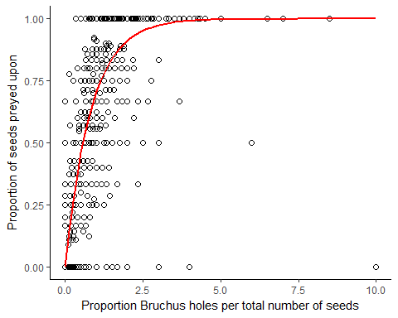

*Figure S4:1. The relationship between proportion of seeds preyed upon and number of* Bruchus atomarius *holes in the pod wall of* Lathyrus vernus *fruits that had not open prior to examination (n = 1938)*.

### References

R Core Team. 2016. R: a language and environment for statistical computing. R Foundation for Statistical Computing, Vienna, Austria.

**R code:**

rm(list=ls())

all <- read.delim("seedmod.txt")

all$hps <- all$predholes/all$seeds # calculate predholes/total seeds

all$pps <- all$predseed/all$seeds # calculate pred.seeds/total seeds

all$hps[all$seeds==0] <- NA # if no seeds, holes/seeds set to NA

all$pps[all$seeds==0] <- NA # if no seeds, predseeds/seeds set to NA

#Subset: Plants with known number of predseeds and predholes

dat <- read.delim("seedmod.txt")

dat <- dat[! is.na(dat$predseed),]

dat <- dat[! is.na(dat$predholes),]

dat <- dat[! is.na(dat$seeds),]

dat$hps <- dat$predholes/dat$seeds

dat$pps <- dat$predseed/dat$seeds

#Exponential asymptotic model:

mod1 <- nls(pps ~ a*(1-exp(-b*hps)),start=list(a=1, b=0.2712151), data=dat)

a <- 1

b <- coef(mod1)[2]

#estimate predseeds/total seeds from model parameters

all$model.pps <- NA

all$model.pps <- with(all,(a*(1-exp(-b*hps))))

# total number of pred.seeds from model pred/seeds

all$model.predeeds <- NA

all$model.predeeds <- all$seeds*all$model.pps