Lv 15 Figures and tables

# Appendix S1: Summary statistics

*Table S1:1: Summary statistics for the variables used for analyses of*  L. vernus *plants (n=672*).*

|  |  |  |  |
| --- | --- | --- | --- |
| **Variable** | **mean** | **min** | **max** |
| Final shoot height | 208.6 | 109 | 399 |
| Final shoot diameter | 2.3 | 1 | 4 |
| Shoot volume | 3828.6 | 242.2 | 58792.1 |
| Number of flowers* | 22.6 | 1 | 214 |
| First flowering day | 125.2 | 112 | 143.5 |
| Number of fruits | 8.2 | 0 | 52 |
| Fitness*** | 28 | 0 | 296 |
|  |  |  |  |
| * summary statistics for a subset of 276 plants that had not been grazed (used for analyses containing flower number) | | | |
| ** Defined as the total number of seeds that escaped seed predation for the 557 individuals that produced seeds | | | |

# Appendix S2: Estimating final shoot height of damaged plants.

To estimate height for plant individuals for which no measures of final height were available (n = 599, due to grazing or damage post flowering), we estimated the coefficients from a linear model of shoot diameter on final shoot height of non-grazed plants (n = 540). The analysis was carried out in R version 3.3.2 (R Core Team 2016). An initial inspection of the data showed increased variance in final height with increasing shoot diameter, why both final height and final diameter were transformed to natural logarithms before analysis. Final height for plants without observed height was estimated by inserting the natural logarithm of the maximum observed shoot diameter of each damaged plant individual into the model formula (Eqn. S2:1, Table S2:1, Figure S2:2). The resulting estimates were then back-transformed into height measures in mm. The correlation coefficient for observed and estimated measures of final height (mm) for intact plants was 0.67 (Pearson's product-moment correlation, t500=20, p <0.001). The resulting final height measures are presented in figure S2:3.

$$ln(Height) \overset{̃}{ }N(μ_{i},σ^{2})$$

$$var(ln(Height))=σ^{2}$$

$$E(ln(Height))=μ_{i}$$

$μ_{i}=β_{1}+β_{2}*ln(diameter)$ (Eqn. S2:1)

*Table S2:1 Coefficients from a linear model of final height on final diameter of intact plants (n=540). Final shoot height and diameter were transformed to natural logarithms before analysis*

|  |  |  |  |  |  |
| --- | --- | --- | --- | --- | --- |
|  | Estimate | SE | t-value | P-value | Adj.R2 |
| Intercept | 4.728 | 0.023 | 210.034 | 0 | 0.527 |
| ln(Final diameter) | 0.701 | 0.029 | 24.540 | 0 |  |

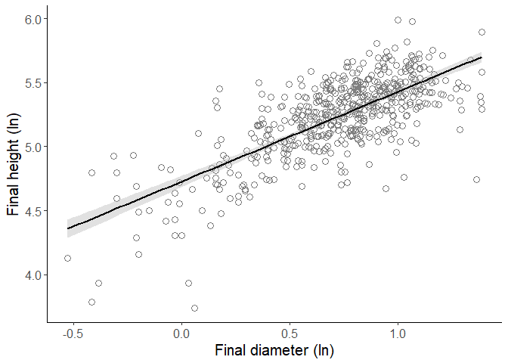

*Figure S2:2. Height-diameter relationship from a linear model of final shoot height on diameter of intact* L. vernus *plants (n=540). Final shoot height and diameter were transformed to natural logarithms before analysis*

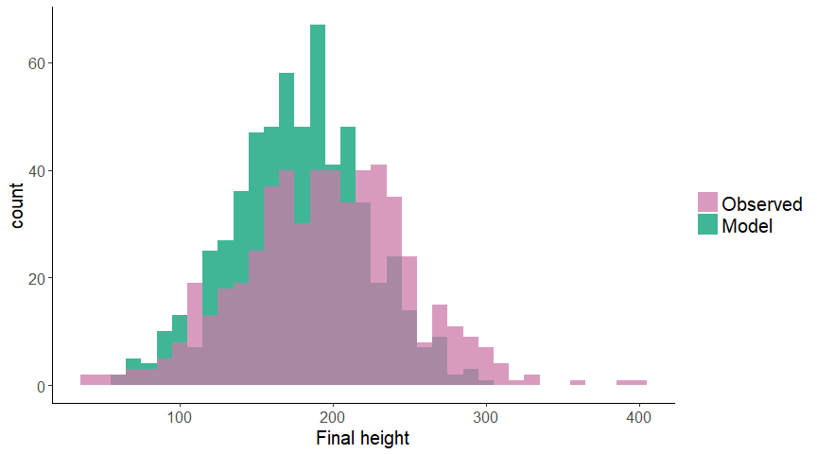

*Figure S2:3. Histogram of observed and model estimates of final heights for the* L. vernus *study population (n=1139)*

### References

R Core Team. 2016. R: a language and environment for statistical computing. R Foundation for Statistical Computing, Vienna, Austria.

# Appendix S3: Estimating first flowering day

We divided all flowering plants (n=670) into four groups: 1) intact plants (n = 341), 2) grazed plants for which buds had been observed prior to grazing (n = 63), 3) plants grazed before displaying buds during weeks when buds were visible in the plant population (n = 182), and 4) plants that had been grazed before any bud size observations had been made in the plant population (n = 84). Due to the variation in information available, different methods had to be used to estimate first flowering day for the different groups. To account for possible measurement errors due to grazing, we removed bud size observations from the week of grazing for all flowering plants marked as grazed. All analyses were carried out in R version 3.3.2 (R Core Team 2016).

## S3:1 Non-grazed plants

First flowering day for non-grazed plants that started flowering between recordings was estimated by adding 1-6 days, based on bud size, to the Julian date of the last recording before flowering (Table S3:1). I.e. if the largest bud of a plant was recorded as large day 118 of the year, and observed to be flowering the next week, its first flowering day was estimated to day 118 + 2 = 120 of the year. These plants were considered to have "observed" first flowering day and were marked as such in the dataset.

*Table S3:1. Bud size categories with description. First flowering day was estimated by adding a specific number of days to the Julian day of the observation of a largest bud in a given category.*

|  |  |  |
| --- | --- | --- |
| **Bud size, abbreviation, (numeric)** | **Description** | **Days from bud size observation until first flowering day** |
| Extra Small, XS (1) | Very small, green bud | 6 |
| Small, S (2) | Petals becoming visible | 5 |
| Medium, M (3) | Visible part of petals longer than sepal tube | 3.5 |
| Large, L (4) | Bud elongated, about to open | 2 |
| Extra Large, XL (5) | Bud opening, flowering the next day | 1 |

## S3:2 Grazed plants with observed bud size

First flowering day of grazed plants for which bud size had been observed on at least one occasion before grazing (n=63) was estimated using coefficients from a linear model of first flowering day on bud size, biomass and week of observation of plants with observed first flowering day (n=341) (R2model = 0.75, Equation S3:1). Bud size per week was the smallest unit in the dataset constructed for this analysis, why measurements from the same intact plant individuals were included repeatedly, week by week (nobservations=915). Bud size categories were transformed into a numeric scale before analysis (Table S3:1). Week was included as the number of the week when an observation was made, counted from the first week of the year. Variance inflation factors for the covariates were lower than 2. Validation of model assumptions was done by visual inspection.

The correlation coefficient for observed FFD and model estimates of FFD, for plants with observed FFD, was 0.924 (Pearson's product-moment correlation, t300=40, p < 0.001). The resulting FFDs are presented in figure S3:1.

$$FFD \overset{̃}{ }N(μ_{i},σ^{2})$$

$$var(FFD)=σ^{2}$$

$$E(FFD)=μ_{i}$$

$μ_{i}=Bud size+Size+Week number$ (Eqn. S3:1)

*Table S3:2. Estimates from a linear model of bud size(nobservations=923), vegetative size and week of observation on first flowering day of intact flowering* L. vernus *individuals (n=341).*

|  |  |  |  |  |
| --- | --- | --- | --- | --- |
|  | **Estimate** | **SE** | **t-value** | **P-value** |
| Intercept | 41.632 | 1.743 | 23.889 | 0 |
| Bud size | -2.415 | 0.076 | -31.877 | 0 |
| Size | 0.000 | 0.000 | -4.372 | 0 |
| Week | 5.172 | 0.103 | 50.361 | 0 |

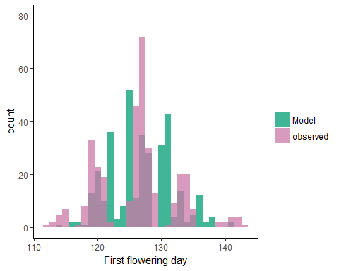

*Figure S3:1: Model estimates and observed values, respectively, of first flowering day in Julian days for*  L. vernus *plants with observed FFD (n=341)*.

## S3:3 Grazed plants without bud size

Ungulate grazers most often target *L. vernus* plants during flowering (Ehrlén 2002) thus plants that were grazed before buds could be observed were considered flowering if they reached a previously observed threshold biomass of >=230mm3 (Ehrlén 1995) during the flowering period.  
Our estimates of FFD for plants without observed buds were founded upon two assumptions: 1) that flowering plants with no observed bud size were in a smallest possible bud stage (XXS) the week before they were grazed (and that their largest bud would be extra-small (XS) buds the week after, had they not been grazed), and 2) that the difference in average FFD between plants with XS and small (S) buds corresponded to the difference in average FFD between plants with XXS and XS buds in the same week. To estimate of the difference in FFD of plants that were in bud stage XXS and XS, respectively, in a given week (*w*), we calculated the difference in average FFD ($\overline{FFD}$) of plants in the two smallest observed bud sizes, XS and S, for each week (“interval”, Table S3:3). FFD for grazed plants without observed bud size was then estimated by adding the difference in average FFD between intact plants displaying XS and S buds to the average FFD of intact plants who had size XS buds the week before grazing of the focal plant (Equation S3:2, Table S3:2b).

Eqn. S3:2 $FFD_{XXS,w}=FFD_{grazed w+1}={\overline{FFD}}_{XS w}+({\overline{FFD}}_{S w}-{\overline{FFD}}_{XS w})$

The first buds were visible in the study population during the second week of field measurements (6-10 April 2015). Thus, the first flowering days of plants grazed that week could not be estimated using observed bud sizes in the previous week of measurements. Instead, we estimated the difference in average FFD of intact plants with XS buds the week of grazing of the focal plant, and the week after grazing of the focal plant. This difference, or interval, was then added to the average FFD of intact plants with XS buds (Equation S3:3, Table S3:2a). The distribution of the resulting estimates of first flowering days in the study population are provided in Figure S3:2.

Eqn. S3:3 $FFD_{XXS w}={\overline{FFD}}_{XS w}+({\overline{FFD}}_{XS w+1}-{\overline{FFD}}_{XS w})$

*Table S3:3. Average first flowering day (FFD) of intact* L.vernus *plants (n=341) with largest observed bud of size XS and/or S during the weeks of the field study (dates of measurement provided) and the difference (interval) in average FFD between a) intact plants with XS buds the week of grazing of the focal plant and plants with size XS buds the week after grazing of the focal plant, and b)intact plants with size S and XS buds, respectively, per week.* *FFD for plants grazed before buds were observed was estimated by adding the interval to the average FFD of intact plants with XS buds a) the week before grazing of the focal plant or b) the week before grazing of the focal plant. Week number refers to the week before grazing was observed, when grazed plants were assumed to have buds in a smallest possible stage of development (XXS)*

|  |  |  |  |  |  |
| --- | --- | --- | --- | --- | --- |
| week | dates | FFD (intact XS) | FFD (intact S) | interval | FFD (XXS) |
| a |  |  |  |  |  |
| 14 | 15-03-30 - 15-04-03 |  |  | 3.087 | 122.455 |
| b |  |  |  |  |  |
| 15 | 15-04-06 - 15-04-10 | 118.49 | 122.016 | 3.526 | 125.542 |
| 16 | 15-04-13 - 15-04-17 | 120.272 | 124.451 | 4.178 | 128.629 |
| 17 | 15-04-20 - 15-04-24 | 123.231 | 127.243 | 4.012 | 131.254 |
| 18 | 15-04-27 - 15-05-01 | 128.758 | 132.804 | 4.045 | 136.849 |
| 19 | 15-05-04 - 15-05-08 | 134.434 | 137.251 | 2.818 | 140.069 |
| 20 | 15-05-11 - 15-05-15 | 141.1 | NaN | NaN | NaN |
| 21 | 15-05-18 - 15-05-22 | NaN | NaN | NaN | NaN |

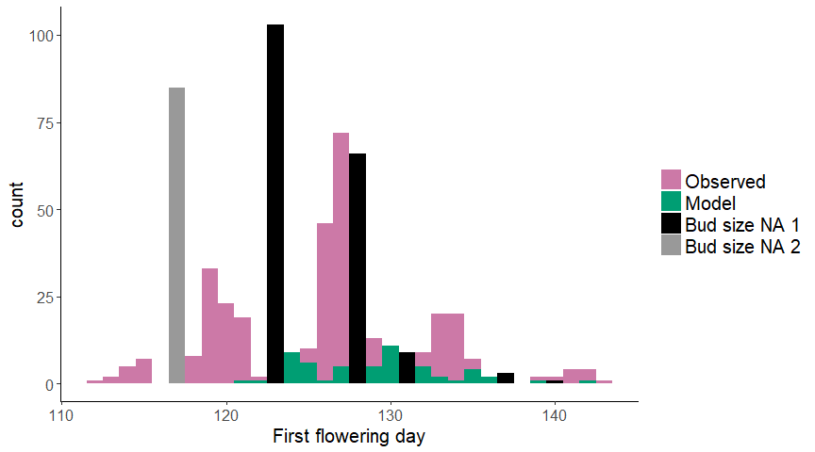

*Figure S3:2 Distribution of observed first flowering days (day of year) of intact plants (n=341) and first flowering days of grazed plants estimated with a linear model ("Model", n=63), average first flowering days of intact plants in the smallest obeserved bud stages the week before grazing ("Bud size NA 1", n=182) and average first flowering day of intact plants the week of grazing of the focal plant ("Bud size NA 2", n=84)*

### References

Ehrlén, J. 1995. Demography of the Perennial Herb Lathyrus Vernus. I. Herbivory and Individual Performance. The Journal of Ecology 83:287.  
Ehrlén, J. 2002. Assessing the lifetime consequences of plant-animal interactions for the perennial herb Lathyrus vernus (Fabaceae). Perspectives in Plant Ecology, Evolution and Systematics 5:145–163.  
R Core Team. 2016. R: a language and environment for statistical computing. R Foundation for Statistical Computing, Vienna, Austria.

# Appendix S4: Estimating predation for dispersed seeds

For fruits that had opened prior to examination (27.9 % of all collected fruits), the number of seeds and holes on the fruit wall could be counted, as ovules stay attached to the fruit when it opens and seeds leave indentations on the fruit wall. However, seed predation for these fruits had to be estimated from fruits that had not yet opened when checked for seed number and evidence of seed predation (n~intact fruits~=1516). We transformed the number of holes made by the seed predator on pod wall and seeds, respectively, into proportions by dividing each measure by the total number of seeds.

This was done for each intact fruit. Linear models could not satisfactory explain the relationship, why we fitted an exponential asymptotic regression model using non-linear least squares (nls) in R version 3.3.2 (R Core Team 2016).

The starting asymptotic value of y was set to 1. The starting value of the rate constant was obtained as the slope from a linear model of the number of holes in pod wall per total number of seeds, on the proportion of seeds preyed upon per total number of seeds (linear model, estimate±SE =0.271±0.008, t= 35.1, p < 0.001) was used as a starting value for the intercept).

The formula that best described the observed data was $y=a(1-e^{-bx})$ where *a* represents the asymptotic value of y, and *b* is the rate constant (Table S4:1). The model explained 74.5% of the variation in proportion of seeds preyed upon. The correlation coefficent for observed and estimated proportions of seeds preyed upon was 0.863 (Pearson's product-moment correlation, t1936=75.114, p <0.001).  
We estimated the proportion of seeds preyed upon for open fruits using the formula above, inserting the rate constant of 1.21 from the non-linear least squares model (Table S4:1) and an asymptotic y of 1. The resulting proportions were back-transformed to counts of seeds preyed upon (Figure S4:1). The correlation coefficient for observed and estimated seeds counts preyed upon was 0.909 (Pearson's product-moment correlation, t1936=96.178, p <0.001)

*Table S4:1. Results from a non-linear least squares model of number of holes on pod walls per total number of seeds on the proportion of seeds preyed upon in fruits that had not open prior to examination (n = 1516).*

|  |  |  |  |  |
| --- | --- | --- | --- | --- |
|  | Estimate | SE | t-value | P-value |
| a, Asymptotic value of y | 0.998 | 0.018 | 54.320 | 0 |
| b, Rate constant | 1.219 | 0.052 | 23.641 | 0 |

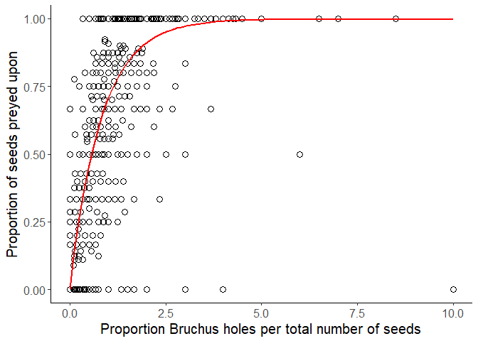

*Figure S4:1. The relationship between proportion of seeds preyed upon and number of* Bruchus atomarius *holes in the pod wall of* Lathyrus vernus *fruits that had not open prior to examination (n = 1516)*.

### References

R Core Team. 2016. R: a language and environment for statistical computing. R Foundation for Statistical Computing, Vienna, Austria.

# Appendix S5: Model equations

Here we present the models used for our statistical analyses.

## S5:1 Phenotypic selection

We used six different linear models. To estimate selection differentials, we ran two single trait models of relative fitness on FFD and number of flowers, respectively (Eqn. S5:1a-b). Phenotypic selection gradients were estimated with multiple linear regressions (Eqn. S5:1c-d)

Eqn. S5:1 $Relative fitness \overset{̃}{ }N(μ,σ)$, $E(Relative fitness)=μ$



$μ=trait_{i}$

$μ=trait_{i}+trait_{i}^{2}$

$μ=FFD+Number of flowers$

$μ=FFD+FFD^{2}$ $+Number of flowers+Number of flowers^{2}$ $+FFD*Number of flowers$

## S5:2 Grazing and fitness components

To estimate the probability of escaping grazing, we used a generalized linear model (GLM) with binomial distribution and logit link function. Incidence of grazing (0 = yes, 1 = no) was used as response variable. FFD and number of flowers were included as covariates together with their respecitve squared term and the interaction term FFD x number of flowers (Eqn. 5:2).

Eqn. S5:2