Update 24/01/2018

2016-2017: corrected FFD = faktiskt blomdatum/blomstart , but for a few plants where this was not noted, I took the last date noted in “uppskattat blomdatum”/blomstart.

2016: cum_n_fl 🡪used either “maxblom” or “Gissat blomantal efter bete”. For a few plants where neither of these was noted, I took the last value noted in “uppskattat blm n”.

2017: cum_n_fl 🡪I used the last noted value of “Blomantal”.

2016-2017: Grazing sometimes hard to determine from the comments, when less than 100% was grazed but I could not calculate from the number of flower recordings in each date, I assigned grazing as 0,5 (few cases).

Recalculated shoot height for grazed shoots in all years 2006-2015 using:

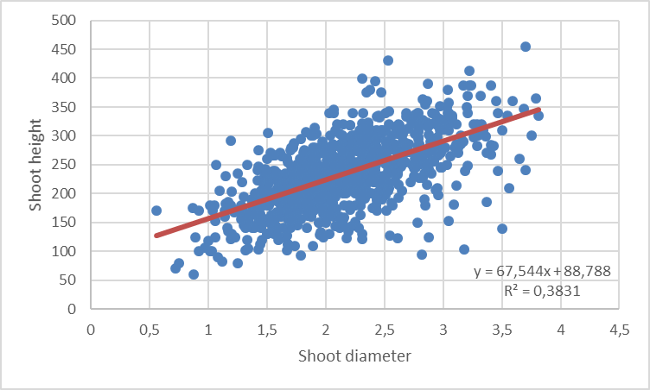

2016: Shoot heights are available, but not diameters. I used the opposite relationship to estimate diameter from height (as only height was noted), but the average diameter was quite small (= 0.92). I guess this is maybe because the height measured is not the real height, but the height after grazing (as many shoots were grazed). I am not sure how to solve this!

2017: there is diameter for grazed shoots, and both diameter and height for ungrazed shoots. I calculated height for grazed shoots using the regression above. Where height was available, the values were extremely low (starting at 14 and lower than 100, so I guessed these were noted in cm and not mm). I used these values multiplied by 10 (so in mm as previous years).