Update 24/01/2018

2016-2017: corrected FFD = faktiskt blomdatum/blomstart , but for a few plants where this was not noted, I took the last date noted in “uppskattat blomdatum”/blomstart.

**OK**

2016: cum_n_fl 🡪used either “maxblom” or “Gissat blomantal efter bete”. For a few plants where neither of these was noted, I took the last value noted in “uppskattat blm n”.

**OK**

2017: cum_n_fl 🡪I used the last noted value of “Blomantal”.

**OK**

2016-2017: Grazing sometimes hard to determine from the comments, when less than 100% was grazed but I could not calculate from the number of flower recordings in each date, I assigned grazing as 0,5 (few cases).

**OK. If you tell me which cases, I can have a look.**

Recalculated shoot height for grazed shoots in all years 2006-2015 using:

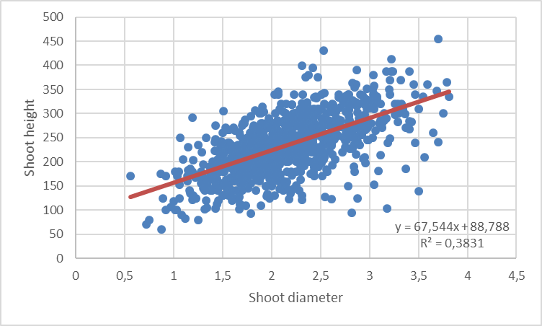

2016: Shoot heights are available, but not diameters. I used the opposite relationship to estimate diameter from height (as only height was noted), but the average diameter was quite small (= 0.92). I guess this is maybe because the height measured is not the real height, but the height after grazing (as many shoots were grazed). I am not sure how to solve this!

**Yes this is clearly a too small value for average diameter. Also in 2016 in 2016 heights are in cm and should be multiplied by then before applying the formula. Could that explain the problem? An approximately median shoot of 24 cm in the 2016 data would then have a diameter of (240-88.8)/67.5=2.24 which makes more sense!?**

2017: there is diameter for grazed shoots, and both diameter and height for ungrazed shoots. I calculated height for grazed shoots using the regression above. Where height was available, the values were extremely low (starting at 14 and lower than 100, so I guessed these were noted in cm and not mm). I used these values multiplied by 10 (so in mm as previous years).

**You are right, also in 2017 all heights are in cm.**