Supplementary Material
Appendix S1: Supplementary methods

Calculations of vegetative size when some shoot measures were missing
In some cases not all shoots belonging to a plant were measured. In these cases, unmeasured shoots were assumed to have values of height and diameter equal to the average values of the measured shoots in the same individual. For shoots that had been grazed before measuring, we could only measure shoot diameter. Height was then estimated using coefficients from a linear model of shoot height on shoot diameter for non-grazed plants (Table S1.1).

Table S1.1: Results from a linear model of shoot height on shoot diameter for non-grazed plants (n = 928 plants).
 | Estimate |  | Std. error | t | Adj. R²
Intercept | 88.788 | *** | 6.243 | 14.22 | 0.382
Shoot diameter | 67.544 | *** | 2.817 | 23.98
***P < 0.001; **P < 0.01; *P < 0.05

Estimation of the number of intact and preyed seeds in fruits that had opened prior to the recording
For fruits that had opened prior to the recording in the field, the remaining pod walls were brought to the lab for examination. At the lab, we counted the number of indentations made by developed seeds in the fruit wall and the number of larval entrance holes in the fruit wall. The proportion of seeds preyed upon was estimated using coefficients from a nonlinear least squares model of the form y = a (1 – e ^ (-bx)), where y represents the proportion of seeds preyed upon, a represents the asymptotic value of y, b is the rate constant and x represents the per seed number of holes in the fruit walls for fruits that had not opened. For this study we used the parameter values a = 0.998 and b = 1.219, which had been estimated using another dataset consisting of 1516 intact fruits of L. vernus (E. Fogelstrom & J. Ehrlén in review).

Estimation of the most likely first flowering day (FFD) for each individual
The most likely first flowering day (FFD) for each individual was estimated based on three sources of information. First, for individuals with just open flowers, FFD was set to the day of recording. Just opened flowers were identified based on that flowers had opened and were accessible to pollinators at the time of recording but were still not fully unfolded. Second, for individuals with flowers that had not opened at the day of the recording we used the information about size and developmental stage of buds at the visit prior to the visit at which the first open flower was recorded to prospectively predict the most likely date at which the individual had started to flower. More specifically, we added 4, 3, 2, or 1 days, respectively, to the day of year of the last bud size observation before flowering to small, medium, large or very large buds, respectively, thus assuming that very large buds had opened the first day of the interval and that small buds had opened the day before a plant was observed to be flowering. Third, for individuals with flowers that had not opened at the day of the recording we also used information on the developmental stage of the most advanced flower and the number of open flowers at the first recording of an individual with open flowers to retrospectively predict the date at which the first flower had opened. More specifically, for open flowers, FFD was estimated to have occurred 1 day earlier if 1-2 flowers had fully opened but showed no sign of wilting at the day of the recording, 2 days earlier if 3 or more flowers had opened and showed no sign of wilting, 3 days earlier if more flowers had opened or if any flower showed early signs of wilting, and 4 days earlier if flowers showed clear sign of wilting. If cases where the prospective and retrospective estimates of FFD differed, we used the mean of these two as an estimate of FFD. Daily recordings of a subset of flowers in some of the study years show that this method often assigns the correct FFD and that the estimate never differs with more than one day from the actual date (J. Ehrlén pers. obs.).
Sometimes plants were grazed before the first flower appeared. If less than 50% of the shoots were grazed, we recorded FFD in the remaining shoot(s), as described above. If 50% or more of the shoots were grazed (n = 102 plants), we considered that using data on the presence or absence of open flowers after grazing to estimate FFD could lead to a bias, because the grazed shoots might have had an earlier phenology than the non-grazed shoots. In cases where bud size had been recorded on at least one occasion before grazing (n = 56 plants 2006-2015), FFD was estimated using coefficients from yearly linear models of FFD on bud size and day of the year for bud size recording (and the interaction bud size : day of the year, when it was significant) for plants that were not grazed (Table S1.2).

Table S1.2: Results from yearly linear models of FFD on bud size, day of the year (and the interaction bud size : day of the year when it was significant) for plants with observed FFD.
Year | Term | Estimate |  | Std. error | t | n | Adj. R²
2006 | Intercept | -65.810 | *** | 12.075 | -5.45 | 97 | 0.591
2006 | Bud size | -4.237 | *** | 0.565 | -7.50 | 97 | 0.591
2006 | Day of the year | 1.019 | *** | 0.094 | 10.99 | 97 | 0.591
2007 | Intercept | -13.965 | ** | 5.110 | -2.73 | 136 | 0.604
2007 | Bud size | -4.246 | *** | 0.395 | -10.74 | 136 | 0.604
2007 | Day of the year | 0.614 | *** | 0.045 | 13.71 | 136 | 0.604
2008 | Intercept | -59.718 | *** | 4.118 | -14.50 | 82 | 0.920
2008 | Bud size | -3.864 | *** | 0.306 | -12.61 | 82 | 0.920
2008 | Day of the year | 0.951 | *** | 0.033 | 29.04 | 82 | 0.920
2009 | Intercept | -54.561 | *** | 6.089 | -8.96 | 124 | 0.758
2009 | Bud size | -3.416 | *** | 0.305 | -11.20 | 124 | 0.758
2009 | Day of the year | 0.906 | *** | 0.048 | 18.91 | 124 | 0.758
2010 | Intercept | 47.586 | *** | 11.125 | 4.28 | 219 | 0.484
2010 | Bud size | -38.111 | *** | 5.033 | -7.57 | 219 | 0.484
2010 | Day | 0.121 |  | 0.086 | 1.41 | 219 | 0.484
2010 | Bud size : Day of the year | 0.267 | *** | 0.038 | 7.11 | 219 | 0.484
2011 | Intercept | -5.404 |  | 9.439 | -0.57 | 254 | 0.622
2011 | Bud size | -17.586 | *** | 3.796 | -4.63 | 254 | 0.622
2011 | Day | 0.505 | *** | 0.076 | 6.66 | 254 | 0.622
2011 | Bud size : Day | 0.120 | *** | 0.030 | 4.04 | 254 | 0.622
2012 | Intercept | 32.833 | *** | 4.499 | 7.30 | 439 | 0.622
2012 | Bud size | -28.149 | *** | 2.517 | -11.18 | 439 | 0.622
2012 | Day | 0.233 | *** | 0.036 | 6.46 | 439 | 0.622
2012 | Bud size : Day | 0.194 | *** | 0.019 | 10.13 | 439 | 0.622
2013 | Intercept | 39.685 |  | 23.503 | 1.69 | 81 | 0.346
2013 | Bud size | -19.305 | * | 7.829 | -2.47 | 81 | 0.346
2013 | Day | 0.154 |  | 0.176 | 0.88 | 81 | 0.346
2013 | Bud size : Day | 0.140 | * | 0.058 | 2.41 | 81 | 0.346
2014 | Intercept | -21.676 | * | 9.751 | -2.22 | 115 | 0.831
2014 | Bud size | -17.682 | *** | 5.220 | -3.39 | 115 | 0.831
2014 | Day | 0.647 | *** | 0.078 | 8.33 | 115 | 0.831
2014 | Bud size : Day | 0.109 | ** | 0.041 | 2.67 | 115 | 0.831
2015 | Intercept | -71.745 | *** | 7.548 | -9.51 | 45 | 0.863
2015 | Bud size | -5.130 | *** | 0.570 | -9.00 | 45 | 0.863
2015 | Day | 1.077 | *** | 0.065 | 16.67 | 45 | 0.863
***P < 0.001; **P < 0.01; *P < 0.05

Estimation of the total number of flowers from vegetative size
Sometimes the total number of flowers could not be assessed because of grazing (n = 75 plants). In these cases, when vegetative size was available (n = 63 plants), total number of flowers was estimated using coefficients from a negative binomial model of total number of flowers on vegetative size in individuals that had not been grazed (Table S1.3).

Table S1.3: Results from a negative binomial model of total number of flowers on vegetative size (n = 2173 plants).
 | Estimate |  | Std. error | z | Nagelkerke R²
Intercept | 1.923 | *** | 0.021 | 91.00 | 0.572
Vegetative size | 0.003 | *** | 8.09*10⁻⁶ | 40.28
Overdispersion (Theta) | 1.985 |  | 0.068
***P < 0.001; **P < 0.01; *P < 0.05

Estimation of missing temperature values
Daily minimum, mean and maximum temperature values were missing from the Södertälje station for 71 days (April 1988, March and April 2015). In those cases, we imputed the missing values using the monthly relationships between values of the Södertälje and Oxelösund stations over all years (Table S1.4).

Table S1.4: Results from linear models of temperatures in Södertälje on temperatures in Oxelösund, for each of the months with missing data.
Month | Temperature variable | Term | Estimate |  | SE | t | Adj. R²
3 | Daily minimum | Intercept | -0.947 | *** | 0.046 | -20.75 | 0.867
3 | Daily minimum | Value Oxelösund | 1.013 | *** | 0.009 | 106.97 | 0.867
3 | Daily mean | Intercept | -0.469 | *** | 0.025 | -18.74 | 0.934
3 | Daily mean | Value Oxelösund | 1.006 | *** | 0.006 | 157.37 | 0.934
3 | Daily maximum | Intercept | 0.376 | *** | 0.057 | 6.55 | 0.842
3 | Daily maximum | Value Oxelösund | 0.939 | *** | 0.010 | 96.80 | 0.842
4 | Daily minimum | Intercept | -0.830 | *** | 0.046 | -17.90 | 0.722
4 | Daily minimum | Value Oxelösund | 0.926 | *** | 0.014 | 65.53 | 0.722
4 | Daily mean | Intercept | 0.127 | * | 0.055 | 2.31 | 0.870
4 | Daily mean | Value Oxelösund | 1.018 | *** | 0.010 | 105.19 | 0.870
4 | Daily maximum | Intercept | 1.468 | *** | 0.142 | 10.38 | 0.725
4 | Daily maximum | Value Oxelösund | 0.967 | *** | 0.015 | 65.92 | 0.725
***P < 0.001; **P < 0.01; *P < 0.05

Table S1: Univariate linear regressions of all climatic variables on year for (A) the 22 study years, and (B) the period 1961-2017.
Variable | A) 1987-1996 and 2006-2017 |  |  |  |  | B) 1961-2017
Variable | Estimate |  | Std. error | t |  | Estimate |  | Std. error | t
Precipitation March | 0.422 |  | 0.605 | 0.70 |  | 0.229 |  | 0.137 | 1.68
Precipitation April | 0.381 |  | 0.729 | 0.52 |  | -0.029 |  | 0.153 | -0.19
Precipitation May | 0.749 |  | 0.779 | 0.96 |  | 0.055 |  | 0.176 | 0.31
Min March | 0.046 |  | 0.097 | 0.47 |  | 0.054 | * | 0.021 | 2.56
Min April | 0.020 |  | 0.034 | 0.59 |  | 0.030 | *** | 0.008 | 3.74
Min May | 0.024 |  | 0.038 | 0.63 |  | 0.026 | ** | 0.008 | 3.19
Mean March | 0.081 |  | 0.090 | 0.90 |  | 0.049 | * | 0.019 | 2.62
Mean April | 0.067 |  | 0.045 | 1.49 |  | 0.045 | *** | 0.010 | 4.40
Mean May | 0.027 |  | 0.049 | 0.55 |  | 0.030 | ** | 0.009 | 3.26
Max March | 0.130 |  | 0.088 | 1.47 |  | 0.048 | * | 0.019 | 2.61
Max April | 0.104 |  | 0.057 | 1.82 |  | 0.057 | *** | 0.013 | 4.26
Max May | 0.034 |  | 0.059 | 0.57 |  | 0.032 | ** | 0.011 | 2.91
***P < 0.001; **P < 0.01; *P < 0.05

Table S2: Results of linear models showing the fixed effects of climate and year on (A) first flowering date (FFD) for individual plants, and on three measures of the position (B) and duration (C) of the flowering season of Lathyrus vernus during 22 study years. The position of the flowering season was defined by the start, i.e. the date when 10% of the plants had started flowering, the mean, i.e. the mean first flowering date, and the end, i.e. the date when 90% of the plants had started flowering. The duration of the flowering season was defined by the number of days between the start and the end. Climatic variables included in each model were selected based on if they had a significant effect in the averaged models resulting from model selection (see Table 1 in main text). In (A), a linear mixed model with plant individual as a random effect was used, and the marginal pseudo-R² (representing the variance explained by the fixed effects) is provided.

Response variable | Predictor variable | Estimate |  | Std. error | t
A) FFD
N = 2411  R² _{marg} = 0.588  R² _{cond} = 0.628 | Precipitation March | -0.756 | *** | 0.103 | -7.31
N = 2411  R² _{marg} = 0.588  R² _{cond} = 0.628 | Precipitation April | -0.269 | * | 0.122 | -2.20
N = 2411  R² _{marg} = 0.588  R² _{cond} = 0.628 | Mean April | -2.180 | *** | 0.121 | -18.06
N = 2411  R² _{marg} = 0.588  R² _{cond} = 0.628 | Mean May | -3.831 | *** | 0.106 | -36.22
N = 2411  R² _{marg} = 0.588  R² _{cond} = 0.628 | Number of flowers | -2.359 | *** | 0.100 | -23.53
N = 2411  R² _{marg} = 0.588  R² _{cond} = 0.628 | Year | -0.054 | *** | 0.012 | -4.68
B) Position of the flowering season
Start  N = 22  R² = 0.712 | Precipitation March | -1.023 |  | 0.902 | -1.14
Start  N = 22  R² = 0.712 | Precipitation April | -0.145 |  | 0.994 | -0.15
Start  N = 22  R² = 0.712 | Mean April | -4.126 | ** | 1.118 | -3.69
Start  N = 22  R² = 0.712 | Mean May | -3.472 | *** | 0.839 | -4.14
Start  N = 22  R² = 0.712 | Year | -0.060 |  | 0.082 | -0.73
Mean  N = 22  R² = 0.779 | Precipitation March | -0.851 |  | 0.701 | -1.21
Mean  N = 22  R² = 0.779 | Precipitation April | -0.298 |  | 0.772 | -0.39
Mean  N = 22  R² = 0.779 | Mean April | -2.891 | ** | 0.868 | -3.33
Mean  N = 22  R² = 0.779 | Mean May | -3.910 | *** | 0.652 | -6.00
Mean  N = 22  R² = 0.779 | Year | -0.095 |  | 0.064 | -1.48
End  N = 22  R² = 0.839 | Precipitation March | -0.479 |  | 0.557 | -0.86
End  N = 22  R² = 0.839 | Precipitation April | -0.683 |  | 0.614 | -1.11
End  N = 22  R² = 0.839 | Mean April | -2.117 | ** | 0.691 | -3.07
End  N = 22  R² = 0.839 | Mean May | -4.519 | *** | 0.518 | -8.72
End  N = 22  R² = 0.839 | Year | -0.036 |  | 0.051 | -0.72
C) Duration of the flowering season
N = 22  R² = 0.544 | Precipitation March | 0.544 |  | 0.620 | 0.88
N = 22  R² = 0.544 | Precipitation April | -0.539 |  | 0.683 | -0.79
N = 22  R² = 0.544 | Mean April | 2.009 | * | 0.768 | 2.62
N = 22  R² = 0.544 | Mean May | -1.047 |  | 0.577 | -1.82
N = 22  R² = 0.544 | Year | 0.023 |  | 0.057 | 0.41
***P < 0.001; **P < 0.01; *P < 0.05

Table S3: Results of linear mixed models testing for effects of climate on fitness of Lathyrus vernus in 22 study years. All candidate models included number of flowers as a condition trait and plant individual as a random effect. Also shown are averaged estimates and z-values across all candidate models with ΔAICc < 2, and values of marginal and conditional pseudo-R² (representing, respectively, the variance explained by the fixed effects and by the entire model, Nakagawa & Schielzeth 2013) were 0.177 and 0.213 for the best model resulting from model selection. ∑w_{i} = Relative variable importance (sum of Akaike weights over all models including each variable). N = 2411 for all models.
Predictor variable | Estimate |  | Std. error | z
Precipitation March | 0.551 | ** | 0.195 | 2.83
Precipitation April | -0.920 | *** | 0.222 | 4.15
Precipitation May | -0.040 |  | 0.124 | 0.32
Min March | 0.042 |  | 0.128 | 0.33
Max March | -0.109 |  | 0.208 | 0.52
Max April | -0.935 | *** | 0.236 | 3.97
Min May | -0.545 | * | 0.214 | 2.55
Number of flowers | 3.731 | *** | 0.176 | 21.15
***P < 0.001; **P < 0.01; *P < 0.05

Table S4: Phenotypic selection differentials and standard errors for first flowering date and number of flowers in Lathyrus vernus in 22 study years. Values in bold are significant at α = 0.05.
Year | First flowering date |  | First flowering date² |  | Number of flowers |  | Number of flowers²
Year | Estimate | SE | Estimate | SE | Estimate | SE | Estimate | SE
1987 | -0.372 | 0.092 | -0.053 | 0.153 | 0.766 | 0.081 | -0.006 | 0.043
1988 | -0.302 | 0.106 | -0.060 | 0.134 | 0.541 | 0.101 | 0.001 | 0.066
1989 | -0.609 | 0.128 | 0.133 | 0.198 | 0.846 | 0.113 | 0.027 | 0.099
1990 | -0.504 | 0.161 | 0.233 | 0.212 | 0.678 | 0.156 | -0.229 | 0.070
1991 | -0.600 | 0.078 | 0.132 | 0.140 | 0.667 | 0.075 | -0.013 | 0.060
1992 | -0.438 | 0.183 | 0.029 | 0.311 | 0.114 | 0.187 | -0.261 | 0.106
1993 | -0.448 | 0.131 | 0.040 | 0.217 | 0.435 | 0.132 | -0.132 | 0.086
1994 | -0.558 | 0.176 | 0.287 | 0.285 | 0.487 | 0.177 | -0.166 | 0.094
1995 | -0.487 | 0.218 | 0.307 | 0.357 | 0.420 | 0.222 | -0.191 | 0.115
1996 | -0.373 | 0.106 | -0.178 | 0.179 | 0.642 | 0.095 | -0.078 | 0.070
2006 | -0.423 | 0.133 | 0.169 | 0.147 | 0.776 | 0.113 | -0.095 | 0.042
2007 | -0.411 | 0.111 | 0.190 | 0.192 | 0.275 | 0.115 | -0.132 | 0.053
2008 | -0.500 | 0.120 | 0.321 | 0.126 | 0.760 | 0.102 | -0.101 | 0.057
2009 | -0.213 | 0.276 | -0.438 | 0.495 | 0.319 | 0.274 | -0.258 | 0.125
2010 | -0.492 | 0.164 | 0.283 | 0.284 | 0.280 | 0.170 | -0.300 | 0.109
2011 | -0.696 | 0.196 | 0.370 | 0.262 | 0.914 | 0.185 | 0.036 | 0.131
2012 | -1.035 | 0.187 | 1.119 | 0.275 | 1.054 | 0.186 | -0.179 | 0.110
2013 | -0.425 | 0.322 | 0.006 | 0.605 | 0.083 | 0.326 | -0.185 | 0.322
2014 | -0.668 | 0.173 | 0.355 | 0.286 | 0.252 | 0.191 | -0.222 | 0.091
2015 | 0.048 | 0.231 | -0.846 | 0.475 | -0.003 | 0.231 | -0.272 | 0.161
2016 | -0.351 | 0.096 | 0.015 | 0.136 | 0.606 | 0.083 | -0.062 | 0.066
2017 | 0.282 | 0.497 | -0.249 | 0.501 | -0.541 | 0.496 | 0.156 | 0.350

Table S5: Phenotypic selection gradients and standard errors for first flowering date and number of flowers in Lathyrus vernus in 22 study years. Values in bold are significant at α = 0.05.
Year | First flowering date |  | First flowering date² |  | First flowering date  x Number of flowers
Year | Estimate | SE | Estimate | SE | Estimate | SE
1987 | -0.078 | 0.088 | -0.071 | 0.085 | 0.010 | 0.180
1988 | -0.088 | 0.111 | 0.091 | 0.075 | 0.578 | 0.179
1989 | -0.144 | 0.143 | 0.035 | 0.134 | 0.061 | 0.225
1990 | -0.276 | 0.169 | -0.009 | 0.129 | -0.285 | 0.287
1991 | -0.321 | 0.089 | 0.056 | 0.087 | 0.183 | 0.172
1992 | -0.463 | 0.199 | 0.096 | 0.184 | 0.172 | 0.252
1993 | -0.321 | 0.144 | 0.105 | 0.127 | 0.222 | 0.196
1994 | -0.439 | 0.188 | 0.099 | 0.160 | -0.084 | 0.225
1995 | -0.371 | 0.248 | 0.100 | 0.280 | -0.070 | 0.496
1996 | -0.170 | 0.101 | -0.049 | 0.093 | -0.006 | 0.139
2006 | -0.210 | 0.117 | 0.131 | 0.085 | 0.340 | 0.255
2007 | -0.368 | 0.131 | 0.248 | 0.147 | 0.394 | 0.263
2008 | -0.201 | 0.112 | 0.070 | 0.066 | -0.096 | 0.245
2009 | -0.052 | 0.332 | 0.031 | 0.301 | 2.395 | 0.883
2010 | -0.478 | 0.195 | 0.196 | 0.165 | 0.379 | 0.358
2011 | -0.292 | 0.218 | 0.050 | 0.168 | -0.313 | 0.503
2012 | -0.665 | 0.210 | 0.370 | 0.187 | -0.335 | 0.430
2013 | -0.426 | 0.331 | 0.178 | 0.362 | 0.455 | 0.449
2014 | -0.777 | 0.211 | 0.340 | 0.207 | 0.315 | 0.351
2015 | 0.083 | 0.315 | -0.975 | 0.364 | -1.041 | 0.555
2016 | -0.055 | 0.097 | 0.005 | 0.076 | 0.500 | 0.189
2017 | -0.020 | 0.595 | -0.206 | 0.406 | -0.006 | 0.759

Table S6: Results of model selection and model averaging for the best candidate linear models testing for effects of climate on (A) total (direct and indirect) and (B) direct selection on flowering time in Lathyrus vernus in 22 study years. Linear mixed models with plant individual as a random effect and interactions of first flowering date with all climatic variables were used in model selection. In (B), number of flowers was used as a condition trait. Fitness was estimated by the number of intact seeds. Traits were standardized and fitness relativized within years before analyses. Averaged estimates and z-values across all models with ΔAICc < 2 are shown, and R² _{marg} and R² _{cond} are shown for the best models resulting from model selection. N = 2411 for all models. ∑w_{i} = Relative variable importance (sum of Akaike weights over all models including each variable).
Predictor variable |  | Estimate |  | Std. error | z | ∑w_{i}
A) Total selection (R²_{marg} = 0.052, R²_{cond} = 0.101)
 | First flowering date | -0.436 | *** | 0.041 | 10.52 | 1.00
 | First flowering date : Precipitation March | 0.177 | *** | 0.048 | 3.72 | 0.99
 | First flowering date : Precipitation April | -0.104 | * | 0.047 | 2.23 | 0.80
 | First flowering date : Precipitation May | -0.013 |  | 0.033 | 0.39 | 0.23
 | First flowering date : Min April | -0.168 | *** | 0.048 | 3.50 | 0.83
 | First flowering date : Min May | 0.020 |  | 0.041 | 0.50 | 0.28
 | First flowering date : Mean May | 0.018 |  | 0.040 | 0.45 | 0.21
 | First flowering date : Max May | 0.016 |  | 0.038 | 0.42 | 0.19
B) Direct selection (R²_{marg} = 0.079, R²_{cond} = 0.109)
 | First flowering date | -0.265 | *** | 0.046 | 5.77 | 1.00
 | Number of flowers | 0.377 | *** | 0.047 | 8.11 | 1.00
 | First flowering date : Precipitation March | 0.190 | *** | 0.047 | 4.04 | 1.00
 | First flowering date : Precipitation April | -0.108 | * | 0.046 | 2.35 | 0.84
 | First flowering date : Precipitation May | -0.013 |  | 0.033 | 0.40 | 0.24
 | First flowering date : Min April | -0.161 | *** | 0.047 | 3.40 | 0.83
 | First flowering date : Min May | 0.023 |  | 0.043 | 0.53 | 0.30
 | First flowering date : Mean May | 0.019 |  | 0.041 | 0.46 | 0.21
 | First flowering date : Max May | 0.016 |  | 0.038 | 0.42 | 0.19
***P < 0.001; **P < 0.01; *P < 0.05
Figure S1: Mean minimum daily temperature for three months in the years 1961-2017. Means (dots) and standard errors (whiskers) of minimum daily temperature during (A) March, (B) April, and (C) May. Lines show significant linear trends in temperature across years.
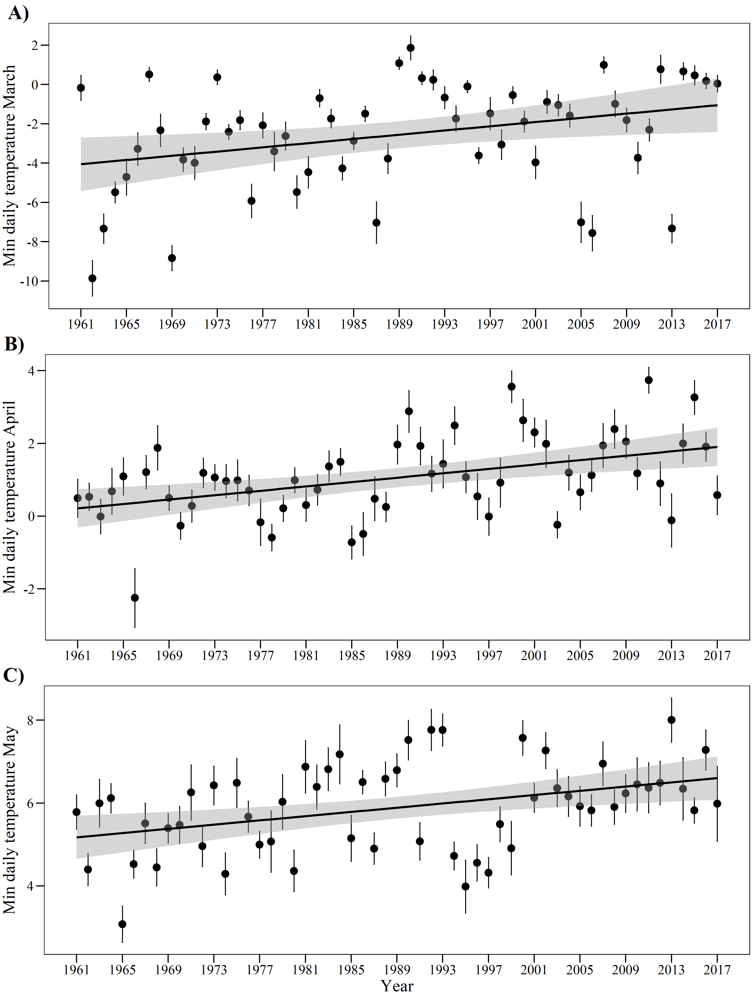
Figure S2: Mean daily mean temperatures for three months in the years 1961-2017. Means (dots) and standard errors (whiskers) of mean daily temperature during (A) March, (B) April, and (C) May. Lines show significant linear trends in temperature across years.
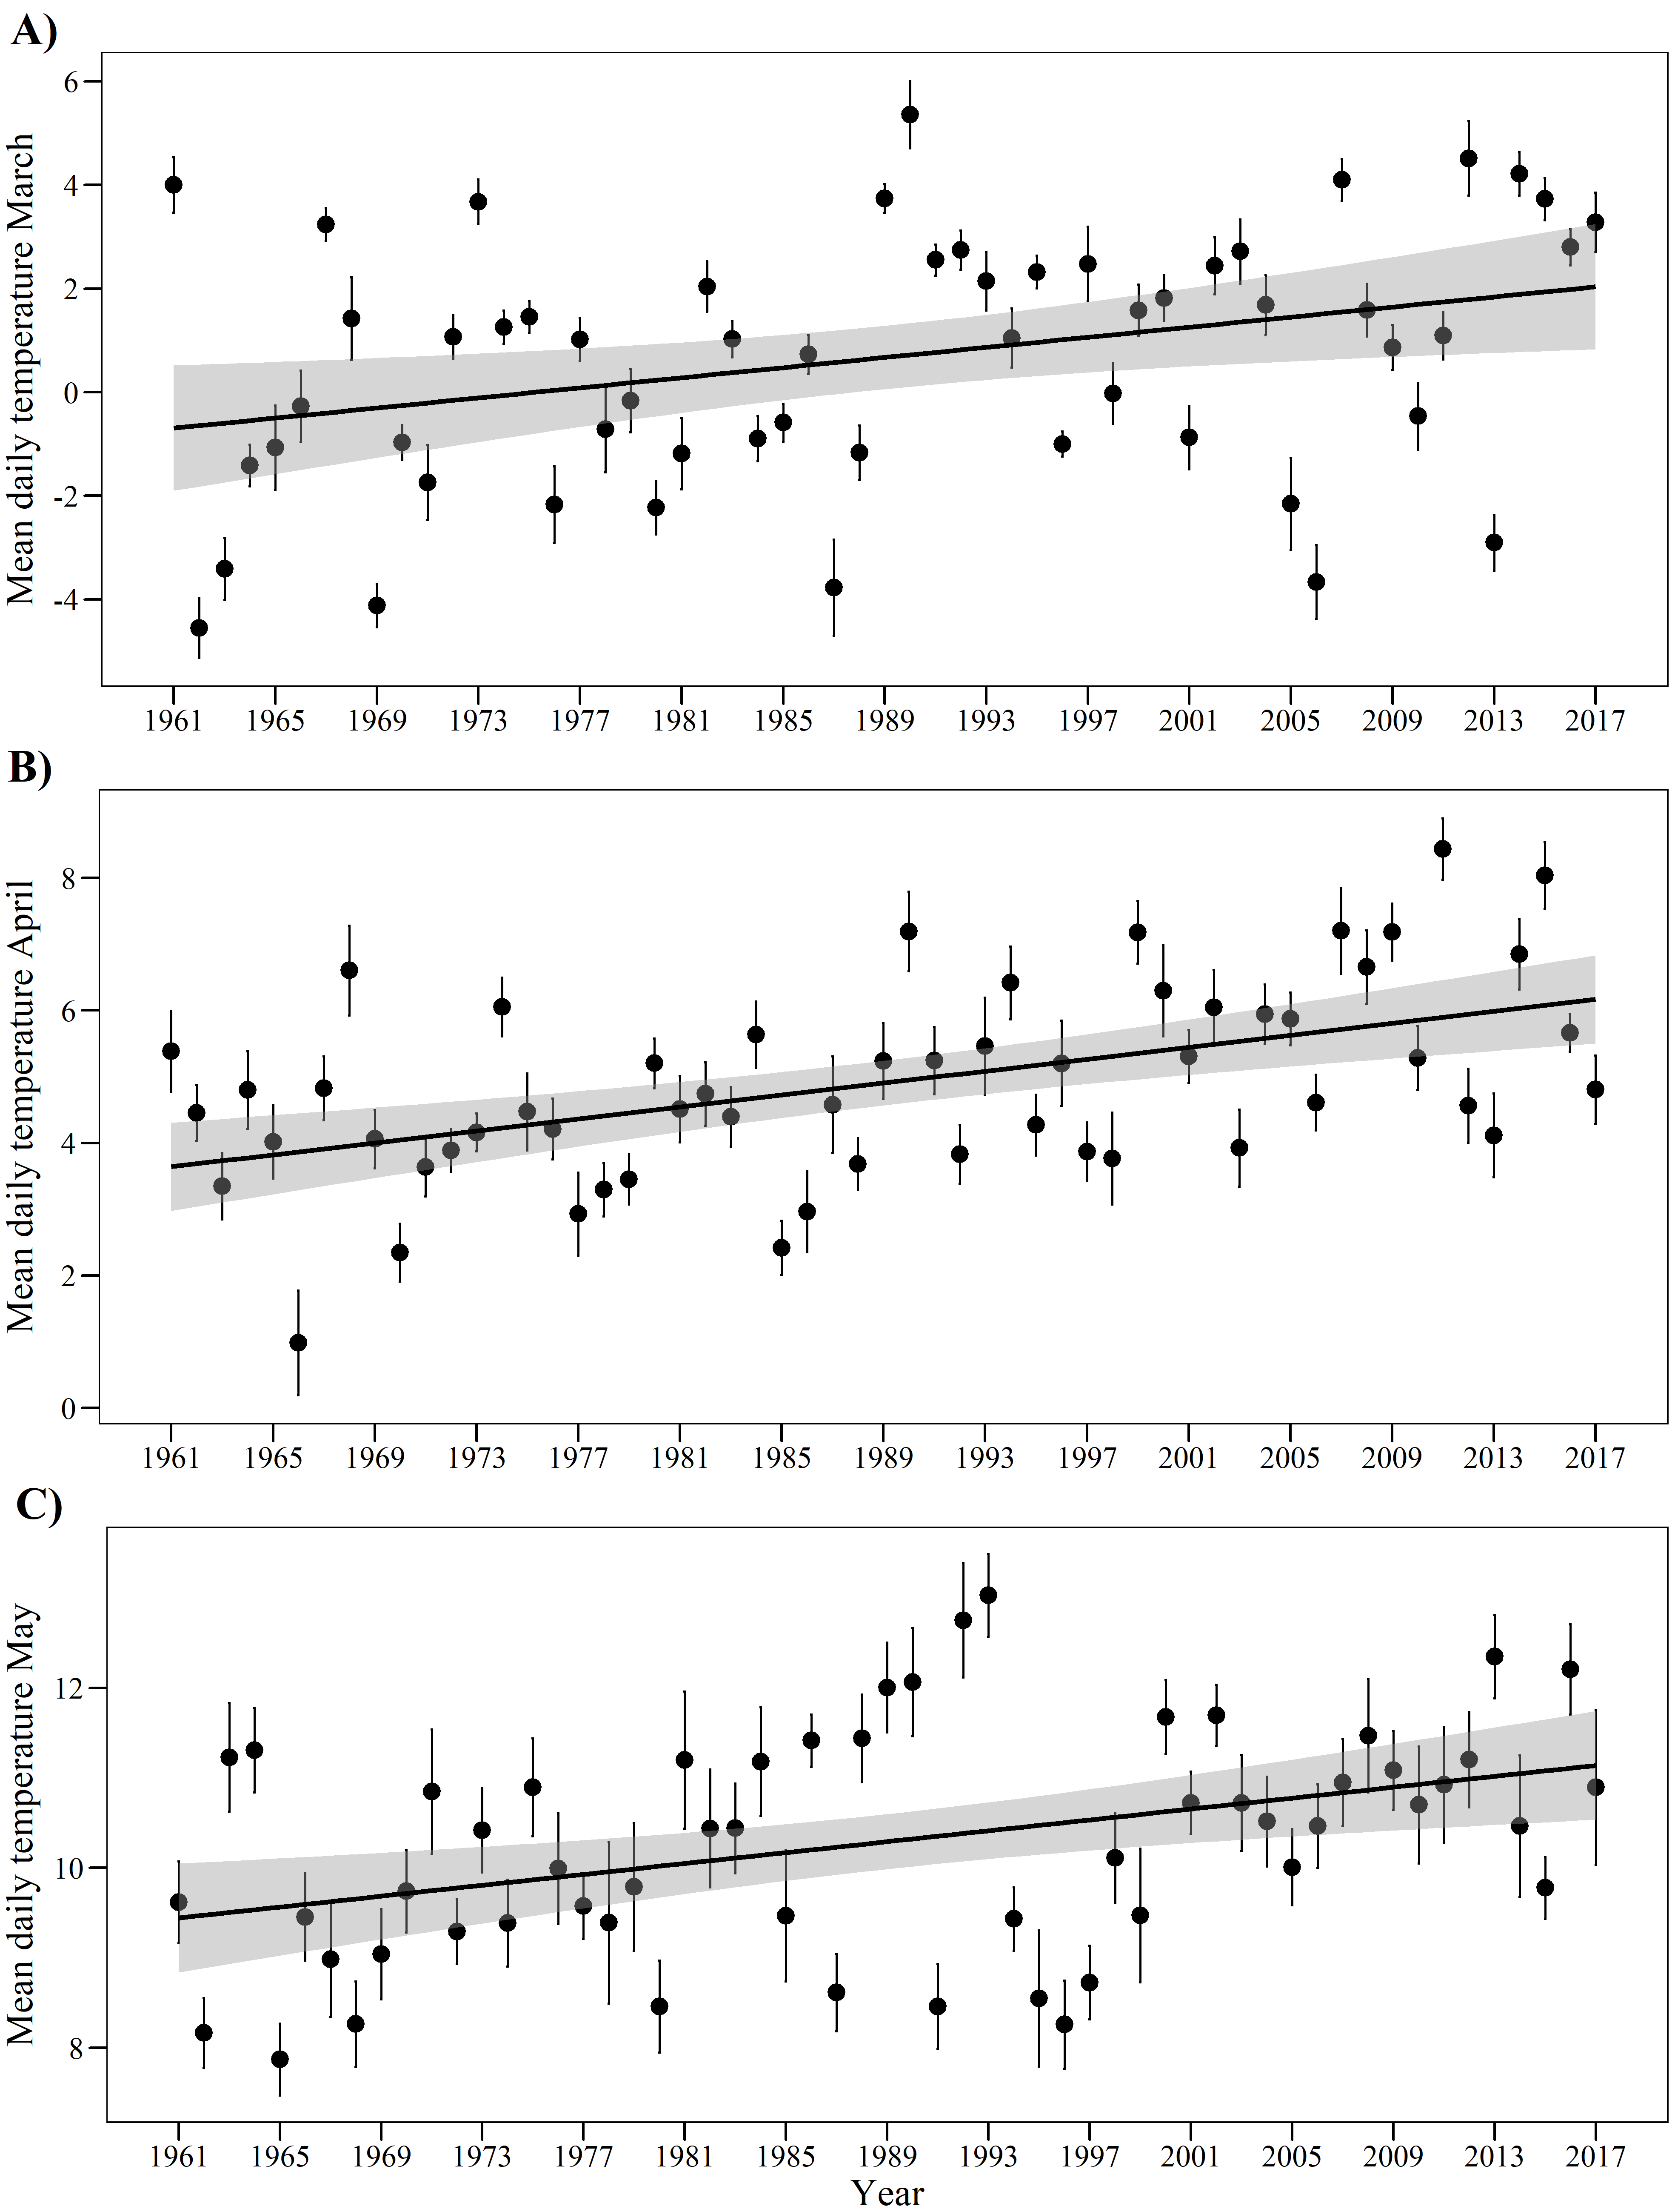
Figure S3: Mean maximum daily temperatures for three months in the years 1961-2017. Means (dots) and standard errors (whiskers) of minimum daily temperature during (A) March, (B) April, and (C) May. Lines show significant linear trends in temperature across years.
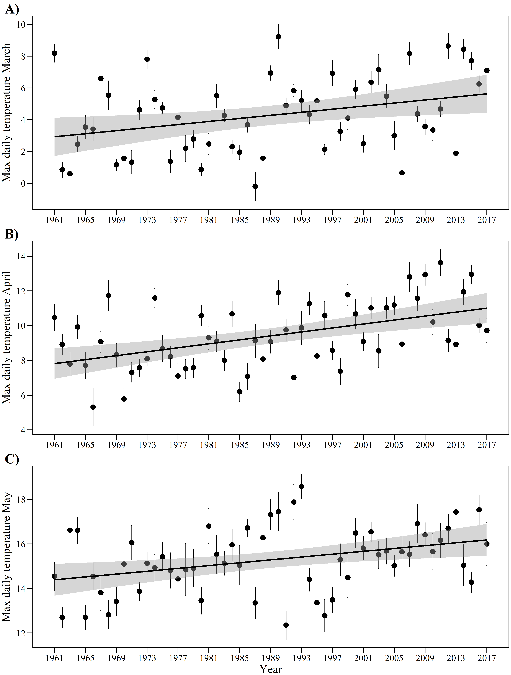
Figure S4: Monthly precipitation in the years 1945-2017. Bars represent the sum of precipitation during (A) March, (B) April, and (C) May.
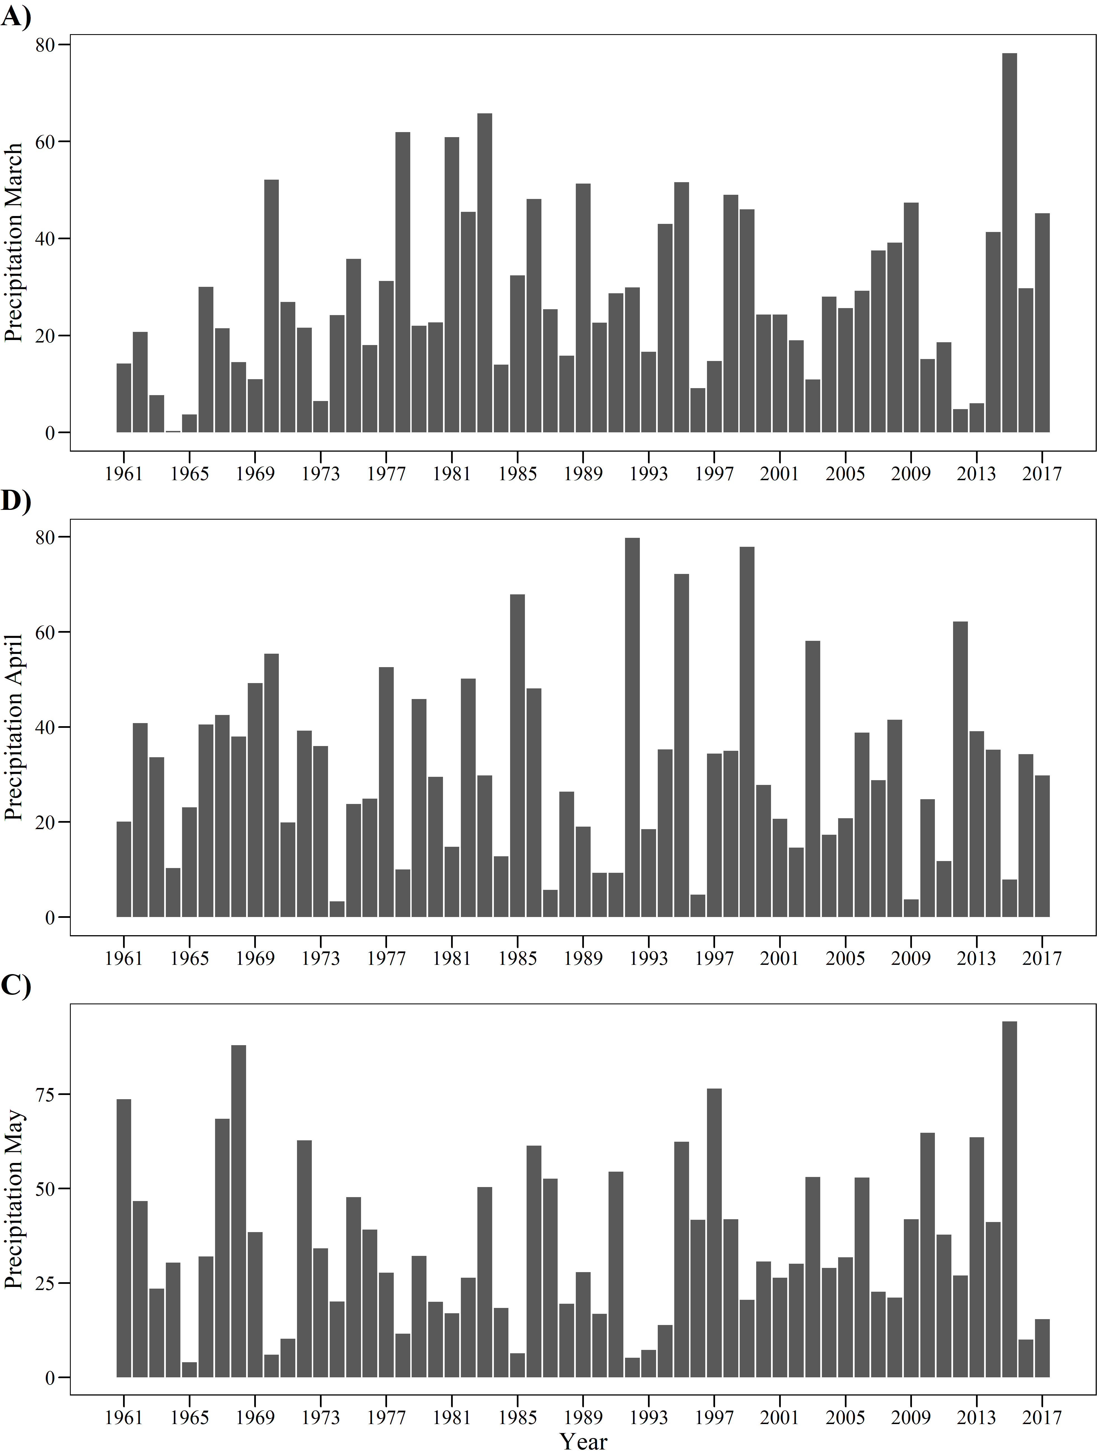
Figure S5: Partial regression plots (i.e. added variable plots) calculated from models in Table S3 showing the independent effects of (A) maximum daily temperature in April, (B) minimum daily temperature in May, (C) sum of precipitation in March, and (D) sum of precipitation in April on fitness, measured as the number of intact seeds. Linear model fit lines and confidence intervals are shown.
