Response of mean FFD* per year to temperatures / precipitation / growing degree days**
*FFD calculated as number of days since vernal equinox for each year
**GDD calculated with a temperature base of 5ºC

Variable | Time period | * | β | Adjusted R² | Plot with the most important variable
Mean temperature | April | Yes | -3.344 | 0.28 | 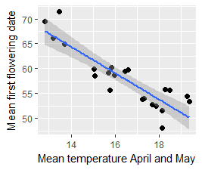
Mean temperature | May | Yes | -3.9006 | 0.4103
Mean temperature | June | No
Mean temperature | April-June | Yes | -4.585 | 0.5861
Mean temperature | April-May | Yes | -5.1842 | 0.7631
Mean temperature | January-June | Yes | -3.8268 | 0.3931
Mean temperature | January-March | Yes | -2.953 | 0.2139
Mean temperature | March-April | Yes | -3.371 | 0.2939
Sum of GDD | April | Yes | -2.915 | 0.207 | 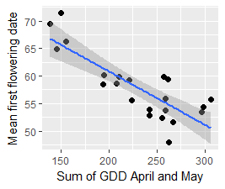
Sum of GDD | May | Yes | -3.8501 | 0.3985
Sum of GDD | June | No
Sum of GDD | April-June | Yes | -4.1278 | 0.4655
Sum of GDD | April-May | Yes | -4.8552 | 0.6632
Sum of GDD | January-June | Yes | -4.2372 | 0.4932
Sum of GDD | January-March | Yes | -2.191 | 0.09528
Sum of GDD | March-April | Yes | -3.153 | 0.2509
Sum of precipitation | April | No |  |  | 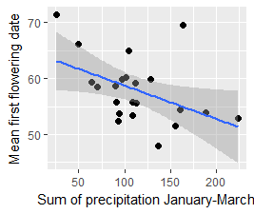
Sum of precipitation | May | No
Sum of precipitation | June | No
Sum of precipitation | April-June | No
Sum of precipitation | April-May | No
Sum of precipitation | January-June | No
Sum of precipitation | January-March | Yes | -2.716 | 0.1731
Sum of precipitation | March-April | No

Proportion of plants that started flowering each year against cumulated GDD
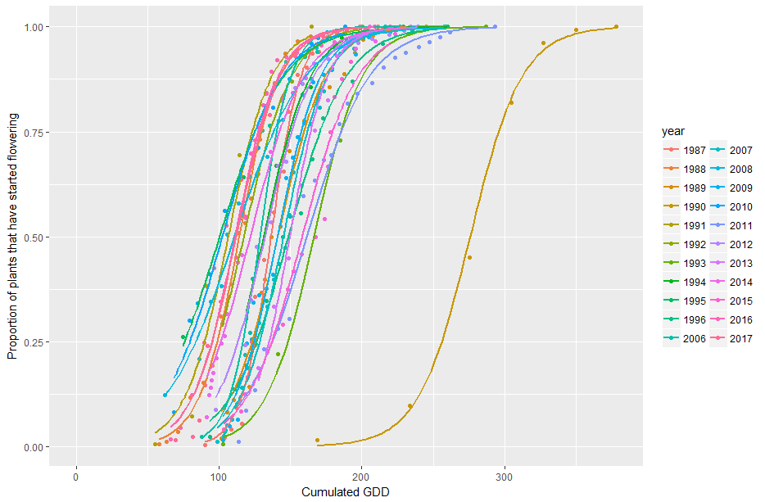
Same with separate plots
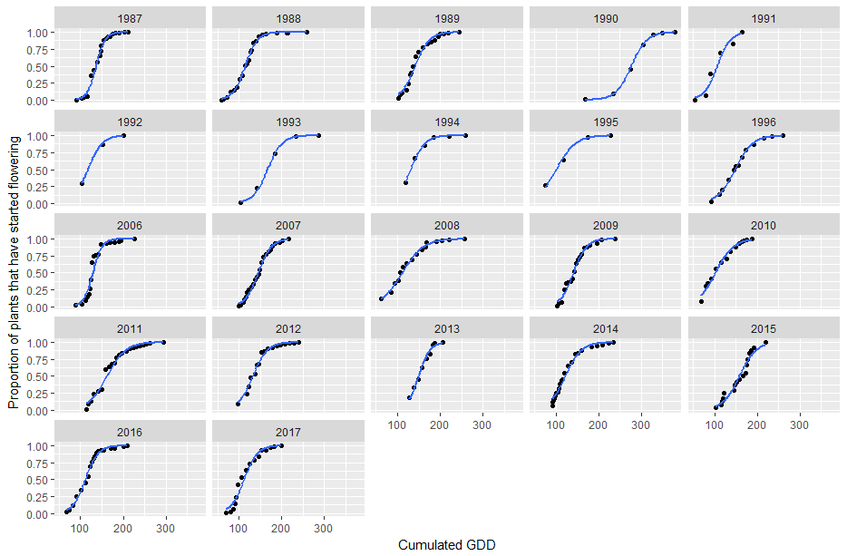
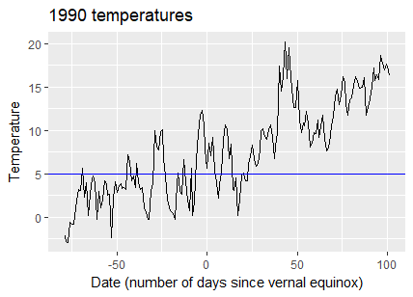

The “strange” year is 1990, where values of cumulated GDD were very high (see below) – probably many more days above 5ºC than other years? I searched for errors but did not find any by now.

