What happens in 1990?
GDD values against date (loess smoother)
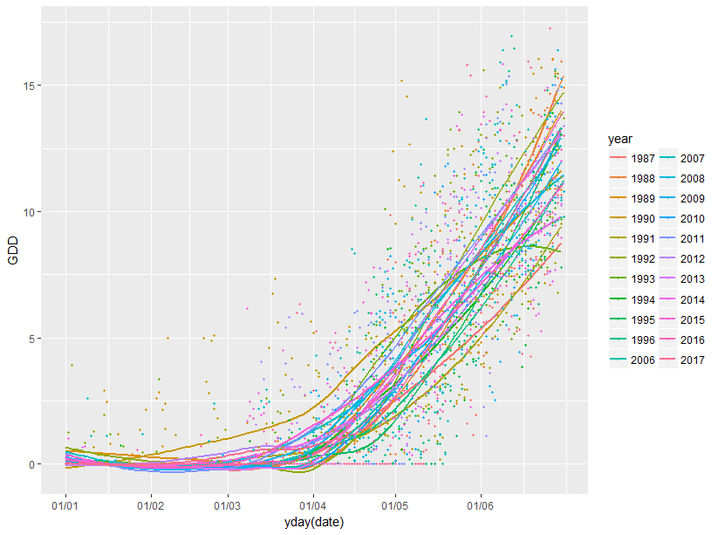
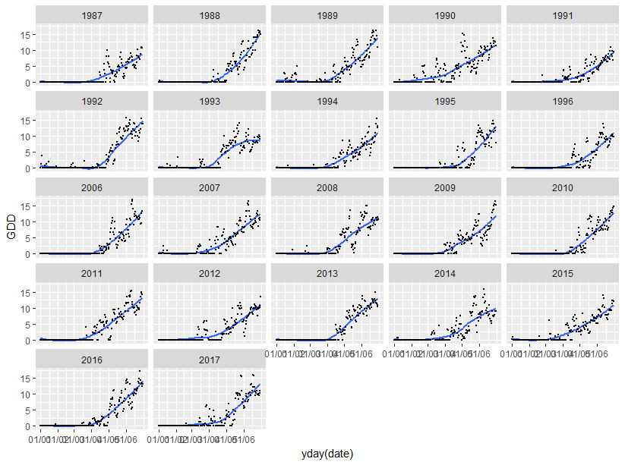
Mean FFD for each year – 1990 does not stand out as a very early or late year (mostly average)
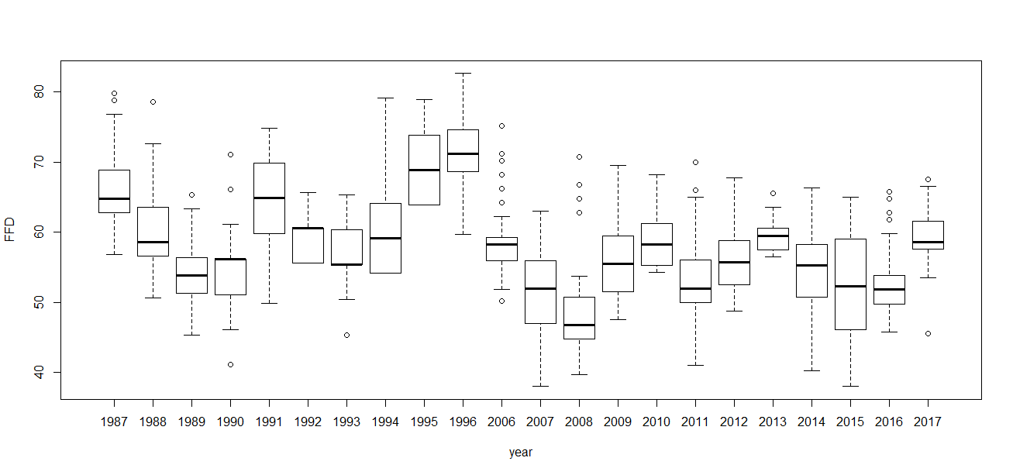
Cumulated GDD for each year – 1990 has very large values of cumulated GDD
(these are values of cumulated GDD from January 1st to the start of flowering)
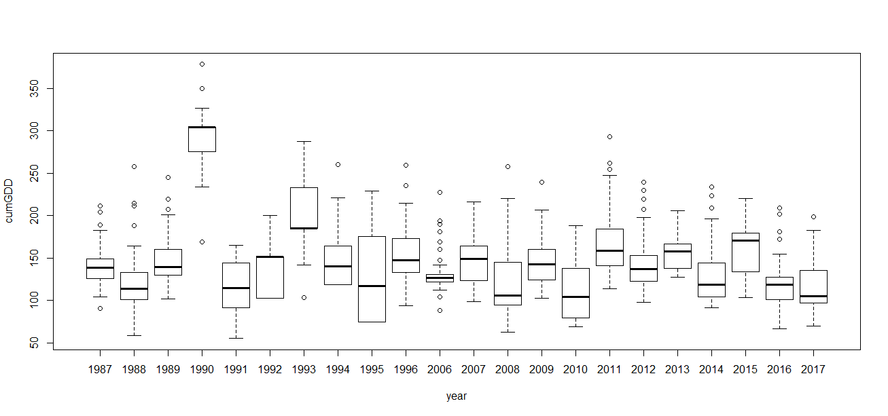
GDD for each month year – Very large value of GDD in February and March for 1990
2012 has also quite a large value for March, but much lower for April and May
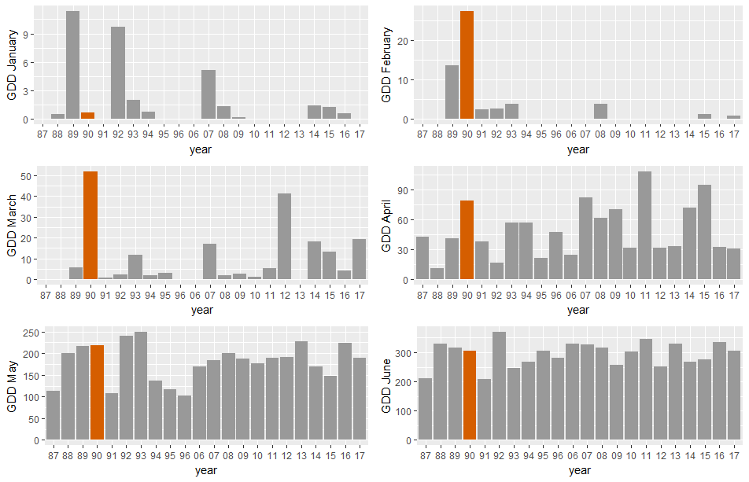
We can see the difference only if we look at the period January-March or March-April, with January-June 1990 it is the largest value but not extremely different from other years

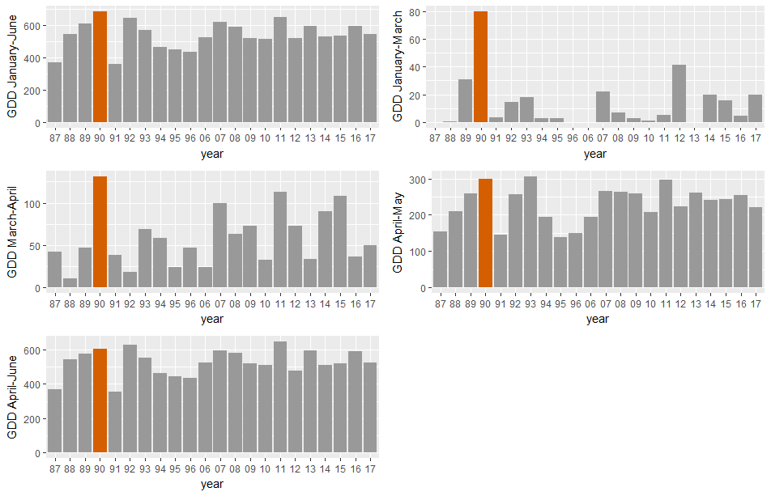
Maybe GDD in February and March do not really “count” for the start of flowering?
See graphs of proportion of plants that started flowering each year against cumulative GDD starting from January 1st (which is the graph I sent you before), from April 1st and from April 20th – the curve for 1990 gets much closer to the others
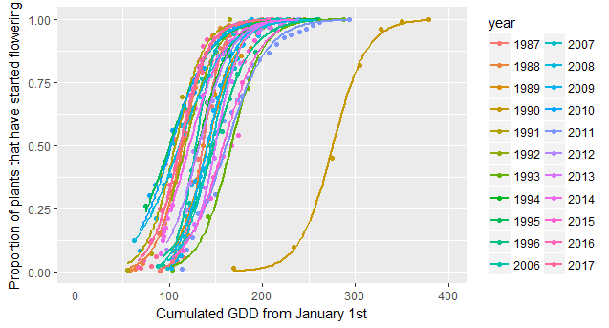
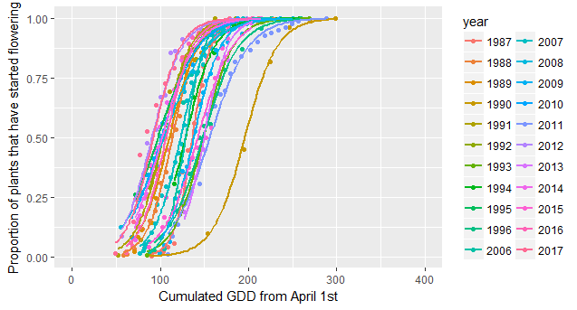
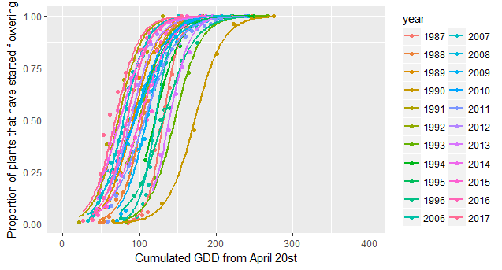
Comparison temperature data from the two stations
