Supplementary Material
Table S1: Univariate linear regressions of all climatic variables against year for (A) the 22 study years, and (B) the period 1961-2017.
Variable | A) 1987-1996 and 2006-2017 |  |  |  |  | B) 1961-2017
Variable | Estimate |  | Std. error | t |  | Estimate |  | Std. error | t
Precipitation January-March | 1.092 |  | 1.640 | 0.67 |  | 0.829 | ** | 0.300 | 2.76
Precipitation April | 0.381 |  | 0.729 | 0.52 |  | -0.029 |  | 0.153 | -0.19
Precipitation May | 0.749 |  | 0.779 | 0.96 |  | 0.055 |  | 0.176 | 0.31
Min March | 0.046 |  | 0.097 | 0.47 |  | 0.054 | * | 0.021 | 2.56
Min April | 0.020 |  | 0.034 | 0.59 |  | 0.030 | *** | 0.008 | 3.74
Min May | 0.024 |  | 0.038 | 0.63 |  | 0.026 | ** | 0.008 | 3.19
Mean March | 0.081 |  | 0.090 | 0.90 |  | 0.049 | * | 0.019 | 2.62
Mean April | 0.067 |  | 0.045 | 1.49 |  | 0.045 | *** | 0.010 | 4.40
Mean May | 0.027 |  | 0.049 | 0.55 |  | 0.030 | ** | 0.009 | 3.26
Max March | 0.130 |  | 0.088 | 1.47 |  | 0.048 | * | 0.019 | 2.61
Max April | 0.104 |  | 0.057 | 1.82 |  | 0.057 | *** | 0.013 | 4.26
Max May | 0.034 |  | 0.059 | 0.57 |  | 0.032 | ** | 0.011 | 2.91
***P < 0.001; **P < 0.01; *P < 0.05

Table S2: Results of linear models showing the effect of yearly climate and year on (A) first flowering date (FFD) for individual plants, and on three measures of the yearly position (B) and the yearly duration (C) of the flowering season of Lathyrus vernus in 22 study years. The position of the flowering season was defined by the date when 10% of the plants had started flowering (10% FFD), the mean first flowering date (Mean FFD), and the date when 90% of the plants had started flowering (90% FFD). The duration of the flowering season was defined by the number of days between the date when 10% of the plants had started flowering and the date when 90% of the plants had started flowering (N days 90-10% FFD). Climatic variables included in each model were selected because they had a significant effect in the averaged models resulting from model selection (see Table 1 in main text). In (A), a linear mixed model with plant individual as a random effect was used, and the marginal pseudo-R² (representing the variance explained by the fixed effects) is provided.
Response variable | Predictor variable | Estimate |  | Std. error | t
A) FFD  N = 2411  R² _{marg} = 0.604  R² _{cond} = 0.646 | Precipitation January-March | -1.148 | *** | 0.099 | -11.58
A) FFD  N = 2411  R² _{marg} = 0.604  R² _{cond} = 0.646 | Min April | -2.036 | *** | 0.096 | -21.17
A) FFD  N = 2411  R² _{marg} = 0.604  R² _{cond} = 0.646 | Max May | -3.205 | *** | 0.097 | -33.09
A) FFD  N = 2411  R² _{marg} = 0.604  R² _{cond} = 0.646 | Number of flowers | -2.410 | *** | 0.098 | -24.52
A) FFD  N = 2411  R² _{marg} = 0.604  R² _{cond} = 0.646 | Year | -0.100 | *** | 0.010 | -9.53
B) Position of the fl. season
Start  N = 22  R² = 0.741 | Precipitation January-March | -1.332 |  | 0.945 | -1.41
Start  N = 22  R² = 0.741 | Min April | -3.543 | ** | 0.921 | -3.85
Start  N = 22  R² = 0.741 | Max May | -2.884 | ** | 0.749 | -3.85
Start  N = 22  R² = 0.741 | Year | -0.134 |  | 0.072 | -1.86
Mean  N = 22  R² = 0.793 | Precipitation January-March | -0.867 |  | 0.751 | -1.15
Mean  N = 22  R² = 0.793 | Min April | -2.499 | ** | 0.733 | -3.41
Mean  N = 22  R² = 0.793 | Max May | -3.535 | *** | 0.596 | -5.94
Mean  N = 22  R² = 0.793 | Year | -0.150 | * | 0.058 | -2.61
End  N = 22  R² = 0.865 | Precipitation January-March | -0.525 |  | 0.564 | -0.93
End  N = 22  R² = 0.865 | Min April | -1.715 | ** | 0.550 | -3.12
End  N = 22  R² = 0.865 | Max May | -4.422 | *** | 0.448 | -9.88
End  N = 22  R² = 0.865 | Year | -0.080 |  | 0.043 | -1.85
C) Duration or the fl. season
N = 22  R² = 0.574 | Precipitation January-March | 0.807 |  | 0.664 | 1.22
N = 22  R² = 0.574 | Min April | 1.828 | * | 0.647 | 2.83
N = 22  R² = 0.574 | Max May | -1.539 | ** | 0.526 | -2.92
N = 22  R² = 0.574 | Year | 0.055 |  | 0.051 | 1.07
***P < 0.001; **P < 0.01; *P < 0.05

Table S3: Phenotypic selection differentials and standard errors for first flowering date and number of flowers in Lathyrus vernus on 22 study years. Values in bold are significant at α = 0.05.
Year | First flowering date |  | First flowering date² |  | Number of flowers |  | Number of flowers²
Year | Estimate | SE | Estimate | SE | Estimate | SE | Estimate | SE
1987 | -0.372 | 0.092 | -0.053 | 0.153 | 0.766 | 0.081 | -0.006 | 0.043
1988 | -0.302 | 0.106 | -0.060 | 0.134 | 0.541 | 0.101 | 0.001 | 0.066
1989 | -0.609 | 0.128 | 0.133 | 0.198 | 0.846 | 0.113 | 0.027 | 0.099
1990 | -0.504 | 0.161 | 0.233 | 0.212 | 0.678 | 0.156 | -0.229 | 0.070
1991 | -0.600 | 0.078 | 0.132 | 0.140 | 0.667 | 0.075 | -0.013 | 0.060
1992 | -0.438 | 0.183 | 0.029 | 0.311 | 0.114 | 0.187 | -0.261 | 0.106
1993 | -0.448 | 0.131 | 0.040 | 0.217 | 0.435 | 0.132 | -0.132 | 0.086
1994 | -0.558 | 0.176 | 0.287 | 0.285 | 0.487 | 0.177 | -0.166 | 0.094
1995 | -0.487 | 0.218 | 0.307 | 0.357 | 0.420 | 0.222 | -0.191 | 0.115
1996 | -0.373 | 0.106 | -0.178 | 0.179 | 0.642 | 0.095 | -0.078 | 0.070
2006 | -0.423 | 0.133 | 0.169 | 0.147 | 0.776 | 0.113 | -0.095 | 0.042
2007 | -0.411 | 0.111 | 0.190 | 0.192 | 0.275 | 0.115 | -0.132 | 0.053
2008 | -0.500 | 0.120 | 0.321 | 0.126 | 0.760 | 0.102 | -0.101 | 0.057
2009 | -0.213 | 0.276 | -0.438 | 0.495 | 0.319 | 0.274 | -0.258 | 0.125
2010 | -0.492 | 0.164 | 0.283 | 0.284 | 0.280 | 0.170 | -0.300 | 0.109
2011 | -0.696 | 0.196 | 0.370 | 0.262 | 0.914 | 0.185 | 0.036 | 0.131
2012 | -1.035 | 0.187 | 1.119 | 0.275 | 1.054 | 0.186 | -0.179 | 0.110
2013 | -0.425 | 0.322 | 0.006 | 0.605 | 0.083 | 0.326 | -0.185 | 0.322
2014 | -0.668 | 0.173 | 0.355 | 0.286 | 0.252 | 0.191 | -0.222 | 0.091
2015 | 0.048 | 0.231 | -0.846 | 0.475 | -0.003 | 0.231 | -0.272 | 0.161
2016 | -0.351 | 0.096 | 0.015 | 0.136 | 0.606 | 0.083 | -0.062 | 0.066
2017 | 0.282 | 0.497 | -0.249 | 0.501 | -0.541 | 0.496 | 0.156 | 0.350

Table S4: Phenotypic selection gradients and standard errors for first flowering date and number of flowers in Lathyrus vernus on 22 study years. Values in bold are significant at α = 0.05.
Year | First flowering date |  | First flowering date² |  | First flowering date  x Number of flowers
Year | Estimate | SE | Estimate | SE | Estimate | SE
1987 | -0.078 | 0.088 | -0.071 | 0.085 | 0.010 | 0.180
1988 | -0.088 | 0.111 | 0.091 | 0.075 | 0.578 | 0.179
1989 | -0.144 | 0.143 | 0.035 | 0.134 | 0.061 | 0.225
1990 | -0.276 | 0.169 | -0.009 | 0.129 | -0.285 | 0.287
1991 | -0.321 | 0.089 | 0.056 | 0.087 | 0.183 | 0.172
1992 | -0.463 | 0.199 | 0.096 | 0.184 | 0.172 | 0.252
1993 | -0.321 | 0.144 | 0.105 | 0.127 | 0.222 | 0.196
1994 | -0.439 | 0.188 | 0.099 | 0.160 | -0.084 | 0.225
1995 | -0.371 | 0.248 | 0.100 | 0.280 | -0.070 | 0.496
1996 | -0.170 | 0.101 | -0.049 | 0.093 | -0.006 | 0.139
2006 | -0.210 | 0.117 | 0.131 | 0.085 | 0.340 | 0.255
2007 | -0.368 | 0.131 | 0.248 | 0.147 | 0.394 | 0.263
2008 | -0.201 | 0.112 | 0.070 | 0.066 | -0.096 | 0.245
2009 | -0.052 | 0.332 | 0.031 | 0.301 | 2.395 | 0.883
2010 | -0.478 | 0.195 | 0.196 | 0.165 | 0.379 | 0.358
2011 | -0.292 | 0.218 | 0.050 | 0.168 | -0.313 | 0.503
2012 | -0.665 | 0.210 | 0.370 | 0.187 | -0.335 | 0.430
2013 | -0.426 | 0.331 | 0.178 | 0.362 | 0.455 | 0.449
2014 | -0.777 | 0.211 | 0.340 | 0.207 | 0.315 | 0.351
2015 | 0.083 | 0.315 | -0.975 | 0.364 | -1.041 | 0.555
2016 | -0.055 | 0.097 | 0.005 | 0.076 | 0.500 | 0.189
2017 | -0.020 | 0.595 | -0.206 | 0.406 | -0.006 | 0.759

Table S5: Results of model selection and model averaging for the best candidate linear models testing for effects of climate on selection on flowering time in Lathyrus vernus in 22 study years. Linear mixed models with number of flowers as a condition trait, plant individual as a random effect and interactions of first flowering date with climatic variables were used in model selection. Fitness was estimated by the number of intact seeds. Traits were standardized and fitness relativized within years before analyses. Averaged estimates and z-values across all models with ΔAICc < 2 are shown. For the best model resulting from model selection, R² _{marg} = 0.078 and R² _{cond} = 0.109, N = 2474 for all models. ∑w_{i} = Relative variable importance (sum of Akaike weights over all models including each variable).
Predictor variable | Estimate |  | Std. error | z | ∑w_{i}
First flowering date | -0.265 | *** | 0.046 | 5.77 | 1.00
Number of flowers | 0.377 | *** | 0.046 | 8.11 | 1.00
First flowering date : Precipitation January | 0.017 |  | 0.036 | 0.46 | 0.36
First flowering date : Precipitation March | 0.194 | *** | 0.048 | 4.08 | 1.00
First flowering date : Min April | -0.167 | *** | 0.052 | 3.24 | 0.74
First flowering date : Precipitation April | -0.117 | * | 0.047 | 2.48 | 0.87
First flowering date : Min May | 0.018 |  | 0.039 | 0.45 | 0.21
First flowering date : Mean May | 0.018 |  | 0.041 | 0.44 | 0.16
First flowering date : Max May | 0.015 |  | 0.037 | 0.40 | 0.17
First flowering date : GDD May | 0.020 |  | 0.043 | 0.47 | 0.18
First flowering date : Precipitation May | -0.007 |  | 0.024 | 0.27 | 0.19
***P < 0.001; **P < 0.01; *P < 0.05

Figure S1: Variation in minimum daily temperature during the period 1961-2017. Means (dots) and standard errors (whiskers) of minimum daily temperature during (A) March, (B) April and (C) May. Significant linear trends, showing warmer temperatures across years, are shown.
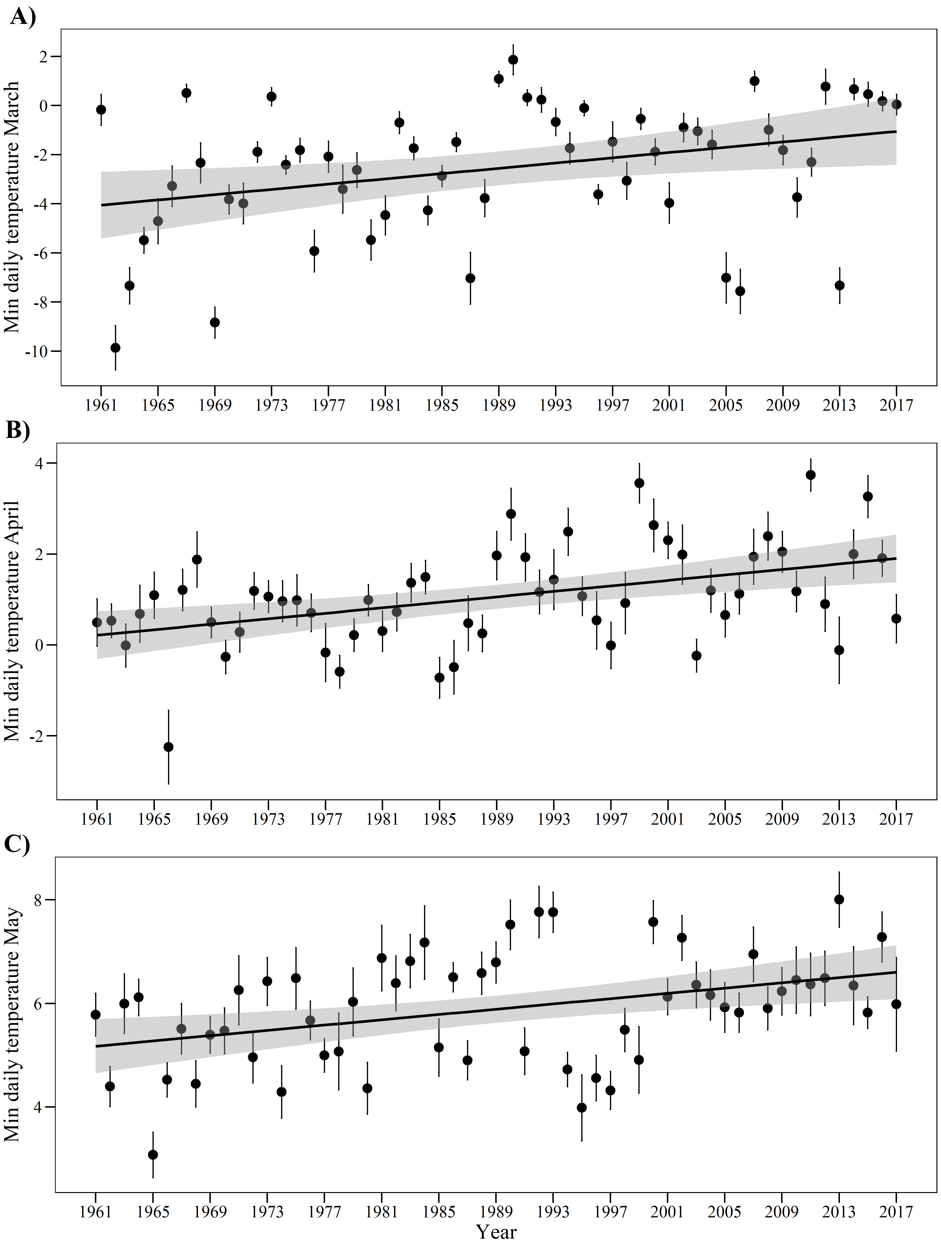
Figure S2: Variation in mean daily temperature during the period 1961-2017. Means (dots) and standard errors (whiskers) of mean daily temperature during (A) March, (B) April and (C) May. Significant linear trends, showing warmer temperatures across years, are shown.
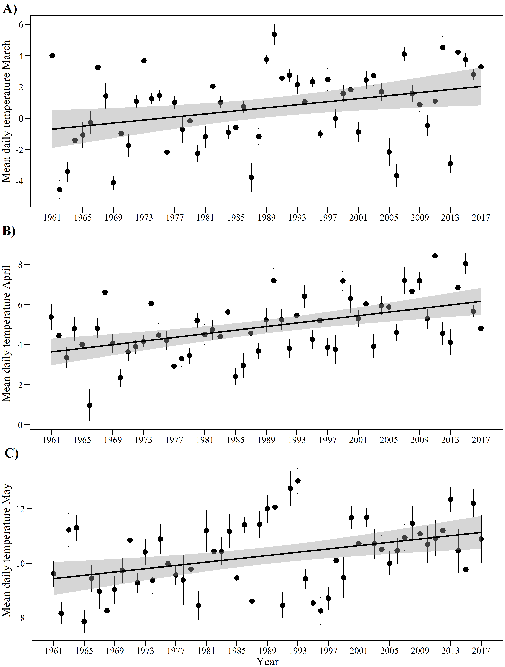
Figure S3: Variation in maximum daily temperature during the period 1961-2017. Means (dots) and standard errors (whiskers) of minimum daily temperature during (A) March, (B) April and (C) May. Significant linear trends, showing warmer temperatures across years, are shown.
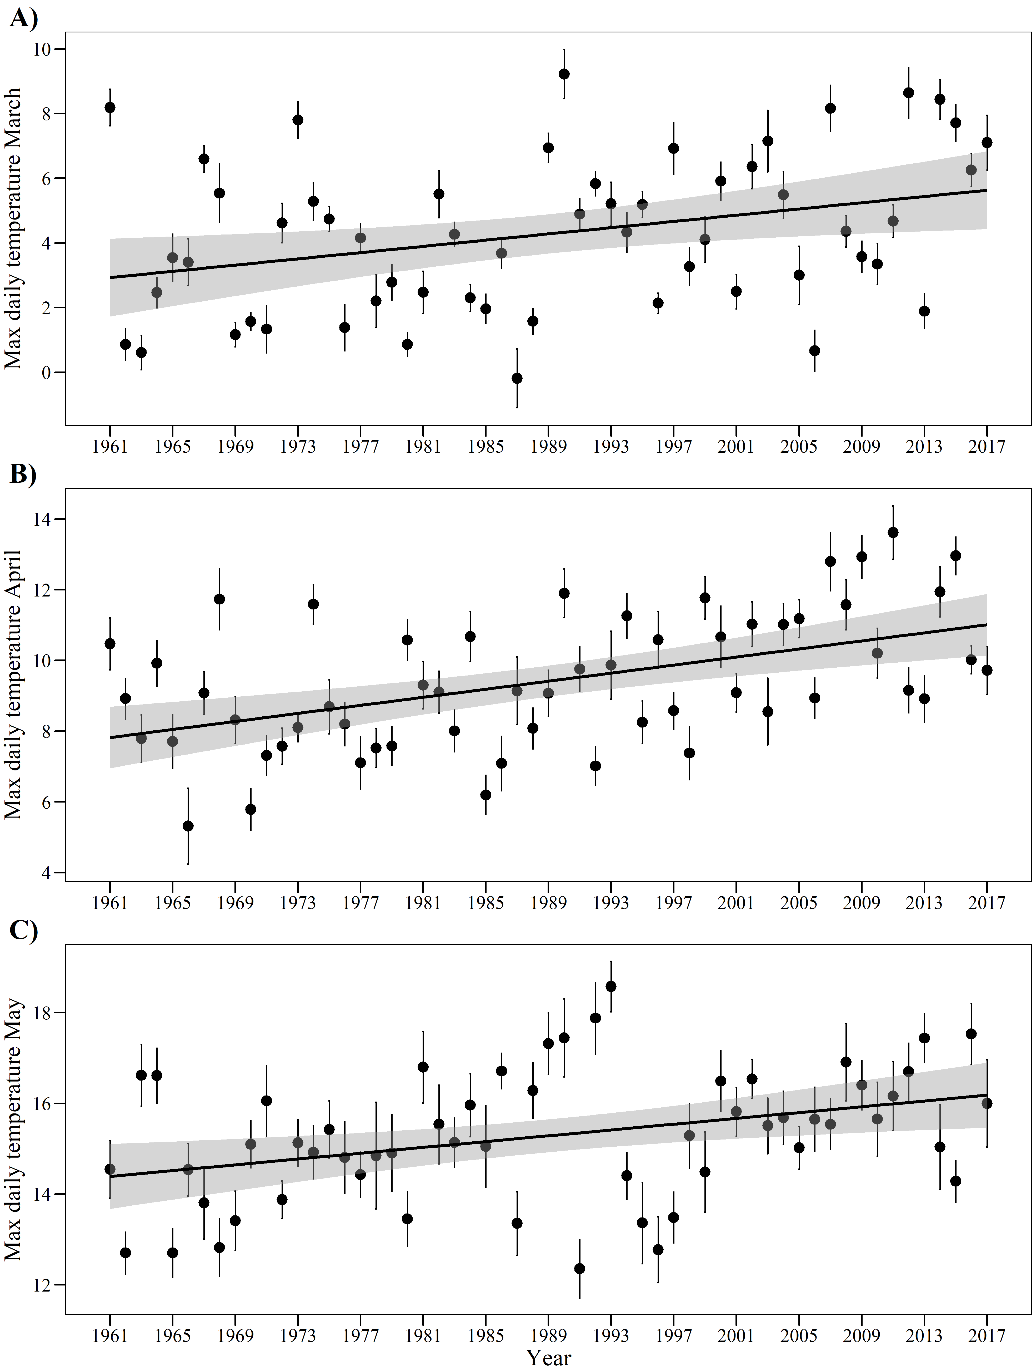
Figure S4: Variation in precipitation during the period 1945-2017. Bars represent the sum of precipitation during (A) January-March, (B) April, and (C) May. In (A), a significant linear trend, showing increasing precipitation in January-March across years, is shown.
