Supporting Information
Table S1: Coefficients from univariate GLMs relating the probability of having eggs (A, binomial model) and the number of eggs in plants with at least one egg (B, negative binomial model) to the abundance of different ant species that might act as hosts of P. alcon in the study site.
 | A) Probability of having eggs (n = 8848) |  |  | B) Number of eggs  (n = 731)
 | Estimate | SE | P | Estimate | SE | P
M. rubra | 0.174 | 0.029 | <0.001 | 0.137 | 0.031 | <0.001
M. ruginodis | -0.215 | 0.046 | <0.001 | -0.016 | 0.033 | 0.620
M. rubra + M. ruginodis | -0.101 | 0.042 | 0.015 | 0.043 | 0.032 | 0.180

Table S2: Results of the GLMs of the effects on the probability of a flowering shoot of Gentiana
pneumonanthe receiving at least one egg from the butterfly Phengaris alcon (binomial GLM)
and the number of eggs in shoots with at least one egg (negative binomial GLM), of shoot
phenology, ant abundance, neighbor density and neighbor phenology, as well as three two-way interactions of these predictors. Ant abundance was measured as abundance of Myrmica ruginodis in A) and as the summed abundance of M. rubra and M. ruginodis in B). In the binomial GLMs, two eigenvectors issued from Moran’s eigenvector mapping (MEM) are also included as predictors, in order to reduce residual spatial autocorrelation (see details in the text).
 |  | Probability of having at least one egg  (n = 8848, R² = 0.45) |  |  |  | Number of eggs  (n = 731, R² = 0.20)
 |  | Estimate | SE | P |  | Estimate | SE | P
A) | Shoot phenology | 1.486 | 0.081 | <0.001 |  | 0.250 | 0.036 | <0.001
 | Ant abundance | -0.211 | 0.086 | 0.014 |  | -0.030 | 0.032 | 0.349
 | Neighbor density | -1.698 | 0.104 | <0.001 |  | -0.394 | 0.068 | <0.001
 | Neighbor phenology | -1.173 | 0.127 | <0.001 |  | -0.110 | 0.041 | 0.007
 | Shoot phenology × Ant abundance | 0.044 | 0.085 | 0.603 |  | 0.013 | 0.039 | 0.744
 | Shoot phenology × Neighbor phenology | 0.109 | 0.071 | 0.124 |  | 0.004 | 0.034 | 0.906
 | Neighbor density × Neighbor phenology | -0.484 | 0.090 | <0.001 |  | -0.111 | 0.043 | 0.010
 | MEM Vector 1 | 0.328 | 0.032 | <0.001
 | MEM Vector 2 | 0.337 | 0.050 | <0.001
B) | Shoot phenology | 1.489 | 0.081 | <0.001 |  | 0.251 | 0.036 | <0.001
 | Ant abundance | -0.219 | 0.085 | 0.010 |  | 0.019 | 0.031 | 0.554
 | Neighbor density | -1.704 | 0.104 | <0.001 |  | -0.381 | 0.068 | <0.001
 | Neighbor phenology | -1.187 | 0.127 | <0.001 |  | -0.105 | 0.041 | 0.010
 | Shoot phenology × Ant abundance | 0.088 | 0.085 | 0.302 |  | 0.027 | 0.037 | 0.459
 | Shoot phenology × Neighbor phenology | 0.105 | 0.071 | 0.137 |  | 0.005 | 0.034 | 0.885
 | Neighbor density × Neighbor phenology | -0.498 | 0.090 | <0.001 |  | -0.105 | 0.043 | 0.014
 | MEM Vector 1 | 0.326 | 0.032 | <0.001
 | MEM Vector 2 | 0.348 | 0.050 | <0.001

Table S3: Results of the binomial GLM (n = 8848, R² = 0.42) relating the probability of a shoot of G. pneumonanthe having eggs of P. alcon to shoot phenology, ant abundance, neighbor density and neighbor phenology, and to three different two-way interactions of these predictors.
 | Estimate | SE | P
Shoot phenology | 1.401 | 0.076 | <0.001
Ant abundance | 0.044 | 0.050 | 0.383
Neighbor density | -1.954 | 0.091 | <0.001
Neighbor phenology | -0.982 | 0.118 | <0.001
Shoot phenology x Ant abundance | 0.123 | 0.061 | 0.044
Shoot phenology x Neighbor phenology | -0.002 | 0.068 | 0.971
Neighbor density x Neighbor phenology | -626 | 0.083 | <0.001
***P < 0.001; **P < 0.01; *P < 0.05

Figure S1: Result of the inverse distance weighted interpolation for abundance of Myrmica rubra based on abundance values (sum of individuals collected in 2 sampling sessions) at 254 sampling points. The color scale indicates the interpolated abundance values.
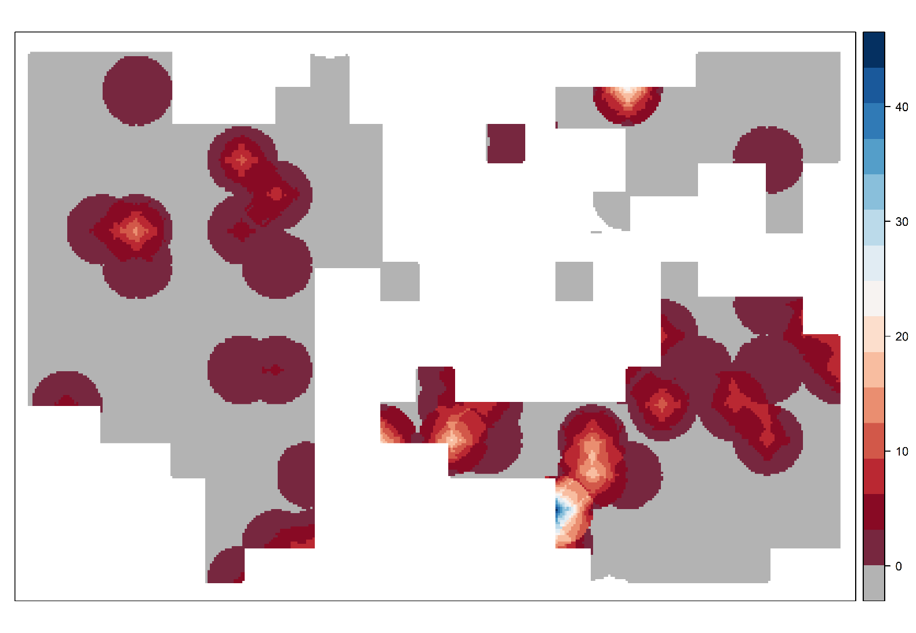
Figure S2: Result of the inverse distance weighted interpolation for abundance of Myrmica scabrinodis based on abundance values (sum of individuals collected in 2 sampling sessions) at 254 sampling points. The color scale indicates the interpolated abundance values.
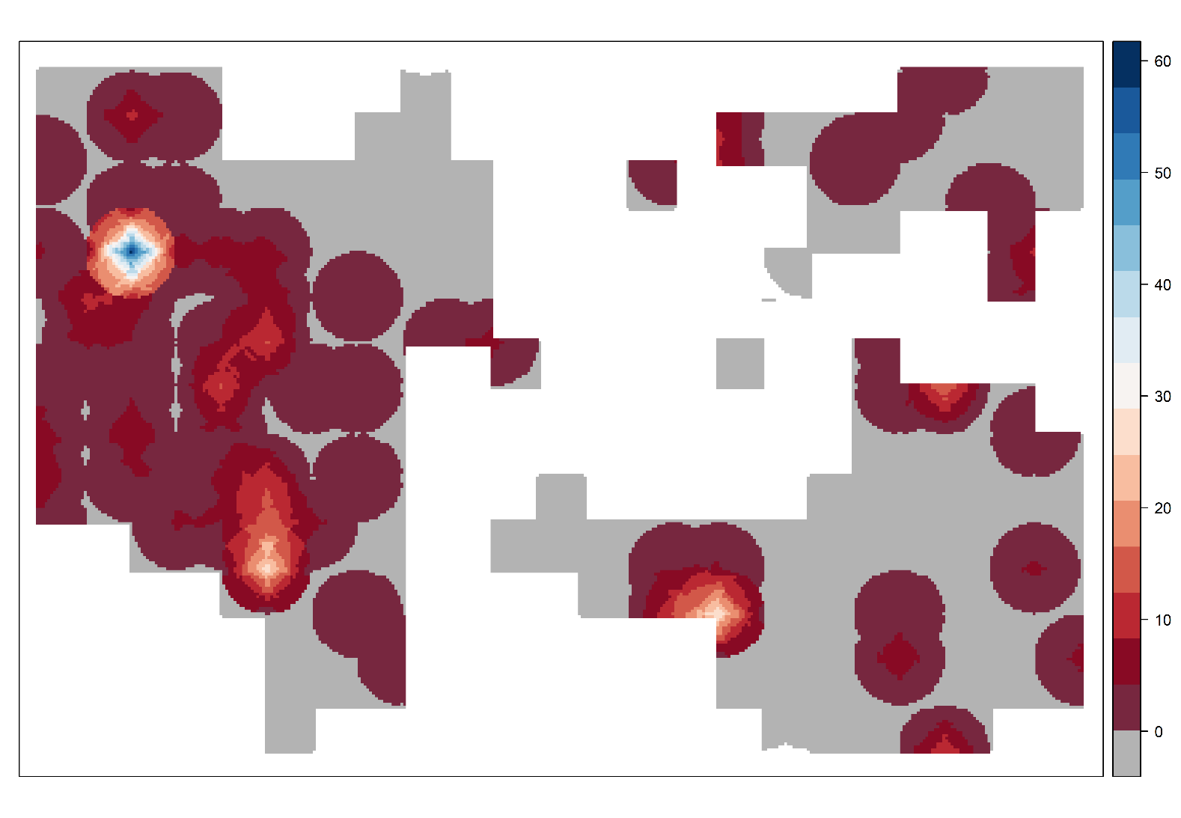
Figure S3: Result of the inverse distance weighted interpolation for abundance of Myrmica ruginodis based on abundance values (sum of individuals collected in 2 sampling sessions) at 254 sampling points. The color scale indicates the interpolated abundance values.
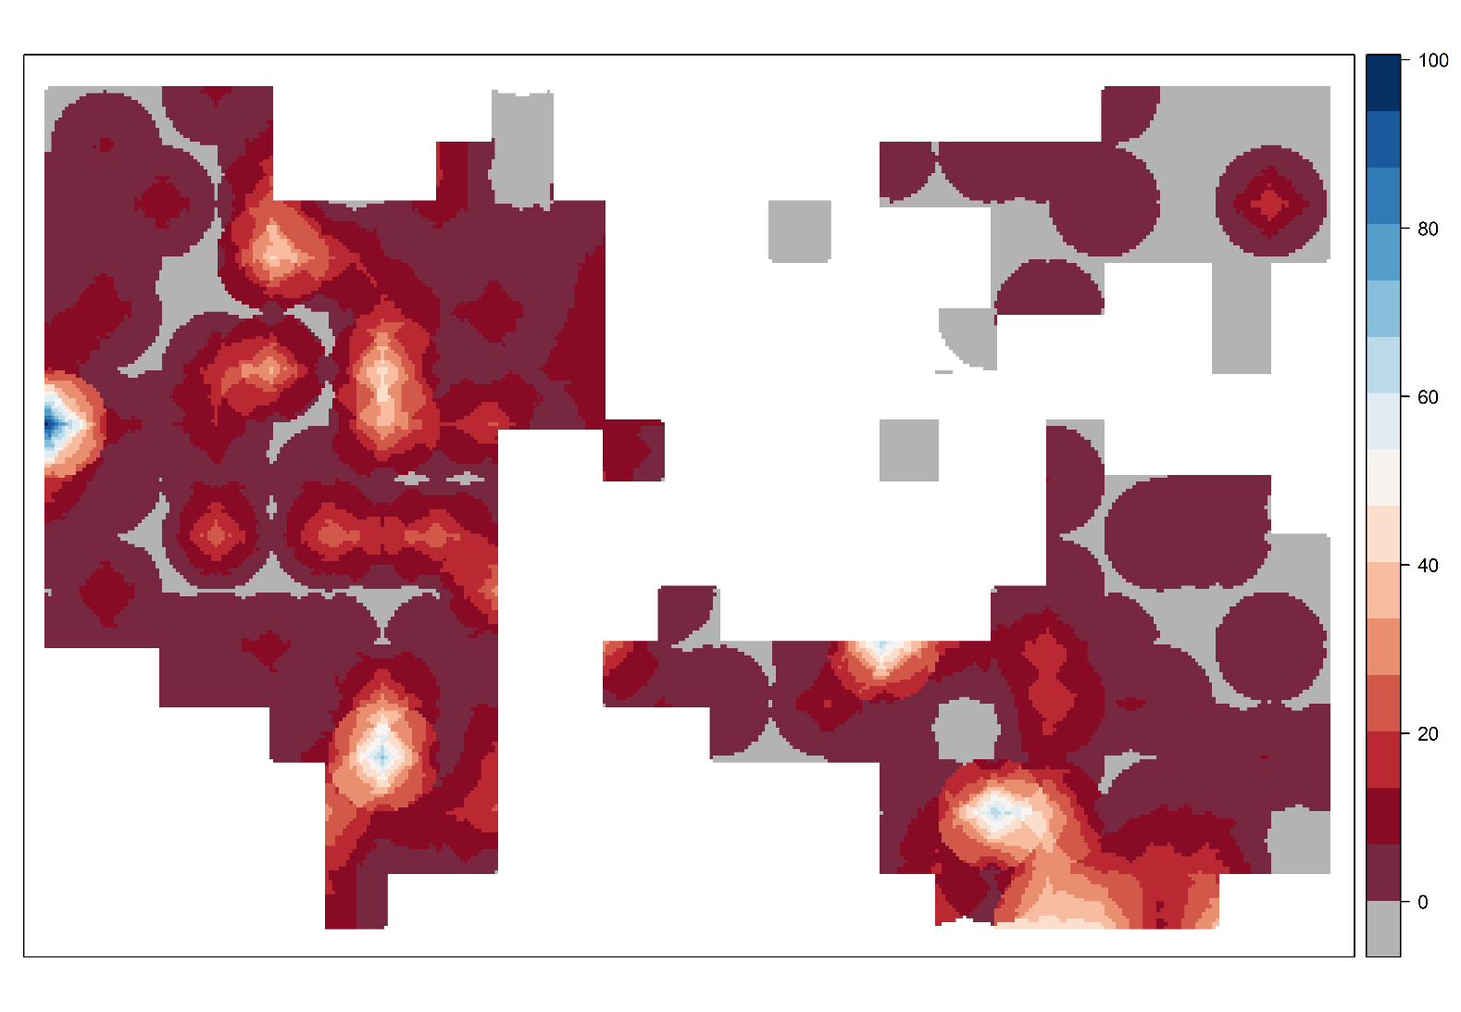
Figure S4: Result of the inverse distance weighted interpolation for abundance of Myrmica schencki based on abundance values (sum of individuals collected in 2 sampling sessions) at 254 sampling points. The color scale indicates the interpolated abundance values.
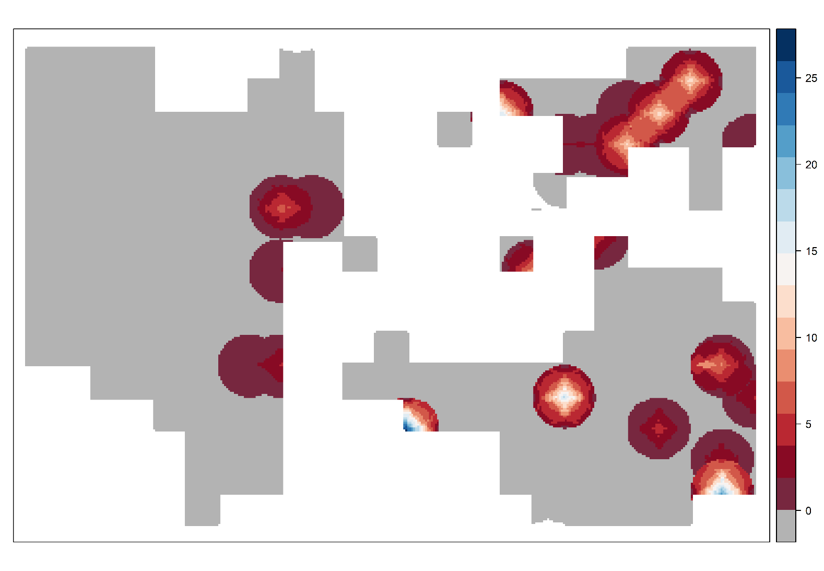
Figure S5: Result of the inverse distance weighted interpolation for abundance of non-Myrmica ants based on abundance values (sum of individuals collected in 2 sampling sessions) at 254 sampling points. The color scale indicates the interpolated abundance values. 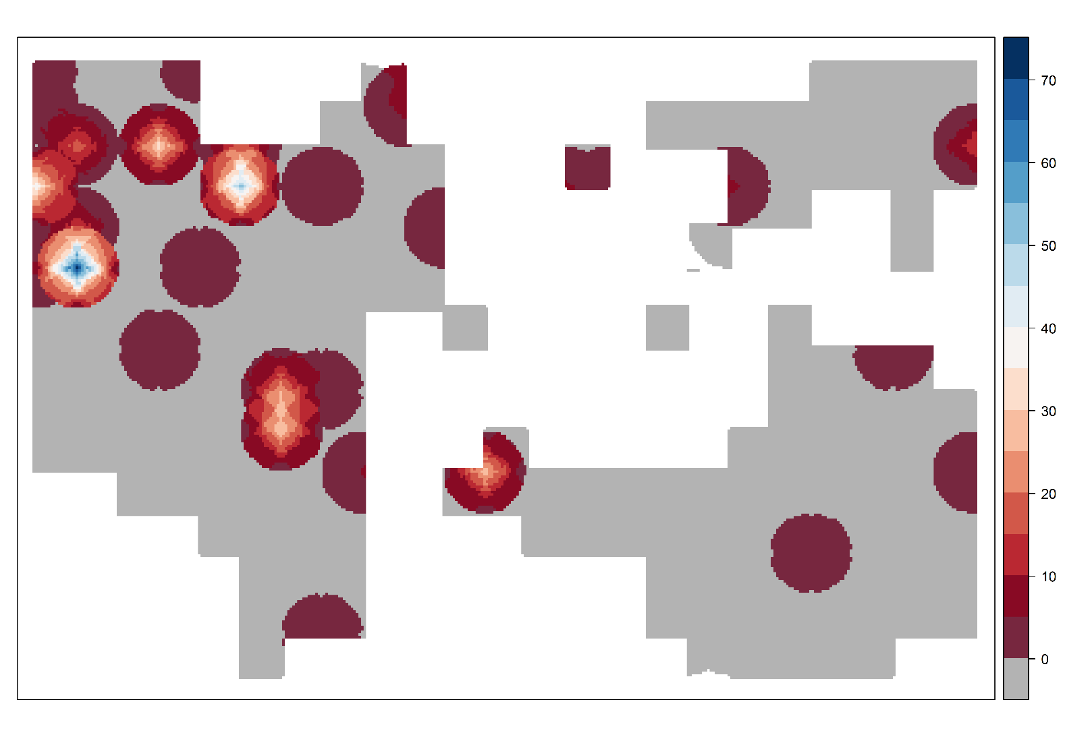
Figure S6: Spatial correlogram of the residuals of the binomial GLMs for the probability of a shoot having eggs before (red) and after (blue) including the two eigenvectors issued from MEM.
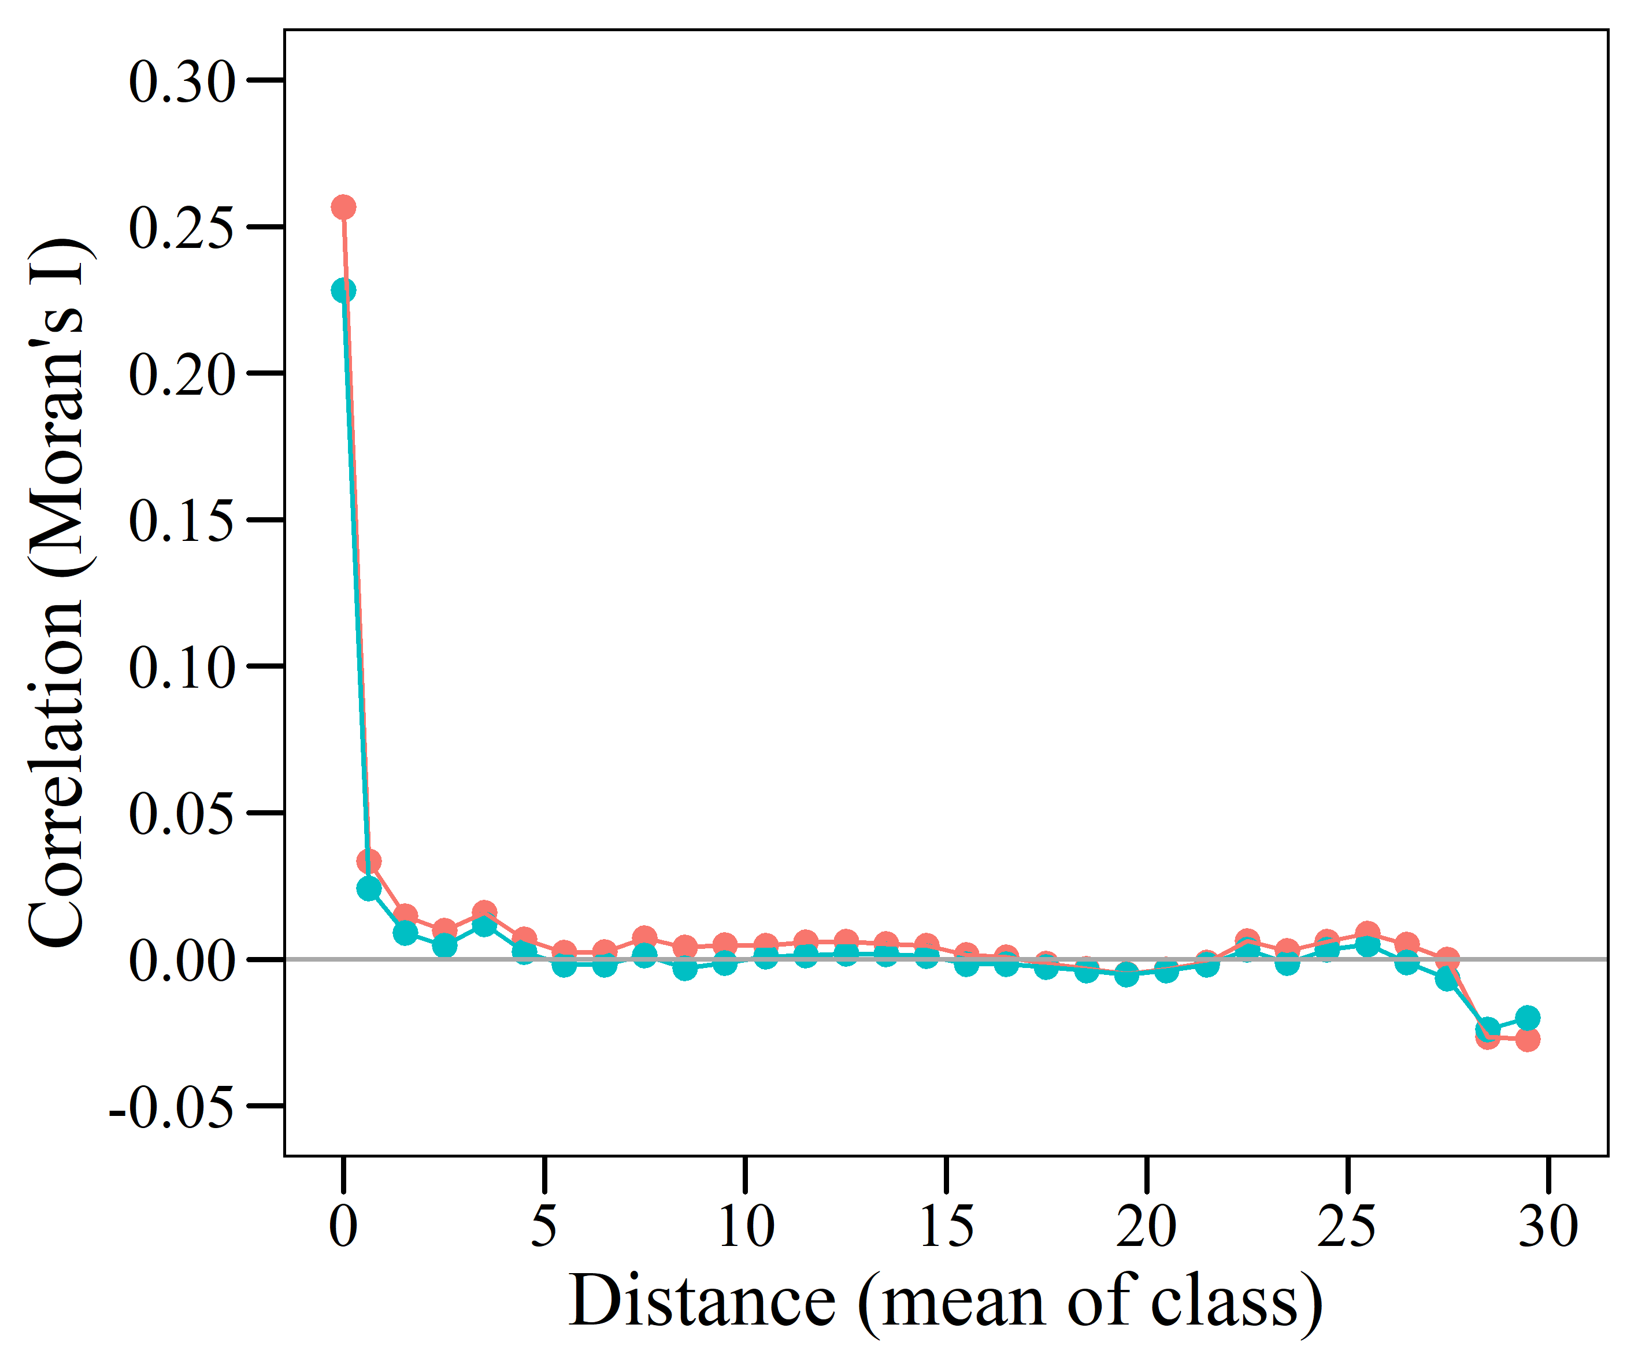
Figure S7: Spatial correlogram of the residuals of the negative binomial GLM for the number of eggs in shoots with at least one egg.
