04-Sept-2017
Dear Editor,

Thank you for the invitation to submit a revised version of our manuscript JAE-2018-00418, entitled “Resource overlap and dilution effects shape host plant use in a myrmecophilous butterfly”.

This manuscript is a thoroughly revised version where we have addressed all the reviewers' comments. We have refocused the study towards the importance of resource abundance and resource timing for consumer responses, instead of speaking about resource quality, which was problematic according to the first reviewer. We have also carefully considered the second reviewer's recommendations about the host ant species. We now present alternative analyses with different species and have tried to justify our choices according to the information provided by this reviewer.

Below, we provide a point-by-point list with answers to all questions and detailing the changes made in response to each of the comments by the reviewers and the editor.

Thanks again for your consideration of our manuscript.

Yours sincerely,
Alicia Valdés, on behalf of both authors
ASSOCIATE EDITOR COMMENTS TO AUTHORS (if any)
Both reviewers agree that the idea is potentially interesting, but also have concerns on the data/analyses used to support the conclusions. In particular, the definition of the quality of the flowering resource needs to be readdressed, also in relation to the host-plant ant interaction. Reviewer 2 details additional points on the ant species, which are likely to be hosts in the region, addressing this comment may alter the interpretation of results and should be considered carefully.
REFEREES'COMMENTS TO AUTHORS
Reviewer: 1
The basic hypothesis of the paper is that the consumers make an optimal choice by selecting high quality resources, which may lead to uneven predation rates where resources are heterogeneoulsy distributed in space. This is an important and timely topic that is well-presented and thoroughly discussed.However, here the quality of the resource is defined by a proxy (flowering time) that is not convincingly demonstrated as reflecting the intrincic properties of the plant that are useful to the consumer (maximization of energetic content, optimization of the time budget of the consumer, etc.). This is a major flaw that curently preclude the validation of the working hypothesis. There are several proximal and ultimate alternative reasons that could produce a pattern of higher egg density on early flowering plants similar to what it is reported here: the presence of eggs as egg-laying signals for time-constrained females; a bias in the pheology of egg-laying females towards the beginning of the flowering season; selective pressures towards a long flowering period in plants to avoid butterfly predation on seeds and a sampling effect that generates the above mentioned bias in the pheology of egg-laying females towards the beginning of the flowering season, etc. If I adopt the plant viewpoint, I would say that late flowering plants are of higher quality because they avoid the predation pressures from the butterfly.

We thank the reviewer for this comment, but we want to precise that in this manuscript we are looking at plant quality from the butterfly viewpoint, and in this case, the plants that provide higher-quality food for the caterpillars in terms of easier-to-digest seeds are the plants with buds in early phenological stages (Arnaldo, Gonzalez, Oliveira, Langevelde, & Wynhoff, 2014). As the presence of these bud stages overlaps more with the period of oviposition in early- than in late-flowering plants (Valdés & Ehrlén, 2017), early-flowering plants can be seen as of higher quality from the butterfly viewpoint. We agree that other aspects might contribute to define resource quality for a particular consumer, but nutritional content is a major aspect of quality. Of course, from the plant viewpoint, late-flowering plants that can avoid predation would be considered of higher quality, but that is not the viewpoint that we use in our study.

However, in order to avoid any confusion about the term “plant quality”, we have now modified the text throughout the manuscript and changed the focus from “resource quality” to “resource timing”, stressing that both resource abundance and resource timing are important for consumer responses. For insect herbivores, host plant phenology is a crucial measure of resource timing, and we now focus on how phenology of one resource (the host plant), the density and phenology of neighboring resources (conspecific plants), and the abundance of another resource (host ants) influence resource use by the consumer butterfly.

I suggest that the authors look for on a quantitative (and probably multi-factorial) definition of plant quality from the consumer side, and test whether this parameter is related to flowering dates. I would recommend the use a long time serie of data (ca. 10 generations or more) to investigate the interactions between butterfly flight periods and plant flowering times. There is a huge inter-annual variability of the flight period in P. alcon that can blur real plant-consumer relationships if the data set is too short.

As mentioned before, we now avoid the use of the term “plant quality”. We agree that investigating a long time series of data on butterfly-plant interactions would definitely be interesting, but we do not have this kind of dataset. However, we believe that our results, together with the results of previous studies (Valdés & Ehrlén, 2017, 2018) provide sufficient evidence to acknowledge that resource timing (i.e. plant phenology) is a very important aspect determining consumer-resource relationships in this system. As an example of the consistence of the increase in resource use with an early timing of the plant resource, we reproduce here a figure that was included as supplementary material in Valdés & Ehrlén (2017), where a positive effect of an early flowering phenology on the number of eggs is shown for several populations in two different years. Although the magnitude of the slopes varies, the number of eggs always increases with an earlier phenology.

Figure S1: Among-population variation on the effect of G. pneumonanthe traits on itensity of predation by P. alcon. Partial linear regression plots showing among-population variation on the effect of G. pneumonanthe flowering phenology on the number of eggs of P. alcon in 2010 and 2011. Populations are represented by different colours (N = 10 in 2010 and N = 11 in 2011).

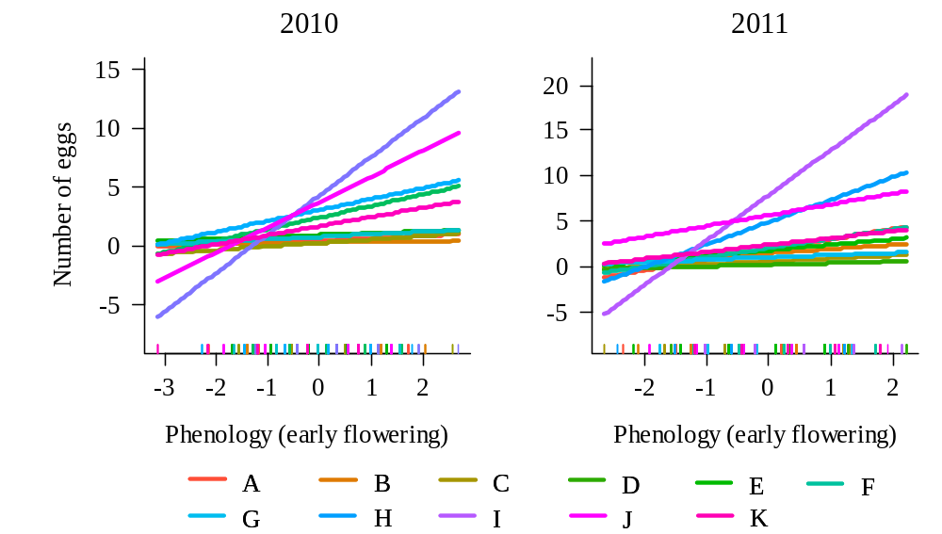
Reviewer: 2
This study is well conducted and provides novel and interesting results. It is also well written and easy to follow.
However, the authors' assumptions about host ants on this site are unlikely to be true, which puts a different spin on their results. I visited several of the sites where Maculinea (Phengaris) alcon is found near to Götteborg about 12 years ago, attempting to find out which Myrmica ants were being used as hosts. This included what I believe is the site mentioned in this manuscript. Here, and elsewhere in the region, the host ant proved to be Myrmica ruginodis (although the number of infested nests that we opened was relatively small). This data has been published, but in a rather obscure Danish paper (Nash, D. R., and Andersen, A. (2015) MACULINEA-sommerfugle og stikmyrer på danske heder - coevolution i tid og rum. Flora og Fauna 121, 133-141), a copy of which which I attach (I am also in the process of including this informationin a large paper on host ant use across Europe). While the assuption that Myrmica rubra is likely to be the main host in this region has some justification, as this is the case in sites on Skåne, Myrmica schencki would be very very unlikely to be a host - it has NEVER been recorded as a host for Maculinea alcon that develop on Gentiana pneumonanthe, only in southern Europe for the form of Maculinea alcon that develops on Gentiana cruciata on much drier sites. Generally M. alcon utuílizes the most common Myrmica on a site, which seems to be M. ruginodis from the supplementary figurse (although when I surveyed this site there were more M. scabrinodis than either M. rubra or M. ruginodis, but again this ant has never been recorded as a host of M. alcon in North-west Europe.)

We are very grateful to the reviewer for his insightful comments about the study system and for sharing his knowledge with us and suggesting the reference. We acknowledge that we cannot completely confirm which Myrmica species acts as a host in our study site, as we have not opened any ant nests or performed experimental manipulations. Alternatively, our measures of host ant abundance were based on correlations with egg occurrence. We understand the concern of the reviewer about M. schencki, and we agree that it is probably unlikely that this species acts as a host for the hygrophilous ecotype of P. alcon, as it has only been recorded as a host for the xerophilous ecotype (which develops on Gentiana cruciata). Therefore, we have now modified our analyses and removed the abundance of M. schencki. We have performed new analyses using the abundance of either M. rubra, M. ruginodis or the summed abundance of M. rubra and M. ruginodis as measures of host ant abundance. We chose to keep the analyses with the abundance of M. rubra in the main text, because this species had the strongest positive effect on both the probability of host plants receiving eggs and the number of eggs in plants with at least one egg (Table S1). As the reviewer mentions, M. rubra has been reported to be the host of P. alcon in other areas in Sweden. According to the reference provided (Nash & Andersen, 2015), M. ruginodis has been confirmed to be a host by opening nests in two sites in Västra Götaland: Remmene and Högsjön. However, our study was carried out in a different site (Tånga Hed), which is 44 km away from Högsjön and 8 km from Remmene and, as far as we know, there is no information on host ant use from this site. Therefore, we believe that either M. rubra or M. ruginodis (or both) could be possible hosts. M. ruginodis is the most common ant species in our study site, but as the reviewer points out with the example of Remmene, and as shown in the map in Fig. 2 in Nash & Andersen, 2015 (see for example the data for Vasalund, where M. ruginodis is the most abundant but M. rubra is the host), P. alcon not always uses the most common Myrmica on a site as a host. The results of our analyses suggest that M. rubra is the most probable host ant species in our study site, although we cannot completely rule out the possibility that other species act as hosts in our study site, and that the correlations with M. rubra abundance are due to the effect of some unmeasured variable, and not to butterflies tracking the distribution of this species. Therefore, we have tried to discuss these findings with caution in the manuscript.
Another aspect of the study that in unclear is whether host plant phenology and Myrmica ant distribution are independent of each other, or whether both are related to small habitat differences across the site. This has been shown to be the cause of spurious correlations between ant distributions and oviposition choices in previous studies (e.g. Thomas, J. A., and Elmes, G. W. (2001) Food-plant niche selection rather than the presence of ant nests explains oviposition patterns in the myrmecophilous butterfly genus Maculinea. Proc Biol Sci 268, 471-477.). The authors have an ideal opportunity to test whether there are correlations between plant phenology and Myrmica distributions with their survey set-up, so I'm surprised that this is not included in the study.

Correlations between plant phenology and Myrmica distributions are very small (r = 0.01 for M. rubra, and all correlations with other species are lower than 0.2). Therefore, we can assume that they are independent of each other. Even if they were related, including both of them in a multiple regression model allows to assess their independent effects.
It was also not clear why phenology was included as an ordinal variable in the analysis - I would think it should be included as a categorical variable to make as few assumptions about optimal phenology as possible, but the results suggest it was treated as a continuous (ratio-scale) variable, not even an ordinal variable.

Phenology was treated as an ordinal variable because the developmental stage of buds is indeed an “ordered” process: buds go from stage 1 to stage 2, 3, 4, 5 and 6 in a specific order. We believe that making phenology a categorical variable would not take into account this ordered process, and besides, we do not think that including it as an ordinal variable is equivalent to making assumptions about optimal phenology for butterflies. As an illustration of this, we have constructed the following figure (see below) where we have plotted the probability of a shoot having at least one egg against phenology treated as an ordinal variable. Here, it is also evident that butterflies prefer to lay eggs in the plants where phenology is most advanced (i.e. in the early-flowering plants).

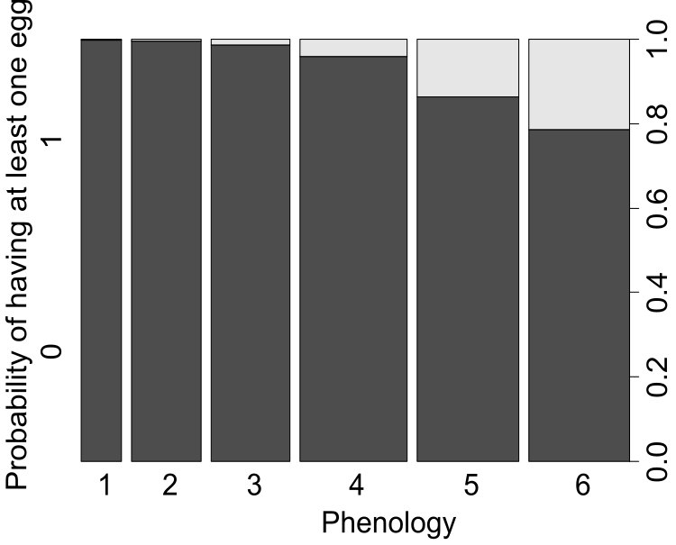
Finally, I was a little worried about the time period over which the study was conducted. At the beginning of the period mentioned (9 July) I would be very surprised if M. alcon were not still flying and laying eggs, so the final distribution of eggs (which is taken as fixed in this study) would not yet be in place...

Although fieldwork was conducted between 9 July and 3 September 2016, the phenology and the number of eggs of P. alcon were recorded between 29 July and 5 August (this is specified in the Methods, and the previous days were used for establishment of the sampling design and other related tasks). Sampling in this period should then account for the final distribution of eggs, as no (or almost no) butterflies would be flying after this date. Indeed, records from the Swedish Species Observation System (https://www.artportalen.se/) show that, for the period 1993-2018, there were 0 records of adults of P. alcon after this date in the study site (Tånga Hed nature reserve), and only 3-5 (some are doubtful) out of 307 records after this date in Västra Götaland county are adults (the rest are eggs).
Given some of the information provided above, I do not wish to remain anonymous.
- David Nash

REFERENCES

Arnaldo, P. S., Gonzalez, D., Oliveira, I., Langevelde, F. van, & Wynhoff, I. (2014). Influence of host plant phenology and oviposition date on the oviposition pattern and offspring performance of the butterfly Phengaris alcon. Journal of Insect Conservation, 18(6), 1115–1122. doi:10.1007/s10841-014-9721-x
Nash, D. R., & Andersen, A. (2015). Maculinea-sommerfugle og stikmyrer på danske heder. Flora Og Fauna, 121(3/4), 137–145.
Valdés, A., & Ehrlén, J. (2017). Caterpillar seed predators mediate shifts in selection on flowering phenology in their host plant. Ecology, 98(1), 228–238. doi:10.1002/ecy.1633
Valdés, A., & Ehrlén, J. (2018). Direct and plant trait-mediated effects of the local environmental context on butterfly oviposition patterns. Oikos, 127(6), 825–833. doi:10.1111/oik.04909
Johan
1.
I think that the comments from reviewer 1 were not very insightful. It seems that (s)he got stuck on the term plant quality. I guess the easiest to deal with this comment would be to clearly explain what we mean by “quality” and acknowledge that there are several possible mechanisms underlying the patterns we observe. Perhaps an even better way to deal with it would be to explain why timing of a resource is an important aspect of quality and then stick to timing rather than the more vague “quality”.
For the comments by Nash, I agree that the best way would be to do also the alternative analyses with only ruginodes, but given that rubra is an important host in other (nearby) regions, we want to maintain also that. I will read his Danish paper.

2.
For the J Anim Ecol, I looked through the paper in Danish as well as another paper referred to in that paper. My understanding of the level of knowledge, in brief, and including also POs findings, (summarized below) is that ruginodes, rubra or both as host species of ants are all quite possible based on previous knowledge. However, we might not be able to argue that schencki is a likely host based on previous knowledge. To motivate our current use of hosts, I guess we have to say that we regard the level of knowledge as incomplete and that we therefore took a broad explorative approach. However, then we have to acknowledge that correlations might not be causal (i.e. that a given species necessarily is a host) but that effects might be mediated by some unmeasured environmental variable.

So perhaps one way to deal with this would be to try other analyses with rubra and or ruginodes in addition to the one we have.

Als et al. 2002:

M. rubra, M. ruginodis and M. scabrinodis used as hosts in different parts of the distribution area. M. rubra and M. ruginodis used in Denmark. M. scabrinodis only used only in central and southern Europe. Of 5 Danish populations investigated in detail one used exclusively M. rubra, one used exclusively M. ruginodis, and one used both M. rubra, M. ruginodis. Hence, use of multiple ant host species within a population of M. alcon seem to be common according to the authors.

Nash & Andersen 2015:

Ants of M. rubra, M. ruginodis and M. scabrinodis found at Remmene but butterfly larvae only found in nests of M. ruginodis. Unclear how many nests that were explored and in how many nests larvae were found. However, comparing the data in Nash & Andersen 2015 with Als et al. 2002 it seems that larvae were found relatively few nests at Remmene (this is also what Nash says in his review).

M. alcon found in nests of M. rubra in southern Sweden

Oral communication with PO Wickman:

“PO picked inflorescence with eggs at Remmene summer 2017. Hatched larvae fed on cultivated plants (very easy he said). Moved to new buds when finished eating on one bud. Larvae first ate stamens and pollen, then turned to ovaries and developing seeds. Larvae always left buds and flowers through the side wall (even if the flower was open). Survived for six days after leaving the flower without problem (in the field this would correspond to the time waiting to being picked up by ants).

Larvae leaving flowers were transferred to nests of different ant species at Remmene in summer 2017. Ants “activated” by disturbing them. Larvae exactly the same size as ant pupae.

Ants of the two species Myrmica lonae (skålrödmyra) och Myrmica scabrinodis (ängsrödmyra) immediately accepted the larvae – reacted strongly according to PO.

Ants of Myrmica ruginodis (skogsrödmyra) were indifferent (two different nests tested).

Ants of Formica (and some species of slave-keeping ants) also picked up the larvae (but then regarded them as food items) and even tried to rob them from Myrmica ants.”

