TITLE: Resource overlap and resource dilution shape egg distribution patterns in a myrmechophilous butterfly
INTRODUCTION
The presence, quality and abundance of a specific set of resources determines habitat suitability for any given species (Dennis et al. 2006). In the case of insects whose larval stages show low mobility, females select oviposition sites that maximize offspring development and survival probability (preference–performance hypothesis or optimal oviposition theory, Jaenike 1978; Scheirs & De Bruyn 2002). Oviposition site selection in herbivorous insects might depend on several factors that enhance offspring survival such as host plant nutritional quality (Chen et al. 2004), size (Wiklund 1984), suitable microclimatic conditions (Eilers et al. 2013) or enemy-free space (Wiklund & Friberg 2008). Therefore, the spatial distribution and quality of resources (i.e. host plants) within a habitat influences the oviposition pattern of the consumer (i.e. the insect), and therefore conditions the outcome of the interaction (Thompson & Pellmyr 1991; Östergård & Ehrlén 2005). The density of resources also plays a role, and herbivore abundance and/or intensity of herbivore attack might respond either positively (resource concentration hypothesis, Root 1973) or negatively (resource dilution, Otway et al. 2005) to host plant density. Oviposition by females of some butterflies, which oviposit repeatedly on individual host plants when host density is low (Jones 1977), is an example of resource dilution which leads to more aggregated egg distributions at low host densities.
Several factors might complicate the relationships among consumer activity and resource distribution in herbivorous insects. First, not only resource density, but also the temporal synchronization among the resource and the consumer activity might be important. Some insects show strong preferences for particular phenological stages of their host plant (e.g. Smyth et al. 2003; Patricelli et al. 2011; Fogelström et al. 2017). In these cases, plant phenology determines resource quality, and the outcome of the interaction might depend on the temporal overlap among the presence of the preferred phenological stages and the activity period of the consumer. Second, consumers might need more than one resource (e.g. host plants, floral nectar, alternative or secondary hosts), and they might use different resources during different phases of the life cycle (Dennis et al. 2003). If their offspring has low mobility, female oviposition patterns could in these cases be related to the spatial distribution of more than one resource, in order to maximize offspring survival.
An example of herbivorous insects with a strong dependency on different resources during different phases of their life cycle are myrmecophilous butterflies of the genus Phengaris. These butterflies need two sequential hosts to complete their larval development, i.e. they change from using one resource to another during their life cycle. Phengaris caterpillars are predispersal seed predators of different host plants during their first larval instars, while they are parasites of ant nests (Myrmica spp.) during later stages of their life cycle. They are known for their specific requirements concerning species identity and phenological stage of host plants (Thomas & Elmes 2001; Valdés & Ehrlén 2017) and species identity of host ants (Elmes et al. 1998). Females oviposit preferentially on flower buds in early phenological stages, probably due to these buds containing food of better quality: the seeds inside the bud might become drier and more difficult to digest as the bud develops into a flower (Arnaldo et al. 2014). Due to this preference, and to the fact that the presence of the preferred buds overlaps more with the oviposition period of the butterfly in early- than in late flowering plants, they also lay more eggs on plants flowering early in the season (Valdés & Ehrlén 2017), which thus represent a higher quality of the plant resource.
In order to optimize oviposition, Phengaris females should be able to track the spatial distribution of both the preferred phenological stages of their host plants and of their host ants within a habitat, as both resources are needed by their offspring to complete their life cycle. Due to the low mobility of Phengaris caterpillars after leaving the plant (Hayes 2015), host plants only offer opportunities for further development if they are located within the foraging range of suitable host ants (which is usually a few meters). Therefore, the spatial overlap of both resources might be important, and butterflies could choose oviposition sites that simultaneously maximize the availability of suitable host plants and suitable host ants in order to increase caterpillar survival probability. The ability of butterfly females to detect host ant presence was previously suggested (e.g. van Dyck et al. 2000), and it has been recently shown that females are able to detect plant chemical compounds produced in reaction to ant damage (Patricelli et al. 2015). In addition to the spatial overlap of both resources, density and suitability of conspecific neighboring plants might also determine oviposition site selection in Phengaris butterflies. Species interactions are context-dependent (Chamberlain et al. 2014), and for insects specialized in particular phenological stages which represent high-quality food for its larvae, the resource dilution effect caused by a high density of host plants could be stronger when neighboring plants are of high quality. In this sense, not only density, but also phenology of conspecific neighboring plants might play a role in oviposition patterns of Phengaris, and host plants surrounded by a given density of conspecifics could show more aggregated egg distributions when these conspecifics are flowering early (i.e. representing a high quality of the plant resource). While many studies have explored the effects of conspecific neighbor density on interactions with insect herbivores and seed predators (e.g. (Yamamura 2002; Kula et al. 2014; Kim & Underwood 2015), the role of neighborhood quality has been overlooked.
In this study, we studied the influence of resource availability and suitability, as well as neighborhood density and quality, on egg distribution patterns of the butterfly Phengaris alcon on its host plant Gentiana pneumonanthe. Specifically, we addressed the following questions: (1) How do egg distribution patterns of P. alcon depend on phenology of its host plant and on host ant abundance? Specifically, we predicted that the relationship among egg distribution patterns and host plant phenology would depend on host ant abundance, i.e. butterflies would select oviposition sites that simultaneously maximize the availability of both resources, therefore showing a stronger preference for early-flowering host plants when host ants are more abundant. (2) Is there a dilution effect of host plant density on egg distribution patterns, and does it depend on the phenology of neighboring host plants? Specifically, we predicted that both the probability of a host plant getting eggs and the number of eggs would decrease with the density of neighboring host plants (i. e. dilution effect), and that this decrease would be stronger when neighboring host plants are flowering early.
METHODS
Study system
The marsh gentian (Gentiana pneumonanthe L.) is a rare, long-lived perennial herb, occurring in open habitats, such as wet heathlands and grasslands (Simmonds 1946). In natural populations, individuals do not flower until their third year (Simmonds 1946). Plants can have one to many, up to 45 cm high, shoots and produce deep blue flowers that are pollinated by bumblebees. The species is self-compatible and flowers in July and August in SW Sweden. Fruits are capsules containing a high number (usually 300-700, Appelqvist & Bengtsson 2007) minute (mean seed weight = 0.044 mg, Simmonds 1946), wind-dispersed seeds. Gentiana pneumonanthe is the primary host of the Alcon Blue butterfly (Phengaris alcon), a specialist predispersal seed predator which oviposits on young buds in July and August (Appelqvist & Bengtsson 2007). The caterpillars feed inside the capsule until they reach the fourth-instar, when then they drop to the ground to be picked up by Myrmica ants. Caterpillars mimic the surface chemistry of the ant brood (Nash et al. 2008) and the acoustic signals of queen ants (Sala et al. 2014), and this makes ants carry them to their nest, where they spend the rest of their larval period as parasites. Contrary to the majority of Phengaris species, which prey on ant brood, P. alcon is a “cuckoo” species (Als et al. 2004), and larvae feed primarily on regurgitations from ant workers, trophic eggs (i.e. nutritious, infertile eggs which are fed to the queens and larvae) and prey items brought to the nest by ants. Only ants belonging to the genus Myrmica can act as second hosts of P. alcon. In Sweden, M. rubra is the most common host ant species (Elmes et al. 1994).
Data collection
The study was carried out in a population of G. pneumonanthe where the butterfly P. alcon was present, located in Tånga Hed nature reserve, in the county of Västra Götaland, SW Sweden (58°01'40.0"N 12°49'47.0"E). Field work was conducted between 9 July and 3 September 2016. The population occupies a fenced meadow that is yearly grazed by cows at the end of the summer. A study plot measuring 69 x 45 m² was established into the meadow, and divided into 345 subplots measuring 3 m² (Fig. 1A) permanently marked with wooden sticks at their corners. After checking all subplots for presence of plants of G. pneumonanthe in mid-July, the species was found in 172 of them (hereafter called “occupied subplots”).
In the occupied subplots, all reproductive shoots of G. pneumonanthe were mapped, and their phenology and the number of eggs of P. alcon were recorded (Fig. 1B), between 29 July and 5 August. We had to exclude 18 subplots due to time constraints, and therefore mapping was performed in 154 occupied subplots. We mapped shoots instead of individual plants (that may have from one to many shoots) because we wanted to assess availability of the host plant resource for the butterflies, and we believe that this is better represented by the number of reproductive shoots than by the number of plants. On each shoot, phenology was recorded as the developmental stage of the most advanced bud, according to six ordinal categories (Valdés & Ehrlén 2017): (1) the sepals covering the bud completely, (2) bud becoming visible, (3) bud growing over the sepals, (4) bud turning blue, (5) flower opening, and (6) flower showing signs of wilting. Each of these stages corresponded to a time interval of flower development, with higher values indicating a more advanced floral development at the day of recording, i.e. an earlier flowering phenology. The number of eggs was counted on the whole shoot.
The ant community was sampled at 254 points (Fig. 1B), corresponding to the four corners of all occupied subplots. Two sampling sessions using sugar baits placed at these points were performed on 14 July and 3 September. Baits consisted of a Falcon plastic tube where we introduced a sugar cube. The tubes were left open on the ground in the evening, and collected the next morning. Ants collected were transferred to 70º ethanol for identification in the lab, where Myrmica ants were identified to the species and counted (using Douwes et al. 2012), and ants belonging to other genera where not identified, but counted as “others”.
Calculation of neighborhood measures
Field maps were digitized using a Geographic Information System (GIS) created with ArcGIS 10.3.1, therefore assigning relative coordinates to each reproductive shoot of G. pneumonanthe found into the study plot (Fig. 1B). For each of these shoots, we defined a buffer of 3 m around the shoot (see example on Fig. 1B), and calculated the density (hereafter, “neighborhood density”, measured in number of shoots / m²) and the mean phenology (hereafter, “neighborhood phenology”, a continuous value between 1 and 6) of all reproductive shoots of G. pneumonanthe into this buffer (excluding in each case the focal shoot).
Interpolations of ant abundances
The locations of the 254 points corresponding to the four corners of all occupied subplots, where the ant community was sampled, were also incorporated in the GIS. We used inverse distance weighted interpolation (Pebesma 2004) to generate values of abundance of the different ant species over the surface of all occupied subplots, based on the values at the sampling points. A maximum distance of 3 m was used because it represents the ground foraging distance of most Myrmica species (Elmes et al. 1998). From these interpolated surfaces (see Figs. S1-5 in Supporting Information), we extracted values of abundance of the different ant species for each of the mapped shoots.
Statistical analyses
The effects of shoot phenology, host ant abundance, neighborhood density and neighborhood phenology on egg distribution patterns of P. alcon were examined using Generalized Linear Models (GLMs). Effects on the probability of a shoot having eggs were evaluated using a binomial GLM, and effects on the number of eggs in shoots with at least one egg were evaluated using a negative binomial GLM. We previously studied the response of egg distribution patterns to the abundance of the different ant species using GLMs with one predictor (i.e. the abundance of one ant species or the combined abundance of several species) at a time. The strongest positive effect on the probability of getting eggs was found when the combined abundance of M. rubra and M. schencki was used as a predictor (Supporting Information Table S1). M. rubra is the most common host ant species of P. alcon in Sweden (Elmes et al. 1994), and M. schencki has been cited as host in several places in Europe (Vilbas et al. 2016). Therefore, we decided to use the combined abundance of these two species (hereafter, “ant abundance”) as a predictor in further models. The final models were two GLMs including the four above mentioned predictors as well as three interactions: 1) the interaction shoot phenology x ant abundance, in order to test if the relationship among egg distribution patterns and phenology depends on abundance of the host ants; 2) the interaction neighborhood density x neighborhood phenology, in order to test if the effect of host plant density depends on phenology of neighboring host plants; and 3) the interaction shoot phenology x neighborhood phenology, in order to test if the relationship among egg distribution patterns and phenology depends on phenology of neighboring host plants.
All predictors were standardized by subtracting the mean and dividing by the standard deviation before the analyses. We checked for spatial autocorrelation in the residuals of both models by plotting spatial correlograms and calculating global Moran's I with a permutation test (1000 random permutations). Moran's I was calculated based on a connectivity matrix of pairwise Euclidean distances among the shoots up to a distance of 30 m. Residual spatial autocorrelation could lead to biased model estimates and invalid statistical inference (Dormann et al. 2007). Therefore, when significant spatial autocorrelation was found in the residuals of the GLMs, we applied Moran’s eigenvector mapping (MEM), which translates the spatial arrangement of data points into explanatory variables (eigenvectors) that capture spatial effects (Dray et al. 2006; Thayn & Simanis 2013). We then refitted the model including the eigenvectors that best reduced the residual spatial autocorrelation as spatial predictors in the GLM, and checked again for spatial autocorrelation in the residuals of the new model.
Statistical analyses were carried out in R 3.4.0 (R Core Team 2017).
RESULTS
The probability of a shoot of G. pneumonanthe having eggs of P. alcon increased with an earlier phenology (i.e. with a more advanced floral development at the day of recording), and this increase was stronger in plants where the host ants were more abundant (significant effect of the interaction shoot phenology x ant abundance, Table 1A, Fig. 2A). The probability of having eggs decreased with the density of neighboring host plants, and this decrease was stronger when neighboring host plants had an earlier phenology (significant effect of the interaction neighbor density x neighbor phenology, Table 1A, Fig. 2B). The residuals of the binomial GLM showed significant spatial autocorrelation (global Moran's I = 0.0150, p < 0.001, Fig. S6 in Supporting Information), therefore we refitted the model including two eigenvectors issued from MEM (Table 1A). After including these spatial predictors, residual spatial autocorrelation was strongly reduced (global Moran's I = 0.0003, p = 0.03297, Fig. S6 in Supporting Information). Although it was still significant, the p-value close to 0.05 and the visual inspection of the spatial correlogram (Fig. S6) indicate that most of the residual spatial autocorrelation was removed by the spatial predictors, and therefore confirms the validity of our model. Results of the binomial GLM before including the spatial predictors are shown in Table S2 in Supporting Information.
In G. pneumonanthe shoots with at least one egg, the number of P. alcon eggs increased with an earlier phenology (Fig. 3A) and with host ant abundance (Fig. 3B), but the effect of shoot phenology did not depend on host ant abundance (the interaction shoot phenology x ant abundance was not significant, Table 1B). Similar to the probability of having eggs, the number of eggs decreased with the density of neighboring host plants, and this decrease was stronger when neighboring host plants had an earlier phenology (significant effect of the interaction neighbor density x neighbor phenology, Table 1B, Fig. 3C). The residuals of the negative binomial GLM did not show significant spatial autocorrelation (global Moran's I = -0.0023, p = 0.613, Fig. S7 in Supporting Information).
DISCUSSION
The results of this study show that egg distribution patterns of the myrmechophilous butterfly P. alcon are shaped by both the spatial overlap of the two key larval resources and by a dilution effect caused by high-quality host plants. Specifically, we found that butterflies prefer ovipositing on early-flowering plants that have a high abundance of host ants, while at the same time they avoid plants surrounded by many early-flowering conspecific neighbors.
In accordance with previous studies showing that animal interactors usually prefer plants with a particular phenology (Elzinga et al. 2007), and more specifically, that antagonistic interactors preferentially attack early-flowering plants (Parachnowitsch & Caruso 2008; König et al. 2015; Valdés & Ehrlén 2017), we found that both the probability of having eggs and the amount of eggs of P. alcon increased with an early phenology of its host plant G. pneumonanthe. However, our study is the first to demonstrate that this phenological preference depends on the abundance of another resource used by the antagonist. Specifically, the preference of P. alcon for early-flowering host plants was stronger in plants where the host ants were more abundant. This means that the butterflies are able to track the distribution of these two resources, and to preferentially oviposit on plants where both the availability of high-quality food for the caterpillars and the probability of adoption by the right species of Myrmica are maximal. Spatial overlap between the distribution of host plants and host ant nests has been shown to increase density and population survival of another species of Phengaris (P. arion, Thomas et al. 2009; Casacci et al. 2011). In addition, our study shows that the spatial overlap between these two resources at a very small scale (i.e. at the scale of the plant individual) increases plant suitability for oviposition. Although previous studies had pointed out the importance of host plant phenology (Thomas & Elmes 2001; Valdés & Ehrlén 2017), host ant presence (van Dyck et al. 2000; Wynhoff et al. 2008) or both of these factors (Patricelli et al. 2011) for oviposition site selection, no study to date has found evidences of ant-dependent phenological preferences in these butterflies. This dependence conditions which plants are attacked, but not the intensity of predation: in oviposited plants, egg loads were higher in early-flowering plants and in plants where the host ants were more abundant, but the preference for early-flowering plants did not depend on ant abundance. This could happen because...
In our study, we have considered both Myrmica rubra and M. schencki as host ant species. Although we have not inspected any ant nests in our study area to confirm that they effectively host caterpillars, both of these species can act as hosts of P. alcon (Elmes et al. 1994; Vilbas et al. 2016), and our choice is based on the strong correlation among the probability of getting eggs on a plant and the combined abundance of these two Myrmica species in the surroundings of that plant.
Our results show not only that phenological preferences of butterflies interact with host ant availability, but also that the effect of host plant availability (i.e. density) depends as well on plant phenology. The dilution effect (Otway et al. 2005) caused by having many conspecific neighbors is stronger when the neighbors are of high quality (i.e. early-flowering). Examples of antagonistic interactors showing negative density-dependence can be found elsewhere (Shea et al. 2000; Fagan et al. 2005; Hasenbank & Hartley 2015), and egg clumping on plants with few conspecific neighbors might be explained because insect herbivores are disproportionallly attracted to more isolated host plants. However, our study is the first to demonstrate that neighborhood quality (i.e. phenology of the surrounding plants) might also play a role in determining density-dependence effects. Specifically, for the same conspecific density, more eggs were found in G. pneumonanthe plants surrounded by non-attractive, low-quality neighbors (i.e. early-flowering plants). If females use plant phenology as a visual cue which indicates plant quality, host plants surrounded by low-quality neighbors would also be more isolated and more attractive to butterflies, while the effect of the seed predator would be diluted in host plants surrounded by high-quality neighbors.
Our study shows that the main factors determining egg distribution patterns in myrmechophilous butterflies are complex and interact with each other. Our results suggest that oviposition decisions could be taken at two levels. First, when flying over an area populated with host plants, female butterflies might use visual cues to evaluate host plant availability and identify high-quality host plants. Visual cues have already been shown to be important when selecting an oviposition site (Van Dyck & Regniers 2010), and our results suggest that neighborhood density and plant quality, represented by its phenology, are important visual cues when selecting a plant for egg laying, and that a dilution effect occurs on plants that have many high-quality neighbors. Second, when they are at a very close distance to host plants, or after they alight on a host plant, females may use chemical cues in combination with visual cues (Wynhoff et al. 2015) to evaluate the spatial overlap of the two resources needed by their offspring. In this sense, chemical cues (probably produced by the host plant in reaction to damage by ants, Patricelli et al. 2015) would allow females to detect host ant presence, as is suggested by the stronger preference for high-quality plants where host ants were abundant. Therefore, this study highlights that not only resource quality and density, but also the spatial overlap of key resources and its temporal synchronization are of vital importance for determining patterns and outcomes of consumer activity in highly-specialized herbivorous insects.
ACKNOWLEDGEMENTS
We thank Annelie Jörgensen for helping with fieldwork and Daniela Guasconi for lab assistance. We acknowledge funding from the Swedish Research Council (VR) to JE and from the “Clarín” postdoctoral program (FICYT, Gobierno del Principado de Asturias, Spain, and Marie Curie-Cofund Actions, EU) to AV.
REFERENCES
1.
Als, T.D., Vila, R., Kandul, N.P., Nash, D.R., Yen, S.-H., Hsu, Y.-F., et al. (2004). The evolution of alternative parasitic life histories in large blue butterflies. Nature, 432, 386–390
2.
Appelqvist, T. & Bengtsson, O. (2007). Åtgärdsprogram för alkonblåvinge och klockgentiana 2007-2011: Maculinea alcon och Gentiana pneumonanthe. Naturvårdsverket, Stockholm, Sweden
3.
Arnaldo, P.S., Gonzalez, D., Oliveira, I., Langevelde, F. van & Wynhoff, I. (2014). Influence of host plant phenology and oviposition date on the oviposition pattern and offspring performance of the butterfly Phengaris alcon. J. Insect Conserv., 18, 1115–1122
4.
Casacci, L.P., Witek, M., Barbero, F., Patricelli, D., Solazzo, G., Balletto, E., et al. (2011). Habitat preferences of Maculinea arion and its Myrmica host ants: implications for habitat management in Italian Alps. J. Insect Conserv., 15, 103–110
5.
Chamberlain, S.A., Bronstein, J.L. & Rudgers, J.A. (2014). How context dependent are species interactions? Ecol. Lett., 17, 881–890
6.
Chen, Y.-Z., Lin, L., Wang, C.-W., Yeh, C.-C. & Hwang, S.-Y. (2004). Response of two Pieris (Lepidoptera: Pieridae) species to fertilization of a host plant. Zool. Stud., 43, 778–786
7.
Dennis, R.L., Shreeve, T.G. & Van Dyck, H. (2003). Towards a functional resource-based concept for habitat: a butterfly biology viewpoint. Oikos, 417–426
8.
Dennis, R.L.H., Shreeve, T.G. & Dyck, H.V. (2006). Habitats and resources: the need for a resource-based definition to conserve butterflies. Biodivers. Conserv., 15, 1943–1966
9.
Dormann, C.F., M. McPherson, J., B. Araújo, M., Bivand, R., Bolliger, J., Carl, G., et al. (2007). Methods to account for spatial autocorrelation in the analysis of species distributional data: a review. Ecography, 30, 609–628
10.
Douwes, P., Abenius, J., Cederberg, B. & Wahlstedt, U. (2012). Steklar: Myror-getingar: Hymenoptera: Formicidae-Vespidae. ArtDatabanken, Sveriges lantbruksuniversitet
11.
Dray, S., Legendre, P. & Peres-Neto, P.R. (2006). Spatial modelling: a comprehensive framework for principal coordinate analysis of neighbour matrices (PCNM). Ecol. Model., 196, 483–493
12.
van Dyck, H., Oostermeijer, J.G.B., Talloen, W., Feenstra, V., Hidde, A. van der & Wynhoff, I. (2000). Does the presence of ant nests matter for oviposition to a specialized myrmecophilous Maculinea butterfly? Proc. R. Soc. Lond. B Biol. Sci., 267, 861–866
13.
Eilers, S., Pettersson, L.B. & Öckinger, E. (2013). Micro-climate determines oviposition site selection and abundance in the butterfly Pyrgus armoricanus at its northern range margin. Ecol. Entomol., 38, 183–192
14.
Elmes, G.W., Hammersted, O., Martin, J., Thomas, J.A., Van Der Made, J.G. & others. (1994). Differences in host-ant specificity between Spanish, Duch and Swedish populations of the endangered butterfly, Maculinea alcon (DENIS at SHIFF>)(Lepidoptera). Memorab. Zool., 55–68
15.
Elmes, G.W., Thomas, J.A., Wardlaw, J.C., Hochberg, M.E., Clarke, R.T. & Simcox, D.J. (1998). The ecology of Myrmica ants in relation to the conservation of Maculinea butterflies. J. Insect Conserv., 2, 67–78
16.
Elzinga, J.A., Atlan, A., Biere, A., Gigord, L., Weis, A.E. & Bernasconi, G. (2007). Time after time: flowering phenology and biotic interactions. Trends Ecol. Evol., 22, 432–439
17.
Fagan, W.F., Lewis, M., Neubert, M.G., Aumann, C., Apple, J.L. & Bishop, J.G. (2005). When can herbivores slow or reverse the spread of an invading plant? A test case from Mount St. Helens. Am. Nat., 166, 669–685
18.
Fogelström, E., Olofsson, M., Posledovich, D., Wiklund, C., Dahlgren, J.P. & Ehrlén, J. (2017). Plant-herbivore synchrony and selection on plant flowering phenology. Ecology, 98, 703–711
19.
Hasenbank, M. & Hartley, S. (2015). Weaker resource diffusion effect at coarser spatial scales observed for egg distribution of cabbage white butterflies. Oecologia, 177, 423–430
20.
Hayes, M.P. (2015). The biology and ecology of the large blue butterfly Phengaris (Maculinea) arion: a review. J. Insect Conserv., 19, 1037–1051
21.
Jaenike, J. (1978). On optimal oviposition behavior in phytophagous insects. Theor. Popul. Biol., 14, 350–356
22.
Kim, T.N. & Underwood, N. (2015). Plant neighborhood effects on herbivory: damage is both density and frequency dependent. Ecology, 96, 1431–1437
23.
König, M.A.E., Wiklund, C. & Ehrlén, J. (2015). Timing of flowering and intensity of attack by a butterfly herbivore in a polyploid herb. Ecol. Evol., 5, 1863–1872
24.
Kula, A.A.R., Castillo, D.M., Dudash, M.R. & Fenster, C.B. (2014). Interactions between a pollinating seed predator and its host plant: the role of environmental context within a population. Ecol. Evol., n/a-n/a
25.
Nash, D.R., Als, T.D., Maile, R., Jones, G.R. & Boomsma, J.J. (2008). A mosaic of chemical coevolution in a Large Blue butterfly. Science, 319, 88–90
26.
Östergård, H. & Ehrlén, J. (2005). Among population variation in specialist and generalist seed predation – the importance of host plant distribution, alternative hosts and environmental variation. Oikos, 111, 39–46
27.
Otway, S.J., Hector, A. & Lawton, J.H. (2005). Resource dilution effects on specialist insect herbivores in a grassland biodiversity experiment. J. Anim. Ecol., 74, 234–240
28.
Parachnowitsch, A.L. & Caruso, C.M. (2008). Predispersal seed herbivores, not pollinators, exert selection on floral traits via female fitness. Ecology, 89, 1802–1810
29.
Patricelli, D., Barbero, F., La Morgia, V., Casacci, L.P., Witek, M., Balletto, E., et al. (2011). To lay or not to lay: oviposition of Maculinea arion in relation to Myrmica ant presence and host plant phenology. Anim. Behav., 82, 791–799
30.
Patricelli, D., Barbero, F., Occhipinti, A., Bertea, C.M., Bonelli, S., Casacci, L.P., et al. (2015). Plant defences against ants provide a pathway to social parasitism in butterflies. Proc R Soc B, 282, 20151111
31.
Sala, M., Casacci, L.P., Balletto, E., Bonelli, S. & Barbero, F. (2014). Variation in butterfly larval acoustics as a strategy to infiltrate and exploit host ant colony resources. PLoS ONE, 9, e94341
32.
Scheirs, J. & De Bruyn, L. (2002). Integrating optimal foraging and optimal oviposition theory in plant–insect research. Oikos, 96, 187–191
33.
Shea, K., Smyth, M., Sheppard, A., Morton, R. & Chalimbaud, J. (2000). Effect of patch size and plant density of Paterson’s curse (Echium plantagineum) on the oviposition of a specialist weevil, Mogulones larvatus. Oecologia, 124, 615–621
34.
Simmonds, N.W. (1946). Gentiana pneumonanthe L. J. Ecol., 33, 295–307
35.
Smyth, R.R., Hoffmann, M.P. & Shelton, A.M. (2003). Effects of host plant phenology on oviposition preference of Crocidolomia pavonana (Lepidoptera: Pyralidae). Environ. Entomol., 32, 756–764
36.
Thayn, J.B. & Simanis, J.M. (2013). Accounting for spatial autocorrelation in linear regression models using spatial filtering with eigenvectors. Ann. Assoc. Am. Geogr., 103, 47–66
37.
Thomas, J.A. & Elmes, G.W. (2001). Food–plant niche selection rather than the presence of ant nests explains oviposition patterns in the myrmecophilous butterfly genus Maculinea. Proc. R. Soc. Lond. B Biol. Sci., 268, 471–477
38.
Thomas, J.A., Simcox, D.J. & Clarke, R.T. (2009). Successful conservation of a threatened Maculinea butterfly. Science, 325, 80–83
39.
Thompson, J.N. & Pellmyr, O. (1991). Evolution of oviposition behavior and host preference in Lepidoptera. Annu. Rev. Entomol., 36, 65–89
40.
Valdés, A. & Ehrlén, J. (2017). Caterpillar seed predators mediate shifts in selection on flowering phenology in their host plant. Ecology, 98, 228–238
41.
Van Dyck, H. & Regniers, S. (2010). Egg spreading in the ant-parasitic butterfly, Maculinea alcon: from individual behaviour to egg distribution pattern. Anim. Behav., 80, 621–627
42.
Vilbas, M., Esperk, T. & Teder, T. (2016). Host ant use of the Alcon blue butterfly at the northern range margin. J. Insect Conserv., 20, 879–886
43.
Wiklund, C. (1984). Egg-laying patterns in butterflies in relation to their phenology and the visual apparency and abundance of their host plants. Oecologia, 63, 23–29
44.
Wiklund, C. & Friberg, M. (2008). Enemy-free space and habitat-specific host specialization in a butterfly. Oecologia, 157, 287–294
45.
Wynhoff, I., Bakker, R.B., Oteman, B., Arnaldo, P.S. & van Langevelde, F. (2015). Phengaris (Maculinea) alcon butterflies deposit their eggs on tall plants with many large buds in the vicinity of Myrmica ants. Insect Conserv. Divers., 8, 177–188
46.
Wynhoff, I., Grutters, M. & Langevelde, F. van. (2008). Looking for the ants: selection of oviposition sites by two myrmecophilous butterfly species. Anim. Biol., 58, 371–388
47.
Yamamura, K. (2002). Biodiversity and stability of herbivore populations: influences of the spatial sparseness of food plants. Popul. Ecol., 44, 33–40

Table 1: Results of the GLMs relating the probability of a shoot of G. pneumonanthe having eggs of P. alcon (binomial GLM, A) and the number of eggs in shoots with at least one egg (negative binomial GLM, B) to shoot phenology, ant abundance, neighborhood density and neighborhood phenology, and to three different two-way interactions of these predictors. In A), two eigenvectors issued from Moran’s eigenvector mapping (MEM) are also included as predictors, in order to reduce residual
spatial autocorrelation (see details in the main text).
 | A) Probability of having eggs (n = 8848, R² = 0.45) |  |  |  |  | B) Number of eggs (n = 731, R² = 0.22)
 | Estimate |  | SE | Z |  | Estimate |  | SE | Z
Shoot phenology | 1.462 | *** | 0.079 | 18.42 |  | 0.257 | *** | 0.036 | 7.07
Ant abundance | -0.017 |  | 0.052 | -0.33 |  | 0.089 | ** | 0.031 | 2.82
Neighborhood density | -1.691 | *** | 0.102 | -16.61 |  | -0.368 | *** | 0.067 | -5.48
Neighborhood phenology | -1.150 | *** | 0.124 | -9.28 |  | -0.121 | ** | 0.041 | -2.95
Shoot phen. x Ant abundance | 0.132 | * | 0.062 | 2.14 |  | 0.004 |  | 0.031 | 0.13
Shoot phen. x Neigh. Phen. | 0.068 |  | 0.074 | 0.92 |  | 0.014 |  | 0.035 | 0.40
Neigh. density x Neigh. phen. | -0.500 | *** | 0.087 | -5.72 |  | -0.100 | * | 0.042 | -2.36
MEM Vector 1 | 0.289 | *** | 0.030 | 9.76
MEM Vector 2 | 0.324 | *** | 0.052 | 6.26
**P < 0.001; **P < 0.01; *P < 0.05

FIGURE LEGENDS
Figure 1: Sampling design. (a) Study plot (69 x 45 m²), comprising 345 3 m² subplots. (b) Detail of several occupied subplots with reproductive shoots of G. pneumonanthe and sampling points for ants. Shoots are represented as points, colored according to shoot phenology. Numbers indicate the number of P. alcon eggs found on the shoot when at least 1 egg was found. An example of a 3-m buffer used for neighborhood measures on a focal shoot (represented with a star) is shown.
Figure 2: Interactive effects on the probability of a shoot of G. pneumonanthe having eggs of P. alcon. In A), the relationship among the probability of having eggs and shoot phenology is shown for different values of ant abundance. Binomial GLM fit lines are represented with a color gradient for a continuous increment in ant abundance within the range of observed values. In B), the relationship among the probability of having eggs and neighborhood density is shown for different values of neighborhood phenology. Binomial GLM fit lines are represented with a color gradient for a continuous increment in neighborhood phenology within the range of observed values. Higher values of both shoot and neighborhood phenology indicate earlier flowering.
Figure 3: Effects of shoot phenology (A), ant abundance (B) and of the interaction neighborhood density x neighborhood phenology (C) on the number of eggs in shoots with at least one egg. In A) and B), negative binomial GLM fit lines and confidence intervals are shown. In C), the relationship among the number of eggs and neighborhood density is shown for different values of neighborhood phenology. Negative binomial GLM fit lines are represented with a color gradient for a continuous increment in neighborhood phenology within the range of observed values. Higher values of both shoot and neighborhood phenology indicate earlier flowering.
Figure 1
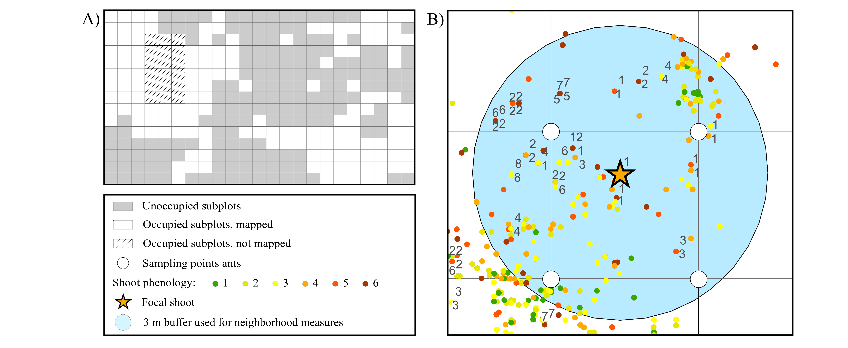
Figure 2
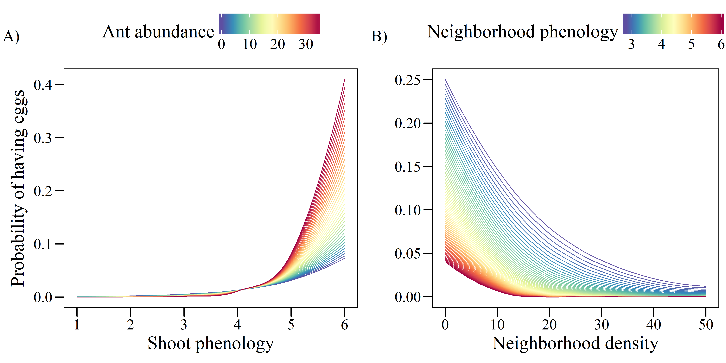

Figure 3
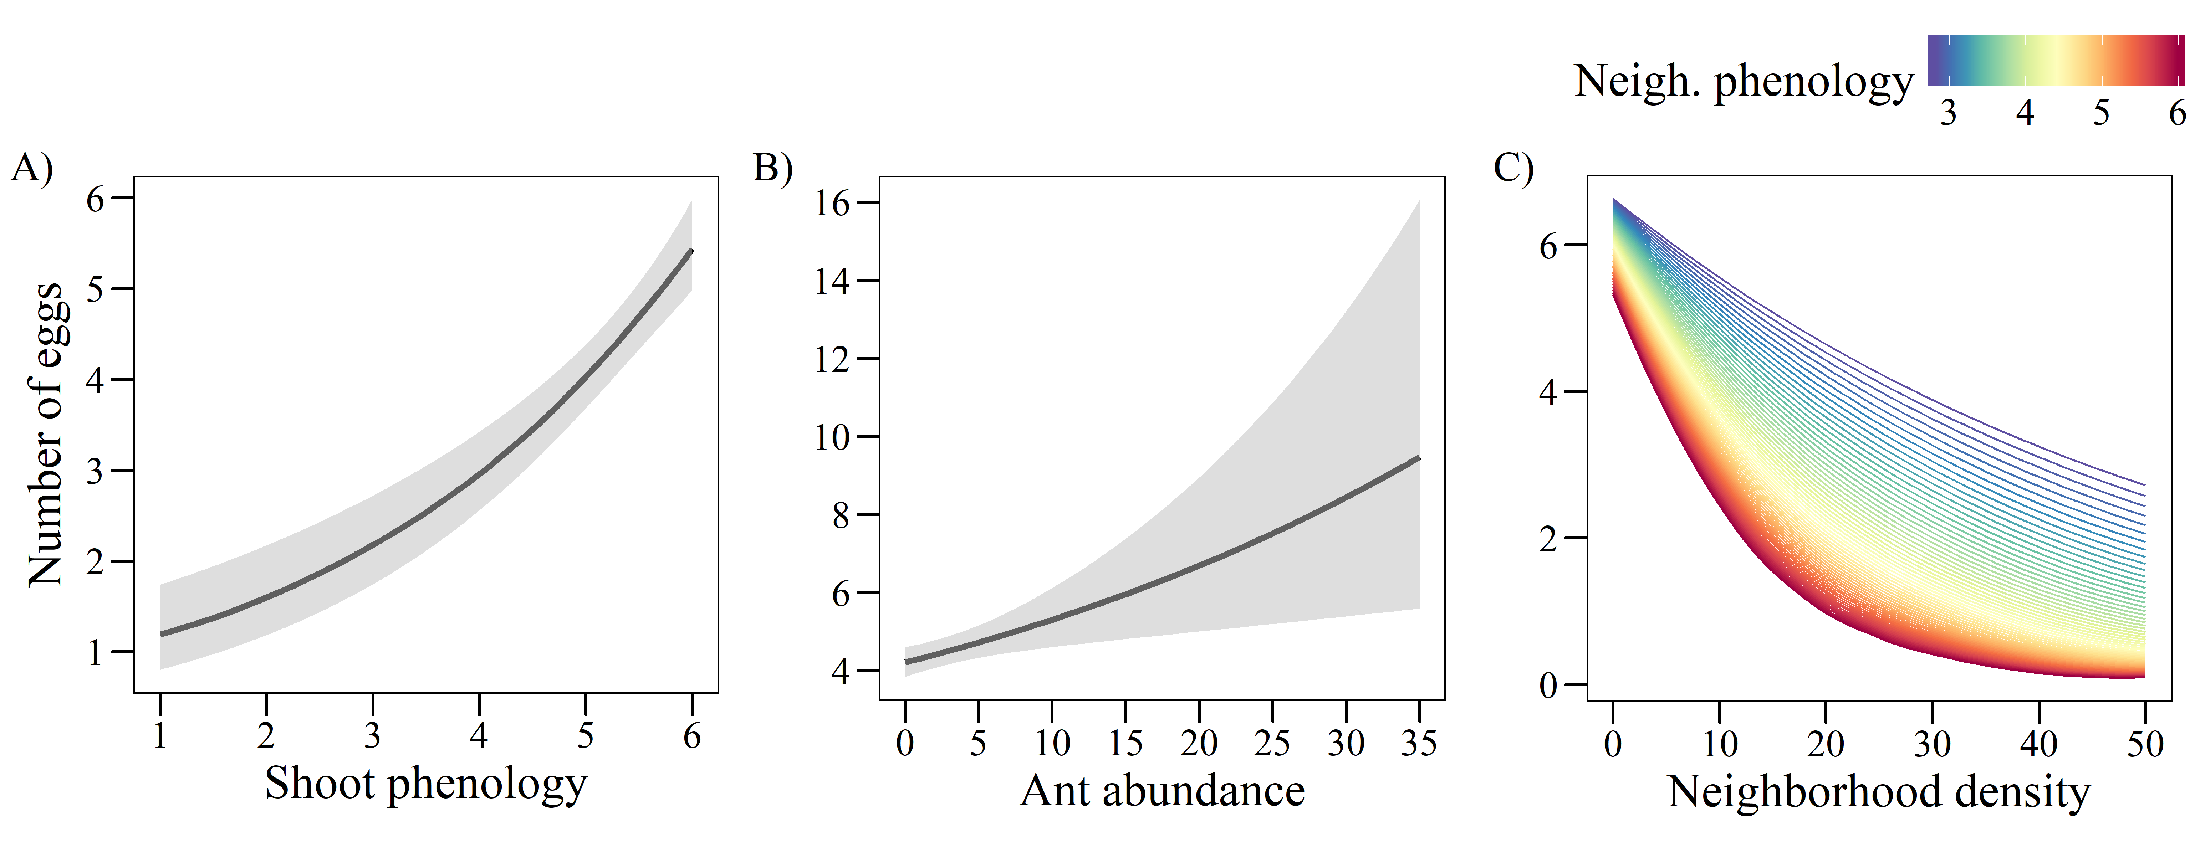

Supporting information
Figure S1: Result of the inverse distance weighted interpolation for abundance of Myrmica rubra based on abundance values (sum of individuals collected in 2 sampling sessions) at 254 sampling points. The color scale indicates the interpolated abundance values.

Figure S2: Result of the inverse distance weighted interpolation for abundance of Myrmica scabrinodis based on abundance values (sum of individuals collected in 2 sampling sessions) at 254 sampling points. The color scale indicates the interpolated abundance values.

Figure S3: Result of the inverse distance weighted interpolation for abundance of Myrmica ruginodis based on abundance values (sum of individuals collected in 2 sampling sessions) at 254 sampling points. The color scale indicates the interpolated abundance values.

Figure S4: Result of the inverse distance weighted interpolation for abundance of Myrmica schencki based on abundance values (sum of individuals collected in 2 sampling sessions) at 254 sampling points. The color scale indicates the interpolated abundance values.

Figure S5: Result of the inverse distance weighted interpolation for abundance of non-Myrmica ants based on abundance values (sum of individuals collected in 2 sampling sessions) at 254 sampling points. The color scale indicates the interpolated abundance values.

Table S1: Coefficients from univariate GLMs relating the probability of having eggs (A, binomial model) and the number of eggs in plants with at least one egg (B, negative binomial model) to the abundance of the different ant species.
 | A) Probability of having eggs (n = 8848) |  | B) Number of eggs  (n = 731)
All Myrmica | -0.522 | *** | -0.006
M. rubra | 0.174 | *** | 0.137 | ***
M. scabrinodis | -1.364 | *** | -0.120 | ***
M. ruginodis | -0.215 | *** | -0.016
M. schencki | 0.358 | *** | 0.006
Other ants | -0.403 | *** | -0.061
M. rubra + M. schencki | 0.360 | *** | 0.115 | ***
**P < 0.001; **P < 0.01; *P < 0.05

Table S2: Results of the binomial GLM (n = 8848, R² = 0.42) relating the probability of a shoot of G. pneumonanthe having eggs of P. alcon to shoot phenology, ant abundance, neighborhood density and neighborhood phenology, and to three different two-way interactions of these predictors.
 | Estimate |  | SE | Z
Shoot phenology | 1.384 | *** | 0.077 | 18.06
Ant abundance | 0.061 |  | 0.051 | 1.19
Neighborhood density | -1.943 | *** | 0.092 | -21.03
Neighborhood phenology | -1.014 | *** | 0.120 | -8.45
Shoot phen. x Ant abundance | 0.120 | * | 0.058 | 2.07
Shoot phen. x Neigh. Phen. | -0.022 |  | 0.071 | -0.32
Neigh. density x Neigh. phen. | -0.650 | * | 0.084 | -7.74
**P < 0.001; **P < 0.01; *P < 0.05

Figure S6: Spatial correlogram of the residuals of the binomial GLMs for the probability of a shoot having eggs before (red) and after (blue) including the two eigenvectors issued from MEM.
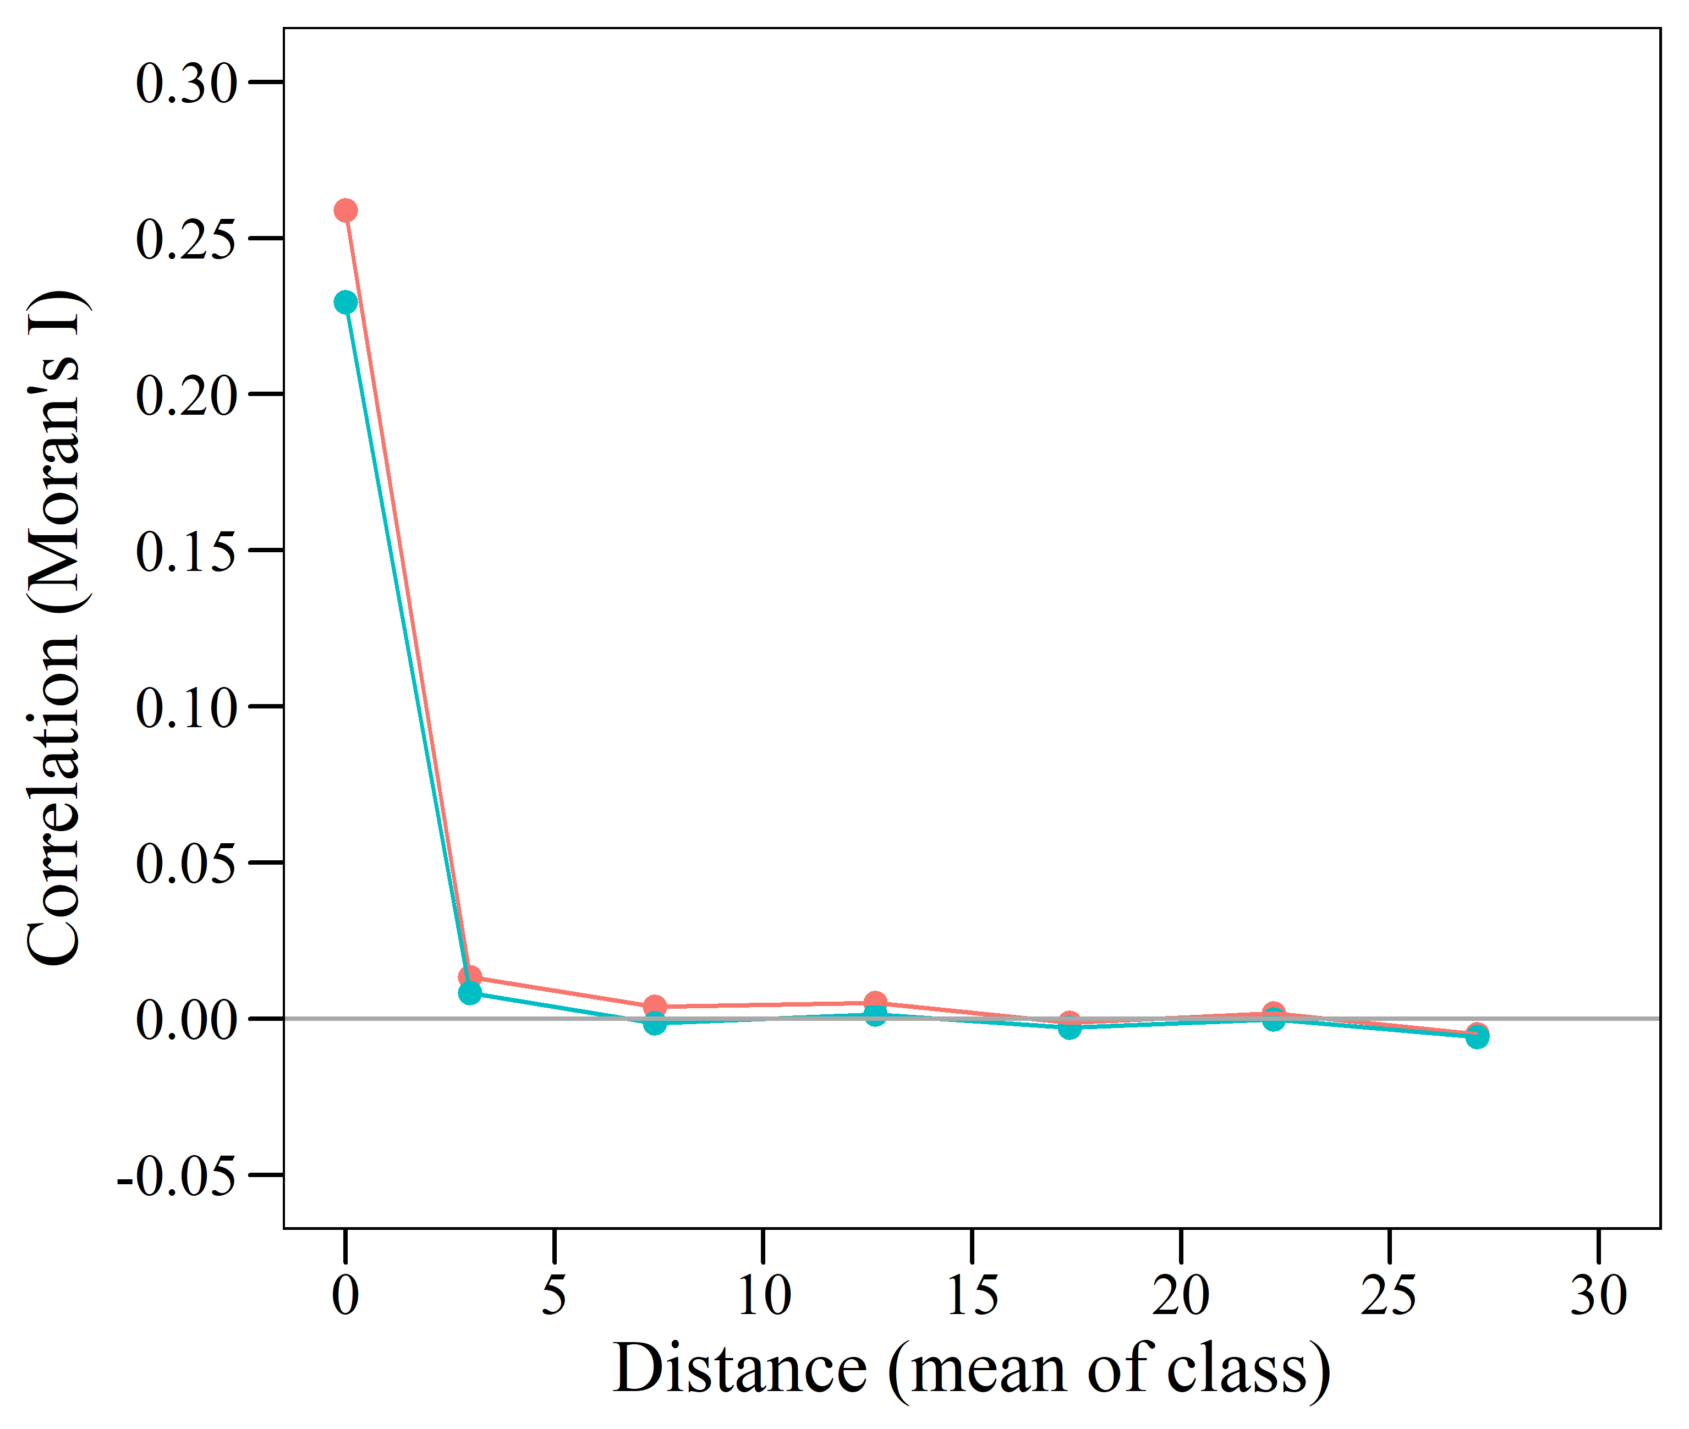
OR
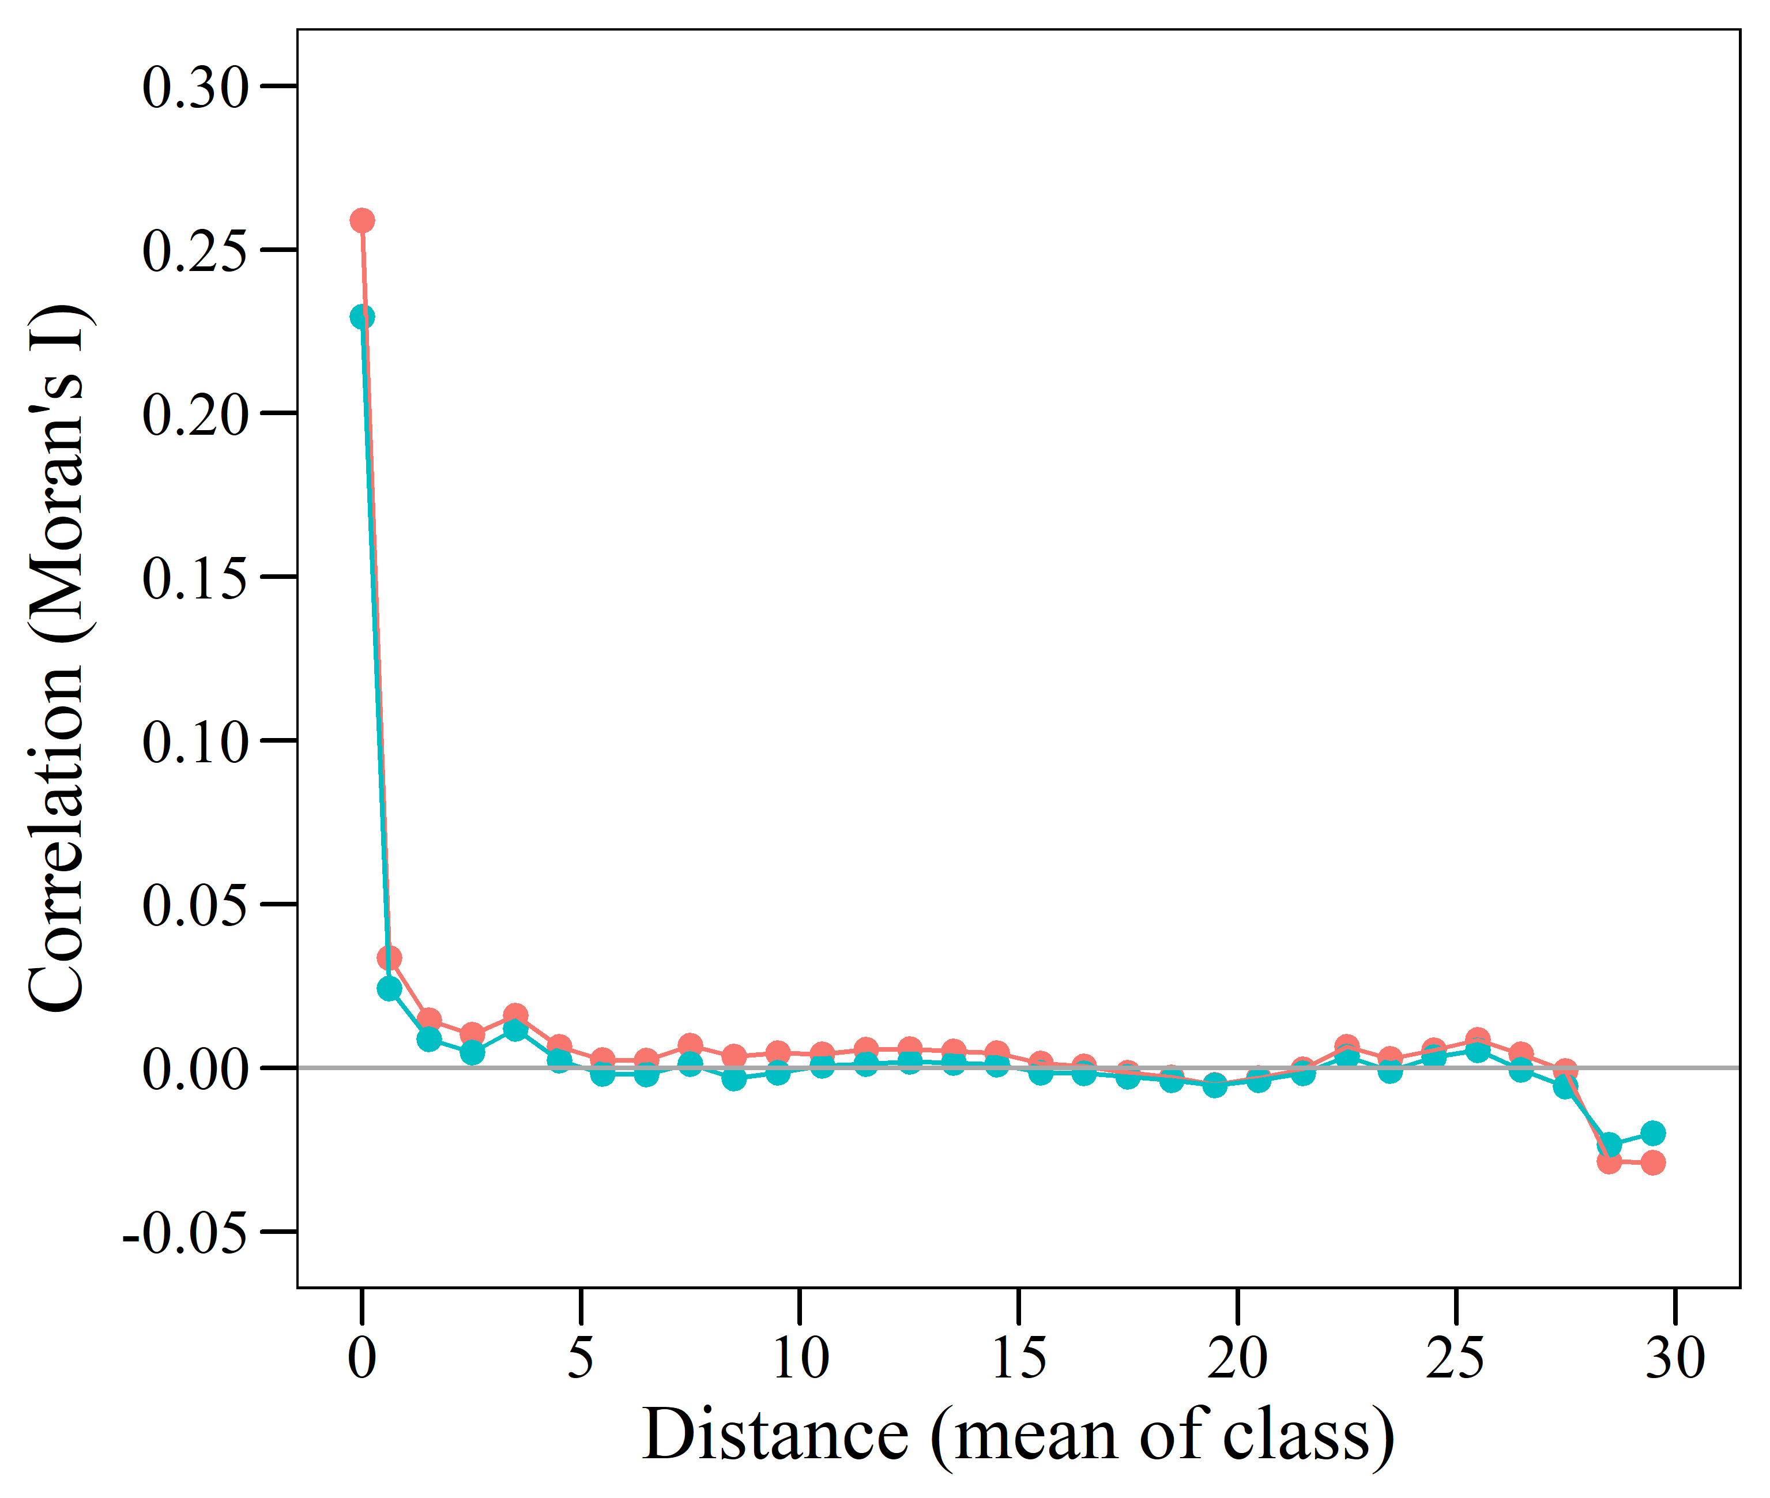
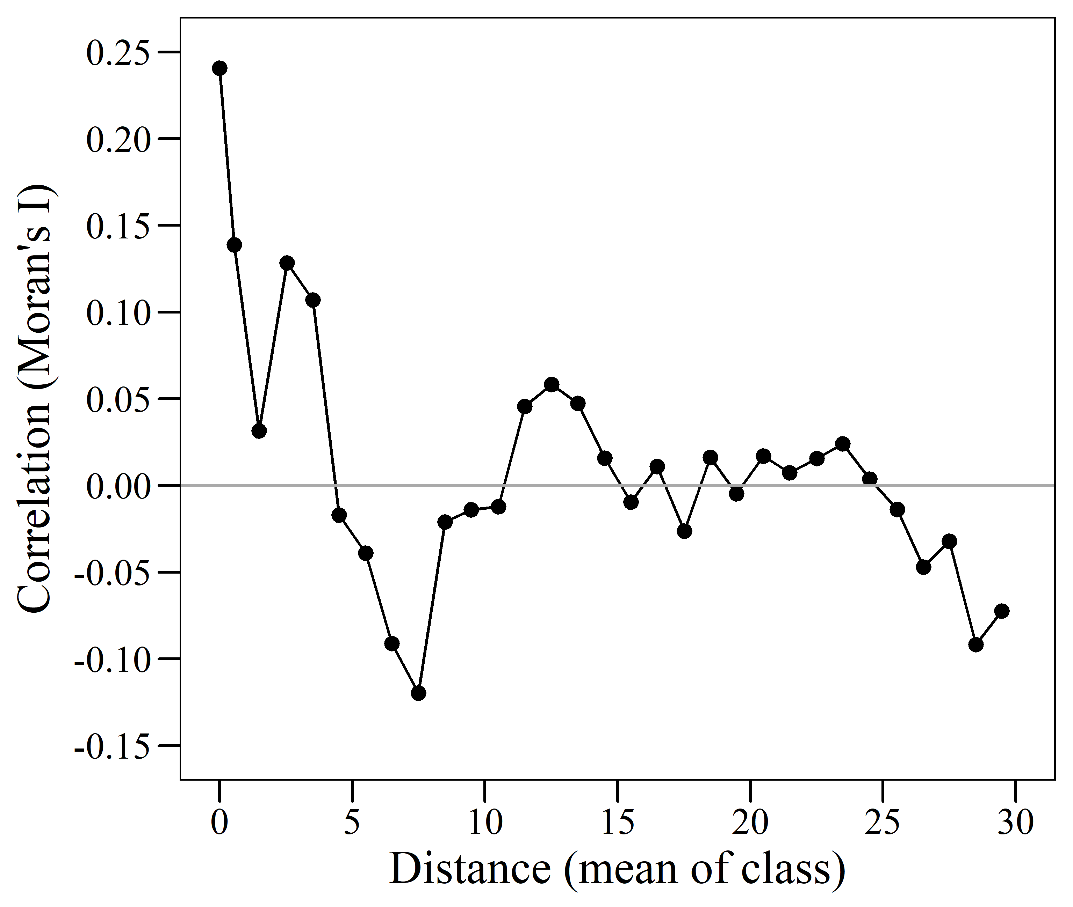
Figure S7: Spatial correlogram of the residuals of the negative binomial GLM for the number of eggs in shoots with at least one egg.
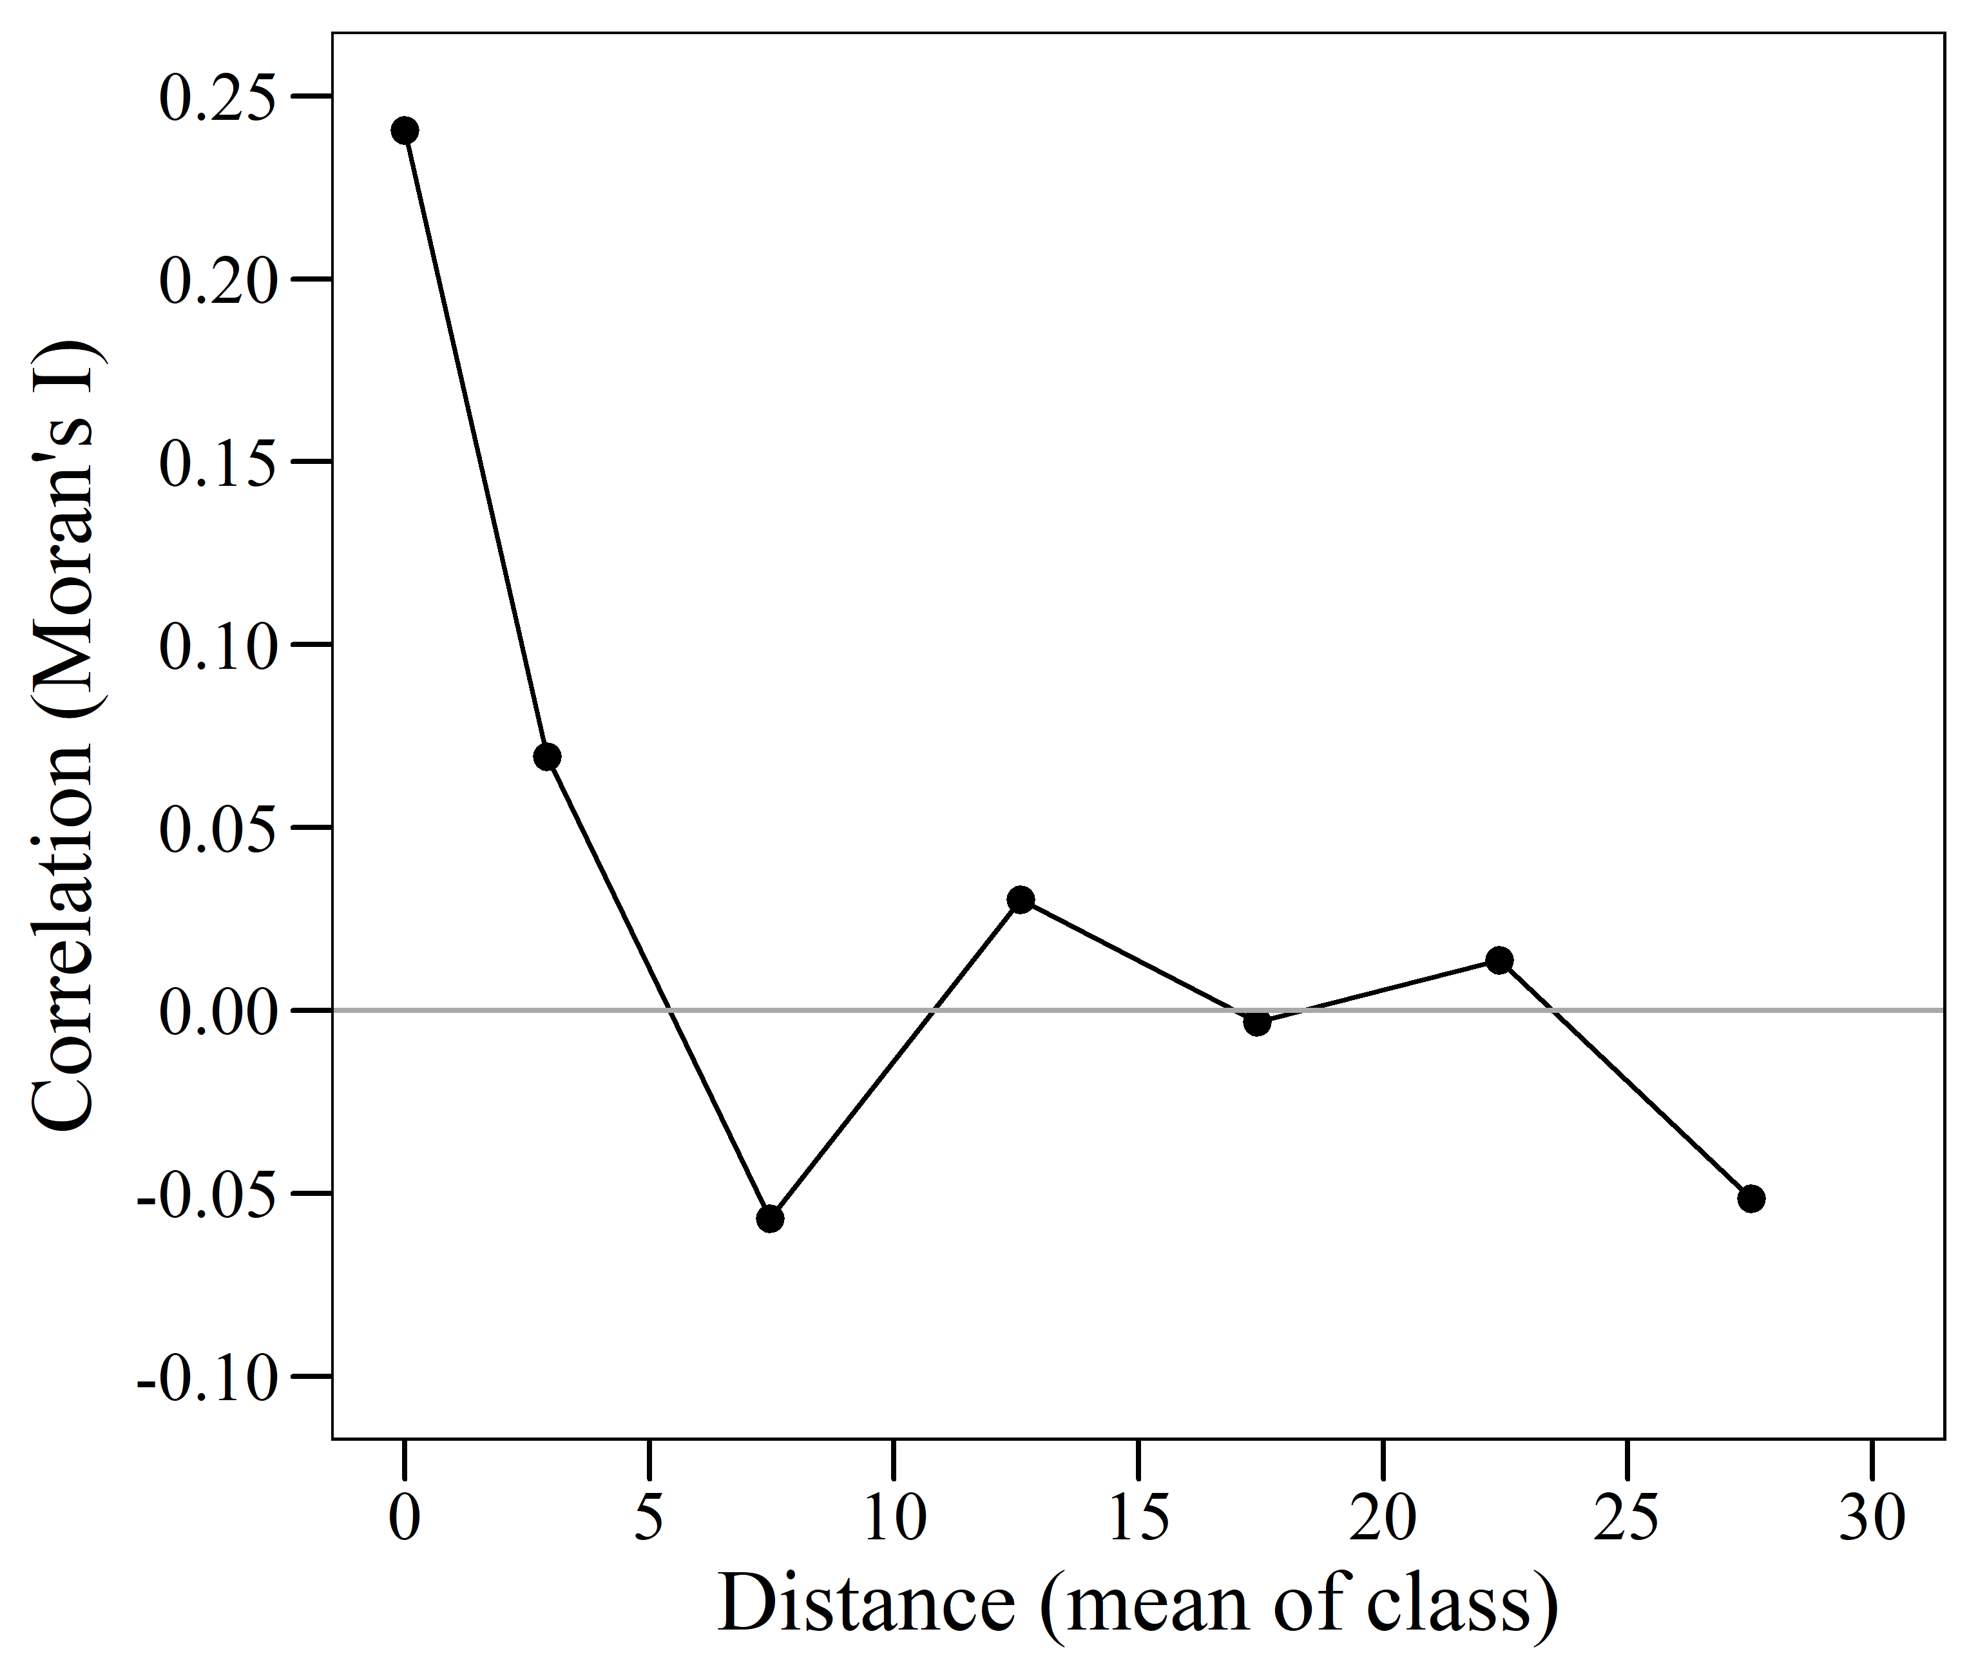
OR

