TITLE: Resource overlap and dilution effects shape host plant use in a myrmechophilous butterfly
ABSTRACT
The effects of a consumer on the absolute and relative fitness of a resource organism is a complex function of the availability of other resources needed by the consumer, consumer preferences, resource distribution over space and time, and the response of consumers to resource abundance. We used a model system consisting of the butterfly Phengaris alcon and its two sequential hosts, the plant Gentiana pneumonanthe and ants of the genus Myrmica, to investigate how the choice of host plants by butterfly females was influenced by the quality of the focal host plant, the quality and quantity neighboring host plants, and the abundance of an ant hosts. Butterflies chose host plant individuals for oviposition that simultaneously maximized the availability of both host resources, i.e., butterflies had a stronger preference for high-quality early-flowering host plants when host ants were more abundant. The probability of a plant being oviposited on as well as the number of eggs in oviposited plants decreased with increasing neighbor density, and that this dilution effect was stronger when neighbors were of high quality. Taken together, …

INTRODUCTION
The presence, abundance and quality of relevant resources determines habitat suitability for any given organism, and consumer distribution and abundance should match the spatiotemporal distribution of its resources (Dennis et al. 2006). When the resource is another organism, resource-consumer interactions have important ecological and evolutionary implications for both interactors. For example, insect herbivory constitute a type of consumer-resource interaction where resource use is often conditioned by oviposition site selection by females. As larval stages usually show low mobility, oviposition preferences are predicted to reflect host plant suitability for offspring development (preference–performance hypothesis or optimal oviposition theory, Jaenike 1978; Scheirs & De Bruyn 2002). The suitability of host plants, in turn, might depend on factors such as host plant nutritional quality (Chen et al. 2004), size (Rabasa et al. 2005), microclimatic conditions (Eilers et al. 2013) or enemy-free space (Wiklund & Friberg 2008). Not only spatial but also temporal matching with the required resources are necessary for consumer presence. For example, in phenologically specialized insects (Smyth et al. 2003; Patricelli et al. 2011; Fogelström et al. 2017), plant phenology is a crucial aspect of resource quality, and a temporal overlap between consumer activity and availability of suitable developmental stages of the host plants is a necessary condition for the interaction. Moreover, because most consumers depend on multiple resources throughout their life cycle, e.g. different sources of food, shelter and resting sites (Dennis et al. 2003), the availability of one resource might influence the use of other resources. For example, the availability of resources such as … (e.g. nectar, alternative or secondary hosts) might influence plant resource use by insects (i.e. oviposition patterns). If consumers have preferences for traits in resource organisms and consumption implies fitness effects in the consumed organism, then the factors determining the intensity of interactions will also influence trait selection (Vanhoenacker et al. 2013, Benkman 2013). For example, trait selection in the consumed organism is influenced by the preferences of the consumer (Parachnowitsch & Caruso 2008; Benkman & Mezquida 2015). Taken together, this implies that the effects of a consumer on the absolute fitness, as well as on the relationships between traits and relative fitness in the resource organism, is a complex function of resource distribution over space and time, the availability of other resources needed by the consumer, and consumer preferences.
The quantitative relationship between the abundance of consumers and the abundance of resource organisms, and thus resource exploitation, is likely to also depend on the behavior of consumers. Consumer density and resource exploitation might both increase (cf. resource concentration hypothesis, e.g. Root 1973) and decrease (cf. resource depletion, e.g. Otway et al. 2005) with increasing patch size and resource abundance. Observed differences in the relationships between resource exploitation and patch size or patch density among different consumers have been suggested to be the result of differences in how emigration and immigration rates depend on patch size and patch density (Hambäck & Englund 2004, Andersson et al. 2013). For example, a strong negative relationship between consumer density and patch area observed in visual searchers like butterflies might be the result of that immigration is diameter-dependent while emigration is perimeter-dependent. Moreover, not only the abundance of the resource organism but also the quality should be important for consumer responses. For example, in herbivores that depend on a specific developmental stage in their host plant, the effects of resource density are expected be stronger when neighboring plants show the preferred phenology (i.e. offer high quality). While many studies have explored the effects of resource density on plant-insect interactions (Yamamura 2002; Kula et al. 2014; Kim & Underwood 2015), these studies have rarely considered also the role of resource quality and the effects of the availability of other resources.
Myrmecophilous butterflies of the genus Phengaris need two sequential hosts to complete their development: the caterpillars are predispersal seed predators of different host plants during their first instars and parasitize ant nests (Myrmica spp.) during later stages. Butterflies are very specific regarding both host species and the developmental stage of host plants (Elmes et al. 1998, Thomas & Elmes 2001; Valdés & Ehrlén 2017). Female butterflies oviposit preferentially on buds in early phenological stages, probably because these constitute higher-quality food; the seeds might become drier and difficult to digest as the bud develops into flower and fruit (Arnaldo et al. 2014). As the presence of the preferred bud developmental stages usually overlaps more with the period of butterfly oviposition period in early- than in late-flowering plants, individuals flowering early in the season are of higher quality and receive more eggs (Valdés & Ehrlén 2017). The spatial overlap of the two hosts is essential as the mobility of caterpillars after leaving the plant is low (Hayes 2015), and host plants only allow further development if located within the foraging range of suitable host ants (usually a few meters). Egg-laying butterfly females are also likely to encounter isolated host plants more often than individual plants in dense stands, and this might result in resource dilution effects. Moreover, not only the conspecific density of host plants but also the quality of neighbors might influence the probability that a focal host plant receives an egg, i.e., the probability of oviposition might increase with the presence of more early-flowering, high-quality, neighbors.
In this study, we investigated the effects of the quality of the focal host plant Gentiana pneumonanthe, the quality and quantity neighboring host plants, and the abundance of a second ant host, on egg-laying of the butterfly Phengaris alcon. We asked two main questions. First, are effects of the plant and ant resources on egg distribution patterns interdependent? We predicted that butterflies would chose plants for oviposition that simultaneously maximize the availability of both resources, i.e., having a stronger preference for high-quality early-flowering host plants when host ants are abundant. Second, does the density and quality of neighboring plants influence the probability that a focal plant will receive eggs? We predicted that the probability of a plant receiving at least one egg, as well as the number of eggs in oviposited plants, should decrease with increasing neighbor density (i. e. dilution effect), and that this decrease should be stronger when neighbors are of high quality.
METHODS
Study system
The marsh gentian (Gentiana pneumonanthe L.) is a rare, long-lived perennial herb, occurring in open habitats, such as wet heathlands and grasslands (Simmonds 1946). In natural populations, individuals do not flower until their third year (Simmonds 1946). Plants can have one to many, up to 45 cm high, shoots and produce deep blue flowers that are pollinated by bumblebees. The species is self-compatible and flowers in July and August in SW Sweden. Fruits are capsules containing a high number (usually 300-700, Appelqvist & Bengtsson 2007) minute (mean seed weight = 0.044 mg, Simmonds 1946), wind-dispersed seeds. Gentiana pneumonanthe is the primary host of the Alcon Blue butterfly (Phengaris alcon), a specialist predispersal seed predator which oviposits on young flower buds in July and August (Appelqvist & Bengtsson 2007). The caterpillars feed inside the capsule until they reach the fourth-instar, when then they drop to the ground to be picked up by Myrmica ants. Caterpillars mimic the surface chemistry of the ant brood (Nash et al. 2008) and the acoustic signals of queen ants (Sala et al. 2014), and this makes ants carry them to their nest, where they spend the rest of their larval period as parasites. Following earlier suggestions, females' detection of host ant presence through plant chemicals produced in reaction to ant damage have recently been shown (van Dyck et al. 2000, Patricelli et al. 2015). Contrary to the majority of Phengaris species, which prey on ant brood, P. alcon is a “cuckoo” species (Als et al. 2004), and larvae feed primarily on regurgitations from ant workers, trophic eggs (i.e. nutritious, infertile eggs which are fed to the queens and larvae) and prey items brought to the nest by ants. Only ants belonging to the genus Myrmica can act as second hosts of P. alcon. In Sweden, M. rubra is considered to be the most common host ant species (Elmes et al. 1994).
Data collection
The study was carried out in a population of G. pneumonanthe where the butterfly P. alcon was present, located in Tånga Hed nature reserve, in the county of Västra Götaland, SW Sweden (58°01'40.0"N 12°49'47.0"E). Field work was conducted between 9 July and 3 September 2016. The population occupies a fenced meadow that is yearly grazed by cows at the end of the summer. A study plot measuring 69 m × 45 m was established in the meadow, and divided into a grid comprising 345 3 m x 3 subplots with corners permanently marked by wooden sticks (Fig. 1A). Careful examinations of each subplot in mid-July showed that G. pneumonanthe was present in 172 subplots (hereafter called “occupied subplots”).
In 154 of the occupied subplots all reproductive shoots of G. pneumonanthe were mapped, and their phenology and the number of eggs of P. alcon were recorded between 29 July and 5 August (Fig. 1B). The remaining 18 occupied subplots were excluded due to time constraints. We mapped shoots instead of individual plants (that may have one or several shoots) because we wanted to assess availability of the host plant resource for the butterflies, and we believe that this is better represented by the number of reproductive shoots (which act as the unit of attraction for butterfly females) than by the number of plants. On each shoot, phenology was recorded as the developmental stage of the most advanced bud, according to six ordinal categories: (1) the sepals covering the bud completely, (2) bud becoming visible, (3) bud growing over the sepals, (4) bud turning blue, (5) flower opening, and (6) flower showing signs of wilting (Valdés & Ehrlén 2017). Each of these stages corresponded to a time interval of flower development, with higher values indicating a more advanced floral development at the day of recording, i.e. an earlier flowering phenology. The number of eggs was counted on the whole shoot.
The ant community was sampled at each of the four corners of all occupied subplots (a total of 254 points) at two occasions, 14 July and 3 September (Fig. 1B). Baits consisted of a Falcon plastic tube where we introduced a sugar cube. The tubes were left open on the ground in the evening, and collected the next morning. Ants collected were transferred to 70º ethanol for identification in the lab, where Myrmica ants were identified to the species and counted (using Douwes et al. 2012), and ants belonging to other genera where not identified to species, but counted as “others”.
Calculation of neighborhood measures
Field maps were digitized using a Geographic Information System (GIS) created with ArcGIS 10.3.1, assigning relative coordinates to each reproductive shoot of G. pneumonanthe found in the study plot (Fig. 1B). For each of these focal shoots, we defined a buffer of 3 m around the shoot (see example in Fig. 1B), and calculated the number of reproductive shoots of G. pneumonanthe per m² (hereafter, “neighbor density”) as well as the mean phenology of these shoots (hereafter, “neighbor phenology”), excluding in each case the focal shoot.
Interpolations of ant abundances
The locations of the 254 points corresponding to the four corners of all occupied subplots, where the ant community was sampled, were also incorporated in the GIS. We used inverse distance weighted interpolation (Pebesma 2004) to generate values of abundance of the different ant species over the surface of all occupied subplots, based on the values at the sampling points. A maximum distance of 3 m was used because it represents the ground foraging distance of most Myrmica species (Elmes et al. 1998). From these interpolated surfaces (see Figs. S1-5 in Supporting Information), we extracted values of abundance of the different ant species for each of the mapped shoots.
Statistical analyses
The effects of shoot phenology, host ant abundance, neighbor density and neighbor phenology on egg distribution patterns of P. alcon were examined using two Generalized Linear Models (GLMs). Effects on the probability of a shoot having at least one egg were evaluated using a binomial GLM, and effects on the number of eggs in shoots with at least one egg were evaluated using a negative binomial GLM. Both of these models included also three interactions. First, the interaction between shoot phenology and ant abundance, in order to test if the effects of the two resources on egg distribution patterns are interdependent. Second, the interaction between neighbor density and neighbor phenology, in order to test if the effect of host plant density depends on phenology of neighboring host plants. We also included the interaction between shoot phenology and neighbor phenology to account for that the relationship between egg distribution and phenology in focal plant might depend on the phenology of neighboring host plants. To corroborate that the host ant species suggested to act as hosts in the study area actually influence butterfly oviposition, we first studied the response of egg distribution patterns to the abundance of the different ant species using GLMs with one predictor (i.e. the abundance of one ant species or the combined abundance of several species) at a time. The strongest positive effect on the probability of getting eggs was found when the combined abundance of M. rubra and M. schencki was used as a predictor (Supporting Information Table S1). This agrees with previous knowledge about the ant hosts, as M. rubra is considered to be the most common host ant species of P. alcon in Sweden (Elmes et al. 1994), and M. schencki has been cited as host in several places in Europe (Vilbas et al. 2016). We therefore used the combined abundance of M. rubra and M. schencki (hereafter, “ant abundance”) as a predictor in further models.
All predictors were standardized by subtracting the mean and dividing by the standard deviation before the analyses. We checked for spatial autocorrelation in the residuals of both models by plotting spatial correlograms and by calculating global Moran's I with a permutation test (1000 random permutations). Moran's I was calculated based on a connectivity matrix of pairwise Euclidean distances among the shoots up to a distance of 30 m. Residual spatial autocorrelation could lead to biased model estimates and invalid statistical inference (Dormann et al. 2007). As significant spatial autocorrelation was found in the residuals of the binomial GLM (global Moran's I = 0.0150, p < 0.001, Fig. S6 in Supporting Information), we applied Moran’s eigenvector mapping (MEM), which translates the spatial arrangement of data points into explanatory variables (eigenvectors) that capture spatial effects (Dray et al. 2006; Thayn & Simanis 2013). The model was refitted including two eigenvectors issued from MEM as spatial predictors, and this strongly reduced the residual spatial autocorrelation (global Moran's I = 0.0003, p = 0.03297, Fig. S6 in Supporting Information). Although residual spatial autocorrelation was still significant, the visual inspection of the spatial correlogram (Fig. S6) indicate that most of the residual spatial autocorrelation was removed by the spatial predictors, and therefore confirms the validity of our model. Results of the binomial GLM before including the spatial predictors are shown in Table S2 in Supporting Information. The residuals of the negative binomial GLM did not show significant spatial autocorrelation (global Moran's I = -0.0023, p = 0.613, Fig. S7 in Supporting Information).
Statistical analyses were carried out in R 3.4.0 (R Core Team 2017).
RESULTS
In total, we found 8848 reproductive shoots of G. pneumonanthe in the 154 occupied subplots that were mapped. Eggs of P. alcon were found on 731 of these shoots (8.3%). In shoots with at least one egg, the mean number of eggs was 5.03 ± 0.20 SE.
Effects of shoot phenology and ant abundance on the probability of P. alcon laying at least one egg were interdependent. The probability of a shoot of G. pneumonanthe having eggs of P. alcon increased with an earlier phenology (i.e. with a more advanced floral development at the day of recording). This increase was stronger in shoots where host ants were more abundant (significant effect of the interaction shoot phenology x ant abundance, Table 1A, Fig. 1A). However, the effects of shoot phenology and ant abundance on the number of eggs in shoots with at least one egg were not interdependent. The number of P. alcon eggs increased with an earlier plant shoot phenology (Fig. 1B) and with a higher host ant abundance (Fig. 1C), but the effect of shoot phenology did not depend on host ant abundance (the effect of the interaction shoot phenology × ant abundance was not significant, Table 1B).
High densities of host plant shoots resulted in a dilution effect, and this effect did depend on the quality of neighboring plants. Both the probability of having at least one egg and the number of eggs in shoots with at least one egg, decreased with the overall density of neighboring host plant shoots, and in both cases the decrease was stronger when neighboring host plants were of a higher quality, i.e., had an earlier phenology (significant effect of the interaction neighbor density × neighbor phenology, Table 1, Fig. 2).
DISCUSSION
The results of this study show that resource use in the myrmechophilous butterfly P. alcon are shaped by both the spatial overlap of the two key larval resources, and by a dilution effect associated with the quantity and quality of host plants. Specifically, we found that butterflies prefer ovipositing on early-flowering plants that have a high abundance of host ants, plants surrounded by many conspecific neighbors receive less eggs, and that the dilution effect was stronger when neighbors were of a high quality.
In accordance with previous studies showing that animal interactors usually prefer plants with a particular phenology (Elzinga et al. 2007), and more specifically, that antagonistic interactors preferentially attack early-flowering plants (Parachnowitsch & Caruso 2008; König et al. 2015; Valdés & Ehrlén 2017), we found that both the probability of P. alcon butterflies laying at least one egg on a host plant and the number of eggs increased with an earlier phenology of its host plant G. pneumonanthe. However, the strength of this preference for an early plant phenology did depend on the abundance of the second host resource used by the antagonist, i.e. the two host ant species Myrmica rubra and M. schencki.
The preference of P. alcon for early-flowering host plants was stronger at locations where the host ants were more abundant. For example, the probability of a shoot with the earliest possible phenology (stage of the most advanced bud = 6, i.e. flower already showing signs or wilting when phenology was recorded, see Methods) receiving at least one egg was 0.07 at sites where host ants were absent, and 0.40 at sites with the maximum ant abundance observed (n = 34 ants). This indicates that the butterflies are able to simultaneously track the distribution of these two resources, and to preferentially oviposit on plants where both the availability of high-quality food for the caterpillars and the probability of adoption by the right species of Myrmica are higher. When suitable host ants were absent or very scarce, host plant phenology did not seem to matter much, and chances of early-flowering plants to receive eggs were very low. Spatial overlap between the distribution of host plants and host ant nests has previously been shown to increase the density and population survival of the congeneric species P. arion (Thomas et al. 2009; Casacci et al. 2011). Other studies had demonstrated effects of host plant phenology (Thomas & Elmes 2001; Valdés & Ehrlén 2017), host ant presence (van Dyck et al. 2000; Wynhoff et al. 2008) or both of these factors (Patricelli et al. 2011) for oviposition site selection. Our study shows that the spatial overlap between these two resources also at a very small scale (i.e. at the scale of the plant individual) influences plant attractiveness to butterflies for oviposition, and that phenological preferences in these butterflies are ant-dependent. Our results illustrates highlights that differences in availability of a resource over very small spatial scales can influence the use of another resource in consumers that are highly dependent on multiple resources during their life cycle. The fact that the effects of plant phenology and ant abundance on the number of eggs in plants with at least one egg were significant but not interdependent, suggests that while plant phenology and ant abundance simultaneously influence if a plant is suitable for oviposition or not, they do not influence variation in attractiveness among those plants that are suitable.
Our results clearly show that there is a dilution effect of host plant density on egg distribution patterns, and also that the strength of this effect depend on the quality of neighbors. In our study, a negative relationship between consumer density and resource abundances (i.e. a dilution effect, Otway et al. 2005) was evident as a decrease in both the probability that a focal plant should receive at least one egg and the number of eggs in plants with at least one egg decreased with the density of neighboring host plants. This decrease was stronger when the neighbors represented high-quality food for the caterpillars, i.e. when surrounding plants flowered early in the season. At a given conspecific density, more eggs were found in G. pneumonanthe plants surrounded by non-attractive, low-quality neighbors (i.e. late-flowering plants). In this system, plant phenology is thus crucial not only because it interacts with host ant availability to determine plant suitability for oviposition, but also because it modulates the strength of host plant density effects on consumer resource use. Our results suggest that oviposition decisions in myrmechophilous butterflies are taken at two levels. First, when flying over an area populated with host plants, females might use visual cues (Van Dyck & Regniers 2010) to evaluate host plant availability (i.e. density) and identify high-quality (i.e. early-flowering) host plants. Second, when they are at a very close distance to host plants, or after they alight on a host plant, females may still use visual cues to evaluate plant quality, but would combine them with the use of chemical cues to detect ant presence (Patricelli et al. 2015; Wynhoff et al. 2015), and therefore to evaluate the spatial overlap of the two resources needed by their offspring. If females use plant phenology as a visual cue indicating plant quality, host plants surrounded by low-quality neighbors would also be more isolated and more attractive to butterflies, while the negative effects of the butterfly would be diluted in host plants surrounded by high-quality neighbors. Negative density-dependence in antagonists have been documented also in other systems (Shea et al. 2000; Fagan et al. 2005; Hasenbank & Hartley 2015), and egg clumping on plants with few conspecific neighbors might be explained because insect herbivores are disproportionallly attracted to more isolated host plants. However, our study is the first to also demonstrate that the quality of neighboring host plants determine the strength of such density-dependent effects. This has general implications for consumer-abundance relationships, as it demonstrates that the response of consumer density to resource abundance might be dependent on resource quality.
For biotic interactions, the resource use of a consumer organism determines the intensity of the interaction, as well as absolute fitness and trait-fitness relationships in both consumers and resource organisms. Identifying the factors determining resource use by consumers is thus key to understand the ecological and evolutionary dynamics of both interactors. The results of this study are important by demonstrating not only that multiple factors simultaneously determine resource use by consumers, but also that the effects can be interactive in several ways. First, the resource use of a butterfly consumer did depend on the spatio-temporal overlap of key resources, in terms of host plant shoot in a favorable development stage being available at a location with high ant abundance at the time of butterfly flight. Second, the use of a given resource organism decreased with increased resource density, in terms of the number of neighboring host plant individuals, and the strength of this effect increased with increased quality of neighbors. Lastly, the fact that the effects were documented at the level of individuals, implies that spatio-temporal overlap of multiple resources and effects of quantity and quality of neighbors can be important to explain differences in fitness and trait selection also within plant populations.
ACKNOWLEDGEMENTS
We thank Annelie Jörgensen for helping with fieldwork and Daniela Guasconi for lab assistance. We acknowledge funding from the Swedish Research Council (VR) to JE and from the “Clarín” postdoctoral program (FICYT, Gobierno del Principado de Asturias, Spain, and Marie Curie-Cofund Actions, EU) to AV.
REFERENCES
1.
Als, T.D., Vila, R., Kandul, N.P., Nash, D.R., Yen, S.-H., Hsu, Y.-F., et al. (2004). The evolution of alternative parasitic life histories in large blue butterflies. Nature, 432, 386–390
x.
Andersson, P., Löfstedt & Hambäck, P.A. (2013) Insect density-plant density relationships: a modified view of insect responses to resource concentrations. Oecologia 173, 1333-1344.

2.
Appelqvist, T. & Bengtsson, O. (2007). Åtgärdsprogram för alkonblåvinge och klockgentiana 2007-2011: Maculinea alcon och Gentiana pneumonanthe. Naturvårdsverket, Stockholm, Sweden
3.
Arnaldo, P.S., Gonzalez, D., Oliveira, I., Langevelde, F. van & Wynhoff, I. (2014). Influence of host plant phenology and oviposition date on the oviposition pattern and offspring performance of the butterfly Phengaris alcon. J. Insect Conserv., 18, 1115–1122
4.
Benkman, C.W. & Mezquida, E.T. (2015). Phenotypic selection exerted by a seed predator is replicated in space and time and among prey species. Am. Nat., 186, 682–691
5.
Casacci, L.P., Witek, M., Barbero, F., Patricelli, D., Solazzo, G., Balletto, E., et al. (2011). Habitat preferences of Maculinea arion and its Myrmica host ants: implications for habitat management in Italian Alps. J. Insect Conserv., 15, 103–110
6.
Chen, Y.-Z., Lin, L., Wang, C.-W., Yeh, C.-C. & Hwang, S.-Y. (2004). Response of two Pieris (Lepidoptera: Pieridae) species to fertilization of a host plant. Zool. Stud., 43, 778–786
7.
Dennis, R.L., Shreeve, T.G. & Van Dyck, H. (2003a). Towards a functional resource-based concept for habitat: a butterfly biology viewpoint. Oikos, 417–426
8.
Dennis, R.L.H., Shreeve, T.G. & Dyck, H.V. (2006). Habitats and resources: the need for a resource-based definition to conserve butterflies. Biodivers. Conserv., 15, 1943–1966
9.
Dennis, R.L.H., Shreeve, T.G. & Van Dyck, H. (2003b). Towards a functional resource-based concept for habitat: a butterfly biology viewpoint. Oikos, 102, 417–426
10.
Dormann, C.F., M. McPherson, J., B. Araújo, M., Bivand, R., Bolliger, J., Carl, G., et al. (2007). Methods to account for spatial autocorrelation in the analysis of species distributional data: a review. Ecography, 30, 609–628
11.
Douwes, P., Abenius, J., Cederberg, B. & Wahlstedt, U. (2012). Steklar: Myror-getingar: Hymenoptera: Formicidae-Vespidae. ArtDatabanken, Sveriges lantbruksuniversitet
12.
Dray, S., Legendre, P. & Peres-Neto, P.R. (2006). Spatial modelling: a comprehensive framework for principal coordinate analysis of neighbour matrices (PCNM). Ecol. Model., 196, 483–493
13.
van Dyck, H., Oostermeijer, J.G.B., Talloen, W., Feenstra, V., Hidde, A. van der & Wynhoff, I. (2000). Does the presence of ant nests matter for oviposition to a specialized myrmecophilous Maculinea butterfly? Proc. R. Soc. Lond. B Biol. Sci., 267, 861–866
14.
Eilers, S., Pettersson, L.B. & Öckinger, E. (2013). Micro-climate determines oviposition site selection and abundance in the butterfly Pyrgus armoricanus at its northern range margin. Ecol. Entomol., 38, 183–192
15.
Elmes, G.W., Hammersted, O., Martin, J., Thomas, J.A., Van Der Made, J.G. & others. (1994). Differences in host-ant specificity between Spanish, Duch and Swedish populations of the endangered butterfly, Maculinea alcon (DENIS at SHIFF>)(Lepidoptera). Memorab. Zool., 55–68
16.
Elmes, G.W., Thomas, J.A., Wardlaw, J.C., Hochberg, M.E., Clarke, R.T. & Simcox, D.J. (1998). The ecology of Myrmica ants in relation to the conservation of Maculinea butterflies. J. Insect Conserv., 2, 67–78
17.
Elzinga, J.A., Atlan, A., Biere, A., Gigord, L., Weis, A.E. & Bernasconi, G. (2007). Time after time: flowering phenology and biotic interactions. Trends Ecol. Evol., 22, 432–439
18.
Fagan, W.F., Lewis, M., Neubert, M.G., Aumann, C., Apple, J.L. & Bishop, J.G. (2005). When can herbivores slow or reverse the spread of an invading plant? A test case from Mount St. Helens. Am. Nat., 166, 669–685
19.
Grez, A.A. & González, R.H. (1995). Resource concentration hypothesis: effect of host plant patch size on density of herbivorous insects. Oecologia, 103, 471–474
x.
Hambäck, P.A. & Englund, G. (2005) Patch area, population density and the scaling of migration rates: the resource concentration hypothesis revisited. Ecol. Lett. 8, 1057-1065.

20.
Hasenbank, M. & Hartley, S. (2015). Weaker resource diffusion effect at coarser spatial scales observed for egg distribution of cabbage white butterflies. Oecologia, 177, 423–430
21.
Hayes, M.P. (2015). The biology and ecology of the large blue butterfly Phengaris (Maculinea) arion: a review. J. Insect Conserv., 19, 1037–1051
22.
Jaenike, J. (1978). On optimal oviposition behavior in phytophagous insects. Theor. Popul. Biol., 14, 350–356
23.
Jones, R.E. (1977). Movement patterns and egg distribution in cabbage butterflies. J. Anim. Ecol., 46, 195–212
24.
Kim, T.N. & Underwood, N. (2015). Plant neighborhood effects on herbivory: damage is both density and frequency dependent. Ecology, 96, 1431–1437
25.
König, M.A.E., Wiklund, C. & Ehrlén, J. (2015). Timing of flowering and intensity of attack by a butterfly herbivore in a polyploid herb. Ecol. Evol., 5, 1863–1872
26.
Kula, A.A.R., Castillo, D.M., Dudash, M.R. & Fenster, C.B. (2014). Interactions between a pollinating seed predator and its host plant: the role of environmental context within a population. Ecol. Evol., n/a-n/a
27.
Nash, D.R., Als, T.D., Maile, R., Jones, G.R. & Boomsma, J.J. (2008). A mosaic of chemical coevolution in a Large Blue butterfly. Science, 319, 88–90
28.
Otway, S.J., Hector, A. & Lawton, J.H. (2005). Resource dilution effects on specialist insect herbivores in a grassland biodiversity experiment. J. Anim. Ecol., 74, 234–240
29.
Parachnowitsch, A.L. & Caruso, C.M. (2008). Predispersal seed herbivores, not pollinators, exert selection on floral traits via female fitness. Ecology, 89, 1802–1810
30.
Patricelli, D., Barbero, F., La Morgia, V., Casacci, L.P., Witek, M., Balletto, E., et al. (2011). To lay or not to lay: oviposition of Maculinea arion in relation to Myrmica ant presence and host plant phenology. Anim. Behav., 82, 791–799
31.
Patricelli, D., Barbero, F., Occhipinti, A., Bertea, C.M., Bonelli, S., Casacci, L.P., et al. (2015). Plant defences against ants provide a pathway to social parasitism in butterflies. Proc R Soc B, 282, 20151111
32.
Rabasa, S.G., Gutiérrez, D. & Escudero, A. (2005). Egg laying by a butterfly on a fragmented host plant: a multi-level approach. Ecography, 28, 629–639
33.
Root, R.B. (1973). Organization of a plant-arthropod association in simple and diverse habitats: the fauna of Collards (Brassica oleracea). Ecol. Monogr., 43, 95–124
34.
Sala, M., Casacci, L.P., Balletto, E., Bonelli, S. & Barbero, F. (2014). Variation in butterfly larval acoustics as a strategy to infiltrate and exploit host ant colony resources. PLoS ONE, 9, e94341
35.
Scheirs, J. & De Bruyn, L. (2002). Integrating optimal foraging and optimal oviposition theory in plant–insect research. Oikos, 96, 187–191
36.
Shea, K., Smyth, M., Sheppard, A., Morton, R. & Chalimbaud, J. (2000). Effect of patch size and plant density of Paterson’s curse (Echium plantagineum) on the oviposition of a specialist weevil, Mogulones larvatus. Oecologia, 124, 615–621
37.
Simmonds, N.W. (1946). Gentiana pneumonanthe L. J. Ecol., 33, 295–307
38.
Thayn, J.B. & Simanis, J.M. (2013). Accounting for spatial autocorrelation in linear regression models using spatial filtering with eigenvectors. Ann. Assoc. Am. Geogr., 103, 47–66
39.
Thomas, J.A. & Elmes, G.W. (2001). Food–plant niche selection rather than the presence of ant nests explains oviposition patterns in the myrmecophilous butterfly genus Maculinea. Proc. R. Soc. Lond. B Biol. Sci., 268, 471–477
40.
Thomas, J.A., Simcox, D.J. & Clarke, R.T. (2009). Successful conservation of a threatened Maculinea butterfly. Science, 325, 80–83
41.
Valdés, A. & Ehrlén, J. (2017). Caterpillar seed predators mediate shifts in selection on flowering phenology in their host plant. Ecology, 98, 228–238
42.
Vilbas, M., Esperk, T. & Teder, T. (2016). Host ant use of the Alcon blue butterfly at the northern range margin. J. Insect Conserv., 20, 879–886
43.
Wiklund, C. & Friberg, M. (2008). Enemy-free space and habitat-specific host specialization in a butterfly. Oecologia, 157, 287–294
44.
Wynhoff, I., Bakker, R.B., Oteman, B., Arnaldo, P.S. & van Langevelde, F. (2015). Phengaris (Maculinea) alcon butterflies deposit their eggs on tall plants with many large buds in the vicinity of Myrmica ants. Insect Conserv. Divers., 8, 177–188
45.
Wynhoff, I., Grutters, M. & Langevelde, F. van. (2008). Looking for the ants: selection of oviposition sites by two myrmecophilous butterfly species. Anim. Biol., 58, 371–388
46.
Yamamura, K. (2002). Biodiversity and stability of herbivore populations: influences of the spatial sparseness of food plants. Popul. Ecol., 44, 33–40

Table 1: Results of the GLMs of the effects on the probablity of a flowering shoot of Gentiana pneumonanthe receiving at least one egg from the butterfly Phengaris alcon (binomial GLM) and the number of eggs in shoots with at least one egg (negative binomial GLM), of shoot phenology, ant abundance, neighbor density and neighbor phenology, as well as three two-way interactions of these predictors. In A), two eigenvectors issued from Moran’s eigenvector mapping (MEM) are also included as predictors, in order to reduce residual
spatial autocorrelation (see details in the text).
 | Probability of having at least one egg  (n = 8848, R² = 0.45) |  |  |  |  | Number of eggs  (n = 731, R² = 0.22)
 | Estimate |  | SE | Z |  | Estimate |  | SE | Z
Shoot phenology | 1.462 | *** | 0.079 | 18.42 |  | 0.257 | *** | 0.036 | 7.07
Ant abundance | -0.017 |  | 0.052 | -0.33 |  | 0.089 | ** | 0.031 | 2.82
Neighbor density | -1.691 | *** | 0.102 | -16.61 |  | -0.368 | *** | 0.067 | -5.48
Neighbor phenology | -1.150 | *** | 0.124 | -9.28 |  | -0.121 | ** | 0.041 | -2.95
Shoot phen. x Ant abundance | 0.132 | * | 0.062 | 2.14 |  | 0.004 |  | 0.031 | 0.13
Shoot phen. x Neigh. Phen. | 0.068 |  | 0.074 | 0.92 |  | 0.014 |  | 0.035 | 0.40
Neigh. density x Neigh. phen. | -0.500 | *** | 0.087 | -5.72 |  | -0.100 | * | 0.042 | -2.36
MEM Vector 1 | 0.289 | *** | 0.030 | 9.76
MEM Vector 2 | 0.324 | *** | 0.052 | 6.26
**P < 0.001; **P < 0.01; *P < 0.05

FIGURE LEGENDS
Figure 1: Sampling design. A) Study plot (69 x 45 m²), comprising 345 3 m² subplots. B) Detail of several occupied subplots with reproductive shoots of Gentiana pneumonanthe and sampling points for ants. Shoots are represented by points, and colored according to shoot phenology. Numbers indicate the number of Phengaris alcon eggs found on the shoot. An example of a 3-m buffer used for neighbor measures on a focal shoot (represented by a star) is shown.

Figure 2: Effects of shoot phenology and host ant abundance on the distribution of Phengaris alcon eggs on its host plant Gentiana pneumonanthe. A) Effects on the probability of a shoot having at least one egg, the relationship between the probability of having at least one egg and shoot phenology shown for different ant abundances. B) Effects of shoot phenology on the number of eggs in shoots with at least one egg . Higher values of shoot phenology indicate earlier flowering. C) Effects of ant abundance on the number of eggs in shoots with at least one egg. In A), binomial GLM fit lines are represented with a color gradient for a continuous increment in ant abundance within the range of observed values. In B) and C), negative binomial GLM fit lines and confidence intervals are shown.

Figure 3: Effects of the interaction between neighbor density and neighbor phenology on the probability of a flowering shoot of Gentiana pneumonanthe having at least one egg of the butterfly Phengaris alcon (A) and the number of eggs in shoots with at least one egg (B). The relationships with neighbor density are shown for different values of neighbor phenology. Binomial (A) or negative binomial (B) GLM fit lines are represented with a color gradient for a continuous increment in neighbor phenology within the range of observed values. Higher values of neighbor phenology indicate earlier flowering.

Figure 1
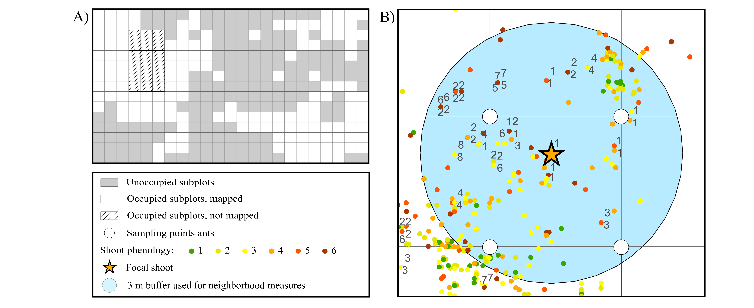
Figure 2
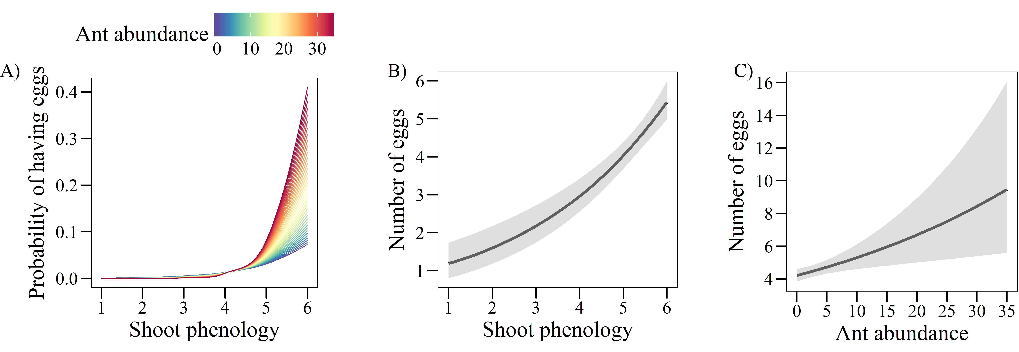

Figure 3
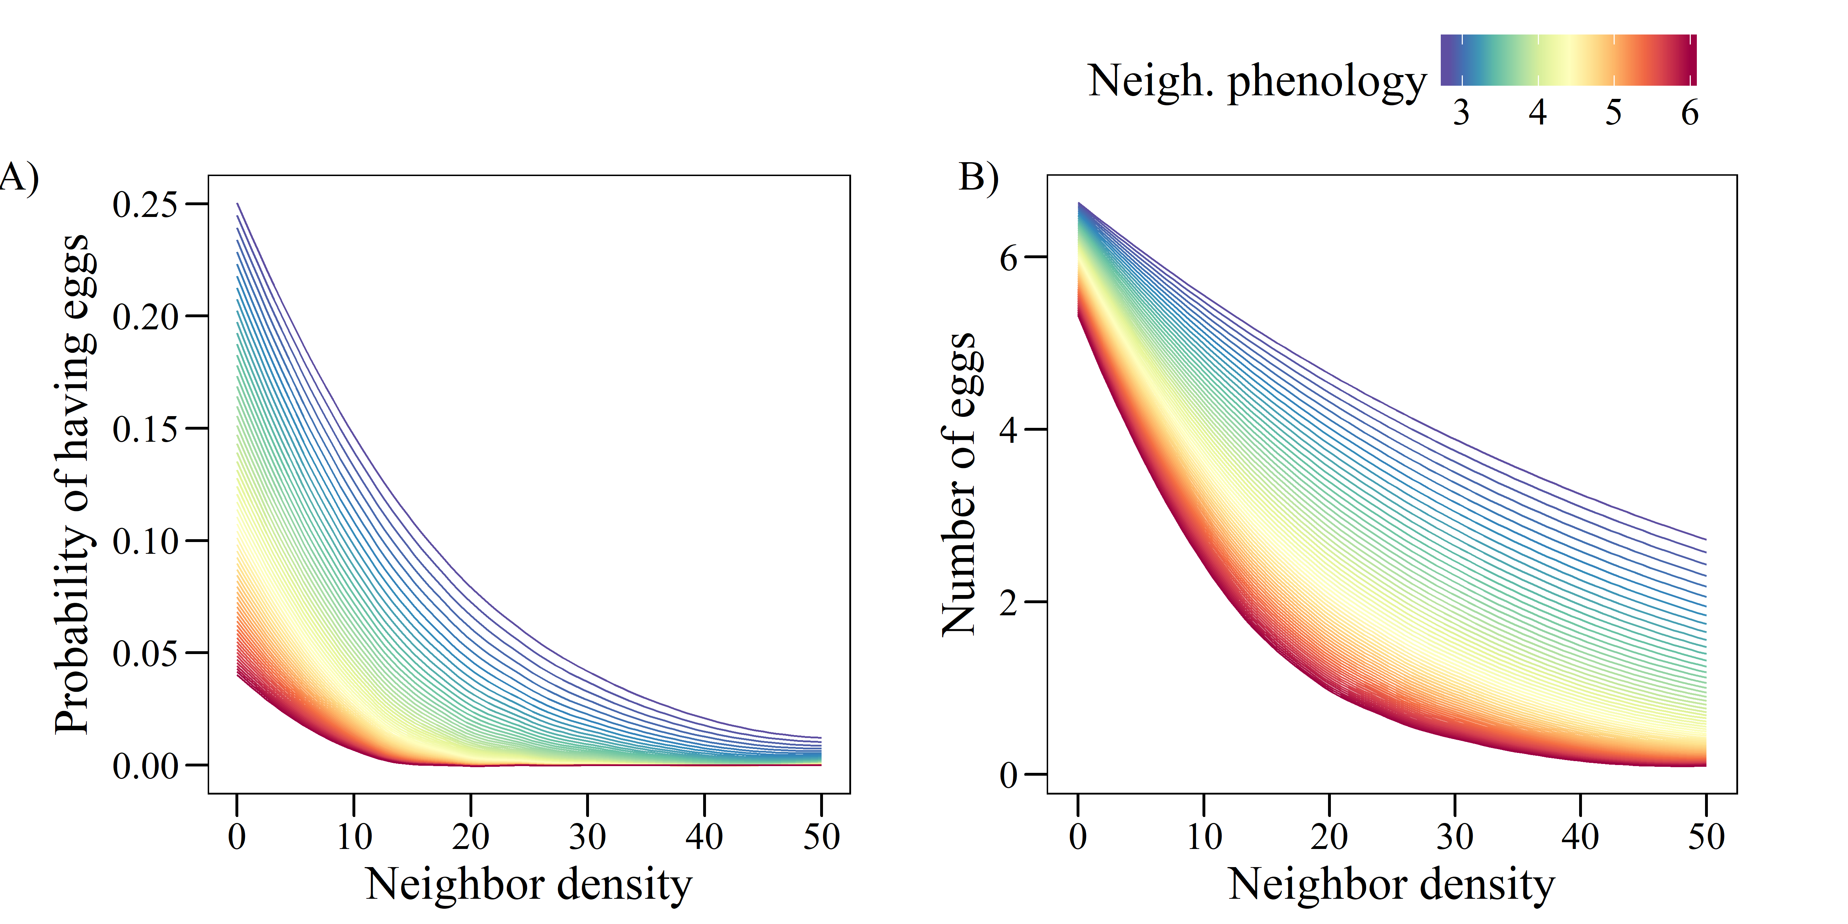

Supporting information
Figure S1: Result of the inverse distance weighted interpolation for abundance of Myrmica rubra based on abundance values (sum of individuals collected in 2 sampling sessions) at 254 sampling points. The color scale indicates the interpolated abundance values.

Figure S2: Result of the inverse distance weighted interpolation for abundance of Myrmica scabrinodis based on abundance values (sum of individuals collected in 2 sampling sessions) at 254 sampling points. The color scale indicates the interpolated abundance values.

Figure S3: Result of the inverse distance weighted interpolation for abundance of Myrmica ruginodis based on abundance values (sum of individuals collected in 2 sampling sessions) at 254 sampling points. The color scale indicates the interpolated abundance values.

Figure S4: Result of the inverse distance weighted interpolation for abundance of Myrmica schencki based on abundance values (sum of individuals collected in 2 sampling sessions) at 254 sampling points. The color scale indicates the interpolated abundance values.

Figure S5: Result of the inverse distance weighted interpolation for abundance of non-Myrmica ants based on abundance values (sum of individuals collected in 2 sampling sessions) at 254 sampling points. The color scale indicates the interpolated abundance values.

Table S1: Coefficients from univariate GLMs relating the probability of having eggs (A, binomial model) and the number of eggs in plants with at least one egg (B, negative binomial model) to the abundance of the different ant species.
 | A) Probability of having eggs (n = 8848) |  | B) Number of eggs  (n = 731)
All Myrmica | -0.522 | *** | -0.006
M. rubra | 0.174 | *** | 0.137 | ***
M. scabrinodis | -1.364 | *** | -0.120 | ***
M. ruginodis | -0.215 | *** | -0.016
M. schencki | 0.358 | *** | 0.006
Other ants | -0.403 | *** | -0.061
M. rubra + M. schencki | 0.360 | *** | 0.115 | ***
**P < 0.001; **P < 0.01; *P < 0.05

Table S2: Results of the binomial GLM (n = 8848, R² = 0.42) relating the probability of a shoot of G. pneumonanthe having eggs of P. alcon to shoot phenology, ant abundance, neighbor density and neighbor phenology, and to three different two-way interactions of these predictors.
 | Estimate |  | SE | Z
Shoot phenology | 1.384 | *** | 0.077 | 18.06
Ant abundance | 0.061 |  | 0.051 | 1.19
Neighbor density | -1.943 | *** | 0.092 | -21.03
Neighbor phenology | -1.014 | *** | 0.120 | -8.45
Shoot phen. x Ant abundance | 0.120 | * | 0.058 | 2.07
Shoot phen. x Neigh. Phen. | -0.022 |  | 0.071 | -0.32
Neigh. density x Neigh. phen. | -0.650 | * | 0.084 | -7.74
**P < 0.001; **P < 0.01; *P < 0.05

Figure S6: Spatial correlogram of the residuals of the binomial GLMs for the probability of a shoot having eggs before (red) and after (blue) including the two eigenvectors issued from MEM.
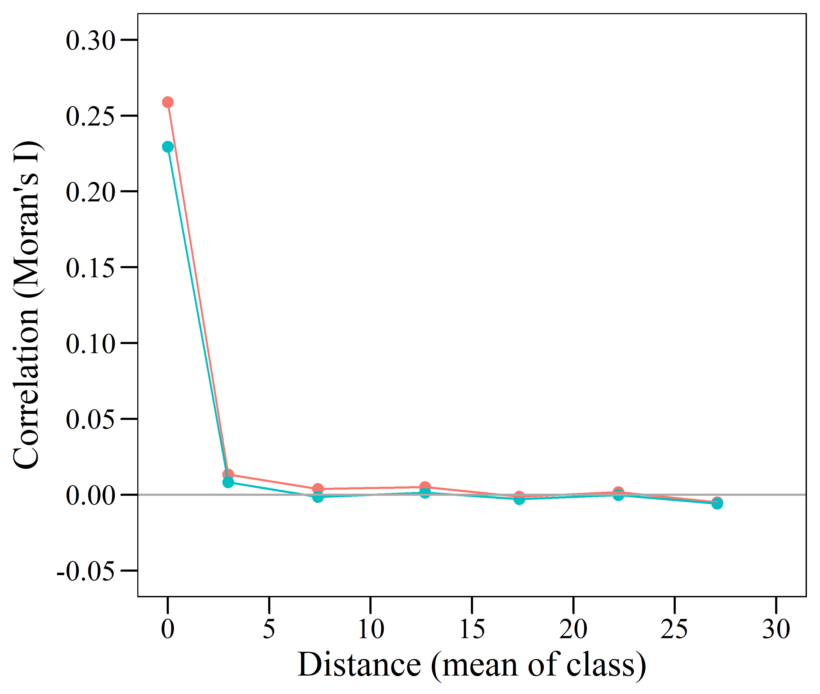
OR
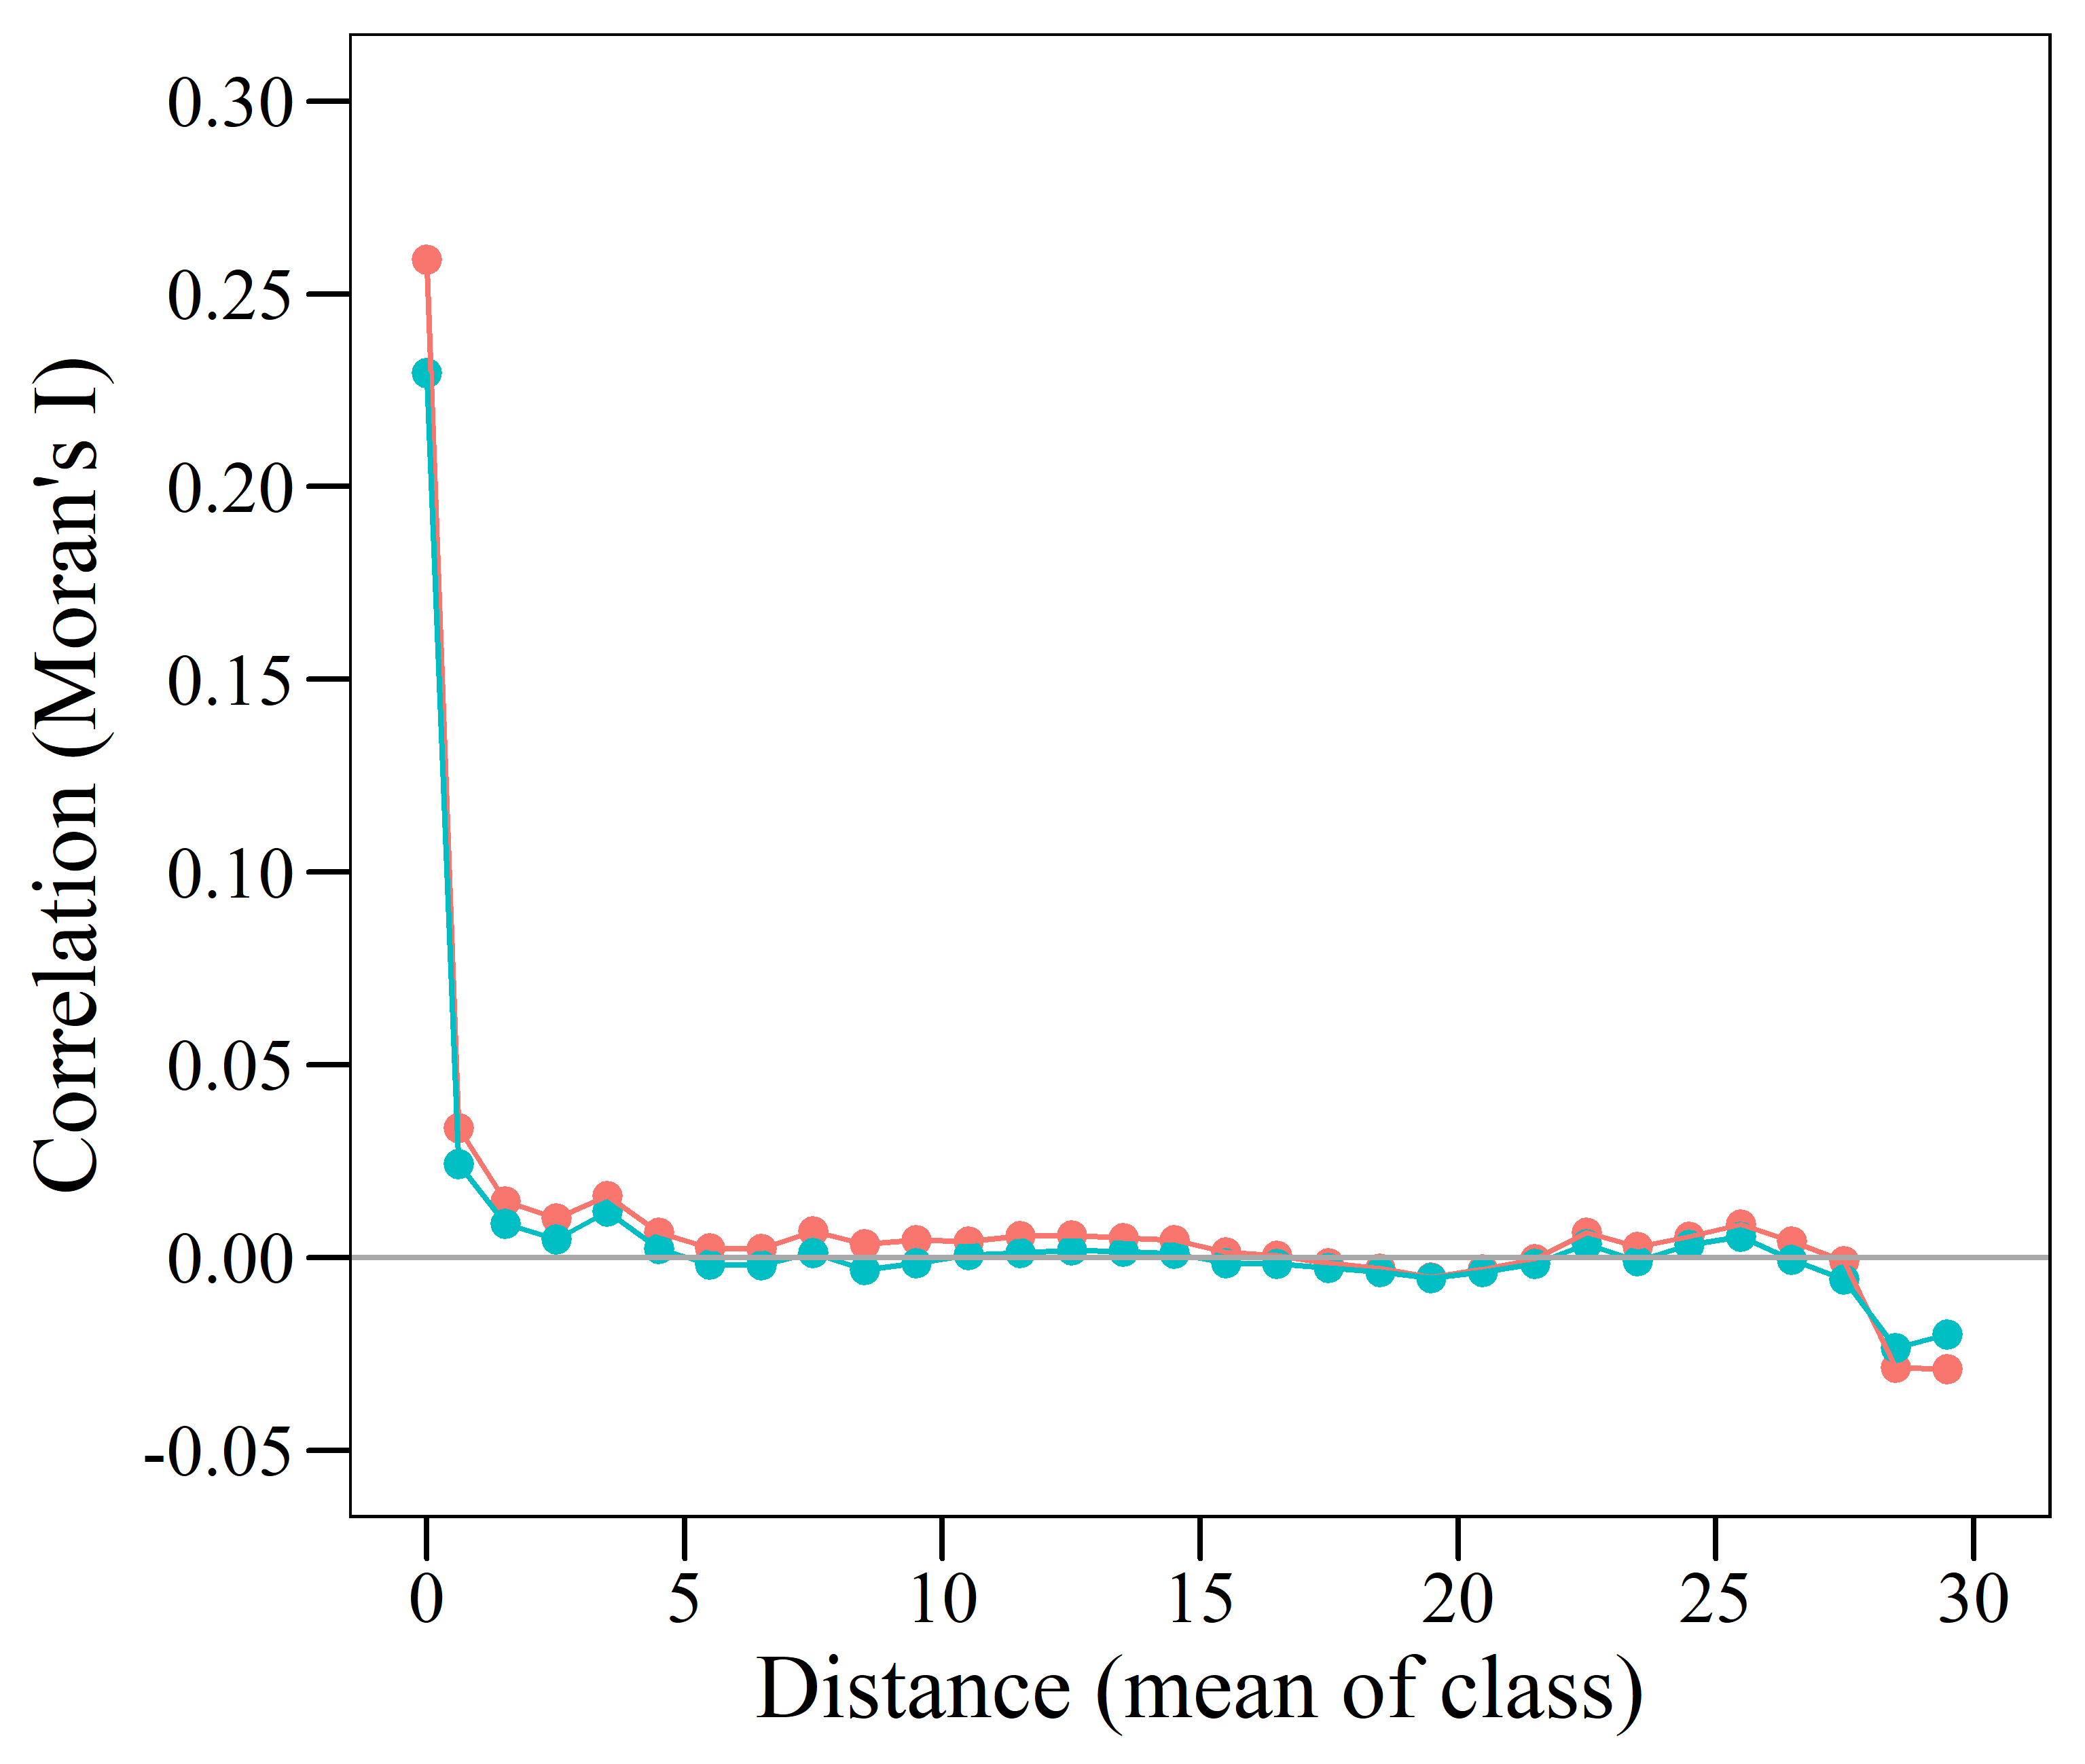
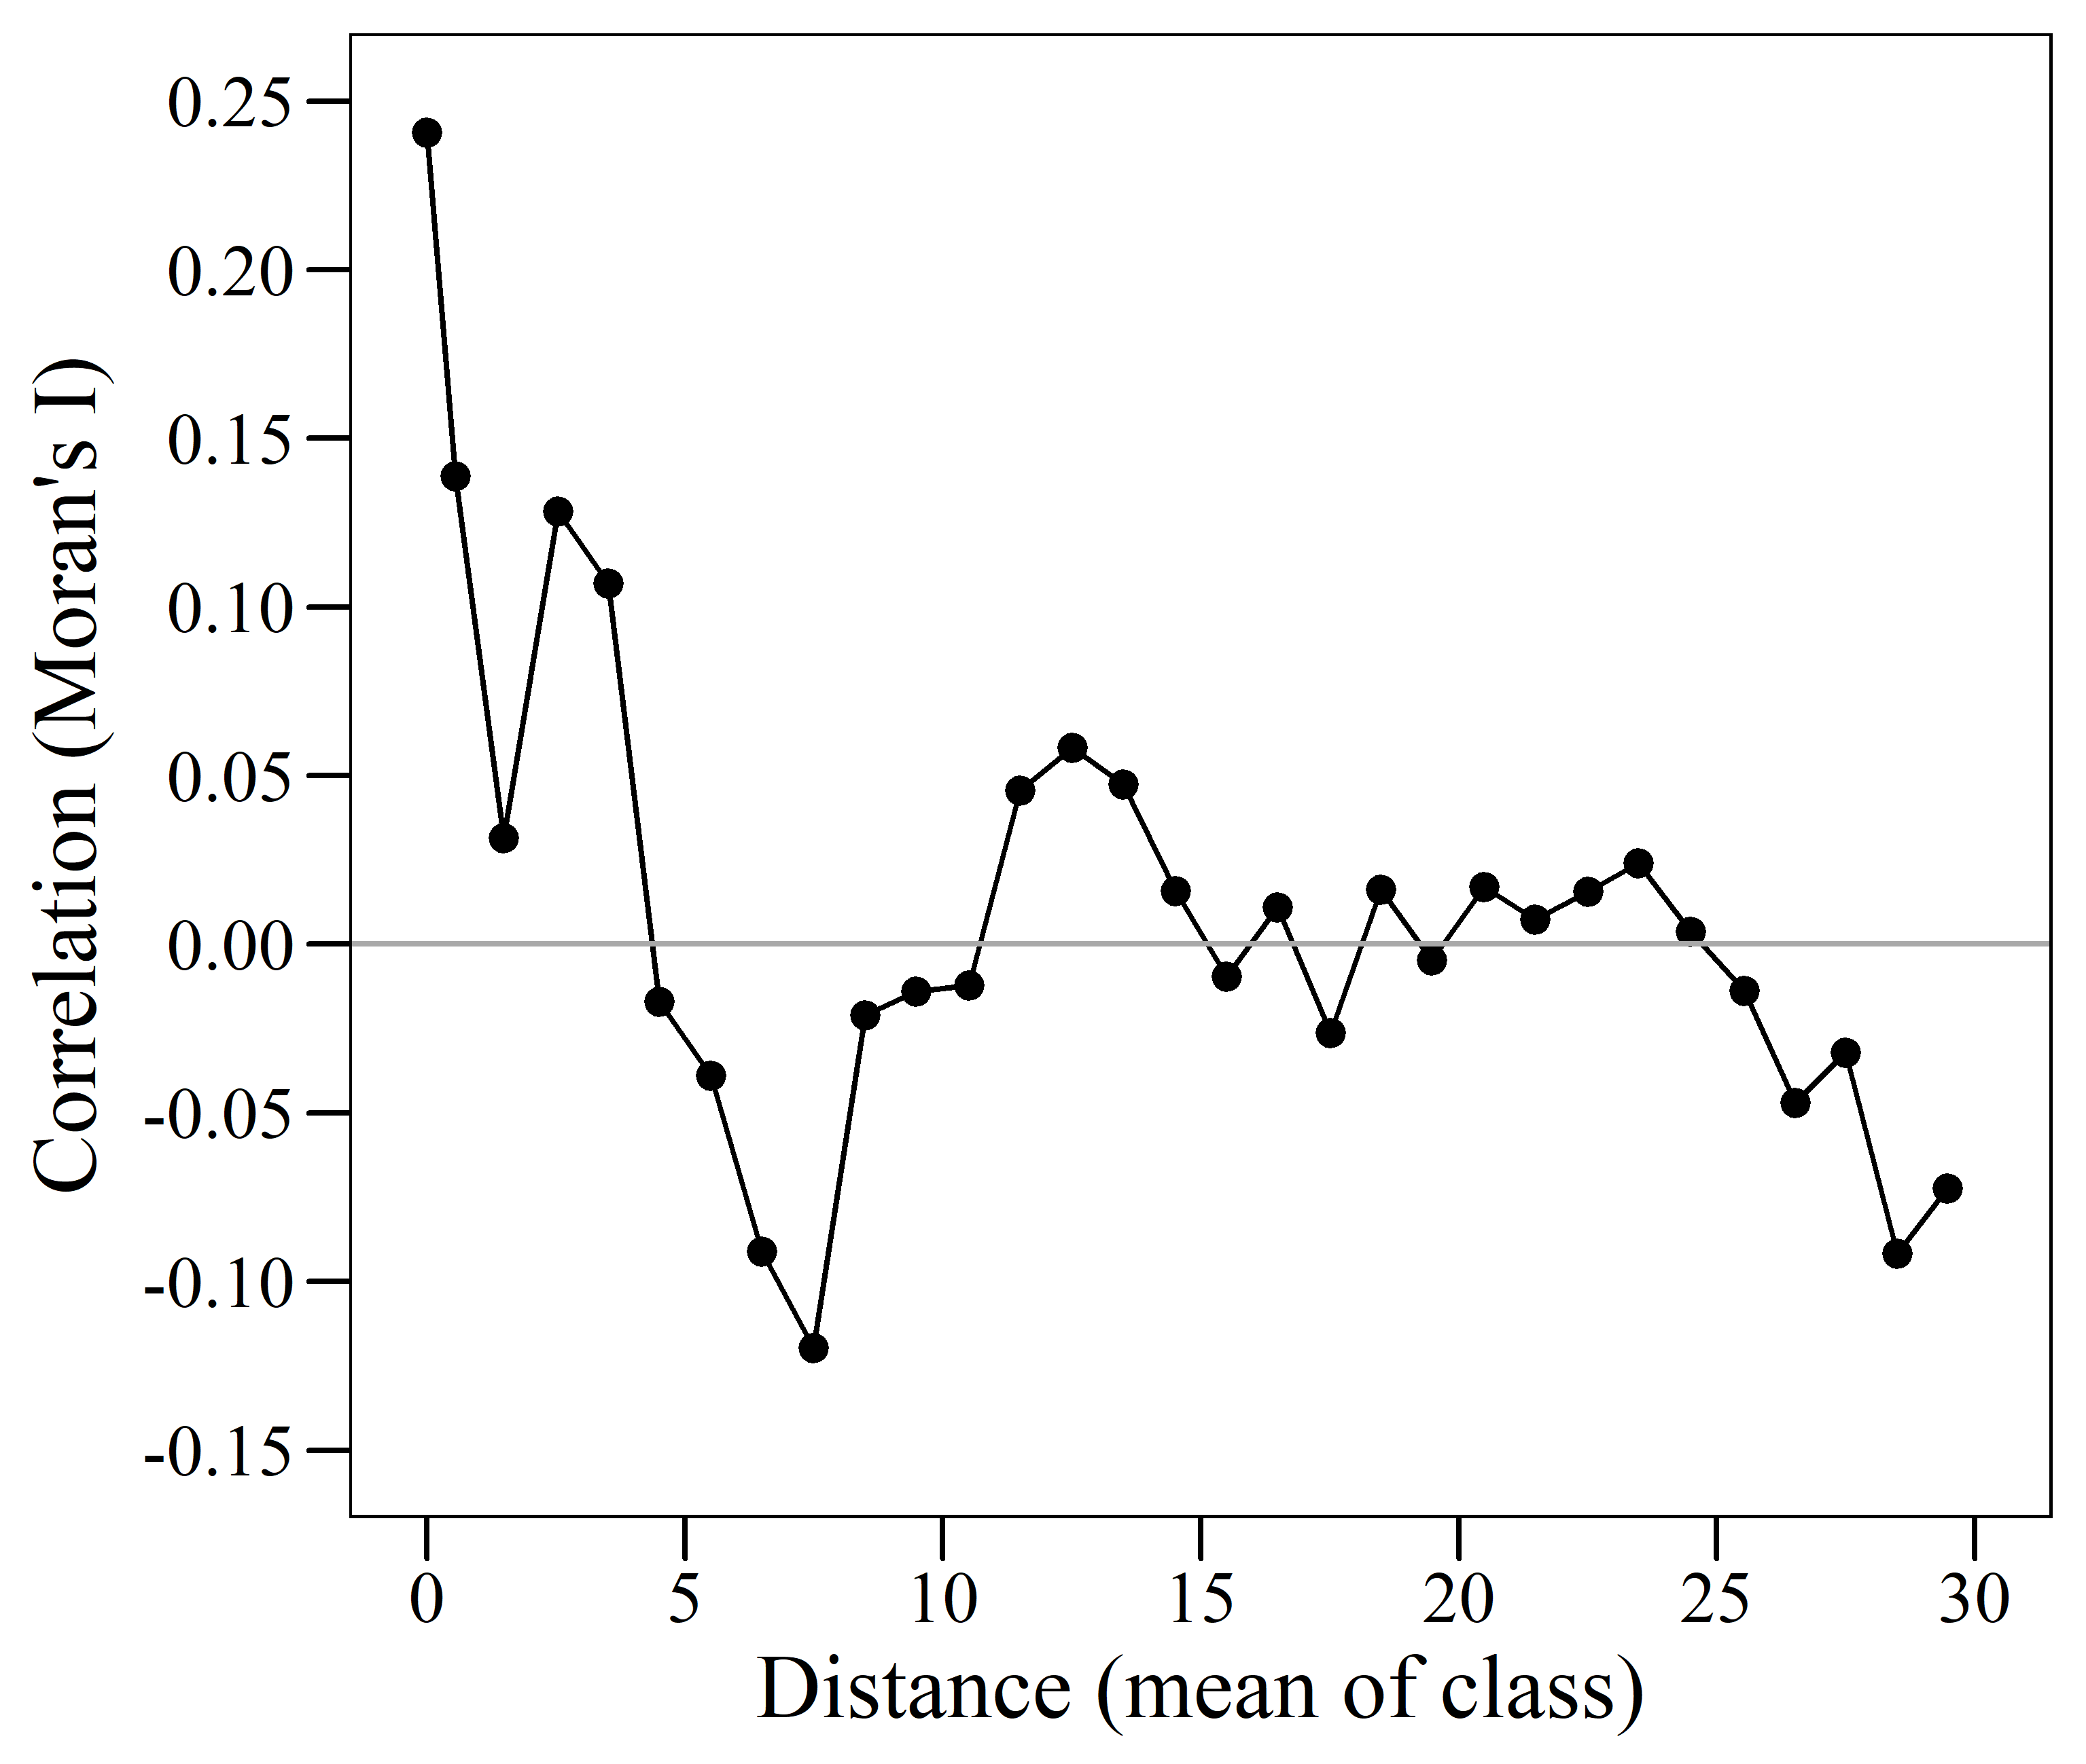
Figure S7: Spatial correlogram of the residuals of the negative binomial GLM for the number of eggs in shoots with at least one egg.
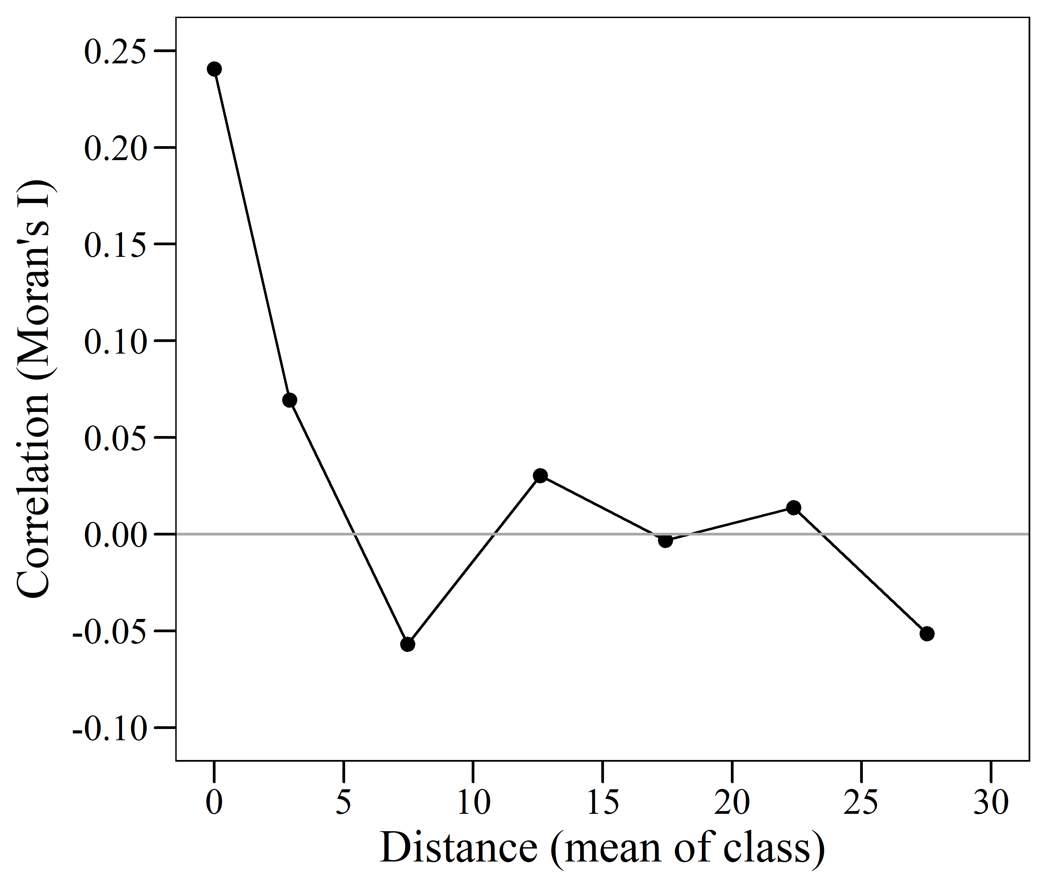
OR

