10-Sept-2017
Dear Editor,

Thank you for the invitation to submit a revised version of our manuscript JAE-2018-00418, entitled “Resource overlap and dilution effects shape host plant use in a myrmecophilous butterfly”.

This manuscript is a thoroughly revised version where we have addressed all the reviewers' comments. We have refocused the study towards the importance of resource abundance and resource timing for consumer responses, rather than using the very broad concept “resource quality”, which might be problematic as pointed out by the first reviewer. We have also carefully considered the second reviewer's recommendations about the host ant species. We now present alternative analyses with different species and have tried to justify our choices according to the information provided by this reviewer.

Below, we provide a point-by-point list with answers to all questions and detailing the changes made in response to each of the comments by the reviewers and the editor.

Thanks again for your consideration of our manuscript.

Yours sincerely,
Alicia Valdés, on behalf of both authors
ASSOCIATE EDITOR COMMENTS TO AUTHORS (if any)
Both reviewers agree that the idea is potentially interesting, but also have concerns on the data/analyses used to support the conclusions. In particular, the definition of the quality of the flowering resource needs to be readdressed, also in relation to the host-plant ant interaction. Reviewer 2 details additional points on the ant species, which are likely to be hosts in the region, addressing this comment may alter the interpretation of results and should be considered carefully.
REFEREES'COMMENTS TO AUTHORS
Reviewer: 1
The basic hypothesis of the paper is that the consumers make an optimal choice by selecting high quality resources, which may lead to uneven predation rates where resources are heterogeneoulsy distributed in space. This is an important and timely topic that is well-presented and thoroughly discussed.However, here the quality of the resource is defined by a proxy (flowering time) that is not convincingly demonstrated as reflecting the intrincic properties of the plant that are useful to the consumer (maximization of energetic content, optimization of the time budget of the consumer, etc.). This is a major flaw that curently preclude the validation of the working hypothesis. There are several proximal and ultimate alternative reasons that could produce a pattern of higher egg density on early flowering plants similar to what it is reported here: the presence of eggs as egg-laying signals for time-constrained females; a bias in the pheology of egg-laying females towards the beginning of the flowering season; selective pressures towards a long flowering period in plants to avoid butterfly predation on seeds and a sampling effect that generates the above mentioned bias in the pheology of egg-laying females towards the beginning of the flowering season, etc. If I adopt the plant viewpoint, I would say that late flowering plants are of higher quality because they avoid the predation pressures from the butterfly.

I suggest that the authors look for on a quantitative (and probably multi-factorial) definition of plant quality from the consumer side, and test whether this parameter is related to flowering dates. I would recommend the use a long time serie of data (ca. 10 generations or more) to investigate the interactions between butterfly flight periods and plant flowering times. There is a huge inter-annual variability of the flight period in P. alcon that can blur real plant-consumer relationships if the data set is too short.

We agree with the reviewer that the quality of a resource includes multiple dimensions and that the proxy we used covers only one of many aspects. We also realize that the text in the previous version was not sufficiently clear on that we considered quality in terms of food for butterfly larvae, and why flowering time is important in this respect. In response to the comments by the reviewer, we have therefore made two changes. First, in order to avoid any confusion about the term “resource quality”, we have now modified the text throughout the manuscript and changed the focus from “resource quality” to “resource timing”, stressing that both resource abundance and resource timing are important for consumer responses. We are now also more specific and talk about the trait actually measured – “plant phenology” – rather than the very general “plant quality”. Second, we now try to better explain that for insect herbivores, host plant phenology is a crucial aspect of resource quality as it determines the developmental stage of floral structures, and thus the quality of larval food at the critical early phases of development. Specifically, the plants that provide higher-quality food for the caterpillars in terms of easier-to-digest seeds are the plants with buds in early phenological stages (Arnaldo, Gonzalez, Oliveira, Langevelde, & Wynhoff, 2014). As the presence of these bud stages overlaps more with the period of oviposition in early- than in late-flowering plants (Valdés & Ehrlén, 2017), early-flowering plants can be seen as of higher quality from the butterfly viewpoint. We thus now focus on how phenology of one resource (the host plant), the density and phenology of neighboring resources (conspecific plants), and the abundance of another resource (host ants) influence resource use by the consumer butterfly.

We acknowledge that the reviewer is right when saying that the relationship between plant phenology and oviposition frequency could vary qualitatively among years, and we agree that investigating a long time series of data on butterfly-plant interactions would definitely be interesting, but we do not have this kind of data. However, we believe that this would not change our reasoning, and that our results in the current study, together with the results of previous studies (Valdés & Ehrlén, 2017, 2018) provide convincing evidence that resource timing (i.e. plant phenology) is an important aspect of consumer-resource relationships in this system. As an example of the consistence of the increase in resource use with an early timing of the plant resource, we reproduce here a figure that was included as supplementary material in Valdés & Ehrlén (2017), where a positive effect of an early flowering phenology on the number of eggs is shown for several populations in two different years. Although the magnitude of the slopes varies, the number of eggs always increases with an earlier phenology.

Figure S1: Among-population variation on the effect of G. pneumonanthe traits on itensity of predation by P. alcon. Partial linear regression plots showing among-population variation on the effect of G. pneumonanthe flowering phenology on the number of eggs of P. alcon in 2010 and 2011. Populations are represented by different colours (N = 10 in 2010 and N = 11 in 2011).

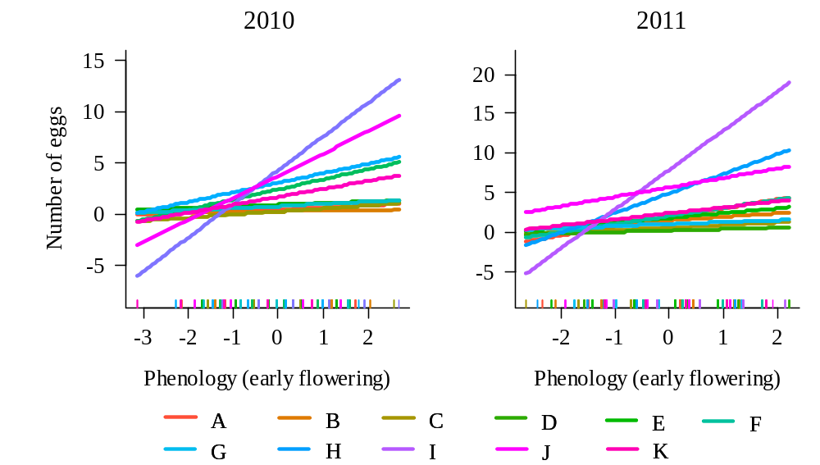
Reviewer: 2
This study is well conducted and provides novel and interesting results. It is also well written and easy to follow.
However, the authors' assumptions about host ants on this site are unlikely to be true, which puts a different spin on their results. I visited several of the sites where Maculinea (Phengaris) alcon is found near to Götteborg about 12 years ago, attempting to find out which Myrmica ants were being used as hosts. This included what I believe is the site mentioned in this manuscript. Here, and elsewhere in the region, the host ant proved to be Myrmica ruginodis (although the number of infested nests that we opened was relatively small). This data has been published, but in a rather obscure Danish paper (Nash, D. R., and Andersen, A. (2015) MACULINEA-sommerfugle og stikmyrer på danske heder - coevolution i tid og rum. Flora og Fauna 121, 133-141), a copy of which which I attach (I am also in the process of including this informationin a large paper on host ant use across Europe). While the assuption that Myrmica rubra is likely to be the main host in this region has some justification, as this is the case in sites on Skåne, Myrmica schencki would be very very unlikely to be a host - it has NEVER been recorded as a host for Maculinea alcon that develop on Gentiana pneumonanthe, only in southern Europe for the form of Maculinea alcon that develops on Gentiana cruciata on much drier sites. Generally M. alcon utuílizes the most common Myrmica on a site, which seems to be M. ruginodis from the supplementary figurse (although when I surveyed this site there were more M. scabrinodis than either M. rubra or M. ruginodis, but again this ant has never been recorded as a host of M. alcon in North-west Europe.)

We are very grateful to the reviewer for his insightful comments about the study system and for sharing his knowledge with us. We agree that we cannot with certainty say which Myrmica species acts as a host in our study site, as we have not opened any ant nests or performed any experimental manipulations. The information that we have from our study site is the relationship between occurrence of eggs on host plants and the abundance of different host ant species. In response to the comments by the reviewer we have now made several changes and new analyses.

We fully understand the concern of the reviewer about M. schencki, and agree that it is probably unlikely that this species acts as a host for the hygrophilous ecotype of P. alcon, as it has only been recorded as a host for the xerophilous ecotype (which develops on Gentiana cruciata). We have therefore now changed our analyses and removed the abundance of M. schencki from all analyses.

Based on the information provided by the reviewer that M. ruginodis has been found to be a host in some populations near the study site, we have now made new analyses using the abundance of either M. rubra or M. ruginodis, or the summed abundance of M. rubra and M. ruginodis, as measures of host ant abundance. We still chose to keep the analyses with the abundance of M. rubra in the main text. This is because this species had the strongest (and the only positive) effect on both the probability of host plants receiving eggs and the number of eggs in plants with at least one egg (Table S1). Besides, the interactive effect of plant phenology and ant abundance was still significant when considering the abundance of M. rubra (marginally significant after including the spatial predictors in the model), but not when considering the abundance of M. ruginodis or the summed abundance of both species (in fact, the abundance of M. ruginodis and the summed abundance of both species had negative effects on egg occurrence, Table S2). As the reviewer mentions, M. rubra also has been reported to be the host of P. alcon in other areas in Sweden. According to the reference kindly provided (Nash & Andersen, 2015), M. ruginodis has been confirmed to be a host by opening nests in two sites in Västra Götaland: Remmene and Högsjön. However, our study was carried out in a different site (Tånga Hed), which is 44 km away from Högsjön and 8 km from Remmene and, as far as we know, there is no information on host ant use from this site. Therefore, we believe that either M. rubra or M. ruginodis (or both) could be possible hosts. M. ruginodis is the most common ant species in our study site, but as the reviewer points out with the example of Remmene, and as shown in the map in Fig. 2 in Nash & Andersen, 2015 (see for example the data for Vasalund, where M. ruginodis is the most abundant but M. rubra is the host), P. alcon not always uses the most common Myrmica on a site as a host. Although the results of our analyses suggest that M. rubra is the most probable host ant species at our study site, we cannot rule out the possibility that other species act as hosts in our study site, and that the correlations with M. rubra abundance are not causal but due to the effect of some unmeasured variable. In discussing our results, we acknowledge these limitations in our ability to make firm conclusions about the causal relationships.
Another aspect of the study that in unclear is whether host plant phenology and Myrmica ant distribution are independent of each other, or whether both are related to small habitat differences across the site. This has been shown to be the cause of spurious correlations between ant distributions and oviposition choices in previous studies (e.g. Thomas, J. A., and Elmes, G. W. (2001) Food-plant niche selection rather than the presence of ant nests explains oviposition patterns in the myrmecophilous butterfly genus Maculinea. Proc Biol Sci 268, 471-477.). The authors have an ideal opportunity to test whether there are correlations between plant phenology and Myrmica distributions with their survey set-up, so I'm surprised that this is not included in the study.

Correlations between plant phenology and Myrmica distributions are very weak (r = 0.01 for M. rubra, and all correlations with other species are lower than 0.2). Moreover, even ant abundance and plant phenology would have been correlated, including both of them in a multiple regression model, as we did, allows to assess their independent effects.
It was also not clear why phenology was included as an ordinal variable in the analysis - I would think it should be included as a categorical variable to make as few assumptions about optimal phenology as possible, but the results suggest it was treated as a continuous (ratio-scale) variable, not even an ordinal variable.

We agree with the reviewer that one should avoid making assumptions about the shape of the relationship between phenology and oviposition, and about optimal phenology. However, we do not think that including phenology as an ordinal variable is the potential problem here, as any type of relationship could be fitted also with an ordinal variable. Phenology was treated as an ordinal variable because the developmental stage of buds is indeed an “ordered” process: buds go from stage 1 to stage 2, 3, 4, 5 and 6 in a specific order. We believe that treating phenology as a categorical variable would not take into account that this is an ordered process, and thus mean a loss of information. Rather it is our assumption that the relationship between phenology and oviposition is linear that is potentially problematic. To examine if our assumption about a linear relationship was reasonable, we therefore plotted the probability of a shoot having at least one egg against phenology treated as an ordinal variable (see below). The result confirms that assuming a linear monotonic relationship was very reasonable in this case, butterflies preferring to lay eggs in the plants where phenology is most advanced (i.e. in the early-flowering plants).

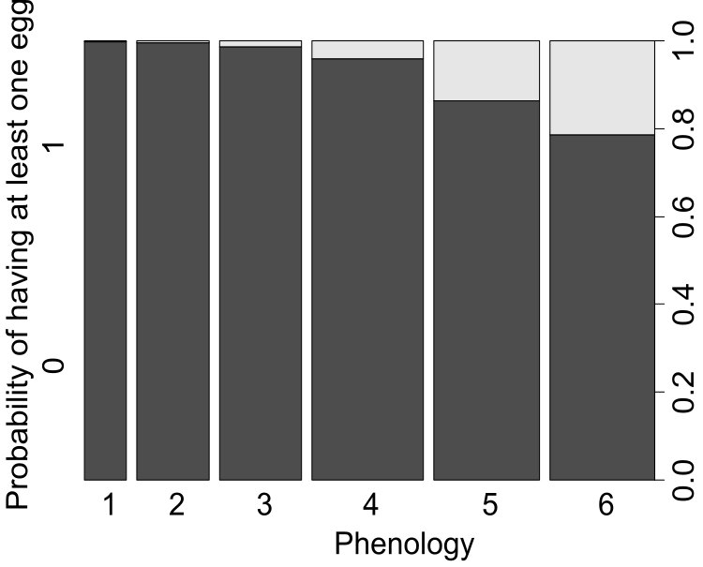
Finally, I was a little worried about the time period over which the study was conducted. At the beginning of the period mentioned (9 July) I would be very surprised if M. alcon were not still flying and laying eggs, so the final distribution of eggs (which is taken as fixed in this study) would not yet be in place...

We think that this worry is based on a misunderstanding. Although fieldwork was conducted between 9 July and 3 September 2016, the phenology and the number of eggs of P. alcon were recorded during a 7-day period, between 29 July and 5 August (this is specified in the Methods). The remaining parts of the fieldwork period were used for establishment of the sampling plots and other tasks. Sampling during this 7-day period should most likely provide information about the final distribution of eggs, as almost no butterflies would be flying after this date. Indeed, records from the Swedish Species Observation System (https://www.artportalen.se/) show that, for the period 1993-2018, there were 0 records of adults of P. alcon after this date in the study site (Tånga Hed nature reserve), and only 3-5 (of which some are doubtful) out of 307 records after this date in Västra Götaland county.
Given some of the information provided above, I do not wish to remain anonymous.
- David Nash

REFERENCES

Arnaldo, P. S., Gonzalez, D., Oliveira, I., Langevelde, F. van, & Wynhoff, I. (2014). Influence of host plant phenology and oviposition date on the oviposition pattern and offspring performance of the butterfly Phengaris alcon. Journal of Insect Conservation, 18(6), 1115–1122. doi:10.1007/s10841-014-9721-x
Nash, D. R., & Andersen, A. (2015). Maculinea-sommerfugle og stikmyrer på danske heder. Flora Og Fauna, 121(3/4), 137–145.
Valdés, A., & Ehrlén, J. (2017). Caterpillar seed predators mediate shifts in selection on flowering phenology in their host plant. Ecology, 98(1), 228–238. doi:10.1002/ecy.1633
Valdés, A., & Ehrlén, J. (2018). Direct and plant trait-mediated effects of the local environmental context on butterfly oviposition patterns. Oikos, 127(6), 825–833. doi:10.1111/oik.04909

