14-Nov-2017
Dear Editor,

Thank you for the invitation to submit a minor revision of our manuscript JAE-2018-00644, entitled “Resource overlap and dilution effects shape host plant use in a myrmecophilous butterfly”.

We have thoroughly revised the manuscript according to the editor's and reviewer's comments. Below, we provide a point-by-point list with answers to all comments and we detail the changes made in the manuscript. Please note that we have also changed the color scales used in Figs. 2 and 3 in order to make them clear and understandable in black and white (as they would appear in the printed version of the Journal).

We provide 3 different figures that could be used as Graphical Abstract for this article. We would also like these images to be considered as potential cover images for Journal of Animal Ecology.

Thanks again for your consideration of our manuscript.

Yours sincerely,
Alicia Valdés, on behalf of both authors

ASSOCIATE EDITOR COMMENTS TO AUTHORS:

Editor comments: The reviewer suggests that some of the additional information given as the response to comments should be incorporated into the manuscript/supplementary info to also help the reader to follow the story. I agree this would strengthen the work, and allow any reader to have the full information should they want it.

Our response: We thank the editor and the reviewer for their suggestions, and agree that including some additional information can improve the readability of the manuscript. We now provide the suggested information in the main text and supplementary materials.
REFEREES' COMMENTS TO AUTHORS
Reviewer: 1
CONFIDENTIAL COMMENTS TO AUTHORS
Re-review for J. Anim. Ecol. of Valdés and Ehrlén, “Resource overlap and dilution effects shape host plant use in a myrmecophilous butterfly”.
I am generally very happy with the way in which the authors have addressed my previous comments, particularly as outlined in their response letter. The current manuscript has improved significantly, and presents a very nice study. The remainder of my comments should be considered as minor, although some clarifications would be useful.
Reviewer comments: It would be helpful if some of the information that the authors have in their response letter was also included in the manuscript or supplementary materials.

Our response: We thank the reviewer for these suggestions, and we have now added the information requested in each case.
Reviewer comments: For example, the information that correlations between plant phenology and Myrmica abundances is universally low is both a necessary precursor to treating them as independent explanatory variables (Multiple-regression models do not allow their effects to be disentangled, as the authors seem to believe, but if correlations are low then any multicollinearity effects will be small), but also an interesting observation in its own right. I would recommend therefore that the authors add a table of correlations between their independent variables to their supplementary material This would also emphasize the different Myrmica ant distributions – for example, looking at their supplementary figures, I’m pretty sure there would be a strong negative correlation between the abundances of M. rubra and M. ruginodis (which is not unusual, as they have fairly similar niches).

Our response: We agree with the reviewer in that presenting the correlations among explanatory variables may be interesting, and we have now added a new Table (Table S1) showing these values. The absolute value of the Pearson correlation coefficient between variables included in the same model was always lower than 0.6.
Reviewer comments: Similarly, the second figure that they included in their response letter, showing a monotonic increase in oviposition probability with phenological stage, would also be worth including in supplementary materials. I am still a little unclear, however, whether phenology was included in the models as an ordinal or continuous (ratio-scale) variable, as the authors refer to treating the relationship between phenology and oviposition probability as linear – this would not be the case if it were included as an ordinal variable (although the monotonic increase would be) – ordinality implies an ordered series of stages, but that there is no implication that they occur at fixed intervals (i.e. an increase in phenology from 2 to 3 or from 3 to 4 may take very different amounts of time, and if phenology was included as an ordinal variable, then the associated increase in probability of oviposition should not be assumed to be equal (but would be assumed to always be positive), and would be fitted as separate values in the model). The smooth curves in figure 2, however, suggest that phenology was actually fitted as a continuous variable, although that may just reflect the limitations of the print-out.

Our response: As we had previously mentioned, phenology was included as an ordinal variable in our models. However, as shown in the figure (now included as Figure S8), we can assume a linear monotonic relationship between oviposition and phenology. Figure 2 shows the result of fitting smooth curves to the points relating the probability of having eggs to the ordinal values of shoot phenology for different levels of ant abundance.
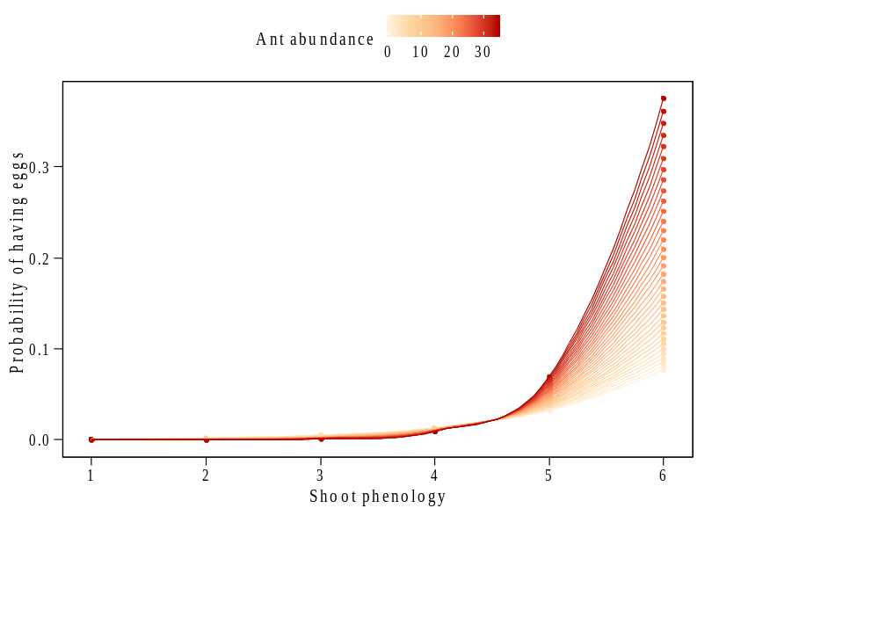
Reviewer comments: The point that reviewer 1 makes about year-to-year variation in phenology should also be explicitly mentioned in the manuscript – not as something that the authors can control, or even examine in a reasonable time-frame, but as another possible confounding factor. Based on historical records, it is clear that P. alcon in Denmark and Sweden are, on average, flying earlier now than 100 years ago, presumably associated with climate change. It is unclear, however, whether the phenology of G. pneumonanthe has changed in the same way, but it is clear that there is strong year-to-year variation in what phenological stage G. pneumonanthe are in at the time of P. alcon emergence, at least on the sites in Denmark with which I am familiar.

Our response: We agree that this is an important point, and we now mention it explicitly in the discussion (lines 271-278), acknowledging that there might be year-to-year variation in the relationship between plant phenology and oviposition, due to changes in both plant and butterfly phenology, and that different responses to e.g. climate change might lead to the disruption of the interaction.

Reviewer comments: When discussing host-ant-dependent oviposition, it would be useful if the authors flagged up that there have also been many studies that have NOT confirmed this in Phengaris butterflies. The current manuscript tends to be rather selective in the references it uses to support the case for ant-dependent oviposition, and misses several of the subtleties involved. For example, many studies do not distinguish between host Myrmica and other Myrmica species, even when hosts are known. For example, the study by Patricelli et al. (2015) shows various pieces of evidence that P. arion may use volatiles produced by Origanum plants to detect the presence of Myrmica nests among their roots, but they found no difference between host and non-host Myrmica in this respect. Hence on line 134, “host ant” should be replaced with “Myrmica”. As the authors will appreciate from their own results, the particular species of Myrmica makes a difference. As far as I know, in all experimental studies of Phengaris oviposition (i.e. where the distribution of ant colonies or host plants has been manipulated to overcome any possible associations with other variables), no evidence of host-ant dependent oviposition has been found (although Myrmica-dependent oviposition has).

Our response: We agree that the existence of host-ant-dependent oviposition has been a controversial issue, and that there are also studies that found no evidence of this. It is true that published experimental studies only show evidence of Myrmica-dependent oviposition, and have now modified the text accordingly (line 134, lines 296-297, line 308). We also now specifically mention a study showing observational evidence of host-species-dependent oviposition, and studies that found no evidence of ant-dependent oviposition (lines 298-301).
A couple of very minor additional comments:
Reviewer comments: Line 151: How were these 154 subplots chosen, or were these all the subplots with G. pneumonanthe?

Our response: G. pneumonanthe was present in 172 of the 345 subplots (this is now specifically stated in the Methods). In 154 of these occupired subplots, we mapped all reproductive shoots and recorded their phenology and number of eggs of P. alcon. Due to time constraints, it was not possible to survey the 18 additional occupied subplots.

Reviewer comments: Line 177: The distance given by Elmes et al. (1998), and conventionally used as the foraging limit of a colony, is 2 m not 3 m, although some workers do forage further afield.

Our response: We agree with the reviewer in that the distance given as the foraging limit for most Myrmica species is 2 m, although Elmes et al. (1998) also says that M. ruginodis and M. rubra can forage further afiled (up to 8 m from the nest). Therefore, we chose 3 m as the maximum distance for the interpolation in order to include most foraging events. We have now clarified this in the text (lines 177-180).
Reviewer comments: Line 202: “any” should be changed to “either”

Our response: This has now been changed.
Reviewer comments: Elmes et al. (1994) in the reference list should not have Graham’s first name, has the authors in the wrong order (and should have “others” replaced with “Munguira, M”, in the right place); it should be “Dutch” not “Duch”, and it should be “et SCHIFF.”, not “at SHIFF>”) – I suggest that the authors also check the other reference thoroughly.
Our response: This has now been changed and we have thoroughly revised the rest of the citations and the reference list.

