Supplementary material
Table S1: Coefficients from univariate GLMs relating the probability of having eggs (A, binomial model) and the number of eggs in plants with at least one egg (B, negative binomial model) to the abundance of different ant species.
 | A) Probability of having eggs (n = 8848) |  | B) Number of eggs  (n = 731)
All Myrmica | -0.522 | *** | -0.006
M. rubra | 0.174 | *** | 0.137 | ***
M. scabrinodis | -1.364 | *** | -0.120 | ***
M. ruginodis | -0.215 | *** | -0.016
M. schencki | 0.358 | *** | 0.006
Other ants | -0.403 | *** | -0.061
M. rubra + M. schencki | 0.360 | *** | 0.115 | ***
***P < 0.001; **P < 0.01; *P < 0.05

Table S2: Results of the binomial GLM (n = 8848, R² = 0.42) relating the probability of a shoot of G. pneumonanthe having eggs of P. alcon to shoot phenology, ant abundance, neighbor density and neighbor phenology, and to three different two-way interactions of these predictors.
 | Estimate |  | SE
Shoot phenology | 1.384 | *** | 0.077
Ant abundance | 0.061 |  | 0.051
Neighbor density | -1.943 | *** | 0.092
Neighbor phenology | -1.014 | *** | 0.120
Shoot phenology x Ant abundance | 0.120 | * | 0.058
Shoot phenology x Neighbor phenology | -0.022 |  | 0.071
Neighbor density x Neighbor phenology | -0.650 | * | 0.084
***P < 0.001; **P < 0.01; *P < 0.05
Figure S1: Result of the inverse distance weighted interpolation for abundance of Myrmica rubra based on abundance values (sum of individuals collected in 2 sampling sessions) at 254 sampling points. The color scale indicates the interpolated abundance values.
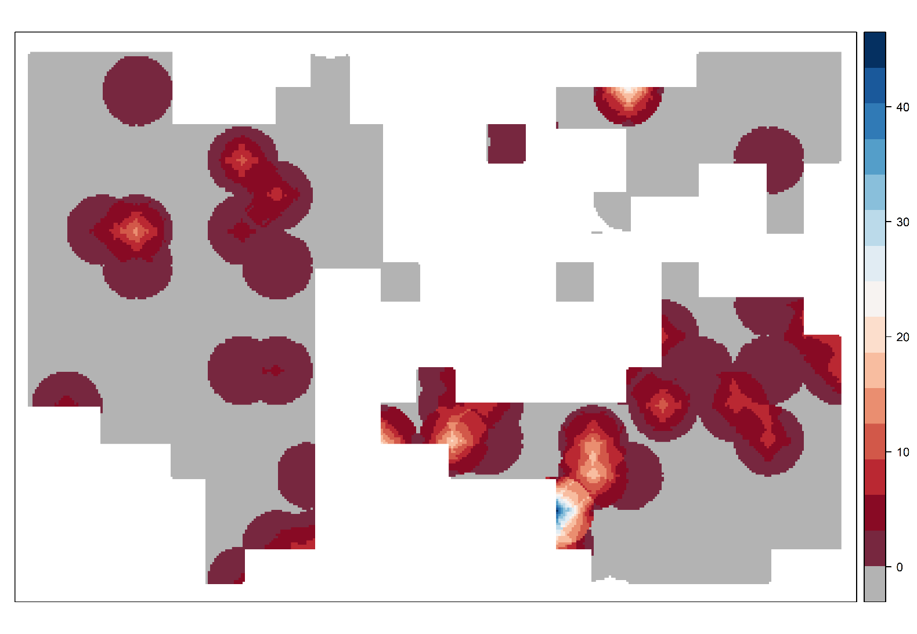
Figure S2: Result of the inverse distance weighted interpolation for abundance of Myrmica scabrinodis based on abundance values (sum of individuals collected in 2 sampling sessions) at 254 sampling points. The color scale indicates the interpolated abundance values.
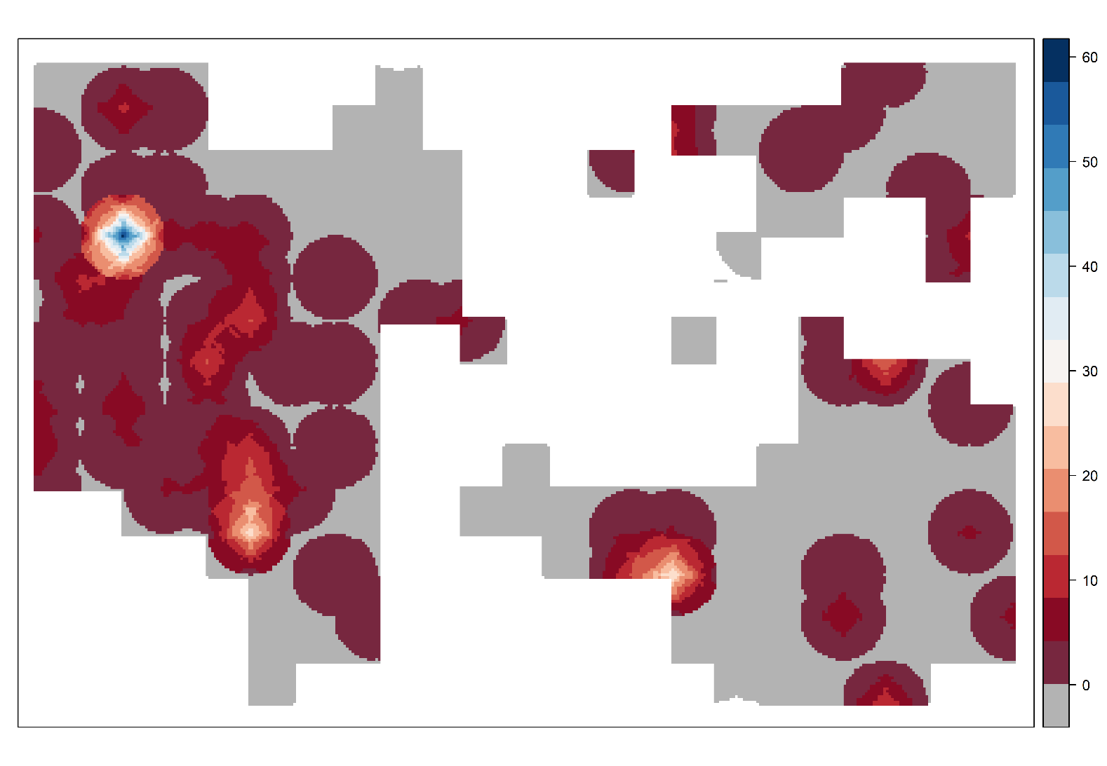
Figure S3: Result of the inverse distance weighted interpolation for abundance of Myrmica ruginodis based on abundance values (sum of individuals collected in 2 sampling sessions) at 254 sampling points. The color scale indicates the interpolated abundance values.
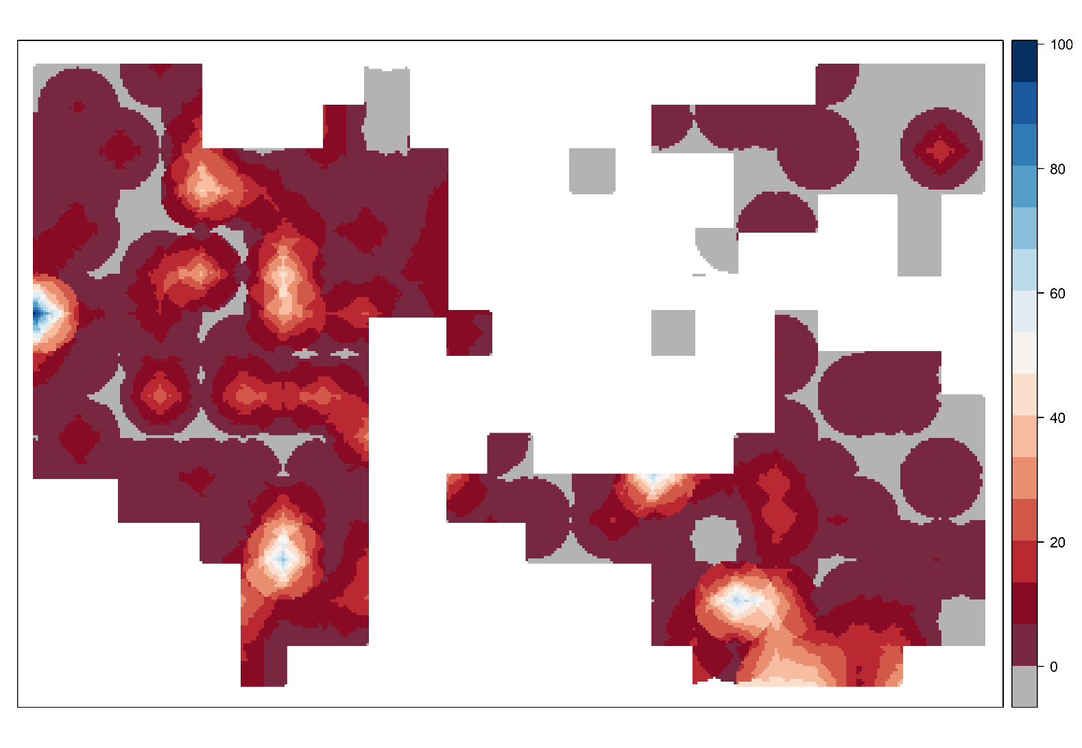
Figure S4: Result of the inverse distance weighted interpolation for abundance of Myrmica schencki based on abundance values (sum of individuals collected in 2 sampling sessions) at 254 sampling points. The color scale indicates the interpolated abundance values.
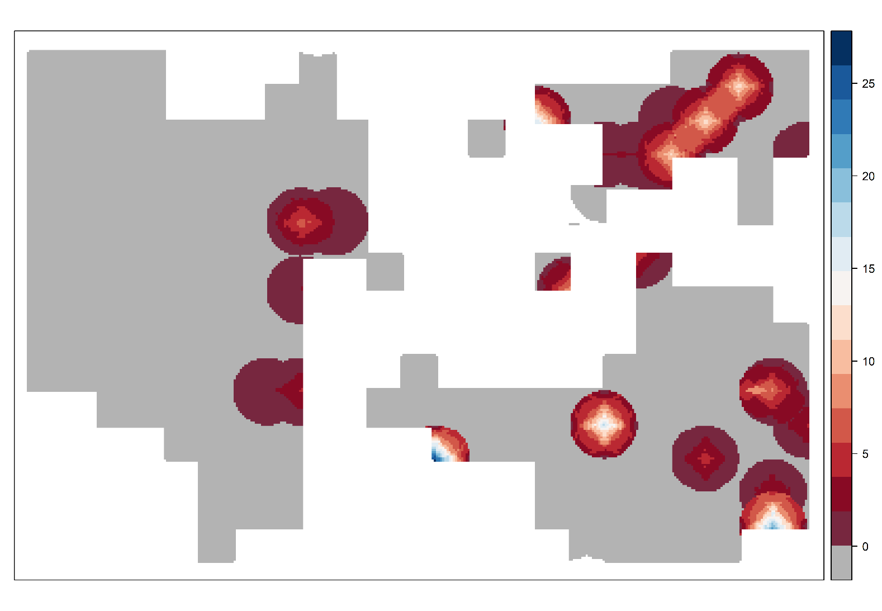
Figure S5: Result of the inverse distance weighted interpolation for abundance of non-Myrmica ants based on abundance values (sum of individuals collected in 2 sampling sessions) at 254 sampling points. The color scale indicates the interpolated abundance values. 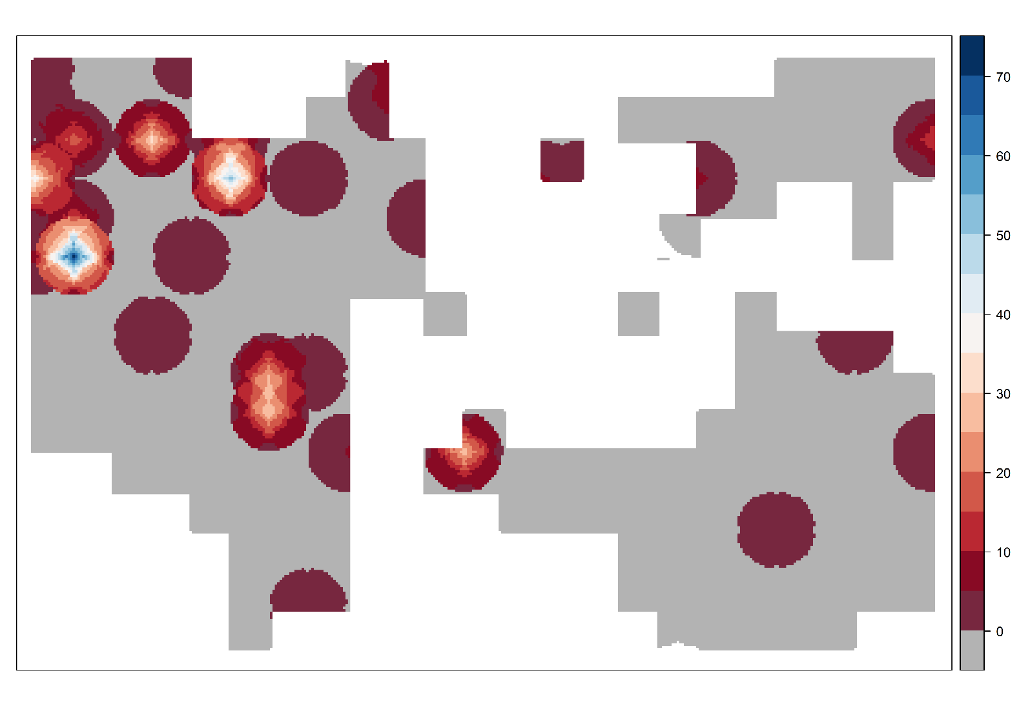
Figure S6: Spatial correlogram of the residuals of the binomial GLMs for the probability of a shoot having eggs before (red) and after (blue) including the two eigenvectors issued from MEM.
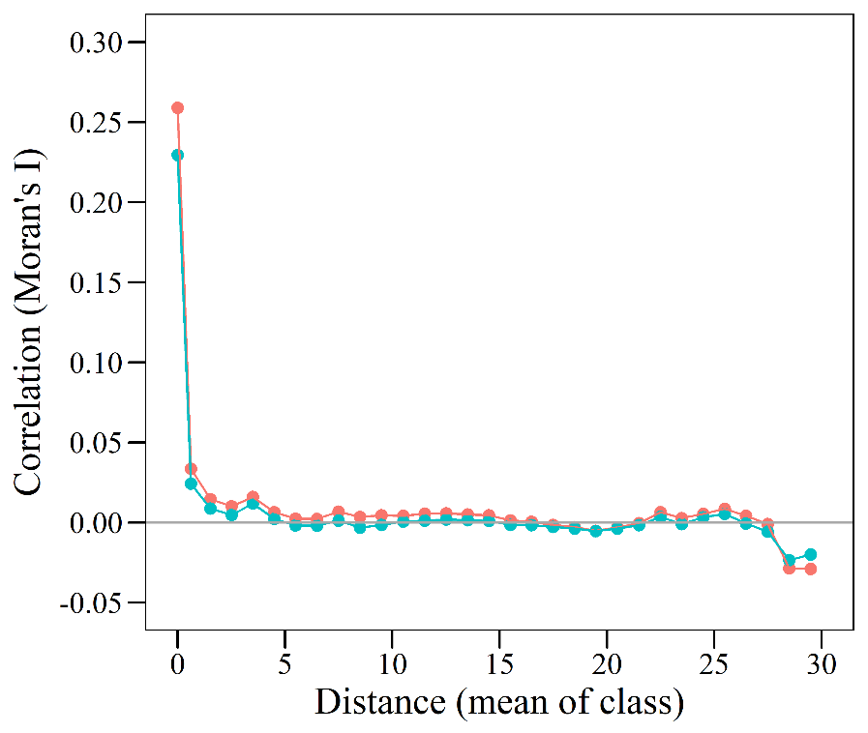
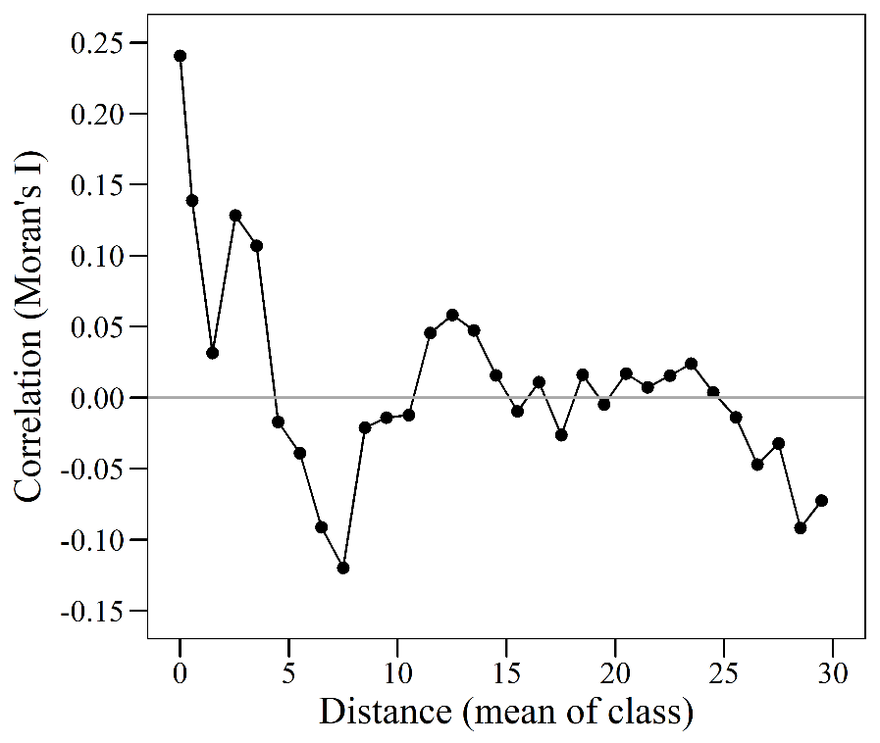
Figure S7: Spatial correlogram of the residuals of the negative binomial GLM for the number of eggs in shoots with at least one egg.

