TITLE: Resource overlap and resource dilution shape egg distribution patterns in a myrmechophilous butterfly
OR
Resource overlap and dilution shape host plant use in a myrmechophilous butterfly
INTRODUCTION
The presence, quality and abundance of a specific set of resources determines habitat suitability for any given organism (Dennis et al. 2006). When the resource is another organism, resource-consumer interactions have important ecological and evolutionary implications for both interactors, e.g. trait selection on the resource associated with consumer preferences (Parachnowitsch & Caruso 2008; Benkman & Mezquida 2015). Consumer activity should match the spatiotemporal distribution of its resources, and the relationship among the relative abundances of consumers and resources strongly influences resource use. The resource concentration hypothesis (Root 1973) predicts consumers to be more abundant where resource abundance is high, because they are more likely to find and remain on these sites than on those with less resource concentration. On the contrary, a negative relationship between consumer and resource abundances would evidence a resource dilution effect (Otway et al. 2005). Irrespective of the sign of this relationship, most consumers depend on multiple resources throughout their life cycle, e.g. different sources of food, shelter and resting sites (Dennis et al. 2003). Therefore, the availability of one resource might influence the use of other resources. In summary, the resource use of a given consumer, and thus the intensity of the consumer-resource interaction, is a complex function of consumer preferences, resource distribution in space and time, response of consumer abundance to resource abundance, and availability of other resources.
Insect herbivory is a consumer-resource interaction where resource use is conditioned by oviposition site selection by females. As larval stages usually show low mobility, oviposition preferences should relate to host suitability for offspring development (preference–performance hypothesis or optimal oviposition theory, Jaenike 1978; Scheirs & De Bruyn 2002), determined by factors as host plant nutritional quality (Chen et al. 2004), size (Rabasa et al. 2005), microclimatic conditions (Eilers et al. 2013) or enemy-free space (Wiklund & Friberg 2008). For phenologically specialized insects (Smyth et al. 2003; Patricelli et al. 2011; Fogelström et al. 2017), plant phenology determines resource quality, and temporal overlap among resource and consumer activity is key. Oviposition response to plant resource abundance depends on adult dispersal ability: bad dispersers have higher probabilities of arriving and remaining on areas with high host plant density, while this might not be true for good dispersers (e.g. Lepidoptera, Grez & González 1995). If dispersal distances are large compared to host plant patch size, oviposition probability is higher on more isolated plants (Jones 1977), and high plant density would lead to resource dilution (Otway et al. 2005). For phenological specialists, this effect could be stronger when neighboring plants show the preferred phenology (i.e. offer high quality). While many studies have explored the effects of resource density on plant-insect interactions (Yamamura 2002; Kula et al. 2014; Kim & Underwood 2015), the role of resource quality has been overlooked. Finally, availability of other resources (e.g. nectar, alternative or secondary hosts) might influence plant resource use by insects (i.e. oviposition patterns).
Myrmecophilous butterflies of the genus Phengaris depend strongly on different resources during their life cycle. They need two sequential hosts to complete their development: the caterpillars are predispersal seed predators of different host plants during their first instars and parasitize ant nests (Myrmica spp.) during later stages. They are very specific regarding host plant species and phenology (Thomas & Elmes 2001; Valdés & Ehrlén 2017) and host ant species (Elmes et al. 1998). Females oviposit preferentially on buds in early phenological stages, probably containing better-quality food: the seeds might become drier and difficult to digest as the bud develops into a flower (Arnaldo et al. 2014). As the presence of the preferred buds overlaps more with the oviposition period in early- than in late-flowering plants, those flowering early in the season are of better quality and receive more eggs (Valdés & Ehrlén 2017). Due to the low mobility of caterpillars after leaving the plant (Hayes 2015), the spatial overlap of both resources is key, as host plants only allow further development if located within the foraging range of suitable host ants (usually a few meters). Females' detection of host ant presence was previously suggested (van Dyck et al. 2000), and responses to plant chemicals produced in reaction to ant damage have recently been shown (Patricelli et al. 2015). Besides, resource dilution due to more probable encounters with isolated host plants might also shape oviposition patterns. Not only quantity, but also neighbor quality might matter: in plants surrounded by a given conspecifics' density, oviposition could increase with early-flowering (i.e. high-quality) neighbors.
In this study, we evaluated the influence of resource availability and suitability, as well as neighbor quantity and quality, on egg distribution patterns of the butterfly Phengaris alcon on its host plant Gentiana pneumonanthe. Specifically, we addressed the following questions: (1) Are effects of the two resources on egg distribution patterns interdependent? We predicted that butterflies would select oviposition sites that simultaneously maximize the availability of both resources, showing thus a stronger preference for early-flowering host plants when host ants are abundant. (2) Is there a dilution effect of host plant density on egg distribution patterns, and does it depend on neighbor quality? We predicted that oviposition probability and intensity would decrease with neighbor density (i. e. dilution effect), this decrease being stronger when neighbors are flowering early (i.e. of high quality).
METHODS
Study system
The marsh gentian (Gentiana pneumonanthe L.) is a rare, long-lived perennial herb, occurring in open habitats, such as wet heathlands and grasslands (Simmonds 1946). In natural populations, individuals do not flower until their third year (Simmonds 1946). Plants can have one to many, up to 45 cm high, shoots and produce deep blue flowers that are pollinated by bumblebees. The species is self-compatible and flowers in July and August in SW Sweden. Fruits are capsules containing a high number (usually 300-700, Appelqvist & Bengtsson 2007) minute (mean seed weight = 0.044 mg, Simmonds 1946), wind-dispersed seeds. Gentiana pneumonanthe is the primary host of the Alcon Blue butterfly (Phengaris alcon), a specialist predispersal seed predator which oviposits on young buds in July and August (Appelqvist & Bengtsson 2007). The caterpillars feed inside the capsule until they reach the fourth-instar, when then they drop to the ground to be picked up by Myrmica ants. Caterpillars mimic the surface chemistry of the ant brood (Nash et al. 2008) and the acoustic signals of queen ants (Sala et al. 2014), and this makes ants carry them to their nest, where they spend the rest of their larval period as parasites. Contrary to the majority of Phengaris species, which prey on ant brood, P. alcon is a “cuckoo” species (Als et al. 2004), and larvae feed primarily on regurgitations from ant workers, trophic eggs (i.e. nutritious, infertile eggs which are fed to the queens and larvae) and prey items brought to the nest by ants. Only ants belonging to the genus Myrmica can act as second hosts of P. alcon. In Sweden, M. rubra is the most common host ant species (Elmes et al. 1994).
Data collection
The study was carried out in a population of G. pneumonanthe where the butterfly P. alcon was present, located in Tånga Hed nature reserve, in the county of Västra Götaland, SW Sweden (58°01'40.0"N 12°49'47.0"E). Field work was conducted between 9 July and 3 September 2016. The population occupies a fenced meadow that is yearly grazed by cows at the end of the summer. A study plot measuring 69 m × 45 m was established into the meadow, and divided into a grid comprising 345 3 m x 3 subplots (Fig. 1A) permanently marked with wooden sticks at their corners. Careful examinations of each subplot in mid-July showed that G. pneumonanthe was present in 172 subplots (hereafter called “occupied subplots”).
In 154 of the occupied subplots all reproductive shoots of G. pneumonanthe were mapped, and their phenology and the number of eggs of P. alcon were recorded between 29 July and 5 August (Fig. 1B). The remaining 18 occupied subplots were excluded due to time constraints. We mapped shoots instead of individual plants (that may have from one to many shoots) because we wanted to assess availability of the host plant resource for the butterflies, and we believe that this is better represented by the number of reproductive shoots (which act as the unit of attraction for butterfly females) than by the number of plants. On each shoot, phenology was recorded as the developmental stage of the most advanced bud, according to six ordinal categories (Valdés & Ehrlén 2017): (1) the sepals covering the bud completely, (2) bud becoming visible, (3) bud growing over the sepals, (4) bud turning blue, (5) flower opening, and (6) flower showing signs of wilting. Each of these stages corresponded to a time interval of flower development, with higher values indicating a more advanced floral development at the day of recording, i.e. an earlier flowering phenology. The number of eggs was counted on the whole shoot.
The ant community was sampled at each of the four corners of all occupied subplots (a total of 254 points) in two occasions, 14 July and 3 September (Fig. 1B). Baits consisted of a Falcon plastic tube where we introduced a sugar cube. The tubes were left open on the ground in the evening, and collected the next morning. Ants collected were transferred to 70º ethanol for identification in the lab, where Myrmica ants were identified to the species and counted (using Douwes et al. 2012), and ants belonging to other genera where not identified, but counted as “others”.
Calculation of neighborhood measures
Field maps were digitized using a Geographic Information System (GIS) created with ArcGIS 10.3.1, therefore assigning relative coordinates to each reproductive shoot of G. pneumonanthe found into the study plot (Fig. 1B). For each of these shoots, we defined a buffer of 3 m around the shoot (see example on Fig. 1B), and calculated the density (hereafter, “neighbor density”, measured in number of shoots / m²) and the mean phenology (hereafter, “neighborh phenology”, a continuous value between 1 and 6) of all reproductive shoots of G. pneumonanthe into this buffer (excluding in each case the focal shoot).
Interpolations of ant abundances
The locations of the 254 points corresponding to the four corners of all occupied subplots, where the ant community was sampled, were also incorporated in the GIS. We used inverse distance weighted interpolation (Pebesma 2004) to generate values of abundance of the different ant species over the surface of all occupied subplots, based on the values at the sampling points. A maximum distance of 3 m was used because it represents the ground foraging distance of most Myrmica species (Elmes et al. 1998). From these interpolated surfaces (see Figs. S1-5 in Supporting Information), we extracted values of abundance of the different ant species for each of the mapped shoots.
Statistical analyses
The effects of shoot phenology, host ant abundance, neighbor density and neighbor phenology on egg distribution patterns of P. alcon were examined using Generalized Linear Models (GLMs). Effects on the probability of a shoot having eggs were evaluated using a binomial GLM, and effects on the number of eggs in shoots with at least one egg were evaluated using a negative binomial GLM. We first studied the response of egg distribution patterns to the abundance of the different ant species using GLMs with one predictor (i.e. the abundance of one ant species or the combined abundance of several species) at a time. The strongest positive effect on the probability of getting eggs was found when the combined abundance of M. rubra and M. schencki was used as a predictor (Supporting Information Table S1). This agrees with previous knowledge about the ant hosts, as M. rubra is the most common host ant species of P. alcon in Sweden (Elmes et al. 1994), and M. schencki has been cited as host in several places in Europe (Vilbas et al. 2016). Therefore, we decided to use the combined abundance of these two species (hereafter, “ant abundance”) as a predictor in further models. The final models were two GLMs, one with the probability of having eggs and one with the number of eggs in shoots with at least one egg as response variables, and both including the four above mentioned predictors as well as three interactions: 1) the interaction shoot phenology x ant abundance, in order to test if the effects of the two resources on egg distribution patterns are interdependent; 2) the interaction neighbor density x neighbor phenology, in order to test if the effect of host plant density depends on phenology of neighboring host plants; and 3) the interaction shoot phenology x neighbor phenology, in order to test if the relationship among egg distribution patterns and phenology depends on phenology of neighboring host plants.
All predictors were standardized by subtracting the mean and dividing by the standard deviation before the analyses. We checked for spatial autocorrelation in the residuals of both models by plotting spatial correlograms and calculating global Moran's I with a permutation test (1000 random permutations). Moran's I was calculated based on a connectivity matrix of pairwise Euclidean distances among the shoots up to a distance of 30 m. Residual spatial autocorrelation could lead to biased model estimates and invalid statistical inference (Dormann et al. 2007). As significant spatial autocorrelation was found in the residuals of the binomial GLM (global Moran's I = 0.0150, p < 0.001, Fig. S6 in Supporting Information), we applied Moran’s eigenvector mapping (MEM), which translates the spatial arrangement of data points into explanatory variables (eigenvectors) that capture spatial effects (Dray et al. 2006; Thayn & Simanis 2013). The model was refitted including two eigenvectors issued from MEM as spatial predictors, and this strongly reduced the residual spatial autocorrelation (global Moran's I = 0.0003, p = 0.03297, Fig. S6 in Supporting Information). Although still significant, the p-value close to 0.05 and the visual inspection of the spatial correlogram (Fig. S6) indicate that most of the residual spatial autocorrelation was removed by the spatial predictors, and therefore confirms the validity of our model. Results of the binomial GLM before including the spatial predictors are shown in Table S2 in Supporting Information. The residuals of the negative binomial GLM did not show significant spatial autocorrelation (global Moran's I = -0.0023, p = 0.613, Fig. S7 in Supporting Information).
Statistical analyses were carried out in R 3.4.0 (R Core Team 2017).
RESULTS
In total, we found 8848 reproductive shoots of G. pneumonanthe in the 154 occupied subplots that were mapped. P. alcon eggs were found in 731 of these shoots (8%). In shoots with at least one egg, the mean number of eggs was 5.03 ± 0.20 SE.
Effects of the two resources used by P. alcon on oviposition probability are interdependent. The probability of a shoot of G. pneumonanthe having eggs of P. alcon increased with an earlier phenology (i.e. with a more advanced floral development at the day of recording). This increase was stronger in plants where the host ants were more abundant (significant effect of the interaction shoot phenology x ant abundance, Table 1A, Fig. 1A). However, effects of the two resources on oviposition intensity are independent. In G. pneumonanthe shoots with at least one egg, the number of P. alcon eggs increased with an earlier phenology (Fig. 1B) and with host ant abundance (Fig. 1C), but the effect of shoot phenology did not depend on host ant abundance (the interaction shoot phenology x ant abundance was not significant, Table 1B).
High densities of host plants cause a dilution effect on egg distribution patterns, and this effect depends on the quality (i.e. phenology) of neighboring plants. Both the probability of having eggs in all shoots and the number of eggs in attacked shoots decreased with the density of neighboring host plants, and this decrease was in both cases stronger when neighboring host plants had an earlier phenology (significant effect of the interaction neighbor density x neighbor phenology, Table 1, Fig. 2).
DISCUSSION
The results of this study show that egg distribution patterns of the myrmechophilous butterfly P. alcon are shaped by both the spatial overlap of the two key larval resources and by a dilution effect associated with the quantity and quality of host plants. Specifically, we found that butterflies prefer ovipositing on early-flowering plants that have a high abundance of host ants, while plants surrounded by many early-flowering conspecific neighbors receive less eggs.
In accordance with previous studies showing that animal interactors usually prefer plants with a particular phenology (Elzinga et al. 2007), and more specifically, that antagonistic interactors preferentially attack early-flowering plants (Parachnowitsch & Caruso 2008; König et al. 2015; Valdés & Ehrlén 2017), we found that both the probability of having eggs and the amount of eggs of P. alcon increased with an early phenology of its host plant G. pneumonanthe. However, this phenological preference depends on the abundance of another resource used by the antagonist, i.e. host ants. In our study, we considered both Myrmica rubra and M. schencki as host ant species. As the butterfly species is red-listed, we were not able to inspect any ant nests in our study area to confirm that they effectively host caterpillars. However, both of these species can act as hosts of P. alcon (Elmes et al. 1994; Vilbas et al. 2016), and our choice is based on the strong correlation among the probability of getting eggs on a plant and the combined abundance of these two Myrmica species in the surroundings of that plant.
The dependence on the ant resource conditioned which plants were attacked, but not the intensity of predation. Specifically, the preference of P. alcon for early-flowering host plants was stronger in plants where the host ants were more abundant. For example, the probability of having eggs in a shoot with the earliest possible phenology (stage of the most advanced bud = 6, i.e. flower already showing signs or wilting when phenology was recorded, see Methods) changes from 0.07 if host ants are absent, to 0.40 with the maximum ant abundance observed (n = 34 ants). This means that the butterflies are able to track the distribution of these two resources, and to preferentially oviposit on plants where both the availability of high-quality food for the caterpillars and the probability of adoption by the right species of Myrmica are maximal. When suitable host ants are absent or very scarce, host plant phenology does not seem to matter so much, and chances of early-flowering plants to receive eggs are very low. Spatial overlap between the distribution of host plants and host ant nests has been shown to increase density and population survival of another species of Phengaris (P. arion, Thomas et al. 2009; Casacci et al. 2011), and previous studies had pointed out the importance of host plant phenology (Thomas & Elmes 2001; Valdés & Ehrlén 2017), host ant presence (van Dyck et al. 2000; Wynhoff et al. 2008) or both of these factors (Patricelli et al. 2011) for oviposition site selection. In addition, our study shows that the spatial overlap between these two resources at a very small scale (i.e. at the scale of the plant individual) influences plant attractiveness to butterflies for oviposition, and that phenological preferences in these butterflies are ant-dependent. This highlights that availability of a resource can influence the use of another resource in consumers that are highly dependent on multiple resources during their life cycle. On the contrary, the effects of the two resources on predation intensity were independent: in oviposited plants, egg loads were higher in early-flowering plants and in plants where the host ants were more abundant, but the preference for early-flowering plants did not depend on ant abundance. A possible explanation for this independence is that ant abundance influences if a plant is suitable for oviposition or not, but it might not influence variation in attractiveness among those plants that are suitable.
Our results clearly show that there is a dilution effect of host plant density on egg distribution patterns, and that this effect does depend on neighbor quality. Specifically, the negative relationship between consumer and resource abundances (i.e. dilution effect, Otway et al. 2005) was evidenced by a decrease in both oviposition probability and intensity with the density of neighboring host plants. This decrease was stronger when the neighbors represented high-quality food for the caterpillars, i.e. when surrounding plants flowered early. For the same conspecific density, more eggs were found in G. pneumonanthe plants surrounded by non-attractive, low-quality neighbors (i.e. late-flowering plants). In this system, plant phenology is crucial not only because it interacts with host ant availability to determine plant suitability for oviposition (see above), but also because it modulates the strength of host plant density effects on egg distribution patterns. Our results suggest that oviposition decisions in myrmechophilous butterflies could be taken at two levels. First, when flying over an area populated with host plants, females might use visual cues (Van Dyck & Regniers 2010) to evaluate host plant availability (i.e. density) and identify high-quality (i.e. early-flowering) host plants. Second, when they are at a very close distance to host plants, or after they alight on a host plant, females may still use visual cues to evaluate plant quality, but would combine them with the use of chemical cues to detect ant presence (Patricelli et al. 2015; Wynhoff et al. 2015), and therefore to evaluate the spatial overlap of the two resources needed by their offspring. If females use plant phenology as a visual cue which indicates plant quality, host plants surrounded by low-quality neighbors would also be more isolated and more attractive to butterflies, while the effect of the seed predator would be diluted in host plants surrounded by high-quality neighbors. Examples of antagonistic interactors showing negative density-dependence can be found elsewhere (Shea et al. 2000; Fagan et al. 2005; Hasenbank & Hartley 2015), and egg clumping on plants with few conspecific neighbors might be explained because insect herbivores are disproportionallly attracted to more isolated host plants. However, our study is the first to demonstrate that quality of neighboring host plants might also play a role in determining density-dependence effects. This has general implications for consumer-abundance relationships, as it evidences that the response of consumer abundance to resource abundance might depend on resource quality.
Disentangling the relationships among the factors determining resource use by consumers is needed to understand the implications that resource-consumer interactions have for the ecological and evolutionary dynamics of both interactors. The resource use of a given consumer conditions the intensity of the consumer-resource interaction, which may in turn have important consequences for fitness of the resource organism and for trait selection exerted by the consumer organism. This study takes an important step forward by evidencing that the main factors determining resource use by consumers might be complex and interact with each other. We show that not only resource quality and quantity, but also the spatial overlap of key resources and its temporal synchronization are of vital importance for determining patterns and outcomes of consumer activity. Moreover, the response consumers to resource availability might depend on the quality of the resources.
ACKNOWLEDGEMENTS
We thank Annelie Jörgensen for helping with fieldwork and Daniela Guasconi for lab assistance. We acknowledge funding from the Swedish Research Council (VR) to JE and from the “Clarín” postdoctoral program (FICYT, Gobierno del Principado de Asturias, Spain, and Marie Curie-Cofund Actions, EU) to AV.
REFERENCES
1.
Als, T.D., Vila, R., Kandul, N.P., Nash, D.R., Yen, S.-H., Hsu, Y.-F., et al. (2004). The evolution of alternative parasitic life histories in large blue butterflies. Nature, 432, 386–390
2.
Appelqvist, T. & Bengtsson, O. (2007). Åtgärdsprogram för alkonblåvinge och klockgentiana 2007-2011: Maculinea alcon och Gentiana pneumonanthe. Naturvårdsverket, Stockholm, Sweden
3.
Arnaldo, P.S., Gonzalez, D., Oliveira, I., Langevelde, F. van & Wynhoff, I. (2014). Influence of host plant phenology and oviposition date on the oviposition pattern and offspring performance of the butterfly Phengaris alcon. J. Insect Conserv., 18, 1115–1122
4.
Benkman, C.W. & Mezquida, E.T. (2015). Phenotypic selection exerted by a seed predator is replicated in space and time and among prey species. Am. Nat., 186, 682–691
5.
Casacci, L.P., Witek, M., Barbero, F., Patricelli, D., Solazzo, G., Balletto, E., et al. (2011). Habitat preferences of Maculinea arion and its Myrmica host ants: implications for habitat management in Italian Alps. J. Insect Conserv., 15, 103–110
6.
Chen, Y.-Z., Lin, L., Wang, C.-W., Yeh, C.-C. & Hwang, S.-Y. (2004). Response of two Pieris (Lepidoptera: Pieridae) species to fertilization of a host plant. Zool. Stud., 43, 778–786
7.
Dennis, R.L., Shreeve, T.G. & Van Dyck, H. (2003a). Towards a functional resource-based concept for habitat: a butterfly biology viewpoint. Oikos, 417–426
8.
Dennis, R.L.H., Shreeve, T.G. & Dyck, H.V. (2006). Habitats and resources: the need for a resource-based definition to conserve butterflies. Biodivers. Conserv., 15, 1943–1966
9.
Dennis, R.L.H., Shreeve, T.G. & Van Dyck, H. (2003b). Towards a functional resource-based concept for habitat: a butterfly biology viewpoint. Oikos, 102, 417–426
10.
Dormann, C.F., M. McPherson, J., B. Araújo, M., Bivand, R., Bolliger, J., Carl, G., et al. (2007). Methods to account for spatial autocorrelation in the analysis of species distributional data: a review. Ecography, 30, 609–628
11.
Douwes, P., Abenius, J., Cederberg, B. & Wahlstedt, U. (2012). Steklar: Myror-getingar: Hymenoptera: Formicidae-Vespidae. ArtDatabanken, Sveriges lantbruksuniversitet
12.
Dray, S., Legendre, P. & Peres-Neto, P.R. (2006). Spatial modelling: a comprehensive framework for principal coordinate analysis of neighbour matrices (PCNM). Ecol. Model., 196, 483–493
13.
van Dyck, H., Oostermeijer, J.G.B., Talloen, W., Feenstra, V., Hidde, A. van der & Wynhoff, I. (2000). Does the presence of ant nests matter for oviposition to a specialized myrmecophilous Maculinea butterfly? Proc. R. Soc. Lond. B Biol. Sci., 267, 861–866
14.
Eilers, S., Pettersson, L.B. & Öckinger, E. (2013). Micro-climate determines oviposition site selection and abundance in the butterfly Pyrgus armoricanus at its northern range margin. Ecol. Entomol., 38, 183–192
15.
Elmes, G.W., Hammersted, O., Martin, J., Thomas, J.A., Van Der Made, J.G. & others. (1994). Differences in host-ant specificity between Spanish, Duch and Swedish populations of the endangered butterfly, Maculinea alcon (DENIS at SHIFF>)(Lepidoptera). Memorab. Zool., 55–68
16.
Elmes, G.W., Thomas, J.A., Wardlaw, J.C., Hochberg, M.E., Clarke, R.T. & Simcox, D.J. (1998). The ecology of Myrmica ants in relation to the conservation of Maculinea butterflies. J. Insect Conserv., 2, 67–78
17.
Elzinga, J.A., Atlan, A., Biere, A., Gigord, L., Weis, A.E. & Bernasconi, G. (2007). Time after time: flowering phenology and biotic interactions. Trends Ecol. Evol., 22, 432–439
18.
Fagan, W.F., Lewis, M., Neubert, M.G., Aumann, C., Apple, J.L. & Bishop, J.G. (2005). When can herbivores slow or reverse the spread of an invading plant? A test case from Mount St. Helens. Am. Nat., 166, 669–685
19.
Grez, A.A. & González, R.H. (1995). Resource concentration hypothesis: effect of host plant patch size on density of herbivorous insects. Oecologia, 103, 471–474
20.
Hasenbank, M. & Hartley, S. (2015). Weaker resource diffusion effect at coarser spatial scales observed for egg distribution of cabbage white butterflies. Oecologia, 177, 423–430
21.
Hayes, M.P. (2015). The biology and ecology of the large blue butterfly Phengaris (Maculinea) arion: a review. J. Insect Conserv., 19, 1037–1051
22.
Jaenike, J. (1978). On optimal oviposition behavior in phytophagous insects. Theor. Popul. Biol., 14, 350–356
23.
Jones, R.E. (1977). Movement patterns and egg distribution in cabbage butterflies. J. Anim. Ecol., 46, 195–212
24.
Kim, T.N. & Underwood, N. (2015). Plant neighborhood effects on herbivory: damage is both density and frequency dependent. Ecology, 96, 1431–1437
25.
König, M.A.E., Wiklund, C. & Ehrlén, J. (2015). Timing of flowering and intensity of attack by a butterfly herbivore in a polyploid herb. Ecol. Evol., 5, 1863–1872
26.
Kula, A.A.R., Castillo, D.M., Dudash, M.R. & Fenster, C.B. (2014). Interactions between a pollinating seed predator and its host plant: the role of environmental context within a population. Ecol. Evol., n/a-n/a
27.
Nash, D.R., Als, T.D., Maile, R., Jones, G.R. & Boomsma, J.J. (2008). A mosaic of chemical coevolution in a Large Blue butterfly. Science, 319, 88–90
28.
Otway, S.J., Hector, A. & Lawton, J.H. (2005). Resource dilution effects on specialist insect herbivores in a grassland biodiversity experiment. J. Anim. Ecol., 74, 234–240
29.
Parachnowitsch, A.L. & Caruso, C.M. (2008). Predispersal seed herbivores, not pollinators, exert selection on floral traits via female fitness. Ecology, 89, 1802–1810
30.
Patricelli, D., Barbero, F., La Morgia, V., Casacci, L.P., Witek, M., Balletto, E., et al. (2011). To lay or not to lay: oviposition of Maculinea arion in relation to Myrmica ant presence and host plant phenology. Anim. Behav., 82, 791–799
31.
Patricelli, D., Barbero, F., Occhipinti, A., Bertea, C.M., Bonelli, S., Casacci, L.P., et al. (2015). Plant defences against ants provide a pathway to social parasitism in butterflies. Proc R Soc B, 282, 20151111
32.
Rabasa, S.G., Gutiérrez, D. & Escudero, A. (2005). Egg laying by a butterfly on a fragmented host plant: a multi-level approach. Ecography, 28, 629–639
33.
Root, R.B. (1973). Organization of a plant-arthropod association in simple and diverse habitats: the fauna of Collards (Brassica oleracea). Ecol. Monogr., 43, 95–124
34.
Sala, M., Casacci, L.P., Balletto, E., Bonelli, S. & Barbero, F. (2014). Variation in butterfly larval acoustics as a strategy to infiltrate and exploit host ant colony resources. PLoS ONE, 9, e94341
35.
Scheirs, J. & De Bruyn, L. (2002). Integrating optimal foraging and optimal oviposition theory in plant–insect research. Oikos, 96, 187–191
36.
Shea, K., Smyth, M., Sheppard, A., Morton, R. & Chalimbaud, J. (2000). Effect of patch size and plant density of Paterson’s curse (Echium plantagineum) on the oviposition of a specialist weevil, Mogulones larvatus. Oecologia, 124, 615–621
37.
Simmonds, N.W. (1946). Gentiana pneumonanthe L. J. Ecol., 33, 295–307
38.
Thayn, J.B. & Simanis, J.M. (2013). Accounting for spatial autocorrelation in linear regression models using spatial filtering with eigenvectors. Ann. Assoc. Am. Geogr., 103, 47–66
39.
Thomas, J.A. & Elmes, G.W. (2001). Food–plant niche selection rather than the presence of ant nests explains oviposition patterns in the myrmecophilous butterfly genus Maculinea. Proc. R. Soc. Lond. B Biol. Sci., 268, 471–477
40.
Thomas, J.A., Simcox, D.J. & Clarke, R.T. (2009). Successful conservation of a threatened Maculinea butterfly. Science, 325, 80–83
41.
Valdés, A. & Ehrlén, J. (2017). Caterpillar seed predators mediate shifts in selection on flowering phenology in their host plant. Ecology, 98, 228–238
42.
Vilbas, M., Esperk, T. & Teder, T. (2016). Host ant use of the Alcon blue butterfly at the northern range margin. J. Insect Conserv., 20, 879–886
43.
Wiklund, C. & Friberg, M. (2008). Enemy-free space and habitat-specific host specialization in a butterfly. Oecologia, 157, 287–294
44.
Wynhoff, I., Bakker, R.B., Oteman, B., Arnaldo, P.S. & van Langevelde, F. (2015). Phengaris (Maculinea) alcon butterflies deposit their eggs on tall plants with many large buds in the vicinity of Myrmica ants. Insect Conserv. Divers., 8, 177–188
45.
Wynhoff, I., Grutters, M. & Langevelde, F. van. (2008). Looking for the ants: selection of oviposition sites by two myrmecophilous butterfly species. Anim. Biol., 58, 371–388
46.
Yamamura, K. (2002). Biodiversity and stability of herbivore populations: influences of the spatial sparseness of food plants. Popul. Ecol., 44, 33–40

Table 1: Results of the GLMs relating the probablity of a shoot of G. pneumonanthe having eggs of P. alcon (binomial GLM, A) and the number of eggs in shoots with at least one egg (negative binomial GLM, B) to shoot phenology, ant abundance, neighbor density and neighbor phenology, and to three different two-way interactions of these predictors. In A), two eigenvectors issued from Moran’s eigenvector mapping (MEM) are also included as predictors, in order to reduce residual
spatial autocorrelation (see details in the main text).
 | A) Probability of having eggs (n = 8848, R² = 0.45) |  |  |  |  | B) Number of eggs (n = 731, R² = 0.22)
 | Estimate |  | SE | Z |  | Estimate |  | SE | Z
Shoot phenology | 1.462 | *** | 0.079 | 18.42 |  | 0.257 | *** | 0.036 | 7.07
Ant abundance | -0.017 |  | 0.052 | -0.33 |  | 0.089 | ** | 0.031 | 2.82
Neighbor density | -1.691 | *** | 0.102 | -16.61 |  | -0.368 | *** | 0.067 | -5.48
Neighbor phenology | -1.150 | *** | 0.124 | -9.28 |  | -0.121 | ** | 0.041 | -2.95
Shoot phen. x Ant abundance | 0.132 | * | 0.062 | 2.14 |  | 0.004 |  | 0.031 | 0.13
Shoot phen. x Neigh. Phen. | 0.068 |  | 0.074 | 0.92 |  | 0.014 |  | 0.035 | 0.40
Neigh. density x Neigh. phen. | -0.500 | *** | 0.087 | -5.72 |  | -0.100 | * | 0.042 | -2.36
MEM Vector 1 | 0.289 | *** | 0.030 | 9.76
MEM Vector 2 | 0.324 | *** | 0.052 | 6.26
**P < 0.001; **P < 0.01; *P < 0.05

FIGURE LEGENDS
Figure 1: Sampling design. A) Study plot (69 x 45 m²), comprising 345 3 m² subplots. B) Detail of several occupied subplots with reproductive shoots of G. pneumonanthe and sampling points for ants. Shoots are represented as points, colored according to shoot phenology. Numbers indicate the number of P. alcon eggs found on the shoot when at least 1 egg was found. An example of a 3-m buffer used for neighbor measures on a focal shoot (represented with a star) is shown.
Figure 2: Effects of shoot phenology and host ant abundance on egg distribution patterns of P. alcon on its host plant G. pneumonanthe. A) Interactive effects on the probability of a shoot having eggs: the relationship among the probability of having eggs and shoot phenology is shown for different values of ant abundance. B) Relationship among the number of eggs in shoots with at least one egg and shoot phenology. Higher values of shoot phenology indicate earlier flowering. C) Relationship among the number of eggs in shoots with at least one egg and ant abundance. In A), binomial GLM fit lines are represented with a color gradient for a continuous increment in ant abundance within the range of observed values. In B) and C), negative binomial GLM fit lines and confidence intervals are shown.
Figure 3: Interactive effects of neighbor density and neighbor phenology on the probability of a shoot having eggs (A) and the number of eggs in shoots with at least one egg (B). The relationships with neighbor density are shown for different values of neighbor phenology. Binomial (A) or negative binomial (B) GLM fit lines are represented with a color gradient for a continuous increment in neighbor phenology within the range of observed values. Higher values of neighbor phenology indicate earlier flowering.

Figure 1
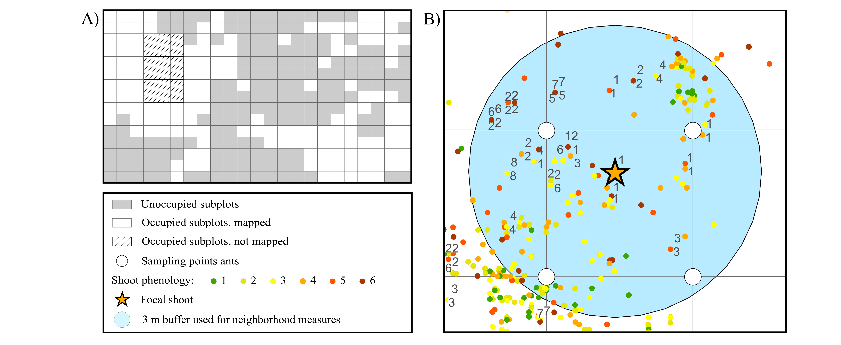
Figure 2
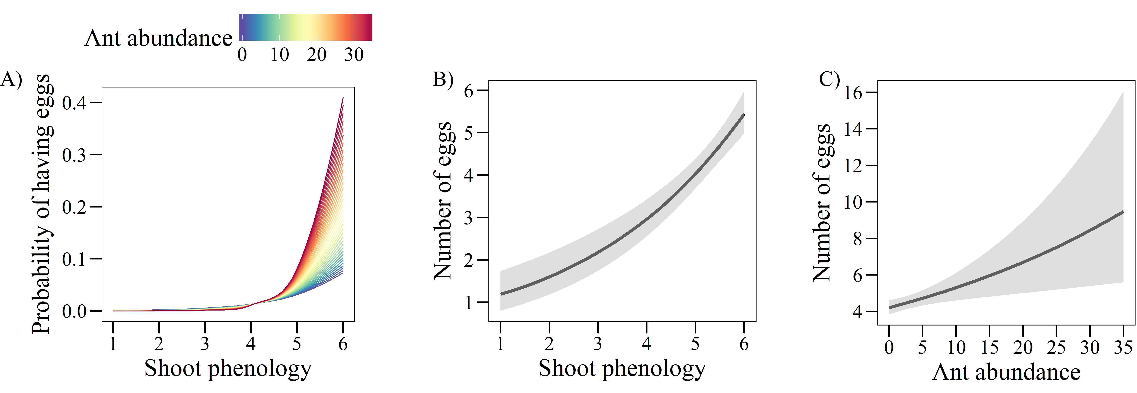

Figure 3
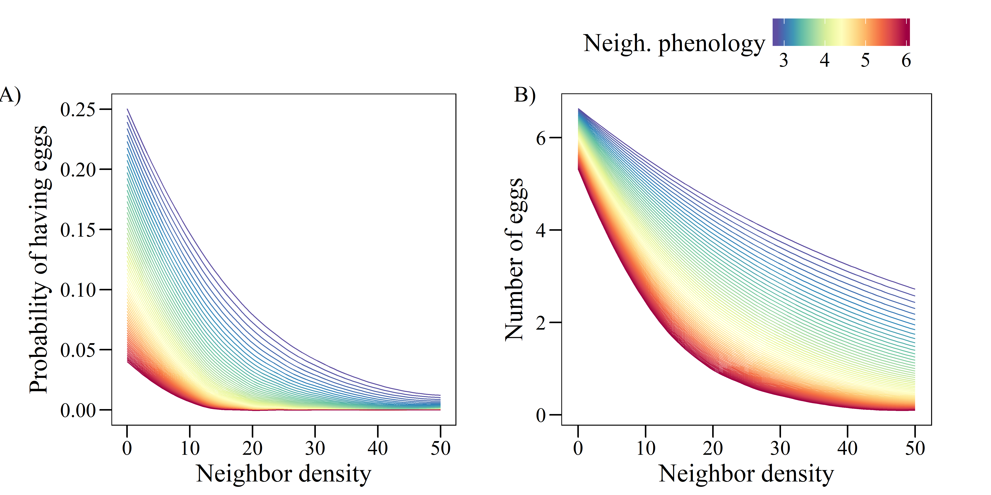

Supporting information
Figure S1: Result of the inverse distance weighted interpolation for abundance of Myrmica rubra based on abundance values (sum of individuals collected in 2 sampling sessions) at 254 sampling points. The color scale indicates the interpolated abundance values.

Figure S2: Result of the inverse distance weighted interpolation for abundance of Myrmica scabrinodis based on abundance values (sum of individuals collected in 2 sampling sessions) at 254 sampling points. The color scale indicates the interpolated abundance values.

Figure S3: Result of the inverse distance weighted interpolation for abundance of Myrmica ruginodis based on abundance values (sum of individuals collected in 2 sampling sessions) at 254 sampling points. The color scale indicates the interpolated abundance values.

Figure S4: Result of the inverse distance weighted interpolation for abundance of Myrmica schencki based on abundance values (sum of individuals collected in 2 sampling sessions) at 254 sampling points. The color scale indicates the interpolated abundance values.

Figure S5: Result of the inverse distance weighted interpolation for abundance of non-Myrmica ants based on abundance values (sum of individuals collected in 2 sampling sessions) at 254 sampling points. The color scale indicates the interpolated abundance values.

Table S1: Coefficients from univariate GLMs relating the probability of having eggs (A, binomial model) and the number of eggs in plants with at least one egg (B, negative binomial model) to the abundance of the different ant species.
 | A) Probability of having eggs (n = 8848) |  | B) Number of eggs  (n = 731)
All Myrmica | -0.522 | *** | -0.006
M. rubra | 0.174 | *** | 0.137 | ***
M. scabrinodis | -1.364 | *** | -0.120 | ***
M. ruginodis | -0.215 | *** | -0.016
M. schencki | 0.358 | *** | 0.006
Other ants | -0.403 | *** | -0.061
M. rubra + M. schencki | 0.360 | *** | 0.115 | ***
**P < 0.001; **P < 0.01; *P < 0.05

Table S2: Results of the binomial GLM (n = 8848, R² = 0.42) relating the probability of a shoot of G. pneumonanthe having eggs of P. alcon to shoot phenology, ant abundance, neighbor density and neighbor phenology, and to three different two-way interactions of these predictors.
 | Estimate |  | SE | Z
Shoot phenology | 1.384 | *** | 0.077 | 18.06
Ant abundance | 0.061 |  | 0.051 | 1.19
Neighbor density | -1.943 | *** | 0.092 | -21.03
Neighbor phenology | -1.014 | *** | 0.120 | -8.45
Shoot phen. x Ant abundance | 0.120 | * | 0.058 | 2.07
Shoot phen. x Neigh. Phen. | -0.022 |  | 0.071 | -0.32
Neigh. density x Neigh. phen. | -0.650 | * | 0.084 | -7.74
**P < 0.001; **P < 0.01; *P < 0.05

Figure S6: Spatial correlogram of the residuals of the binomial GLMs for the probability of a shoot having eggs before (red) and after (blue) including the two eigenvectors issued from MEM.
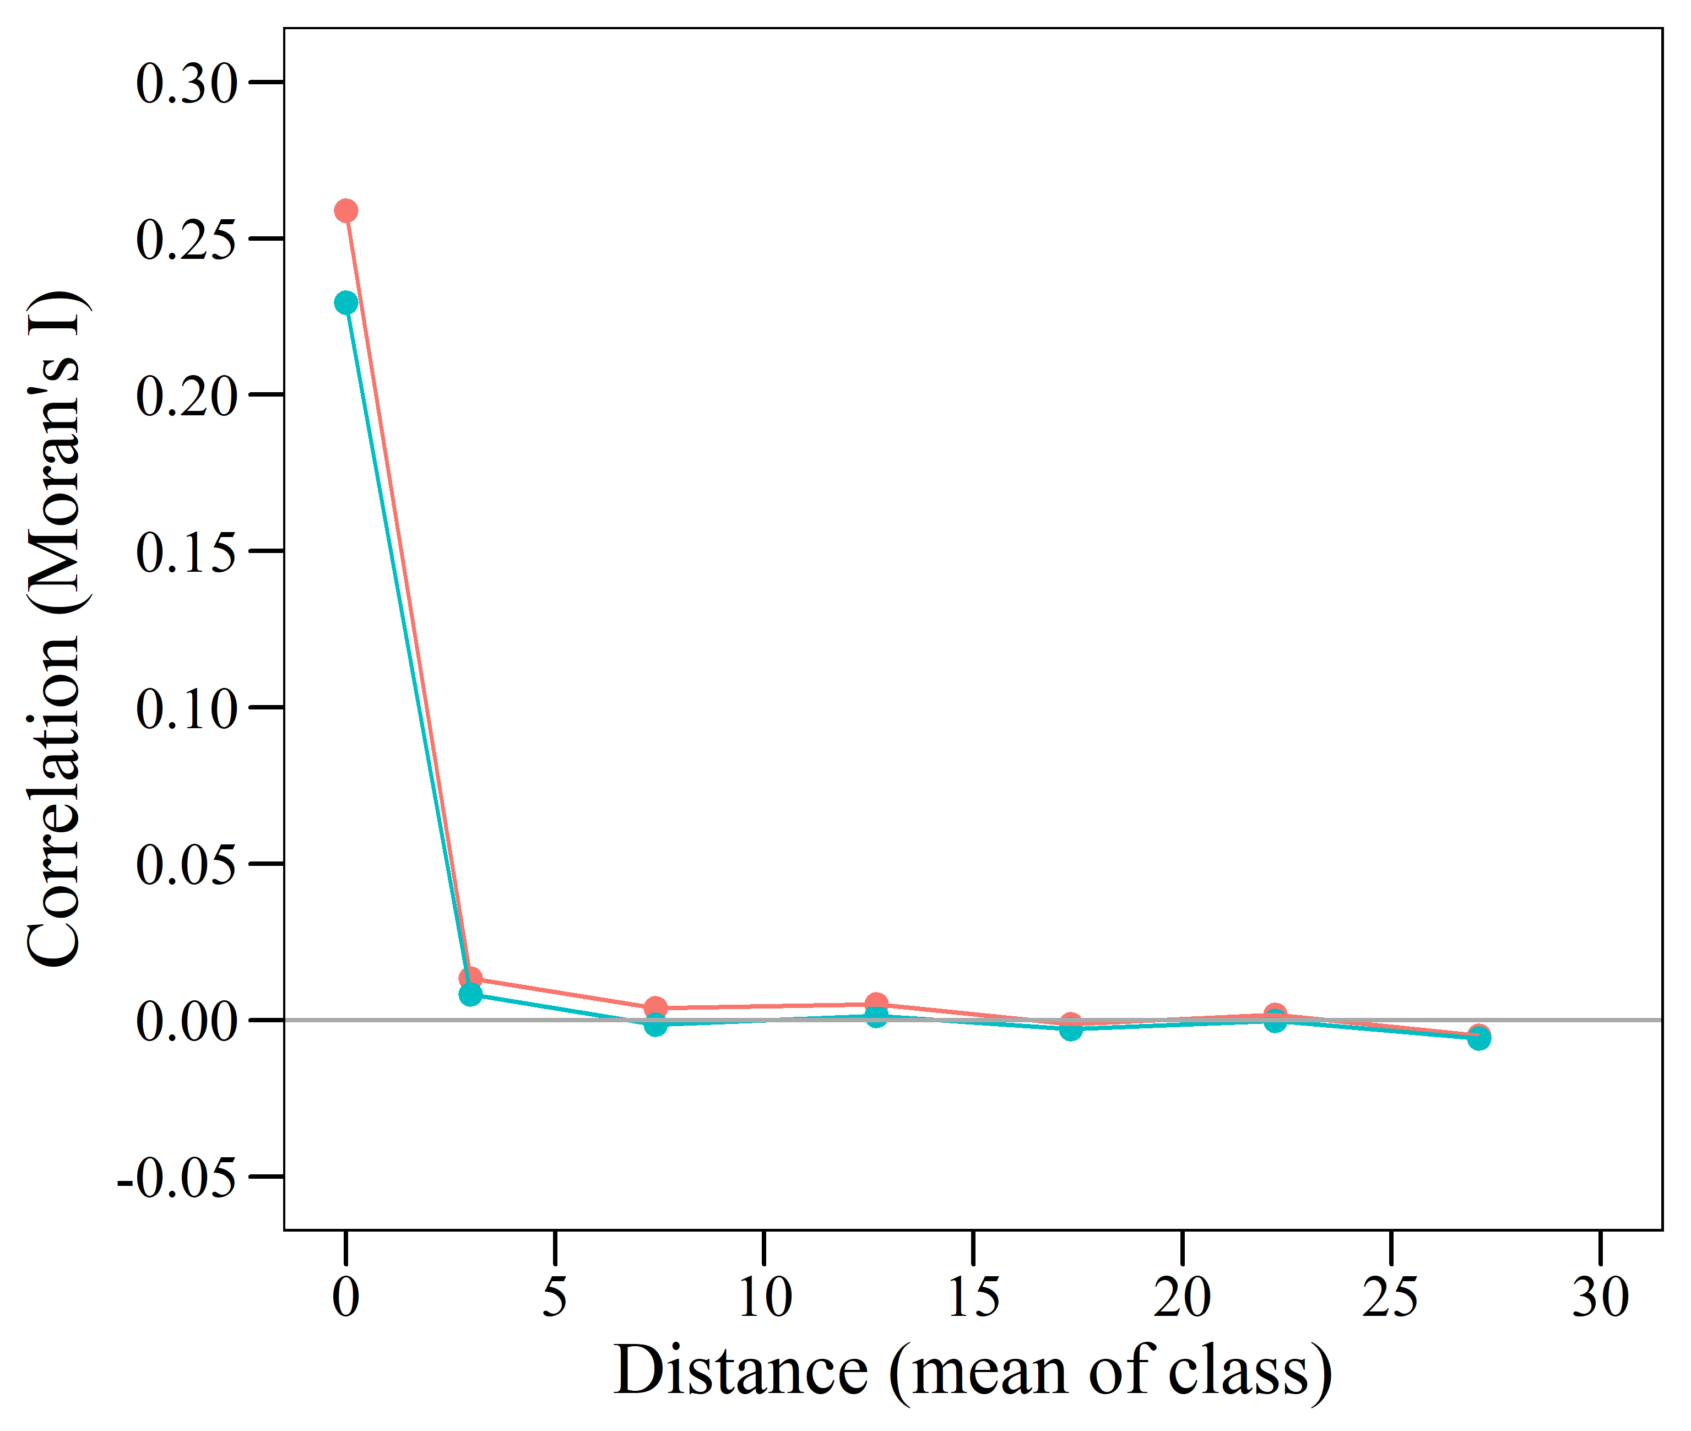
OR
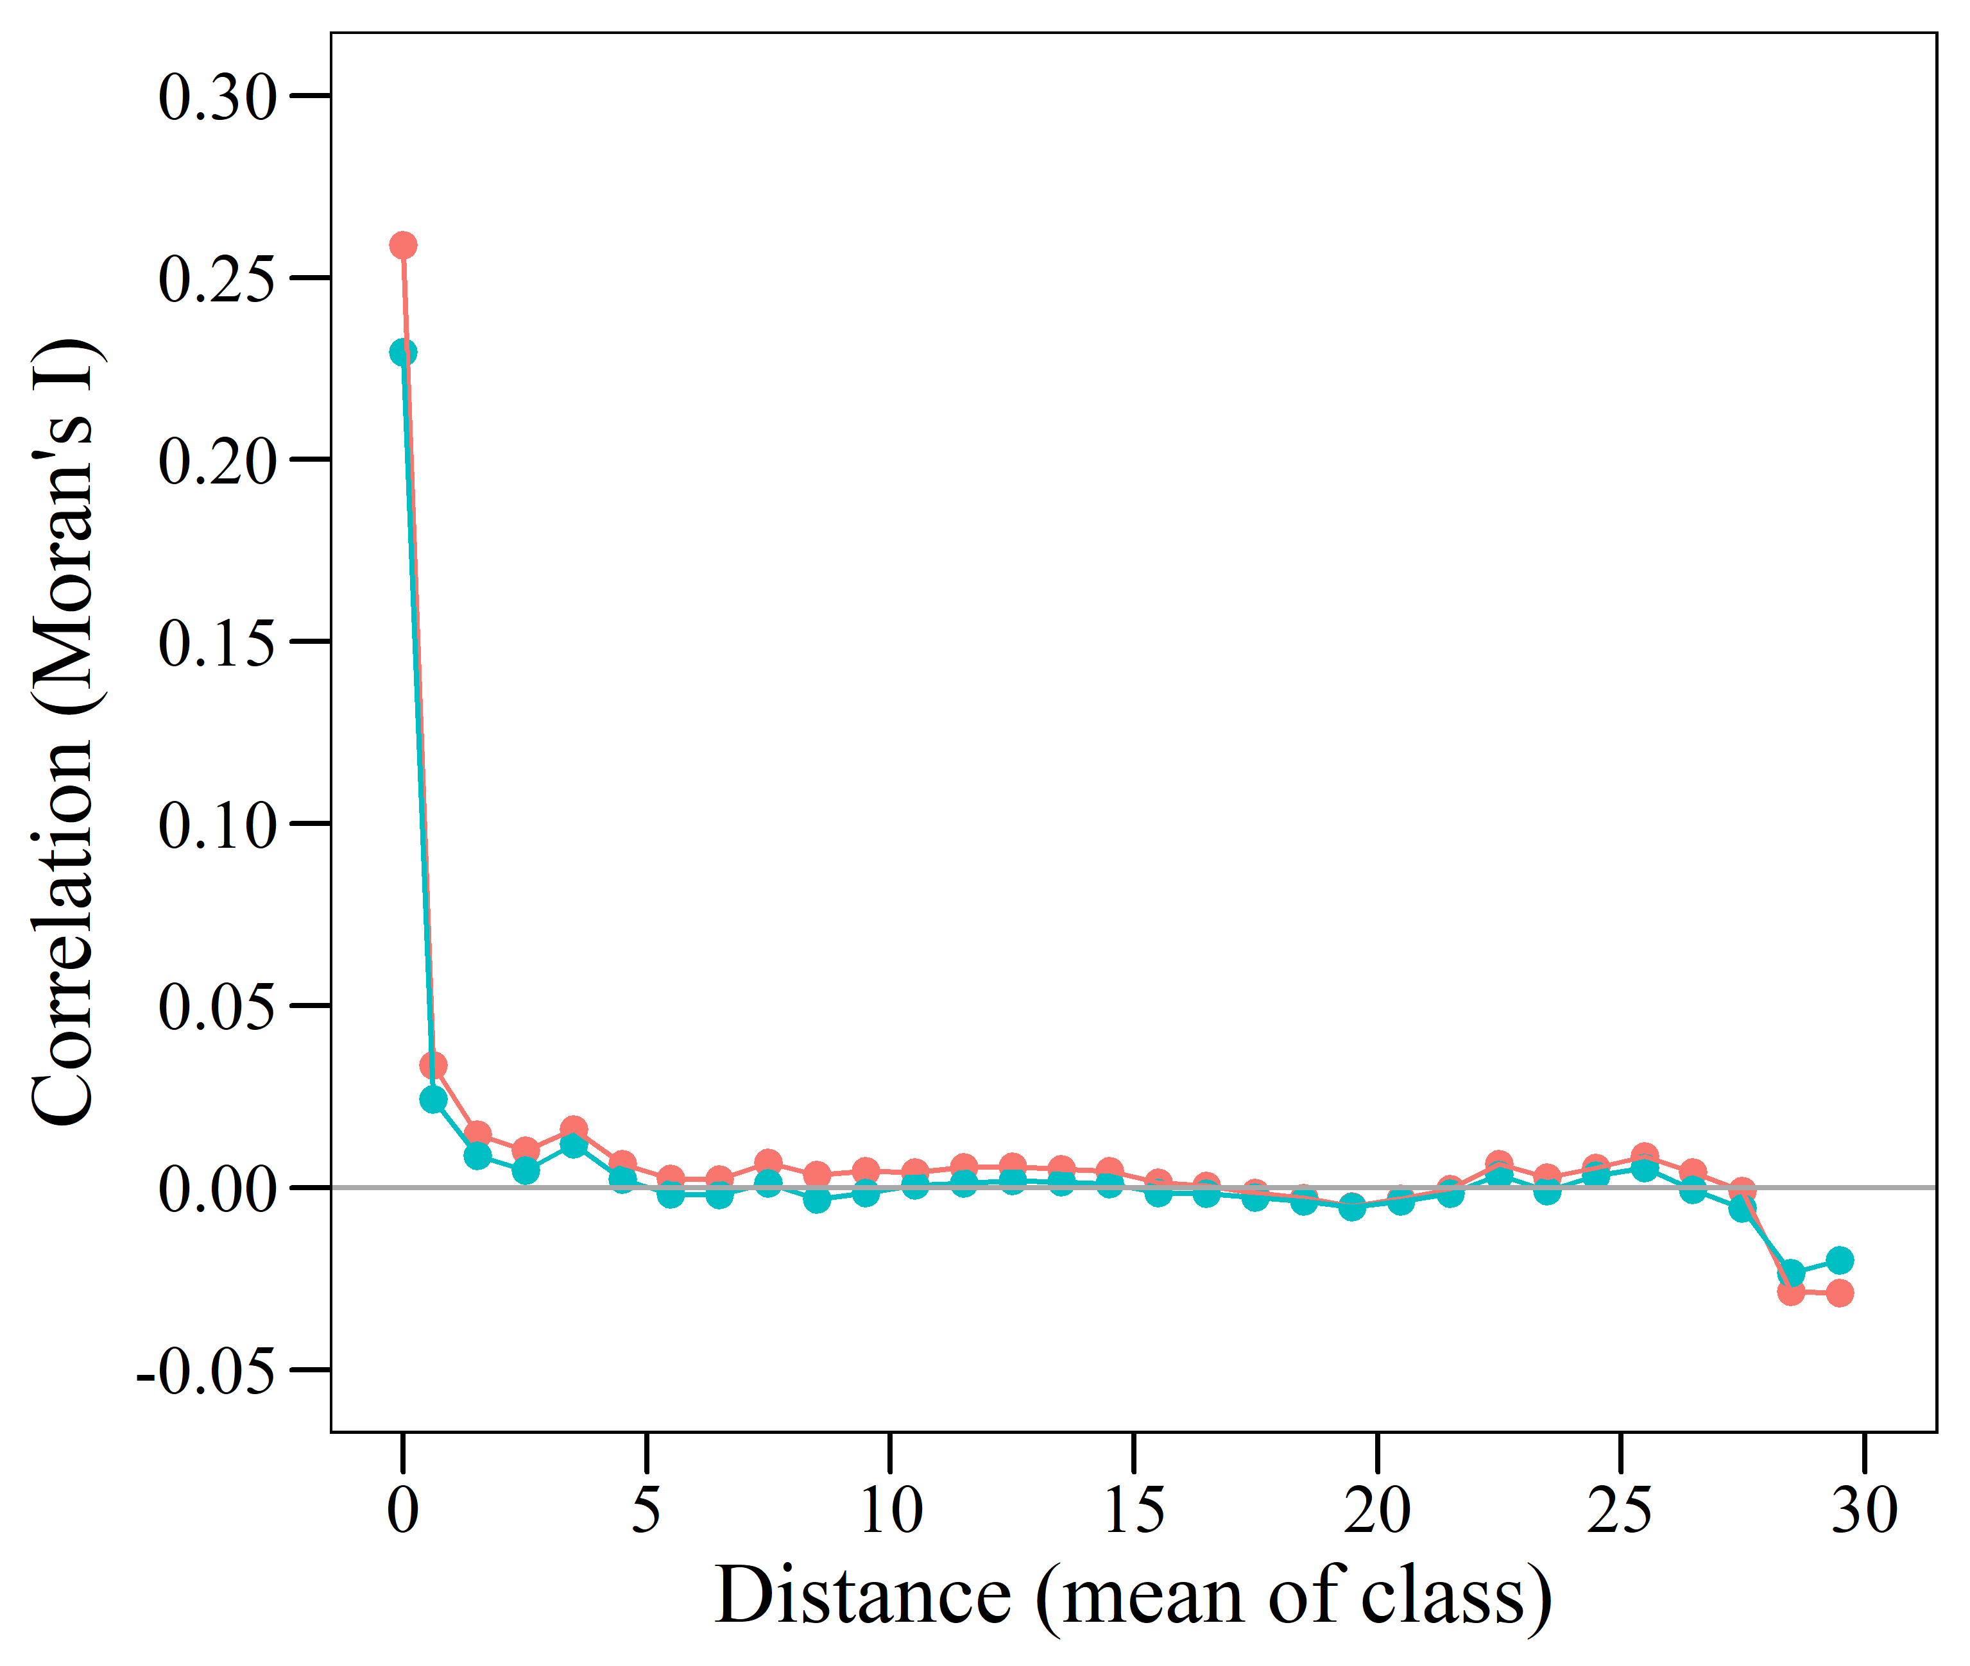
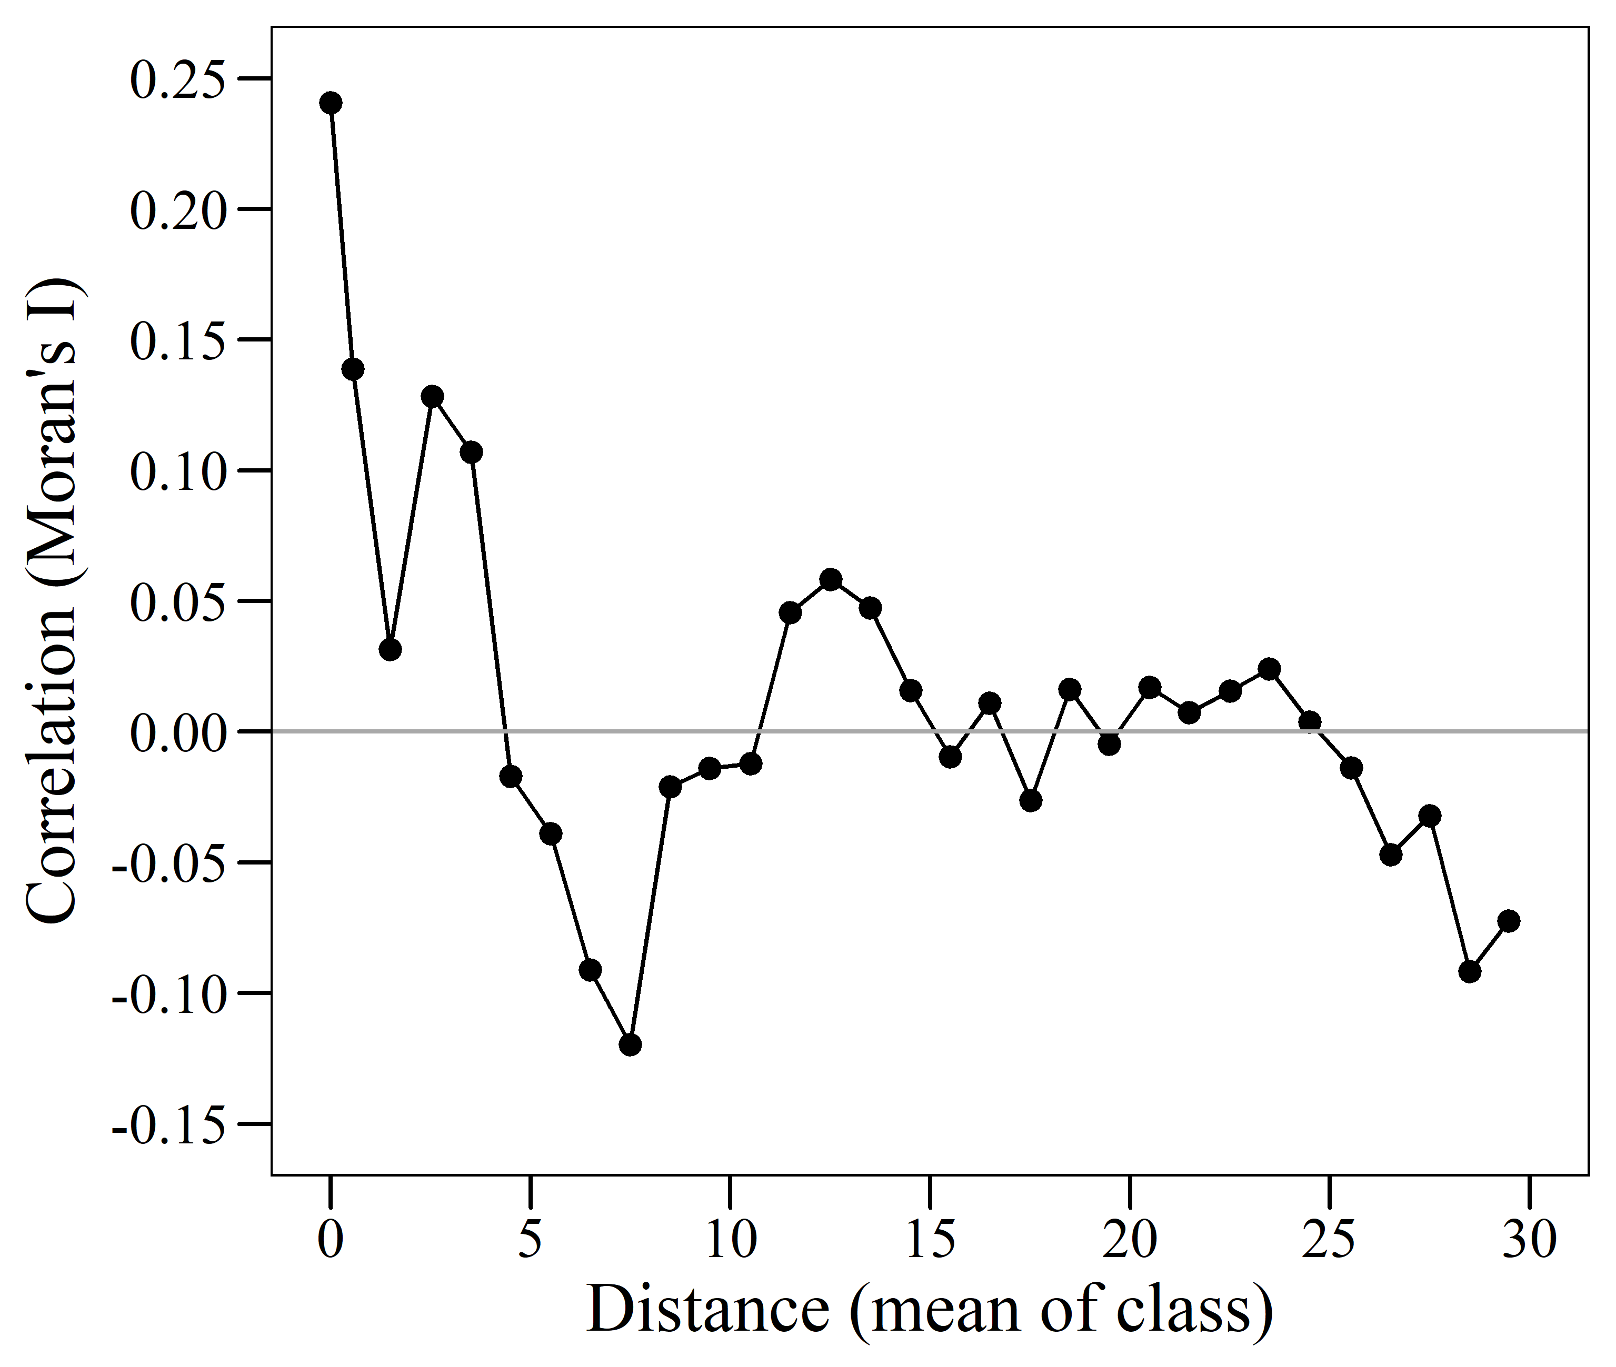
Figure S7: Spatial correlogram of the residuals of the negative binomial GLM for the number of eggs in shoots with at least one egg.
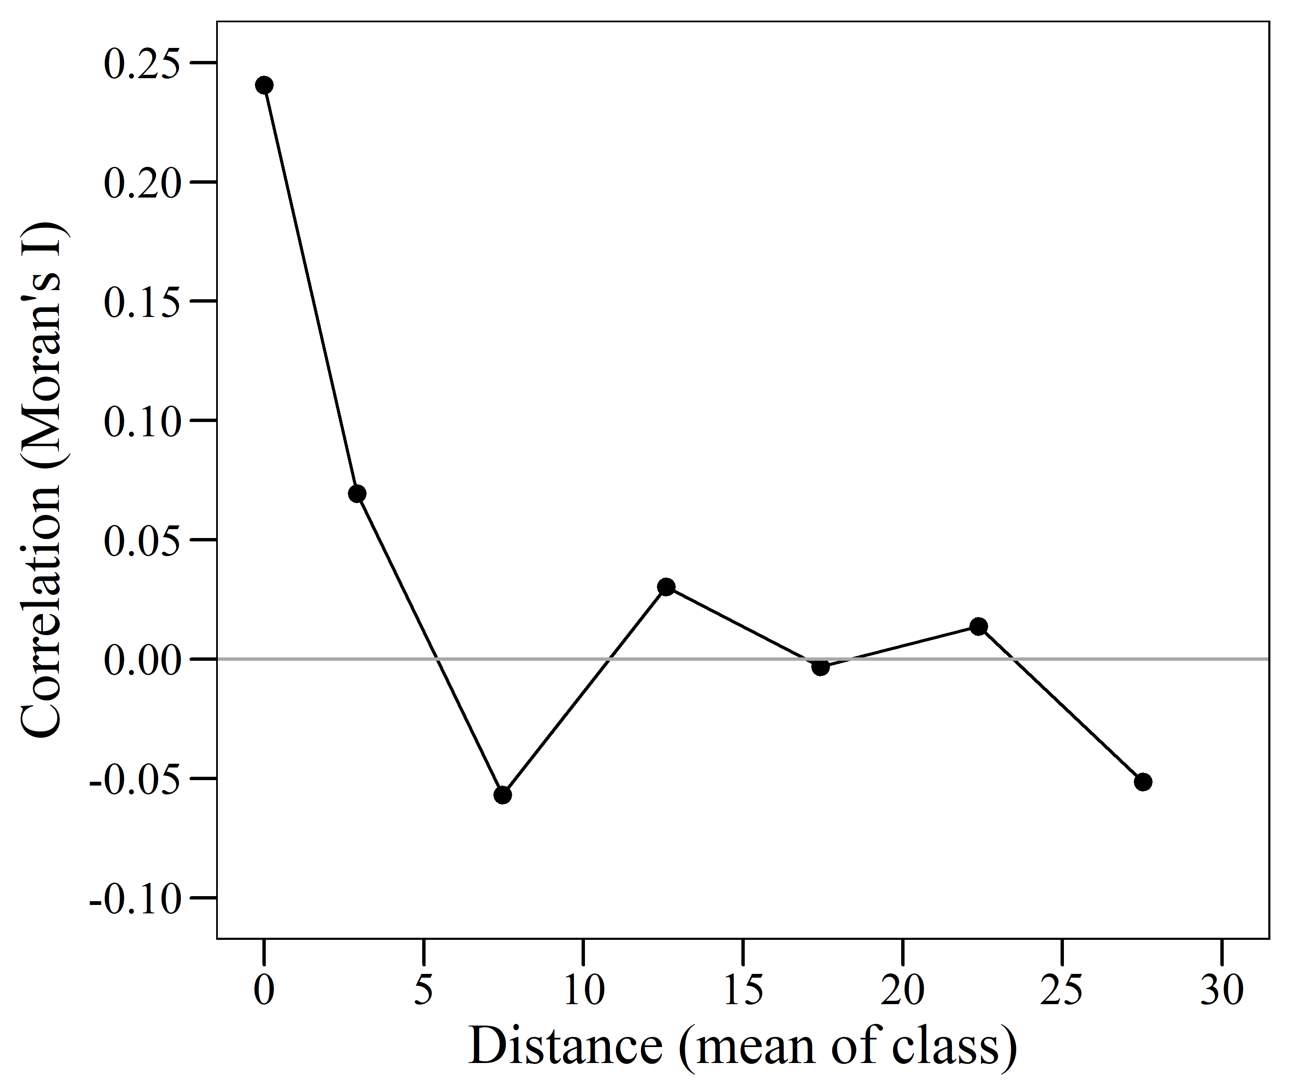
OR

