TITLE: Resource overlap and dilution effects shape host plant use in a myrmechophilous butterfly
Valdés, Alicia* and Ehrlén, Johan
Department of Ecology, Environment and Plant Sciences, Stockholm University, SE-106 91 Stockholm, Sweden
ABSTRACT

Effects of consumers on fitness of resource organisms are a complex function of the spatio-temporal distribution of resources, consumer functional responses and trait preferences, as well as the availability of other resources. Using the butterfly Phengaris alcon and its two sequential hosts, the plant Gentiana pneumonanthe and Myrmica ants, we investigated how butterfly egg-laying depended on focal host plant quality, quantity and quality of neighboring host plants and host ant abundance. Butterflies preferred plants that simultaneously maximized the availability of both larval resources, i.e., they chose higher-quality early-flowering plants at micro-sites with abundant host ants. Both the probability of oviposition and the number of eggs decreased with increasing neighbor density, and this dilution effect was stronger when neighbors were of high quality. Our study shows how the intensity of interactions between individual plants and herbivores can depend on small-scale spatial variation in the abundance of other resources used by the herbivore, as well as on the spatio-temporal distribution of neighboring plants. Given preferences for plant traits in the herbivore and negative effects on fitness, this has important implications for trait selection in the plant.
INTRODUCTION
The presence, abundance and quality of relevant resources determine habitat suitability for any organism. The distribution and abundance of consumers is expected to match the spatio-temporal distribution of its resources, and resource-consumer interactions often have important effects on the performance of both partners (Dennis et al. 2006; Dennis 2012).. Resource use by insect herbivores is often conditioned by oviposition site selection by females. As larval stages usually show low mobility, oviposition preferences are predicted to match the spatial distribution of host plants suitable for offspring development (preference–performance hypothesis or optimal oviposition theory, Jaenike 1978; Scheirs & De Bruyn 2002; Gripenberg et al. 2010). The suitability of host plants, in turn, might depend on factors such as host plant nutritional quality (Chen et al. 2004), size (Rabasa et al. 2005), microclimatic conditions (Eilers et al. 2013) or enemy-free space (Kaminski et al. 2010). Not only spatial, but also temporal matching with the required resources is necessary for the consumer. For example, in phenologically specialized insects, a temporal overlap between consumer activity and availability of suitable developmental stages of the host plants is necessary for the interaction to take place (Smyth et al. 2003; Patricelli et al. 2011; Fogelström et al. 2017). Moreover, as most consumers depend on multiple resources throughout their life cycle, e.g. different sources of food, shelter and resting sites (Dennis et al. 2003b), the availability of one resource might influence the use of other resources. For example, t
he availability of nectar resources for adults (Öckinger 2008) or the presence of secondary hosts for larvae (Wynhoff et al. 2015) might determine host plant selection in butterflies. If consumers have preferences for traits in resource organisms and consumption reduce fitness in the consumed organism, then the factors determining the intensity of interactions will also influence trait selection (Parachnowitsch & Caruso 2008; Benkman 2013; Vanhoenacker et al. 2013; Benkman & Mezquida 2015; Valdés & Ehrlén 2017).
The quantitative relationship between the abundance of consumers and the abundance of resource organisms, and thus resource exploitation, is likely to depend also on the behavior of consumers. Consumer density and resource exploitation might both increase (cf. resource concentration hypothesis, e.g. Root 1973; Stephens & Myers 2012) and decrease (cf. resource dilution, e.g. Otway et al. 2005) with increasing patch size and resource abundance. Observed differences in the relationships between resource exploitation and patch size or patch density among different consumers have been suggested to be the result of differences in how emigration and immigration rates depend on patch size and patch density (Hambäck & Englund 2005; Andersson et al. 2013). For example, a strong negative relationship between consumer density and patch area observed in visual searchers like butterflies might result from the fact that immigration is diameter-dependent while emigration is perimeter-dependent. Not only the abundance of the resource organism but also its quality should be important for consumer responses. For example, in herbivores that depend on a specific developmental stage of their host plant, the effects of resource density are expected to be stronger when neighboring plants show the preferred phenology (i.e. offer a high quality resource). While many studies have explored the effects of resource density on plant-insect interactions (Yamamura 2002; Kula et al. 2014; Kim & Underwood 2015), these studies have rarely considered also the role of resource quality and the effects of the availability of other resources.
Myrmecophilous butterflies of the genus Phengaris need two sequential hosts to complete their development: the caterpillars are predispersal seed predators of different host plants during their first instars and parasitize ant nests (Myrmica spp.) during later stages. Butterflies are very specific regarding both host species and the developmental stage of host plants (Elmes et al. 1998; Thomas & Elmes 2001; Valdés & Ehrlén 2017). Female butterflies oviposit preferentially on buds in early phenological stages, probably because these constitute higher-quality food; the developing seeds might become tougher, drier and more difficult to digest as buds develop into flowers and fruits (Arnaldo et al. 2014). As the presence of the preferred bud developmental stages usually overlaps more with the period of butterfly oviposition in early- than in late-flowering plants, individuals flowering early in the season receive more eggs (Valdés & Ehrlén 2017). Moreover, the mobility of caterpillars after leaving the plant is low (Hayes 2015), and host plants will only allow further development if located within the foraging range of suitable host ants (usually a few meters). Butterflies are therefore expected to oviposit on host plants in suitable development stages only if plants occur at micro-sites where ant hosts are present. Lastly, because the butterfly is a visual searcher the probability that egg-laying butterfly females encounter a specific host plant individual might depend on the density of neighbors, and not only the overall density of neighbors but also their quality can be important for such density effects.
In this study, we investigated how the quality of the focal host plant Gentiana pneumonanthe, the quality and quantity of neighboring conspecific plants, and the abundance of ant hosts, infleunce egg-laying of the butterfly Phengaris alcon. First, we asked if effects of plant quality and ant abundance on egg distribution patterns are interdependent. We predicted that butterflies would chose plants for oviposition that simultaneously maximize the availability of both resources, i.e., having a stronger preference for high-quality early-flowering host plants when host ants are abundant. Second, we asked if the density and quality of neighboring plants influence the number of eggs that a focal plant receives. We predicted that the probability of a plant receiving at least one egg, as well as the number of eggs in oviposited plants, should decrease with increasing neighbor density (i. e. dilution effect), and that this decrease should be stronger when neighbors are of high quality.
METHODS
Study system
The marsh gentian (Gentiana pneumonanthe L.) is a rare, long-lived perennial herb, occurring in open habitats, such as wet heathlands and grasslands (Simmonds 1946). Plants can have one to many, up to 45 cm high, shoots and produce deep blue flowers that are pollinated by bumblebees. The species is self-compatible and flowers in July and August in the study area (SW Sweden). Fruits are capsules containing a high number of minute, wind-dispersed seeds (mean seed number per fruit = 490 ± 17 SE, mean seed weight = 0.041 mg, authors’ unpublished data). Gentiana pneumonanthe is the primary host of the Alcon Blue butterfly (Phengaris alcon), a specialist predispersal seed predator which oviposits on young flower buds in July and August (Appelqvist & Bengtsson 2007). The caterpillars feed inside the capsule until they reach the fourth instar, when then they drop to the ground to be picked up by Myrmica ants. Caterpillars mimic the surface chemistry of the ant brood (Nash et al. 2008) and the acoustic signals of queen ants (Sala et al. 2014), and this makes ants carry them to their nest, where they spend the rest of their larval period as parasites. Following earlier suggestions (van Dyck et al. 2000), females' detection of host ant presence through plant chemicals produced in reaction to ant damage have recently been shown (Patricelli et al. 2015). Contrary to the majority of Phengaris species, which prey on ant brood, P. alcon is a “cuckoo” species (Als et al. 2004), and larvae feed primarily on regurgitations from ant workers, trophic eggs (i.e. nutritious, infertile eggs which are fed to the queens and larvae) and prey items brought to the nest by ants. Only ants belonging to the genus Myrmica can act as second hosts of P. alcon. In Sweden, M. rubra is considered to be the most common host ant species (Elmes et al. 1994).
Data collection
The study was carried out in a population of G. pneumonanthe where the butterfly P. alcon was present, located in Tånga Hed nature reserve, in the county of Västra Götaland, SW Sweden (58°01'40.0"N 12°49'47.0"E). Field work was conducted between 9 July and 3 September 2016. The population occupies a fenced meadow that is grazed by cattle at the end of the summer every year. A study plot measuring 69 m × 45 m was established in the meadow, and divided into a grid comprising 345 3 m x 3 m subplots with corners permanently marked by wooden poles (Fig. 1A).
In 154 of the subplots where G. pneumonanthe was present, all reproductive shoots of G. pneumonanthe were mapped, and their phenology and the number of eggs of P. alcon were recorded between 29 July and 5 August (18 additional occupied subplots were not possible to fully survey due to time constraints, Fig. 1B). We mapped shoots rather than of plant individuals (that may have one or several shoots) because we judged that individual shoots are the relevant level for the butterfly to assess the quality of the food resource and because individual shoots act as the unit of attraction for butterfly females. For each shoot, phenology was recorded as the developmental stage of the most advanced bud, according to six ordinal categories: (1) the sepals covering the bud completely, (2) bud becoming visible, (3) bud growing over the sepals, (4) bud turning blue, (5) flower opening, and (6) flower showing signs of wilting (Valdés & Ehrlén 2017). Each of these stages corresponded to a time interval of flower development, with higher values indicating a more advanced floral development at the day of recording, i.e. an earlier flowering phenology. The number of eggs was counted on the whole shoot.
The ant community was sampled at each corner of the occupied subplots (a total of 254 points) at two occasions, 14 July and 3 September (Fig. 1B). Baits consisted of a Falcon plastic tube in which we placed a sugar cube. The tubes were left open on the ground in the evening, and collected the next morning. Ants collected were transferred to 70º ethanol and the number of ants of different Myrmica species were counted in the lab (using Douwes et al. 2012). Ants belonging to other genera where not identified to species, but counted as “other ants”.
Calculation of neighborhood measures
Field maps were digitized using a Geographic Information System (GIS) created with ArcGIS 10.3.1, assigning relative coordinates to each recorded reproductive shoot of G. pneumonanthe (Fig. 1B). For each shoot, we defined a buffer zone with a 3 m radius, centered at the focal shoot (see example in Fig. 1B), and calculated the number of reproductive shoots of G. pneumonanthe per m² within this buffer zone (hereafter, “neighbor density”) as well as the mean phenology of these shoots (hereafter, “neighbor phenology”), excluding in each case the focal shoot.
Interpolations of ant abundances
We also incorporated the locations of the 254 points where the ant community was sampled into the GIS. We used inverse distance weighted interpolation (Pebesma 2004) based on the values at the sampling points to generate values of the abundance of ant species over the surface of all occupied subplots. A maximum distance of 3 m was used because it represents the ground foraging distance of most investigated Myrmica species (Elmes et al. 1998). From these interpolated surfaces (see Figs. S1-5 in Supporting Information), we extracted values of abundance of the different ant species for each of the mapped shoots.
Statistical analyses
The effects of shoot phenology, host ant abundance, neighbor density and neighbor phenology on P. alcon egg distribution were examined using two Generalized Linear Models (GLMs). Effects on the probability of a shoot having at least one egg were evaluated using a binomial GLM, and effects on the number of eggs in shoots with at least one egg were evaluated using a negative binomial GLM. Both of these models included also three interactions. First, the interaction between shoot phenology and ant abundance, in order to test if the effects of the two resources on egg distribution patterns are interdependent. Second, the interaction between neighbor density and neighbor phenology, in order to test if the effect of host plant density depends on phenology of neighboring host plants. Third, we included also the interaction between shoot phenology and neighbor phenology to account for the fact that the relationship between egg distribution and phenology of the focal plant might depend on the phenology of neighboring host plants. As a measure of host ant abundance, we used the summed abundances of M. rubra and M. schencki (hereafter, “ant abundance”). M. rubra is considered to be the most common host ant species of P. alcon in Sweden (Elmes et al. 1994), and M. schencki has been cited as host in several places in Europe (Vilbas et al. 2016). Our data agreed with this previous knowledge, as the combined abundance of M. rubra and M. schencki had the strongest positive effect on the probability of host plants receiving eggs (Supporting Information Table S1).
All predictors were standardized by subtracting the mean and dividing by the standard deviation before the analyses. We checked for spatial autocorrelation in the residuals of models by plotting spatial correlograms and by calculating global Moran's I with a permutation test (1000 random permutations). Moran's I was calculated based on a connectivity matrix of pairwise Euclidean distances among the shoots up to a distance of 30 m. Residual spatial autocorrelation could lead to biased model estimates and invalid statistical inference (Dormann et al. 2007). A significant spatial autocorrelation was found in the residuals of the binomial GLM, but not for the negative binomial GLM (global Moran's I = 0.0150, p < 0.001 and global Moran's I = 0.0023, p = 0.613, respectively, Fig. S6 and S7 in Supporting Information). We therefore applied Moran’s eigenvector mapping (MEM), which translates the spatial arrangement of data points into explanatory variables (eigenvectors) that capture spatial effects, to the binomial model examining effects on the probability of a shoot having at least one egg (Dray et al. 2006; Thayn & Simanis 2013). The model was refitted including two eigenvectors issued from MEM as spatial predictors, and this strongly reduced the residual spatial autocorrelation (global Moran's I = 0.0003, p = 0.03297, Fig. S6 in Supporting Information). Although residual spatial autocorrelation was still significant, the low value of Moran’s I and visual inspection of the spatial correlogram (Fig. S6) indicated that most of the residual spatial autocorrelation was removed by the spatial predictors. The results of this model was similar to the results of the binomial GLM not including the spatial predictors (Table S2 in Supporting Information). Statistical analyses were carried out in R 3.4.0 (R Core Team 2017).
RESULTS
In total, we found 8848 reproductive shoots of G. pneumonanthe in the 154 occupied subplots that were mapped. Eggs of P. alcon were found on 731 of these shoots (8.3%). In shoots with at least one egg, the mean number of eggs was 5.03 ± 0.20 SE.
The effects of shoot phenology and ant abundance on P. alcon oviposition were interdependent. The probability of a shoot of G. pneumonanthe having at least one egg increased with an earlier phenology (i.e. with a more advanced floral development at the day of recording, Table 1, Fig. 1A). This increase was stronger in shoots where host ants were more abundant (significant effect of the interaction shoot phenology × ant abundance, Table 1, Fig. 1A). The number of P. alcon eggs in individuals with at least one egg increased with an earlier shoot phenology and with a higher host ant abundance, but there was no significant effect of the interaction between phenology and ant abundance (Table 1, Fig. 1B and C).
High densities of host plant shoots resulted in a dilution effect, and the strength of this effect depended on the quality of neighboring plants. Both the probability of having at least one egg and the number of eggs in shoots with at least one egg decreased with the overall density of neighboring host plant shoots, and in both cases the decrease was stronger when neighboring host plants were of higher quality, i.e. had an earlier phenology (significant effect of the interaction neighbor density × neighbor phenology, Table 1, Fig. 2).
DISCUSSION
The results of this study show that resource use in the myrmecophilous butterfly P. alcon is shaped by both the spatial overlap of the two key larval resources and by a dilution effect. Specifically, we found that butterflies prefer ovipositing on early-flowering plants that have a high abundance of host ants, that plants surrounded by many conspecific neighbors receive less eggs, and that the dilution effect was stronger when neighbors were of a high quality.
In accordance with previous studies showing that animal interactors usually prefer plants with a particular phenology (Elzinga et al. 2007), and more specifically, that antagonistic interactors preferentially attack early-flowering plants (Parachnowitsch & Caruso 2008; König et al. 2015; Valdés & Ehrlén 2017), we found that both the probability of P. alcon butterflies laying at least one egg on a host plant and the number of eggs increased with an earlier phenology of its host plant G. pneumonanthe. However, the strength of this preference for an early plant phenology did depend on the abundance of the second resource used by the antagonist, i.e. the two host ant species Myrmica rubra and M. schencki. The preference of P. alcon for early-flowering host plants was stronger at locations where the host ants were more abundant. For example, the probability of a shoot with the earliest possible phenology receiving at least one egg was 0.07 at sites where host ants were absent, and 0.40 at sites with the maximum ant abundance observed (n = 34 ants). This indicates that the butterflies are able to simultaneously track the distribution of these two resources, and to preferentially oviposit on plants where both the availability of high-quality food for the caterpillars and the probability of adoption by the right species of Myrmica are higher. When suitable host ants were absent or very scarce, host plant phenology did not seem to matter much, and the probability that early-flowering plants should receive eggs was very low. Spatial overlap between the distribution of host plants and host ant nests at larger scales has previously been shown to increase the density and population persistence of the congeneric species P. arion (Thomas et al. 2009; Casacci et al. 2011). Other studies had demonstrated effects of host plant phenology (Thomas & Elmes 2001; Valdés & Ehrlén 2017), host ant presence (van Dyck et al. 2000; Wynhoff et al. 2008) or both of these factors (Patricelli et al. 2011) for oviposition site selection. Our study shows that the spatial overlap between these two resources also at a very small scale (i.e. at the scale of the plant individual) is associated with butterfly oviposition preference, and provides a new insight by showing that phenological preferences in these butterflies are ant-dependent. The fact that the effects of plant phenology and ant abundance on the number of eggs in plants with at least one egg were significant but not interdependent suggests that, while plant phenology and ant abundance simultaneously influence if a plant is suitable for oviposition or not, they do not influence variation in attractiveness among those plants that are suitable. A general implication of our findings is that differences in availability of a resource over very small spatial scales can influence the use of another resource in consumers that depend on multiple resources during their life cycle.
Our results show both that there is a dilution effect of host plant density on egg distribution patterns, and that the strength of this effect depends on the quality of the neighbors. In our study, this negative relationship between consumer density and resource abundances was evident as both a decreasing probability of a focal plant receiving at least one egg and a lower number of eggs in plants with eggs at higher densities of neighboring host plants. This decrease was stronger when the neighbors represented high-quality food for the caterpillars, i.e. when surrounding plants flowered early in the season. In other words, at a given conspecific density more eggs were found in G. pneumonanthe plants surrounded by non-attractive, low-quality neighbors (i.e. late-flowering plants). In this system, plant phenology is thus crucial not only because the phenology of a focal plant interacts with host ant availability to determine plant suitability for oviposition, but also because the phenology of neighbors modulates the strength of host plant density effects on oviposition. Our results suggest that oviposition decisions in myrmechophilous butterflies are taken at two levels. First, when flying over an area populated with host plants, females might use visual cues (Van Dyck & Regniers 2010) to evaluate host plant availability (i.e. density) and identify high-quality (i.e. early-flowering) host plants. Second, when they are at a very close distance to host plants, or after they alight on a host plant, females may still use visual cues to evaluate plant quality, but would combine them with the use of chemical cues to detect ant presence (Patricelli et al. 2015; Wynhoff et al. 2015), thereby evaluating the spatial overlap of the two resources needed by their offspring. If females use plant phenology as a visual cue indicating plant quality, host plants surrounded by low-quality neighbors would also be more isolated and more attractive to butterflies, while the negative effects of the butterfly would be diluted in host plants surrounded by high-quality neighbors. Negative density-dependence in antagonists has been documented also in other systems, where egg clumping on plants with few conspecific neighbors was explained because insect herbivores were disproportionally attracted to more isolated host plants (Shea et al. 2000; Hasenbank & Hartley 2015). However, our study is the first to also demonstrate that the quality of neighboring host plants determines the strength of such density-dependent effects. This has general implications for consumer-abundance relationships, as it demonstrates that the response of consumer density to resource abundance might be dependent on resource quality.
In biotic interactions, the resource use of a consumer organism determines the intensity of the interaction, as well as absolute fitness and trait-fitness relationships in both consumers and resource organisms. Therefore, identifying the factors that determine resource use by consumers is key to understand the ecological and evolutionary dynamics of both partners. The results of this study are important because they not only demonstrate that multiple factors simultaneously determine resource use by consumers, but also that the effects can be interactive in several ways. First, the resource use of a butterfly consumer did depend on the spatio-temporal overlap of key resources, in terms of host plants in a suitable development stage being available at a location with high host ant abundance at the time of butterfly oviposition. Second, the use of a given resource organism decreased with increased resource density, in terms of the number of neighboring host plant individuals, and the strength of this effect increased with the quality of neighbors. Lastly, the fact that the effects were documented at the level of individuals implies that spatio-temporal overlap of multiple resources and effects of quantity and quality of neighbors can be important to explain differences in fitness and trait selection also at very small spatial scales, e.g. among individual plants within a population.
ACKNOWLEDGEMENTS
We thank Annelie Jörgensen for helping with fieldwork and Daniela Guasconi for lab assistance. We acknowledge funding from the Swedish Research Council (VR) to JE and from the “Clarín” postdoctoral program (FICYT, Gobierno del Principado de Asturias, Spain, and Marie Curie-Cofund Actions, EU) to AV.
REFERENCES
Als, T.D., Vila, R., Kandul, N.P., Nash, D.R., Yen, S.-H., Hsu, Y.-F., et al. (2004). The evolution of alternative parasitic life histories in large blue butterflies. Nature, 432, 386–390.
Andersson, P., Löfstedt, C. & Hambäck, P.A. (2013). Insect density–plant density relationships: a modified view of insect responses to resource concentrations. Oecologia, 173, 1333–1344.
Appelqvist, T. & Bengtsson, O. (2007). Åtgärdsprogram för alkonblåvinge och klockgentiana 2007-2011: Maculinea alcon och Gentiana pneumonanthe. Naturvårdsverket, Stockholm, Sweden.
Arnaldo, P.S., Gonzalez, D., Oliveira, I., Langevelde, F. van & Wynhoff, I. (2014). Influence of host plant phenology and oviposition date on the oviposition pattern and offspring performance of the butterfly Phengaris alcon. J. Insect Conserv., 18, 1115–1122.
Benkman, C.W. (2013). Biotic interaction strength and the intensity of selection. Ecol. Lett., 16, 1054–1060.
Benkman, C.W. & Mezquida, E.T. (2015). Phenotypic selection exerted by a seed predator is replicated in space and time and among prey species. Am. Nat., 186, 682–691.
Casacci, L.P., Witek, M., Barbero, F., Patricelli, D., Solazzo, G., Balletto, E., et al. (2011). Habitat preferences of Maculinea arion and its Myrmica host ants: implications for habitat management in Italian Alps. J. Insect Conserv., 15, 103–110.
Chen, Y.-Z., Lin, L., Wang, C.-W., Yeh, C.-C. & Hwang, S.-Y. (2004). Response of two Pieris (Lepidoptera: Pieridae) species to fertilization of a host plant. Zool. Stud., 43, 778–786.
Dennis, R.L. (2012). A resource-based habitat view for conservation: butterflies in the British landscape. John Wiley & Sons.
Dennis, R.L., Shreeve, T.G. & Van Dyck, H. (2003a). Towards a functional resource-based concept for habitat: a butterfly biology viewpoint. Oikos, 417–426.
Dennis, R.L.H., Shreeve, T.G. & Dyck, H.V. (2006). Habitats and resources: the need for a resource-based definition to conserve butterflies. Biodivers. Conserv., 15, 1943–1966.
Dennis, R.L.H., Shreeve, T.G. & Van Dyck, H. (2003b). Towards a functional resource-based concept for habitat: a butterfly biology viewpoint. Oikos, 102, 417–426.
Dormann, C.F., M. McPherson, J., B. Araújo, M., Bivand, R., Bolliger, J., Carl, G., et al. (2007). Methods to account for spatial autocorrelation in the analysis of species distributional data: a review. Ecography, 30, 609–628.
Douwes, P., Abenius, J., Cederberg, B. & Wahlstedt, U. (2012). Steklar: Myror-getingar: Hymenoptera: Formicidae-Vespidae. ArtDatabanken, Sveriges lantbruksuniversitet.
Dray, S., Legendre, P. & Peres-Neto, P.R. (2006). Spatial modelling: a comprehensive framework for principal coordinate analysis of neighbour matrices (PCNM). Ecol. Model., 196, 483–493.
van Dyck, H., Oostermeijer, J.G.B., Talloen, W., Feenstra, V., Hidde, A. van der & Wynhoff, I. (2000). Does the presence of ant nests matter for oviposition to a specialized myrmecophilous Maculinea butterfly? Proc. R. Soc. Lond. B Biol. Sci., 267, 861–866.
Eilers, S., Pettersson, L.B. & Öckinger, E. (2013). Micro-climate determines oviposition site selection and abundance in the butterfly Pyrgus armoricanus at its northern range margin. Ecol. Entomol., 38, 183–192.
Elmes, G.W., Hammersted, O., Martin, J., Thomas, J.A., Van Der Made, J.G. & others. (1994). Differences in host-ant specificity between Spanish, Duch and Swedish populations of the endangered butterfly, Maculinea alcon (DENIS at SHIFF>)(Lepidoptera). Memorab. Zool., 55–68.
Elmes, G.W., Thomas, J.A., Wardlaw, J.C., Hochberg, M.E., Clarke, R.T. & Simcox, D.J. (1998). The ecology of Myrmica ants in relation to the conservation of Maculinea butterflies. J. Insect Conserv., 2, 67–78.
Elzinga, J.A., Atlan, A., Biere, A., Gigord, L., Weis, A.E. & Bernasconi, G. (2007). Time after time: flowering phenology and biotic interactions. Trends Ecol. Evol., 22, 432–439.
Fogelström, E., Olofsson, M., Posledovich, D., Wiklund, C., Dahlgren, J.P. & Ehrlén, J. (2017). Plant-herbivore synchrony and selection on plant flowering phenology. Ecology, 98, 703–711.
Gripenberg, S., Mayhew, P.J., Parnell, M. & Roslin, T. (2010). A meta-analysis of preference–performance relationships in phytophagous insects. Ecol. Lett., 13, 383–393.
Hambäck, P.A. & Englund, G. (2005). Patch area, population density and the scaling of migration rates: the resource concentration hypothesis revisited. Ecol. Lett., 8, 1057–1065.
Hasenbank, M. & Hartley, S. (2015). Weaker resource diffusion effect at coarser spatial scales observed for egg distribution of cabbage white butterflies. Oecologia, 177, 423–430.
Hayes, M.P. (2015). The biology and ecology of the large blue butterfly Phengaris (Maculinea) arion: a review. J. Insect Conserv., 19, 1037–1051.
Jaenike, J. (1978). On optimal oviposition behavior in phytophagous insects. Theor. Popul. Biol., 14, 350–356.
Kaminski, L.A., Freitas, A.V.L. & Oliveira, P.S. (2010). Interaction between mutualisms: ant‐tended butterflies exploit enemy‐free space provied by ant-treehopper associations. Am. Nat., 176, 322–334.
Kim, T.N. & Underwood, N. (2015). Plant neighborhood effects on herbivory: damage is both density and frequency dependent. Ecology, 96, 1431–1437.
König, M.A.E., Wiklund, C. & Ehrlén, J. (2015). Timing of flowering and intensity of attack by a butterfly herbivore in a polyploid herb. Ecol. Evol., 5, 1863–1872.
Kula, A.A.R., Castillo, D.M., Dudash, M.R. & Fenster, C.B. (2014). Interactions between a pollinating seed predator and its host plant: the role of environmental context within a population. Ecol. Evol., n/a-n/a.
Nash, D.R., Als, T.D., Maile, R., Jones, G.R. & Boomsma, J.J. (2008). A mosaic of chemical coevolution in a Large Blue butterfly. Science, 319, 88–90.
Öckinger, E. (2008). Distribution of burnet moths (Zygaena spp.) in relation to larval and adult resources on two spatial scales. Insect Conserv. Divers., 1, 48–54.
Otway, S.J., Hector, A. & Lawton, J.H. (2005). Resource dilution effects on specialist insect herbivores in a grassland biodiversity experiment. J. Anim. Ecol., 74, 234–240.
Parachnowitsch, A.L. & Caruso, C.M. (2008). Predispersal seed herbivores, not pollinators, exert selection on floral traits via female fitness. Ecology, 89, 1802–1810.
Patricelli, D., Barbero, F., La Morgia, V., Casacci, L.P., Witek, M., Balletto, E., et al. (2011). To lay or not to lay: oviposition of Maculinea arion in relation to Myrmica ant presence and host plant phenology. Anim. Behav., 82, 791–799.
Patricelli, D., Barbero, F., Occhipinti, A., Bertea, C.M., Bonelli, S., Casacci, L.P., et al. (2015). Plant defences against ants provide a pathway to social parasitism in butterflies. Proc R Soc B, 282, 20151111.
Pebesma, E.J. (2004). Multivariable geostatistics in S: the gstat package. Comput. Geosci., 30, 683–691.
R Core Team. (2017). R: A language and environment for statistical computing. R Foundation for Statistical Computing, Vienna, Austria. URL http://www.R-project.org/.
Rabasa, S.G., Gutiérrez, D. & Escudero, A. (2005). Egg laying by a butterfly on a fragmented host plant: a multi-level approach. Ecography, 28, 629–639.
Root, R.B. (1973). Organization of a plant-arthropod association in simple and diverse habitats: the fauna of Collards (Brassica oleracea). Ecol. Monogr., 43, 95–124.
Sala, M., Casacci, L.P., Balletto, E., Bonelli, S. & Barbero, F. (2014). Variation in butterfly larval acoustics as a strategy to infiltrate and exploit host ant colony resources. PLoS ONE, 9, e94341.
Scheirs, J. & De Bruyn, L. (2002). Integrating optimal foraging and optimal oviposition theory in plant–insect research. Oikos, 96, 187–191.
Shea, K., Smyth, M., Sheppard, A., Morton, R. & Chalimbaud, J. (2000). Effect of patch size and plant density of Paterson’s curse (Echium plantagineum) on the oviposition of a specialist weevil, Mogulones larvatus. Oecologia, 124, 615–621.
Simmonds, N.W. (1946). Gentiana pneumonanthe L. J. Ecol., 33, 295–307.
Smyth, R.R., Hoffmann, M.P. & Shelton, A.M. (2003). Effects of host plant phenology on oviposition preference of Crocidolomia pavonana (Lepidoptera: Pyralidae). Environ. Entomol., 32, 756–764.
Stephens, A.E.A. & Myers, J.H. (2012). Resource concentration by insects and implications for plant populations. J. Ecol., 100, 923–931.
Thayn, J.B. & Simanis, J.M. (2013). Accounting for spatial autocorrelation in linear regression models using spatial filtering with eigenvectors. Ann. Assoc. Am. Geogr., 103, 47–66.
Thomas, J.A. & Elmes, G.W. (2001). Food–plant niche selection rather than the presence of ant nests explains oviposition patterns in the myrmecophilous butterfly genus Maculinea. Proc. R. Soc. Lond. B Biol. Sci., 268, 471–477.
Thomas, J.A., Simcox, D.J. & Clarke, R.T. (2009). Successful conservation of a threatened Maculinea butterfly. Science, 325, 80–83.
Valdés, A. & Ehrlén, J. (2017). Caterpillar seed predators mediate shifts in selection on flowering phenology in their host plant. Ecology, 98, 228–238.
Van Dyck, H. & Regniers, S. (2010). Egg spreading in the ant-parasitic butterfly, Maculinea alcon: from individual behaviour to egg distribution pattern. Anim. Behav., 80, 621–627.
Vanhoenacker, D., Ågren, J. & Ehrlén, J. (2013). Non-linear relationship between intensity of plant–animal interactions and selection strength. Ecol. Lett., 16, 198–205.
Vilbas, M., Esperk, T. & Teder, T. (2016). Host ant use of the Alcon blue butterfly at the northern range margin. J. Insect Conserv., 20, 879–886.
Wynhoff, I., Bakker, R.B., Oteman, B., Arnaldo, P.S. & van Langevelde, F. (2015). Phengaris (Maculinea) alcon butterflies deposit their eggs on tall plants with many large buds in the vicinity of Myrmica ants. Insect Conserv. Divers., 8, 177–188.
Wynhoff, I., Grutters, M. & Langevelde, F. van. (2008). Looking for the ants: selection of oviposition sites by two myrmecophilous butterfly species. Anim. Biol., 58, 371–388.
Yamamura, K. (2002). Biodiversity and stability of herbivore populations: influences of the spatial sparseness of food plants. Popul. Ecol., 44, 33–40.

Table 1: Results of the GLMs of the effects on the probability of a flowering shoot of Gentiana pneumonanthe receiving at least one egg from the butterfly Phengaris alcon (binomial GLM) and the number of eggs in shoots with at least one egg (negative binomial GLM), of shoot phenology, ant abundance, neighbor density and neighbor phenology, as well as three two-way interactions of these predictors. In the binomial GLM, two eigenvectors issued from Moran’s eigenvector mapping (MEM) are also included as predictors, in order to reduce residual spatial autocorrelation (see details in the text).
 | Probability of having at least one egg  (n = 8848, R² = 0.45) |  |  |  |  | Number of eggs  (n = 731, R² = 0.22)
 | Estimate |  | SE | Z |  | Estimate |  | SE | Z
Shoot phenology | 1.462 | *** | 0.079 | 18.42 |  | 0.257 | *** | 0.036 | 7.07
Ant abundance | -0.017 |  | 0.052 | -0.33 |  | 0.089 | ** | 0.031 | 2.82
Neighbor density | -1.691 | *** | 0.102 | -16.61 |  | -0.368 | *** | 0.067 | -5.48
Neighbor phenology | -1.150 | *** | 0.124 | -9.28 |  | -0.121 | ** | 0.041 | -2.95
Shoot phen. x Ant abundance | 0.132 | * | 0.062 | 2.14 |  | 0.004 |  | 0.031 | 0.13
Shoot phen. x Neigh. Phen. | 0.068 |  | 0.074 | 0.92 |  | 0.014 |  | 0.035 | 0.40
Neigh. density x Neigh. phen. | -0.500 | *** | 0.087 | -5.72 |  | -0.100 | * | 0.042 | -2.36
MEM Vector 1 | 0.289 | *** | 0.030 | 9.76
MEM Vector 2 | 0.324 | *** | 0.052 | 6.26
**P < 0.001; **P < 0.01; *P < 0.05

FIGURE LEGENDS
Figure 1: Sampling design. A) Study plot (69 x 45 m²), comprising 345 3 m² subplots. B) Detail of several occupied subplots with reproductive shoots of Gentiana pneumonanthe and sampling points for ants. Shoots are represented by points, and colored according to shoot phenology. Numbers indicate the number of Phengaris alcon eggs found on the shoot. An example of a 3-m buffer used for neighbor measures on a focal shoot (represented by a star) is shown.

Figure 2: Effects of shoot phenology and host ant abundance on the distribution of Phengaris alcon eggs on its host plant Gentiana pneumonanthe. A) Effects on the probability of a shoot having at least one egg, the relationship between the probability of having at least one egg and shoot phenology shown for different ant abundances. B) Effects of shoot phenology on the number of eggs in shoots with at least one egg . Higher values of shoot phenology indicate earlier flowering. C) Effects of ant abundance on the number of eggs in shoots with at least one egg. In A), binomial GLM fit lines are represented with a color gradient for a continuous increment in ant abundance within the range of observed values. In B) and C), negative binomial GLM fit lines and confidence intervals are shown.

Figure 3: Effects of the interaction between neighbor density and neighbor phenology on the probability of a flowering shoot of Gentiana pneumonanthe having at least one egg of the butterfly Phengaris alcon (A) and the number of eggs in shoots with at least one egg (B). The relationships with neighbor density are shown for different values of neighbor phenology. Binomial (A) or negative binomial (B) GLM fit lines are represented with a color gradient for a continuous increment in neighbor phenology within the range of observed values. Higher values of neighbor phenology indicate earlier flowering.

Figure 1
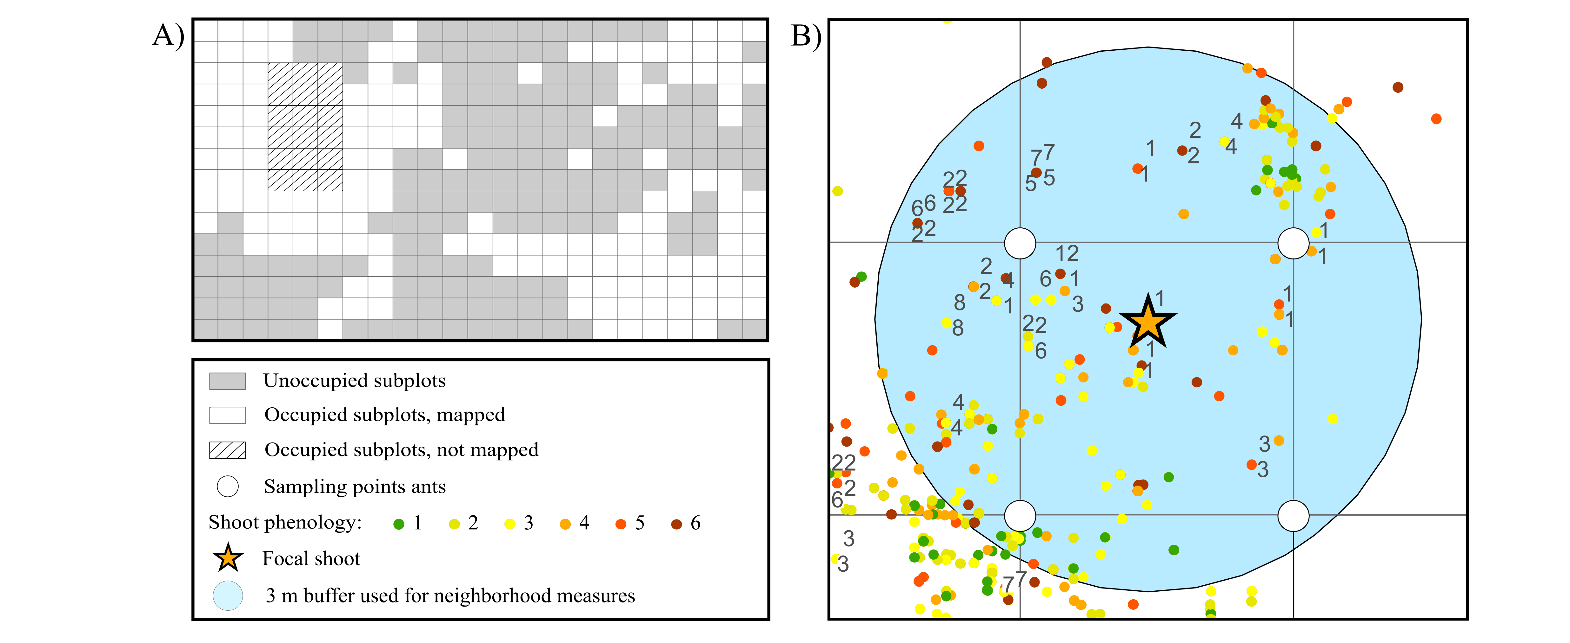
Figure 2
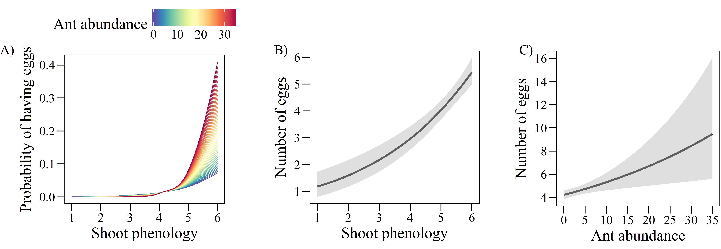

Figure 3
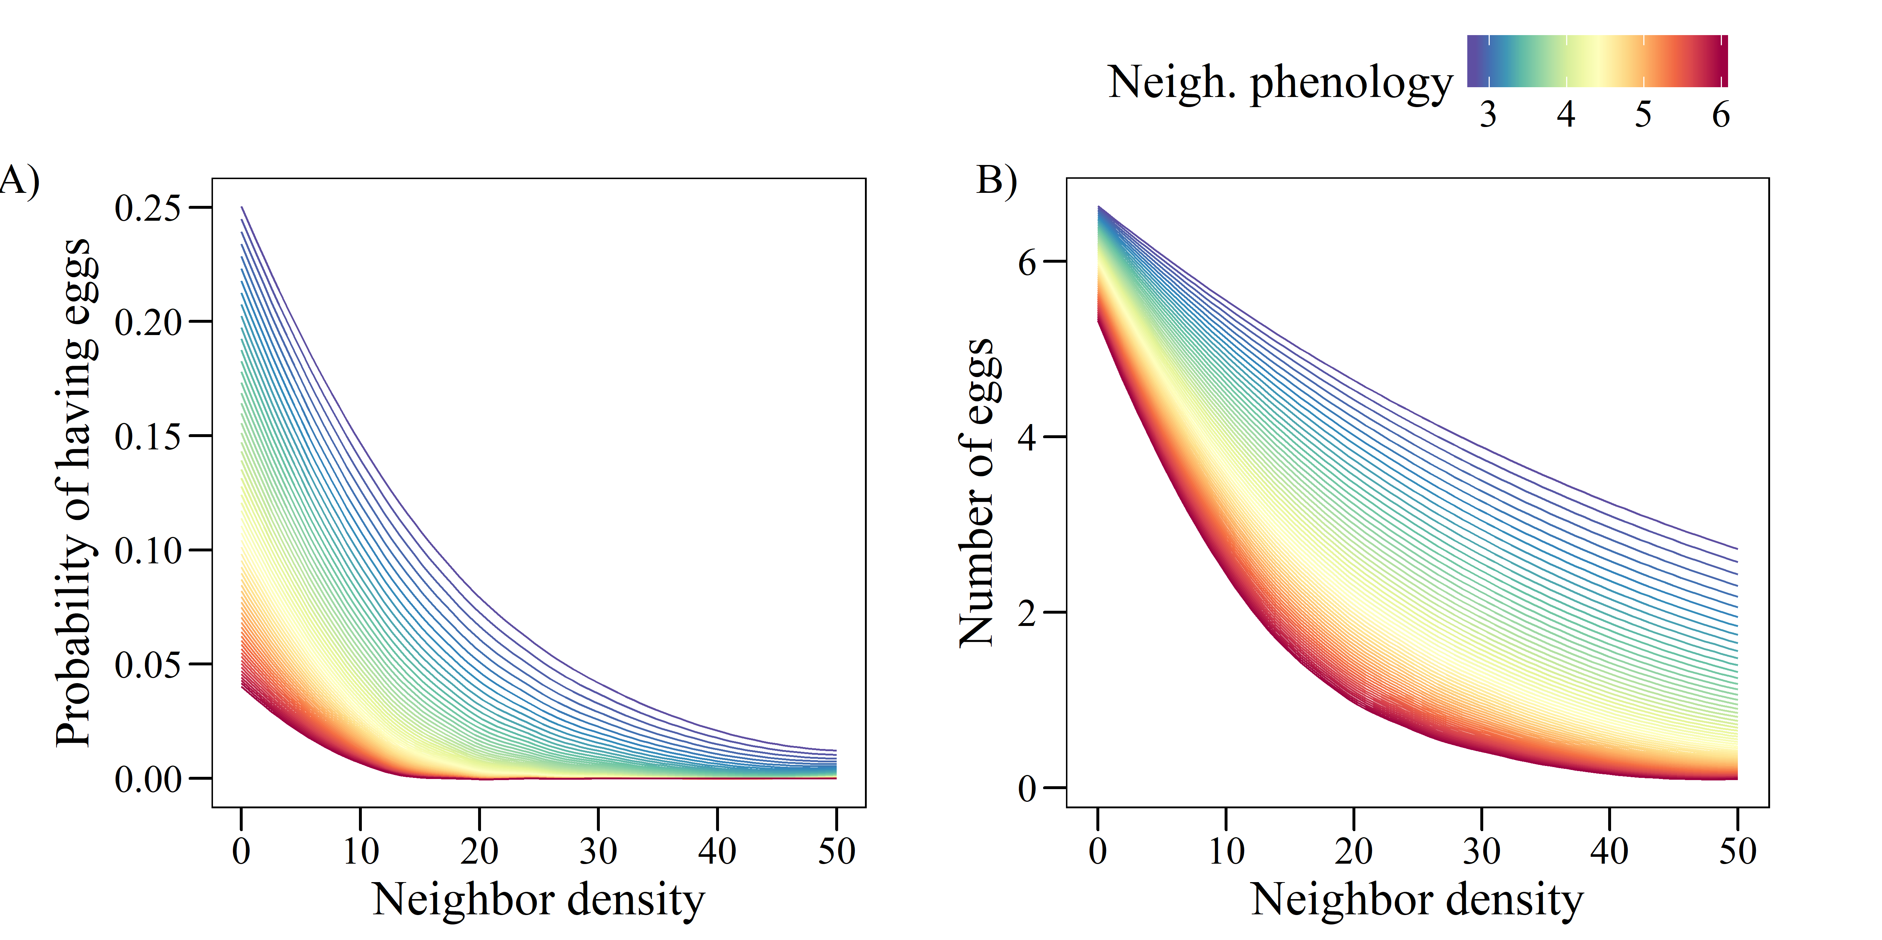

Supporting information
Table S1: Coefficients from univariate GLMs relating the probability of having eggs (A, binomial model) and the number of eggs in plants with at least one egg (B, negative binomial model) to the abundance of different ant species.
 | A) Probability of having eggs (n = 8848) |  | B) Number of eggs  (n = 731)
All Myrmica | -0.522 | *** | -0.006
M. rubra | 0.174 | *** | 0.137 | ***
M. scabrinodis | -1.364 | *** | -0.120 | ***
M. ruginodis | -0.215 | *** | -0.016
M. schencki | 0.358 | *** | 0.006
Other ants | -0.403 | *** | -0.061
M. rubra + M. schencki | 0.360 | *** | 0.115 | ***
**P < 0.001; **P < 0.01; *P < 0.05

Table S2: Results of the binomial GLM (n = 8848, R² = 0.42) relating the probability of a shoot of G. pneumonanthe having eggs of P. alcon to shoot phenology, ant abundance, neighbor density and neighbor phenology, and to three different two-way interactions of these predictors.
 | Estimate |  | SE | Z
Shoot phenology | 1.384 | *** | 0.077 | 18.06
Ant abundance | 0.061 |  | 0.051 | 1.19
Neighbor density | -1.943 | *** | 0.092 | -21.03
Neighbor phenology | -1.014 | *** | 0.120 | -8.45
Shoot phen. x Ant abundance | 0.120 | * | 0.058 | 2.07
Shoot phen. x Neigh. Phen. | -0.022 |  | 0.071 | -0.32
Neigh. density x Neigh. phen. | -0.650 | * | 0.084 | -7.74
**P < 0.001; **P < 0.01; *P < 0.05

Figure S1: Result of the inverse distance weighted interpolation for abundance of Myrmica rubra based on abundance values (sum of individuals collected in 2 sampling sessions) at 254 sampling points. The color scale indicates the interpolated abundance values.

Figure S2: Result of the inverse distance weighted interpolation for abundance of Myrmica scabrinodis based on abundance values (sum of individuals collected in 2 sampling sessions) at 254 sampling points. The color scale indicates the interpolated abundance values.

Figure S3: Result of the inverse distance weighted interpolation for abundance of Myrmica ruginodis based on abundance values (sum of individuals collected in 2 sampling sessions) at 254 sampling points. The color scale indicates the interpolated abundance values.

Figure S4: Result of the inverse distance weighted interpolation for abundance of Myrmica schencki based on abundance values (sum of individuals collected in 2 sampling sessions) at 254 sampling points. The color scale indicates the interpolated abundance values.

Figure S5: Result of the inverse distance weighted interpolation for abundance of non-Myrmica ants based on abundance values (sum of individuals collected in 2 sampling sessions) at 254 sampling points. The color scale indicates the interpolated abundance values.
Figure S6: Spatial correlogram of the residuals of the binomial GLMs for the probability of a shoot having eggs before (red) and after (blue) including the two eigenvectors issued from MEM.
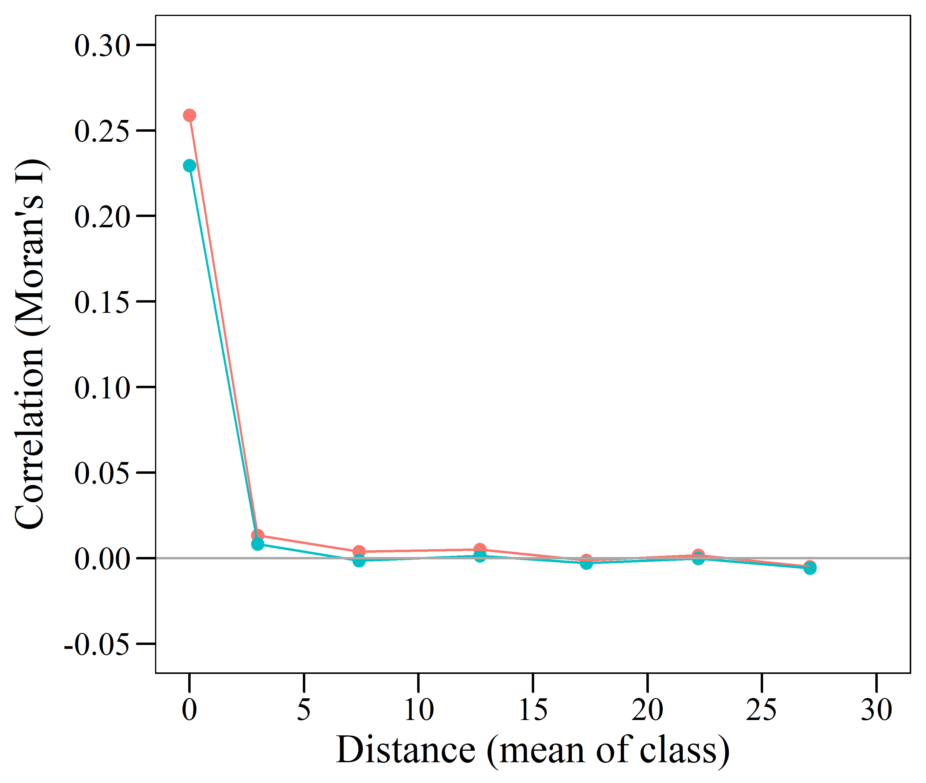
OR
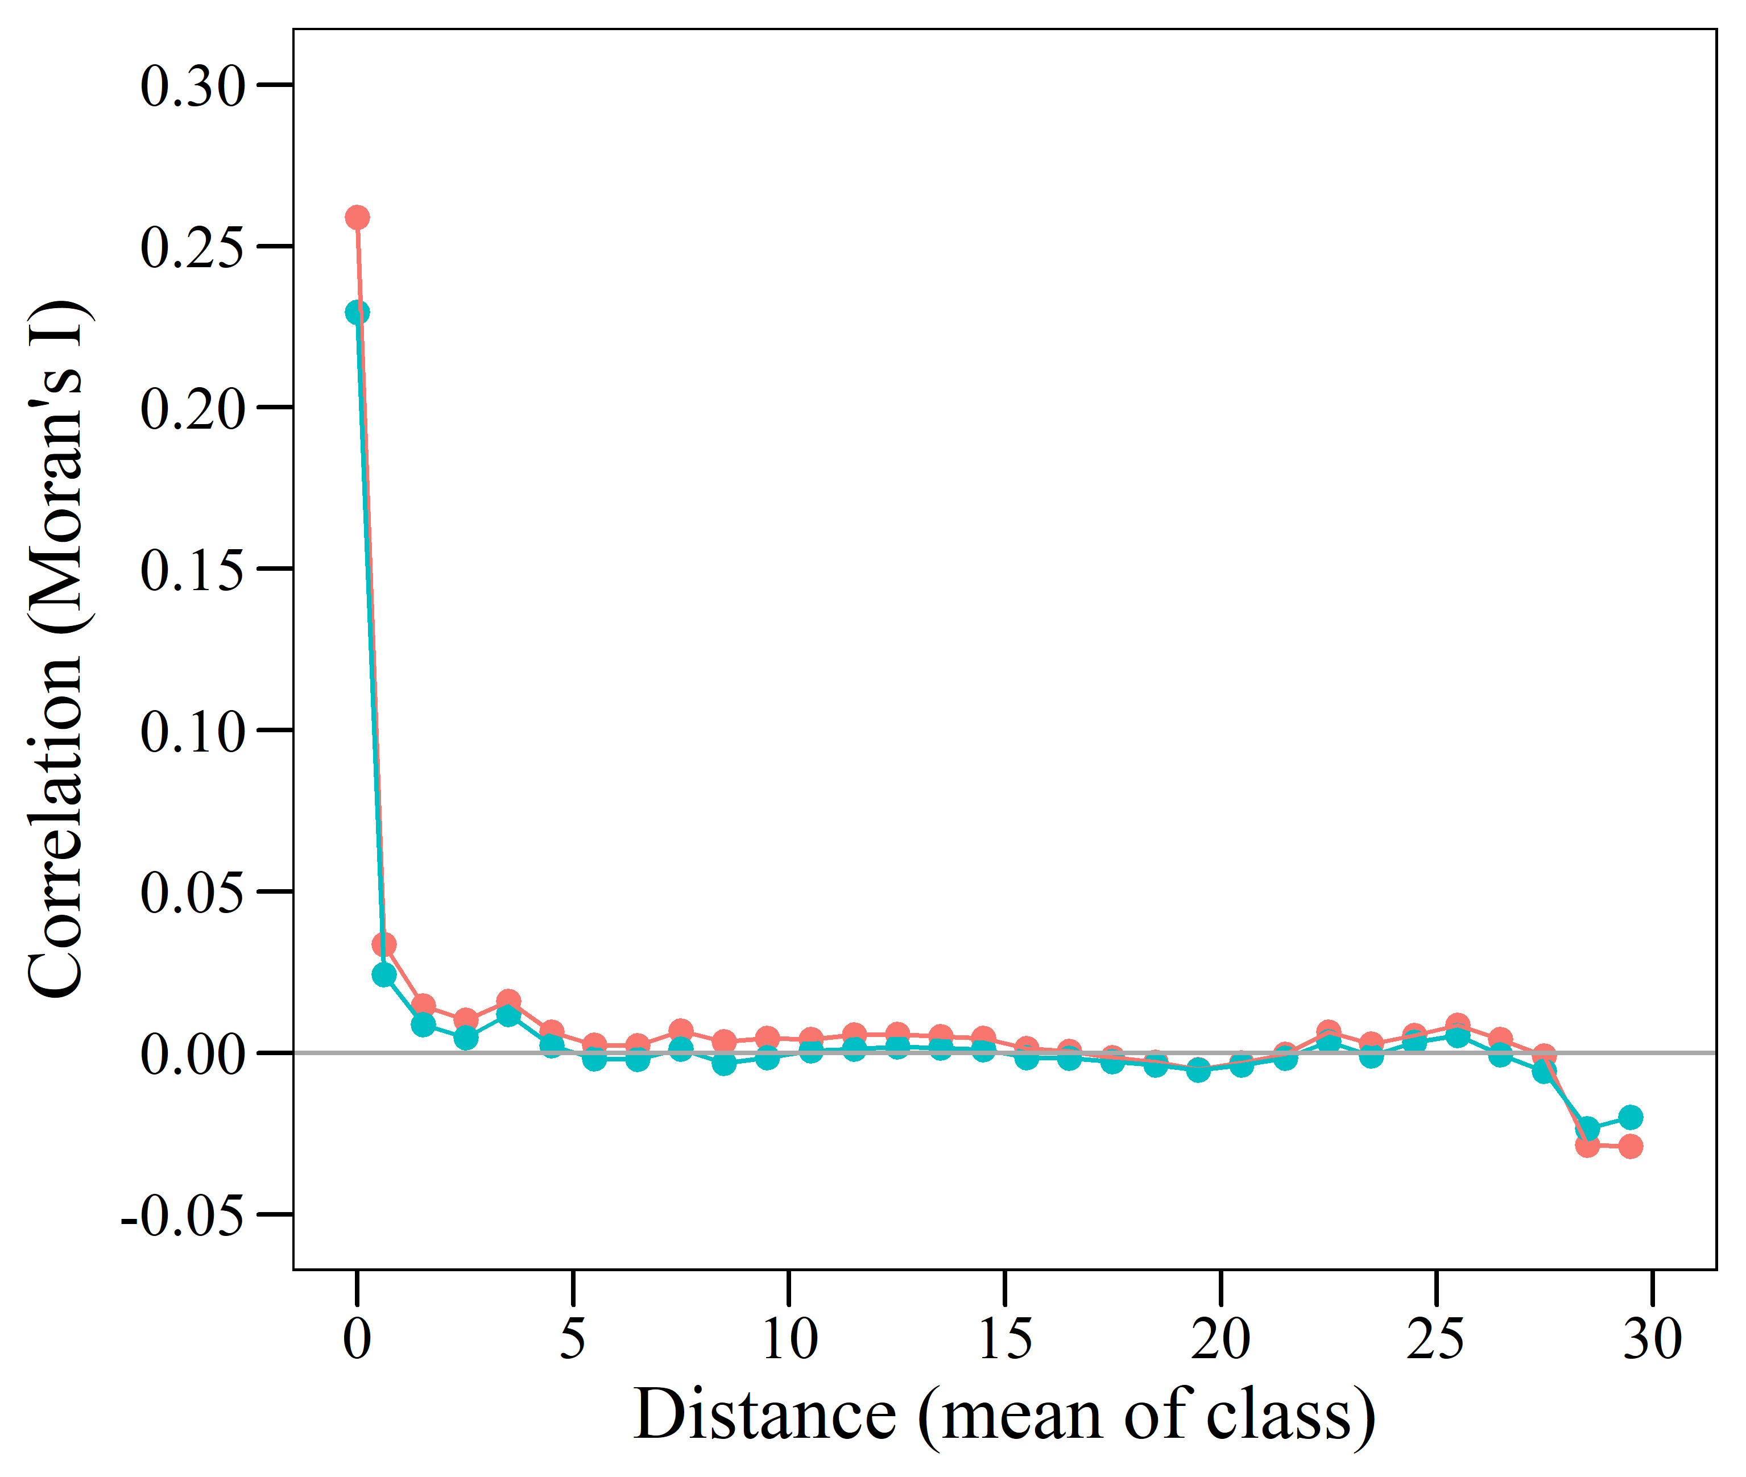
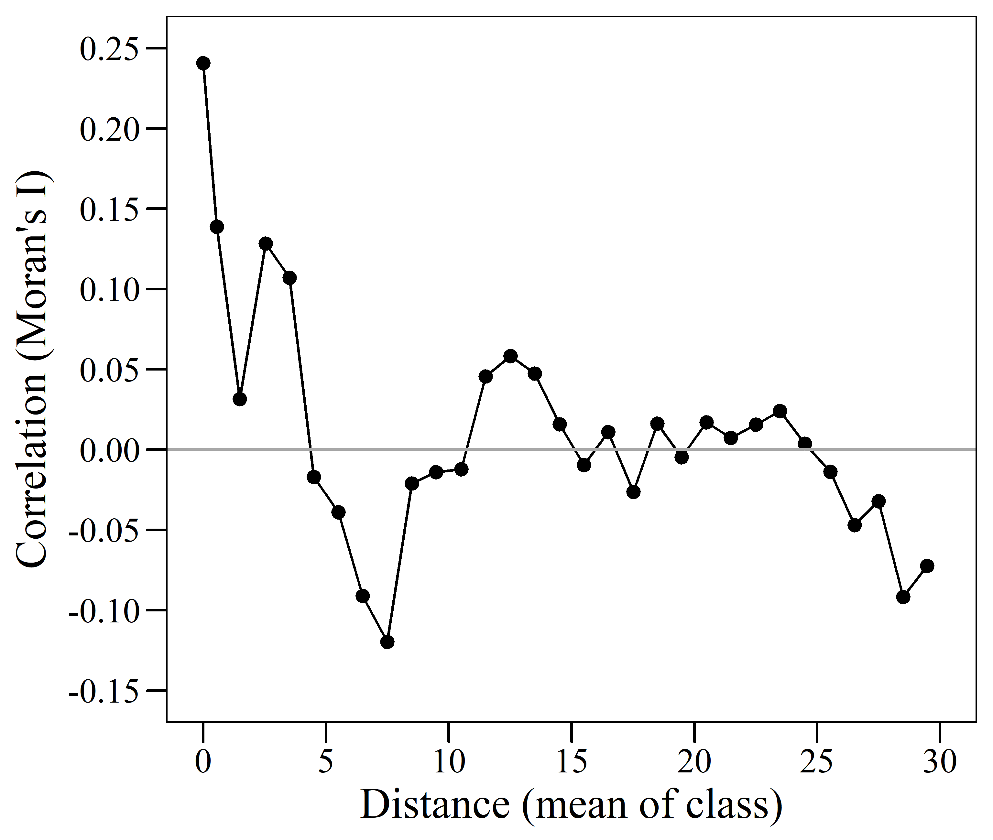
Figure S7: Spatial correlogram of the residuals of the negative binomial GLM for the number of eggs in shoots with at least one egg.
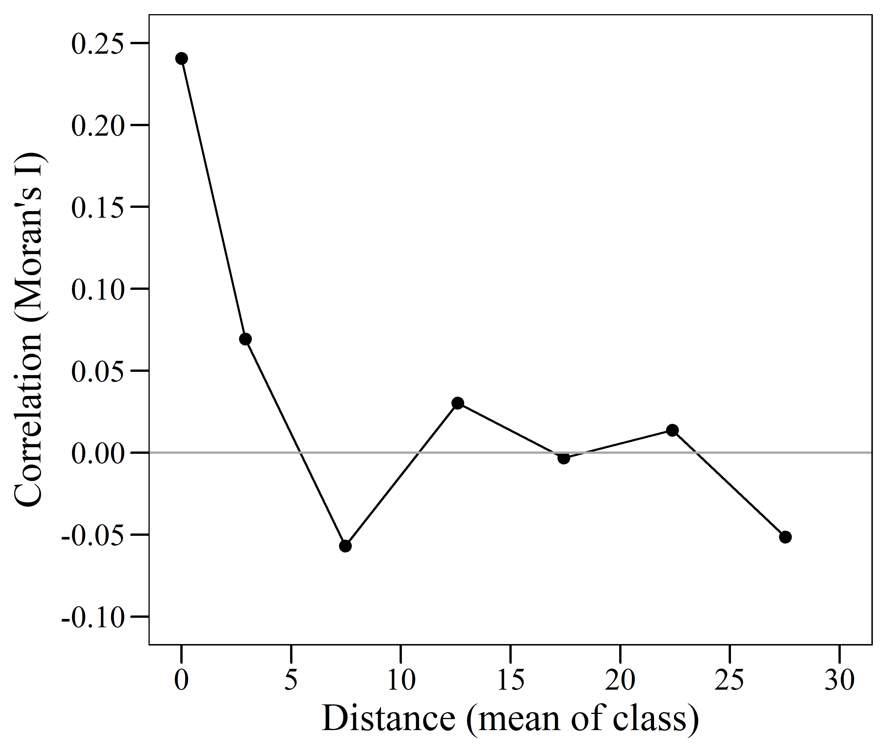
OR

