> #Example model with all vars (all plants)

> mod1<-glm.nb(n_eggs_max~scale(as.integer(phen))+scale(meanTday)+scale(moist_per)+scale(Mrub_sum)+scale(pldens_2)+scale(phen_n2),allplants)

Coefficients:

Estimate Std. Error z value Pr(>|z|)

(Intercept) -3.43533 0.09026 -38.062 < 2e-16 ***

scale(as.integer(phen)) 1.61554 0.07275 22.206 < 2e-16 ***

scale(meanTday) 0.78584 0.06187 12.703 < 2e-16 ***

scale(moist_per) 0.39489 0.07082 5.576 2.47e-08 ***

scale(Mrub_sum) 0.18711 0.03820 4.898 9.66e-07 ***

scale(pldens_2) -2.17810 0.08877 -24.536 < 2e-16 ***

scale(phen_n2) -0.34822 0.06643 -5.242 1.59e-07 ***

---

Signif. codes: 0 ‘***’ 0.001 ‘**’ 0.01 ‘*’ 0.05 ‘.’ 0.1 ‘ ’ 1

(Dispersion parameter for Negative Binomial(0.1463) family taken to be 1)

Null deviance: 4812.6 on 8851 degrees of freedom

Residual deviance: 2006.1 on 8845 degrees of freedom

AIC: 7160.5

2 x log-likelihood: -7144.51600

> NagelkerkeR2(mod1)

$N

[1] 8852

$R2

[1] 0.6478583

>

> #Example model with all vars (marked plants)

> mod2<-glm.nb(n_eggs_max~scale(as.integer(phen))+scale(meanTday)+scale(moist_per)+scale(Mrub_sum)+scale(pldens_2)+scale(phen_n2),subset(allplants,!is.na(pl_id)))

> summary(mod2)

Coefficients:

Estimate Std. Error z value Pr(>|z|)

(Intercept) 0.16608 0.09584 1.733 0.08312 .

scale(as.integer(phen)) 1.11425 0.12185 9.144 < 2e-16 ***

scale(meanTday) 0.70163 0.12310 5.700 1.20e-08 ***

scale(moist_per) 0.38827 0.14134 2.747 0.00601 **

scale(Mrub_sum) 0.21061 0.07727 2.726 0.00642 **

scale(pldens_2) -1.12761 0.13766 -8.191 2.58e-16 ***

scale(phen_n2) -0.27472 0.10702 -2.567 0.01026 *

---

Signif. codes: 0 ‘***’ 0.001 ‘**’ 0.01 ‘*’ 0.05 ‘.’ 0.1 ‘ ’ 1

(Dispersion parameter for Negative Binomial(0.3183) family taken to be 1)

Null deviance: 666.74 on 591 degrees of freedom

Residual deviance: 457.58 on 585 degrees of freedom

AIC: 1923.1

2 x log-likelihood: -1907.1390

> NagelkerkeR2(mod2)

$N

[1] 592

$R2

[1] 0.4404477

Correlograms for marked plants

|  |  |
| --- | --- |
| Number of eggs (Moran’s I 1-20 m significant) | Residuals mod2 (Moran’s I 1-20 m significant) |
|  |  |

Create autocovariate – neighobourhood of 20 m – inverse distance weighting - Repeat model with autocovariate

> mod2aut<-glm.nb(n_eggs_max~scale(as.integer(phen))+scale(meanTday)+scale(moist_per)+scale(Mrub_sum)+scale(pldens_2)+scale(phen_n2)+

+ scale(ac_mark),subset(allplants,!is.na(pl_id)))

> summary(mod2aut)

Coefficients:

Estimate Std. Error z value Pr(>|z|)

(Intercept) 0.14243 0.09519 1.496 0.134590

scale(as.integer(phen)) 1.14717 0.12340 9.296 < 2e-16 ***

scale(meanTday) 0.51297 0.12878 3.983 6.80e-05 ***

scale(moist_per) 0.29980 0.14086 2.128 0.033306 *

scale(Mrub_sum) 0.08794 0.08187 1.074 0.282741

scale(pldens_2) -0.96241 0.13977 -6.886 5.75e-12 ***

scale(phen_n2) -0.27843 0.10633 -2.619 0.008829 **

scale(ac_mark) 0.33168 0.09545 3.475 0.000511 ***

---

Signif. codes: 0 ‘***’ 0.001 ‘**’ 0.01 ‘*’ 0.05 ‘.’ 0.1 ‘ ’ 1

(Dispersion parameter for Negative Binomial(0.3297) family taken to be 1)

Null deviance: 682.48 on 591 degrees of freedom

Residual deviance: 458.32 on 584 degrees of freedom

AIC: 1916.1

2 x log-likelihood: -1898.1250

> NagelkerkeR2(mod2aut)

$N

[1] 592

$R2

[1] 0.4606524

|  |  |
| --- | --- |
|  | Correlogram residuals model with autocovariate - Moran’s I 1-20 m not significant |

#Example model with marked plants (no temp or moist) + interactions

> mod6<-glm.nb(n_eggs_max~(scale(as.integer(phen))+scale(Mrub_sum)+scale(pldens_2)+scale(phen_n2))^2, subset(allplants,!is.na(pl_id)), na.action="na.fail")

> mods1<-dredge(mod6)

> summary(model.avg(mods6,subset=delta<2))

Model-averaged coefficients:

(full average)

Estimate Std. Error Adjusted SE z value Pr(>|z|)

(Intercept) 0.043181 0.118853 0.119096 0.363 0.716921

scale(as.integer(phen)) 1.070636 0.122010 0.122259 8.757 < 2e-16 ***

scale(Mrub_sum) 0.207597 0.082521 0.082691 2.511 0.012055 *

scale(phen_n2) -0.370931 0.113902 0.114138 3.250 0.001155 **

scale(pldens_2) -1.341855 0.168931 0.169272 7.927 < 2e-16 ***

scale(phen_n2):scale(pldens_2) -0.449667 0.131995 0.132266 3.400 0.000675 ***

scale(Mrub_sum):scale(phen_n2) 0.063154 0.114565 0.114682 0.551 0.581848

scale(as.integer(phen)):scale(pldens_2) -0.062570 0.118082 0.118192 0.529 0.596531

scale(as.integer(phen)):scale(Mrub_sum) 0.026480 0.077350 0.077452 0.342 0.732434

scale(as.integer(phen)):scale(phen_n2) 0.003049 0.031043 0.031099 0.098 0.921908

scale(Mrub_sum):scale(pldens_2) -0.003210 0.037853 0.037923 0.085 0.932542

Relative variable importance:

scale(as.integer(phen)) scale(Mrub_sum) scale(phen_n2) scale(pldens_2)

Importance: 1.00 1.00 1.00 1.00

N containing models: 9 9 9 9

scale(phen_n2):scale(pldens_2) scale(Mrub_sum):scale(phen_n2)

Importance: 1.00 0.38

N containing models: 9 3

scale(as.integer(phen)):scale(pldens_2)

Importance: 0.34

N containing models: 3

scale(as.integer(phen)):scale(Mrub_sum)

Importance: 0.25

N containing models: 3

scale(as.integer(phen)):scale(phen_n2) scale(Mrub_sum):scale(pldens_2)

Importance: 0.07 0.07

N containing models: 1 1

> NagelkerkeR2(mod6)

$N

[1] 592

$R2

[1] 0.4015525

> #Effects of temperature and moisture on phenology, ants, density

> mod7<-lm(as.integer(phen)~scale(meanTday)*scale(moist_per),allplants, na.action="na.fail")

> summary(mod7)

Coefficients:

Estimate Std. Error t value Pr(>|t|)

(Intercept) 4.96595 0.01699 292.320 < 2e-16 ***

scale(meanTday) -0.24941 0.01824 -13.676 < 2e-16 ***

scale(moist_per) -0.60836 0.01810 -33.609 < 2e-16 ***

scale(meanTday):scale(moist_per) 0.10632 0.01830 5.809 6.52e-09 ***

---

Signif. codes: 0 ‘***’ 0.001 ‘**’ 0.01 ‘*’ 0.05 ‘.’ 0.1 ‘ ’ 1

Residual standard error: 1.473 on 8848 degrees of freedom

Multiple R-squared: 0.1179, Adjusted R-squared: 0.1176

F-statistic: 394.3 on 3 and 8848 DF, p-value: < 2.2e-16

> mod8<-glm.nb(Mrub_sum~scale(meanTday)*scale(moist_per),allplants, na.action="na.fail")

> summary(mod8)

Coefficients:

Estimate Std. Error z value Pr(>|z|)

(Intercept) -0.10783 0.02588 -4.166 3.1e-05 ***

scale(meanTday) 0.10886 0.03081 3.533 0.000411 ***

scale(moist_per) -0.49966 0.02849 -17.535 < 2e-16 ***

scale(meanTday):scale(moist_per) 1.09176 0.03670 29.748 < 2e-16 ***

---

Signif. codes: 0 ‘***’ 0.001 ‘**’ 0.01 ‘*’ 0.05 ‘.’ 0.1 ‘ ’ 1

(Dispersion parameter for Negative Binomial(0.2724) family taken to be 1)

Null deviance: 7373.0 on 8851 degrees of freedom

Residual deviance: 6267.2 on 8848 degrees of freedom

AIC: 19094

2 x log-likelihood: -19084.42200

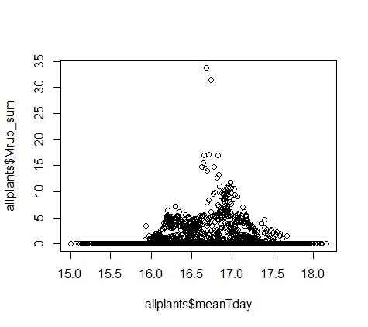 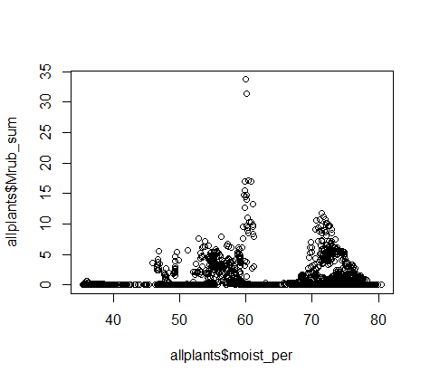

> mod9<-lm(pldens_2~scale(meanTday)*scale(moist_per),allplants, na.action="na.fail")

> summary(mod9)

Coefficients:

Estimate Std. Error t value Pr(>|t|)

(Intercept) 23.5224 0.1186 198.31 <2e-16 ***

scale(meanTday) 3.2455 0.1273 25.49 <2e-16 ***

scale(moist_per) 7.5341 0.1264 59.61 <2e-16 ***

scale(meanTday):scale(moist_per) 4.2375 0.1278 33.16 <2e-16 ***

---

Signif. codes: 0 ‘***’ 0.001 ‘**’ 0.01 ‘*’ 0.05 ‘.’ 0.1 ‘ ’ 1

Residual standard error: 10.29 on 8848 degrees of freedom

Multiple R-squared: 0.4538, Adjusted R-squared: 0.4537

F-statistic: 2451 on 3 and 8848 DF, p-value: < 2.2e-16

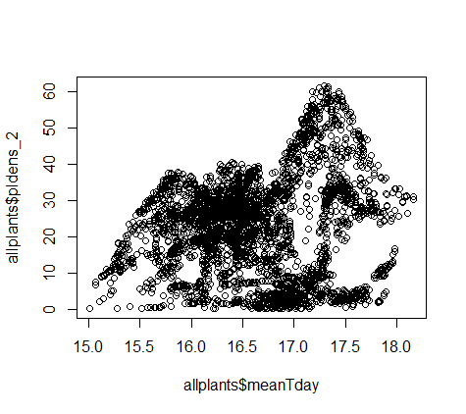 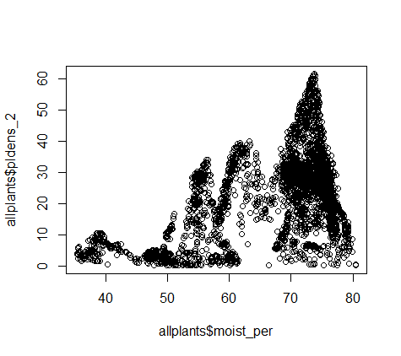

> mod10<-lm(phen_n2~scale(meanTday)*scale(moist_per),allplants, na.action="na.fail")

> summary(mod10)

Coefficients:

Estimate Std. Error t value Pr(>|t|)

(Intercept) 3.948191 0.004693 841.37 <2e-16 ***

scale(meanTday) -0.261129 0.005038 -51.84 <2e-16 ***

scale(moist_per) -0.622349 0.005000 -124.47 <2e-16 ***

scale(meanTday):scale(moist_per) 0.107108 0.005056 21.18 <2e-16 ***

---

Signif. codes: 0 ‘***’ 0.001 ‘**’ 0.01 ‘*’ 0.05 ‘.’ 0.1 ‘ ’ 1

Residual standard error: 0.407 on 8848 degrees of freedom

Multiple R-squared: 0.6474, Adjusted R-squared: 0.6473

F-statistic: 5416 on 3 and 8848 DF, p-value: < 2.2e-16

