PAPER 3.1

Effect of different ant species on probability of attack and number of eggs (univariate models)

Model coefficients

|  |  |  |  |
| --- | --- | --- | --- |
| Predictor: | | Response: probability of attack (n = 8848) | Response: number of eggs in attacked plants (n = 731) |
| Abundance (sum) of | |  |  |
|  | All *Myrmica* | -0.52232* | NS |
|  | *M. rubra* | 0.17423* | 0.13664* |
|  | *M. scabrinodis* | -1.36392* | -0.11955* |
|  | *M. ruginodis* | -0.21499* | NS |
|  | *M. schencki* | 0.35843* | NS |
|  | Other ants | -0.40260* | NS |
|  | *M. rubra* + *M. schencki* | 0.36009* | 0.11490* |
| Presence (0/1, in 3 m) of | |  |  |
|  | *M. rubra* | 0.22471* | NS |
|  | *M. scabrinodis* | -1.58382* | NS |
|  | *M. ruginodis* | -0.25981* | NS |
|  | *M. schencki* | 1.46238* | NS |
|  | Other ants | -0.85729* | NS |
|  | *M. rubra* or *M. schencki* | 1.08614* | 0.14917* |

They respond positively to *M. rubra* and *M. schencki* and to both of them combined, and negatively to other species (competition?)

*M. rubra* 🡪 cited as host in Sweden

*M. ruginodis*🡪 cited as host in Västra Götaland

*M. schencki* 🡪cited as host of the xeropihlous ecotype of *P. alcon* (feeding on *Gentiana cruciata*) in several places in Europe (and also one citation as host of the hygrophilous ecotype in Poland, map in Vilbas et al. J Insect Conserv (2016) 20:879–886)

Full model

With *M. rubra* (the one used before – before adding the Moran eigenvectors)

|  |
| --- |
| Nagelkerke R2 = 0.41 |
| Estimate Std. Error z value Pr(>|z|)  (Intercept) -4.32565 0.11251 -38.447 < 2e-16 ***  phen 1.37326 0.07632 17.994 < 2e-16 ***  Mrub_sum 0.03710 0.05099 0.728 0.4669  pldens_2 -1.92550 0.09032 -21.318 < 2e-16 ***  phen_n2 -0.78411 0.11385 -6.887 5.68e-12 ***  phen:Mrub_sum 0.14309 0.06191 2.311 0.0208 *  phen:phen_n2 0.01769 0.06653 0.266 0.7904  pldens_2:phen_n2 -0.48041 0.08258 -5.818 5.96e-09 *** |

With *M. rubra* + *M. schencki* (coefficient slightly higher)

|  |
| --- |
| Nagelkerke R2 = 0.41 |
| Estimate Std. Error z value Pr(>|z|)  (Intercept) -4.33171 0.11354 -38.150 < 2e-16 ***  phen 1.35841 0.07674 17.701 < 2e-16 ***  Mrub_sch_s 0.05759 0.05130 1.123 0.262  pldens_2 -1.91099 0.09111 -20.975 < 2e-16 ***  phen_n2 -0.81546 0.11495 -7.094 1.30e-12 ***  phen:Mrub_sch_s 0.14874 0.05853 2.541 0.011 *  phen:phen_n2 -0.00789 0.06835 -0.115 0.908  pldens_2:phen_n2 -0.50317 0.08318 -6.049 1.46e-09 *** |

With only *M. schencki*, the effect of ants and the interaction with phenology are not significant

With both species included as separate terms, the effect of *M. schencki* (and its interaction with phenology) is not significant.

Distances

Sum ants 2 m, neighbors 2 m

Attack R2=0.41

Estimate Std. Error z value Pr(>|z|)

(Intercept) -4.326885 0.113478 -38.130 < 2e-16 ***

scale(as.integer(phen)) 1.352928 0.076675 17.645 < 2e-16 ***

scale(Mrub_sch_s) 0.018507 0.053548 0.346 0.7296

scale(pldens_2) -1.925297 0.091265 -21.096 < 2e-16 ***

scale(phen_n2) -0.809557 0.115034 -7.038 1.96e-12 ***

scale(as.integer(phen)):scale(Mrub_sch_s) 0.127336 0.058270 2.185 0.0289 *

scale(as.integer(phen)):scale(phen_n2) 0.009464 0.067266 0.141 0.8881

scale(pldens_2):scale(phen_n2) -0.508654 0.083770 -6.072 1.26e-09 ***

Number of eggs R2=0.26

Estimate Std. Error z value Pr(>|z|)

(Intercept) 1.49558 0.03744 39.943 < 2e-16 ***

scale(as.integer(phen)) 0.23633 0.03707 6.375 1.83e-10 ***

scale(Mrub_sch_s) 0.08972 0.02993 2.998 0.00272 **

scale(pldens_2) -0.39978 0.05583 -7.160 8.04e-13 ***

scale(phen_n2) -0.12020 0.03824 -3.144 0.00167 **

scale(as.integer(phen)):scale(Mrub_sch_s) 0.02370 0.03122 0.759 0.44785

scale(as.integer(phen)):scale(phen_n2) -0.02516 0.03614 -0.696 0.48640

scale(pldens_2):scale(phen_n2) -0.12133 0.03749 -3.236 0.00121 **

Sum ants 3 m, neighbors 3 m 🡪 USE

Attack R2=0.42

(Intercept) -4.42298 0.11869 -37.264 < 2e-16 ***

scale(as.integer(phen)) 1.38375 0.07662 18.060 < 2e-16 ***

scale(Mrub_sch_s) 0.06083 0.05094 1.194 0.2324

scale(pldens_3) -1.94302 0.09240 -21.028 < 2e-16 ***

scale(phen_n3) -1.01370 0.11992 -8.453 < 2e-16 ***

scale(as.integer(phen)):scale(Mrub_sch_s) 0.11984 0.05797 2.067 0.0387 *

scale(as.integer(phen)):scale(phen_n3) -0.02229 0.07050 -0.316 0.7519

scale(pldens_3):scale(phen_n3) -0.65035 0.08399 -7.743 9.7e-15 ***

Number of eggs R2=0.22

(Intercept) 1.495890 0.040271 37.145 < 2e-16 ***

scale(as.integer(phen)) 0.257067 0.036385 7.065 1.60e-12 ***

scale(Mrub_sch_s) 0.088750 0.031456 2.821 0.00478 **

scale(pldens_3) -0.367678 0.067148 -5.476 4.36e-08 ***

scale(phen_n3) -0.120551 0.040855 -2.951 0.00317 **

scale(as.integer(phen)):scale(Mrub_sch_s) 0.003997 0.030968 0.129 0.89731

scale(as.integer(phen)):scale(phen_n3) 0.014317 0.035418 0.404 0.68605

scale(pldens_3):scale(phen_n3) -0.099857 0.042397 -2.355 0.01851 *

Elmes et al. 1998: Most species are ground foragers searching up to 2 m from the nest (Elmes, 1975) but *Myrmica ruginodis* Nyl. and *M. rubra* can forage in shrubs up to 8 m from their nest (Stradling, 1968; McGlynn, 1994).

Wynhoff et al. 2001: Normally worker ants collect the food only relatively close to the nest site. The distances they walk are not more than about 2 m from the nest entrance for *Myrmica scabrinodis* and 5-6 m for *Myrmica rubra*. *Myrmica scabrinodis* usually stays on the ground. The workers explore their surrounding walking through the plants, under the litter and under moss cushions. *Myrmica rubra* also moves up into the vegetation, bushes and small trees like willows (Van Boven & Mabelis 1986, Elmes et al. 1998).

GRAPHS

Model 1: attack

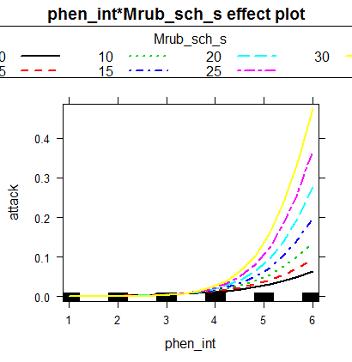 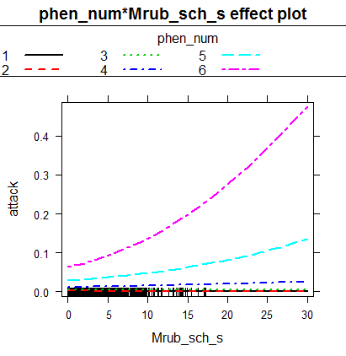

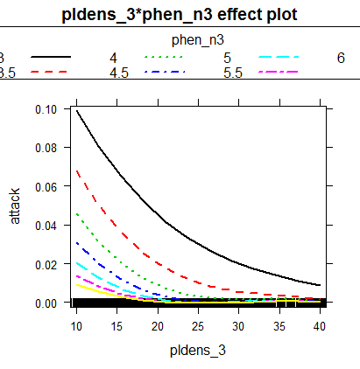 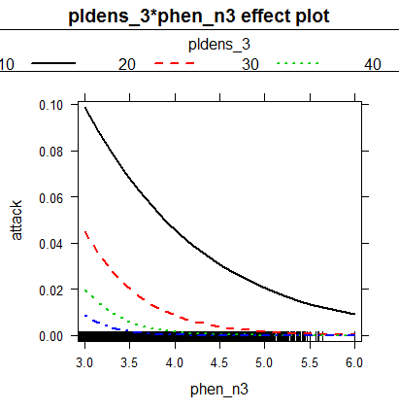

GRAPHS

Model 2: Number of eggs

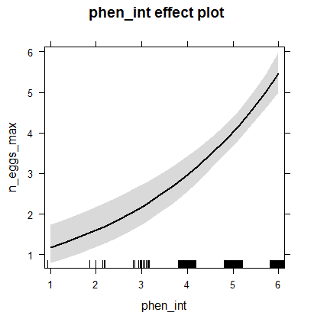 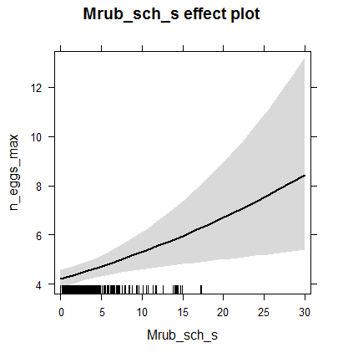

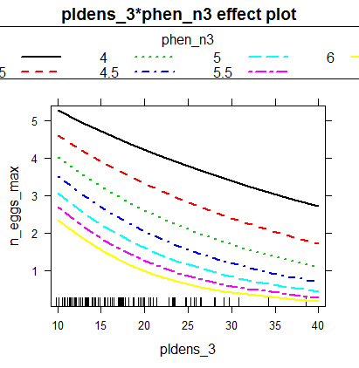 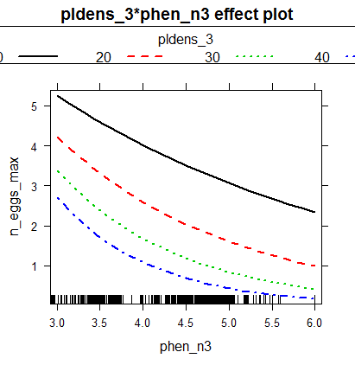

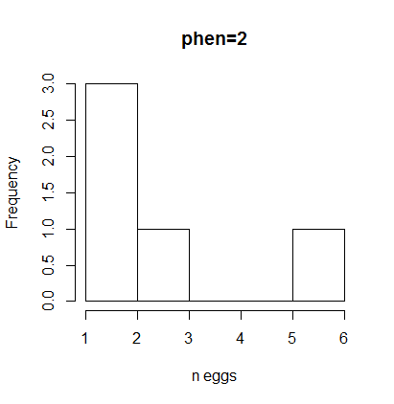 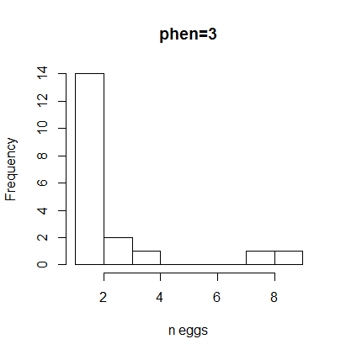

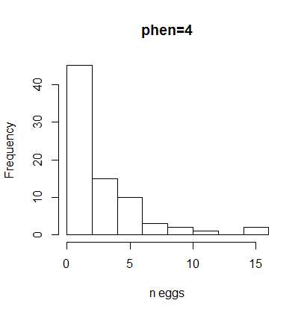 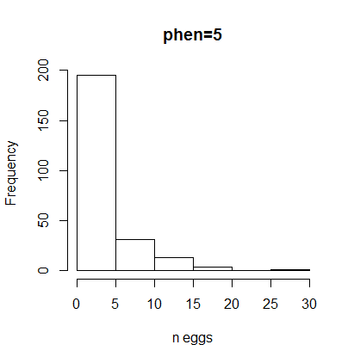

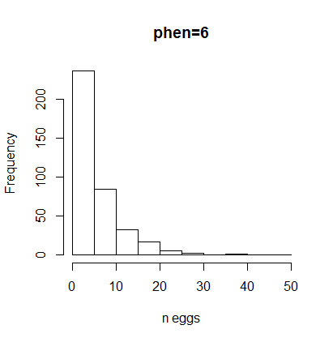

PAPER 3.2

Effects of temperature and moisture on ants

Analyses done with point data (i.e. real, not interpolated data: temperature measured with loggers and moisture measured with moisture meter at each point, n=254 points)

Relationship among moisture (moisture %) and temperature (mean temperature)



Coefficients linear model:

Estimate Std. Error t value Pr(>|t|)

(Intercept) 229.320 24.528 9.349 < 2e-16 ***

meanT -10.543 1.518 -6.945 3.36e-11 ***

Multiple R-squared: 0.1639

Adjusted R-squared: 0.1605

Points with presence of each ant species colored (point size and color indicates abundance represented by the sum of individuals found in 2 sampling sessions)



*M. scabrinodis* – wet places

*M. schenki*- warm, dry places

Constrained ordination – to see if ant species composition is driven by temperature and moisture. It is a regression-type model that predicts where points and species will occur in an ordination graph based on constraining variables (here, temperature and moisture). The new axes for displaying the species matrix (here, four *Myrmica* species + “other species”) are constrained to be linear combinations of these variables.

Performed with presence (0-1, left), sum (sum of individuals found in 2 sampling sessions, center) and maximum (maximum number of individuals found in 2 sampling sessions, right) values.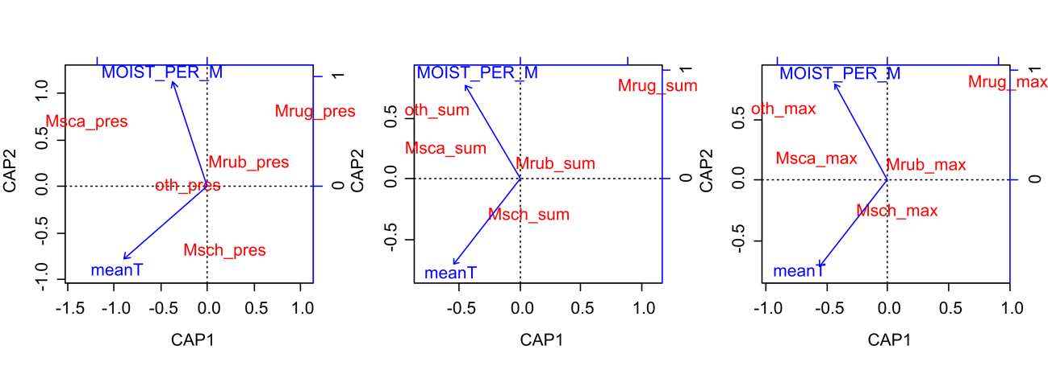

Overall models and both terms (temperature and moisture) are significant (also when doing the analysis only with *Myrmica*). This means that temperature and moisture determine ant species composition (although the level of variance explained is low, around 5%).

Responses of presence of each ant species to temperature and moisture (interaction temperature x moisture was never significant)

|  |  |  |
| --- | --- | --- |
| glm(formula = Mrub_pres ~ scale(meanT) + scale(MOIST_PER_M),  family = "binomial", data = data_pts)  Estimate Std. Error z value Pr(>|z|)  (Intercept) -1.7211 0.1809 -9.514 <2e-16 ***  scale(meanT) -0.3717 0.1864 -1.994 0.0461 *  scale(MOIST_PER_M) -0.3186 0.1967 -1.620 0.1053 |  |  |
| glm(formula = Msca_pres ~ scale(meanT) + scale(MOIST_PER_M),  family = "binomial", data = data_pts)  Estimate Std. Error z value Pr(>|z|)  (Intercept) -1.1588 0.1591 -7.283 3.28e-13 ***  scale(meanT) 0.4252 0.1750 2.430 0.0151 *  scale(MOIST_PER_M) 0.7668 0.1773 4.324 1.53e-05 *** |  |  |
| glm(formula = Mrug_pres ~ scale(meanT) + scale(MOIST_PER_M),  family = "binomial", data = data_pts)  Estimate Std. Error z value Pr(>|z|)  (Intercept) 0.001736 0.131756 0.013 0.98949  scale(meanT) -0.400523 0.150255 -2.666 0.00768 **  scale(MOIST_PER_M) 0.274319 0.145866 1.881 0.06002 . |  |  |
| glm(formula = Msch_pres ~ scale(meanT) + scale(MOIST_PER_M),  family = "binomial", data = data_pts)  Estimate Std. Error z value Pr(>|z|)  (Intercept) -2.3603 0.2357 -10.015 <2e-16 ***  scale(meanT) 0.1630 0.2576 0.633 0.527  scale(MOIST_PER_M) -0.3864 0.2572 -1.502 0.133 |  |  |
| glm(formula = oth_pres ~ scale(meanT) + scale(MOIST_PER_M),  family = "binomial", data = data_pts)  Estimate Std. Error z value Pr(>|z|)  (Intercept) -2.1391 0.2105 -10.163 <2e-16 ***  scale(meanT) 0.1975 0.2309 0.855 0.392  scale(MOIST_PER_M) 0.2994 0.2242 1.335 0.182 |  |  |

Responses of abundance (sum) of each ant species to temperature and moisture (interaction temperature x moisture only significant for “other ants”)

|  |  |  |
| --- | --- | --- |
| glm.nb(formula = Mrub_sum ~ scale(meanT) + scale(MOIST_PER_M),data = data_pts, init.theta = 0.05906049164, link = log)  Estimate Std. Error z value Pr(>|z|)  (Intercept) 0.07937 0.26977 0.294 0.7686  scale(meanT) -0.45252 0.29571 -1.530 0.1259  scale(MOIST_PER_M) -0.66485 0.29976 -2.218 0.0266 * |  |  |
| glm.nb(formula = Msca_sum ~ scale(meanT) + scale(MOIST_PER_M), data = data_pts, init.theta = 0.1263145145, link = log)  Estimate Std. Error z value Pr(>|z|)  (Intercept) 0.3739 0.1882 1.986 0.046991 *  scale(meanT) 0.4027 0.2084 1.932 0.053343 .  scale(MOIST_PER_M) 0.7399 0.2085 3.549 0.000386 *** |  |  |
| glm.nb(formula = Mrug_sum ~ scale(meanT) + scale(MOIST_PER_M), data = data_pts, init.theta = 0.2168987156, link = log)  Estimate Std. Error z value Pr(>|z|)  (Intercept) 1.86869 0.13875 13.468 <2e-16 ***  scale(meanT) -0.30325 0.15175 -1.998 0.0457 *  scale(MOIST_PER_M) 0.02383 0.15230 0.156 0.8756 |  |  |
| glm.nb(formula = Msch_sum ~ scale(meanT) + scale(MOIST_PER_M),data = data_pts, init.theta = 0.03457169411, link = log)  Estimate Std. Error z value Pr(>|z|)  (Intercept) -0.5977 0.3613 -1.654 0.0981 .  scale(meanT) 0.6498 0.4098 1.586 0.1128  scale(MOIST_PER_M) -0.7088 0.4019 -1.763 0.0778 . |  |  |
| glm.nb(formula = oth_sum ~ scale(meanT) * scale(MOIST_PER_M), data = data_pts, init.theta = 0.03327492047, link = log)  Estimate Std.Error z value Pr(>|z|)  (Intercept) 0.33754 0.37795 0.893 0.3718  scale(meanT) -0.08383 0.39948 -0.210 0.8338  scale(MOIST_PER_M) 0.75673 0.39816 1.901 0.0574 .  scale(meanT):scale(MOIST) 0.73543 0.35567 2.068 0.0387 * |  | |

Response of plant phenology to temperature and moisture

Distribution plant phenology

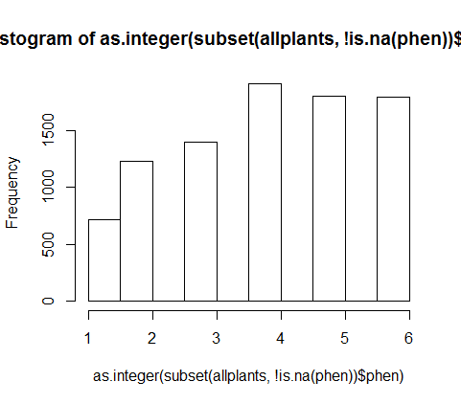

lm(formula = as.integer(phen) ~ scale(meanT) * scale(moist_per),

data = subset(allplants, !is.na(phen)))

Coefficients:

Estimate Std. Error t value Pr(>|t|)

(Intercept) 3.96021 0.01698 233.208 < 2e-16 ***

scale(meanT) -0.22017 0.01809 -12.172 < 2e-16 ***

scale(moist_per) -0.59471 0.01793 -33.161 < 2e-16 ***

scale(meanT):scale(moist_per) 0.08319 0.01771 4.697 2.68e-06 ***

Residual standard error: 1.474 on 8844 degrees of freedom

Multiple R-squared: 0.1151, Adjusted R-squared: 0.1148

F-statistic: 383.4 on 3 and 8844 DF, p-value: < 2.2e-16

Plot interaction effect temperature x moisture

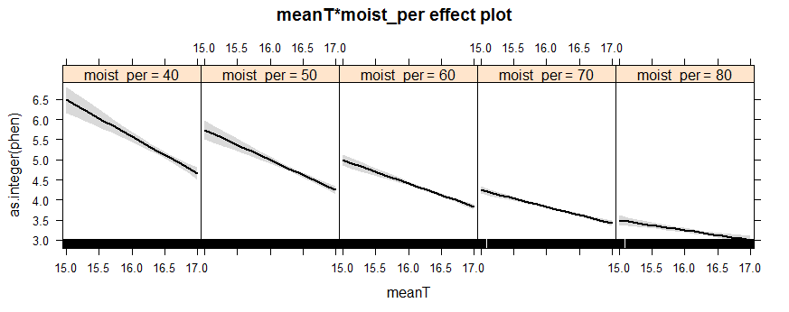

Higher temperatures 🡪 later flowering (!!)

Response of plant density to temperature and moisture

Distribution plant density (2 m)

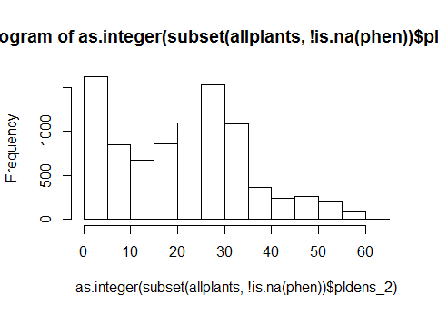

lm(formula = pldens_2 ~ scale(meanT) * scale(moist_per), data = subset(allplants,

!is.na(phen)))

Coefficients:

Estimate Std. Error t value Pr(>|t|)

(Intercept) 23.4819 0.1199 195.88 <2e-16 ***

scale(meanT) 3.2068 0.1277 25.11 <2e-16 ***

scale(moist_per) 7.6888 0.1266 60.73 <2e-16 ***

scale(meanT):scale(moist_per) 4.0122 0.1250 32.09 <2e-16 ***

Residual standard error: 10.41 on 8844 degrees of freedom

Multiple R-squared: 0.4411, Adjusted R-squared: 0.4409

F-statistic: 2327 on 3 and 8844 DF, p-value: < 2.2e-16

Plot interaction effect temperature x moisture

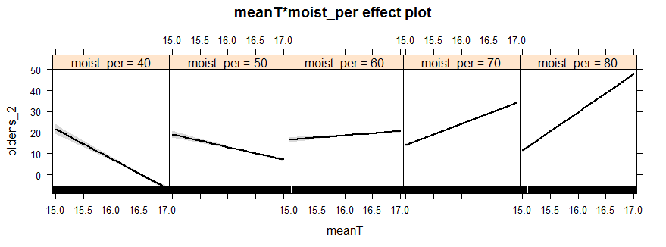

Plant density decreases with temperature when moisture is low, but increases with temperature when moisture is high

Models for probability of attack and number of eggs – with marked plants, added effects of number of flowers, shoot height and vegetation height. All second order interactions included

Probability of attack

glm(formula = attack ~ (scale(phen_int) + scale(Mrub_sch_s) +

scale(pldens_2) + scale(phen_n2) + scale(n_fl) + scale(shoot_h) +

scale(veg_h_mean))^2, family = "binomial", data = subset(allplants,

!is.na(pl_id) & !is.na(phen)), na.action = "na.fail")

Coefficients:

Estimate Std. Error z value Pr(>|z|)

(Intercept) -0.52902 0.18314 -2.889 0.003868 **

scale(phen_int) 0.29670 0.19558 1.517 0.129258

scale(Mrub_sch_s) 0.32101 0.14475 2.218 0.026580 *

scale(pldens_2) -1.10168 0.21428 -5.141 2.73e-07 ***

scale(phen_n2) -0.19646 0.14919 -1.317 0.187868

scale(n_fl) 0.97433 0.27056 3.601 0.000317 ***

scale(shoot_h) 0.02156 0.18987 0.114 0.909589

scale(veg_h_mean) -0.30688 0.15011 -2.044 0.040917 *

scale(phen_int):scale(Mrub_sch_s) 0.03475 0.18946 0.183 0.854457

scale(phen_int):scale(pldens_2) -0.32427 0.21200 -1.530 0.126123

scale(phen_int):scale(phen_n2) -0.37497 0.18396 -2.038 0.041520 *

scale(phen_int):scale(n_fl) -0.71913 0.34018 -2.114 0.034521 *

scale(phen_int):scale(shoot_h) 0.42539 0.22179 1.918 0.055112 .

scale(phen_int):scale(veg_h_mean) -0.60089 0.21713 -2.767 0.005650 **

scale(Mrub_sch_s):scale(pldens_2) 0.13057 0.21487 0.608 0.543406

scale(Mrub_sch_s):scale(phen_n2) 0.14003 0.18398 0.761 0.446604

scale(Mrub_sch_s):scale(n_fl) -0.01513 0.21094 -0.072 0.942813

scale(Mrub_sch_s):scale(shoot_h) -0.01138 0.15665 -0.073 0.942089

scale(Mrub_sch_s):scale(veg_h_mean) 0.06970 0.15829 0.440 0.659683

scale(pldens_2):scale(phen_n2) -0.40921 0.16309 -2.509 0.012105 *

scale(pldens_2):scale(n_fl) -0.08341 0.29160 -0.286 0.774859

scale(pldens_2):scale(shoot_h) -0.40288 0.26742 -1.507 0.131934

scale(pldens_2):scale(veg_h_mean) 0.48410 0.21491 2.253 0.024286 *

scale(phen_n2):scale(n_fl) -0.01463 0.18566 -0.079 0.937182

scale(phen_n2):scale(shoot_h) -0.09791 0.21147 -0.463 0.643375

scale(phen_n2):scale(veg_h_mean) 0.08993 0.15964 0.563 0.573204

scale(n_fl):scale(shoot_h) -0.44012 0.15294 -2.878 0.004005 **

scale(n_fl):scale(veg_h_mean) 0.30886 0.20288 1.522 0.127919

scale(shoot_h):scale(veg_h_mean) 0.12139 0.15376 0.789 0.429835

$R2 0.3502558

Best model – stepwise selection

Estimate Std. Error z value Pr(>|z|)

(Intercept) -0.46728 0.16576 -2.819 0.004816 **

scale(phen_int) 0.27532 0.19000 1.449 0.147318

scale(Mrub_sch_s) 0.30304 0.10867 2.789 0.005291 **

scale(pldens_2) -1.07447 0.20307 -5.291 1.22e-07 ***

scale(phen_n2) -0.19516 0.14757 -1.323 0.185998

scale(n_fl) 0.96825 0.25807 3.752 0.000175 ***

scale(shoot_h) 0.04501 0.18493 0.243 0.807718

scale(veg_h_mean) -0.31091 0.14592 -2.131 0.033113 *

scale(phen_int):scale(pldens_2) -0.35167 0.19681 -1.787 0.073961 .

scale(phen_int):scale(phen_n2) -0.40829 0.16894 -2.417 0.015660 *

scale(phen_int):scale(n_fl) -0.74354 0.32183 -2.310 0.020868 *

scale(phen_int):scale(shoot_h) 0.40517 0.21798 1.859 0.063058 .

scale(phen_int):scale(veg_h_mean) -0.55129 0.20948 -2.632 0.008497 **

scale(pldens_2):scale(phen_n2) -0.37776 0.15650 -2.414 0.015789 *

scale(pldens_2):scale(shoot_h) -0.35816 0.17842 -2.007 0.044707 *

scale(pldens_2):scale(veg_h_mean) 0.40286 0.18615 2.164 0.030449 *

scale(n_fl):scale(shoot_h) -0.40768 0.14173 -2.876 0.004022 **

scale(n_fl):scale(veg_h_mean) 0.37266 0.17573 2.121 0.033945 *

$R2 0.3803854

Number of eggs

glm.nb(formula = n_eggs_max ~ (scale(phen_int) + scale(Mrub_sch_s) +

scale(pldens_2) + scale(phen_n2) + scale(n_fl) + scale(shoot_h) +

scale(veg_h_mean))^2, data = subset(allplants, !is.na(phen) &

n_eggs_max > 0), init.theta = 2.669105296, link = log)

Coefficients:

Estimate Std. Error z value Pr(>|z|)

(Intercept) 1.5748736 0.0987952 15.941 < 2e-16 ***

scale(phen_int) 0.3807436 0.1049264 3.629 0.000285 ***

scale(Mrub_sch_s) 0.1532340 0.0690472 2.219 0.026469 *

scale(pldens_2) -0.5597575 0.1320542 -4.239 2.25e-05 ***

scale(phen_n2) -0.2753632 0.0780985 -3.526 0.000422 ***

scale(n_fl) -0.0333416 0.1343827 -0.248 0.804050

scale(shoot_h) -0.0097790 0.0962504 -0.102 0.919075

scale(veg_h_mean) 0.0522943 0.0813983 0.642 0.520581

scale(phen_int):scale(Mrub_sch_s) 0.0080037 0.0685288 0.117 0.907023

scale(phen_int):scale(pldens_2) 0.1167385 0.0996486 1.172 0.241397

scale(phen_int):scale(phen_n2) 0.0878953 0.0833821 1.054 0.291825

scale(phen_int):scale(n_fl) 0.1182651 0.1540604 0.768 0.442693

scale(phen_int):scale(shoot_h) 0.0263878 0.1108611 0.238 0.811861

scale(phen_int):scale(veg_h_mean) -0.1136596 0.0965564 -1.177 0.239143

scale(Mrub_sch_s):scale(pldens_2) 0.0007222 0.0993461 0.007 0.994199

scale(Mrub_sch_s):scale(phen_n2) 0.0257108 0.0942721 0.273 0.785061

scale(Mrub_sch_s):scale(n_fl) 0.0602316 0.0968333 0.622 0.533934

scale(Mrub_sch_s):scale(shoot_h) -0.0720300 0.0769774 -0.936 0.349413

scale(Mrub_sch_s):scale(veg_h_mean) -0.0237899 0.0795153 -0.299 0.764798

scale(pldens_2):scale(phen_n2) -0.0807155 0.0795231 -1.015 0.310109

scale(pldens_2):scale(n_fl) -0.3929857 0.1508345 -2.605 0.009176 **

scale(pldens_2):scale(shoot_h) -0.1054338 0.1091484 -0.966 0.334061

scale(pldens_2):scale(veg_h_mean) 0.0910143 0.1100481 0.827 0.408213

scale(phen_n2):scale(n_fl) -0.0828031 0.0843019 -0.982 0.325991

scale(phen_n2):scale(shoot_h) -0.0094287 0.0971279 -0.097 0.922667

scale(phen_n2):scale(veg_h_mean) 0.1778955 0.0710236 2.505 0.012254 *

scale(n_fl):scale(shoot_h) 0.0137546 0.0702509 0.196 0.844772

scale(n_fl):scale(veg_h_mean) 0.0518018 0.0851438 0.608 0.542920

scale(shoot_h):scale(veg_h_mean) -0.0825690 0.0670567 -1.231 0.218199

$R2 0.473813

Best model – stepwise selection

Estimate Std. Error z value Pr(>|z|)

(Intercept) 1.68237 0.05822 28.896 < 2e-16 ***

scale(phen_int) 0.26782 0.06943 3.858 0.000114 ***

scale(Mrub_sch_s) 0.12246 0.04803 2.549 0.010792 *

scale(pldens_2) -0.40287 0.07705 -5.229 1.71e-07 ***

scale(phen_n2) -0.21387 0.06250 -3.422 0.000621 ***

scale(n_fl) 0.05175 0.08010 0.646 0.518210

scale(shoot_h) 0.04527 0.07248 0.625 0.532253

scale(veg_h_mean) -0.01732 0.06132 -0.282 0.777573

scale(Mrub_sch_s):scale(shoot_h) -0.08654 0.03588 -2.412 0.015851 *

scale(pldens_2):scale(n_fl) -0.36135 0.11263 -3.208 0.001336 **

scale(phen_n2):scale(veg_h_mean) 0.14197 0.05886 2.412 0.015866 *

$R2 0.4391302